- Download far manager from and install it in your pc
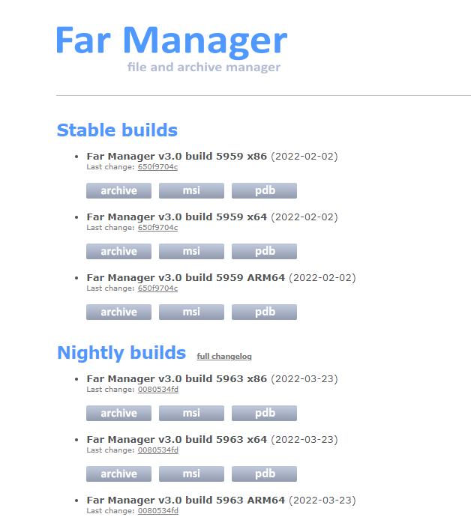

BASIC OPERATITONS
- TAB: move between left and right pane
- ENTER: to navigate to the directory
.. : to come out from a directory

- F7 :
Create directory
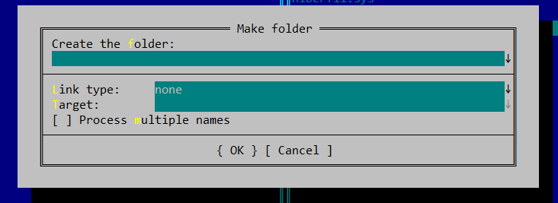

- Change directory ALT F1
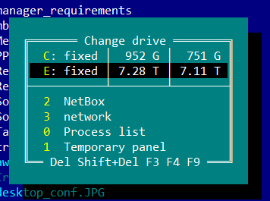

- Change to network drive
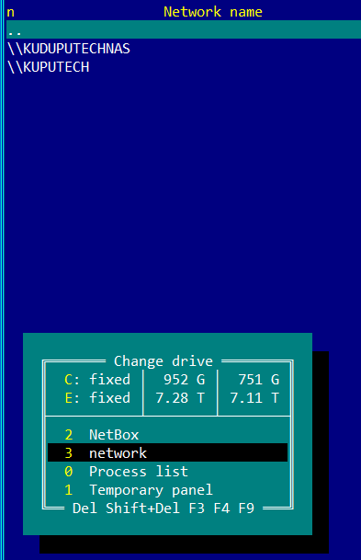

- Use F5 key to initiate the copying process.
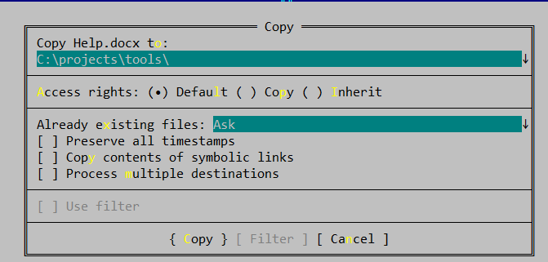

- DELETE A FILE F8

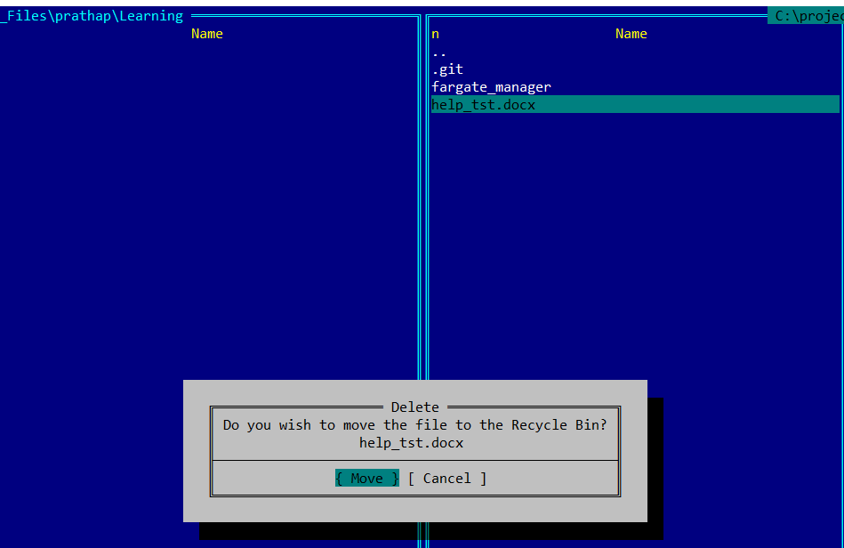

Note all operations of are listed below

