UNKNOWN: An Evidence-Grounded Hybrid Retrieval and Reasoning System for Intelligent Information Discovery
Author 1 Name  Dept. of Computer Science and Engineering (IoT and Cybersecurity including Blockchain Technology)  Dayananda Sagar College of Engineering  Bengaluru, India  email@domain | Author 2 Name  Dept. of Computer Science and Engineering (IoT and Cybersecurity including Blockchain Technology)  Dayananda Sagar College of Engineering  Bengaluru, India  email@domain | Author 3 Name  Dept. of Computer Science and Engineering (IoT and Cybersecurity including Blockchain Technology)  Dayananda Sagar College of Engineering  Bengaluru, India  email@domain

Abstract—Researchers must find relevant papers, judge whether the available evidence is sufficient, detect disagreement among sources, and check their own documents against the current literature. Retrieval-augmented generation (RAG) systems usually return one fused answer and leave these judgments to the reader. This paper presents UNKNOWN, a multi-source scholarly retrieval system in which an evidence-sufficiency signal controls retrieval and answer generation. A query is decomposed into sub-questions; each is scored for sufficiency, and insufficient ones are reformulated, searched in additional sources, or reported as gaps. Every atomic claim in a generated answer, including numbers, dates and named entities, is checked against its cited passage and repaired or removed. Sources are weighted by venue, recency and retraction status, conflicting evidence is reported with both sides, and statements in a user’s document are compared with the literature. On [datasets], the full pipeline reduces the unsupported-claim rate from [X]% to [Y]% against hybrid retrieval with the same retriever, with [Z] change in nDCG@10 and [L]× latency. Ablations show [which components contribute most].
Index Terms—Evidence sufficiency, retrieval-augmented generation, claim verification, conflict-aware retrieval, scholarly question answering, research-gap analysis.

I. INTRODUCTION
Research relies on reading many papers. The answer to a literature question is rarely contained in one snippet: a definition may come from one paper, a number from another and a limitation from a third, and the papers may disagree. A system must therefore decide whether it has enough evidence and whether that evidence can be trusted before it answers.
Retrieval-augmented generation (RAG) reduces unsupported answers by conditioning a language model on retrieved passages [1]. Four problems remain. First, an answer is generated even when the retrieved evidence is weak or irrelevant [2]. Second, a generated sentence may contain a number, date or name that is absent from the cited passage. Third, when papers disagree, the answer tends to blend the conflicting statements. Fourth, a user’s own document is not systematically checked against the literature.
Lexical ranking with BM25 and dense retrieval over a FAISS index are standard and complementary [3]–[8]. UNKNOWN uses them as a base and does not claim them as a contribution. The contribution is the control layer around retrieval and generation:
1. Sufficiency-controlled retrieval. Evidence sufficiency is computed per sub-question across independent sources and decides whether to answer, search again, or report a gap.
2. Claim-level verification with repair. Atomic claims, including numbers, dates and names, are checked against the cited passage and corrected or removed.
3. Conflict-aware, reliability-weighted evidence. Sources are weighted by venue, recency and retraction status; disagreements are reported with both sides and a likely cause.
4. Document-versus-literature comparison. Statements in a user’s document are compared with external literature to expose outdated or contradicted claims.
A typed research-gap report and evidence-linked visual tools (concept map, Knowledge DNA, 3D orbit view) are supporting features described in Section IV but not evaluated as core contributions. We do not claim to be the first scholarly question-answering system. The claim is the combination of the four mechanisms in one workflow, and its measured benefit, reported in Section VII. The remainder of the paper is organized as follows: Section II reviews related work, Section III states the problem, Section IV presents the method, Section V the implementation, Section VI the experimental setup, Section VII the results, Section VIII the limitations, and Section IX concludes.

II. RELATED WORK

A. Retrieval and Adaptive Retrieval
BM25 ranks passages by term frequency, inverse document frequency and length normalization [6]. Dense retrievers compare embeddings and match paraphrases [4], [5], and FAISS supports efficient nearest-neighbor search [7]. Reciprocal rank fusion (RRF) merges ranked lists without requiring comparable scores [8], and the behavior of fusion functions has been analyzed in detail [9]. Hybrid RAG with re-ranking has also been studied in an IEEE conference paper [10], and a survey covers RAG extensions [11].
Self-RAG, CRAG and Adaptive-RAG adapt when and how to retrieve by critiquing retrieved passages or by selecting a strategy from question complexity [12]–[14]. Work on sufficient context reports that language models frequently answer even when the provided context is insufficient [2]. These works show that multi-round and adaptive retrieval is established. They do not compute sufficiency per sub-question over independent scholarly sources, nor connect that measurement to a gap report.

B. Scholarly Question Answering
PaperQA2 and OpenScholar answer scientific questions with citations to papers [15], [16]; Elicit and Consensus are commercial tools for literature search and synthesis [17], [18]. Knowledge-graph methods can structure extracted knowledge for LLMs [19]. In the sources we reviewed, these systems do not compare a user’s own document with the literature or repair individual claims.

C. Claim Verification and Conflicting Evidence
Attribution studies ask whether generated text is supported by its sources [20]. FEVER and SciFact formalize claim verification against evidence [21], [22], and ALCE and FActScore evaluate citation quality and atomic factual precision [23], [24]. VeriCite applies natural language inference to improve citations in RAG [25], and a fake-news framework retrieves external evidence to verify extracted claims [26]. Surveys explain why generated text drifts from sources [27]. Numeric and date verification inside scholarly answers has received less attention.

D. Literature Survey
We analyzed eleven papers on RAG, claim verification, evaluation and knowledge structuring, seven of them published by IEEE. Table I gives each paper’s contribution and the limitation, relative to our problem, that UNKNOWN addresses. Two papers serve as base papers. The fake-news framework of Bai and Fu [26] shares our extract–retrieve–verify verification stage, and the hybrid RAG work of Omrani et al. [10] is the closest IEEE counterpart to our retrieval base. UNKNOWN differs from [26] by verifying scholarly passages instead of news, producing an evidence-based explanation instead of a class label, and adding sufficiency control, source weighting, conflict reporting and document comparison. It differs from [10] by adding the control and verification layers around a comparable hybrid retriever.

TABLE I
LITERATURE SURVEY (IEEE PAPERS: 1–7)
No. | Paper (venue, year) | Main contribution | Limitation relative to UNKNOWN
1 | Omrani et al. [10] (IEEE ICWR, 2024) | Hybrid RAG combining sentence-window and parent–child retrieval with re-ranking for LLM query responses. | Targets response quality; no claim-level verification, sufficiency check or multi-source scholarly setting.
2 | Bai and Fu [26] (IEEE Big Data, 2024) — base paper | Extracts claims, retrieves external evidence and verifies claims for fake-news detection. | News-domain classification in a three-page paper; no source weighting, conflict explanation or abstention on sparse evidence.
3 | Budakoglu and Emekci [28] (IEEE Access, 2025) | Compares RAG, fine-tuning and their combination across tasks for performance and efficiency. | Compares adaptation strategies; no evidence control or per-claim verification.
4 | Shen et al., MGPRAG [29] (IEEE Access, 2025) | Task decomposition, medical entity alignment and knowledge-graph retrieval for medical QA. | Medical domain; decomposition is not coupled to a sufficiency decision or document comparison.
5 | Brehme et al. [30] (IEEE SDS, 2025) | Systematic review of 63 articles on RAG evaluation (datasets, retrievers, indexing, generators). | A survey, not a system; calls for domain-specific datasets, which motivates our protocol in Section VI.
6 | Pan et al. [19] (IEEE TKDE, 2024) | Roadmap for unifying LLMs and knowledge graphs. | Conceptual roadmap; no scholarly retrieval pipeline with evidence-linked outputs.
7 | Evaluation of LLMs’ reasoning for RAG [31] (IEEE Xplore) [year/venue] | Reports that reasoning models exceed a non-reasoning baseline in faithfulness and semantic similarity under good retrieval. | Evaluates generators given retrieval; no retrieval control or claim repair.
8 | Asai et al., Self-RAG [12] (ICLR, 2024) | Learns to retrieve on demand and critique its own output with reflection tokens. | Needs a trained generator; no per-sub-question sufficiency over independent scholarly sources or document comparison.
9 | Yan et al., CRAG [13] (arXiv, 2024) | Retrieval evaluator that triggers corrective actions, including web search. | Corrects at document level; does not verify generated claims or report gaps.
10 | Skarlinski et al., PaperQA2 [15] (arXiv, 2024) | Agentic RAG over scientific literature with cited answers. | No comparison of a user’s own document with the literature; no per-claim numeric repair reported.
11 | Asai et al., OpenScholar [16] (arXiv, 2024) | Retrieval-augmented LM over a large open-access datastore with iterative self-feedback and citations. | Centered on its datastore; user-document comparison and conflict explanation not reported.

E. Research Gap
Table II summarizes which of the four mechanisms are reported in the closest systems. The comparison reflects our reading of the cited papers and may omit unpublished features. The gap is not a missing component but a missing combination: controlling retrieval by evidence sufficiency, verifying claims, reporting contradictions and comparing a user’s document with the literature in one scholarly workflow. We do not state that these gaps exist in every system.
TABLE II
MECHANISMS REPORTED IN RELATED SYSTEMS
System | Suff. | Claim | Confl. | Doc-lit. | Gaps
Self-RAG [12] | Partial | Partial | N/R | N/R | N/R
CRAG [13] | Partial | N/R | N/R | N/R | N/R
PaperQA2 [15] | Partial | N/R | Partial | N/R | N/R
OpenScholar [16] | Partial | Partial | N/R | N/R | N/R
VeriCite [25] | N/R | Yes | N/R | N/R | N/R
FCRV [26] | N/R | Yes | N/R | N/R | N/R
UNKNOWN | Yes | Yes | Yes | Yes | Yes
Suff.: sufficiency-controlled retrieval; Claim: claim-level verification; Confl.: conflict reporting; Doc-lit.: document-versus-literature comparison; Gaps: typed research-gap report. N/R: not reported in the cited paper.

III. PROBLEM FORMULATION

A. Problem Statement
Let D = D_{u} ∪ D_{o} be a collection of papers, where D_{u} holds the user’s documents and D_{o} holds open scholarly sources. For a query q, the system must return an answer a, a verdict for each sub-question, and a report of conflicts, document-versus-literature differences and gaps, such that every assertion in the output is supported by a passage in D or is removed.
The query is decomposed into sub-questions q₁, …, q_{m}. For each, the retriever returns evidence E_{i}, and the sufficiency test assigns one of three statuses: sufficient, weak or insufficient.

B. Research Questions
RQ1. Compared with single-pass hybrid retrieval using the same retriever, does sufficiency-controlled retrieval improve answer accuracy and reduce unsupported claims?
RQ2. How accurately does claim-level verification identify unsupported claims, and what share is repaired or removed?
RQ3. Do reliability-weighted conflict reporting and document-versus-literature comparison surface known disagreements and seeded outdated statements?
RQ4. What latency and cost does the full pipeline add relative to the base retriever and to a general-purpose assistant given the same documents?

IV. METHODOLOGY

A. System Overview
Fig. 1 shows the pipeline. Documents are ingested, chunked and indexed. A query is analyzed and decomposed, and evidence is retrieved from the user’s library and from open scholarly sources. Each sub-question is checked for sufficiency, selected evidence is weighted for reliability and compared across sources, an answer is generated from the selected passages only, and every claim is verified. The comparison, gap report and visual tools are generated from the verified evidence.
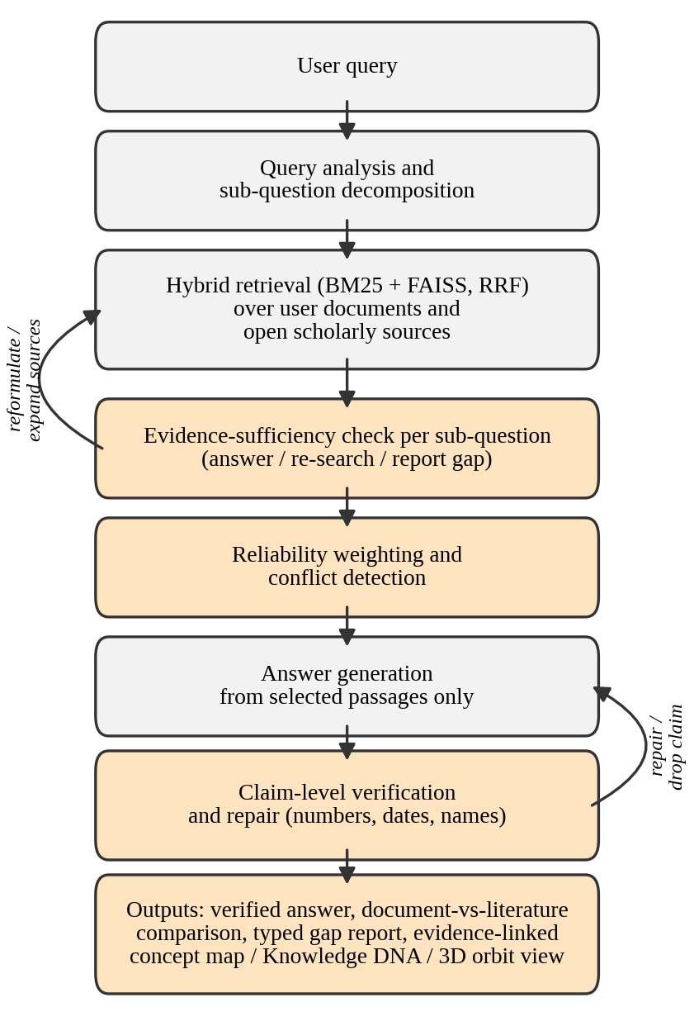
Fig. 1. UNKNOWN pipeline. Shaded stages are the contributions of this work.

B. Ingestion and Chunking
TXT, DOCX and PDF files are converted to text, and OCR is applied to pages without a text layer. The text is split into overlapping chunks that store the document name, title, page number, chunk number and a content hash. This metadata is kept through all later stages so that every output can be traced to its source.

C. Hybrid Retrieval Base
For each sub-question, BM25 [6] ranks the chunk index and a dense retriever ranks the FAISS [7] index built with all-MiniLM-L6-v2 [4], [32]. The two ranked lists are fused by reciprocal rank fusion [8]:
score(c) = Σ_{*L*} 1 / (k + rank_{*L*}(c)) (1)
where L ranges over the two lists and k is a smoothing constant. This base is identical in all experiments.

D. Sufficiency-Controlled Retrieval
For sub-question q_{i}, let E_{i} be the top fused chunks and n_{i} the number of independent source papers among them (chunks from one paper count once, and papers that reuse each other’s results are merged). Let r_{i} be the mean relevance of E_{i} to q_{i}, scored by [cross-encoder model] [33] and normalized to [0, 1]. The status is
status(q_{i}) = sufficient if n_{i} ≥ τ_{n} and r_{i} ≥ τ_{r} (2)
weak if n_{i} ≥ 1 and r_{i} ≥ τ_{r}/2; insufficient otherwise
The thresholds τ_{n} and τ_{r} are tuned on a development split and reported in Section VII. Algorithm 1 gives the control loop and Fig. 2 its decision logic. An insufficient sub-question is reformulated and searched in additional sources for at most T rounds. If it remains insufficient, it is reported as a gap and the generator is not allowed to answer it from its own memory.
Algorithm 1. Sufficiency-controlled retrieval
Input: query q, corpus D, thresholds τ_{n}, τ_{r}, max rounds T
1 Decompose q into q₁, …, q_{m}
2 for each q_{i}: t ← 0, Q ← q_{i}
3 repeat E_{i} ← Retrieve(Q, D) by Eq. (1); compute n_{i}, r_{i}; s ← status(q_{i}) by Eq. (2)
4 if s = insufficient: Q ← Reformulate(Q), expand sources, t ← t + 1
5 until s ≠ insufficient or t = T
6 if s = insufficient: mark q_{i} as gap else keep E_{i}
7 return {(q_{i}, s_{i}, E_{i})}

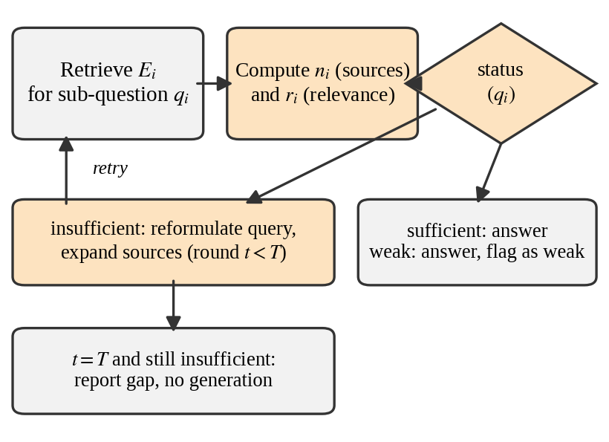
Fig. 2. Decision logic of the sufficiency check for one sub-question.

E. Claim-Level Verification and Repair
The generated answer is split into atomic claims, each linked to its cited passage. A claim is supported only if three checks pass: the passage entails the claim according to [NLI model]; every number and date in the claim appears in the passage after normalization of units and formats; and every named entity in the claim appears in the passage. A failed claim is regenerated from the passage alone and checked again; if it fails twice it is removed. Algorithm 2 summarizes the procedure.
Algorithm 2. Claim verification and repair
Input: answer a, evidence passages P
1 Split a into atomic claims c_{j}, each linked to a passage p_{j} ∈ P
2 for each c_{j}: e ← Entails(p_{j}, c_{j}); u ← numbers and dates of c_{j} found in p_{j}; v ← entities of c_{j} found in p_{j}
3 if e ∧ u ∧ v: label c_{j} supported
4 else: regenerate c_{j} from p_{j}; re-check; if it fails again, drop c_{j}
5 return verified answer and claim labels

F. Reliability Weighting and Conflict Reporting
Each source s receives a weight
w(s) = 0 if s is retracted
w(s) = αV(s) + βR(s) + γC(s) otherwise (3)
with α + β + γ = 1 and α, β > γ so that citation count has the smallest influence. V(s) is a venue score [source of venue scores], R(s) = exp(−λΔt) decays with the age Δt of the paper in years, and C(s) = log(1 + cites)/log(1 + cites_{max}). Retraction status is read from metadata when available. When two evidence sets contradict each other on the same sub-question, as judged by [NLI model], both are shown with their weights and a candidate cause extracted from metadata, such as year, dataset or method.

G. Document-Versus-Literature Comparison
Statements from the user’s document are aligned with statements on the same topic retrieved from D_{o}. Each aligned pair is labeled agree, disagree or not addressed. For a disagree pair, both statements are shown with their reliability weights, which can reveal outdated or contradicted claims.

H. Typed Research-Gap Report
Candidate gaps are stored in three lists: limitations stated by the authors, gaps inferred across several papers, and future directions. An inferred gap is listed only with its supporting evidence and rationale, because an author-stated limitation is not necessarily a research gap. Each entry carries its document, page, chunk and sufficiency status.

I. Evidence-Linked Interface
The overview, Knowledge DNA, mind map and 3D orbit view are generated from concepts and relations extracted from retrieved chunks. A node or edge is kept only if a retrieved chunk supports it, and it stores the document, page and chunk. This does not remove extraction errors; it makes them traceable.

V. IMPLEMENTATION
UNKNOWN is a Python application. FastAPI serves the backend, Streamlit provides the interface, and Pydantic validates request and response schemas. Ingestion, retrieval, generation, validation and research analysis are separate modules that can be tested individually. A provider layer handles timeouts, retries and fallback across the configured language-model providers; this is engineering and not a research contribution. Table III lists the technologies. The backend regression suite of 304 tests passes. These tests check functionality and say nothing about retrieval quality or answer accuracy, which Section VII measures. The code revision, dependency versions, model settings and random seeds are available at [repository link].
TABLE III
IMPLEMENTATION TECHNOLOGIES
Component | Technology | Purpose
Language | Python | Backend logic
Backend / UI | FastAPI / Streamlit | Services, API, queries and results
Lexical search | BM25 [6] | Term-based ranking
Vector search | FAISS [7] | Dense similarity search
Embeddings | all-MiniLM-L6-v2 [4], [32] | Query and chunk vectors
Scholarly sources | [e.g., OpenAlex, arXiv, Crossref] | Open scholarly metadata and text
Re-ranker | [cross-encoder model] [33] | Relevance score r_{i}
Entailment | [NLI model] | Claim and conflict checks
OCR | [OCR engine] | Scanned PDF pages
LLM providers | [providers, versions] | Generation with fallback
Validation / tests | Pydantic / pytest | Schemas; unit, integration, API tests

VI. EXPERIMENTAL SETUP

A. Datasets
For retrieval we use the SciFact, SCIDOCS, TREC-COVID and NFCorpus subsets of BEIR [34]. For answer quality we use QASPER [35] and the claims of SciFact [22]. For RQ3 we built two sets: [N] papers with [M] deliberately outdated or incorrect statements seeded into user documents, and [K] question–evidence pairs with known disagreement between papers. Two annotators labeled relevance and claim support independently and resolved differences; agreement is reported as Cohen’s κ = [value]. A development split is used only to tune τ_{n}, τ_{r}, α, β, γ and λ, and all reported numbers come from the held-out test split.

B. Baselines and Ablations
All configurations share the same corpus, chunking, embedding model, candidate count, language model and temperature. Baselines are BM25 only, FAISS only, hybrid retrieval with RRF, a standard hybrid RAG pipeline, and a general-purpose assistant ([model, version, date]) given the same documents. Ablations remove one component of the full pipeline at a time: the sufficiency loop, claim verification, reliability weighting, and document-versus-literature comparison.

C. Metrics and Protocol
Retrieval is measured by Recall@10, nDCG@10 and MRR. Answer quality is measured by accuracy and the unsupported-claim rate, with claim-support precision for verification. Conflict handling is the share of known disagreements shown with both sides; document comparison is the recall and precision of flagged seeded statements and the false-alarm rate. Efficiency is median and 95th-percentile latency and cost per answer, with hardware and concurrency stated. Each configuration is run [3] times; we report means with 95% bootstrap confidence intervals and test differences with a paired bootstrap.

VII. RESULTS AND DISCUSSION

A. Retrieval
Table IV compares the retrieval base. Hybrid retrieval with RRF reached nDCG@10 of [X] against [Y] for BM25 and [Z] for FAISS alone. [State whether hybrid outperforms both and on which datasets.]
TABLE IV
RETRIEVAL COMPARISON (TEST SPLIT, MEAN OVER DATASETS)
Method | Recall@10 | nDCG@10 | MRR
BM25 only | TBD | TBD | TBD
FAISS only | TBD | TBD | TBD
Hybrid (RRF) | TBD | TBD | TBD

B. End-to-End Answer Quality and Ablation
Table V reports end-to-end results. Relative to the hybrid RAG baseline, sufficiency-controlled retrieval changed accuracy from [A] to [B] and the unsupported-claim rate from [C]% to [D]% (RQ1). Claim verification reached claim-support precision of [E] and removed [F]% of unsupported claims (RQ2). Removing each component changed the unsupported-claim rate by [values], showing that [which component contributes most].
TABLE V
END-TO-END RESULTS AND ABLATION
Configuration | Acc. | Unsup. (%) | Claim prec. | Latency p50/p95 (s) | Cost / ans.
Hybrid RAG (baseline) | TBD | TBD | TBD | TBD | TBD
Full UNKNOWN | TBD | TBD | TBD | TBD | TBD
− sufficiency loop | TBD | TBD | TBD | TBD | TBD
− claim verification | TBD | TBD | TBD | TBD | TBD
− reliability weights | TBD | TBD | TBD | TBD | TBD
− doc-vs-literature | TBD | TBD | TBD | TBD | TBD
General assistant [model] | TBD | TBD | TBD | TBD | TBD
Acc.: answer accuracy; Unsup.: unsupported-claim rate; Claim prec.: claim-support precision.

C. Conflicts and Document Comparison
Table VI addresses RQ3. The full pipeline showed both sides for [P]% of known disagreements and flagged [Q]% of seeded outdated statements with precision [R]% and a false-alarm rate of [S]%.
TABLE VI
CONFLICT REPORTING AND DOCUMENT COMPARISON
Measure | Hybrid RAG | Full UNKNOWN
Known disagreements with both sides shown (%) | TBD | TBD
Seeded outdated statements flagged: recall (%) | TBD | TBD
Seeded outdated statements flagged: precision (%) | TBD | TBD
False alarms on correct statements (%) | TBD | TBD

D. Cost and Discussion
The additional stages increased median latency from [a] s to [b] s and cost per answer from [c] to [d] (RQ4). Compared with the general-purpose assistant, UNKNOWN [describe accuracy, repeatability and cost]. [Discuss when each component helped, representative failure cases, and the sensitivity of the sufficiency thresholds to the dataset.]

VIII. LIMITATIONS AND THREATS TO VALIDITY
Verification. Entailment and number matching can fail on paraphrase and implicit claims, and the cited passage itself may be wrong. Reliability weights. Venue and recency are imperfect proxies for quality, and retraction metadata may be incomplete; weights need tuning and bias checks. Comparison and gaps. Aligning a statement with the literature can misjudge scope, and an inferred gap needs expert confirmation. Model confidence is not a calibrated probability. Extraction. A supported node is not necessarily a correct extraction. Data and models. Only open-access text and abstracts are used, so coverage is partial; language-model output is not fully deterministic; any model-based judge can be biased; and the evaluated domains may not represent all fields. Scope. The typed gap report and the visual tools were not evaluated quantitatively.

IX. CONCLUSION AND FUTURE WORK
UNKNOWN uses an evidence-sufficiency signal to control retrieval and generation, verifies claims against their passages, weights sources by reliability, reports conflicts, and compares a user’s document with the literature. On [datasets], the full pipeline [summarize the main measured findings with numbers], at a cost of [latency/cost overhead]. Future work includes verifying evidence in tables and figures, validating gap reports with expert annotation, evaluating more domains and larger corpora, running usability studies with students and researchers, and releasing datasets, configuration and code.
Acknowledgment. [Funding and guide acknowledgment.] The authors used an AI writing assistant to help structure and edit the manuscript text [confirm wording against the venue’s AI-disclosure policy]. The authors reviewed all content, ran all experiments and are responsible for the paper.

REFERENCES
[1] P. Lewis et al., “Retrieval-augmented generation for knowledge-intensive NLP tasks,” in Proc. Adv. Neural Inf. Process. Syst., vol. 33, 2020, pp. 9459–9474.
[2] H. Joren et al., “Sufficient context: A new lens on retrieval augmented generation systems,” in Proc. Int. Conf. Learn. Represent., 2025. [verify authors]
[3] C. D. Manning, P. Raghavan, and H. Schütze, Introduction to Information Retrieval. Cambridge, U.K.: Cambridge Univ. Press, 2008.
[4] N. Reimers and I. Gurevych, “Sentence-BERT: Sentence embeddings using Siamese BERT-networks,” in Proc. EMNLP-IJCNLP, 2019, pp. 3982–3992.
[5] V. Karpukhin et al., “Dense passage retrieval for open-domain question answering,” in Proc. EMNLP, 2020, pp. 6769–6781.
[6] S. Robertson and H. Zaragoza, “The probabilistic relevance framework: BM25 and beyond,” Found. Trends Inf. Retr., vol. 3, no. 4, pp. 333–389, 2009.
[7] J. Johnson, M. Douze, and H. Jégou, “Billion-scale similarity search with GPUs,” IEEE Trans. Big Data, vol. 7, no. 3, pp. 535–547, 2021.
[8] G. V. Cormack, C. L. A. Clarke, and S. Büttcher, “Reciprocal rank fusion outperforms Condorcet and individual rank learning methods,” in Proc. 32nd Int. ACM SIGIR Conf., 2009, pp. 758–759.
[9] S. Bruch, S. Gai, and A. Ingber, “An analysis of fusion functions for hybrid retrieval,” ACM Trans. Inf. Syst., vol. 42, no. 1, 2023.
[10] P. Omrani, A. Hosseini, K. Hooshanfar, Z. Ebrahimian, R. Toosi, and M. A. Akhaee, “Hybrid retrieval-augmented generation approach for LLMs query response enhancement,” in Proc. 10th Int. Conf. Web Res. (ICWR), IEEE, 2024.
[11] Y. Gao et al., “Retrieval-augmented generation for large language models: A survey,” arXiv:2312.10997, 2023.
[12] A. Asai, Z. Wu, Y. Wang, A. Sil, and H. Hajishirzi, “Self-RAG: Learning to retrieve, generate, and critique through self-reflection,” in Proc. Int. Conf. Learn. Represent., 2024.
[13] S.-Q. Yan, J.-C. Gu, Y. Zhu, and Z.-H. Ling, “Corrective retrieval augmented generation,” arXiv:2401.15884, 2024.
[14] S. Jeong, J. Baek, S. Cho, S. J. Hwang, and J. C. Park, “Adaptive-RAG: Learning to adapt retrieval-augmented large language models through question complexity,” in Proc. NAACL-HLT, 2024.
[15] M. D. Skarlinski et al., “Language agents achieve superhuman synthesis of scientific knowledge,” arXiv:2409.13740, 2024.
[16] A. Asai et al., “OpenScholar: Synthesizing scientific literature with retrieval-augmented LMs,” arXiv:2411.14199, 2024.
[17] Elicit. [Online]. Available: https://elicit.com (accessed Oct. 24, 2026).
[18] Consensus. [Online]. Available: https://consensus.app (accessed Oct. 24, 2026).
[19] S. Pan, L. Luo, Y. Wang, C. Chen, J. Wang, and X. Wu, “Unifying large language models and knowledge graphs: A roadmap,” IEEE Trans. Knowl. Data Eng., 2024. [add volume, pages]
[20] H. Rashkin et al., “Measuring attribution in natural language generation models,” Comput. Linguistics, vol. 49, no. 4, pp. 777–840, 2023.
[21] J. Thorne, A. Vlachos, C. Christodoulopoulos, and A. Mittal, “FEVER: A large-scale dataset for fact extraction and VERification,” in Proc. NAACL-HLT, 2018, pp. 809–819.
[22] D. Wadden et al., “Fact or fiction: Verifying scientific claims,” in Proc. EMNLP, 2020, pp. 7534–7550.
[23] T. Gao, H. Yen, J. Yu, and D. Chen, “Enabling large language models to generate text with citations,” in Proc. EMNLP, 2023, pp. 6465–6488.
[24] S. Min et al., “FActScore: Fine-grained atomic evaluation of factual precision in long form text generation,” in Proc. EMNLP, 2023, pp. 12076–12100.
[25] [Authors], “VeriCite: Towards reliable citations in retrieval-augmented generation via rigorous verification,” [venue], 2025, doi: 10.1145/3767695.3769505.
[26] [Initials] Bai and [initials] Fu, “A large language model-based fake news detection framework with RAG fact-checking,” in Proc. IEEE Int. Conf. Big Data, Washington, DC, USA, 2024, pp. 8617–8619.
[27] Z. Ji et al., “Survey of hallucination in natural language generation,” ACM Comput. Surv., vol. 55, no. 12, Art. no. 248, 2023.
[28] [Initials] Budakoglu and [initials] Emekci, “Unveiling the power of large language models: A comparative study of RAG, fine-tuning and their synergistic fusion,” IEEE Access, vol. 13, pp. 30936–30951, 2025, doi: 10.1109/ACCESS.2025.3542334.
[29] [Initials] Shen, [initials] Xu, [initials] Li, [initials] Fu, and [initials] Liu, “MGPRAG: Enhancing medical large language models via precision retrieval-augmented generation,” IEEE Access, vol. 13, pp. 183225–183241, 2025, doi: 10.1109/ACCESS.2025.3624887.
[30] L. Brehme, T. Ströhle, and R. Breu, “Can LLMs be trusted for evaluating RAG systems? A survey of methods and datasets,” in Proc. IEEE Swiss Conf. Data Sci. (SDS), 2025, doi: 10.1109/SDS66131.2025.00010.
[31] [Authors], “Evaluation of LLMs’ reasoning for retrieval augmented generation (RAG) systems,” IEEE Xplore document 11199211, [venue, year].
[32] W. Wang et al., “MiniLM: Deep self-attention distillation for task-agnostic compression of pre-trained transformers,” in Proc. Adv. Neural Inf. Process. Syst., vol. 33, 2020, pp. 5776–5788.
[33] R. Nogueira and K. Cho, “Passage re-ranking with BERT,” arXiv:1901.04085, 2019.
[34] N. Thakur et al., “BEIR: A heterogeneous benchmark for zero-shot evaluation of information retrieval models,” in Proc. NeurIPS Datasets Benchmarks Track, 2021.
[35] P. Dasigi et al., “A dataset of information-seeking questions and answers anchored in research papers,” in Proc. NAACL-HLT, 2021, pp. 4599–4610.
[36] S. Es et al., “RAGAs: Automated evaluation of retrieval augmented generation,” in Proc. EACL Syst. Demonstrations, 2024.

