LILY Big delta printer
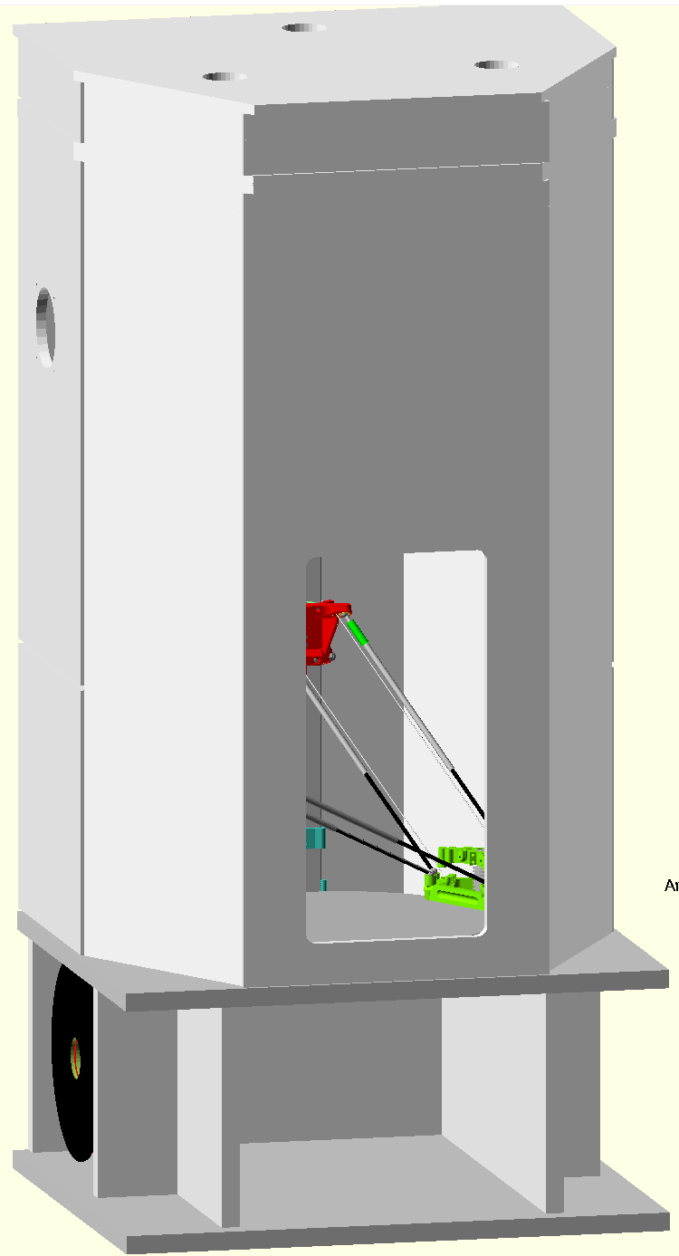
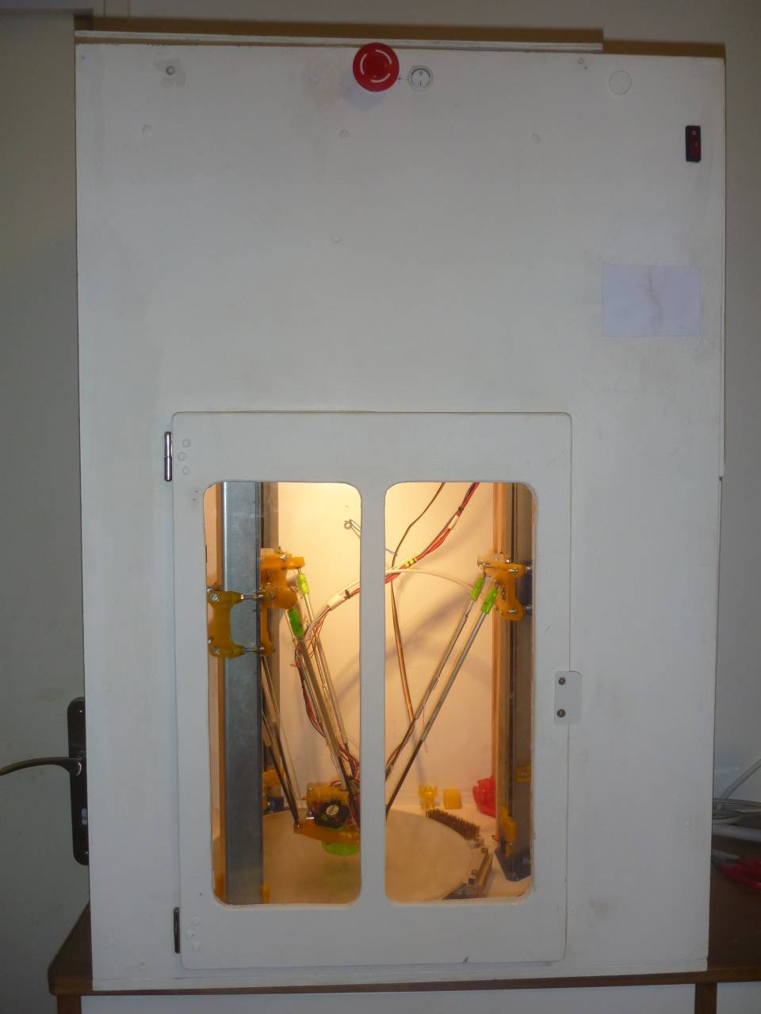
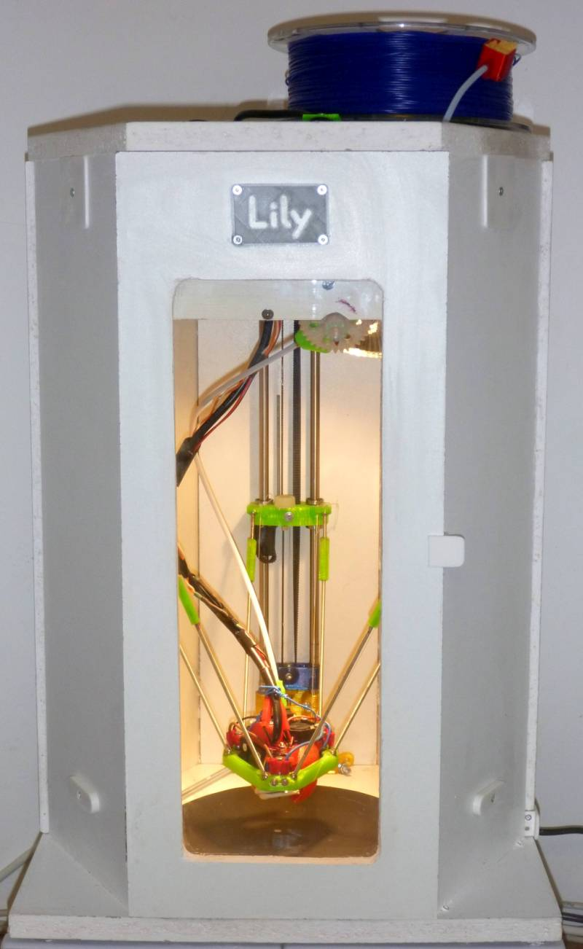

= D-Box mechanics in Lily form factor

Lily “Big”

Based on my experiences on the Lily F and the D-Box printer , I developed a new printer, the Lily Big which is basically the mechanics of the D-Box in the ‘Lily’ form factor, which have some advantages over a rectangular box. I slightly improved the D-Box mechanics after a few month of service and implemented the more precise Lily construction method (column position adjusted with threaded rods).

References :
https://github.com/Prouzeau/Lily-Big-delta-printer
https://github.com/Prouzeau/Lily-F-delta-printer
https://github.com/PRouzeau/Bowden-extruder-direct-drive
http://rouzeau.net/Print3D/Lily
http://rouzeau.net/Print3D/D_Box
http://rouzeau.net/twg/index.php?twg_album=3DPrint%2FLily ‘Lily’ Photos Gallery
http://rouzeau.net/twg/index.php?twg_album=3DPrint%2FDBox ‘D-Box’ Photos Gallery

…/...

Characteristics
The D-Box is now operating flawlessly since eight months and have approximately used 5 kg plastic.
- Usable space and delta geometry is unchanged from D-Box, so its really usable space is diameter is 280mm, 442mm height at center and 402 mm height at 280mm diameter.
- Box size is Width 540mm x depth 470mm x overall height 1120mm.
- The arms are made with balls in printed cups, maintained with tensioning wires. I discovered experimentally that a good tension creates friction and dampen vibrations, reducing the ringing on parts. Yet I never had any break on wires.
- The hotend is installed in a support with kinematic positioning on the effector. This serve two purposes:
*Hotend escape if submitted to extra-load, and in case of large incident, it is totally ejected
*The contact on the kinematic support is used as a hotend height sensor
This is in fact the system used on the Fisher delta bed, transferred on the effector.

- There is an activated carbon filter which remove VOC and odors and may have some efficiency to remove ultra-fine particles.

- Carriage are made with ball bearings rolling on steel iron angle. This is fairly stiff and yet there is no wear on flat part, the central bearings having created their way in a stable manner. The carriage play adjustment is stable and only need readjustment after the first hours of service and none later.

- The Bowden tube length is optimised and the shortest possible for a delta of this size (640 mm)

While its box construction makes it much more stiff than most deltas, this is not a high performance machine for a few reasons:
* With the kinematic positioning system on the effector, the effector weight (all included), is a bit on the heavy side (~210g). Also, the Prometheus hotend is not the lightest, especially compared to J-head.
*The box walls and overall design prevent to install multiple part cooling fans and you shall cope with the single fan (30x30) and duct cooling. Duct is quite directive and makes the best of this fan for reasonable printing speeds (80mm/s in PLA, more with other materials). So, this printer is not designed for fast PLA printing, which anyway is difficult to handle with a direct drive extruder.

This said, it normally print around 80mm/s with 0.3mm layer, and for my use, I found that the limit are the extrusion and not the mechanical speed. I use 8000 mm/s^2 as standard acceleration, which indicates that the mechanics is sufficiently precise for most use and is fair for a machine of that size.

While the box dampens significantly the hotend fan noise, the reduction of overall mechanical noises by the box is noticeable but not dramatic. The high speed movement of delta printers makes them noisier than Cartesian. I expect however some improvement from a ‘Lily’ form factor with thicker panels of lower areas. Also the drivers of the board (a Duet 0.8.5) are not very silent, which was reputed to be improved by the Duet WiFi. Steppers are 0.9° (400 steps per rotation).

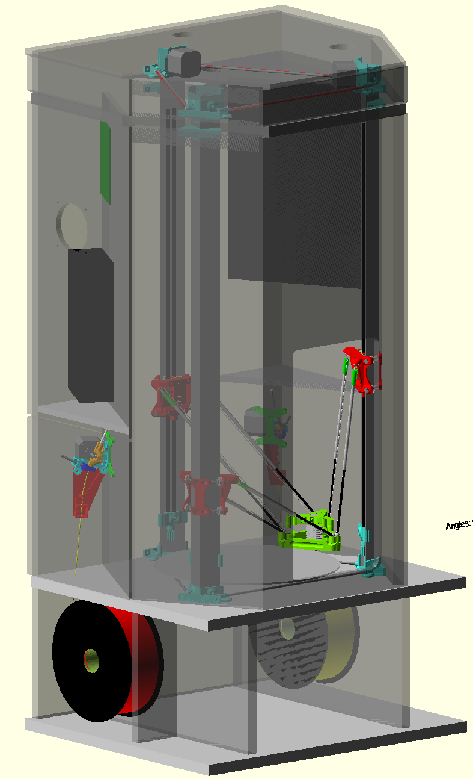
What are the improvement of the Lily form factor over the D-Box:
* Less bulky and more aesthetic
* Lower area so less thermal loss for chamber heating
* Important increase of filtration area.
* Better layout for electronic accessories (added DC/DC converter or Thermocouple boards)
* Better installation if dual extrusion
* Magnetic attachment of the hotend support invite to build a tool changer, but this is not easy with both extruders on the same side.
* Using chipboard instead of plywood will be much lower cost and safer
* Filament spools are below the printing area, which is safer in case of fire.

So, The Lily form factor appear preferable and using threaded rods for accurate column positioning during construction will simplify precise box assembly.

What is lost:
* There are more panels and doors (4 side doors, 1 front door, 1 top cover)
* It is much heavier (Lily Big Box is ~40kg)
* It is taller (by ~250 mm)
* You need sealant for panel tight junction
* on the D-box, I have a fixed brush for hotend cleaning. The room available in the Lily is quite limited for this function, a small brush may however be installed near the door (there is ~15mm added clearance on door side)
* Slightly more woodwork (1 to 2 h)
* Because of the increased height (by 250 mm) Installing an automatic extinguisher atop the printer may be more difficult if ceiling is low (e.g. in a cellar). This is true for my future setup.

The spools are stored below the printer, so the Lily big is significantly taller than the D-Box. The space between operating spools could be used to store tools. However, for safety reasons, it is not recommended to use this space for spool storage, as the unused spools shall be stored as far as possible of the printer in case of fire.

Evolution of mechanics:
Mechanics is slightly improved to ease building and material supply.
The mechanics of the D-Box is modified to accommodate a larger angle as I found that the torsional stiffness of the angle was low, however it doesn’t seems to lower quality print. Also, the chosen angle size (40x40x2) is more common than the prototype (35.5x35.5x1.5).
Effector size is very slightly increased (by 2mm) for fan clearance and ducts were improved.
The effector was reinforced from the initial D-Box version, as the PETG version was flexing under wire tension.
PETG is abandoned, as it was not properly resisting to temperature.
It is usable either for a Prometheus or an E3D-V6. There is three length of part duct to accommodate the miscellaneous adjustments of the Prometheus hotend (1, 2 and 3 nuts). The 2nuts version is the one which shall be used for the E3D-V6.
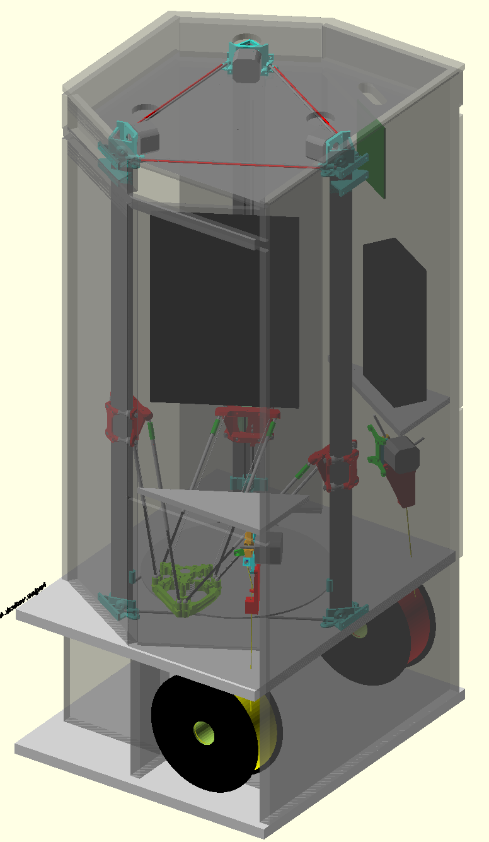
There is no end stops for simplicity and reliability (while they could be installed). The motors are stalled while carriage is locked on its top stops. That makes quite a bad noise while stalling, but precision is not that bad if you use a not too low current. There was recent improvement in RepRap Firmware which ease the setup without end-stops.

The difficulty of building a delta printer is accurate column positioning, so I use threaded rods to make the triangles, instead of templates on the D-Box (which is not geometrically that bad, anyway). On the bottom, the positioning rods should be cut after assembly for effector/bed clearance (at least one to use the maximum diameter without conflict with the fan part duct).

D-Box plastic parts were printed in PETG, but experience while heating the chamber have shown that PETG thermal resistance is insufficient for purpose and I now recommend to NOT use PETG inside the chamber or on movement stepper supports. Parts shall be built in ABS or better (Polycarbonate/Nylon). Extruder can be built in PETG.

I got some troubles with the chamber heating, that I will detail later.

For fan part, I have used a high quality Sunon 30x30x10 fans (9m3/h) supplied in 5V, which is extremely silent.
The fan supplied with the Prometheus was a short lived, high speed 25x25 noisy fan, which have been replaced by the same 30x30 fan used for part cooling. The duct for this fan on the Prometheus is part of the supplied files.

The 5V fan setup works, however you shall be very cautious while wiring it on Duet 0.8.5. Check and recheck polarity on the controlled fan. I have an independent 5V supply, so the risk is lower than with the board 5V. (sending 24V on the 5V board input cannot be nice). It is safer to use 12V fans, but it needs a DC/DC converter.
Fans in 5V is now easy to implement on the new Duet WiFi board.

Alas, for the hotend sensor, like on all mechanically based sensors, you will not escape to do some manual calibration as the offset on the calibration points is not constant, because on the center, you are using 3 belts and near columns, mainly one belt is used, so the offset is larger on the periphery (this is in reverse of the Fisher delta, where offset is larger at center due to spring loads). But with recent version of DC42 fork, it is a bit easier to do, but a procedure have to be written. Macros P0 to P6 which move the effector to the calibrations points helps that. The new arms reduced significantly the offset variations.

Printing on melaminated chip board did not work, even with glue. I have now a silicon heatbed with an aluminium diffuser and glass bed, covered with PrintBite surface.

Evolution
This printer is developed in OpenScad and the printer is mostly parametric. The box building ‘engine’ is an evolution of what was done for the original smaller Lily-F.
You have some examples of other sizes in the file. If creating your own size, some stuff shall be adjusted manually as the base dimension, the tensioner height (check clearance by simulation) or the filter details.

Some may prefer to use 20x40 aluminium extrusion with wheels than these steel on steel carriages. This will be a bit more silent.
A quick study shown that with an extrusion base mechanism, you can maintain same usable diameter setting the belts behind the extrusions, but I won’t do myself this study. You can benefit from the work done one the box, which was more complex than the mechanics.

Credits:
- Johann C. Rocholl, for iniating the delta printer movement
- Tim Jacobsen, for the rod system with wire tensioning system.
- RepRapPro company, for the idea of kinematic positioning system used as a sensor, but here I set it on the effector instead of the bed.
- I designed my filtration system before consulting the RepRap forum on this subject, however, you will find there a lot of useful information and caution.
- The Google deltabot forum is a remarkable resource for delta technical information. There is more useful critics, theory and analysis in this forum than on the RepRap forum which is more ‘hands-on’. Delta printers are a magnet for engineers (I am a member of this crowd !).

Chamber heater/cooler:
I tested radiative heaters with problems, the biggest problem being that the radiation shall be shielded as it heat a lot the columns, this heat climbing up to the steppers supports, which then deformed (they were in PETG). I think radiative heating shall be abandoned.
Depending the bed temperature, the Bed power may not be sufficient to heat the chamber quickly. The chamber heating due to the bed is very slow and it may need more than one hour to stabilize. If you really want a stabilized temperature in the chamber, it is better to use a heater with a fan, as used on some printers, which heat the air instead of heating all printer parts. See the Spiderbot heater here: http://www.spiderbot.eu/en/products/upgrades.html
However, for high bed temperature (>120°C for the D-Box, but that will be lower for the Lily Big), after some time, the chamber temperature began to be excessive and you need to remove heat. It will be quite easy to remove heat with an extracting fan (and a inlet air check valve) and the RepRapFirmware provide a control loop on the fan. But this is a bad design for safety, as allowing air to enter the chamber will allow to sustain an internal fire, while a completely tight chamber will stop fire by oxygen depletion.
There is a commercial filtration unit named 3dPrintClean: http://www.3dprintclean.com which extract heat through an aluminum exchanger. This is a very neat solution which could inspired a DIY unit made with two back to back computer processor coolers, one cooler for the recycling flow, fixed speed, and the other cooler on external air, with flow controlled by chamber temperature.
It depends from the material you use for printed parts, but I recommend to not exceed 60°C in the chamber.

© Pierre ROUZEAU cc BY-SA – GFDL 1.2 -
first issue 2 August 2016

