HXM delta printer
Presentation

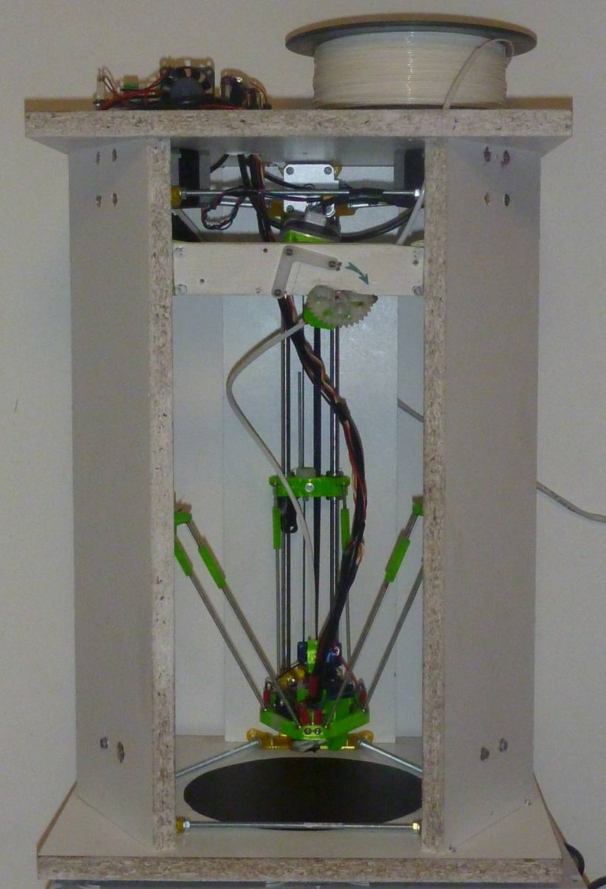
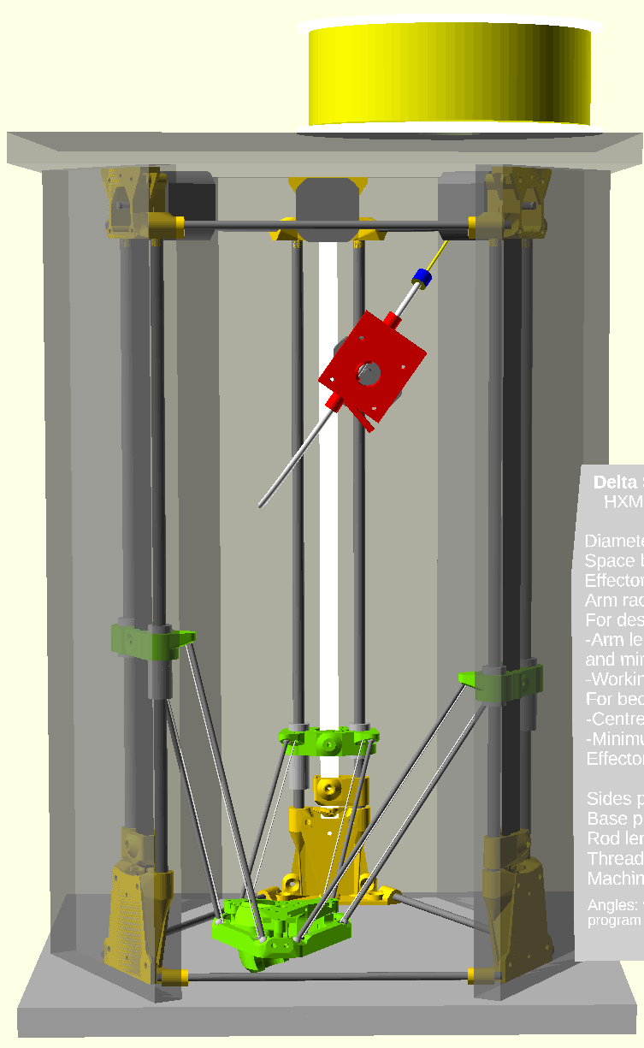

Based on my experiences on the Fisher and the creation of the D-Box printer , I developed a new printer, the HXM (hexagon minimum) which was meant to use the Fisher delta components. It was designed to be used with the Fisher mechanical kit, but with RRP closure, it does have lost some interest as it is now.

Its really usable space is diameter 170mm, 242mm height at center and 223 mm height at 170mm diameter. Base size is 320x370mm, with 500mm between plates. That is roughly twice the really usable volume of the fisher (which is 140mm diameter, ~90mm height at 140mm diameter and 180mm at center.
However, with the exact same parts, you could make another variant with 186mm diameter and a reduced height of 230mm at center and 208mm at 186mm diameter, but with a base increased to 340x380mm.

References :

https://github.com/Prouzeau/HXM-delta-printer
https://github.com/PRouzeau/3D-printer-spool-on-top
https://github.com/PRouzeau/Geared-Extruder
http://rouzeau.net/Print3D/HXM
http://rouzeau.net/twg/index.php?twg_album=3DPrint%2FHXM Photos Gallery

My aim was to:
- Having a more silent printer
- Having a part fan controlled by the board
- Got rid of all acrylic and fragile parts
- Few mechanical adjustement
- Being capable to enclose the printer later.
- Increase the printable dimensions

I have done like on the D-Box, with the kinematic positioning system moved from the bed to the effector. Globally the effector weight is increased by 10g (including balls), which is compensated by the lighter arms.
For the arms, I have not changed the winning team and they are made with M3 threaded rods. This is relatively light and super strong. I was capable to lift the printer (8kg naked) by its effector. Don't even try that with a Fisher, even if its weight is less than half that.
Please note that you can use this effector and carriages on a Fisher, without diameter loss, the height loss being compensated by the bed removal. The big advantage is that the Fisher bottom plate may be much more flat than the Fisher bed. The rod space is the Fisher 1 (42mm), but that could be modified.

The arms are made as on the D-Box, with balls in printed cups, maintained with tensioning wires. My experience showed that there is no need for high tension, so I used nylon wire instead of high grade Dyneema, and this is simpler to install and with elasticity of nylon, there is no need for springs. Tension is just made by adding knots on the wires.

There is no end stops for simplicity and reliability (while they could be installed). I stall the motors on the top support. That makes quite a bad noise while stalling, but precision is not that bad if you use a not too low current.

The difficulty of delta printer is positioning, so I use threaded rods to make the triangles. On the bottom, they could be cut after assembly (at least one to use the maximum diameter without conflict with the fan part duct).

The assembly is faster than the Fisher, but you have to do some woodwork before (quite easy) and modify and complete the wiring (fairly tedious).

Plastic parts are printed in PETG, and so, all components have been reinforced compared to the Fisher, because the PETG stiffness just above half of the PLA stiffness.

I have used two high quality Sunon 20x20x10 fans (5m3/h),supplied in 5V, which are extremely silent. They are not that powerful, but that seems to work. Hotend cooling is not perfect, but seems not worse than the Fisher, however, plastic parts are more exposed to heat (insulation is done with a plumbing fiber gasket).

This fan setup works, however you shall be very cautious while wiring them. Check and recheck polarity on the controlled fan, a mistake will burn the board (sending 19V on the 5V input cannot be nice) . It is safer to use 12V fans, but it needs a DC/DC converter.

- I simplified the already designed spool on top system, with no bearings neither any mechanical part. Its works better !

- I improved a bit the already designed extruder, with stiffer bearing holders. As I already experienced on the Fisher, a good position of the extruder is fairly difficult to establish. I tested 6 positions before settling on the final one. But this allow to use the original bowden tube of the Fisher ( I have to lengthen mine, which was reduced with my spool on top installation, but this extra-length is the original cutted part...).

Does it work ?
It is really the beginning, but for now, I don't see significant differences with the Fisher. I have not printed large parts, anyway.
As for the noise, there is a huge improvement. Indeed, it is a bit less noisy than the D-Box, which is enclosed. Enclosing it will improve noise, as everything is inside.

What are the drawbacks and compromises ?
- There is a bit more than twice the weight in plastic (total ~350 g), which translate in a bit less than twice the printing time (parts are globally more simple). They are printable on the Fisher, however I printed them on the D-Box, which is faster in PETG because of its hotend and controlled cooling, mostly with 0.3mm layers.
Total printing time ~16h on the D-box, maybe 20h on the Fisher.

- The fixation of the hotend on its support is improvable, indeed I redesigned somewhat this, but this is not yet tested.

- For weight and dimensions reasons, I have not used magnets to maintain the hotend like on the D-Box, instead I used rubbers cuts in bike tire tubes. This is less practical to install, but I find a reasonably easy way to do it. So, in case of mechanical trouble, that is not the hotend which is ejected, but the arms which pops out (I tested during commissioning...).

- You have to order a few stuff (2 fans, a diode, cables and connectors, some M3 screws, a larger buildtak, 25cm of bowden tube for filament inlet) and buy parts in DIY stores (wood, to be cut by the store for accuracy, M4 bolts and nuts, wood screws, M5 rods, M3 rods, rubber supports, nylon wire, aluminium sheet for board shielding), for a total which may not exceed 50 euros.

- Alas, like on the Fisher, you will not escape to do some manual calibration as the offset on the calibration points is not constant, because on the center, you are using 3 belts and near columns, mainly one belt is used, so the offset is larger on the periphery (this is in reverse of the Fisher, where offset is larger at center due to spring loads). But with recent version of DC42 fork, it is a bit easier to do, but a procedure have to be written.

- The effector plug installation is really messy. On the D-box, I wired directly to the board and find it much more simple, with minimal drawback as the route is direct and so wire replacement easy. The best installation may be to use a sleeve instead of zip-ties to group independent cables.

Ah, and printing on melaminated chip board did not work, even with glue. So I have installed a BuildTak surface, which is efficient, but quite fragile.

Credits:
- Tim Jacobsen, for the rod system with wire tensioning system.
- RepRapPro company, for the idea of kinematic positioning system used as a sensor, but here I set it on the effector instead of the bed.

© Pierre ROUZEAU cc BY-SA – GFDL 1.2 - 17 January 2016

