**IIT MANDI CS-207 APPLIED DATABASE PRACTICUM FALL 2018**

ASSIGNMENT 1: Understanding HTML and CSS

(In groups of 5 students containing B. Tech. 2nd years)

**Dr. Varun Dutt Due: Before 12:00 NOON on August 13, 2018**

**Readings:**

* Class notes and slides from week 1
* Activity 1 on Moodle

**Objectives:**

* Understand how HTML and CSS tags.
* Understand how to create webpages.

**Submission:**

Please submit as a zipped file, the following documents:

* + HTML file and CSS stylesheet with proper filenames
  + Any supplementary material that is required to run the HTML files (e.g. images, video, Audio)

**Assignment:**

Q1. Create a webpage similar to the one attached below using HTML, HTML5 and CSS.

The following things should be present in the webpage:

1. The webpage should contain a dropdown menu on the left which changes color when the mouse pointer hovers over it. (You can see: https://www.w3schools.com/bootstrap/tryit.asp?filename=trybs_ref_js_dropdown_multilevel_css&stacked=h)
2. The webpage should contain a table in the format given below.
3. An Audio should be present in the webpage. (The audio file is can be downloaded from Moodle).
4. The Webpage should also contain a slider for performing addition as shown in the image below. When we move the slider the correct value should be shown. (you can see: https://www.w3schools.com/jsref/event_oninput.asp)

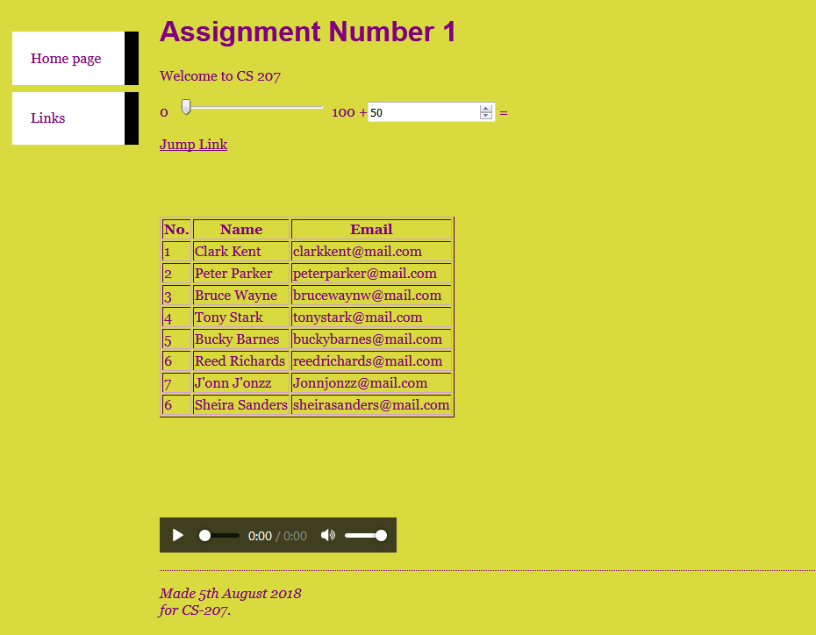

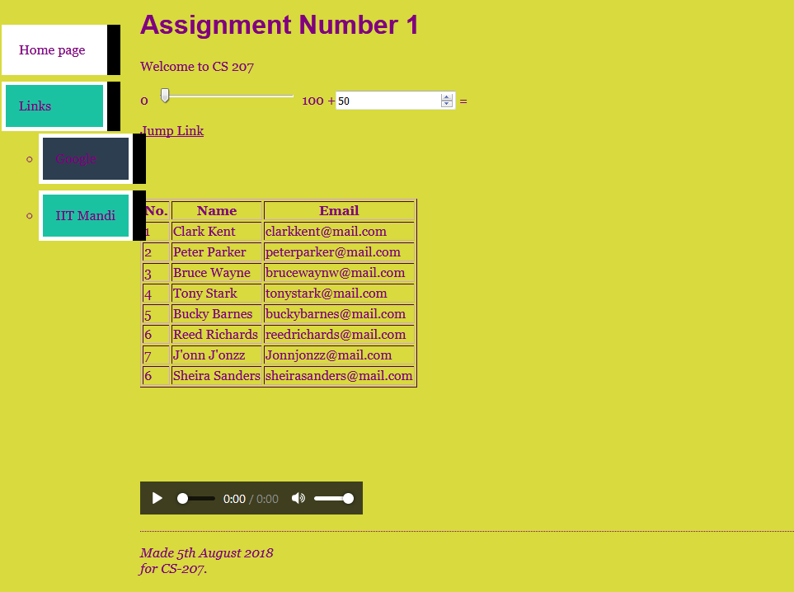

Q6. **[Optional Bonus]** When you click on the “Jump Link” (as shown the image below) it should take you to the end of the document.

