QUESTION 1

i) CREATE TABLE customer_quantity_copy(customerName varchar(255) NULL, QUANTITY int(11) NULL);

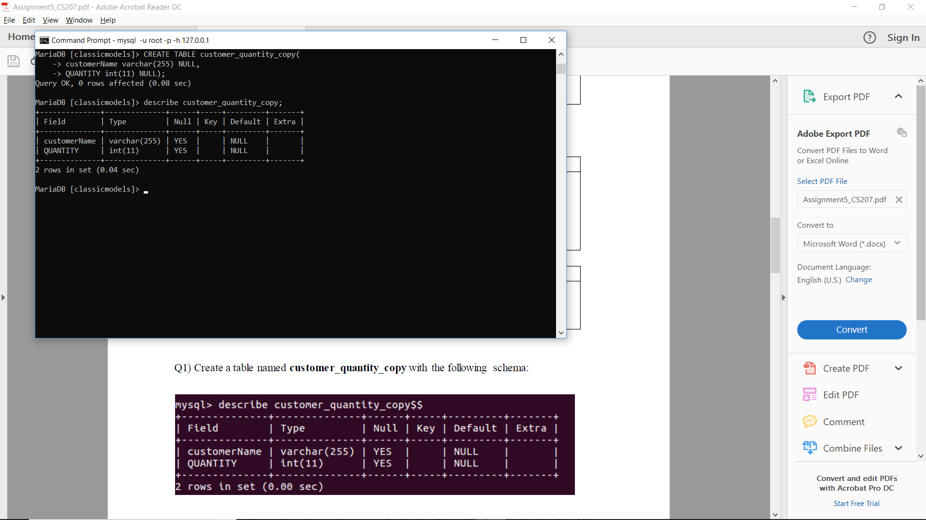

_____________________________________________________________________________________

ii)

DELIMITER $$

CREATE PROCEDURE store_quantity()

BEGIN

DECLARE a varchar(255);

DECLARE b int(11);

DECLARE done INT DEFAULT FALSE;

DECLARE cur CURSOR FOR SELECT customers.customerName, sum(quantityOrdered)

from customers

left outer join orders

ON customers.customerNumber = orders.customerNumber

Left outer join orderdetails

on orders,orderNumber = orderdetails.orderNumber

group by customers.customerNumber;

DECLARE CONTINUE HANDLER FOR NOT FOUND SET done = TRUE;

OPEN cur;

Loop_copy: LOOP

FETCH cur INTO a, b;

IF done THEN

LEAVE loop_copy;

END IF;

INSERT INTO customer_quantity_copy(customerName,QUANTITY) VALUES (a,b);

END LOOP;

CLOSE cur;

END$$

DELIMITER ;

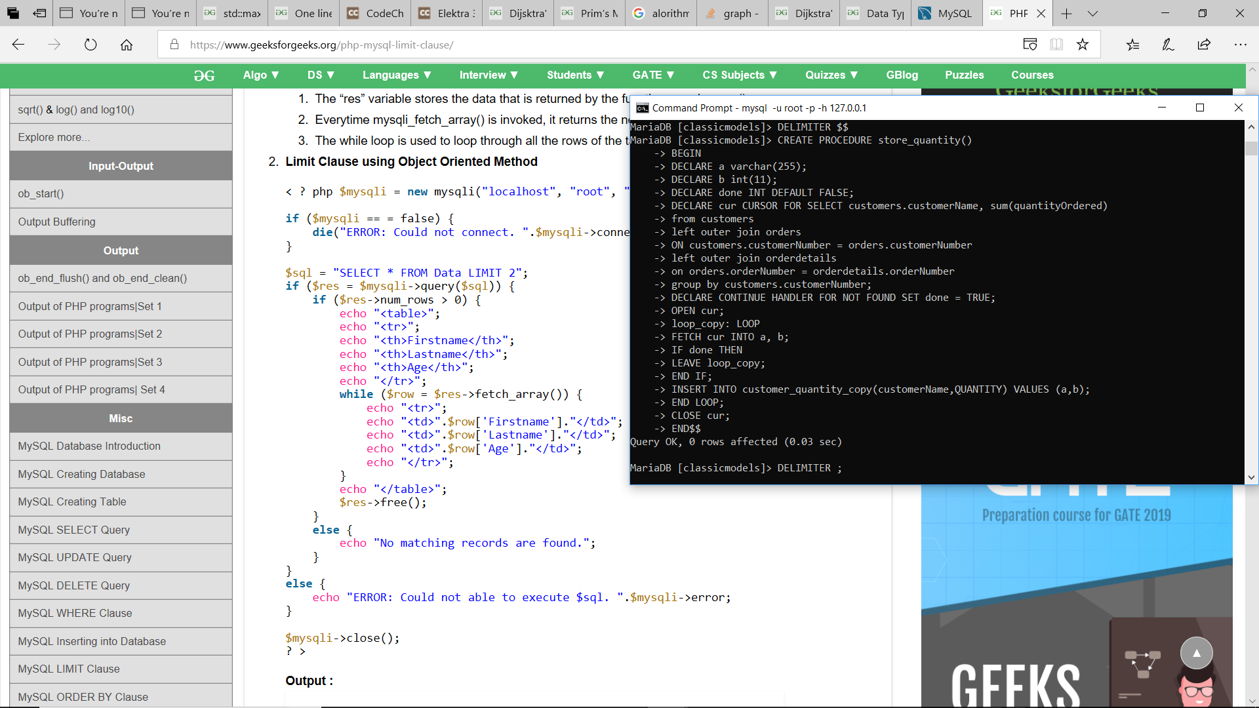

Result –

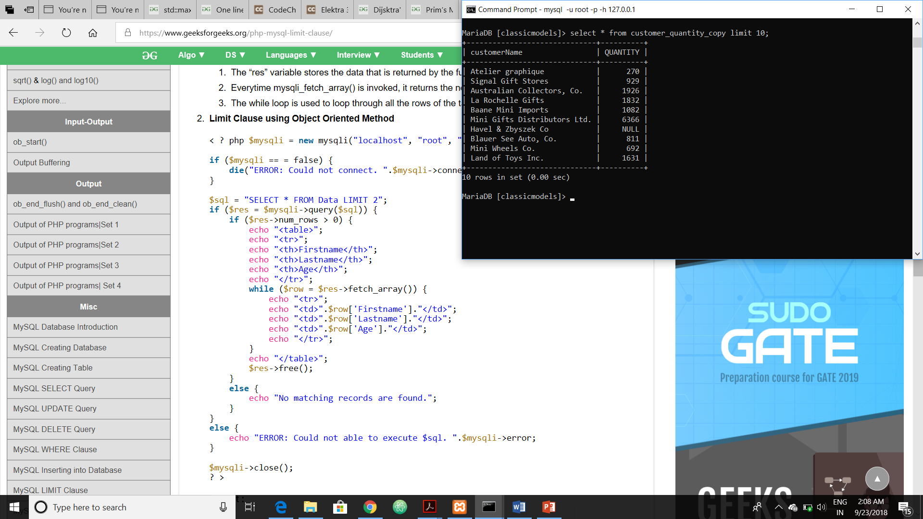

QUESTION2

i)

CREATE TABLE employee_audit(

id int(11) NOT NULL PRIMARY KEY AUTO_INCREMENT,

employeeNumber int(11) NOT NULL,

lastname varchar(50) NOT NULL,

changedat datetime NULL,

action varchar(50) NULL);

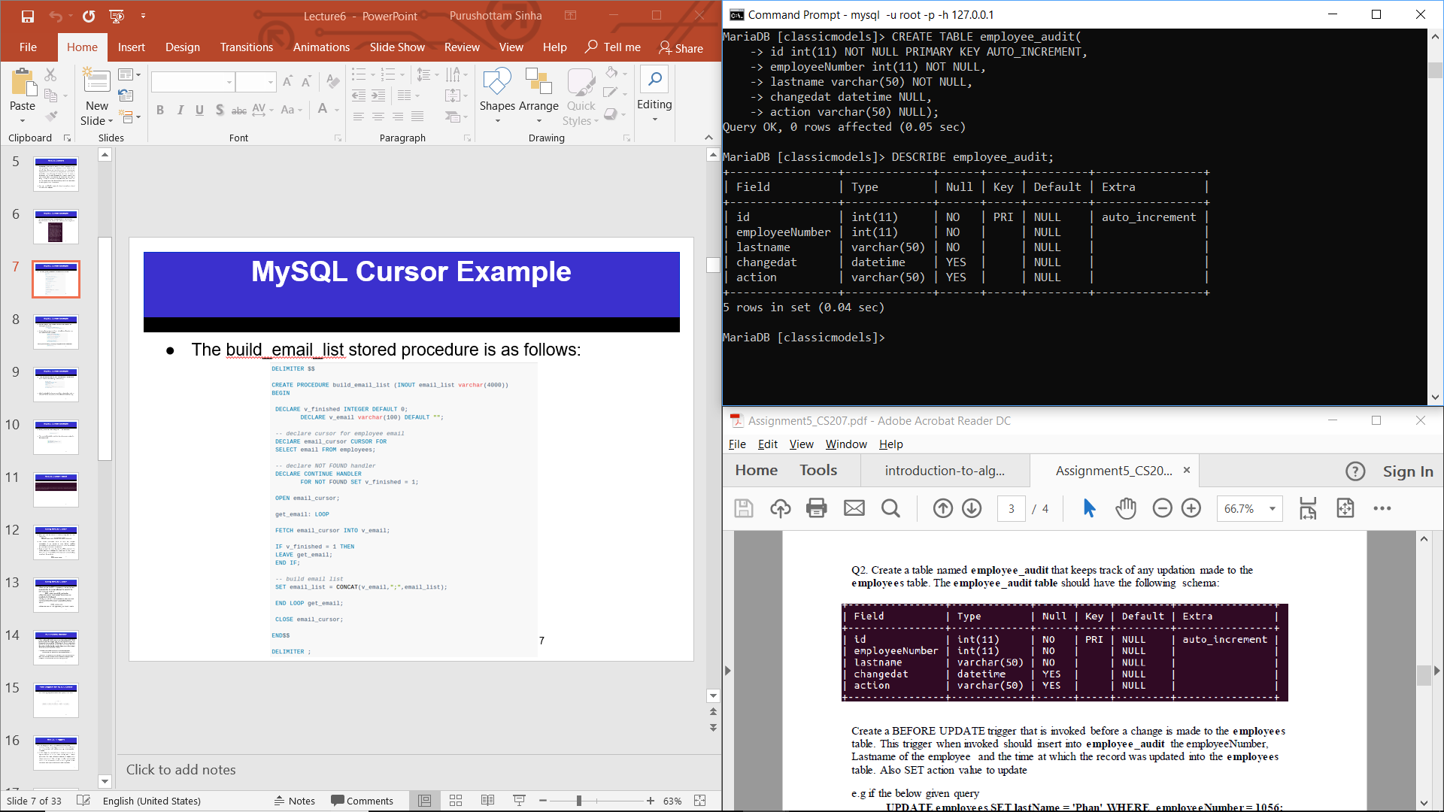

_____________________________________________________________________________________

ii)

DELIMITER $$

CREATE TRIGGER employees_before_update BEFORE UPDATE

ON employees

FOR EACH ROW

BEGIN

IF NEW.employeeNumber = OLD.employeeNumber AND NEW.lastName = OLD.lastName AND NEW.firstName = OLD.firstName AND NEW.extension = OLD.extension AND NEW.email = OLD.email AND NEW.officeCode = OLD.officeCode AND NEW.reportsTo = OLD.reportsTo AND NEW.jobTitle = OLD.jobTitle THEN

set @a = 'No change';

ELSE

set @a = 'update';

END IF;

INSERT INTO employee_audit (employeeNumber,lastName,changedat,action)

VALUES (OLD.employeeNumber, OLD.lastName, now(), @a);

END$$

Delimiter ;

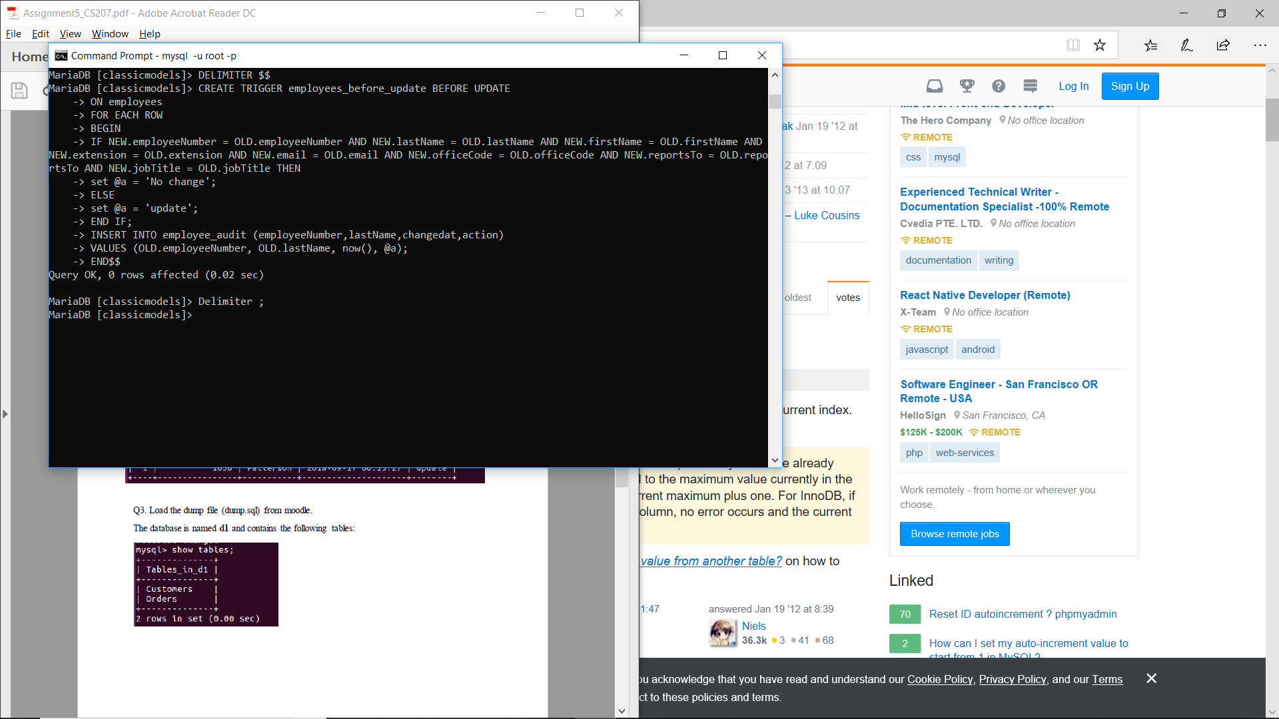

_____________________________________________________________________________________

RESULT-

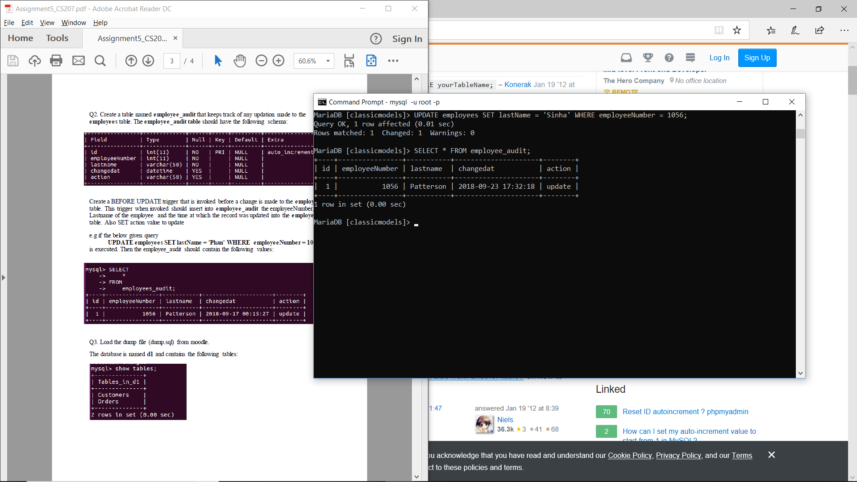

QUESTION 3

i)

CREATE TABLE customer_audit (

id int(11) NOT NULL PRIMARY KEY AUTO_INCREMENT,

customerID int(11) NOT NULL,

user_name varchar(50) NOT NULL,

ContactName varchar(100) NOT NULL,

changedat datetime NULL,

action varchar(50) NULL);

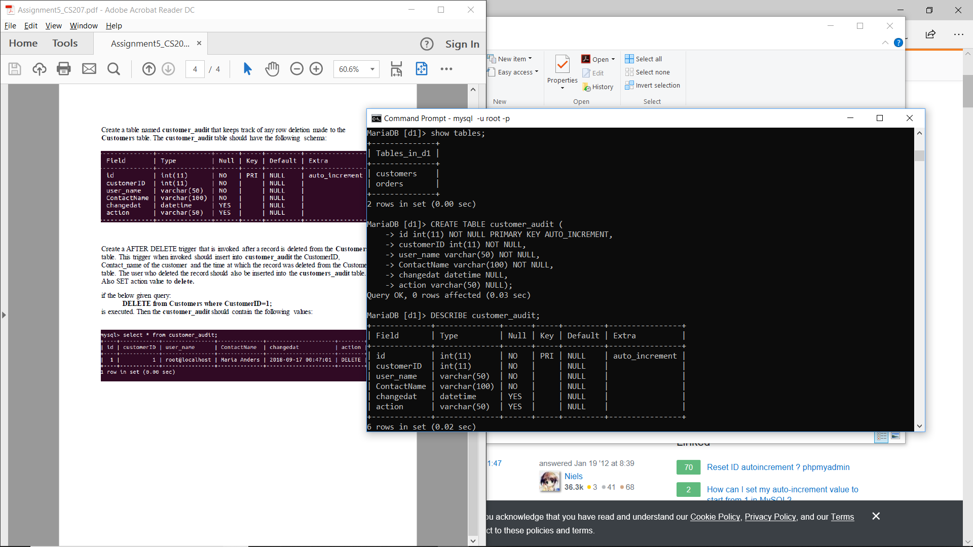_____________________________________________________________________________________

ii)

DELIMITER $$

CREATE TRIGGER customers_after_delete AFTER DELETE

ON customers

FOR EACH ROW

BEGIN

SET @act = 'DELETE';

INSERT INTO customer_audit(customerID,user_name,ContactName, changedat,action)

VALUES (OLD.CustomerID, CURRENT_USER(), OLD.ContactName, NOW(), @act);

END$$

DELIMITER ;

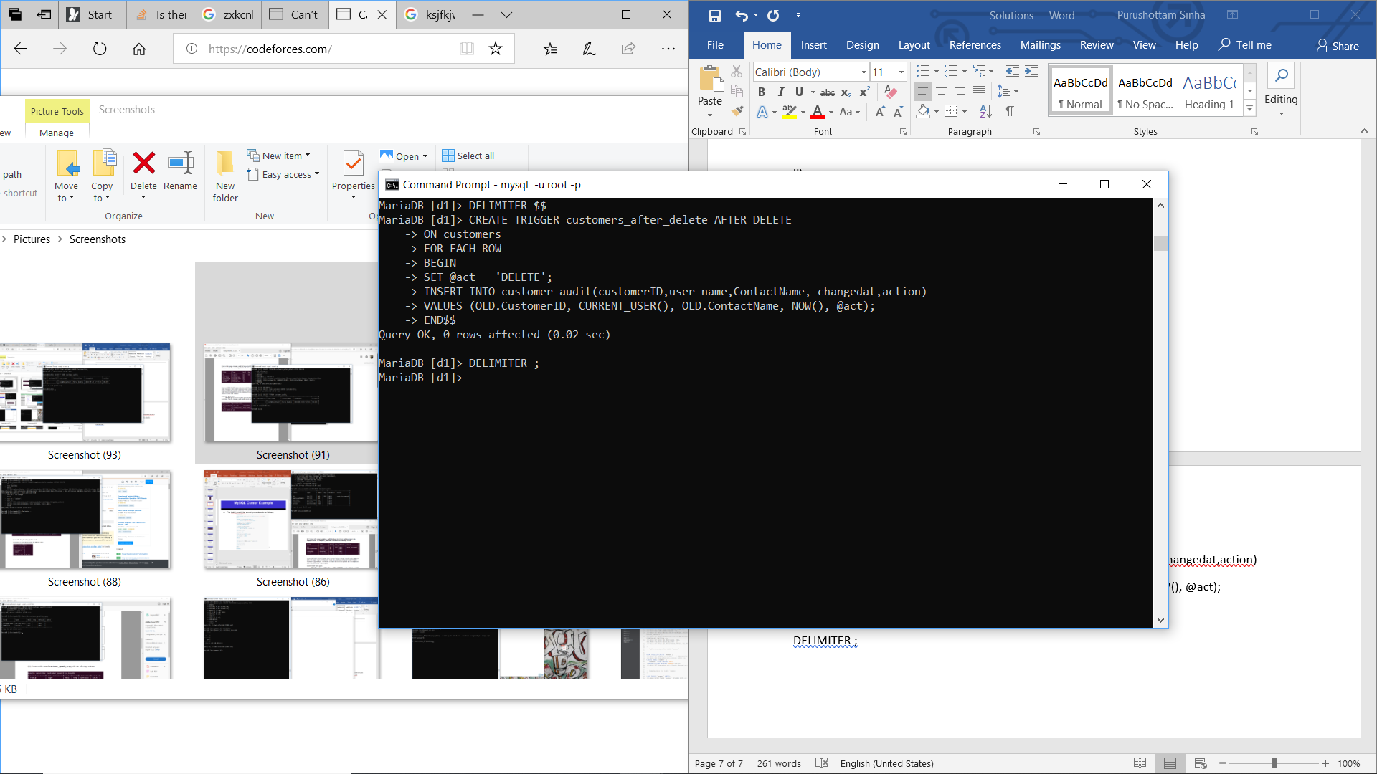

RESULT-

