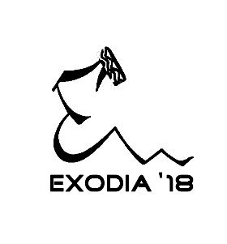

**Statement of No Objection**

This is to state that a _________ member contingent holding this certificate of declaration will be representing ____________________________ college/institute in the technical-cultural fest Exodia ’18, to be hosted from 6th-8th April, 2018 in IIT Mandi. We have no objections pertaining to the same.

________________

Authorized Signatory and Institute Stamp.