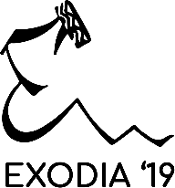 

**Creative Writing**

Write something for us, write it there and then. Pour your soul into it, weave magic with words.

The theme will be announced a week before Exodia, your work should be yours, unseen,

unheard.

Time: 8 hours- 10 AM to 6 PM

Word limit: 1000 words or less.

Form of write up: no bounds: story, article, play, poem, satire, your imagination is your limit.

Contact:

Mamta Bhagia (8629015434)