Time-table assist tool

Deepak Kumar
Purushottam Sinha
Roshan Sharma
Vinay Kumar

Email:
b17039@students.iitmandi.ac.in
b17053@students.iitmandi.ac.in
b17054@students.iitmandi.ac.in
b17070@students.iitmandi.ac.in

November 2019
Time-table Assist Tool
Design Document
Revision History

Version | Date | Author(s) | Description
v1.0 | 14/10/19 | Purushottam SInha | Version 1.0
v2.0 | 05/10/19 | Purushottam Sinha | Version 2.0

Table of Contents
1 Introduction 1
1.1 Design Overview 1
1.2 Intended Audience 1
1.3 References 1
2 Detailed Design 2
2.1 Architecture 2
Components 2
Interfaces 2
2.2 External Data 2
Databases 2
Files 2
2.3 Performance 2
2.4 Miscellaneous 2

Introduction

Design Overview
Time-table assist tool is a tkinter based GUI interface designed in python. It is integrated with APIs to handle data from ods, excel and docs files. The application in designed to use python3.x version. The requirements for the software to work in given in a requirement.txt file.

Intended Audience
This document is intended for faculty who assigned for preparing the timetable.

References
[1] MKDocs Documentation https://www.mkdocs.org/user-guide/writing-your-docs/

Detailed Design
The GUIs organises the slots for the work days. It respond to various errors in the making by showing popup notifications.
These errors include:
1) Choosing mutliple time for the same slot on any given day.
2) Choosing more than 4 time for a slot in a week. Assuming all slots need not more 4 time-slot a week.
3) It assign slots to to different subject in baskets.
4) Check the constraint about the sam efaculty not having more than one course in a slot.
5) Assigning classes to the courses.

Architecture
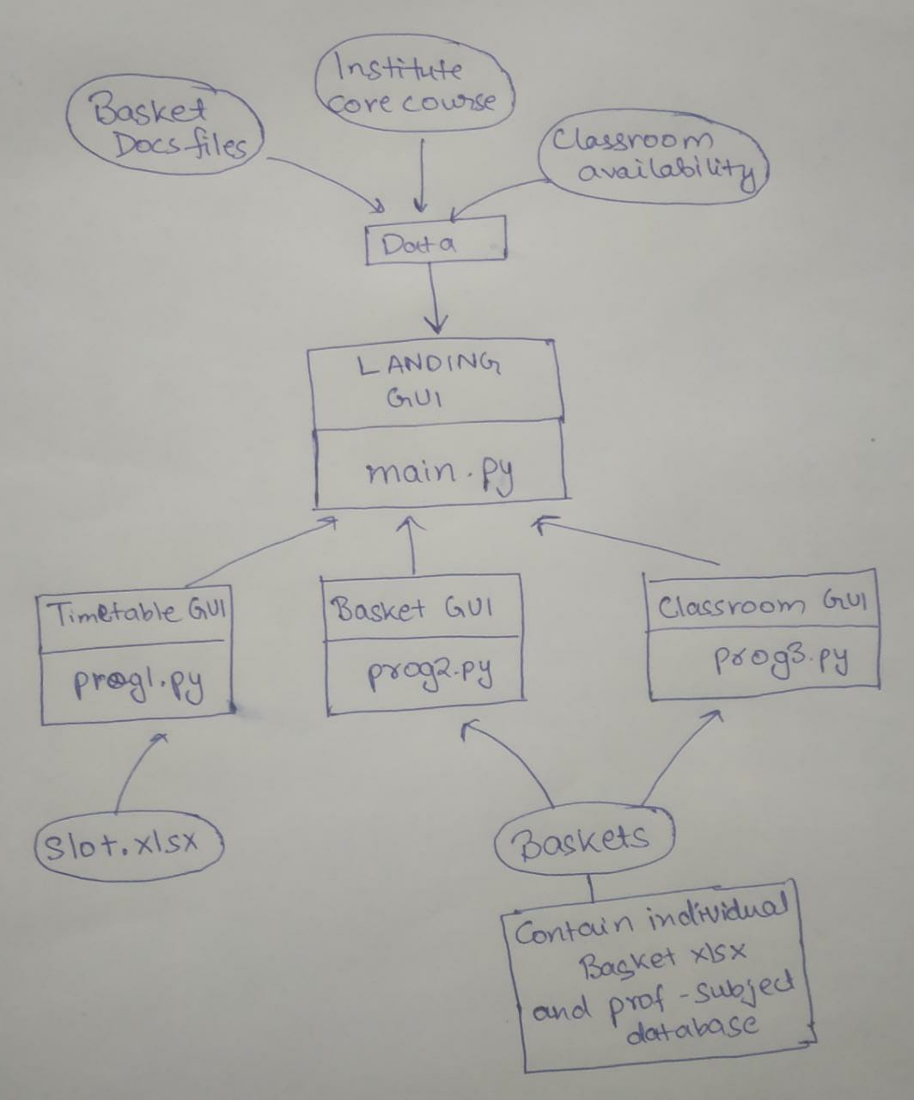

Components
GUIs:
1. Time-table GUI: Used as a interface to support the managing of slots throughout the week.
2. Slot Scheduling GUI: Used to defin slots to different baskets.
3. Classroom Allotment GUI: Used to allocated classrooms for varios courses

Interfaces
The interface is a Python based GUI made using tkinter framework.

External Data

Databases
The database of the courses available for the semester which include the course name, course id, credits and faculties.

Files
The files made available by the client include:
1. Classroom with the capacity.
2. The docs files of the electives received from the faculties.

Performance
The software is design to provide the necessary requirement for the assitance in developing of time table. SQLite data engine will satisfy the requirement for efficient managemt of database and also care about the easy tranfer of data between system.

Miscellaneous
The project repo is currently hosted at https://github.com/PS-Ddevil/Time-table-assist-tool
Documentation is available at https://time-table-assist-tool.readthedocs.io/en/latest/index.html

