SMART DOCUMENT ASSISTANT

1. Project Overview
The Smart Document Assistant is an AI-powered document question-answering application based on Retrieval-Augmented Generation (RAG).The system allows users to upload documents in multiple formats and ask questions about their content using natural language. Instead of manually searching through large documents, the system identifies the most relevant information and uses it to generate a context-aware answer. The application combines document processing, semantic search, vector storage, information retrieval, and Large Language Model (LLM) capabilities to provide an intelligent and efficient document interaction experience. The system also includes fallback mechanisms to maintain functionality when the primary AI or retrieval components are unavailable.

2. Problem Statement
Searching for specific information in large documents manually can be time-consuming and inefficient. Traditional document search mainly depends on matching exact words or phrases. This can produce poor results when the user's question and the document use different words with similar meanings. The Smart Document Assistant addresses this problem by understanding the semantic meaning of the user's question, retrieving the most relevant document content, and generating an answer based on the retrieved information.

3. Project Objectives
The main objectives of the project are:
- To develop an intelligent document-based question-answering system.
- To support multiple document formats.
- To automatically extract and process document content.
- To divide large documents into smaller meaningful sections.
- To convert document content into semantic representations.
- To efficiently search and retrieve relevant information.
- To generate context-aware answers using an LLM.
- To provide source information along with the generated answer.
- To provide a simple and user-friendly interface.
- To maintain system availability through fallback mechanisms.

4. Architecture
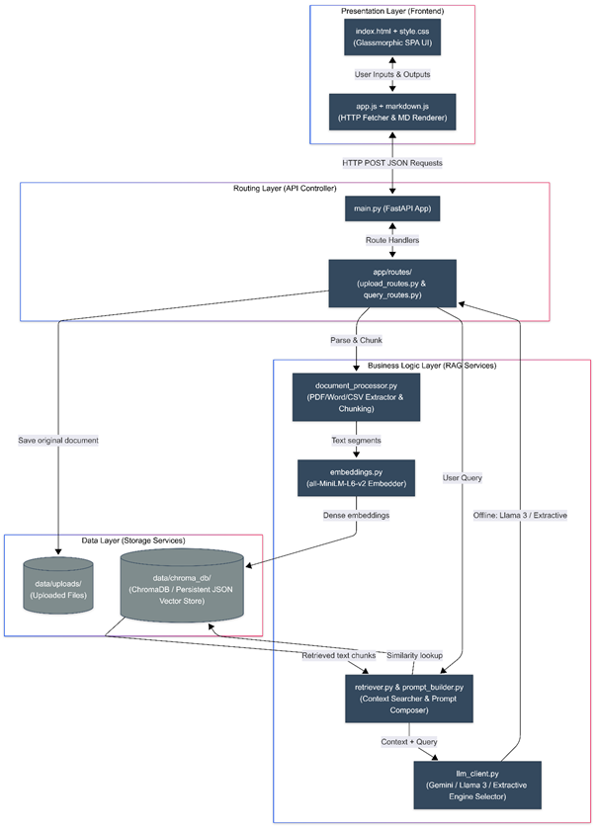

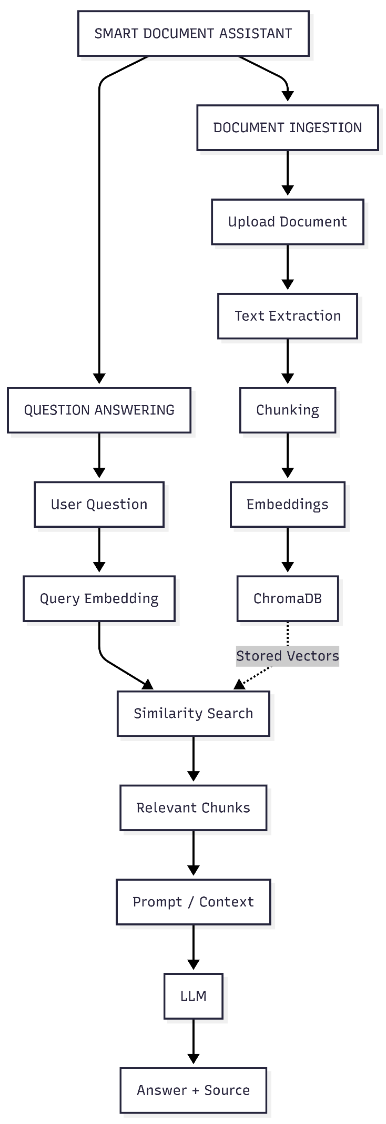

5. Proposed Solution
The proposed solution provides a single platform where users can upload documents and interact with their content through natural-language questions.
The system follows two major processes:
Document Processing
Documents are uploaded, processed, divided into smaller sections, converted into embeddings, and stored in a vector database.
Question Answering
When a user asks a question, the system converts the question into an embedding, searches the stored document information, retrieves the most relevant sections, and uses them to generate the final answer.
This approach allows the system to provide answers based on the content of the uploaded documents rather than relying only on general knowledge.

6. Document Ingestion Workflow
The document ingestion process prepares uploaded documents for intelligent search.

Step 1: Document Upload
The user uploads one or more supported documents through the application interface.
The system supports formats including:
- PDF
- DOC
- DOCX
- TXT
- CSV
- Markdown
- JSON
- LOG

Step 2: Document Validation
The system validates the uploaded documents and checks whether the file format is supported.
If a document with the same name already exists, the previous indexed information can be removed before processing the new version. This helps prevent duplicate information in the search system.

Step 3: Text Extraction
The system extracts readable text from the uploaded documents.
Different document formats require different extraction approaches. The extracted information is converted into a common text representation so that it can be processed by the remaining stages.

Step 4: Text Chunking
Large documents are divided into smaller overlapping sections called chunks.
The project uses approximately:
- Chunk size: 600 characters
- Overlap: 100 characters
The overlap helps maintain context between consecutive sections and reduces the possibility of losing information at chunk boundaries.
Step 5: Embedding Generation
Each document chunk is converted into a numerical representation called an embedding.
The project uses the all-MiniLM-L6-v2 embedding model, which produces a 384-dimensional representation of the text.
These embeddings represent the semantic meaning of the document content and allow the system to identify information that is conceptually related to a user's question.
Step 6: Vector Storage
The generated embeddings and associated document information are stored in Chroma DB, a vector database.
The stored information allows the system to quickly identify document sections that are semantically similar to a user's question.
A local JSON-based storage mechanism is also available as a fallback option.
7. Question Answering Workflow
After documents have been processed and indexed, users can ask questions through the application.

Step 1: User Question
The user enters a natural-language question about the uploaded documents.

Step 2: Question Embedding
The user's question is converted into a numerical embedding using the same semantic representation approach used during document processing.
This allows the system to compare the question with the stored document information.

Step 3: Similarity Search
The system compares the question representation with the stored document embeddings.
The similarity calculation identifies the document sections that are most relevant to the question.
The most relevant sections are selected according to the configured Top-K retrieval value.

Step 4: Context Preparation
The retrieved document sections are combined with the user's question to create the context required for answer generation.
The system also applies instructions that guide the AI to use the retrieved document information when generating the response.

Step 5: Answer Generation
The prepared context is provided to the configured Large Language Model.
The model generates a natural-language answer based on the relevant document information.
The project supports Llama through Ollama as a local LLM option.

Step 6: Fallback Answer Generation
If the primary LLM is unavailable, the system can use a local extractive approach.
The fallback mechanism identifies relevant sentences from the retrieved document content and presents the information directly.
This allows the system to continue providing useful document-based responses even when the primary generation component is unavailable.

Step 7: Final Response
The final response is displayed to the user along with available source information and response metadata.
The interface can display:
- Generated answer
- Source references
- Response time
- Additional response information

8. RAG Architecture Used
The project uses Dense Vector RAG as its primary retrieval approach.
The system converts both documents and user questions into numerical vectors and compares them to identify semantically relevant information.
The project also follows a Modular RAG architecture, where document processing, embedding generation, retrieval, vector storage, prompt preparation, and answer generation are handled as separate components.
In addition, the project uses a Dual-Engine approach, consisting of a generative RAG engine and an extractive fallback engine.

9. Core Algorithms

Sliding Window Chunking
The system divides large documents into smaller sections using a sliding-window approach. The sections overlap so that important context is maintained between neighboring chunks.

Semantic Embedding

The embedding model converts text into numerical vectors that represent the semantic meaning of the content. This enables the system to identify related information even when the wording of the question differs from the wording used in the document.

Cosine Similarity
Cosine similarity is used to measure the similarity between the question representation and document representations. The system uses the similarity results to identify the most relevant document sections

Extractive Retrieval
The fallback mechanism uses text matching and scoring to identify relevant sentences directly from retrieved document content.
This provides a local alternative when an LLM is not available.
10. User-Controlled AI Parameters
The application provides configurable parameters that allow users to control retrieval and response generation.
Temperature
Controls the level of creativity or variation in the generated response.
A lower value is more suitable for factual document-based answers.
Top-K
Controls the number of relevant document sections retrieved for a question.
A lower value provides a more focused context, while a higher value can provide broader context.
Top-P
Controls the range of possible word selections during response generation.
These parameters provide users with greater control over the behaviour of the AI system.
11. Project Outcomes
The implementation achieved the following outcomes:
- Developed a complete RAG-based document question-answering system.
- Reduced the time required to search through large documents.
- Improved information retrieval through semantic search.
- Added support for multiple document formats.
- Implemented vector-based document storage and retrieval.
- Integrated Llama through Ollama for local answer generation.
- Implemented fallback mechanisms for improved reliability.
- Provided source information with generated answers.
- Added configurable Temperature, Top-K, and Top-P parameters.
- Developed a user-friendly web interface for document interaction.
12. Conclusion
The Smart Document Assistant demonstrates the practical implementation of Retrieval-Augmented Generation for document-based question answering.
The system combines document processing, semantic embeddings, vector search, contextual retrieval, LLM-based generation, and fallback mechanisms into a single application.
The main advantage of the solution is that users can interact with their documents using natural language instead of manually searching through large amounts of information.
The modular and extensible architecture also provides a foundation for future improvements such as OCR, hybrid retrieval, reranking, evaluation capabilities, and agentic document operations.

A chunk is a smaller piece of a document created by splitting the document into manageable sections. Each chunk is converted into an embedding and stored so that RAG can retrieve only the relevant information when a user asks a question.

