Official Atlassian MCP Server(Jira &Confluence) - 3E Technology - Confluence
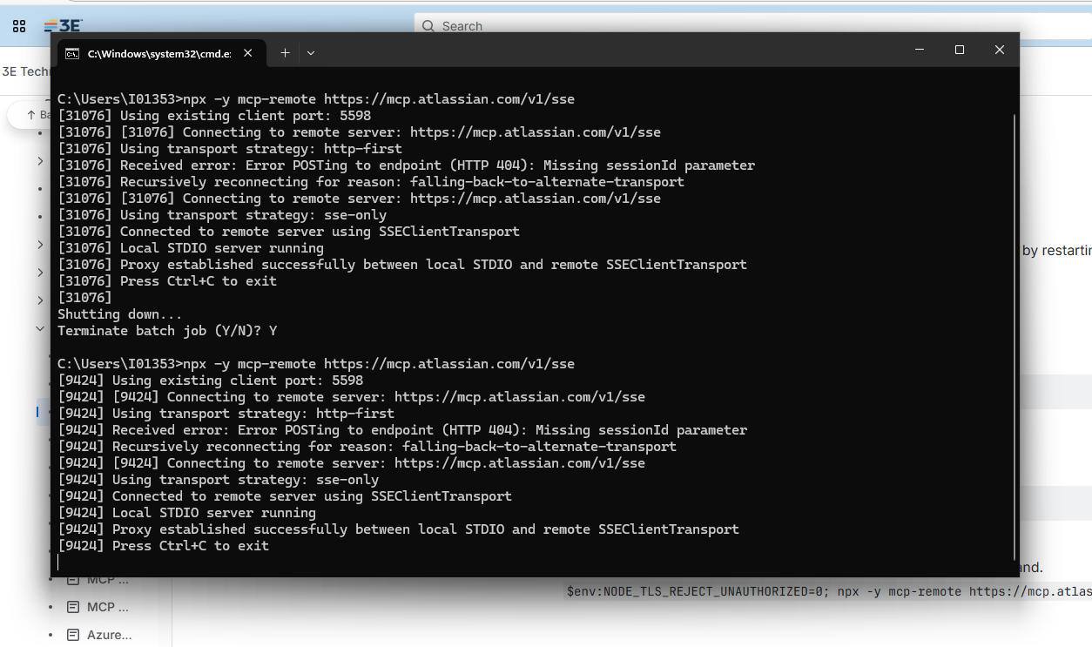

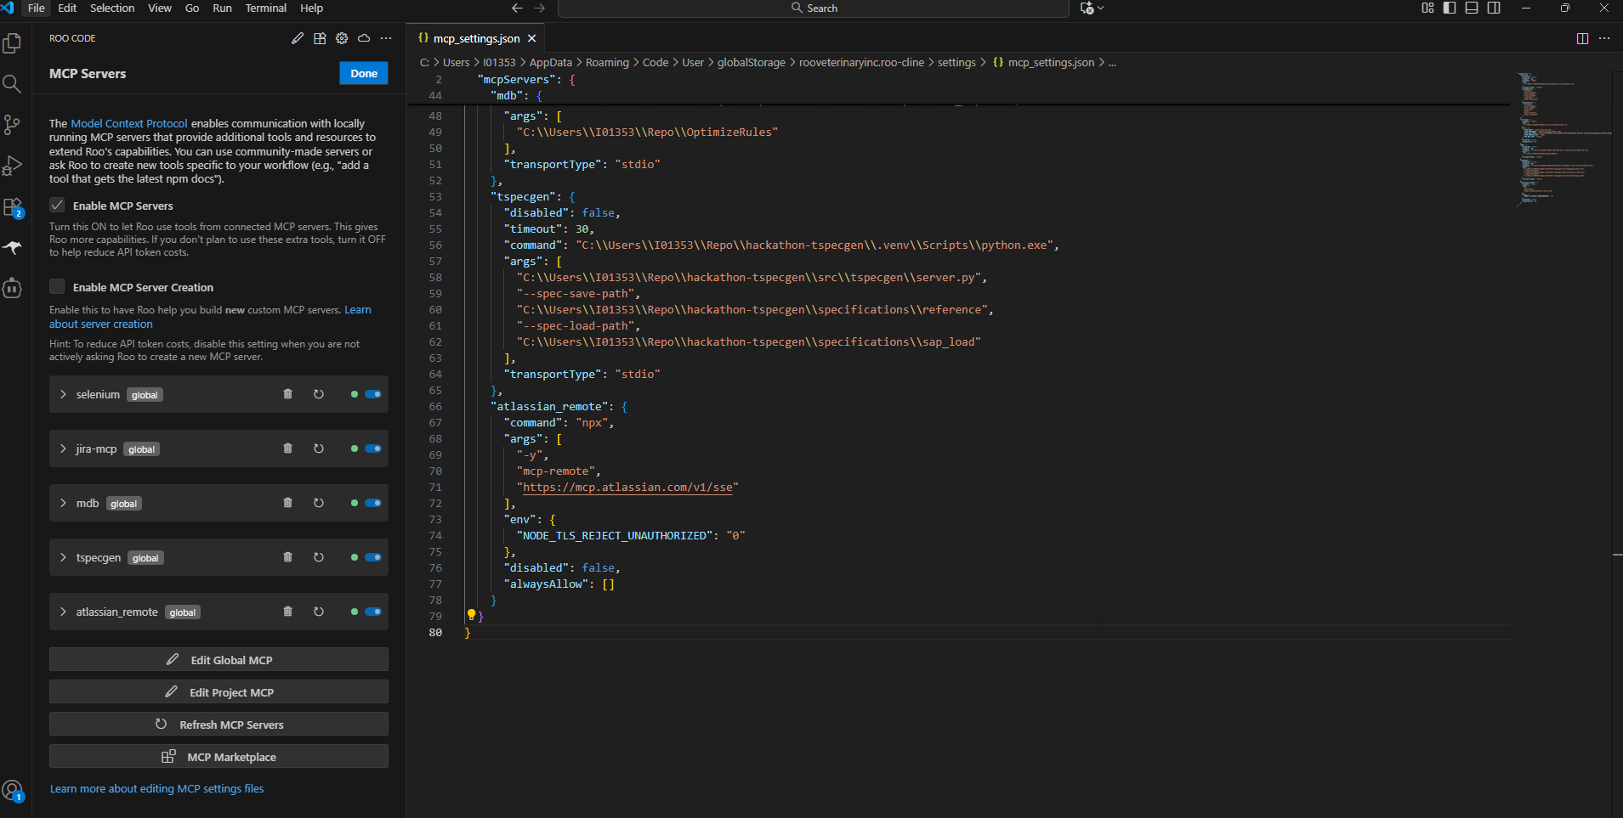
Roo code reply for bug ticket -
I have retrieved the "Bug" type tickets from the "ERC2410" project. Here are some of the key details:

1. **ERC2410-2809**: ZEU_GPN is not included in phrase mapping
- **Status**: In Progress
- **Priority**: Normal
- **Description**: Warning appears for various components.

2. **ERC2410-2806**: 2 Rules use an additional external value file but this was not delivered
- **Status**: In Progress
- **Priority**: Normal
- **Description**: Missing external value file in the delivery folder.

3. **ERC2410-2793**: ZEXP_EUSPM in 3E_ERC_ExpertRules_Overview_2510.xlsx
- **Status**: Completed
- **Priority**: Normal
- **Description**: Missing rule in MULTICALL_COMP or MULTICALL_PROD.

4. **ERC2410-2792**: Rules - Americas Release Notes Contain Several Entries from 2504
- **Status**: Completed
- **Priority**: Normal
- **Description**: Review release notes for duplicates.

5. **ERC2410-2791**: Bug: EU templates - Section 15 is not showing on EU standard templates
- **Status**: In QA
- **Priority**: High
- **Description**: Missing Section 15 information in standard EU templates.

6. **ERC2410-2790**: 3 DG transports missing in Excel Customizing overview
- **Status**: Completed
- **Priority**: Normal
- **Description**: Missing transports in Excel overview.

7. **ERC2410-2783**: 17 TDCLE phrases listed as new do not exist
- **Status**: Completed
- **Priority**: Normal
- **Description**: Missing phrases in the import file.

8. **ERC2410-2758**: Customizing for Language Kazach KK is missing
- **Status**: Completed
- **Priority**: Normal
- **Description**: Missing language customization for KK.

9. **ERC2410-2757**: phrases Documentation typos
- **Status**: Completed
- **Priority**: Normal
- **Description**: Typos in documentation.

10. **ERC2410-2756**: Read me File in Property tree update folder is missing
- **Status**: Completed
- **Priority**: Normal
- **Description**: Missing ReadMe file in the update folder.

These are some of the tickets retrieved. If you need more details or further actions, please let me know!

