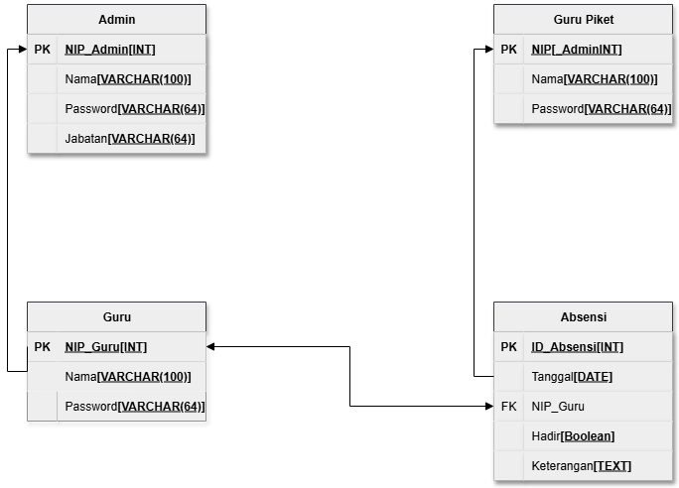

|  |  |  |
| --- | --- | --- |
| Tabel Guru | | |
| NIP | Nama_Guru | Password |
| 199202192017011007 | Ian Barker | 54267574 |
| 198903012015032008 | Brendan Husrt | 45277845 |
| 199201082019051006 | Luis Holt | 35656737 |
| 199104112018092009 | Leah Stewart | 34579863 |
| 198905172009041010 | Micheal Chen | 46358969 |
| 197912092002032011 | Sonia Horn | 47469648 |
| 199407052018011012 | Bobbie Hopkin | 84708752 |
| 199108092017041013 | Marvin Mcqueen | 53804437 |
| 198909102015081014 | Bella Morris | 85902796 |
| 198810142011122015 | Cara Lane | 79672638 |

|  |  |  |  |
| --- | --- | --- | --- |
| Tabel Admin | | | |
| NIP_Admin | Nama_Admin | Password | Jabatan |
| 198104232005061001 | Tina Bolton | 21452416 | Kepala Sekolah |
| 198507222003091002 | Fraser Bernet | 32135545 | Wakil Kepala Sekolah |
| 197903132003031003 | Louise Heath | 14533664 | Tata Usaha |
| 198111072007102004 | Kayla Bryan | 24216367 | Tata Usaha |
| 197902202004032005 | Maddie Phelps | 54216324 | Tata Usaha |

| Tabel Data Absen | | | | |
| --- | --- | --- | --- | --- |
| ID_Absen | Tanggal | NIP | Kehadiran | Keterangan |
| 01 | 12-2-25 | 199201082019051006 | Hadir | - |
| 02 | 12-2-25 | 199202192017011007 | Hadir | - |
| 03 | 12-2-25 | 198903012015032008 | Hadir | - |
| 04 | 12-2-25 | 199104112018092009 | Tidak | Izin |
| 05 | 12-2-25 | 198905172009041010 | Hadir | - |
| 06 | 13-2-25 | 197912092002032011 | Tidak | Izin |
| 07 | 13-2-25 | 199407052018011012 | Hadir | - |
| 08 | 13-2-25 | 199108092017041013 | Hadir | - |
| 09 | 13-2-25 | 198909102015081014 | Tidak | Sakit |
| 10 | 13-2-25 | 198810142011122015 | Hadir | - |

|  |  |  |
| --- | --- | --- |
| Tabel Guru Piket | | |
| NIP_Piket | Nama_Piket | Password |
| 199112092016091016 | Kareem Levine | 15436585 |
| 198602032014041017 | Maira Buck | 23148678 |
| 198903032015052018 | Jan Levine | 43677999 |
| 198104152011101019 | Shaun Duran | 45786796 |
| 199305162015112020 | Aine Frost | 15376589 |
| 199106172019051021 | Kade Barron | 90752214 |