Hospital Middleware Development Planning
Back-end Developer Candidate Assignment
Prepared for Agnos | Go 1.24, Gin, PostgreSQL, Docker Compose, Nginx | Version 1.0
Purpose. Define a secure, testable middleware service that authenticates hospital staff, searches patient data through a hospital-specific HIS adapter, and guarantees that every patient query stays within the staff member's hospital.

Delivery snapshot
Area | Decision
API surface | Staff creation, staff login, authenticated patient search, and health check
Tenant boundary | Hospital identity comes only from the verified access token
HIS integration | Hospital A exact lookup by national ID or passport ID
Runtime | Nginx -> Go/Gin API -> PostgreSQL, orchestrated by Docker Compose
Verification | Positive and negative tests for every required API; 76.7% aggregate statement coverage

Key assumptions
- Staff usernames are globally unique because login accepts only username and password.
- Every patient filter is optional individually, but at least one criterion is required to prevent bulk enumeration.
- Identifier searches call Hospital A, normalize and cache the response, then apply every supplied filter.
- Searches without an identifier query already normalized records for the authenticated hospital.
- The upstream authentication contract is unspecified, so X-API-Key support is optional and configurable.

1. Project structure
The implementation uses a small ports-and-adapters structure. HTTP concerns remain in the Gin layer; application services own security and business rules; repositories and hospital clients implement external boundaries.

1.1 Component flow
Client
-> Nginx (routing, limits, request IDs)
-> Gin handlers (validation and response mapping)
-> Staff / patient services (business rules)
-> PostgreSQL repositories
-> Hospital A HIS adapter

1.2 Directory responsibilities
Path | Responsibility
cmd/api | Configuration, dependency wiring, HTTP lifecycle, graceful shutdown
internal/httpapi | Routes, strict JSON/query parsing, JWT middleware, DTOs, error mapping
internal/staff | Registration and login rules; username normalization; credential flow
internal/patient | Hospital scoping, search validation, HIS hydration, result cap
internal/hospital | Hospital A HTTP contract and response normalization
internal/storage/postgres | Staff and patient persistence with hospital-scoped SQL
internal/security | bcrypt password hashing and JWT issue/verification
migrations | Hospital, staff, and patient schema plus Hospital A seed
deploy / Docker files | Nginx, non-root API image, Compose services and runtime settings

1.3 Main request flows

Staff registration
- Validate JSON, username, password bytes, and hospital code.
- Normalize username and hospital code to lowercase.
- Hash the password with bcrypt cost 12.
- Insert staff only when the hospital exists; return conflict for duplicate username.

Patient search
- Verify the Bearer token and read its staff and hospital claims.
- Reject empty, unknown, oversized, or malformed filters.
- For an ID search, call the adapter selected by the token's hospital code.
- Upsert the normalized HIS record with the token's hospital ID.
- Query by the same hospital ID and all supplied filters; return at most 100 rows.

2. API specification

2.1 Conventions
- Base URL in the Compose environment: http://localhost:8080
- Request and response media type: application/json
- Dates use YYYY-MM-DD; timestamps use RFC 3339 UTC.
- Protected routes require Authorization: Bearer <access_token>.
- Errors use a stable error.code and a safe human-readable message.
- Responses use Cache-Control: no-store and include X-Request-ID.

2.2 POST /staff/create
Creates credentials for a staff member at an existing hospital.
Field | Required | Rules
username | Yes | 3-64 ASCII letters, numbers, dot, underscore, or hyphen; normalized lowercase
password | Yes | 12-72 valid UTF-8 bytes; never trimmed or returned
hospital | Yes | Existing lowercase hospital code; hospital-a is seeded

Request
{"username":"doctor.one","password":"correct-horse-battery","hospital":"hospital-a"}
201 Created
{"data":{"id":"<uuid>","username":"doctor.one","hospital":"hospital-a","created_at":"2026-08-15T10:00:00Z"}}
Errors: 400 invalid_request, 404 not_found, 409 conflict, 500 internal_error.

2.3 POST /staff/login
Authenticates a globally unique username and returns a hospital-scoped JWT.
Request
{"username":"doctor.one","password":"correct-horse-battery"}
200 OK
{"data":{"access_token":"<jwt>","token_type":"Bearer","expires_in":28800,"staff":{"id":"<uuid>","username":"doctor.one","hospital":"hospital-a","created_at":"2026-08-15T10:00:00Z"}}}
Errors: 400 invalid_request, 401 unauthorized, 500 internal_error. Unknown user and wrong password intentionally return the same 401 response.

2.4 GET /patient/search
Searches only the hospital carried by the verified token. The client cannot submit or override a hospital ID. All fields are optional individually, but at least one must be present.
Query parameter | Match behavior
national_id | Exact; preferred upstream identifier when both IDs are supplied
passport_id | Exact; upstream identifier when national_id is absent
first_name | Case-insensitive substring across Thai and English first names
middle_name | Case-insensitive substring across Thai and English middle names
last_name | Case-insensitive substring across Thai and English last names
date_of_birth | Exact date in YYYY-MM-DD
phone_number | Exact normalized source value
email | Case-insensitive exact match

GET /patient/search?national_id=1234567890123&last_name=Lovelace
Authorization: Bearer <access_token>
200 OK
{"data":{"patients":[{"first_name_th":"","middle_name_th":"","last_name_th":"","first_name_en":"Ada","middle_name_en":"","last_name_en":"Lovelace","date_of_birth":"1815-12-10","patient_hn":"HN-001","national_id":"1234567890123","passport_id":"","phone_number":"0800000000","email":"ada@example.com","gender":"F"}],"count":1}}
No match returns 200 with an empty patients array. Errors: 400 invalid_request, 401 unauthorized, 502 hospital_unavailable, 500 internal_error.

2.5 Error catalog
HTTP | Code | Meaning
400 | invalid_request | Malformed body/query or failed validation
401 | unauthorized | Missing, invalid, expired token or bad credentials
404 | not_found | Route, hospital, or requested resource does not exist
409 | conflict | Username or unique patient identity conflicts
429 | Nginx response | Per-client route rate limit exceeded
500 | internal_error | Unexpected application or database failure
502 | hospital_unavailable | HIS timeout, failure, or invalid response

{"error":{"code":"invalid_request","message":"request validation failed"}}

2.6 Hospital A upstream contract
GET {HOSPITAL_A_BASE_URL}/patient/search/{national_id_or_passport_id}
Accept: application/json
X-API-Key: <optional HOSPITAL_A_API_KEY>
The adapter expects the required Thai/English names, date of birth, HN, national/passport identifiers, phone, email, and M/F gender fields. It rejects malformed dates, unsupported gender values, missing HN, and missing identifiers as upstream failures.

3. Entity-relationship model
Hospital is the tenant root. Staff and patient rows each belong to exactly one hospital. This relationship, plus token-derived scoping in the query layer, creates the primary cross-hospital privacy boundary.
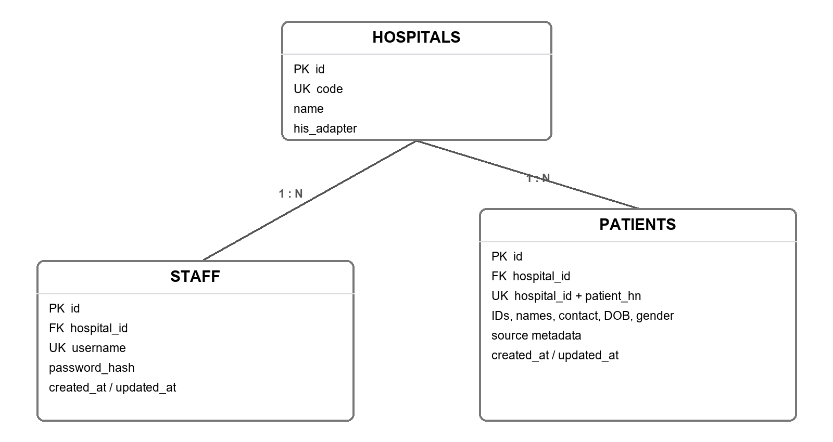
Figure 1. Hospital, staff, and patient tenant relationships

3.1 Entity definitions

HOSPITALS
Stable tenant record. code is unique and selects the corresponding HIS adapter.

STAFF
Authentication record. username is globally unique; password_hash stores bcrypt output; hospital_id is immutable in the authentication context.

PATIENTS
Normalized HIS cache with Thai/English names, date of birth, HN, identifiers, contact details, gender, source, and timestamps.

3.2 Constraints and indexes
- hospitals.code is unique and uses a lowercase hyphenated format.
- staff.username is unique and stored in normalized lowercase.
- patients(hospital_id, patient_hn) is unique.
- Hospital-scoped national ID and passport ID indexes are unique when the value is present.
- A patient must have at least one national ID or passport ID.
- Gender is constrained to M or F to match the stated upstream contract.
- Name and date indexes begin with hospital_id to preserve tenant-local access patterns.

4. Security and privacy controls
- Hospital scope is signed into JWT claims and never accepted from the search request.
- JWT verification requires HS256, issuer, issued-at, and expiration checks.
- Passwords use bcrypt cost 12 and never appear in responses or application logs.
- Request logs record route templates, not patient query strings, bodies, tokens, or response payloads.
- Empty searches are blocked and results are capped at 100.
- Nginx limits authentication and search rates separately and caps request bodies at one megabyte.
- API responses use no-store caching and defensive content/frame headers.
Production follow-up. Restrict staff creation to an administrator or invitation workflow, add access audit events without patient values, move secrets to a managed store, and define retry behavior only after the HIS contract is known.

5. Test and verification plan
Layer | Coverage focus
HTTP APIs | Success and negative status codes, strict JSON/query parsing, auth, response shape, error mapping
Staff service | Normalization, password policy, safe failures, token result, password-hash removal
Patient service | Token hospital scope, HIS hydration, cache path, empty/not-found/upstream failures
Hospital A adapter | URL/header contract, mapping, normalization, malformed payload and status handling
PostgreSQL repositories | Queries, conflict/not-found mapping, parameter order, row mapping, failure paths
Security | Password hash/compare and JWT round trip/tamper rejection

Automated checks completed in the development workspace:
- go test ./... - all packages passed
- go vet ./... - passed
- go mod verify - all modules verified
- Aggregate statement coverage - 76.7%; business packages - approximately 76% to 100%
- Compose and OpenAPI YAML syntax - passed
Environment limitation. Docker/Nginx runtime validation was not available on the current host. Race detection requires CGO and a C compiler, neither of which is installed. Run docker compose config, docker compose up --build, nginx -t, and go test -race ./... in CI or a Docker-capable review environment.

6. Delivery plan
- Copy .env.example to .env and replace the database password and JWT secret.
- Run docker compose up --build and verify GET /health through Nginx.
- Create a synthetic staff account, log in, and exercise positive and negative patient searches.
- Keep the GitHub repository private; invite only the intended reviewers.
- Do not commit the assignment PDF, .env, credentials, logs, or real patient data.
- Upload this document to Google Drive and open it as a native Google Doc for the planning deliverable.

7. Acceptance checklist
- Required staff and patient endpoints are implemented with the documented fields.
- Hospital scoping is derived from a verified token and appears in every patient query.
- Positive and negative tests cover each required API.
- Docker Compose defines Nginx, Go, and PostgreSQL services.
- Project structure, API specification, ER diagram, assumptions, and limitations are documented.
- The repository is free of secrets, assignment source files, and real patient data.

