CHAPTER 1:

EXECUTIVE SUMMARY

The internship report shall have a brief executive summary. It shall include five or more Learning Objectives and Outcomes achieved, a brief description of the sector of business and intern organization and summary of all the activities done by the intern during the period.
This internship report provides an overview of the experience gained during the internship at VAULTSPHERE AI TECHNOLOGIES PRIVATE LIMITED. VAULTSPHERE
AI TECHNOLOGIES PRIVATE LIMITED is a dynamic organization specializing in providing skill development programs aimed at empowering individuals with relevant expertise to thrive in the modern workforce.
During the internship, various aspects of the organization's operations were explored, including program development, implementation strategies, and participant engagement. The report outlines key learnings, challenges encountered, and recommendations for enhancing the effectiveness of VAULTSPHERE AI TECHNOLOGIES PRIVATE LIMITED's initiatives.
Learning Objectives and Outcomes:
Project Management Skills: Developed proficiency in planning and executing tasks, meeting deadlines, and adapting to dynamic project requirements.
Industry Insight: Gained a comprehensive understanding of the Full Stack Java through hands-on experience and exposure to the day-to-day operations of VAULTSPHERE AI TECHNOLOGIES PRIVATE LIMITED.
Technical Proficiency: Acquired practical skills in specific tools, Proficiency in Java Database Connectivity (JDBC) for interacting with relational databases from Java applications, Java Server Pages (JSP) and Servlets for dynamic web content generation.
Professional Communication: Improved interpersonal and communication skills by collaborating with team members, presenting findings, and interacting with professionals both within and outside the organization.
Problem-Solving and Critical Thinking: Faced and resolved challenges related to specific challenges encountered during the internship.

Brief description of the sector of business and intern organization:
VAULTSPHERE AI TECHNOLOGIES PRIVATE LIMITED is a sought-after real time learning platform that bridges the gap between industry experts and students. It offers a plethora of advanced courses, specifically designed to meet various industry’s standards.
VAULTSPHERE AI TECHNOLOGIES PRIVATE LIMITED is an innovative online learning platform designed to empower individuals with the necessary skills to excel in today's competitive job market. It offers a wide range of courses and programs tailored to meet the diverse needs of learners across various industries.
- Interactive learning experiences include videos, quizzes, assignments, and projects, ensuring engagement and knowledge retention.
- Courses are curated and taught by industry experts and professionals, providing practical insights and real-world expertise.
- Flexibility and convenience are prioritized, allowing learners to access course materials at their own pace and convenience.
- Skill assessment tests and certifications validate learners' proficiency, enhancing their credibility in the job market.
- VAULTSPHERE AI TECHNOLOGIES PRIVATE LIMITED promotes
empowerment, accessibility, and continuous learning, serving as a catalyst for personal and professional growth.
Summary of Internship activities:

Course Participation: Actively participated in VAULTSPHERE AI TECHNOLOGIES PRIVATE LIMITED's full stack Java internship program, engaging in various learning modules and activities.
Project Development: Contributed to the development of real-world projects using full stack Java technologies, applying concepts learned during training sessions.
Hands-on-practice: Gained practical experience by working on assignments, coding exercises, and mini-projects.
Collaborative Learning: Engaged in collaborative learning activities with fellow interns, exchanging ideas, troubleshooting challenges, and sharing best practices to foster a supportive learning environment.
Mentorship and Guidance: Received mentorship and guidance from experienced instructors and industry professionals, benefiting from their expertise and insights into full stack Java development.

Problem Solving: Developed problem-solving skills through hands-on experience with debugging, troubleshooting, and resolving technical issues encountered during project development.
Documentation and Reporting: Maintained thorough documentation of project progress, including code documentation, project reports, and documentation.

CHAPTER 2:

OVERVIEW OF THE ORGANIZATION

Suggestive contents
- Introduction of the Organization
- Vision, Mission, and Values of the Organization
- Policy of the Organization, in relation to the intern role
- Organizational Structure
- Roles and responsibilities of the employees in which the intern is placed.
- Performance of the Organization in terms of turnover, profits, market reach and market value.
- Future Plans of the Organization.
Introduction of the Organization
VAULTSPHERE AI TECHNOLOGIES PRIVATE LIMITED is a leading online
learning platform committed to providing individuals with the skills and knowledge necessary to succeed in today's dynamic job market. Established with the vision of bridging the gap between education and employment, VAULTSPHERE AI TECHNOLOGIES PRIVATE LIMITED offers a diverse range of courses and programs tailored to meet the evolving needs of learners across various industries.
At VAULTSPHERE AI TECHNOLOGIES PRIVATE LIMITED, they believe that
education is the cornerstone of personal and professional growth. Our platform serves as a catalyst for empowering individuals to unlock their full potential and achieve their career aspirations. Whether you're a seasoned professional looking to upskill or a student preparing to enter the workforce, VAULTSPHERE AI TECHNOLOGIES PRIVATE LIMITED offers the resources and support needed to succeed in today's competitive landscape.
One of the key pillars of VAULTSPHERE AI TECHNOLOGIES PRIVATE LIMITED is accessibility. We understand that traditional education models may not always be feasible for everyone, which is why we have developed a platform that allows learners to access course materials anytime, anywhere. Whether you prefer to learn at your own pace or

participate in live sessions, VAULTSPHERE AI TECHNOLOGIES PRIVATE LIMITED offers flexible learning options to accommodate your needs.
Furthermore, VAULTSPHERE AI TECHNOLOGIES PRIVATE LIMITED is
committed to fostering a supportive learning community where learners can interact, collaborate, and share knowledge and experiences with peers and instructors. Through forums, discussion boards, and networking opportunities, learners can connect with like- minded individuals and build valuable professional relationships.

Vision, Mission, and Values of the Organization Vision:
VAULTSPHERE AI TECHNOLOGIES PRIVATE LIMITED envisions a future
where every individual has the opportunity to unleash their full potential through accessible, high-quality education. We strive to be a leading force in shaping the future of learning, empowering learners worldwide to thrive in a rapidly evolving global economy.

Mission:
Our mission at VAULTSPHERE AI TECHNOLOGIES PRIVATE LIMITED is to
bridge the gap between education and employment by providing individuals with the skills, knowledge, and support they need to succeed in their careers and personal endeavours. We are committed to delivering innovative, engaging learning experiences that empower learners to achieve their goals and make a meaningful impact in their communities.

Values:
Excellence: VAULTSPHERE AI TECHNOLOGIES PRIVATE LIMITED are dedicated to delivering excellence in everything we do, from the quality of our courses to the support we provide to our learners. We continuously strive to exceed expectations and raise the bar for online education.
Accessibility: VAULTSPHERE AI TECHNOLOGIES PRIVATE LIMITED believe that education should be accessible to all. We are committed to removing barriers to learning by providing flexible, affordable options that accommodate diverse learning styles, backgrounds, and needs.
Empowerment: VAULTSPHERE AI TECHNOLOGIES PRIVATE LIMITED believe in the transformative power of education to empower individuals to create positive change in their

lives and communities. We are committed to empowering learners with the skills, knowledge, and confidence they need to succeed.
Innovation: VAULTSPHERE AI TECHNOLOGIES PRIVATE LIMITED embrace
innovation and embrace new technologies, methodologies, and approaches to learning. We are committed to staying at the forefront of educational trends and best practices to ensure that our learners receive the most relevant and up-to-date education possible.
Community: VAULTSPHERE AI TECHNOLOGIES PRIVATE LIMITED believe in the power of community to support, inspire, and uplift one another. We foster a supportive learning community where learners can connect, collaborate, and share knowledge and experiences with peers and instructors.
Continuous Improvement: VAULTSPHERE AI TECHNOLOGIES PRIVATE LIMITED are committed to continuous improvement and lifelong learning.

Policy of the Organization, in relation to the intern role Purpose:
The internship program at VAULTSPHERE AI TECHNOLOGIES PRIVATE LIMITED is designed to provide students and recent graduates with hands-on experience in their field of study or interest. The program aims to offer valuable learning opportunities, mentorship, and practical exposure to help interns develop their skills and kick-start their careers.

Eligibility:
Internship positions at VAULTSPHERE AI TECHNOLOGIES PRIVATE LIMITED are open to students currently enrolled in undergraduate or graduate programs, as well as recent graduates looking to gain practical experience in their field. Candidates must possess relevant skills and qualifications as outlined in the internship job description.

Duration and Schedule:
The duration of internships at VAULTSPHERE AI TECHNOLOGIES PRIVATE LIMITED may vary depending on the specific program or project. Interns may be required to commit to a minimum number of hours per week or a predetermined duration of the internship period. Flexible scheduling options may be available to accommodate academic commitments.

Roles and Responsibilities:
Interns at VAULTSPHERE AI TECHNOLOGIES PRIVATE LIMITED will be assigned specific roles and responsibilities aligned with their skills, interests, and learning objectives. These may include assisting with project development, conducting research, providing administrative support, and participating in team meetings and discussions.

Supervision and Mentorship:
Interns will be supervised and mentored by experienced professionals within their respective departments or teams. Mentors will provide guidance, feedback, and support to help interns navigate their roles, develop their skills, and achieve their learning goals.

Learning and Development:
VAULTSPHERE AI TECHNOLOGIES PRIVATE LIMITED is committed to providing interns with valuable learning and development opportunities during their internship tenure.

Organizational Structure Executive Leadership:
CEO: Oversees the overall strategic direction and growth of VAULTSPHERE AI TECHNOLOGIES PRIVATE LIMITED.
COO: Responsible for operational activities and ensuring efficient day-to-day functionality. CFO: Manages financial operations, budgeting, and financial planning.

Departments:
- Human Resources
- Technology and Development
- Content Creation
- Marketing and Communications
- Customer Support

Team Structure:
- Headed by Directors or Managers in each department.
- Teams consist of specialized professionals.

Hierarchy:
- Clear lines of authority and reporting.
- Senior executives oversee department heads, who supervise teams.

Organizational Culture:
- Values diversity, inclusivity, and creativity.
- Promotes open communication and mutual respect.

Roles and responsibilities of the employees in which the intern is placed Mentor or Supervisor:
- Provide guidance, support, and mentorship to the intern.
- Assign tasks and projects aligned with the intern's learning objectives.
- Offer feedback and constructive criticism to help the intern grow and improve.

Team Members:
- Collaborate with the intern on various projects and tasks.
- Share knowledge, insights, and best practices related to their areas of expertise.
- Provide assistance and support to help the intern integrate into the team.

Department Head or Manager:
- Oversee the intern's progress and performance within the department.
- Ensure that the intern's tasks and projects align with departmental goals and objectives.
- Address any issues or concerns raised by the intern and provide necessary support and resources.

Trainers or Instructors:
- Conduct training sessions or workshops to provide the intern with relevant skills and knowledge.
- Offer guidance and assistance in understanding complex concepts or technologies.

Project Managers:
- Assign specific tasks or responsibilities to the intern as part of project teams.
- Monitor the intern's contributions to project deliverables and outcomes.
- Provide direction and guidance on project-related tasks and deadlines.

Performance of the Organization in terms of turnover, profits, market reach and market value.

Turnover:
This refers to the total revenue generated by the organization over a specific period. VAULTSPHERE AI TECHNOLOGIES PRIVATE LIMITED would assess its turnover to understand its sales performance and revenue growth. Increasing turnover typically indicates a healthy demand for the organization's products or services.

Profits:
Profitability is crucial for the long-term sustainability of the organization. VAULTSPHERE AI TECHNOLOGIES PRIVATE LIMITED would evaluate its profits to determine its financial health and efficiency in managing costs. Consistently growing profits indicate effective financial management and a strong business model.

Market Reach:
VAULTSPHERE AI TECHNOLOGIES PRIVATE LIMITED would analyse its market reach to assess the extent of its presence and influence in its target market. This may include factors such as the number of customers served, geographical reach, and market share. Expanding market reach indicates successful marketing strategies and effective customer engagement.

Market Value:
Market value reflects the perceived worth of the organization by investors and stakeholders. VAULTSPHERE AI TECHNOLOGIES PRIVATE LIMITED would track its market value through metrics such as stock prices (if publicly traded), valuation multiples, or investor sentiment. A rising market value indicates investor confidence and reflects positively on the organization's performance and prospects.

Future Plans of the Organization Expansion of Course Offerings:
VAULTSPHERE AI TECHNOLOGIES PRIVATE LIMITED plans to expand its course catalogue to cover a broader range of industries and topics, catering to the diverse learning needs of its audience. New courses will be developed to address emerging trends and technologies in the job market.

Enhanced Learning Experience:
The organization aims to enhance the learning experience for its users by incorporating interactive and immersive elements into its courses. This may include virtual labs, simulations, and gamified learning activities to increase engagement and retention.

Global Reach:
VAULTSPHERE AI TECHNOLOGIES PRIVATE LIMITED intends to expand its reach beyond its current market and establish a global presence. This involves targeting international audiences, localization of content, and partnerships with educational institutions and organizations worldwide.

Technology Integration:
The organization plans to leverage advanced technologies such as artificial intelligence (AI) and machine learning (ML) to personalize learning experiences, provide adaptive feedback, and automate administrative tasks. This will improve efficiency and effectiveness in delivering educational content.

CHAPTER 3:

INTERNSHIP PART

Description of the Activities/Responsibilities in the Intern Organization during Internship, which shall include - details of working conditions, weekly work schedule, equipment used, and tasks performed. This part could end by reflecting on what kind of skills the intern acquired.
Details of working Condition:
Virtual Workspace: Employees at VAULTSPHERE AI TECHNOLOGIES PRIVATE LIMITED primarily work in a virtual environment, utilizing online platforms and tools for communication, collaboration, and project management.
Remote Work Setup: Employees have the flexibility to work remotely from their preferred location, whether it be from home or a co-working space, provided they have access to a stable internet connection and necessary equipment.
Flexible Schedule: Working hours are often flexible in the online mode, allowing employees to manage their time effectively and accommodate personal commitments while ensuring productivity and meeting deadlines.
Digital Tools and Software: VAULTSPHERE AI TECHNOLOGIES PRIVATE LIMITED provides employees with access to a range of digital tools and software applications necessary for their roles, including video conferencing tools, project management platforms, and cloud-based document storage systems.
Training and Development: Employees receive online training and development opportunities tailored to their roles and career aspirations, delivered through virtual workshops, webinars, and e-learning platforms.
Weekly work Schedule:

Monday to Thursday:
Team meetings, individual work time, project meetings, course development, training sessions, content review, assessment preparation, and team collaboration.

Wednesday:
Online classes, quiz preparation, and content review.
Friday: Conduct quizzes or assessments, team meeting, individual work time, and planning for the next week.

Tasks Performed:

Networking:
Developing networked applications using Java networking APIs. Implementing client-server communication protocols.

Data Structures and Collection:
Utilizing Java collection framework classes like Array List, HashMap, and LinkedList. Implementing data structures and algorithms for efficient data manipulation.

File I/O Operations:
Reading from and writing to files using Java I/O classes. Handling file streams and file system operations.

Web Development (Servlets and JSP):
Creating dynamic web pages using Java Server Pages (JSP) and Servlet technologies.

Spring Framework:
Implementing dependency injection and inversion of control (IoC) with Spring. Developing web applications using Spring MVC architecture.

ACTIVITY LOG FOR THE FIRST WEEK
DAY | BRIEF DESCRIPTION OF THE DAILY ACTIVITY | LEARNING OUTCOME | Person In-charge Signature
Day – 1 | Recording classes: Introduction to java | Gain a foundational understanding of Java  programming language.
Day – 2 | Introduction to java | Gain a foundational understanding of Java programming language
Day – 3 | Java Basics | Learned how to write and execute basic Java programs.
Day – 4 | Introduction to Java syntax, variables, and data types. | Learned how to write and execute basic Java programs.
Day – 5 | Understanding primitive data types and operators in Java. | Become familiar with different data types and their usage in Java programming.
Day – 6 | Quiz | Identified areas of strengths and weaknesses in learning.

WEEKLY REPORT
WEEK – 1 (From Dt 24-11-2025 to Dt 29-11-2025)
Objective of the Activity Done: “Introduction to Java" and "Java Basics"
Detailed Report:
In the recorded classes on "Introduction to Java," students were introduced to the foundational concepts of the Java programming language. The primary objective was to provide learners with a solid understanding of Java's syntax, structure, and fundamental principles. Through these sessions, participants gained insight into the core elements of Java, including variables, data types, and basic program execution. Moreover, the classes emphasized the importance of grasping these fundamental concepts as they form the building blocks for more complex programming tasks and projects. By the end of the sessions, learners had acquired a foundational understanding of Java, laying the groundwork for further exploration and development in the language.
Subsequently, in the "Java Basics" sessions, participants delved deeper into the practical aspects of Java programming. The focus shifted towards practical implementation, as learners were guided through the process of writing and executing basic Java programs. Key topics covered included Java syntax, variables, data types, and operators. Through hands-on exercises and examples, students gained proficiency in writing code and understanding the basic principles underlying Java programming. By mastering these fundamental concepts, learners developed the necessary skills to tackle more advanced programming challenges with confidence.
As part of the learning process, regular quizzes were conducted to assess participants' comprehension and retention of the material covered in the classes. These quizzes served as valuable tools for identifying areas of strengths and weaknesses in learning. By analysing quiz results, both learners and instructors gained insights into which concepts were well- understood and which required further clarification or review. This feedback loop enabled learners to focus their efforts on areas needing improvement, ultimately enhancing their overall understanding and mastery of Java programming concepts.
Overall, the recorded classes on Introduction to Java, Java Basics, and quizzes provided participants with a comprehensive learning experience. Through a combination of theoretical knowledge and practical application, learners gained a solid foundation in Java programming.

ACTIVITY LOG FOR THE SECOND WEEK

DAY | BRIEF DESCRIPTION OF THE DAILY ACTIVITY | LEARNING OUTCOME | Person In-charge Signature
Day – 1 | Loops and Controls | Learn how to control program flow and iterate over data structures.
Day – 2 | Implementing loops (for, while, do-while) and control statements (if-else, switch) in Java. | Learn how to control program flow and iterate over data structures.
Day – 3 | Encapsulation | Understand the concept of data hiding and access control in Java classes.
Day – 4 | Introduction to encapsulation and access modifiers in Java. | Understand the concept of data hiding and access control in Java classes.
Day – 5 | Inheritances | Learn how to create subclasses and super  classes to achieve code reusability.
Day – 6 | Quiz | Identified areas of strengths and weaknesses in learning.

WEEKLY REPORT
WEEK – 2(From Dt 01-12-2025 to Dt 06-12-2025)

Objective of the Activity Done:
Detailed Report:
In the recorded classes focusing on "Loops and Controls," participants delved into the essential concepts of controlling program flow and iterating over data structures in Java. The sessions emphasized the implementation of various types of loops, including for, while, and do-while loops, along with control statements such as if-else and switch statements. Through practical examples and hands-on exercises, learners gained proficiency in using these constructs to navigate program execution and manipulate data structures efficiently. By the end of the sessions, participants had acquired a solid understanding of how to manage program flow and iterate over data structures, essential skills for developing robust Java applications.
Subsequently, in the "Encapsulation" sessions, learners explored the concept of encapsulation and access control within Java classes. The focus was on understanding the principles of data hiding and access control mechanisms provided by access modifiers in Java. Participants learned how encapsulation enables the bundling of data and methods within a class while restricting access to certain components from external sources. Through theoretical discussions and practical examples, participants gained insight into how encapsulation enhances code maintainability, security, and flexibility in Java programming. By grasping these concepts, learners acquired the ability to design and implement encapsulated classes effectively, ensuring data integrity and code modularity in their Java projects.
Throughout the learning process, regular quizzes were conducted to assess participants' comprehension and retention of the material covered in the classes. These quizzes served as valuable tools for identifying areas of strengths and weaknesses in learning. By analysing quiz results, both learners and instructors gained insights into which concepts were well-understood and which required further clarification or review. This feedback loop enabled participants to focus their efforts on areas needing improvement, ultimately enhancing their overall understanding and proficiency in Java programming concepts.

ACTIVITY LOG FOR THE THIRD WEEK
DAY | BRIEF DESCRIPTION OF THE DAILY ACTIVITY | LEARNING OUTCOME | Person In-charge Signature
Day – 1 | Exploring inheritance and class hierarchies in Java | Learn how to create subclasses and super  classes to achieve code reusability.
Day – 2 | Polymorphism | Understand how  polymorphism enhances code flexibility and  extensibility.
Day – 3 | Implementing polymorphic behaviour using method overriding and overloading | Understand how  polymorphism enhances code flexibility and  extensibility.
Day – 4 | Abstraction | Implementing polymorphic behaviour using method  overriding and overloading.
Day – 5 | Introduction to abstraction and abstract classes/interfaces in Java | Implementing polymorphic behaviour using method  overriding and overloading.
Day – 6 | Quiz | Identified areas of strengths and weaknesses in learning.

WEEKLY REPORT
WEEK – 3(From Dt 08-12-2025 to Dt 13-12-2025)

Objective of the Activity Done: Exploring inheritance, Polymorphism and Abstraction
Detailed Report:
In the sessions on "Exploring inheritance and class hierarchies in Java," participants learned how to create subclasses and super classes to achieve code reusability. By understanding the concept of inheritance, they gained insights into organizing code hierarchically, facilitating the reuse of code across related classes.
The topic of "Polymorphism" aimed to elucidate how polymorphism enhances code flexibility and extensibility. Through discussions on method overriding and overloading, participants grasped the concept of polymorphic behaviour, enabling them to write more adaptable and scalable code.
Similarly, in the sessions on "Abstraction," participants learned about implementing polymorphic behaviour using method overriding and overloading, emphasizing the importance of abstraction in simplifying complex systems and enhancing maintainability.
Participants learned the benefits of inheritance in promoting code reuse, reducing redundancy, and facilitating the creation of extensible and maintainable codebases. By mastering the principles of inheritance, learners gained the skills necessary to design and implement class hierarchies effectively, enhancing the scalability and flexibility of their Java applications.
In the sessions on abstraction, participants learned about implementing polymorphic behaviour using method overriding and overloading. The concept of abstraction was emphasized, highlighting its role in simplifying complex systems and enhancing maintainability. Participants gained insights into how abstract classes and interfaces enable the definition of common behaviours and characteristics shared by multiple classes, promoting code reuse and modularity.
Regular quizzes were conducted throughout the learning process to identify areas of strengths and weaknesses in learning. These quizzes served as valuable tools for assessing participants' comprehension and retention of the material covered in the classes, providing insights for both learners and instructors to gauge understanding and address any gaps effectively.

ACTIVITY LOG FOR THE FOURTH WEEK
DAY  & DATE | BRIEF DESCRIPTION OF THE DAILY ACTIVITY | LEARNING OUTCOME | Person In-charge Signature
Day – 1 | String, String Buffer, String Builder | Understand the differences between these classes and their usage in Java  applications
Day – 2 | Working with string manipulation using String, String Buffer, and StringBuilder classes | Understand the differences between these classes and their usage in Java  applications
Day – 3 | Arrays | Learn how to work with arrays to store and  manipulate collections of elements
Day – 4 | Declaring, initializing, and manipulating arrays in Java | Learn how to work with arrays to store and  manipulate collections of elements
Day – 5 | Exception Handling in java | Learn how to handle runtime errors and  exceptions gracefully in Java programs
Day – 6 | Quiz | Identified areas of strengths and weaknesses in learning.

WEEKL

WEEKLY REPORT

WEEK-4 (From Dt 15-12-25 to Dt 20-12-25)

Objective of the Activity Done: String Builder, Exception Handling
Detailed Report:

In the recorded classes, participants embarked on an in-depth exploration of string manipulation in Java, where they delved into the intricacies of the String, String Buffer, and StringBuilder classes. The objective was not only to comprehend these classes but also to discern their individual usage and differences within Java applications. Through hands-on exercises and real-world examples, learners gained a deeper understanding of how each class operates and when it's most appropriate to use them. For instance, they learned that while String objects are immutable, String Buffer and StringBuilder offer mutable alternatives, with String Buffer being thread-safe and StringBuilder being more efficient in single- threaded environments. By grasping these distinctions, participants were empowered to make informed decisions when selecting the appropriate class for their string manipulation tasks, thereby optimizing the performance and efficiency of their Java applications.
Additionally, the classes addressed the critical aspect of exception handling in Java, an indispensable skill for writing reliable and resilient programs. Participants were introduced to the concept of exceptions and learned how to implement exception handling mechanisms using try-catch blocks. Through practical examples and scenario-based exercises, learners understood the importance of gracefully handling runtime errors and exceptions to prevent program crashes and ensure smooth execution. By mastering exception handling techniques, participants enhanced the robustness and stability of their Java applications, thus delivering a more seamless user experience.
Throughout the learning journey, regular quizzes were administered to evaluate participants' comprehension and retention of the covered material. These quizzes served as valuable diagnostic tools, enabling both learners and instructors to identify areas of strength and weakness in learning. By analysing quiz results, participants could pinpoint areas requiring further review and reinforcement, thus facilitating targeted learning interventions and ultimately fostering a deeper understanding and mastery of Java programming concepts.

ACTIVITY LOG FOR THE FIFTH WEEK
DAY | BRIEF DESCRIPTION OF THE DAILY ACTIVITY | LEARNING OUTCOME | Person In-charge Signature
Day – 1 | Implementing exception handling using try-catch blocks in Java | Learn how to handle runtime errors and exceptions gracefully in Java programs
Day – 2 | Multithreading | Understand how to create and manage multiple threads to achieve parallel execution
Day – 3 | Introduction to multithreading and concurrent programming in Java | Understand how to create and manage multiple threads to achieve parallel execution
Day – 4 | HTML and CSS | Gain fundamental knowledge of front-end web technologies for building user interfaces
Day – 5 | Learning basics of HTML and CSS for web development | Gain fundamental knowledge of front-end web technologies for building user interfaces
Day – 6 | Quiz | Identified areas of strengths and  weaknesses in learning

Objective of the Activity Done: Detailed Report:

WEEKLY REPORT

WEEK – 5(From Dt 22-12-25 to Dt 27-12-25)

In the recorded classes, participants delved into essential topics such as exception handling, multithreading, HTML, and CSS, each crucial for comprehensive understanding and proficiency in Java programming and web development. Through detailed instruction and practical examples, participants learned how to implement exception handling using try- catch blocks in Java, enabling them to gracefully manage runtime errors and exceptions in their programs. This skill is essential for writing robust and reliable Java applications, ensuring smooth execution even in the face of unexpected errors.
Additionally, participants explored multithreading, where they gained insights into creating and managing multiple threads to achieve parallel execution in Java programs. Understanding multithreading is vital for leveraging the full potential of modern computing systems, enabling developers to enhance performance and responsiveness in their applications through concurrent execution of tasks.
Furthermore, participants were introduced to HTML and CSS, fundamental technologies for front-end web development. By learning the basics of HTML and CSS, participants acquired essential skills for creating and styling web pages, laying the foundation for building user-friendly and visually appealing interfaces for web applications.
Throughout the learning process, regular quizzes were conducted to assess participants' comprehension and retention of the material covered in the classes. These quizzes served as valuable tools for identifying areas of strengths and weaknesses in learning, allowing participants to focus their efforts on areas needing improvement. By analysing quiz results, both learners and instructors gained insights into the effectiveness of the teaching methodology and the level of understanding among participants, facilitating targeted learning interventions and ultimately enhancing the overall learning experience.

ACTIVITY LOG FOR THE SIXTH WEEK
DAY | BRIEF DESCRIPTION OF THE DAILY ACTIVITY | LEARNING OUTCOME | Person In-charge Signature
Day – 1 | SQL | Understand how to write basic SQL queries to  retrieve, manipulate, and manage data in databases.
Day – 2 | Introduction to Structured Query Language (SQL) for database management | \  Understand how to write basic SQL queries to  retrieve, manipulate, and manage data in databases.
Day – 3 | Practice | Apply theoretical concepts in practical scenarios to  solidify understanding and enhance problem-solving skills.
Day – 4 | Engaging in hands-on coding exercises and projects to reinforce learning | Apply theoretical concepts in practical scenarios to  solidify understanding and enhance problem-solving skills.
Day – 5 | Java Database Connectivity | Learn how to connect Java applications to databases, execute SQL queries, and manage database  transactions.
Day – 6 | Quiz | Identified areas of strengths and weaknesses in learning

Objective of the Activity Done: Detailed Report:

WEEKLY REPORT

WEEK – 6 (From Dt 29-12-25 to Dt 03-01-26)
In the recorded classes, participants delved into the realm of database management with a focus on SQL (Structured Query Language), an essential skill for interacting with databases. Through comprehensive instruction and practical examples, participants gained proficiency in writing basic SQL queries to retrieve, manipulate, and manage data in databases effectively. This foundational knowledge is crucial for developers as it enables them to interact with databases seamlessly, allowing for efficient data retrieval and manipulation to support various applications and business processes.
Furthermore, participants engaged in practical exercises and projects to reinforce their understanding of theoretical concepts and enhance problem-solving skills. By applying theoretical knowledge in real-world scenarios, participants solidified their understanding of SQL and honed their ability to tackle database-related challenges effectively. This hands-on approach not only deepened participants' comprehension but also equipped them with practical skills essential for success in database management and application development.
Additionally, participants learned about Java Database Connectivity (JDBC), which enabled them to connect Java applications to databases, execute SQL queries, and manage database transactions. Understanding JDBC is crucial for Java developers as it allows them to leverage the power of databases within their applications, enabling seamless data interaction and management. Through practical demonstrations and exercises, participants acquired the skills necessary to integrate databases into their Java applications effectively, enhancing the functionality and utility of their software solutions.
Throughout the learning journey, regular quizzes were administered to assess participants' comprehension and retention of the material covered in the classes. These quizzes served as valuable tools for identifying areas of strengths and weaknesses in learning, enabling participants to focus their efforts on areas needing improvement. By analysing quiz results, both learners and instructors gained insights into the effectiveness of the teaching methodology and the level of understanding among participants, facilitating targeted learning interventions and ultimately enhancing the overall learning experience. Throughout the learning journey, regular quizzes were administered to assess participants' comprehension and retention of the material covered in the classes.

ACTIVITY LOG FOR THE SEVENTH WEEK
DAY  & DATE | BRIEF DESCRIPTION OF THE DAILY ACTIVITY | LEARNING OUTCOME | Person In-charge Signature
Day – 1 | Live Session Introduction to java | Introduction to Java covered basics of Java programming
Day – 2 | Java Features | Learned about Java features during the session
Day – 3 | Java Installation and JVM Architecture | Java installation and JVM architecture were explained
Day – 4 | Data Types | Different data types in Java were discussed
Day – 5 | Data Types | Different data types in Java were discussed
Day – 6 | Practice | Practice exercises were conducted to reinforce learning

WEEKLY REPORT
WEEK – 7 (From Dt 05-01-26 to Dt 10-01-26)
Objective of the Activity Done:
Detailed Report:
The live session on "Introduction to Java" served as an essential primer for participants, providing them with a comprehensive overview of the basics of Java programming. In this session, participants were introduced to the core concepts and syntax of the Java programming language, laying the foundation for their understanding of more advanced topics in Java development. The session covered essential topics such as variables, data types, operators, control structures, and basic program execution.
Following the introduction to Java, participants delved into an exploration of Java's key features. This segment of the session focused on elucidating the distinctive features of Java that set it apart from other programming languages.
The session also included a detailed discussion on Java installation and the architecture of the Java Virtual Machine (JVM). Participants were guided through the process of installing the Java Development Kit (JDK) and setting up their development environment. Additionally, they gained an understanding of the JVM architecture, including its components and how it executes Java bytecode. This segment of the session equipped participants with the practical knowledge necessary to set up and configure their Java development environment effectively.
Another crucial aspect covered in the live session was an in-depth exploration of data types in Java. Participants learned about the various primitive data types, such as integers, floating-point numbers, characters, and Booleans, as well as reference data types, such as arrays, classes, and interfaces. Understanding the different data types and their usage in Java programs enabled participants to effectively manage and manipulate data within their applications.
These exercises provided participants with hands-on experience in writing Java code, allowing them to solidify their understanding of Java fundamentals and develop their programming skills.
Overall, the live session on "Introduction to Java" provided participants with a solid foundation in Java programming, covering essential concepts, features, installation, and data types. Through theoretical instruction, practical demonstrations, and hands-on practice.

ACTIVITY LOG FOR THE EIGTH WEEK
DAY  & DATE | BRIEF DESCRIPTION OF THE DAILY ACTIVITY | LEARNING OUTCOME | Person In-charge Signature
Day – 1 | Constructors | Learned the purpose and usage of constructors in Java, facilitating object  initialization.
Day – 2 | Interface | Grasped the concept of interfaces as contracts for  classes in Java.
Day – 3 | Exception Handling | Learned the fundamentals of exception handling,  including try-catch-finally blocks
Day – 4 | Exception Handling | Gained skills in detecting and gracefully handling  runtime errors and exceptions
Day – 5 | Practice | Practice exercises were conducted to reinforce learning
Day – 6 | Practice | Practice exercises were conducted to reinforce learning

WEEKLY REPORT
WEEK – 8 (From Dt 12-01-26 to Dt 17-01-26) Objective of the Activity Done:
Detailed Report:
Participants embarked on a comprehensive journey of learning, focusing on fundamental concepts in Java programming. The exploration commenced with constructors, where participants delved into the purpose and usage of these essential components in Java. They gained insights into how constructors facilitate the initialization of objects, playing a pivotal role in setting up their initial state within a program.
Transitioning to interfaces, participants delved deeper into this concept, understanding interfaces as contracts for classes in Java. This understanding enabled them to grasp the significance of interfaces in promoting polymorphic behaviour and facilitating code reusability across different classes. By comprehending the role of interfaces, participants expanded their toolkit for creating flexible and extensible Java applications.
The learning journey continued with a focus on exception handling, a critical aspect of robust software development. Participants were introduced to the fundamentals of exception handling, including the use of try-catch-finally blocks. They acquired essential skills in detecting and gracefully managing runtime errors and exceptions, ensuring the reliability and stability of Java programs. Through practical examples and exercises, participants honed their ability to handle exceptions effectively, enhancing the robustness of their code.
To reinforce their understanding of these concepts, participants engaged in practice exercises tailored to each topic. These exercises provided hands-on experience, allowing participants to apply theoretical knowledge in practical scenarios. By actively participating in these exercises, participants solidified their understanding of constructors, interfaces, and exception handling, strengthening their proficiency in Java programming.
Overall, the learning journey equipped participants with a comprehensive understanding of key Java programming principles, empowering them to develop robust and efficient software solutions. Through a combination of theoretical instruction, practical exercises, and hands-on experience, participants enhanced their skills and confidence in Java programming, preparing them for success in their software development endeavours.

ACTIVITY LOG FOR THE NINETH WEEK
DAY  & DATE | BRIEF DESCRIPTION OF THE DAILY ACTIVITY | LEARNING OUTCOME | Person In-charge Signature
Day – 1 | Multithreading | Mastered multithreading concepts, enabling them to create and manage multiple threads for parallel  execution.
Day – 2 | Multithreading | Applied multithreading skills to real-world  scenarios
Day – 3 | Input Output Operations | Became proficient in  input/output operations, including reading from and writing to files and streams
Day – 4 | Networking | Gained a deep understanding of  networking concepts, enabling them to develop networked applications in  Java.
Day – 5 | Collection Framework | Mastered Java's Collection Framework, allowing them to store, manipulate, and manage collections of  objects effortlessly.
Day – 6 | Practice | Practice exercises were conducted to reinforce learning

WEEKLY REPORT
WEEK – 9 (From Dt 19-01-26 to Dt 24-01-26)
Objective of the Activity Done:
Detailed Report:
Engaged in a comprehensive learning journey focused on mastering essential Java programming concepts. They began by delving into multithreading, where they acquired a thorough understanding of the underlying principles and techniques involved in creating and managing multiple threads for parallel execution. Through practical exercises and demonstrations, participants honed their skills in effectively leveraging multithreading to enhance the performance and efficiency of Java applications. Subsequently, participants applied their newly acquired multithreading skills to real-world scenarios, gaining hands-on experience and solidifying their ability to develop robust and scalable concurrent Java applications.
Transitioning to input/output operations, participants focused on developing proficiency in handling various input and output tasks, including reading from and writing to files and streams. Through a combination of theoretical instruction and practical exercises, participants became adept at performing file operations, manipulating data streams, and effectively managing input/output resources within Java applications.
In the realm of networking, participants delved into the intricacies of network communication and protocol implementation in Java. They gained a deep understanding of networking concepts, including sockets, client-server communication, and network protocols, empowering them to develop sophisticated networked applications. Through hands-on projects and case studies, participants acquired practical experience in designing and implementing networked solutions, ensuring seamless communication and data exchange across distributed systems.
Throughout the learning journey, practice exercises were conducted to reinforce participants' understanding of the concepts covered. These exercises provided participants with valuable hands-on experience, allowing them to apply theoretical knowledge to practical scenarios and consolidate their learning effectively.
Overall, the comprehensive exploration of multithreading, input/output operations, networking, and the Collection Framework equipped participants with a diverse skill set and a solid foundation in Java programming, enabling them to tackle complex software development challenges with confidence and proficiency.

ACTIVITY LOG FOR THE TENTH WEEK
DAY  & DATE | BRIEF DESCRIPTION OF THE DAILY ACTIVITY | LEARNING OUTCOME | Person In-charge Signature
Day – 1 | List Implemented Classes | Familiarity with various classes implemented in Java's List interface, such as Array List and LinkedList.
Day – 2 | Streams | Mastered the use of streams in Java, enabling them to  perform efficient bulk  operations on sequences of elements.
Day – 3 | JDBC | Developed proficiency in JDBC, allowing them to connect Java applications to databases and execute SQL queries.
Day – 4 | JDBC | Manage database  transactions and handle result sets effectively, enabling seamless  interaction with relational databases
Day – 5 | JSP and Servlet | Acquired a deep  understanding of JSP and Servlet technologies,  enabling them to develop dynamic web applications in Java
Day – 6 | Practice | Practice exercises were conducted to reinforce learning

WEEKLY REPORT
WEEK – 10( From Dt 26-01-26 to Dt 31-01-26)
Objective of the Activity Done:
Detailed Report:
Participants engaged in a series of learning activities focused on key Java technologies and concepts, each contributing to their proficiency in Java programming. They began by exploring the List interface in Java, gaining familiarity with various implemented classes such as Array List and LinkedList. This understanding equipped them with the ability to effectively store and manipulate collections of objects within their Java applications.
Transitioning to streams, participants delved into the intricacies of stream processing in Java, mastering the use of streams to perform efficient bulk operations on sequences of elements. Through practical exercises and demonstrations, they honed their skills in filtering, mapping, and reducing data effectively, enhancing their ability to process collections in a concise and expressive manner.
Next, participants developed proficiency in Java Database Connectivity (JDBC), enabling them to connect Java applications to databases and execute SQL queries. They learned to manage database transactions and handle result sets effectively, ensuring seamless interaction with relational databases. This skill set empowered participants to incorporate robust and efficient data management capabilities into their Java applications.
Additionally, participants acquired a deep understanding of Java Server Pages (JSP) and Servlet technologies, enabling them to develop dynamic web applications in Java. Through comprehensive instruction and hands-on projects, they learned to create interactive web pages and handle client requests and server responses effectively, laying the foundation for building scalable and responsive web applications.
Throughout the learning journey, practice exercises were conducted to reinforce participants' understanding of the concepts covered. These exercises provided valuable hands-on experience, allowing participants to apply theoretical knowledge to practical scenarios and consolidate their learning effectively. Overall, the exploration of List implemented classes, streams, JDBC, JSP, and Servlet technologies equipped participants with a diverse skill set and a solid foundation in Java programming, enabling them to tackle complex software development challenges with confidence and proficiency.

ACTIVITY LOG FOR THE ELEVENTH WEEK
DAY  & DATE | BRIEF DESCRIPTION OF THE DAILY ACTIVITY | LEARNING OUTCOME | Person In-charge Signature
Day – 1 | Practice | Practice exercises were conducted to reinforce learning
Day – 2 | Spring | Acquired a comprehensive understanding of the Spring Framework, including its core concepts and features
Day – 3 | Object Oriented Programming | Gained a deep  understanding of object- oriented programming  principles, including all.
Day – 4 | Servlets | Acquired proficiency in developing web  applications using Servlets
Day – 5 | Practice | Practice exercises were conducted to reinforce learning
Day – 6 | Practice | Practice exercises were conducted to reinforce learning

WEEKLY REPORT
WEEK – 11 (From Dt 02-02-26 to Dt 07-02-26)
Objective of the Activity Done:
Detailed Report:
Throughout the daily activities, participants engaged in a series of practice exercises aimed at reinforcing their learning and solidifying their understanding of key Java concepts and technologies. These exercises provided valuable hands-on experience, allowing participants to apply theoretical knowledge to practical scenarios and consolidate their learning effectively.
One significant focus of the learning activities was on Spring, where participants acquired a comprehensive understanding of the Spring Framework. They delved into its core concepts and features, including dependency injection, aspect-oriented programming, and application development methodologies. This deep understanding of Spring empowered participants to develop robust and scalable Java applications, leveraging the framework's powerful functionalities.
Additionally, participants gained a deep understanding of object-oriented programming (OOP) principles, encompassing encapsulation, inheritance, polymorphism, and abstraction. Through comprehensive instruction and practical exercises, participants honed their skills in applying OOP principles to design and develop well-structured and modular Java applications. This proficiency in OOP principles equipped participants with problem-solving skills, enabling them to analyse and solve real-world programming challenges effectively.
The incorporation of practice exercises throughout the learning activities played a crucial role in reinforcing participants' understanding and skills. By providing hands-on experience and opportunities for application, these exercises contributed significantly to participants' ability to grasp and apply key Java concepts and technologies effectively. Overall, the combination of theoretical instruction and practical application through practice exercises facilitated a comprehensive and well-rounded learning experience for participants, preparing them to tackle complex software development challenges with confidence and proficiency.

ACTIVITY LOG FOR THE TWELVENTH WEEK
DAY  & DATE | BRIEF DESCRIPTION OF THE DAILY ACTIVITY | LEARNING OUTCOME | Person In-charge Signature
Day – 1 | Bank Management System | Proficiency in System Design: Participants  mastered designing and implementing a Bank Management System
Day – 2 | Simple Bank Management System | Application Development Skills: Participants  developed a simple bank system with essential  functionalities
Day – 3 | Spring Boot Application Online Shopping | E-commerce Development Skills
Day – 4 | Spring Boot School Management System | System Design Skills
Day – 5 | Spring Security Project | Security Features Implementation
Day – 6 | Spring Security with in Memory Authentication, Assessment-1 | Authentication Mechanisms Implementation

WEEKLY REPORT
WEEK-12 (From Dt 09-02-26 to Dt 14-02-26)
Objective of the Activity Done:
Detailed Report:
In the Bank Management System activity, participants focused on mastering system design, where they acquired proficiency in designing and implementing a comprehensive Bank Management System. They delved into various aspects of system architecture, including customer management, account handling, and transaction processing, ensuring a robust and efficient system design that meets the requirements of banking operations.
Moving on to the Simple Bank Management System task, participants honed their application development skills by creating a simplified version of a bank management system. They focused on developing essential functionalities such as account creation, fund transfer, and balance inquiry, demonstrating their ability to implement core banking features within a simplified framework.
Transitioning to the Spring Boot Application Online Shopping project, participants delved into e-commerce development skills, leveraging the capabilities of Spring Boot to build an online shopping platform. They focused on designing and implementing features such as product cat log management, cart functionality, and secure payment integration, ensuring a seamless and intuitive shopping experience for users.
In the Spring Boot School Management System endeavour, participants concentrated on system design skills, emphasizing the creation of a robust and scalable school management system. They tackled various components of school administration, including student management, teacher assignments, and course scheduling, demonstrating their ability to design complex systems to meet the diverse needs of educational institutions.
Finally, participants engaged in the Spring Security with In-Memory Authentication task, where they delved into implementing authentication mechanisms within their applications. They focused on in-memory authentication, ensuring secure access to application resources through user authentication and password encryption mechanisms. Through these activities, participants gained a comprehensive understanding of system design, application development, and security implementation, equipping them with valuable skills for building robust and secure software solutions

`ACTIVITY LOG FOR THE THIRTEENTH WEEK
DAY  & DATE | BRIEF DESCRIPTION OF THE DAILY ACTIVITY | LEARNING OUTCOME | Person In-charge Signature
Day – 1 | Simple Chat Application | Developed a simple chat application, demonstrating proficiency in designing
Day – 2 | Micro Services | Knowledge of  microservices architecture and its principles
Day – 3 | Assessment - 2 | Developed skills in evaluating their  understanding and proficiency in specific subject areas through assessments
Day – 4 | Certificate Processing | Mastered the process of generating certificates for  individuals or entities based on predefined criteria or achievements
Day – 5 | Certificate Processing | Mastered the process of generating certificates for  individuals or entities based on predefined criteria or achievements
Day – 6 | Certificate Processing | Mastered the process of generating certificates for  individuals or entities based on predefined criteria or achievements

WEEKLY REPORT
WEEK – 13 (From Dt 16-02-26 to Dt 21-02-26)
Objective of the Activity Done:
Detailed Report:
In the Simple Chat Application project, participants showcased their proficiency in application development by designing and implementing a straightforward chat application. They demonstrated their ability to create real-time communication features and develop user- friendly interfaces, enhancing the overall usability and user experience of the application.
Transitioning to the Microservices activity, participants gained knowledge of microservices architecture and its underlying principles. They learned how to decompose monolithic applications into smaller, independent services, fostering modularity, scalability, and fault tolerance. Additionally, participants became familiar with containerization technologies like Docker and orchestration tools such as Kubernetes, enabling them to deploy and manage microservices in distributed environments effectively.
In the Assessment - 2 task, participants honed their skills in evaluating their understanding and proficiency in specific subject areas through assessments. They learned to incorporate feedback from assessments to identify areas for improvement and enhance their learning outcomes. Moreover, participants gained insights into their performance through assessments, enabling them to track progress and identify strengths and weaknesses in their knowledge and skills.
Lastly, in the Certificate Processing project, participants mastered the process of generating certificates for individuals or entities based on predefined criteria or achievements. They developed automation skills to streamline the certificate processing workflow, improving efficiency and reducing manual effort. Participants also ensured the accuracy and integrity of generated certificates through quality assurance measures, such as validation checks and verification mechanisms, contributing to the overall reliability of the certificate generation process.

CHAPTER 5: OUTCOMES DESCRIPTION

Describe the work environment you have experienced (in terms of people interactions, facilities available and maintenance, clarity of job roles, protocols, procedures, processes, discipline, time management, harmonious relationships, socialization, mutual support and teamwork, motivation, space and ventilation, etc.)
People Interactions and Socialization:
- Encouraged vibrant and collaborative interactions among team members.
- Fostered a culture of open communication and teamwork.
- Regular team meetings and informal gatherings facilitated socialization and networking.
- Provided opportunities for the exchange of ideas and building camaraderie among colleagues.

Facilities and Maintenances:
- Well-maintained facilities ensured a conducive workspace.
- Meeting rooms equipped with audiovisual tools were available.
- Maintenance staff addressed issues promptly to minimize disruptions.

Clarify of Job Roles and Protocols:
- Clearly defined job roles and responsibilities at the beginning of the internship.
- Effective communication of protocols and procedures.
- Interns were guided on navigating workflows and seeking assistance when needed.
- Enabled interns to contribute effectively to assigned projects and tasks.

Discipline and Time Management:
- Emphasized discipline and adherence to deadlines.
- Utilized time-tracking tools and project management platforms.
- Interns were expected to prioritize tasks and manage time effectively.
- Helped in meeting project milestones and achieving objectives.

Harmonious Relationships and Mutual support:
- Encouraged harmonious relationships and mutual support among interns and colleagues.
- Promoted a supportive and inclusive work environment.
- Interns readily assisted each other and sought guidance from experienced colleagues.
- Team leaders and mentors provided mentorship and nurtured positive relationships.

Motivation and Teamwork:
- Motivated interns through meaningful work assignments and skill development opportunities.
- Opportunities to contribute to real projects and make a tangible impact.
- Emphasized teamwork through collaborative group projects and tasks.
- Encouragement and recognition from supervisors and mentors boosted intern morale.

Space and Ventilation:
- Provided a conducive workspace with adequate space and ventilation.
- Comfortable workstations and breakout areas were available.
- Designed to promote collaboration, creativity, and productivity.
- Ample natural light and comfortable seating arrangements enhanced the workspace environment.

Describe the real time technical skills you have acquired (in terms of the job- related skills and hands on experience)
Programming Languages Proficiency:
- Developed proficiency in programming languages such as Java, Python, or others relevant to the internship role.
- Acquired hands-on experience in coding, debugging, and optimizing algorithms and data structures.

Frameworks and Technologies Mastery:
- Gained expertise in frameworks and technologies specific to the internship domain, such as Spring Boot.
- Acquired practical experience in developing applications using these frameworks and integrating various components.

Database Management:
- Learned database management concepts and gained proficiency in SQL and NoSQL databases.
- Acquired hands-on experience in designing database schemas, writing complex queries, and performing database operations.

Web Development Skills:
- Developed skills in front-end and back-end web development, including HTML, CSS, JavaScript, and server-side scripting languages.
- Acquired practical experience in building responsive and dynamic web applications.

Version Control System:
- Learned to use version control systems like Git for collaborative development and code management.
- Acquired skills in branching, merging, and resolving conflicts in code repositories.

Testing and Debugging:
- Gained proficiency in software testing techniques, including unit testing, integration testing, and end-to-end testing.
- Acquired hands-on experience in debugging and troubleshooting software issues to ensure robustness and reliability.

Cybersecurity Awareness:
- Gained awareness of cybersecurity best practices and principles.
- Acquired knowledge of common security threats and techniques to mitigate risks in software development.

Solution Implemented:
- Explain the solutions implemented to overcome the challenges and achieve project goals.

Architecture Overview:
- Provide an overview of the project's architecture, including the high-level design and components.

Documentation and Communication:
- Developed skills in documenting code, writing technical documentation, and creating user manuals.
- Improved communication skills through interactions with team members, presenting technical concepts, and participating in meetings.

Describe the managerial skills you have acquired (in terms of planning, leadership, team work, behaviour, workmanship, productive use of time, weekly improvement in competencies, goal setting, decision making, performance analysis, etc.
Planning:
- Developed the ability to create comprehensive weekly schedules, allocating time for live sessions, practical exercises, assessments, and project work.
- Utilized project management tools like Trello or JIRA to organize tasks, set priorities, and track progress effectively.

Leadership:
- Demonstrated leadership by taking initiative in group projects, coordinating tasks, and fostering collaboration among team members.
- Provided guidance and support to peers facing challenges, contributing to a positive and supportive team environment.

Teamwork:
- Successfully collaborated with team members on group projects, respecting diverse perspectives and leveraging individual strengths.
- Actively participated in group discussions, contributing ideas, and solutions to project challenges.

Behaviour and Workmanship:
- Maintained a professional demeanour throughout the training program, exhibiting reliability, integrity, and accountability in all tasks and interactions.
- Upheld high standards of workmanship, consistently delivering quality outputs and striving for excellence in all endeavours.

Productive Use of Time:
- Demonstrated effective time management skills by balancing coursework, project assignments, assessments, and personal commitments.
- Prioritized tasks based on urgency and importance, optimizing productivity and minimizing procrastination.

Weekly Improvement in Competencies:
- Regularly assessed personal competencies and identified areas for improvement through self-reflection and feedback from mentors and peers.
- Actively sought out additional resources, tutorials, and practice exercises to enhance skills and deepen understanding of challenging concepts.

Goal Setting:
- Set specific, measurable, achievable, relevant, and time-bound (SMART) goals for skill development and project completion.
- Reviewed progress towards goals on a weekly basis, adjusting strategies and priorities as needed to stay on track.

Decision Making:
- Developed the ability to make informed decisions by weighing options, considering potential outcomes, and consulting with relevant stakeholders.
- Applied critical thinking and problem-solving skills to address challenges and navigate complex situations effectively.

Performances Analysis:
- Conducted regular performance analysis to evaluate strengths, weaknesses, opportunities, and threats (SWOT analysis) in personal and team performance.
- Leveraged performance data and feedback to identify areas for improvement and implement targeted interventions.

Describe how you could improve your communication skills (in terms of improvement in oral communication, written communication, conversational abilities, confidence levels while communicating, anxiety management, understanding others, getting understood by others, extempore speech, ability to articulate the key points, closing the conversation, maintaining niceties and protocols, greeting, thanking and appreciating others, etc.,)
Oral communication:
- Practice speaking clearly and articulately, focusing on enunciation and pronunciation.
- Engage in public speaking opportunities, such as presentations or group discussions, to build confidence and fluency.
- Seek feedback from peers or mentors on your verbal communication skills and areas for improvement.

Written Communication:
- Hone your writing skills by regularly composing emails, reports, or project documentation.
- Pay attention to grammar, spelling, and punctuation to ensure clarity and professionalism in written communication.
- Use concise and clear language, avoiding jargon or overly complex terminology.

Conversational Abilities:
- Practice active listening during conversations, showing genuine interest and attentiveness to the speaker.
- Ask open-ended questions to encourage dialogue and deepen understanding of the topic.
- Practice empathy and empathy, acknowledging others' perspectives and validating their feelings.

Confidence Levels while Communicating:
- Build confidence through practice and preparation before engaging in communication tasks.

- Visualize successful communication scenarios and positive outcomes to boost self- assurance.
- Focus on your strengths and past successes to bolster confidence in your abilities.

Anxiety Management:
- Identify triggers that contribute to communication anxiety and develop coping strategies to manage stress.
- Practice relaxation techniques such as deep breathing or visualization to calm nerves before important communication events.
- Gradually expose yourself to challenging communication situations to desensitize anxiety over time.

Understanding Others:
- Practice active listening techniques, such as paraphrasing and summarizing, to ensure understanding of others' messages.
- Pay attention to non-verbal cues, such as body language and tone of voice, to glean additional meaning from communication.
- Seek clarification when unsure about someone else's message, demonstrating a commitment to clear understanding.

Getting Understood by others:
- Use clear and concise language to convey your message effectively, avoiding ambiguity or complexity.
- Provide examples or analogies to clarify complex concepts and ensure comprehension by others.
- Encourage feedback from others to ensure that your message has been understood as intended.

Extempore Speech:
- Practice impromptu speaking by engaging in spontaneous conversations or delivering short speeches on familiar topics.
- Develop the ability to think on your feet and organize thoughts quickly to articulate key points coherently.

Ability to Articulate Key Points:
- Identify the main points of your message and prioritize them when communicating to ensure clarity and focus.
- Structure your communication using techniques like the "inverted pyramid" method, starting with the most important information first.
- Practice summarizing complex ideas into succinct, memorable statements to reinforce key points effectively.

Closing the Conversations:
- Conclude conversations with a clear summary or recap of key points discussed to ensure understanding and alignment.
- Express gratitude for the interaction and invite further discussion or follow-up if necessary.
- Maintain professionalism and courtesy in closing remarks, leaving a positive impression on the other party.

Maintaining Niceties and Protocols:
- Practice good etiquette and manners in all communication interactions, including greetings, farewells, and expressions of appreciation.
- Adhere to cultural norms and protocols, showing respect for diversity and inclusivity in communication.
- Use polite language and tone, avoiding sarcasm or rudeness, to foster positive rapport with others.

Greeting, Thanking and Appreciating Others:
- Make it a habit to greet others warmly and sincerely in all communication encounters, fostering a friendly and welcoming atmosphere.
- Express gratitude and appreciation for others' contributions or assistance, acknowledging their efforts and value.

Describe how could you could enhance your abilities in group discussions, participation in teams, contribution as a team member, leading a team/activity.
Enhancing abilities in group discussions, participation in teams, contribution as a team member, and leading a team/activity requires a combination of interpersonal skills, collaboration techniques, and leadership qualities. Here's how you could enhance each aspect:

Group Discussions:
Active Listening: Practice active listening techniques such as paraphrasing and summarizing to demonstrate understanding and engagement during group discussions.
Contribution of Ideas: Prepare for discussions by researching topics and generating thoughtful ideas to contribute to the conversation.
Respect for Others: Show respect for others' viewpoints by avoiding interruptions, acknowledging their contributions, and fostering an inclusive environment.
Constructive Feedback: Provide constructive feedback to others' ideas, offering suggestions for improvement while maintaining a positive and supportive tone.
Conflict Resolution: Develop conflict resolution skills to address disagreements or differing opinions diplomatically, focusing on finding common ground and mutual understanding.

Participation in Teams:
Proactive Engagement: Take initiative in team activities by volunteering for tasks, offering assistance to teammates, and seeking opportunities to contribute.
Collaborative Approach: Embrace a collaborative approach to teamwork, valuing teamwork over individual achievements and fostering a sense of camaraderie among team members.
Adaptability: Be flexible and adaptable in responding to changing team dynamics, priorities, and project requirements, demonstrating resilience and willingness to adjust plans as needed.
Communication Skills: Communicate openly and transparently with team members, sharing updates, progress, and challenges effectively to ensure alignment and clarity.

Role Clarity: Clarify roles and responsibilities within the team to avoid confusion and duplication of effort, ensuring that each team member understands their contribution to the overall project goals.

Contribution as a Team Member:
Strengths Identification: Identify your strengths and expertise that you can leverage to contribute meaningfully to the team's objectives.
Active Participation: Actively participate in team meetings, brainstorming sessions, and collaborative activities, offering insights, solutions, and support to advance team goals.
Commitment to Excellence: Strive for excellence in your work, delivering high-quality outputs and meeting or exceeding expectations to contribute positively to team success.
Continuous Learning: Pursue opportunities for personal and professional development to enhance your skills and knowledge, bringing new ideas and perspectives to the team.
Recognition of others: Acknowledge and appreciate the contributions of fellow team members, fostering a culture of recognition and appreciation within the team.

Leading a Team/Activity:
Vision and Direction: Provide clear vision and direction for the team or activity, setting goals, priorities, and expectations to guide collective efforts.
Effective Communication: Communicate openly and transparently with team members, ensuring clarity of objectives, roles, and responsibilities, and soliciting feedback to foster engagement and alignment.
Empowerment and Delegation: Empower team members by delegating tasks and responsibilities based on their strengths and expertise, trusting them to take ownership and deliver results.
Conflict Resolution: Address conflicts or challenges within the team promptly and constructively, facilitating open dialogue, seeking consensus, and finding mutually acceptable solutions.
Lead By Examples: Lead by example by demonstrating professionalism, integrity, and commitment to excellence in your own work, inspiring and motivating team members to perform at their best.

Describe the technological developments you have observed and relevant to the subject area of training (focus on digital technologies relevant to your job role)
Throughout the training program, several technological developments relevant to the subject area of Full Stack Java development have been observed. These developments encompass both foundational concepts and emerging trends in digital technologies. Here are some notable observations:

Advancements in Java Ecosystem:
- Continuous updates and enhancements in the Java programming language, frameworks, and libraries.
- Adoption of modern Java features and APIs to improve developer productivity and code efficiency.
- Integration of Java with other technologies such as cloud computing, microservices architecture, and containerization.

Emergence of Full Stack Development Tools:
- Introduction of integrated development environments (IDEs) specifically designed for Full Stack Java development, offering comprehensive features for both front-end and back-end development.
- Development of DevOps tools and practices to streamline the deployment, monitoring, and management of Full Stack Java applications.

Expansion of web Development Frameworks:
- Evolution of web development frameworks such as Spring Boot, Hibernate, and Apache Struts, providing robust solutions for building scalable and maintainable Java web applications.
- Integration of front-end frameworks like Angular, React, and Vue.js with Java back- end technologies to create modern, interactive user interfaces.

Rise of Microservices Architecture:
- Adoption of microservices architecture for building distributed, modular, and scalable Java applications.
- Implementation of containerization technologies such as Docker and Kubernetes to deploy and manage microservices-based Java applications efficiently.

Enhancements in Database Technologies:
- Advancements in database technologies such as relational databases (e.g., MySQL, PostgreSQL) and NoSQL databases (e.g., MongoDB, Cassandra) to support diverse data storage and retrieval needs.
- Integration of object-relational mapping (ORM) frameworks like Hibernate and JPA for seamless interaction between Java applications and databases.

Focus on Security and Authentication:
- Increasing emphasis on security measures such as encryption, authentication, and authorization in Full Stack Java development.
- Adoption of security frameworks like Spring Security to implement robust authentication and authorization mechanisms in Java web applications.

PROJECT REPORT

INTELLIGENT HUB AI: Unified Document Analysis and Decision Support System

Introduction
Intelligent Hub AI is an advanced Artificial Intelligence-powered platform designed to analyze and interpret different types of documents, including legal agreements and machine learning project documents. The system integrates intelligent document processing with decision-making capabilities to provide meaningful insights, risk analysis, and automated code generation.
In today’s fast-paced environment, analyzing complex documents such as legal contracts or technical reports requires significant time and expertise. This project aims to simplify that process by leveraging AI techniques to automate document understanding, extract critical information, and provide actionable insights in real time.

Key Features
- Multi-Domain Document Analysis
  - Supports both legal documents and machine learning/project documents
- Legal Risk Assessment
  - Generates document summary
  - Provides trust/credibility score
  - Identifies risky clauses and hidden issues
  - Detects compliance gaps
  - Suggests whether it is safe to proceed or not
- ML Document Intelligence
  - Extracts:
    - Title
    - Problem Statement
    - Model Used
    - Dataset
    - Training Method
    - Evaluation Metrics
    - Final Results
- Automated Code Generation
  - Generates implementation code based on extracted ML details
- AI-Based Decision Support
  - Helps users make informed decisions using intelligent insights
- Interactive User Interface
  - Homepage with two modules:
    - Legal Document Analyzer
    - ML Document Analyzer

System Description
The Intelligent Hub AI system is designed as a unified platform where users can upload different types of documents and receive domain-specific analysis.
- When a legal document is uploaded, the system performs deep textual analysis to identify important clauses, risks, and compliance issues, and generates a final recommendation.
- When a machine learning/project document is uploaded, the system extracts structured information and automatically generates corresponding implementation code.
The system ensures accuracy and efficiency by using intelligent processing techniques and structured workflows.

Application Flow

1. User Interface
- User visits homepage
- Selects:
  - Legal Document Analyzer
  - ML Document Analyzer
- Uploads document

2. System Processing (AI Engine)

For Legal Documents:
- Text extraction and preprocessing
- Contextual analysis
- Risk detection and compliance checking
- Score generation

For ML Documents:
- Content parsing
- Information extraction
- Code generation based on extracted data

3. Output
- Summary of document
- Risk analysis (if legal)
- Trust/decision score
- Extracted structured details (if ML document)
- Generated code (if applicable)

Project Flow

Milestone 1: Project Setup
- Setup Java Full Stack development environment
- Configure backend and frontend integration

Milestone 2: Data Handling
- Collect sample legal and ML documents
- Perform preprocessing and structuring

Milestone 3: AI Logic Development
- Develop document analysis logic
- Implement extraction and scoring mechanisms

Milestone 4: System Integration
- Connect frontend with backend
- Enable document upload and processing

Milestone 5: Testing and Deployment
- Test with different document types
- Optimize performance and accuracy
- Finalize deployment

Technologies Used
- Java Full Stack Development
- Artificial Intelligence
- Natural Language Processing (NLP)
- Database Management Systems

Output
- Intelligent document summary
- Risk and compliance analysis
- Trust score and decision recommendation
- Extracted ML project details
- Auto-generated code

Conclusion
The Intelligent Hub AI project demonstrates a powerful integration of Artificial Intelligence and full-stack development to solve real-world problems in document analysis and decision-making. By combining legal risk assessment and machine learning document intelligence into a single platform, the system significantly reduces manual effort and enhances accuracy.
This project showcases the potential of AI-driven automation in both legal and technical domains, making it a scalable and impactful solution for organizations and individuals. With further improvements such as advanced models and real-time processing, the system can evolve into a comprehensive enterprise-level decision support tool.

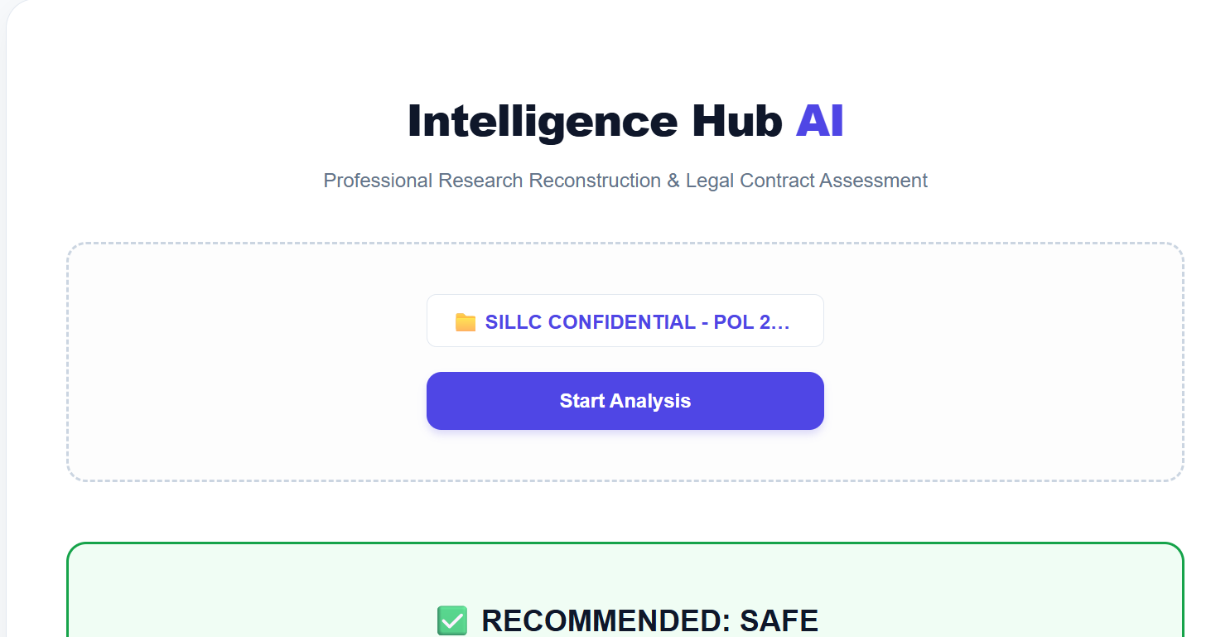

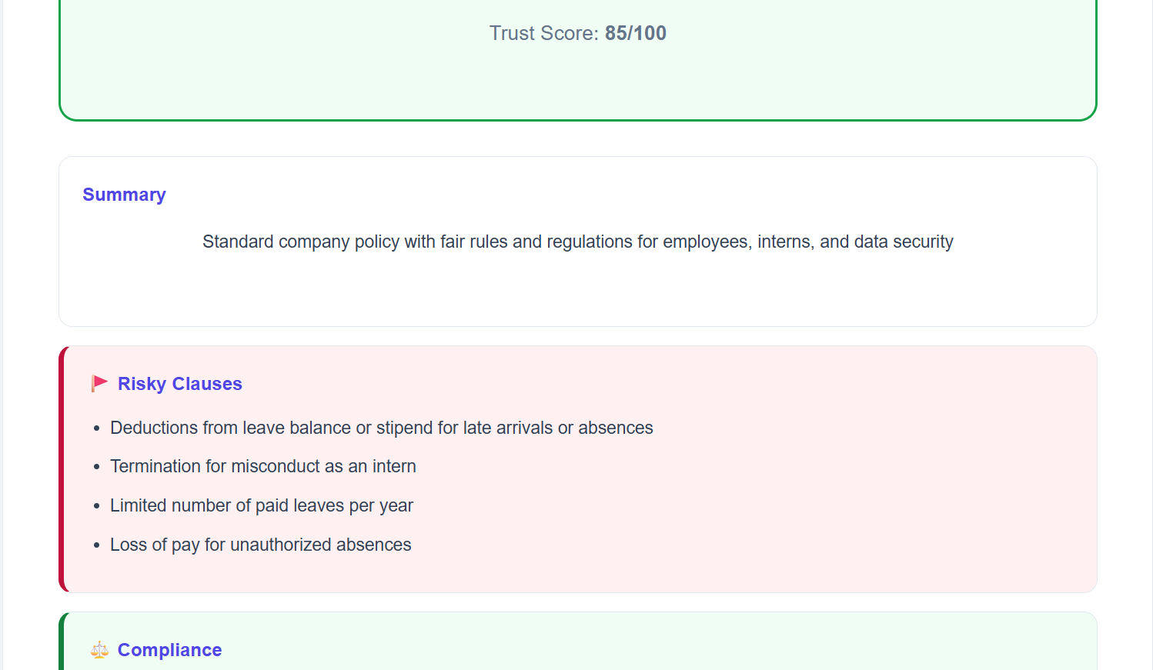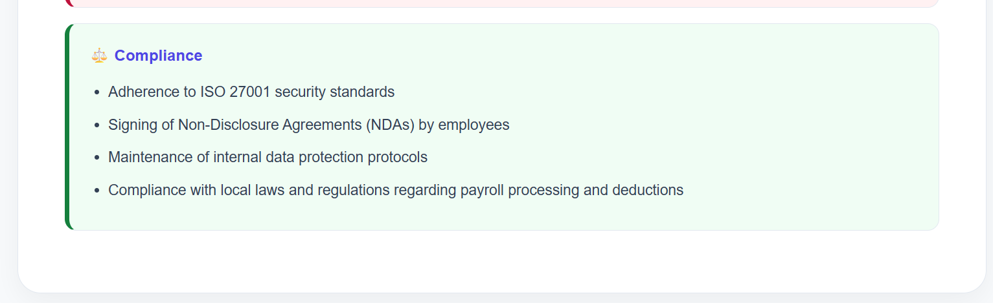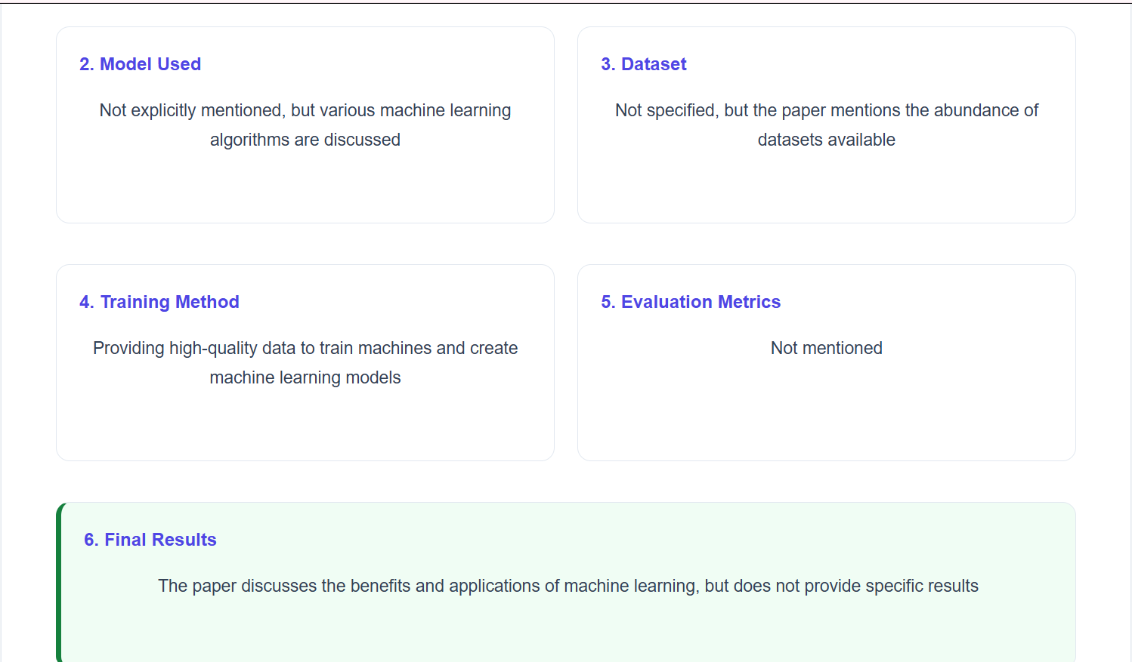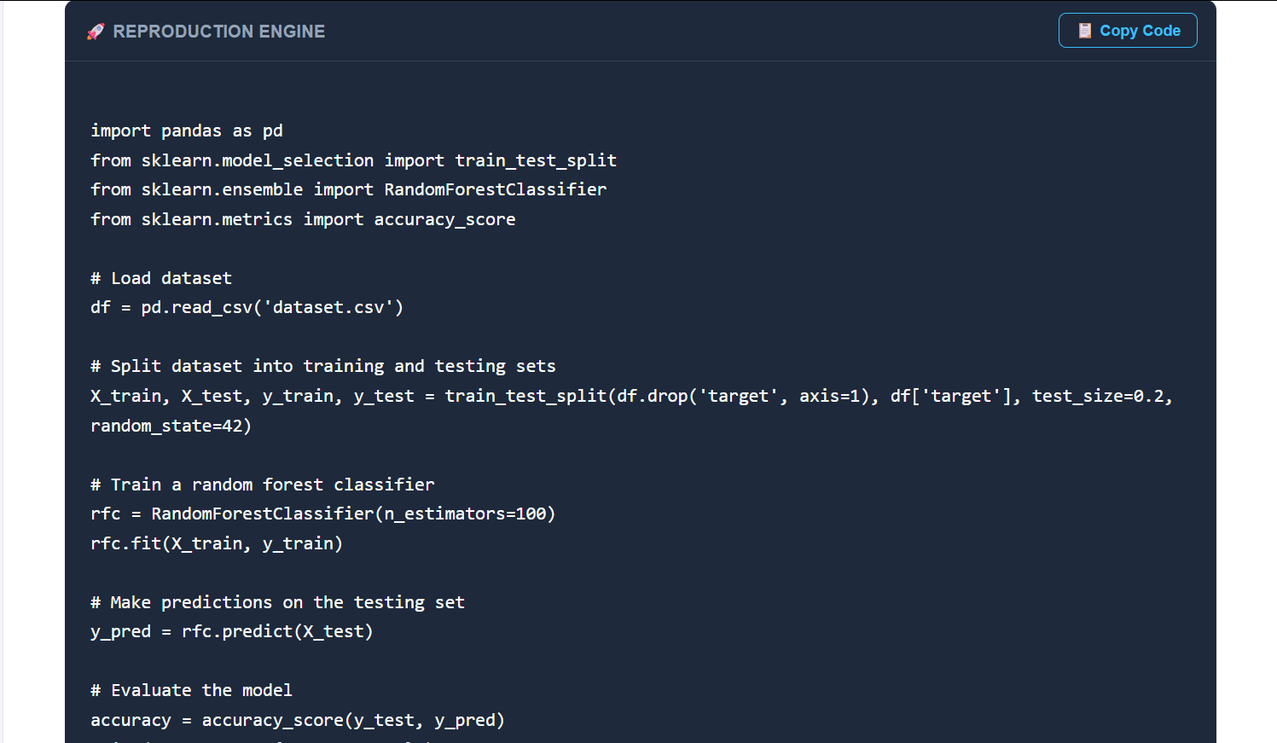

Student Self Evaluation of the Long-Term Internship

Student Name: P.SAI GREESHMITHA Registration No: 22F41A0580

Term of Internship : 4 Months FROM: 24-11-25 TO: 31-03-26

Date of Evaluation:
Organization Name & Address : : VAULTSPHERE AI TECHNOLOGIES PRIVATE LIMITED, Kuppam.

Please rate your performance in the following areas:

Rating Scale: Letter grade of CGPA calculation to be provided

1 | Oral communication | 1 | 2 | 3 | 4 | 5
2 | Written communication | 1 | 2 | 3 | 4 | 5
3 | Proactiveness | 1 | 2 | 3 | 4 | 5
4 | Interaction ability with community | 1 | 2 | 3 | 4 | 5
5 | Positive Attitude | 1 | 2 | 3 | 4 | 5
6 | Self-confidence | 1 | 2 | 3 | 4 | 5
7 | Ability to learn | 1 | 2 | 3 | 4 | 5
8 | Work Plan and organization | 1 | 2 | 3 | 4 | 5
9 | Professionalism | 1 | 2 | 3 | 4 | 5
10 | Creativity | 1 | 2 | 3 | 4 | 5
11 | Quality of work done | 1 | 2 | 3 | 4 | 5
12 | Time Management | 1 | 2 | 3 | 4 | 5
13 | Understanding the Community | 1 | 2 | 3 | 4 | 5
14 | Achievement of Desired Outcomes | 1 | 2 | 3 | 4 | 5
15 | OVERALL PERFORMANCE | 1 | 2 | 3 | 4 | 5

Date: Signature of the Student

Evaluation by the Supervisor of the Intern Organization

Name & Address of the Supervisor
with Mobile Number: R.NAGI REDDY -8106975810
Student Name: P.SAI GREESHMITHA Registration No: 22F41A0580

Term of Internship : 4 Months FROM: 24-11-25 TO: 31-03-26

Date of Evaluation:

Organization Name & Address : VAULTSPHERE AI TECHNOLOGIES Pvt Ltd, KUPPAM

Please rate the student’s performance in the following areas:

Please note that your evaluation shall be done independent of the Student’s self- evaluation

Rating Scale: 1 is lowest and 5 is highest rank

1 | Oral communication | 1 | 2 | 3 | 4 | 5
2 | Written communication | 1 | 2 | 3 | 4 | 5
3 | Proactiveness | 1 | 2 | 3 | 4 | 5
4 | Interaction ability with community | 1 | 2 | 3 | 4 | 5
5 | Positive Attitude | 1 | 2 | 3 | 4 | 5
6 | Self-confidence | 1 | 2 | 3 | 4 | 5
7 | Ability to learn | 1 | 2 | 3 | 4 | 5
8 | Work Plan and organization | 1 | 2 | 3 | 4 | 5
9 | Professionalism | 1 | 2 | 3 | 4 | 5
10 | Creativity | 1 | 2 | 3 | 4 | 5
11 | Quality of work done | 1 | 2 | 3 | 4 | 5
12 | Time Management | 1 | 2 | 3 | 4 | 5
13 | Understanding the Community | 1 | 2 | 3 | 4 | 5
14 | Achievement of Desired Outcomes | 1 | 2 | 3 | 4 | 5
15 | OVERALL PERFORMANCE | 1 | 2 | 3 | 4 | 5

Date: Signature of the Supervisor

PHOTOS & VIDEO LINKS
Video link: https://go.screenpal.com/watch/cOf1QBnTHGr

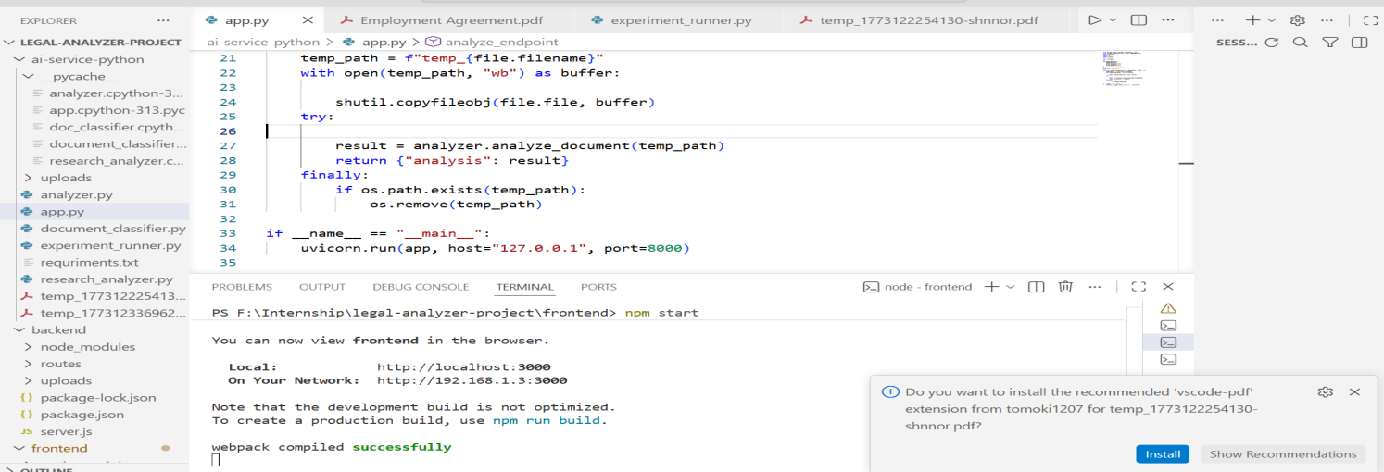
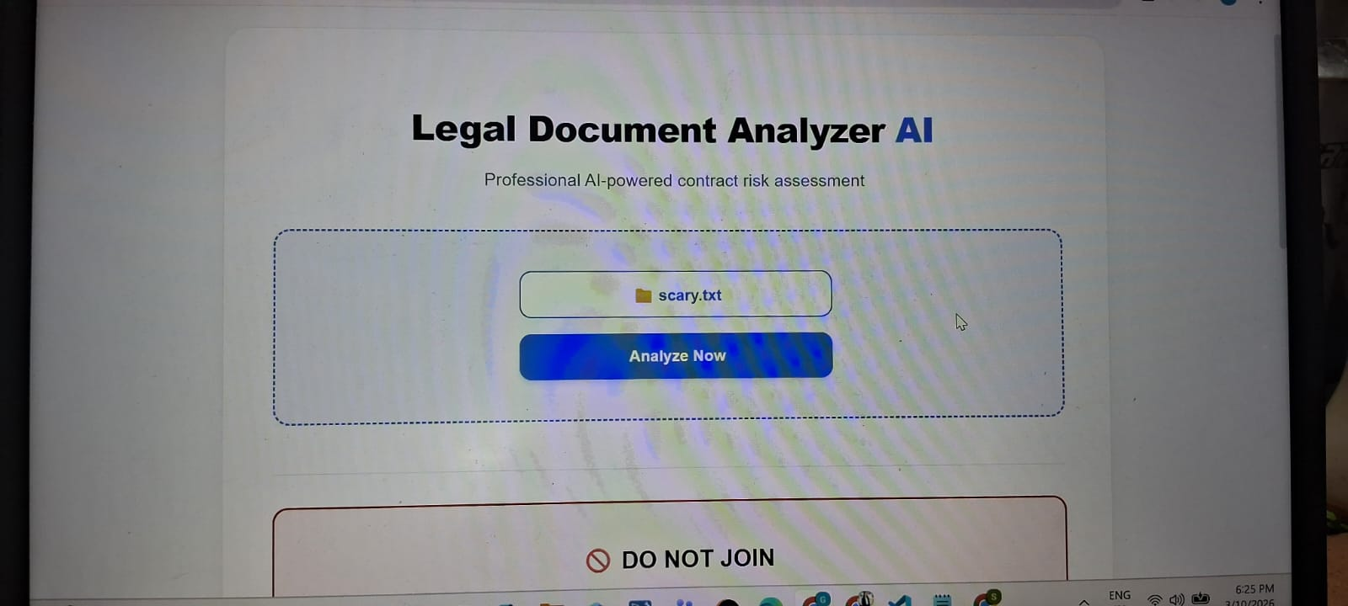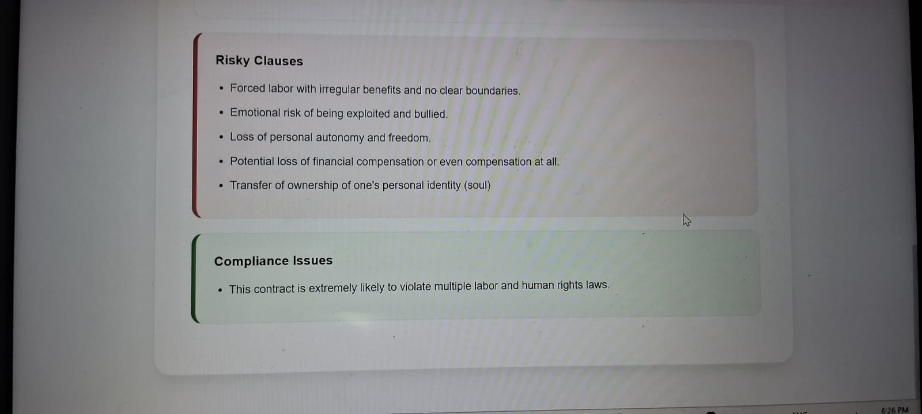



EVALUATION

Internal & External Evaluation for Semester Internship

Objectives:
- Explore career alternatives prior to graduation.
- To assess interests and abilities in the field of study.
- To develop communication, interpersonal and other critical skills in the future job.
- To acquire additional skills required for the world of work.
- To acquire employment contacts leading directly to a full-time job following graduation from college.

Assessment Model:
- There shall be both internal evaluation and external evaluation
- The Faculty Guide assigned is in-charge of the learning activities of the students and for the comprehensive and continuous assessment of the students.
- The assessment is to be conducted for 200 marks. Internal Evaluation for 50 marks and External Evaluation for 150 marks
- The number of credits assigned is 12. Later the marks shall be converted into grades and grade points to include finally in the SGPA and CGPA.
- The weightings for Internal Evaluation shall be:
  - Activity Log 10 marks
  - Internship Evaluation 30 marks
  - Oral Presentation 10 marks
- The weightings for External Evaluation shall be:
  - Internship Evaluation 100 marks
  - Viva-Voce 50 marks
- The External Evaluation shall be conducted by an Evaluation Committee comprising of the Principal, Faculty Guide, Internal Expert and External Expert nominated by the affiliating University. The Evaluation Committee shall also consider the grading given by the Supervisor of the Intern Organization.
- Activity Log is the record of the day-to-day activities. The Activity Log is assessed on an individual basis, thus allowing for individual members within groups to be assessed this way. The assessment will take into consideration
the individual student’s involvement in the assigned work.
- While evaluating the student’s Activity Log, the following shall be considered -
- The individual student’s effort and commitment.

- The originality and quality of the work produced by the individual student.
- The student’s integration and co-operation with the work assigned.
- The completeness of the Activity Log.
- The Internship Evaluation shall include the following components and based on Weekly Reports and Outcomes Description a. Description of the Work Environment.
- Real Time Technical Skills acquired.
- Managerial Skills acquired.
- Improvement of Communication Skills.
- Team Dynamics
- Technological Developments recorded.

MARKS STATEMENT

INTERNAL ASSESSMENT STATEMENT

Name Of the Student : P.SAI GREESHMITHA
Programme of Study : B.TECH
Year of Study :4th Year( 2025-2026)
Group : COMPUTER SCIENCE AND ENGINEERING
Register No/H.T. No : 22F41A0580
Name of the College : KUPPAM ENGINEERING COLLEGE
University : JNTUA

Sl.No | Evaluation Criterion | Maximum Marks | Marks Awarded
1. | Activity Log | 25
2. | Internship Evaluation | 50
3. | Oral Presentation | 25
 | GRAND TOTAL | 100

Date: Signature of the Faculty Guide

EXTERNAL ASSESSMENT STATEMENT

Name Of the Student : P.SAI GREESHMITHA
Programme of Study : B.TECH
Year of Study : 4th Year( 2025-2026)
Group : COMPUTER SCIENCE AND ENGINEERING
Register No/H.T. No : 22F41A0580
Name of the College : KUPPAM ENGINEERING COLLEGE
University : JNTUA

Sl.No | Evaluation Criterion | Maximum Marks | Marks Awarded
1. | Internship Evaluation | 80
2. | For the grading given by the Supervisor of the Intern Organization | 20
3. | Viva-Voce | 50
 | TOTAL | 150
GRAND TOTAL(EXT.50 M+INT.100M) |  | 200

Signature of the Faculty Guide

Signature of the Internal Expert

Signature of the External Expert

Signature of the Principal with Seal

