Capstone Project: PSAS

Design Document
Table of Contents
1 Introduction 1
2 Design Considerations 2
3 System Overview 4
4 System Architecture 6
5 Detailed System Design 8

Introduction
PSAS, the Portland State Aerospace Society, is in search of a way to test their rocketry software without the need for hardware (which may not even exist). They would like to simulate how the different software modules (some located on micro-controllers) behave when controlling the flight of a rocket.

Purpose and Scope
This document represents our most current design of the system. It is designed as a reference and building block for an actual implementation of the desired software system. Its scope is limited to the software for testing PSAS software/firmware by our capstone group, and does not detail how rockets work or emulate any micro-controller.

Target Audience
The target audience for this document is PSAS. It will be used to describe our proposed implementation and to guide developers through the implementation phase.

Terms and Definitions
PSAS: Portland State Aerospace Society. Capstone Sponser.
RTOS: Real-Time Operating System.
Micro-controller: Specialized single board computer used for data acquisition and hardware control.
Rocket: A rocket is a missile or vehicle that obtains motion through thrust generated by burning a solid or liquid propellant.
LWIP: Light Weight Internet Protocol. A protocol
ChibiOS: The RTOS used by the microcontrollers used on PSAS rockets.
Sensor: A device that converts physical phenomena into a signal that can be acted on and/or captured for later analysis.
GPS: Global Positioning System. A satellite based means of navigation.
GCC: Gnu C compiler.

Design Considerations

Constraints and Dependencies
- No unit testing.
- The PSAS software modules will undergo functional testing only within the test framework (black box testing).
- The Linux operating system the software will run on must be 64-bit. The latest Debian Linux is recommended, but any 64-bit system based on Debian (Ubuntu, for instance) should suffice.
- The minimum version of GCC compiler is 4.8.

System Overview
The system consists of a number of individual computers and microcontrollers. With the exception of a servo control microcontroller, nearly all signals flow into the Flight Computer, which is a single-board computer running embedded Debian Linux. The flight computer is also acting as a webserver that delivers telemetry information via browser.

Currently there are four microcontrollers responsible for carrying out measurement and control functions:

- Servo Control
- GPS
- RocketNet Hub
- Sensors

**Elderberry and Packet modules that are connected to other modules by dashed lines
need to be described as well as descriptions of the microcontroller responsibilities.

The Launch Tower computer (running Debian Linux) is responsible for detecting system readiness, initiation of launch, and monitoring telemetry via a web browser.

The Flight computer reacts to information coming from the microcontrollers, sends control commands to the Servo Control microcontroller, and provides a dynamic web page for viewing by the Launch Tower system.

With the exception of sensor simulations, information flow between subsystems will be based on TCP/IP and LWIP.

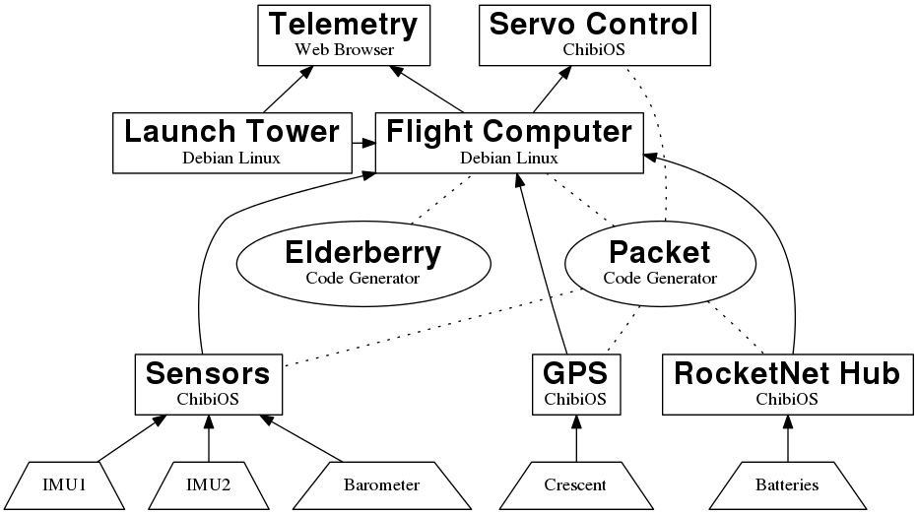
Overview of PSAS control system.

System Architecture
This section describes the components of the system and how they relate to the requirements for the PSAS system testing framework.

Command Line Interface
After starting the program, the testing framework is configured through a text menu and command line entries.

Flight Controller Software
The software running on the flight controller is central to both the operation of the rocket and to the test framework, which runs it. The flight controller software listens to incoming data from the assorted microcontrollers and makes decisions regarding changes to the rocket’s flight behavior.

The flight controller software is also responsible for updating an onboard web server with the most up-to-date telemetry information.

Web Server
The system will interact with a web server that is running as a separate process. The pages that will be displayed by the user’s browser will reflect artificial (or historic) data received from the simulated chibiOS software components.

ChibiOS Port Modules (maybe a better title…)
There are at least four modules (see figure in section 3) that rely on the RTOS ChibiOS to run software that normally would run on a microcontroller. We will use a port of ChibiOS that enables us to run ChibiOS as a process under Debian Linux, which in turn will let us run specific software under it.

Sensors
While physical sensors will not be used for this project, we still need sources that will mimic the data streams from such devices in order to effectively test those ChibiOS related modules.

Additional spawned processes that stream data by formula or reading of a data file will mimic these sources.

Data Logging
Data received from modules as well as commands issued to the module that, on the rocket, is responsible for rocket behavior, will be logged for later review.

LWIP Port
In keeping with the spirit of trying to maintain the verisimilitude of the test frame work matching the actual hardware, we will have a port of the LWIP stack run on the Debian Linux system. It may be possible that such a port already exists.

Detailed System Design

Command Line Menu

The highest level of our test framework is the menu and command line interface.

The menu will display a list of software modules available for testing. A user will have the option of mixing and matching modules that normally feed data to the flight computer. Unless the module that controls parachutes or flight attitude returns status information to the flight controller (perhaps final motor encoder values?), that module will not be represented as a running process (although commands that would be sent to it are captured in a log).

In addition being able select the upper-level software modules, the user will be able to select a list of available ‘sensors’ to use. In turn, for each of those sensors, the user will be able to select a data file that contains the information that the sensor will ‘provide’.

Different versions of software that can be run from the same module will not be able to run in parallel. Different versions of a sensor that would normally occupy the same channels on the microcontroller will also not be allowed operate in parallel.

The opening menu will also have a note reminding the user to make sure the web server is operating, and that a browser is pointed at that web server to display ‘telemetry’ data.

5.2 Web Server
Beyond knowing how to supply the web server with data, the software is not responsible for starting the web server or controlling any of its aspects. There will be a reminder on the opening menu for the user to make sure the server is running, and that telemetry data will be displayed in a browser that should also be manually started and pointed to the web server.

5.3 Sensors
While we will not be using objects per se, the sensor data that is integral to the operation of the system will be generated by software constructs running as processes alongside the other processes spawned by the test framework.

The data that flows from these constructs will not be raw analog data, but digital data found in comma separated variable format. In other words, data coming from the sensor simulations will not require A/D conversions before being passed up to the flight computer. Buffers should be large enough to cover any dataset (so we need to know how big these datasets can be.) However, since we’ll be pulling information from data buffers, care must be taken to insure that the data flow rate is consistent with the sampling and A/D conversion speeds normally seen on the real hardware.

5.4 Data Logs
Data logs will be in the form of text files whose names will include the timestamp.

The top of each log file will include a header consisting of the date and time of the test, the modules and programs being tested, the list of sensors and the list of sensor data files used.

The body of the log file will consist of column headers followed by all values in chronological order. The headers and values will be comma separated.

