POWER SCIENCE
12-Month Retail Launch Business Plan

1. Executive Summary
Power Science is an established supplier of RV and caravan electrical and fit-out components, based in Campbellfield, Victoria, with an 11-category product range spanning powerpoints and switches, circuit protection, connectors, solar charging systems, lighting, ceramic basins, cooling systems, entertainment, and diesel heating kits. This plan sets out a 12-month roadmap for launching the retail online store, growing the Facebook audience, and building toward sustainable monthly sales volume and revenue.
All sales volume and revenue figures in this plan are illustrative starting targets, not verified projections. They assume a blended average order value of roughly $130-150 and a conservative month-on-month growth curve. Replace them with real numbers once actual margins, ad spend, and fulfillment capacity are confirmed.

2. Business Overview
Trading name: Power Science | Location: 74 Killara Road, Campbellfield VIC 3061 | Website: powersciencegroup.com.au
Power Science's catalogue covers the full electrical and fit-out needs of an RV or caravan build, positioning the brand as a one-stop supplier rather than a single-category retailer:
Section | Category | Positioning
1 | Powerpoints & Switches | Core replacement/upgrade item
2 | Circuit Breakers & Fuses | Essential safety/maintenance stock
3 | Connectors | High-frequency repeat purchase
4-5 | Solar Panels & Chargers | Flagship / highest-value category
6 | Lights, Side Markers & Reflectors | Upgrade & compliance item
7 | Ceramic Basins & Waste | Fit-out / renovation category
8 | Fan Cooling System | Electrical board accessory
9 | TV & Speaker | Comfort upgrade, higher basket value
10-11 | Diesel Heater Kit & Accessories | Premium seasonal category
Category groupings summarised from the 2026 Power Science Product Catalogue.

3. Target Market & Sales Channels
- Primary: RV and caravan owners in Australia doing their own electrical fit-out, repairs, or upgrades.
- Secondary: caravan builders, installers, and dealers sourcing components in volume.
- Channels: direct-to-consumer online store, Facebook Page and Group community, and trade/dealer outreach for repeat bulk orders.
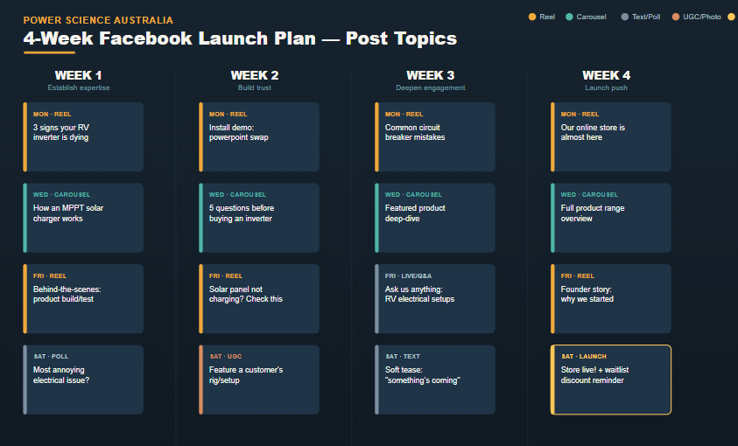

4. 12-Month Roadmap
The roadmap below sequences store build, launch, and promotional activity across the year. Black bars are operational/build milestones; red bars are promotional activities.
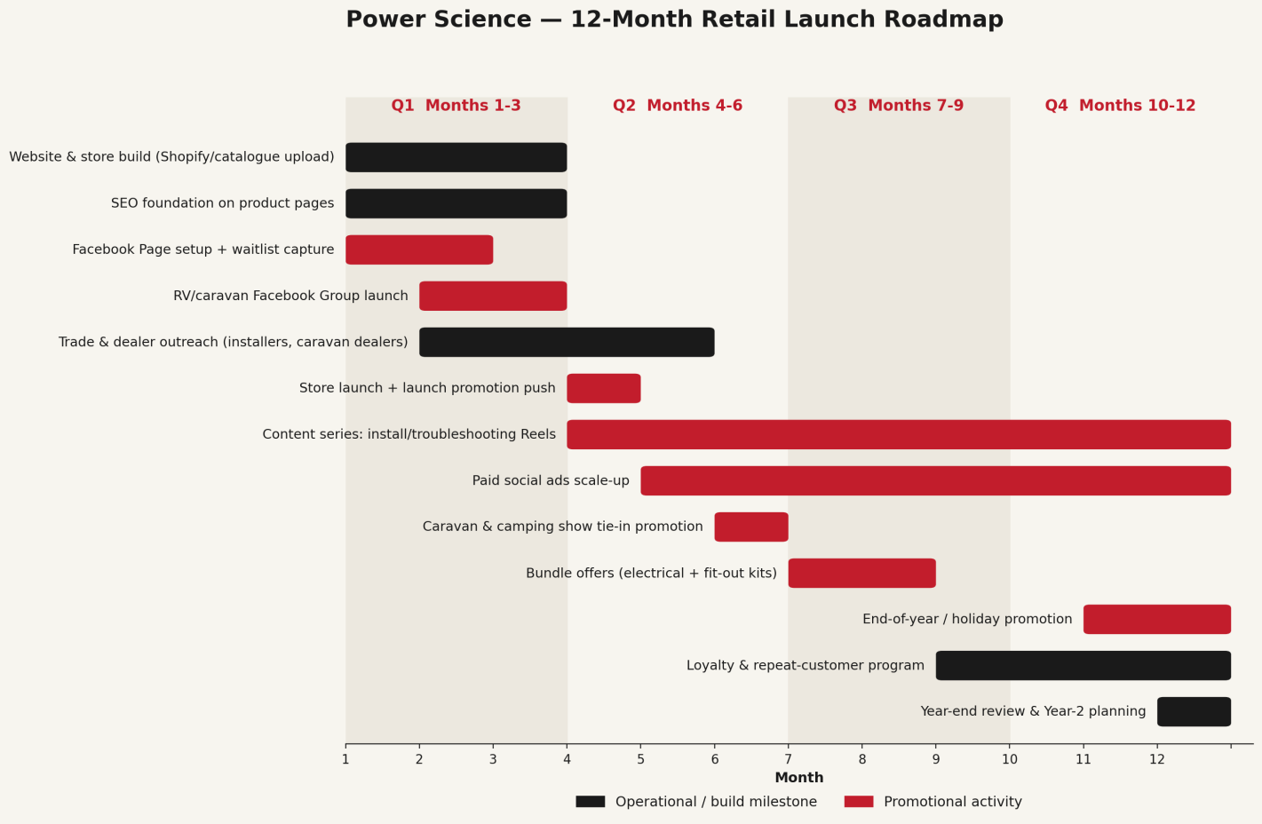

5. Quarterly Sales Volume & Revenue Targets
Quarter | Sales Volume Target | Revenue Target (AUD) | Key Promotional Focus
Q1 — Months 1-3  Pre-launch | No public sales (build phase) | $0 | Website/SEO build, Facebook Page + waitlist, community seeding
Q2 — Months 4-6  Launch | ~100 units  (~10-25 orders/mo by M6) | ~$10,000 | Store launch campaign, launch discount, Reels content series begins
Q3 — Months 7-9  Growth | ~300 units  (~20-30 orders/mo) | ~$20,000 | Paid social scale-up, caravan/camping show tie-in, bundle offers
Q4 — Months 10-12  Scale | ~1,050 units  (~40-70 orders/mo) | ~$35,000 | End-of-year promotion, loyalty program, Year-2 planning

6. Key Assumptions & Notes
- Figures assume the online store goes live at the start of Month 2; adjust the whole timeline if the actual launch date differs.
- Revenue targets are gross sales estimates and do not yet account for cost of goods, shipping, ad spend, or margin.
- Solar panels/chargers and diesel heater kits are treated as higher-value, lower-frequency purchases; connectors and powerpoints as lower-value, higher-frequency purchases — the blended AOV assumption should be revisited once real order data exists.
- Seasonal camping/caravan shows and the November-December holiday period are treated as the two strongest promotional windows; confirm actual Australian RV show dates for the target year and adjust Q3/Q4 timing accordingly.

7. Next Steps
- Confirm actual store launch month and shift the roadmap dates accordingly.
- Set real pricing and margin per category to replace the illustrative revenue targets.
- Assign ownership for each roadmap item (who runs the Facebook Group, who handles trade outreach, etc.).

