****Camera2架构概述****

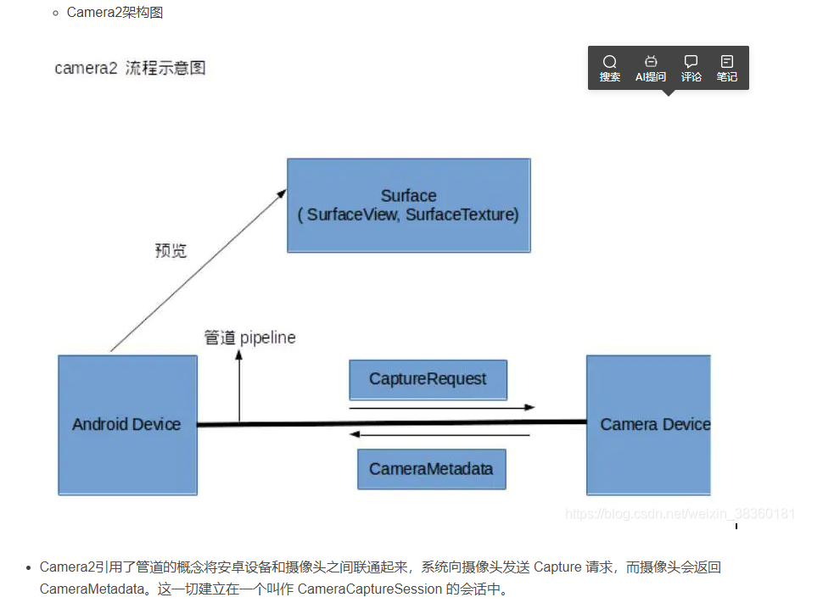

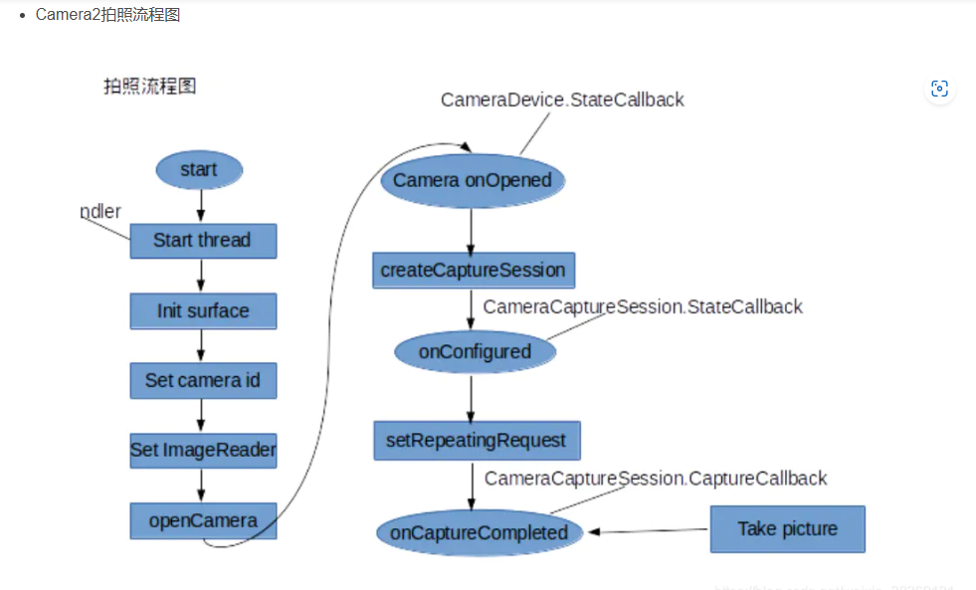

[一篇文章带你了解Android 最新Camera框架 (qq.com)](https://mp.weixin.qq.com/s?__biz=MzA3ODMzMTM1NA==&mid=2247484350&idx=1&sn=decb3613f95b45d5bf1073373704b2d8&chksm=9f452f0ba832a61d7d77c9d7b492bb5ce9e2785ccacab3473ae1de5c6d40bf5e355c8fad92ca&scene=21" \l "wechat_redirect)