I will perform my all operation with respect to this 2 tables

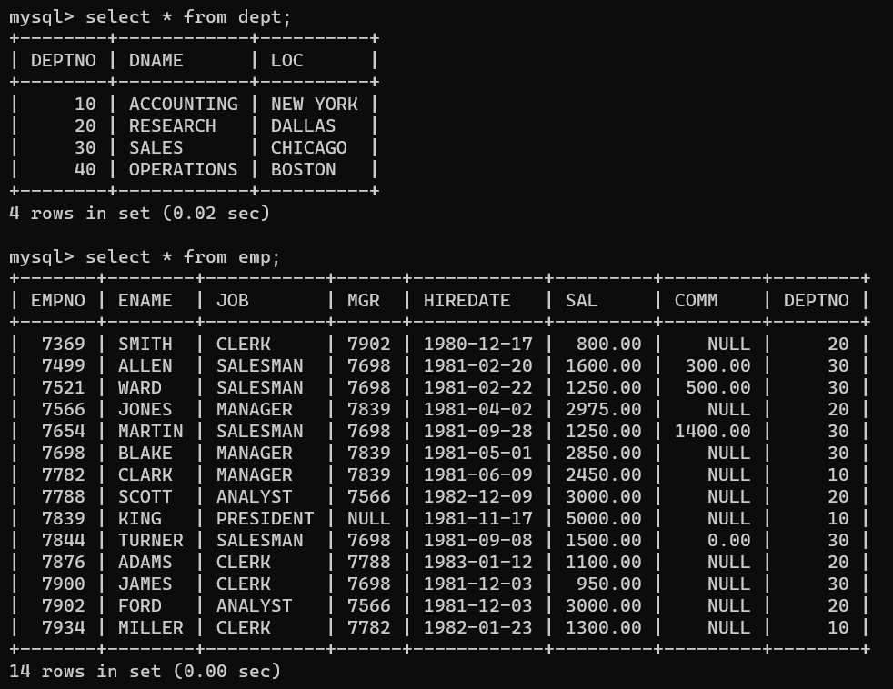

mysql> select * from emp where ename='CLARK';

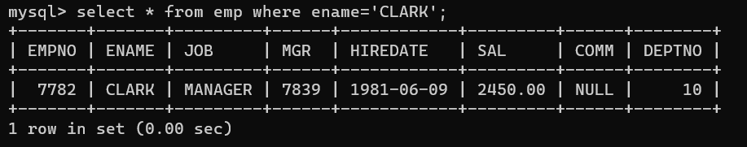

mysql> select * from emp where comm is null;

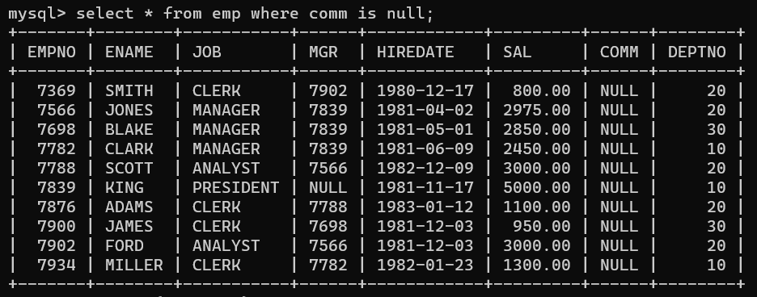

mysql> select * from emp where ename like '%E_';

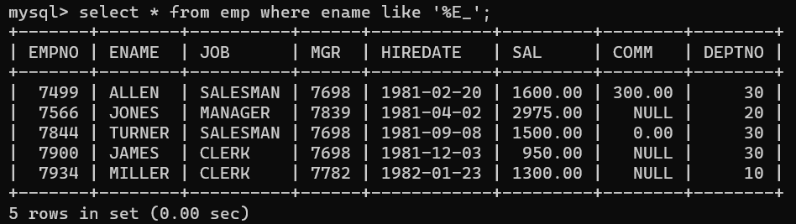

mysql> select * from emp where deptno=10;

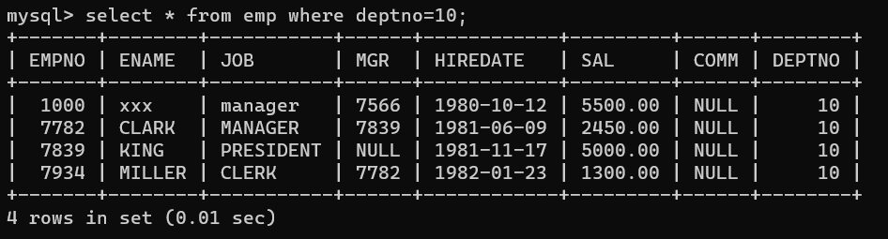

mysql> select * from emp where sal between 2000 and 5000;

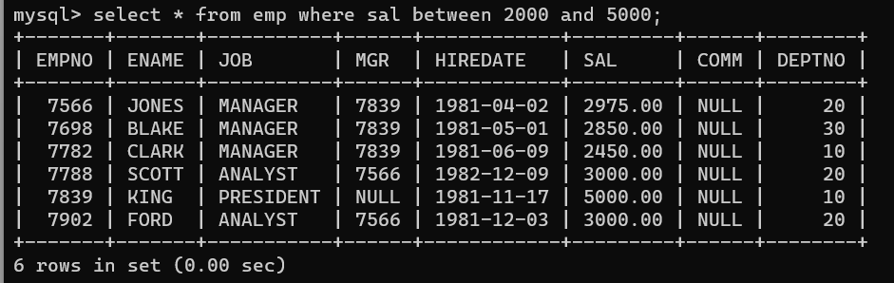

mysql> select * from emp where job='manager';

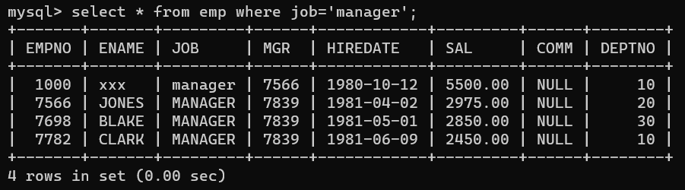

mysql> select * from emp where job='clerk';

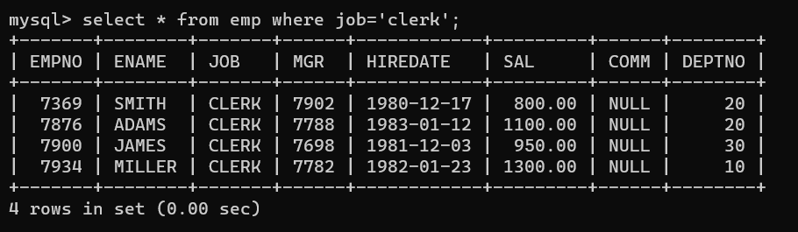

mysql> delete from emp where empno=1000;

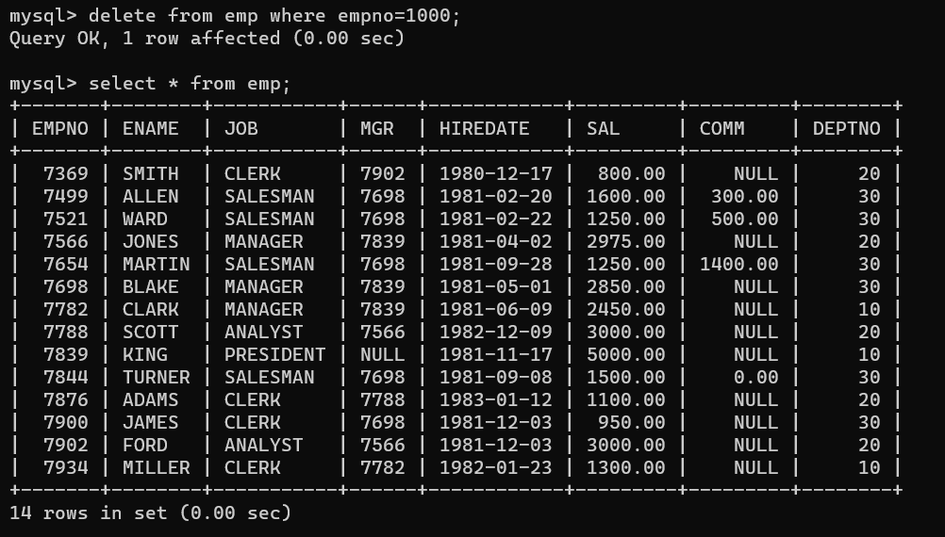

mysql> select * from emp

-> order by empno;

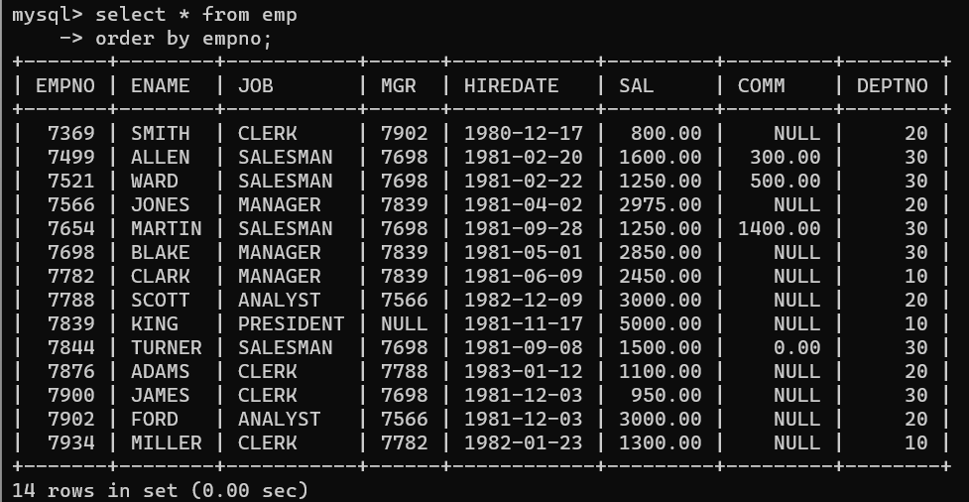

mysql> select * from emp where ename like '%s';

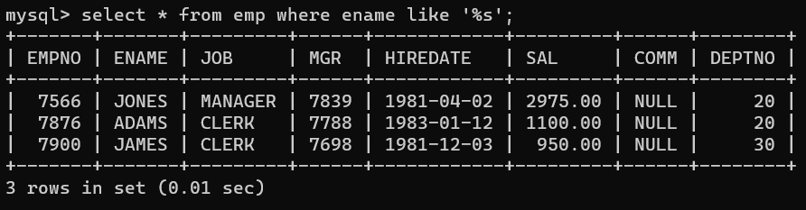

mysql> select empno,ename,sal,deptno,

-> case deptno when 10 then 'sales'

-> when 20 then 'Accounts'

-> else 'purcahse'

-> end 'dname'

-> from emp;

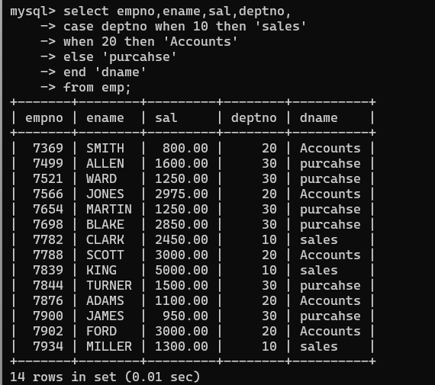

Database changed

mysql> create view imp2

-> as

-> select * from emp

-> where 1=2;

Query OK, 0 rows affected (0.09 sec)

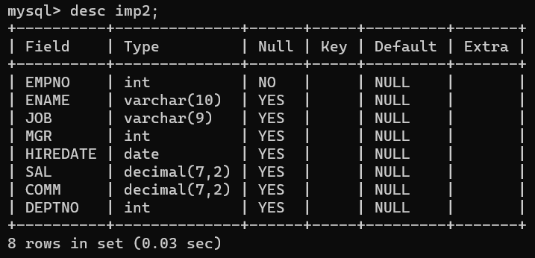

mysql> select * from emp where sal>=2000 order by sal;

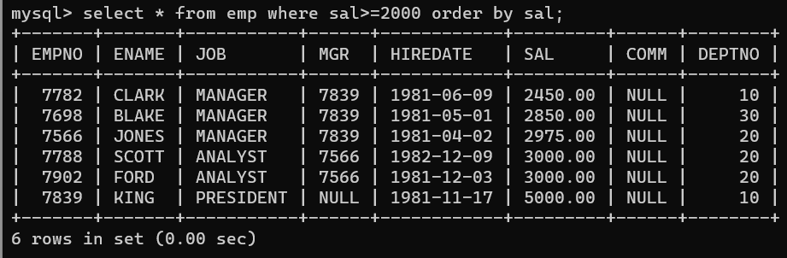

mysql> select * from emp where sal>=2000 and sal<=3000;

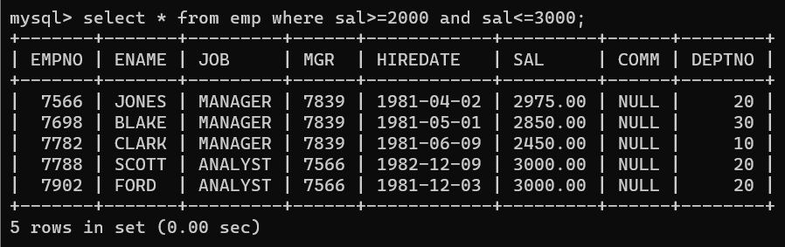

mysql> select * from emp where sal in (3000,1250);

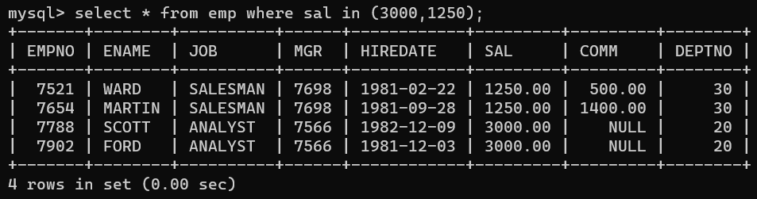

mysql> select sum(sal),avg(sal),count(*) from emp

-> group by deptno

-> order by deptno;

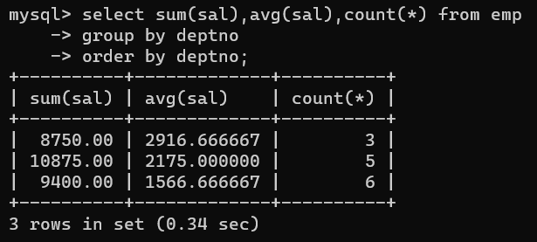

mysql> select * from emp where deptno=(select deptno from emp where ename='blake');

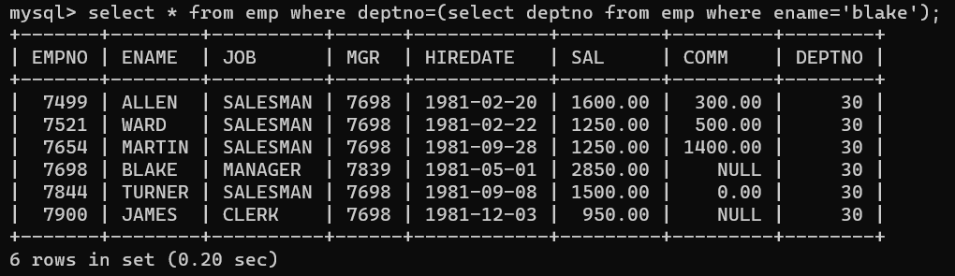

mysql> select * from emp where ename like '%a%r%';

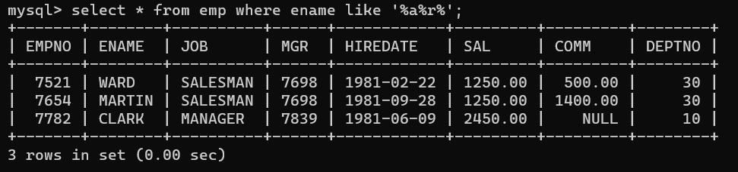

mysql> select * from emp where sal in (select sal from emp where deptno=10);

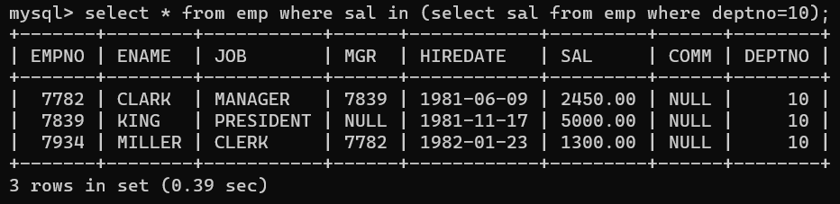

mysql> select now();

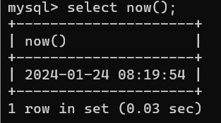

To list all record with job=’Clerk’ or sal>2000

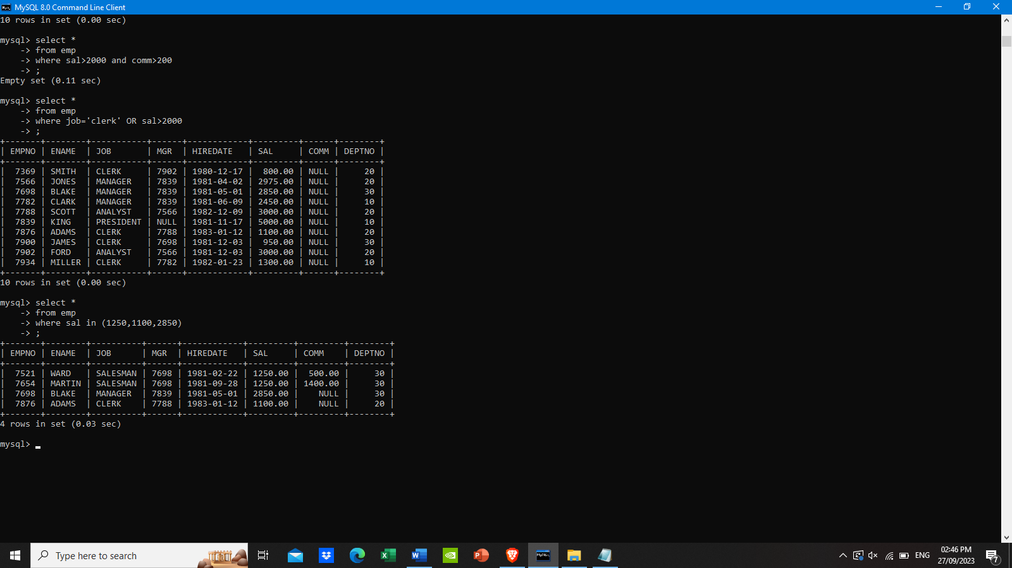

To list all the record with sal=1250 or 1100 or 2850.



To list all employees with job starts with C and ends with K

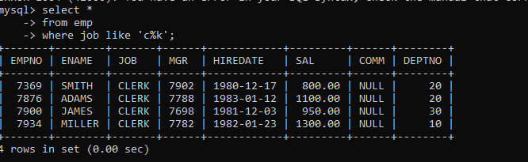

To list all employees with job contains L at third position and

M at third last position

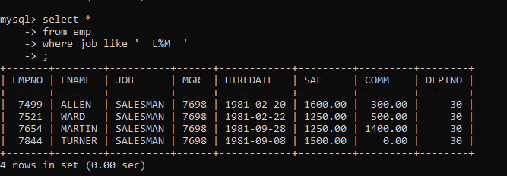

To list all employees with job contains 5 characters.

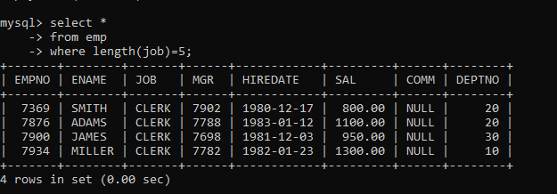

To list all employees with name contain ‘A’ at 1 position and job

Contains 5 characters

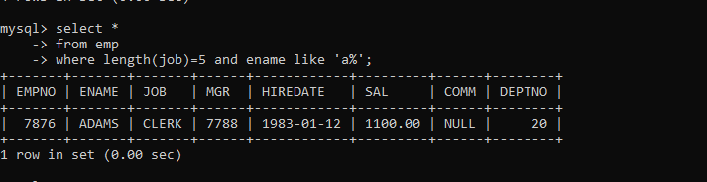

Retrieve the details (Name, Salary and dept no) of the emp who are working in

department code 20, 30 and 40.

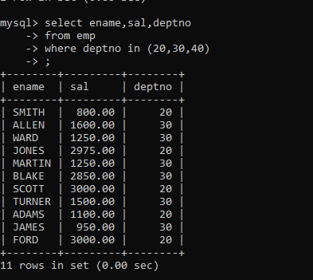

Display the total salary of all employees . Total salary will be calculated as

sal+comm+sal*0.10

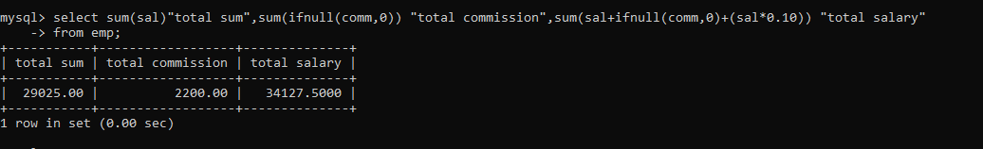

List the Name and job of the emp who have joined before 1 jan 1986 and whose

salary range is between 1200and 2500. Display the columns with user defined Column

headers.

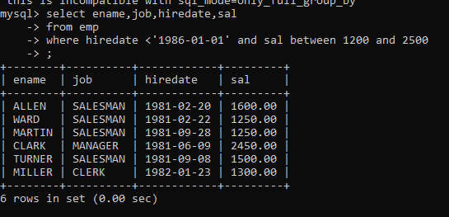

List the empno, name, and department number of the emp works under manager

with id 7698

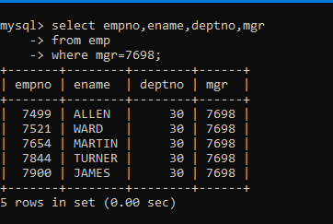

List the name, job, and salary of the emp who are working in departments 10 and 30

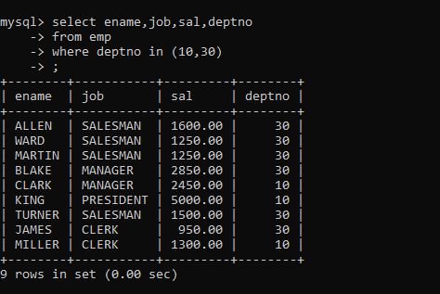

Display name concatenated with dept code separated by comma and space. Name

the column as ‘Emp info’.

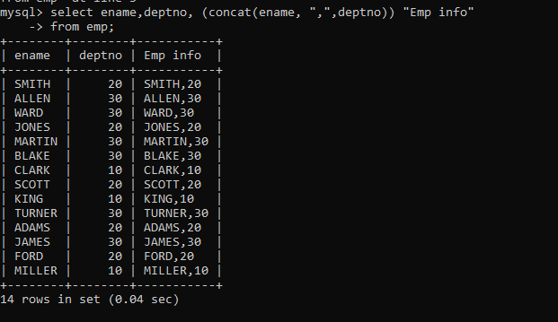

Display the emp details who do not have manager.

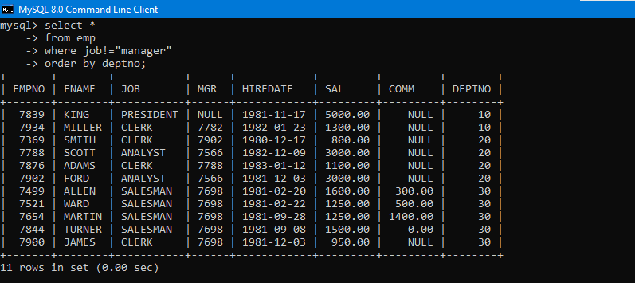

Write a query which will display name, department no and date of joining of all

employee who were joined January 1, 1981 and March 31, 1983. Sort it based on date of

joining (ascending).

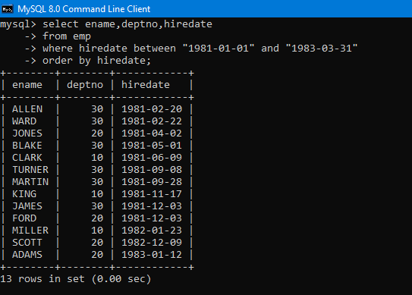

Display the employee details where the job contains word ‘AGE’ anywhere in the Job

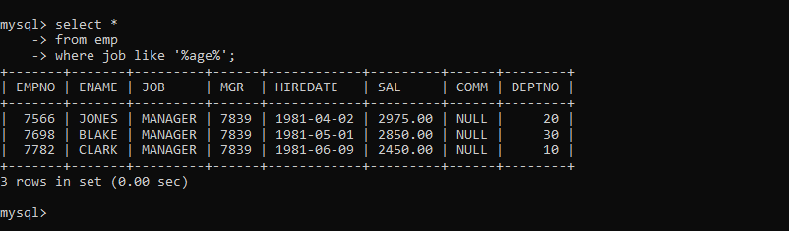

List the details of the employee , whose names start with ‘A’ and end with ‘S’ or

whose names contains N as the second or third character, and ending with either ‘N’ or ‘S’.

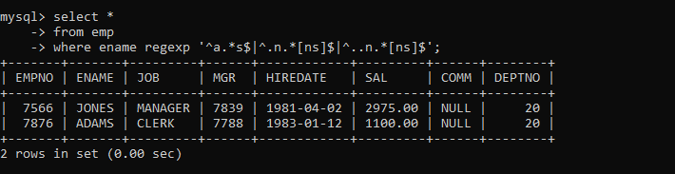

List the names of the emp having ‘_’ character in their name.

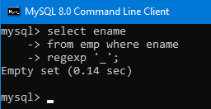

find 3rd highly paid employee

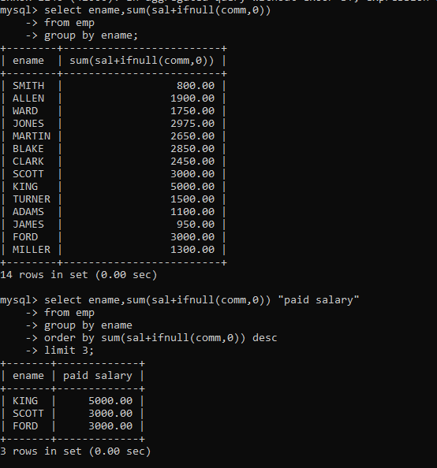

find employee who has earned highest commission

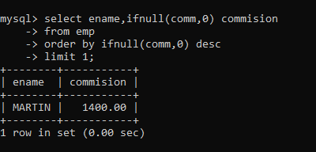

display ascii value of 1st character of job from emp.

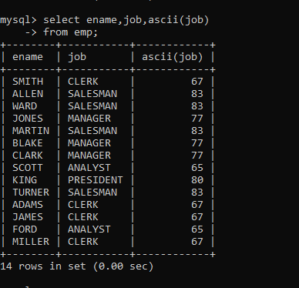

display empno,ename,job,code code should be 1 st 3 characters of ename and 1

st 3 characters of job.

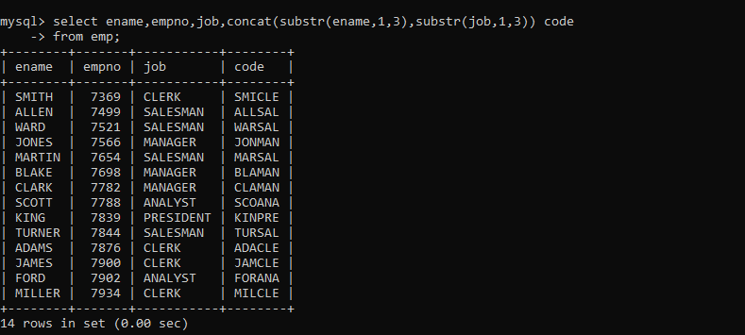

To list all employees and their email, to generate email use 2 to 5 characters from ename

Concat it with 2 to 4 characters in job and then concat it with ‘@mycompany.com’

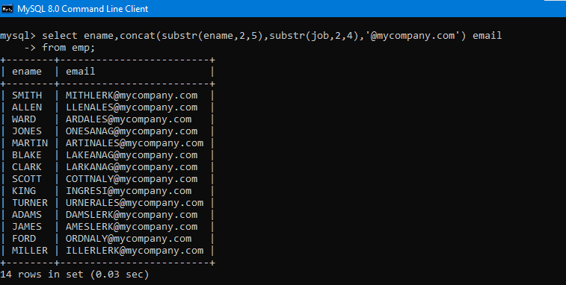

List all employees who joined in September.

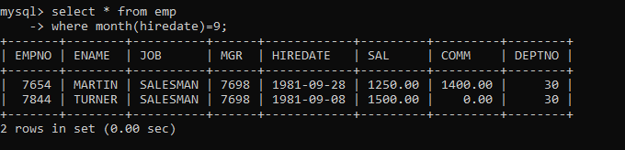

List the empno, name, and department number of the emp who have experience of 18 or

more years and sort them based on their experience.

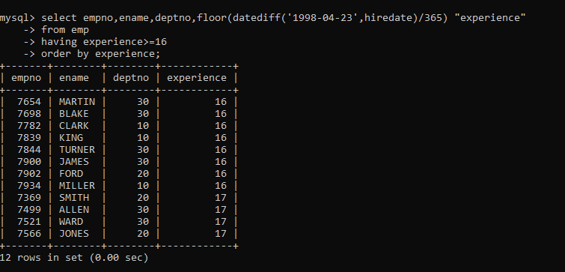

Display the employee details who joined on 3rd of any month or any year

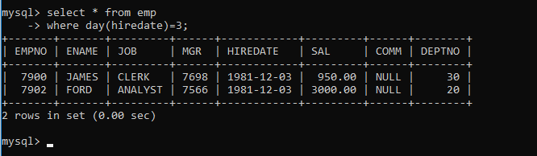

display all employees who joined between years 1981 to 1983.

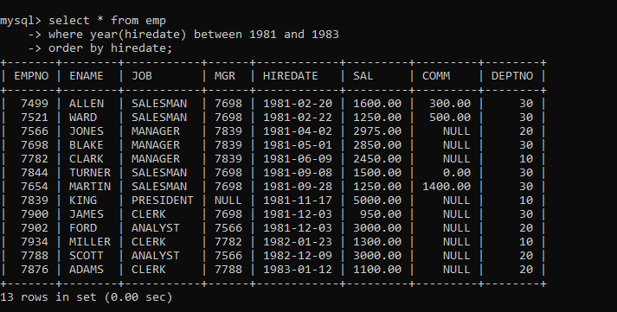

Display the Highest, Lowest, Total & Average salary of all employee. Label the columns

Maximum, Minimum, Total and Average respectively for each Department. Also round the

result to the nearest whole number.

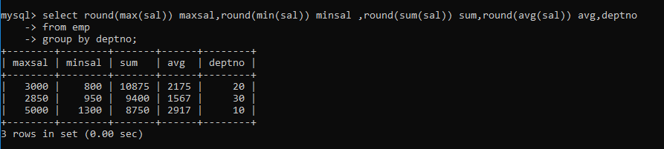

Display Department no and number of managers working in that department. Label the

column as ‘Total Number of Managers’ for each department.

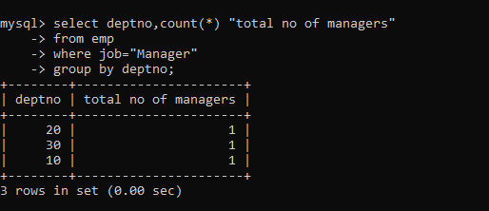

Get the Department number, and sum of Salary of all non managers where the sum is

greater than 20000.

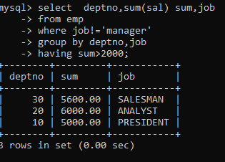

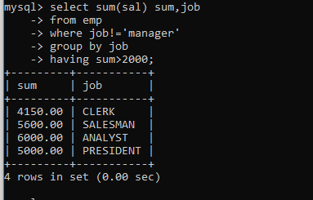

Write a query to display the first day of the month (in datetime format) three

months before the current month.

Sample current date : 2014-09-03

Expected result : 2014-06-01

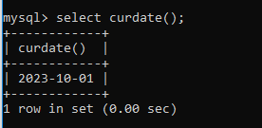

Write a query to get the distinct Mondays from hiredate in emp tables.

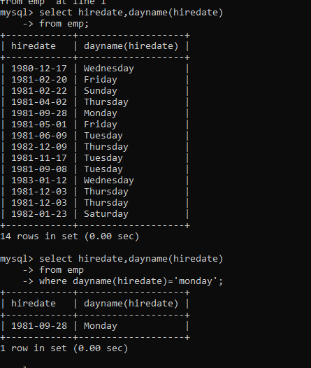

Write a query to get the first day of the current year.

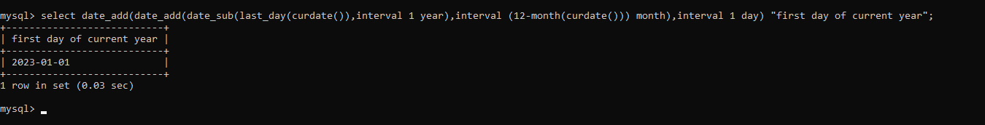

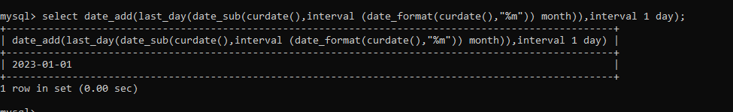

Write a query to get the last day of the current year.

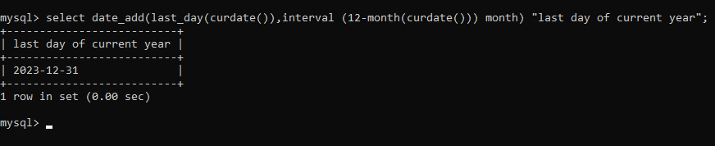

Write a query to calculate your age in year.

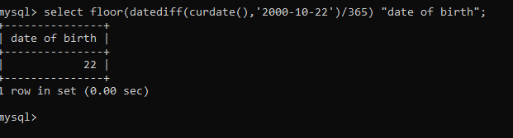

Write a query to get the current date in the following format.

Sample date : 04-sep-2014

Output : September 4, 2014

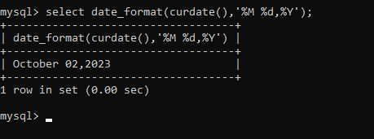

Write a query to get the current date in Thursday September 2014 format.

Thursday September 2014

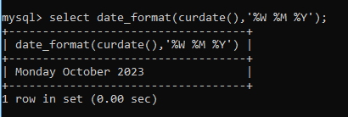

Write a query to extract the year from the current date.

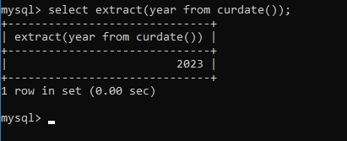

Write a query to get the first name and hire date from employees table

where hire date between '1987-06-01' and '1987-07-30'

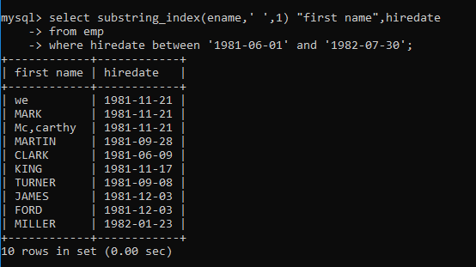

Write a query to display the current date in the following format.

Sample output: Thursday 4th September 2014 00:00:00

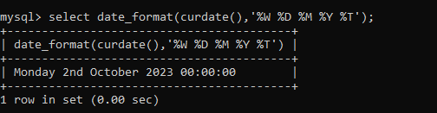

Write a query to display the current date in the following format.

Sample output: 05/09/2014

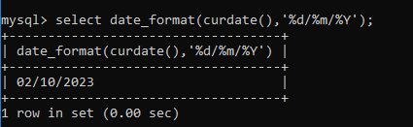

Write a query to display the current date in the following format.

Sample output: 12:00 AM Sep 5, 2014

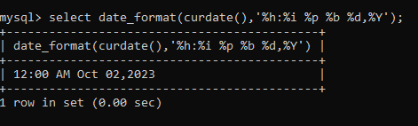

Write a query to get the employees who joined in the month of June.

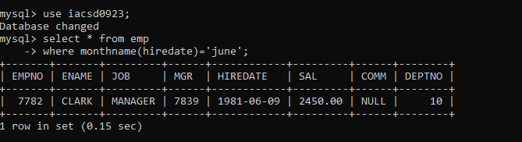

Write a query to get the years in which more than 10 employees joined.

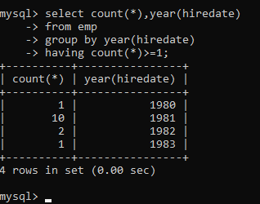

Write a query to get first name of employees who joined in 1987.

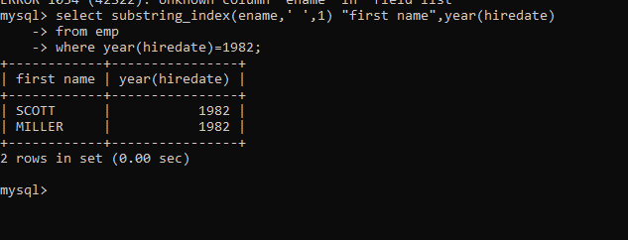

Write a query to get employees whose experience is more than 5 years.

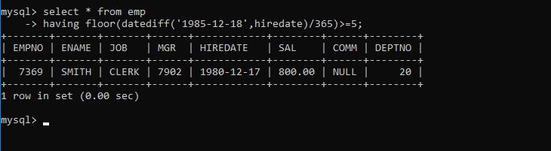

Write a query to get employee ID, last name, and date of first salary of the

employees.

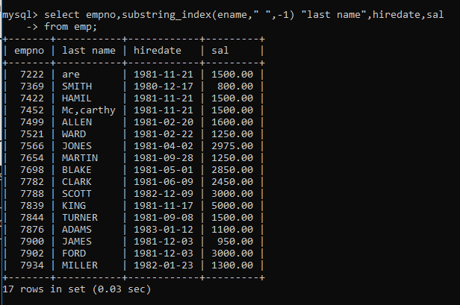

Write a query to get first name, hire date and experience of the

employees.

Sample table: employees

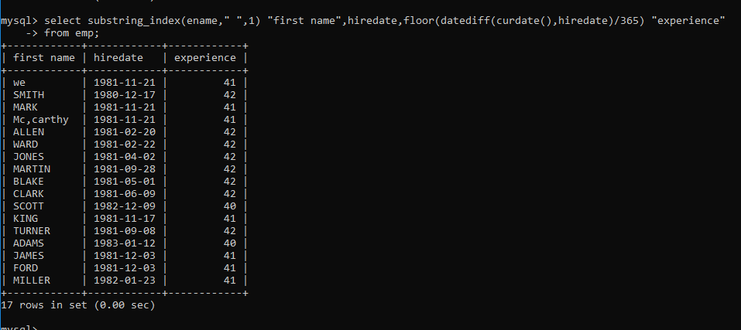

Write a query to get the department ID, year, and number of employees

joined.

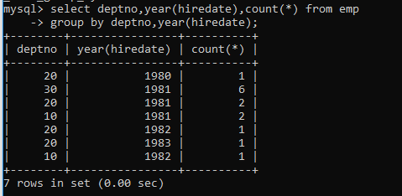

To find all managers with salary >1500

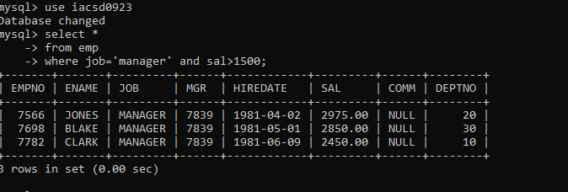

list all employees with sal >1200 and < 2000

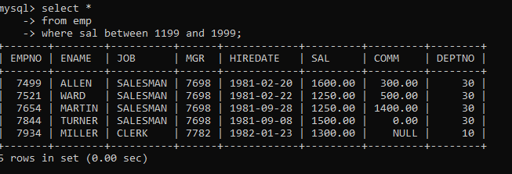

list all employees with sal is 1600 or sal is 800 or sal is 1900

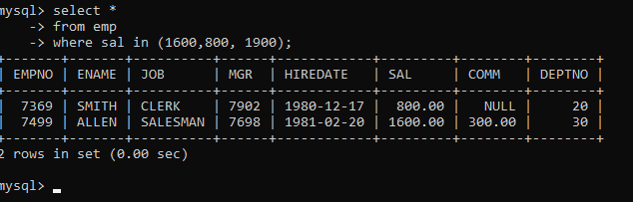

list all employees with R at second last position in name

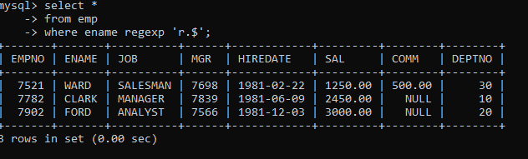

List all employees with name starts with A and ends with N

