

Admin Dashboard User Guide
Owner & Manager Operations Guide
A practical owner-and-manager guide for daily operations, menu publishing, customer service, payments, reporting, and safe account administration.

Version 1.0 • September 2026
Prepared by Recon Dev LLC
Keep this handbook with the designated owner and admin team. It contains operational guidance, not passwords or secret keys.

How to use this handbook
Start with the role and safety guidance, then use the numbered chapters as task-based instructions. Screenshots come from a local training environment with fictional people, orders, and provider references. Your live totals and records will differ, and some screens may change slightly after future updates.
First-day priority: Sign in with your own account, confirm your role, review Business Settings, and learn the launch-hold checklist before publishing sellable content.

Contents
1. Getting started and navigation
2. Roles, access, and account safety
3. Dashboard and daily rhythm
4. Orders and approval workflow
5. Kitchen view and fulfillment
6. Catering and personal-chef requests
7. Standard menu management
8. Weekly meal plans
9. Gallery management
10. Customers
11. Payments and reconciliation
12. Reports
13. Notifications and email
14. Business settings
15. Role manager and owner controls
16. Publishing, launch hold, and go-live
17. Troubleshooting and escalation
18. Daily and weekly checklists
The clickable contents links jump to major sections in Word and compatible PDF viewers.

1. Getting started and navigation
The Admin area is the control center for orders, content, customer service, and business operations.

Sign in and open Admin
1. Open the website and select Account.
2. Sign in with your individual account. Never share an owner password.
3. Select Admin in the site header. If Admin is missing, ask the owner to verify your role.

Navigation at a glance
- Dashboard: operating summary and quick links.
- Orders and Kitchen View: approval, payment visibility, prep, and completion.
- Menu Manager and Weekly Menu Manager: what customers can see and purchase.
- Service Requests: catering and personal-chef leads.
- Gallery Manager: public gallery images and category ordering.
- Customers, Reports, Payments, Notifications, Business Settings, Audit Log, and Role Manager: oversight tools.
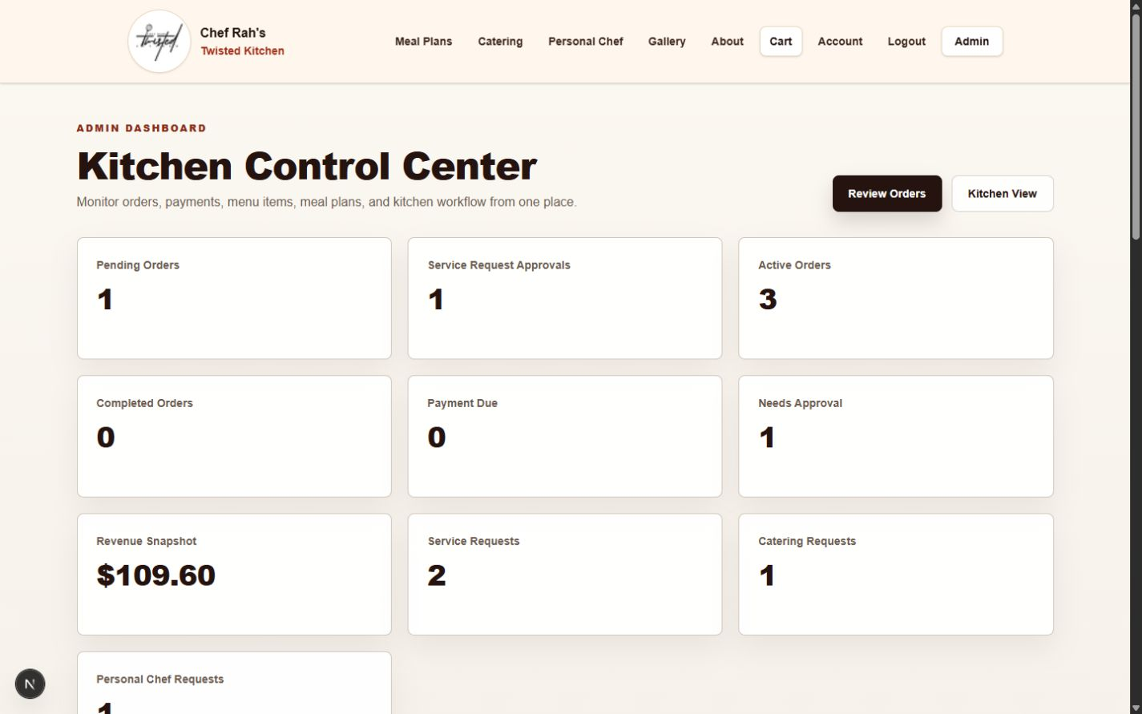
Training dashboard with operational summaries and quick links.
Privacy: Screenshots in this guide are sanitized. Do not include customer contact details in screenshots, shared chats, or public documents.

2. Roles, access, and account safety
Use the least access needed. Owner-only controls should stay with the business owner or a specifically authorized backup.

Role overview
Role | Typical use | Guardrail
Owner | Full operational ownership and role management | Keep at least one verified owner account; change roles deliberately.
Admin | Day-to-day operations and content management | Do not grant Owner merely for convenience.
Customer | Public account and order history | Never use for admin work.

Account safety
- Use a unique password and an individual login for every team member.
- Sign out on shared devices.
- Review the Audit Log after sensitive changes.
- Never copy payment secrets, tokens, or hosting credentials into customer notes.
- If access looks wrong, stop and contact the owner before changing roles.
Done | Check
☐ | Owner account sign-in confirmed
☐ | Admin role assigned only to authorized staff
☐ | Shared-device sign-out routine understood
☐ | Escalation contact recorded offline

3. Dashboard and daily rhythm
The dashboard summarizes work that needs attention. Counts are cues to investigate, not substitutes for opening the underlying record.

What to review first
1. Review pending orders and approvals.
2. Open service requests that need a response.
3. Check payments due and any reconciliation warning.
4. Check weekly capacity before accepting time-sensitive work.
5. Review notification status if a customer reports missing email.

Recommended daily rhythm
- Morning: pending approvals, paid orders, kitchen work, service leads.
- Midday: status updates, customer questions, capacity.
- Close: payments and reconciliation, completed work, next-day prep.
Important: A dashboard number may lag briefly after a save. Open the destination page or refresh once before repeating an action.

4. Orders and approval workflow
Orders may be payment-ready immediately or may require approval first. Read the approval and payment badges together before acting.
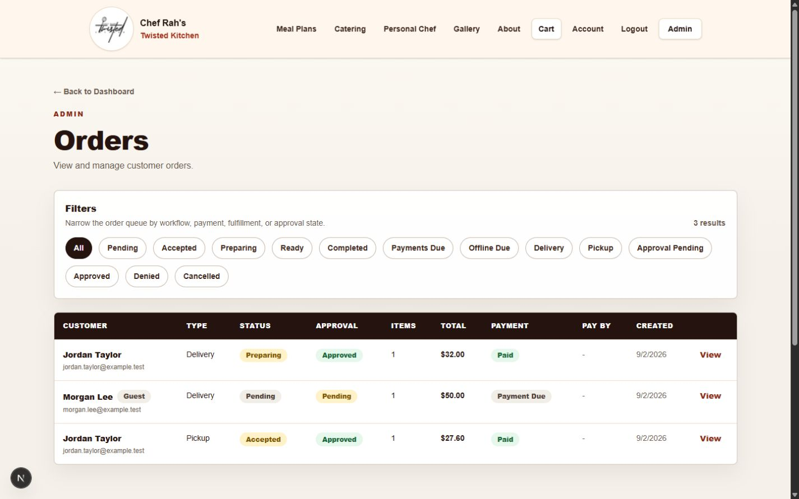
Orders list with filters and payment/approval badges.

Review an order
1. Use filters to find the order, then select View.
2. Confirm customer, fulfillment type, requested timing, line items, options, allergens, and total.
3. For approval-required work, approve or deny only after the business decision is complete.
4. Update operational status as work progresses. Do not mark an order paid based only on a customer message.
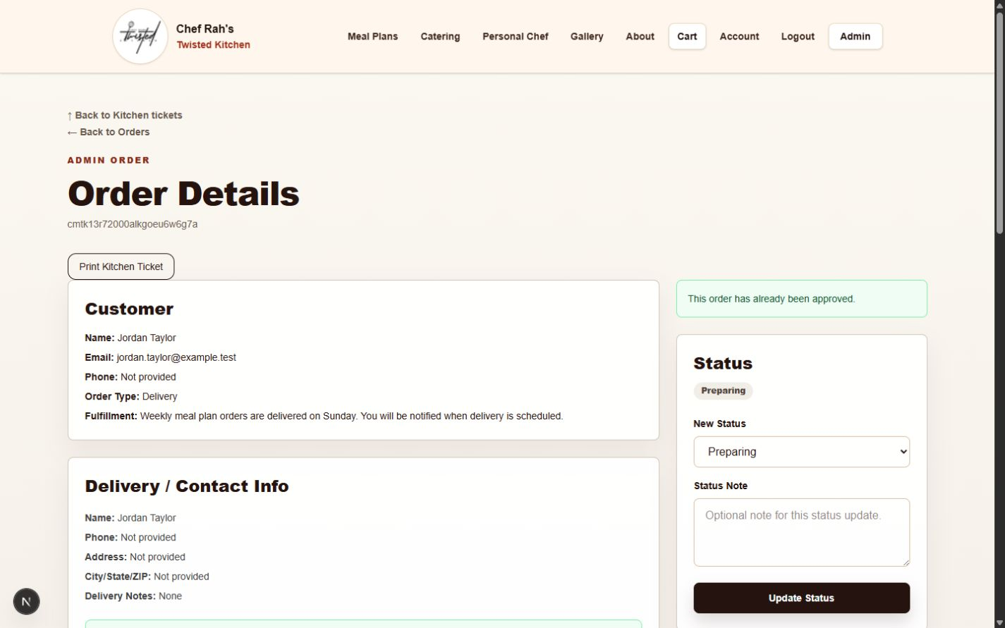
Order detail: customer, fulfillment, and status controls.
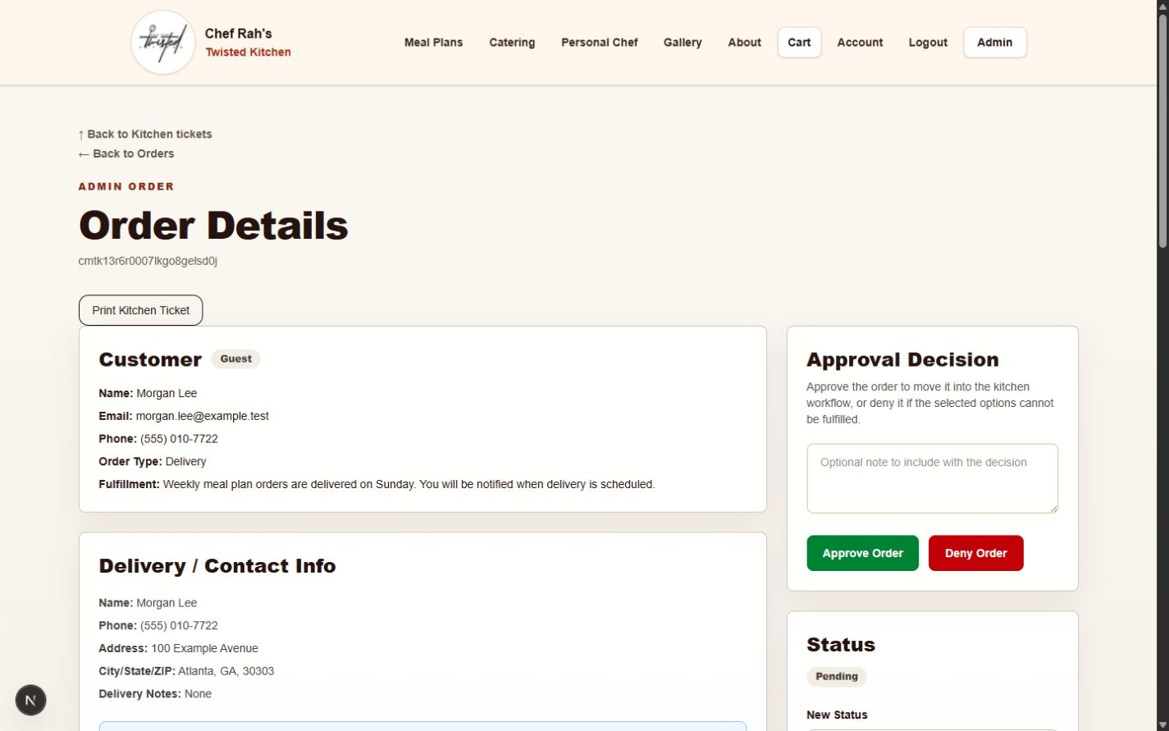
Approval decision controls appear only where the workflow requires them.
Payment authority: Square and the payment ledger are the receipt/reconciliation sources. Never create a second charge because a status is temporarily pending.

5. Kitchen view and fulfillment
Kitchen View turns approved work into a focused preparation queue.
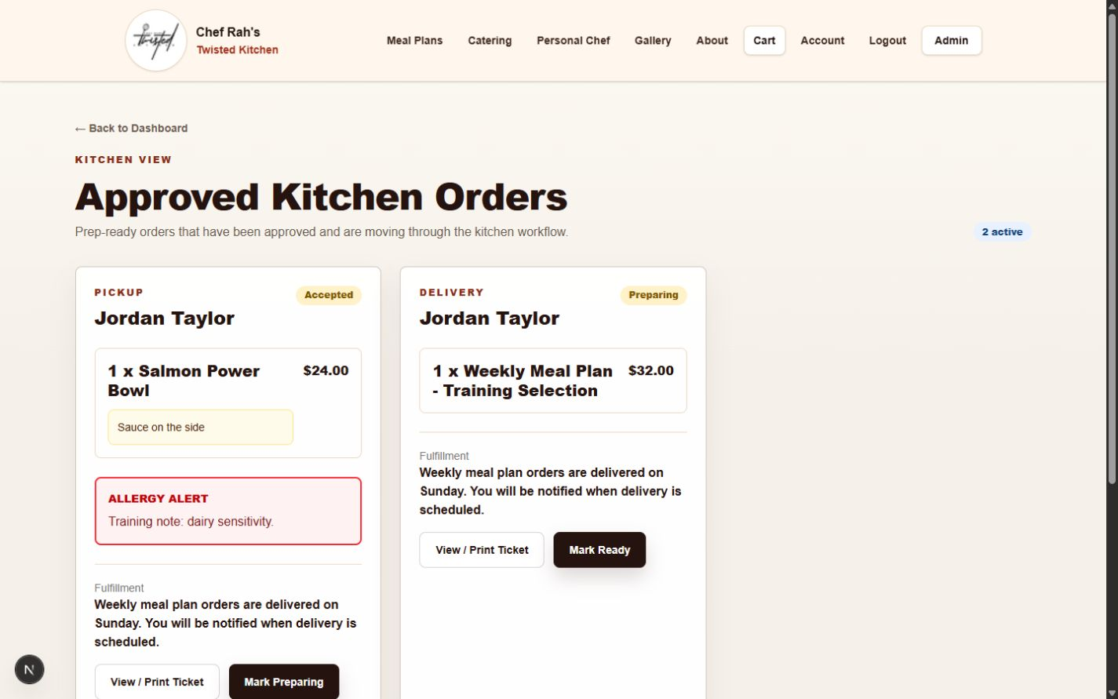
Approved Kitchen Orders groups prep-relevant order cards.

Safe status handling
- Read allergy and instruction warnings before preparation.
- Use View Order when details are abbreviated.
- Advance status only when the real work reaches that stage.
- Preparing or later affects normal refund eligibility; confirm before moving forward.
- Use Print Prep only on a trusted workstation and collect printed sheets promptly.

6. Catering and personal-chef requests
Service requests are approval-first leads. Submission does not automatically mean a paid or accepted booking.
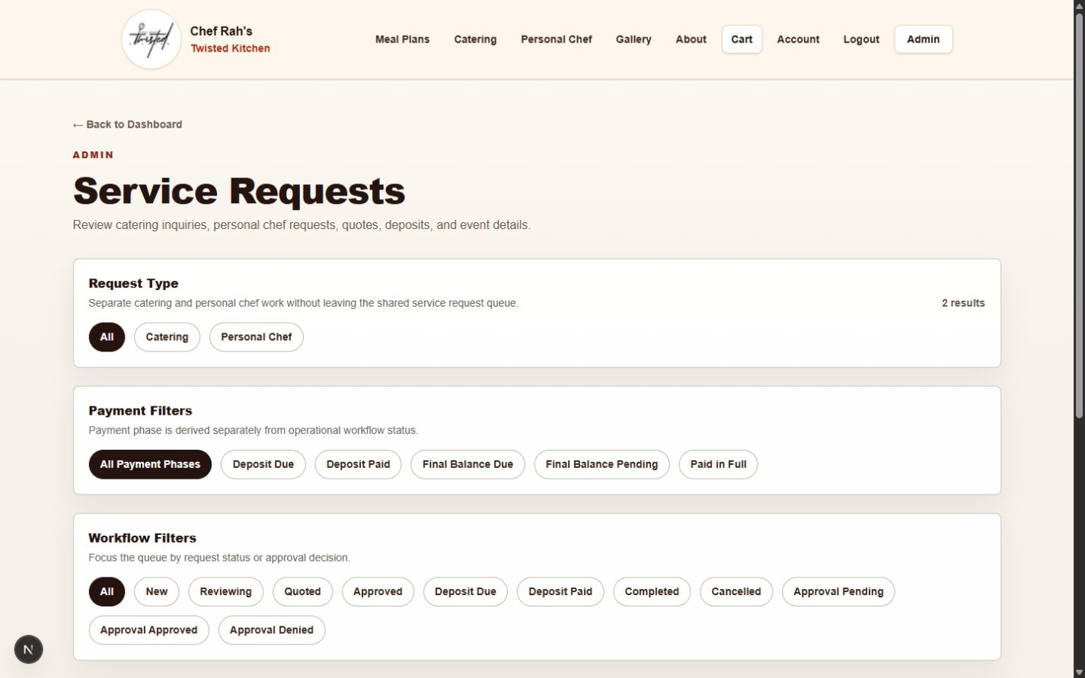
Service Requests filters catering and personal-chef leads.

Request review
1. Open the request and confirm contact information, event date, guest count, location, and notes.
2. Contact the customer if scope or timing is unclear.
3. Record a clear quote and internal status before approving.
4. Approve or deny according to owner policy.
5. Send a deposit or final-payment request only when the workflow is ready and the amount has been verified.
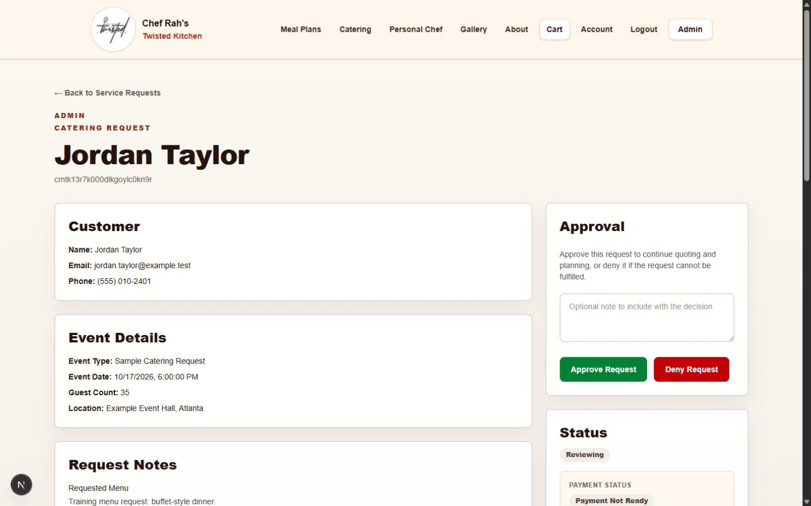
Service request detail centralizes event information and approval controls.
Do not duplicate links: If a payment request is pending, do not resend it just because the customer has not paid. Review the active attempt first.

7. Standard menu management
The Menu Manager controls customer-visible meals, categories, availability, approval requirements, instructions, allergens, and options.
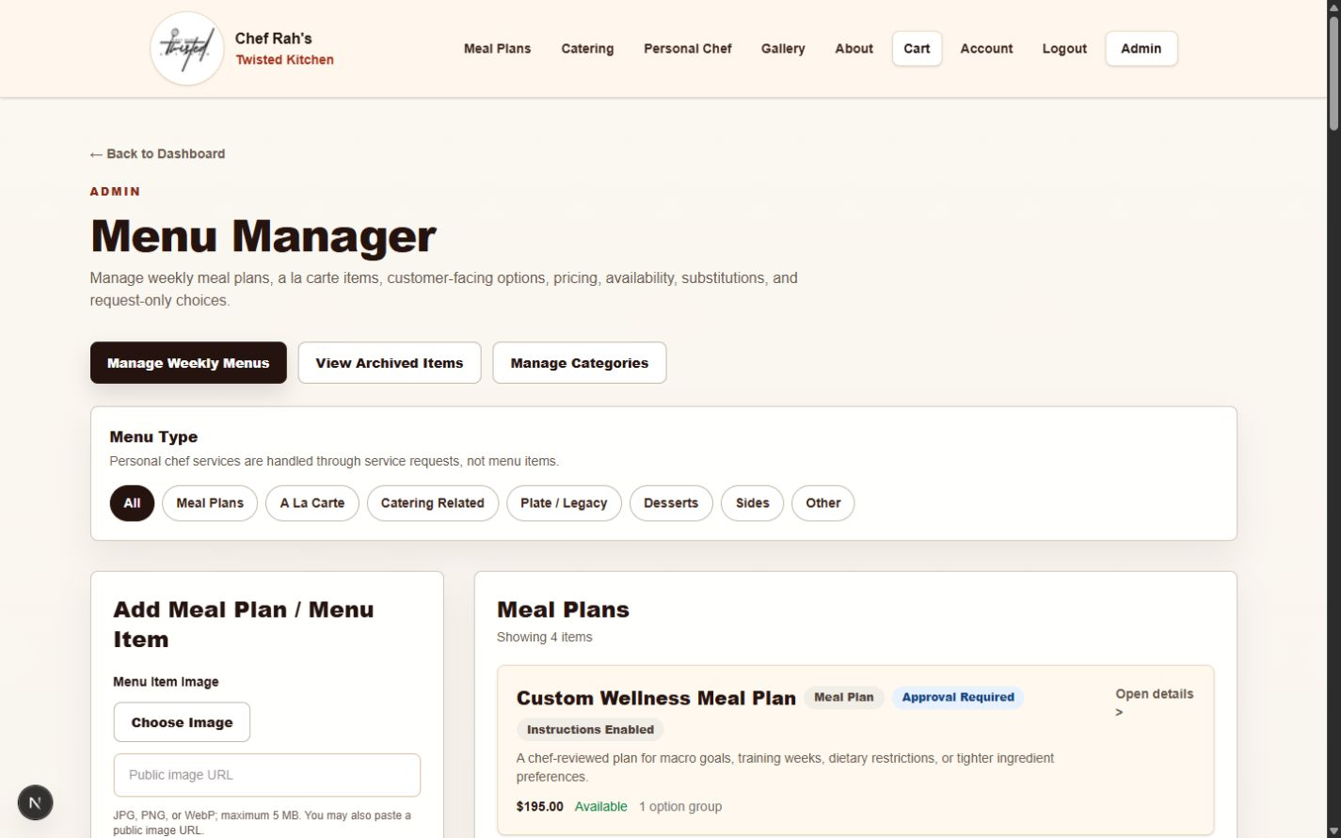
Menu Manager overview with category filters and item cards.

Create or edit an item
1. Choose a clear customer-facing name and short description.
2. Set the trusted base price and category.
3. Choose availability and seasonal visibility intentionally.
4. Use approval-required for items that should not charge immediately.
5. Configure instruction, allergen, and option groups carefully.
6. Preview the public menu after saving.
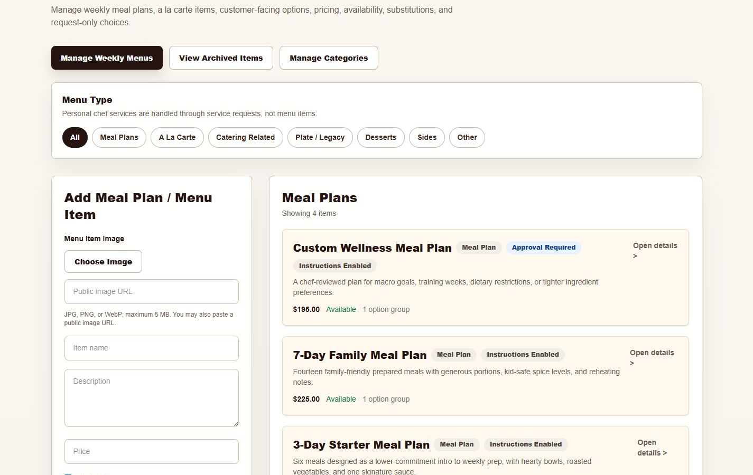
Menu item editor and the first portion of the current catalog.

Before publishing
Done | Check
☐ | Name and description are customer-ready
☐ | Price and upcharges verified
☐ | Allergens and options reviewed
☐ | Approval requirement correct
☐ | Image and category correct
☐ | Public menu preview checked

Archive versus delete
- Archive hides an item from normal selling while preserving it for possible restoration.
- Restore returns an archived item to management; verify availability before customers can buy it.
- Permanent Delete is irreversible in normal administration. Use it only when the owner has confirmed the item and its history no longer need the managed record.
Caution: Prefer Archive when there is any chance the item may return. Review the exact item before using Permanent Delete.

8. Weekly meal plans
Weekly menus combine a selling period, capacity, packages, slot labels, and eligible offerings. Publishing makes an offering customer-visible.
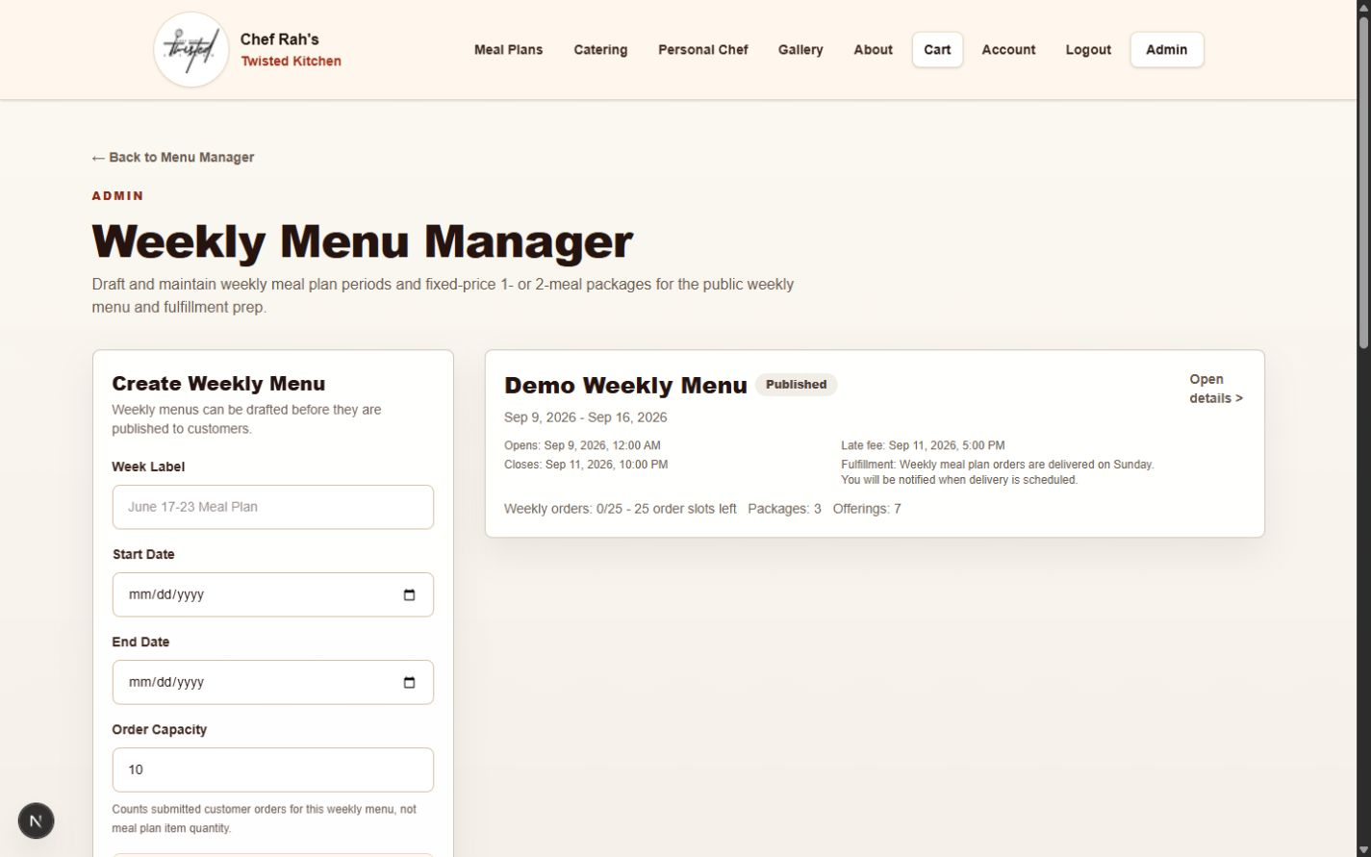
Weekly Menu Manager overview and current training period.

Weekly workflow
1. Create the weekly period and confirm open, late-fee, close, and fulfillment timing.
2. Set realistic order capacity.
3. Create packages with complete names, prices, days, meals per day, and approval rules.
4. Use admin-configured slot labels that make sense to the customer.
5. Add eligible offerings and review Breakfast versus Standard labels.
6. Preview all required selections, allergens, and option upcharges.
7. Publish only after a complete customer preflight.
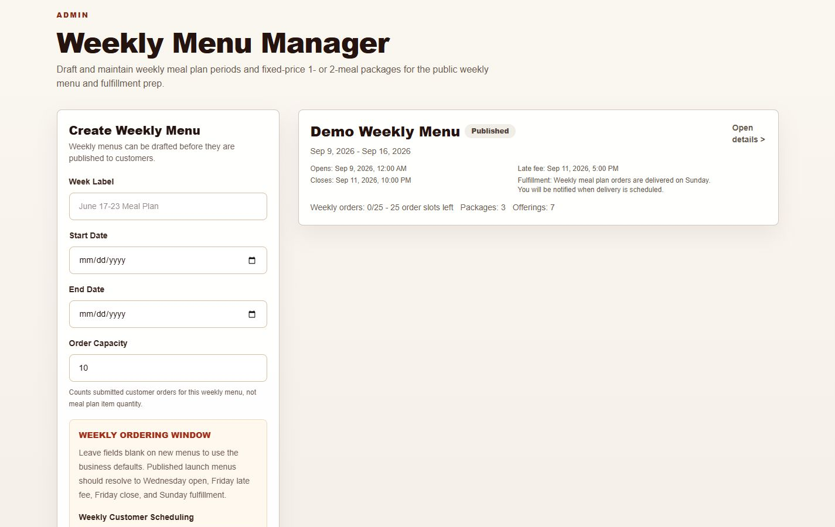
Weekly period creation and published-period summary.
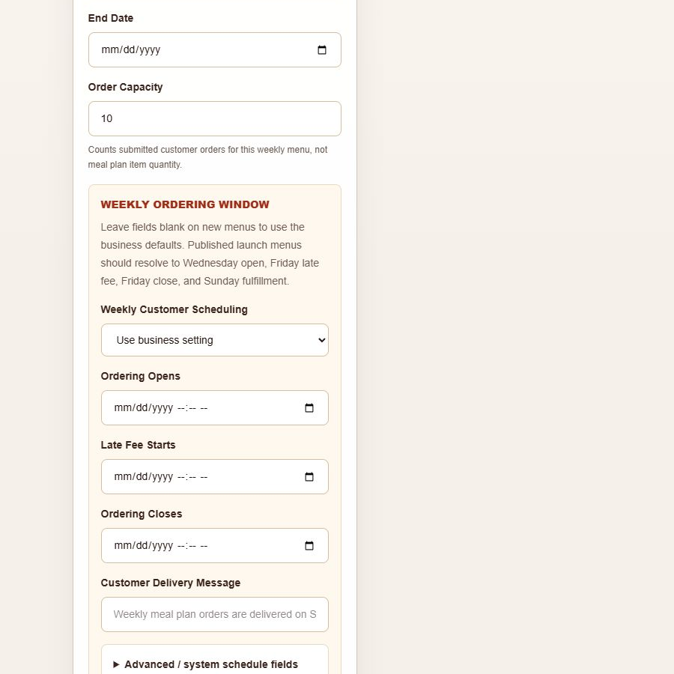
Weekly scheduling fields inherit business defaults unless specifically overridden.
Approval-first packages: By-request weekly packages must show Submit for Approval and must not show card fields until approved and a payment request is intentionally sent.

9. Gallery management
Gallery Manager is the current source of truth for the public gallery. Categories use “Meal Plans,” not “Meal Prep.”
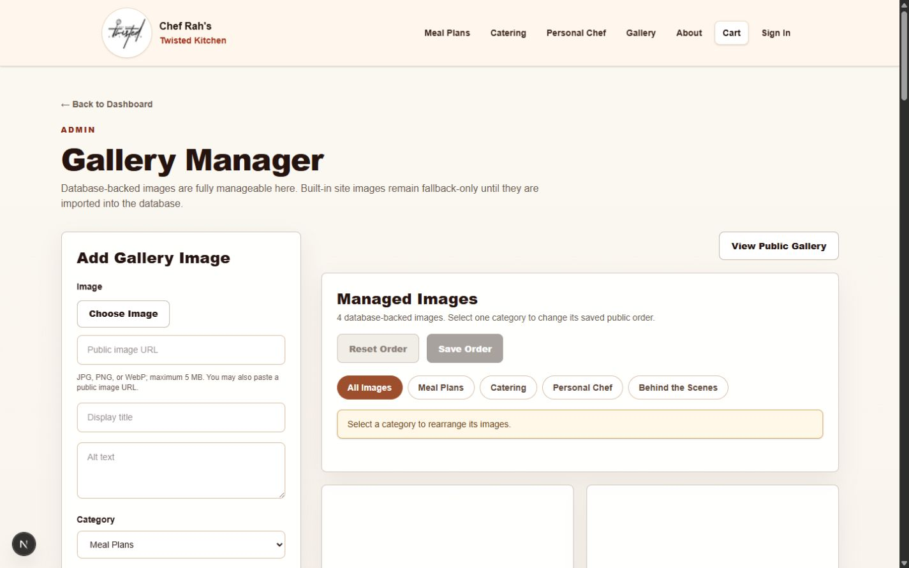
Gallery Manager add form, filters, and ordering controls.

Add or edit an image
1. Choose an approved JPG, PNG, or WebP image.
2. Use a short title and descriptive alt text.
3. Choose the correct category.
4. Save, then open View Public Gallery to verify cropping and context.

Reorder safely
1. Choose a category or All Images.
2. Drag cards into the desired order.
3. Select Save Order. Use Reset only to discard unsaved movement.
4. Verify the public gallery.
- All Images is for review and cannot be rearranged; choose one category first.
- Dragging changes only the working arrangement until Save Order is selected.
- New images appear at the end of their category. Moving an image to another category also places it at the end.
- Keyboard: focus the move handle, press Space or Enter to pick up the image, use the arrow keys to move it, then press Space or Enter to place it. Press Escape to cancel.

10. Customers
Customer records help support orders, service requests, and account activity without exposing payment credentials.
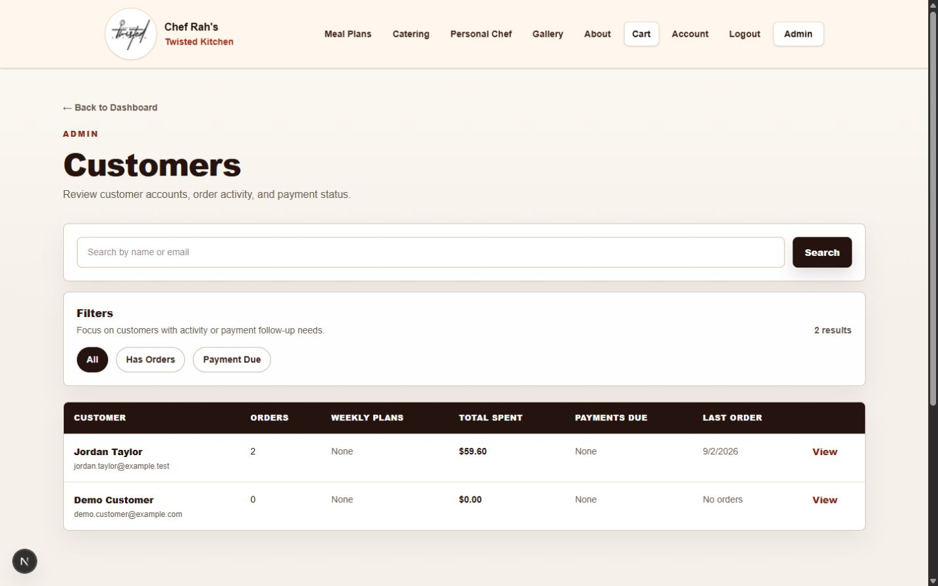
Customer search and summary list.

Customer support guardrails
- Verify identity before discussing an order.
- Use the order or request record for fulfillment details.
- Do not store card data or passwords in notes.
- Escalate account ownership or unusual payment issues to the owner.
- Treat exports as confidential business records.

11. Payments and reconciliation
Payment Management compares the website ledger with provider status. Square remains the official customer receipt source.
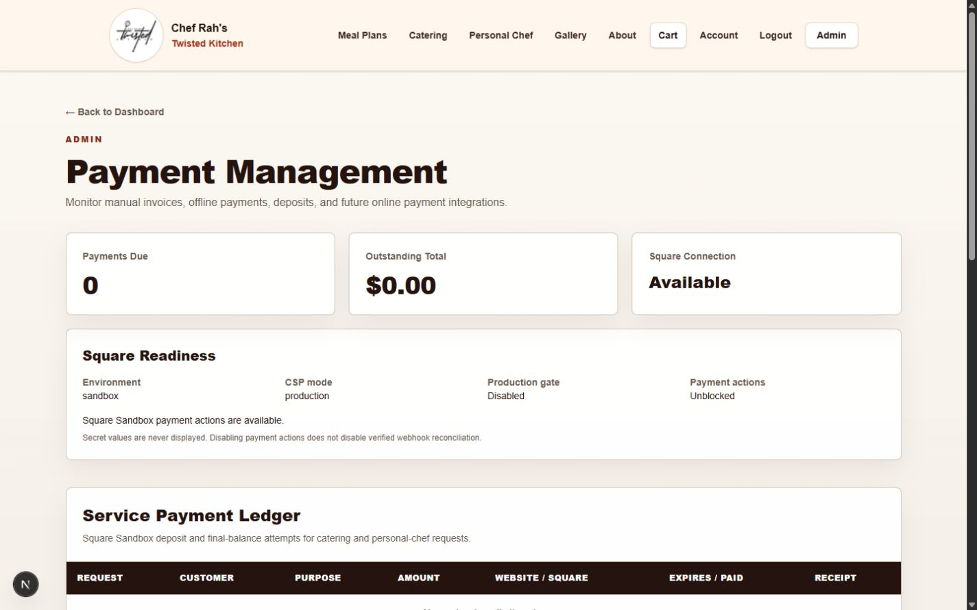
Payment Management readiness and ledger overview.

Daily reconciliation
1. Review payments due and mismatch warnings.
2. Match order, amount, website status, provider status, and paid time.
3. Open the related order or request when context is needed.
4. If a status is pending, allow the payment confirmation process to complete before taking another payment action.
5. Record and escalate a real mismatch; do not manually invent provider confirmation.

Refunds
- The normal policy is a full refund within 24 hours unless fulfilled or service work has started.
- Preparing or later blocks the normal refund action.
- A refund can remain Pending while Square finishes processing.
- Do not issue another refund while one is pending.
- Close the task only after completed provider status and no reconciliation mismatch.

12. Reports
Business Insights provides operational summaries for owner review and exports.
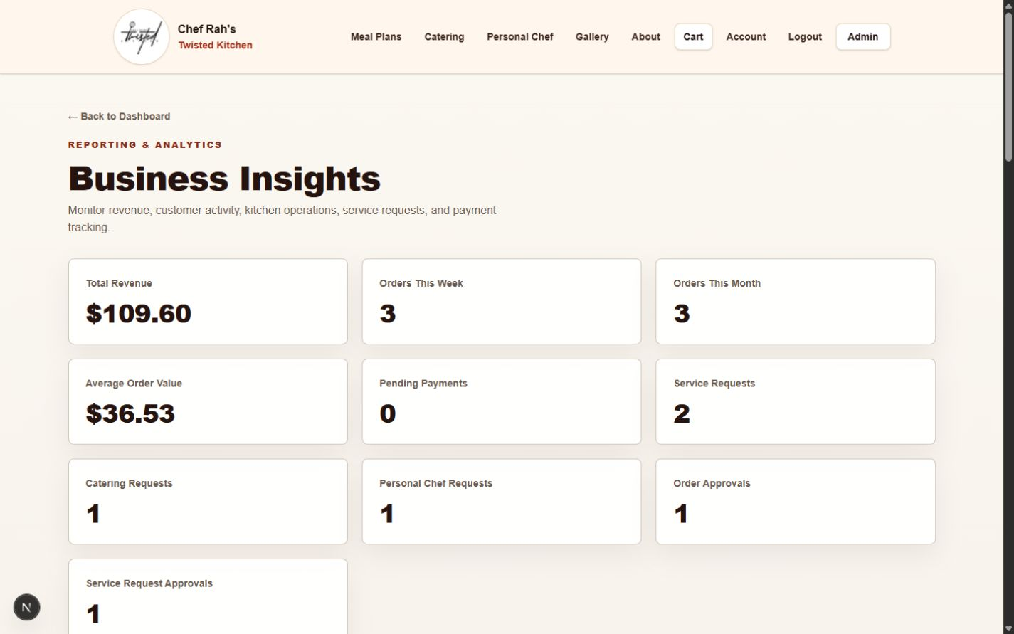
Business Insights summary cards.

Reporting habits
- Choose a consistent reporting period.
- Compare summary figures with the underlying filtered records when a number looks unexpected.
- Store downloaded reports securely.
- Remember that pending, refunded, and approval-first work may belong to different operational categories.
- Use exports for analysis; do not edit exports and treat them as the system record.

13. Notifications and email
Notifications shows which customer and admin messages are active and highlights operational follow-up.
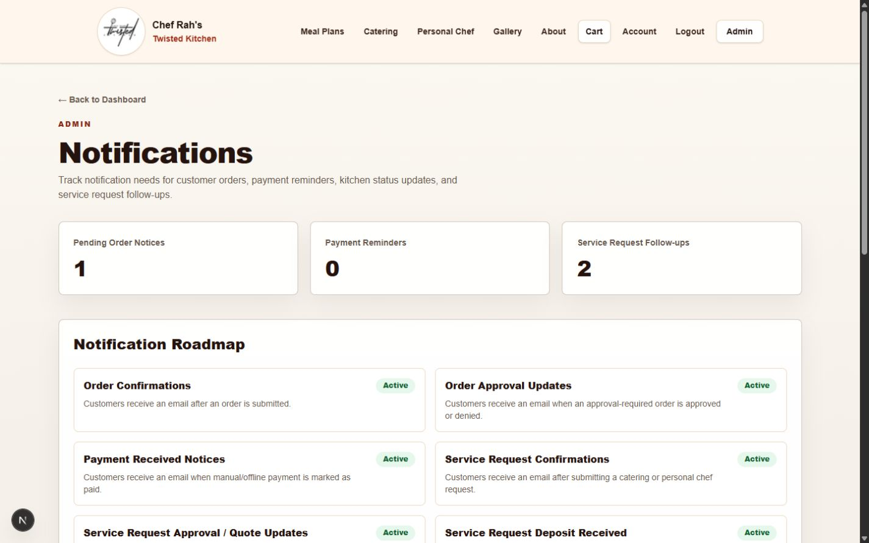
Notifications overview and message roadmap.

When email is missing
1. Confirm the email address on the order or request.
2. Check whether the relevant notification is listed as active.
3. Ask the recipient to check spam and filtered folders.
4. Review the order/payment state before resending a payment request.
5. Escalate persistent delivery issues with the record ID and approximate time—never with secrets.

14. Business settings
Business Settings controls operational rules shown to customers and used by server-authoritative calculations.
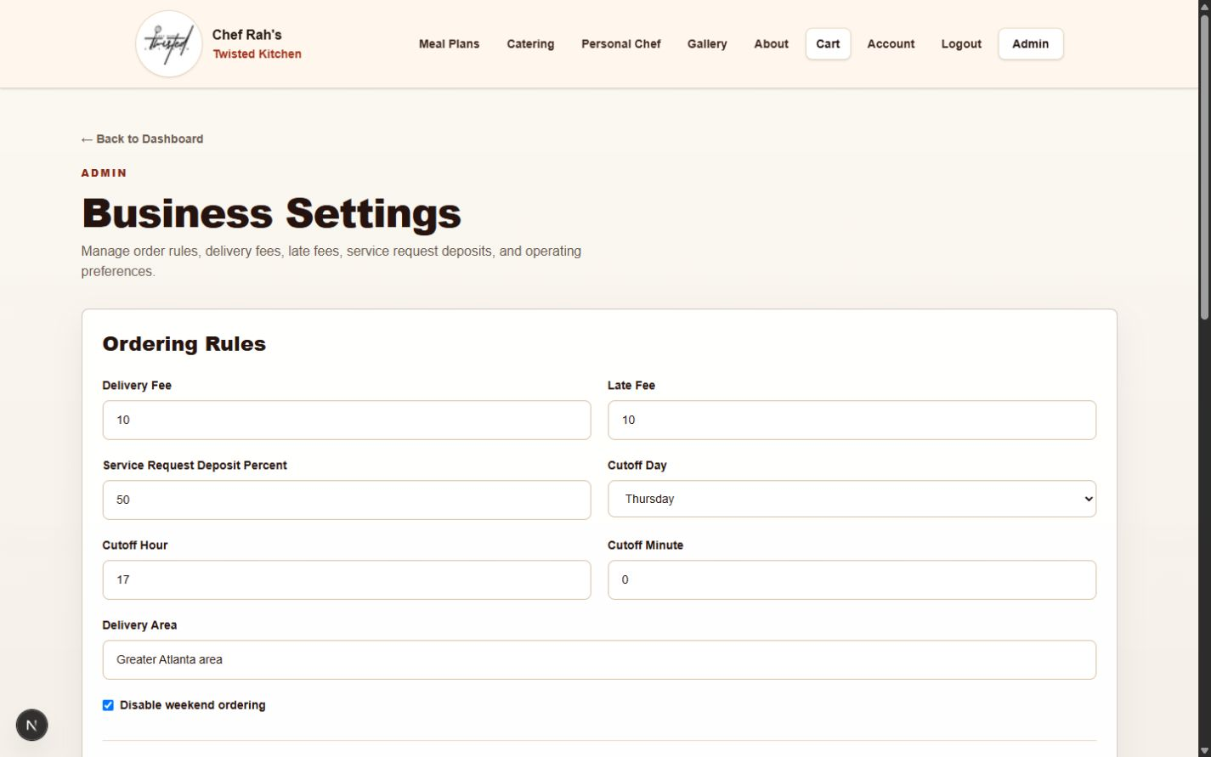
Business Settings ordering rules.

High-impact settings
- Delivery fee and late fee.
- Ordering cutoff day and time.
- Weekend ordering behavior.
- Service-request deposit percentage.
- Customer-facing scheduling and policy copy where supported.
Done | Check
☐ | Write down the intended value before editing
☐ | Confirm the business owner approved the change
☐ | Save once and verify the success state
☐ | Check the customer-facing page
☐ | Run a non-payment preflight when totals or timing are affected
Authority: Public policy copy reflects current settings, but checkout/server calculations remain authoritative.

15. Role manager and owner controls
Role Manager is sensitive. A mistaken change can expose admin tools or lock out the business owner.
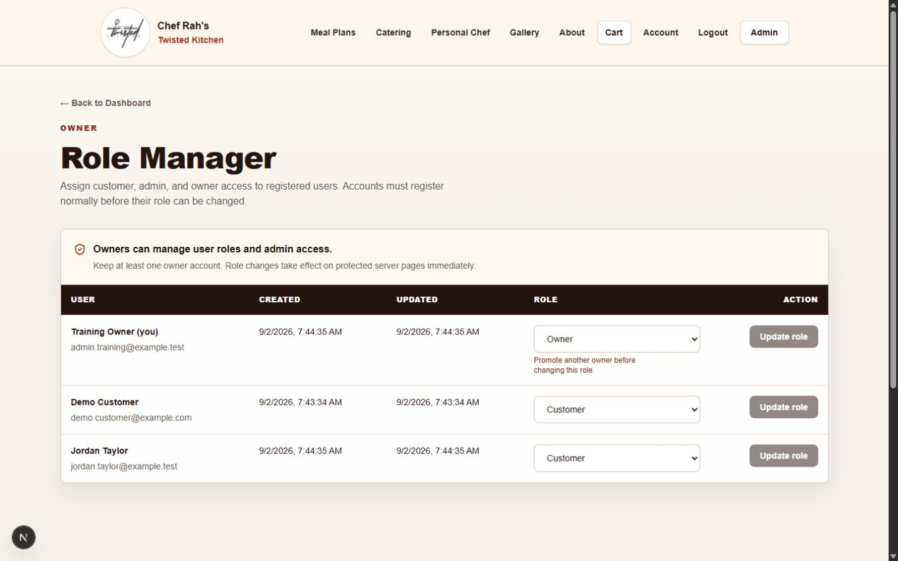
Role Manager lists accounts and authorized role controls.

Change a role safely
1. Confirm the person and business need outside the application.
2. Select the least-privileged appropriate role.
3. Save once and read the resulting status.
4. Ask the user to sign out and back in.
5. Review the Audit Log.
Owner protection: Do not remove the last working owner account. Setup/bootstrap features should remain disabled unless the technical owner intentionally enables them for a controlled recovery.

16. Publishing, launch hold, and go-live
Production payments can remain technically available while purchasing is held through unpublished menu and weekly content.

Launch-hold mode
- Unpublish or remove standard items that are not intentionally sellable.
- Keep weekly offerings draft/unpublished until final approval.
- Review by-request packages separately.
- Service-request forms may stay live if lead collection is desired.
- Review active hosted payment requests separately; hiding menu content does not invalidate an already-created link.

Before publishing real content
Done | Check
☐ | Names, descriptions, prices, allergens, and options approved
☐ | Weekly package names, prices, slots, and offerings approved
☐ | Delivery and late-fee settings confirmed
☐ | Payment readiness intentionally confirmed
☐ | Public menu, cart, and checkout preflight completed
☐ | Admin payments monitored after publishing
Active links: Do not send or resend a hosted payment request unless payment is intended. Use existing expiration and stale-link handling when a link is no longer valid.

17. Troubleshooting and escalation
Pause when the safe next action is unclear. Most operational mistakes become worse when the same payment, approval, or publish action is repeated.
Situation | Safe response
A save appears unchanged | Refresh once, reopen the record, and verify the displayed value before saving again.
Customer cannot see an item | Check availability, published status, weekly period, category, and required configuration.
Payment is pending | Wait for provider completion; review the ledger and provider dashboard. Do not charge again.
Payment mismatch warning | Compare order amount and statuses, then escalate with IDs and time—not credentials.
Hosted link is unavailable | Check the attempt; let stale-link handling invalidate it before creating a replacement.
Email was not received | Verify address and status, check spam, then escalate with event time.
Admin control is missing | Confirm the user’s role and sign-in session. Do not share an owner login.
Page error persists | Capture a sanitized screenshot, URL, time, and exact steps; contact technical support.

Escalation package
- What you were trying to do.
- Page name and approximate time.
- Order/request/payment ID if relevant.
- Sanitized screenshot with private customer details hidden.
- What happened and what you expected.
- Whether you already refreshed or repeated an action.
Contact Support: Contact Recon Dev LLC through your usual support channel for server errors, repeated payment records, website/Square disagreement, access failures affecting multiple people, suspected unauthorized access, hosting or credential changes, or repeated email-delivery failures.

18. Daily and weekly checklists
These compact routines reduce missed approvals, duplicate actions, and accidental publishing.

Daily open
Done | Check
☐ | Pending orders and approvals reviewed
☐ | Kitchen queue reviewed
☐ | Service requests reviewed
☐ | Payments due/mismatches reviewed
☐ | Capacity and timing checked

Daily close
Done | Check
☐ | Statuses match real work
☐ | Completed provider payments reconcile
☐ | Pending refunds left alone and monitored
☐ | Next-day prep reviewed
☐ | Sensitive downloads stored or removed safely

Weekly content cycle
Done | Check
☐ | Menu availability reflects what can actually be sold
☐ | Weekly period and schedule verified
☐ | Packages and offerings proofread
☐ | Prices/upcharges/allergens verified
☐ | Customer menu/cart/checkout preflight completed
☐ | Launch-hold state intentionally confirmed

Support contacts
Business owner: ______________________________
Technical support: ____________________________
Payment/provider escalation owner: ______________
Email delivery escalation owner: _________________
Primary website: https://rahstwistedkitchen.com

Appendix: friendly reference
Reference | Meaning
Order flow | New → Approval when required → Payment → Accepted → Preparing → Ready → Out for Delivery when applicable → Completed
Service flow | New request → Review and quote → Approval → Deposit when required → Service work → Final payment → Completed after the service is finished
Payment labels | Paid: confirmed. Payment Due: action needed. Payment Pending: still processing. Refunded: completed refund. Expired: payment window ended. Reconciliation warning: website and provider need review.
Admin versus Owner | Admins manage routine operations. Owners additionally control roles and high-impact decisions.
Archive versus Delete | Archive is reversible. Permanent Delete is not a routine substitute for Archive.
Safe action | Refresh once, reopen the record, verify current state, then act once.
Contact Support | Stop and contact Recon Dev LLC when payment records disagree, errors repeat, access broadly fails, or a technical configuration change is required.
End of handbook • Version 1.0 • September 2026

