Kissan Buddy-An Android Application for Estimating

the Nearest Mandi and Transaction Costs for Farmers

KV Achyuth Reddy1, Lochan S2, Dr. M Swapna3, Shrusthi4, Ediga Purushotham Goud5

1,2,4,5 Student, Computer Science Engineering and Block Chain, Presidency University , Bengaluru,

3Associate Professor , Computer Science Engineering , Presidency University, Bengaluru.

**Abstract:**

**Kissan Buddy is an Android application developed to assist farmers in accessing real-time information about nearby mandis (agricultural markets) where they can sell their produce at optimal prices. The app utilizes Google Maps for accurate location services and Firebase for backend support, enabling farmers to input essential details such as their location, types of crops, and expected production costs. Based on this input, the application identifies the nearest mandis and estimates the transaction costs involved in selling the produce. This empowers The application uses advanced technologies such as Firebase, Google Maps, and cloud computing to offer farmers an intuitive platform where they can track their location, manage crops, and estimate nearby mandis (markets) where they can sell their produce, ensuring better price transparency and reducing reliance on middlemen. Key features of the app include location-based mandi search, real-time price estimation, and detailed transaction cost analysis. By improving market access, optimizing pricing transparency, and minimizing costs, Kissan Buddy aims to enhance profit margins for farmers and contribute to a more efficient and sustainable agricultural economy.**

**Keywords[ Android application, Kissan Buddy ,Google maps api,Firebase Backend,Real Time Market prices, Transaction Cost Estimation ,Mandi Location Services,Mobile Based Solutions,Price Discovery,Rural Market Accessibility].**

I.INTRODUCTION

Farmers, particularly those in rural areas, face significant challenges when it comes to selling their produce. Issues such as high transaction costs, limited access to market information, and the involvement of middlemen who often exploit their lack of knowledge make it difficult for farmers to maximize profits. Additionally, farmers may not always be aware of the nearest mandis or may be unaware of the most lucrative market in their vicinity, resulting in underpricing of their crops. In many cases, without real-time information, farmers are compelled to sell their products at lower prices, sometimes far from their location, to meet their immediate cash needs. Mobile technology has been instrumental in bridging the information gap in various sectors, and the agricultural domain is no exception By integrating Google Maps, Firebase, and other cutting-edge technologies, the app offers a solution to help farmers determine the nearest mandi and estimate transaction costs, facilitating easier and more profitable crop sales. This application helps optimize market access, minimize transportation costs, and increase profitability by ensuring that farmers sell their produce at the best possible prices.

One of the most significant issues in agriculture today is the inefficiency of traditional supply chains. Farmers frequently struggle with price volatility, which makes it difficult to plan their finances and achieve optimal profits. Furthermore, farmers often have little to no information on where to sell their produce for the best prices or how to reduce transportation costs. Many farmers either sell their produce locally at lower prices or are forced to travel long distances, which incurs high transportation costs, further reducing their margins. The advent of mobile technology and applications, especially smartphones, has presented a significant opportunity to address these challenges. By integrating features like GPS-based location services and cost estimation algorithms, mobile applications can streamline the process of connecting farmers to the market, making it more transparent and efficient In response to these issues, *Kissan Buddy* was developed as a mobile application aimed at supporting farmers by leveraging cutting-edge technologies such as Google Maps, Firebase, and cloud computing. The application offers farmers a platform to manage their crops, track their production, and estimate the nearest mandis for selling their produce. It also provides an estimate of transaction costs, including transportation and handling, helping farmers make informed decisions about where to sell their crops to maximize profit. The main objective of *Kissan Buddy* is to empower farmers by reducing market inefficiencies and providing them with tools that ensure they get the best possible prices for their crops with minimal logistical costs.

Kissan Buddy is an app designed for Android devices that addresses these issues by providing farmers with relevant market information, a cost estimator, and an option to make more determined conclusion about venues for selling agricultural products. The app helps optimize market access, minimize transportation costs, and increase profitability by ensuring that farmers sell their produce at the best possible prices. Mobile technology has been instrumental in bridging the information gap in various sectors has been implemented.

II. LITERATURE SURVEY

The use of mobile applications to assist farmers with market linkages has garnered attention in recent years. Several studies have explored how digital tools can help farmers make better decisions in terms of crop pricing and market selection.

**Mobile Applications for Agricultural Market Access**:

A research conducted by Poonia et al. (2020) suggests that mobile platforms can help overcome market access challenges for farmers by offering real-time pricing details and linking them to local markets.This helps farmers make informed choices on when and where to sell their crops, potentially increasing their profitability.

**Google Maps in Agriculture**: Patel et al. (2021) discuss the use of Google Maps in helping farmers locate mandis and agricultural resources. Google Maps has been a useful tool in navigating rural areas, where farmers may otherwise struggle to find accurate and timely information. By integrating this functionality into an application, farmers can save time and reduce the stress of searching for the right mandi.

**Transaction Cost Analysis**: Mishra et al. (2019) have shown that transaction costs, including transportation, commission fees, and other operational costs, play a vital role in determining the profitability of agricultural sales. They emphasize the need for a tool that can accurately estimate these costs and assist farmers in making decisions that minimize financial losses. While various apps provide market prices, very few incorporate comprehensive transaction cost estimations, which is a major gap that the proposed app intends to fill.

This review highlights the growing need for integrated solutions that not only provide market access but also calculate transaction costs, which the proposed app directly addresses.

In recent years, the agricultural sector has seen significant growth in technology adoption, particularly mobile applications and digital platforms aimed at improving market access, crop management, and overall efficiency. Various agricultural apps and platforms have emerged to support farmers in making informed decisions regarding their production and sales. Below, we provide a detailed analysis of key technological solutions in the agricultural domain, discussing their impact, strengths, and weaknesses. This literature review will explore applications designed for market accessibility, crop management, financial solutions, and location-based services, with a focus on how they address the challenges faced by farmers.

**2.1. Agricultural Market Access and Price Discovery App**s:

One of the most pressing issues for farmers is the lack of access to timely and accurate market prices. Price volatility in agricultural markets is a widespread problem, leading to farmers either underselling their produce or having to bear high costs for transportation in search of better prices.

**eNAM (National Agriculture Market)**

**Overview**: *eNAM* is a government initiative launched by the Ministry of Agriculture and Farmers Welfare of India, aimed at transforming agricultural markets by creating a pan-India electronic trading platform. It allows farmers to access real-time market prices, track demand and supply trends, and participate in online auctions.

**Strengths**: *eNAM* offers farmers the ability to access transparent pricing from multiple mandis (markets) across the country, ensuring better price discovery. Additionally, it supports a national network of traders, making it easier for farmers to connect with buyers.

**Weaknesses**: While *eNAM* provides essential market data, it lacks location-based features that help farmers find nearby mandis or estimate transportation costs. Furthermore, farmers often face challenges in navigating the platform, particularly in rural areas with low technological literacy.

**Kisan Suvidha App**

**Overview**: Developed by the Ministry of Agriculture and Farmers Welfare, the *Kisan Suvidha* app provides various services, including weather updates, market prices, expert advice, and information on agricultural schemes and subsidies.

**Strengths**: The app helps farmers stay informed about weather conditions and market prices, which are crucial for making decisions about when to sell crops. It also offers government notifications on subsidies and schemes.

**Weaknesses**: The app's focus is more on general agricultural advice rather than specific tools for market transactions or price optimization. Furthermore, it does not provide location-based mandi suggestions or cost estimations for farmers to compare selling options.

**AgriBazaar**

**Overview**: *AgriBazaar* is an online platform that connects farmers with buyers, traders, and agri-businesses. It facilitates the sale of agricultural produce, reducing the reliance on intermediaries.

**Strengths**: The platform offers an online marketplace where farmers can list their produce and negotiate prices with potential buyers directly. It also provides value-added services like packaging, logistics, and payment security.

**Weaknesses**: While it simplifies the selling process, *AgriBazaar* still requires farmers to manually assess the best markets or mandi options, making it less efficient for those seeking immediate or location-based solutions.

**2.2. Crop Management Apps**

Crop management apps aim to assist farmers in improving productivity and managing their agricultural activities effectively. These apps typically provide features such as crop scheduling, pest management, irrigation management, and disease prediction. However, they often lack market-related functionalities like price discovery and transaction cost estimation.

**AgriApp**

**Overview**: *AgriApp* is a mobile app that helps farmers manage their crops by offering advice on inputs (seeds, fertilizers, etc.), crop protection, irrigation, and pest control.

**Strengths**: It provides actionable advice on crop management, ensuring that farmers can improve yields and optimize their farming practices. The app also connects farmers with agri-input suppliers, streamlining the purchase of essential farming materials.

**Weaknesses**: While *AgriApp* contributes to productivity improvements, it does not focus on market-related aspects, such as providing market price information or facilitating crop sales.

**FarmLogs**

**Overview**: *FarmLogs* is a crop management platform that helps farmers track their operations and yields using field-level data, including weather forecasts, crop performance metrics, and inputs used.

**Strengths**: It provides farmers with comprehensive data analysis and insights to optimize their farming practices, helping them increase crop productivity.

**Weaknesses**: Like *AgriApp*, *FarmLogs* primarily focuses on farm management and lacks market connectivity, price discovery, or cost optimization features that are essential for farmers looking to sell their crops at competitive prices.

**CropIn**

**Overview**: *CropIn* offers a cloud-based platform that provides precision farming solutions, enabling farmers to track their crops through satellite data, weather patterns, and crop health indicators.

**Strengths**: It offers advanced data analytics and AI-based insights that allow farmers to optimize farming practices and improve yields. The platform also integrates with supply chain management, which helps in optimizing post-harvest operations.

**Weaknesses**: While *CropIn* focuses heavily on farming and productivity, it lacks tools for farmers to access market data or compare prices between different mandis. Its primary focus is on farm operations, making it less effective for farmers seeking market access solutions.

**2.3. Location-Based Agricultural Solutions**

The integration of location-based services, particularly GPS and mapping technologies, has revolutionized how farmers can access relevant information about local resources, input suppliers, and nearby mandis for selling produce.

**AgroStar**

**Overview:** AgroStar is a mobile platform that provides a range of agricultural solutions, from input sourcing to advice on crop management. It also offers location-based services to help farmers find nearby suppliers and services.

**Strengths**: The app provides a one-stop solution for farming needs, integrating location-based services to connect farmers with nearby agri-input suppliers. The platform also supports the purchase of inputs, which streamlines the farm-to-market process.

**Weaknesses:** However, AgroStar still does not provide direct solutions for price discovery, mandi estimates, or transaction cost calculations, which are crucial for farmers when selling their produce.

**Farmers Friend**

**Overview:** Farmers Friend uses GPS technology to provide nearby agricultural services, including farm equipment rentals, pesticide spraying services, and suppliers of agricultural products. It helps farmers connect with local service providers.

**Strengths:** The app’s location-based features offer practical services for farmers, particularly those in remote regions who need equipment or inputs for farming operations.

**Weaknesses:** While Farmers Friend is useful for providing farm-related services, it does not provide the necessary tools to estimate or compare prices from nearby mandis, thus limiting its usefulness for selling crops.

2.4. Financial and Transaction Management Apps

In addition to market access and crop management, financial apps that help farmers manage income, expenditures, and transactions are becoming increasingly popular. These apps aim to simplify payments, track earnings, and assist with budgeting.

**Bharat Krishak Samaj (BKS)**

**Overview:** The BKS app offers a suite of services to farmers, including weather forecasts, crop guidance, market prices, and financial tools to manage transactions and budget farm-related expenses.

**Strengths:** The app provides financial tools and market updates, which are useful for managing farming costs. It also offers price comparisons between different mandis.

**Weaknesses:** While it does offer price data and financial management tools, it lacks real-time mandi estimation and cost optimization features, which are vital for minimizing transportation costs.

**Rural India Online (RIO)**

**Overview:** RIO is a financial platform that offers services like crop insurance, loan applications, and financial planning tools for farmers. It also helps farmers with market price information.

**Strengths:** The app’s focus on financial services is valuable for farmers seeking loans or insurance to protect their crops.

**Weaknesses:** While RIO helps farmers manage finances, it does not integrate location-based services or transaction cost estimates, which are critical when farmers are deciding where to sell their crops.

2.5. Key Findings and Gaps

The literature reveals that while there are numerous apps aimed at addressing specific aspects of farming, there is a noticeable gap in applications that provide a complete solution for market access, price estimation, and cost optimization. Most existing apps focus on crop management, weather predictions, or financial planning but do not combine these features with real-time market data and transaction cost estimation, which are essential for a farmer's profitability. Kissan Buddy aims to fill this gap by integrating features such as location-based mandi estimation, real-time market prices, transaction cost analysis, and optimization tools. This app focuses not only on improving farm productivity but also on simplifying the decision-making process for farmers when it comes to selling their produce, ensuring they can make informed decisions based on comprehensive, real-time data. The integration of these functionalities makes Kissan Buddy a comprehensive solution for the modern farmer, enabling them to optimize both their production and selling processes, ultimately leading to better financial outcomes.

Most existing applications, such as *eNAM*, *AgriApp*, and *AgroStar*, offer valuable services but tend to focus either on crop management or market information separately. They often lack the seamless integration of features that could guide farmers in making cost-effective decisions regarding the sale of their produce. Moreover, while some apps do incorporate location-based services to help farmers find inputs or nearby services, they do not provide the necessary tools for identifying nearby mandis, estimating transportation costs, or comparing market prices efficiently.

The emergence of apps like *Kissan Buddy* that combine multiple functionalities — including location-based mandi estimation, real-time market price updates, and transaction cost analysis — addresses the key challenges farmers face today. By enabling farmers to access real-time market data and offering price comparison tools, *Kissan Buddy* enhances their decision-making, ensuring that they can sell their crops at the most favorable terms. This integration of features into a single platform has the potential to bridge the technological gap in the agricultural sector, helping farmers maximize their profits while reducing inefficiencies in the market.

Therefore, the literature suggests that while existing solutions have made strides in improving productivity and market connectivity for farmers, a comprehensive and integrated platform like *Kissan Buddy* could significantly enhance their ability to make informed, profitable decisions. The introduction of such a platform can potentially revolutionize how farmers interact with the agricultural market, fostering greater transparency, efficiency, and financial success in the farming community.

III. PROPOSED METHOD

Android application in this paper combines multiple elements to offer a comprehensive solution. for farmers looking to sell their crops. Below is a detailed description of the system's design, its block diagram, and the workflow involved in estimating the nearest mandi and transaction costs.

**BLOCK DIAGRAM:**

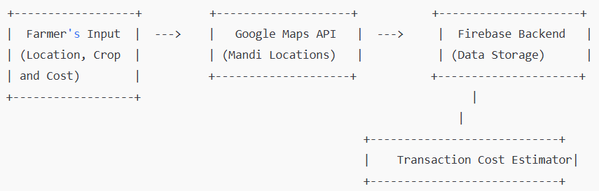

**Workflow:**

**User Input**: The first step involves the farmer entering basic information into the app, such as their current location, the crops they are producing, and the expected cost of production. This step is crucial for tailoring the app's results to the specific needs of the farmer. The cost of production can include factors such as seeds, fertilizers, labor, and other overheads, which are required for accurate profit estimation.

**Location Services (Google Maps API)**: Once the farmer inputs their data, the app uses the Google Maps API to determine the farmer’s geographical location. This location data is essential in finding the nearest mandis. Google Maps provides precise mapping, which ensures that the farmer is directed to the most accessible mandi, reducing travel time and costs.

**Mandi Estimation**: Using the location data, the app queries a database of mandis (stored in Firebase) to identify all available mandis in the vicinity. The app considers the proximity and geographical accessibility of these mandis, ensuring that farmers can reach the markets with the least amount of effort. The app then ranks the mandis based on distance and market size, taking into account the diversity of produce sold in each mandi.

**Transaction Cost Estimation**: Once mandis are identified, the app estimates the transaction costs for each market. The cost calculation factors in transportation fees, commission rates charged by mandis, and other hidden costs such as packaging and unloading fees. Firebase is used to store and manage historical data on mandi fees and transportation costs, which helps in calculating a realistic cost estimate. The app uses an algorithm that computes these values and presents a clear breakdown to the farmer.

**Result Display**: After the analysis, the app displays the results to the farmer, including a list of mandis with associated transaction costs. This helps the farmer make a decision based on both the price they can expect to receive for their produce and the costs they will incur in the process. The user interface (UI) of the app ensures that the results are presented in an easy-to-read format, with detailed cost breakdowns.

data is essential in finding the nearest mandis.

**Location Detection**: The app uses GPS data to detect the farmer’s location and provides real-time information on nearby mandis. The system can identify mandis within a specified radius based on the farmer's position.

**Crop and Cost Input**: Farmers input details about their crops, including type and quantity, and the estimated cost for each crop. This information is used to assess potential pricing at different mandis.

**Transaction Cost Estimation**: The app calculates transaction costs based on distance from the farmer's location to the mandi, transportation fees, and any other overheads associated with the market (such as commission or handling fees). A cost algorithm helps compare different mandis to find the most cost-effective choice.

**Market Recommendations:** The app ranks nearby mandis based on multiple criteria: crop prices, distance, and estimated transaction costs. Farmers are shown a list of the best mandis for selling their produce.

**Least Cost Transaction Calculation**: Using a cost-minimization model, the app computes the most economical transaction, factoring in the farmer’s location, crop type, and all associated expenses**.**

The application relies on a backend database containing market pricing, mandi information, and historical data to generate accurate recommendations. Additionally, machine learning algorithms can be incorporated to refine recommendations over time, enhancing the app's accuracy.

**Results and Discussions:**

Transaction Cost Estimation: The core strength of the app lies in its ability to estimate transaction costs accurately. Farmers are often unaware of the hidden costs involved in the sale of crops, and the app’s estimator can provide them with a comprehensive breakdown of these expenses. The estimated transaction cost includes:

Transportation Costs: The app uses the geographical distance between the farmer and each mandi to calculate transportation expenses. These costs may vary based on the mode of transportation (e.g., truck, bullock cart).

Commission Fees: The app integrates mandi commission rates into the transaction cost estimation. These fees can significantly reduce the farmer’s profits, and knowing the commission structure of different mandis can influence their choice.

Other Miscellaneous Costs: The app also considers minor costs like packaging, labor for loading and unloading, and potential toll fees.

Efficiency: The app enables farmers to make smarter, cost-efficient decisions by factoring in both proximity and transaction costs. This reduces the likelihood of farmers selling their crops at a lower price or incurring unnecessary expenses while traveling long distances to distant mandis.

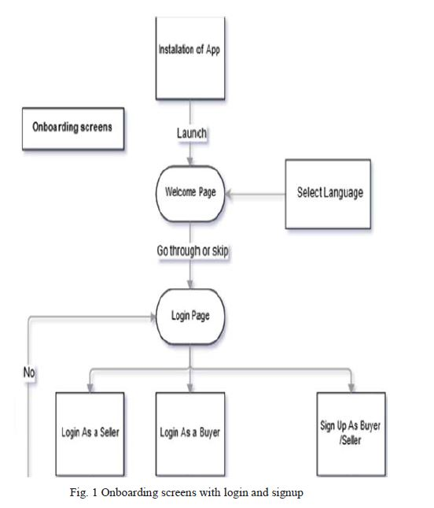

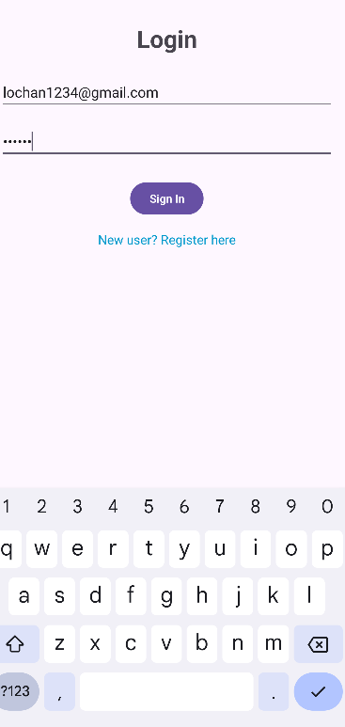

Output 1

The first step in the process is installing the mobile application. Upon opening the app, users are greeted with a language selection portal, which, as shown in Fig. 1, directs them to the login page. This page also includes an option to navigate to the SignUp portal. In the SignUp section, users can choose to register as either a buyer or a seller. For buyers, the required information includes shop details, personal details, and more. Sellers, on the other hand, need to provide personal information, as well as details about their crops and fields. The SignUp page is shown in Fig. 2. A key feature on both the buyer and seller registration forms is the "Availability of Transport" section. Here, users are asked whether they have access to transport. If they do, they must provide the transport details; if not, they can simply enter "No." This information is essential as it influences the pricing of the crops, as transportation costs can either be included or excluded based on the availability of transport.

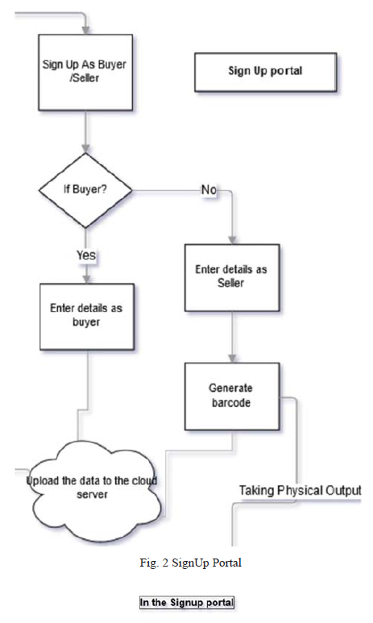

The signup portal is the first step for a farmer to access the features of the Kissan Buddy app. The portal requires farmers to provide essential information such as: Name, Location (via GPS or manual input),Contact details, Farm details (types of crops, area of cultivation, etc.).Upon completing the signup, the farmer’s account is created in the system, and they can proceed to login .

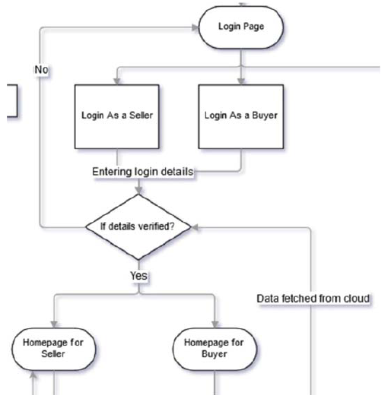

Fig.3 Login Portal

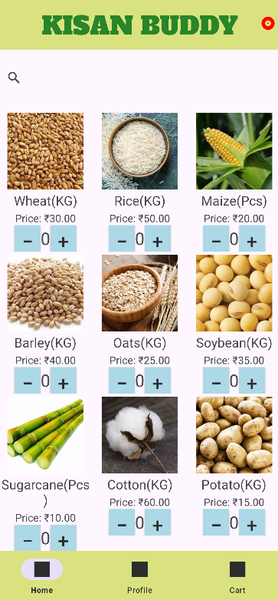

After registering on the app, users will be redirected to the login screen, where they can enter their credentials. The information provided will be matched with the data in the system, and once confirmed, users will be directed to their personalized homepage. Sellers can use their **homepage** to create product listings, while buyers can browse available offerings. Both types of users will also have access to a news feed with updates related to local crops. Furthermore, contact details for customer support are available on the homepage, as shown in Fig. 4.

Within the filter section, users can set specific criteria before choosing their products and buyers. Common filters include crop type, transport availability, buyer's location, and more, as illustrated in Fig. 4. These criteria play a key role in determining the price variations of the products. Additionally, a sample request can be made before finalizing the purchase to verify the product's quality. The purpose and function of these filters are further explained in the diagram below.

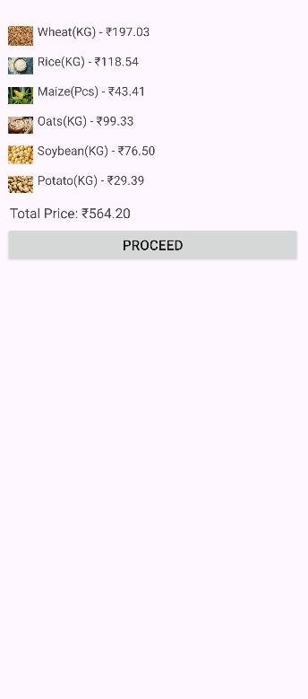

Cart Section

The cart section displayed in the application serves as a summary of the selected agricultural produce along with their respective prices. Each item, including its quantity (e.g., Wheat, Rice, Maize), is listed with the corresponding cost per unit. The total price at the bottom aggregates the individual costs, providing farmers with a clear breakdown of their expenses. A "Proceed" button facilitates further actions, such as confirming the transaction or proceeding to checkout.

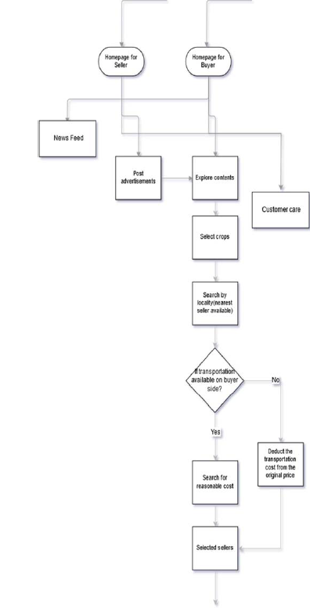

Fig.4 Home Page

**Applications**

This app can be applied across various facets of the agricultural industry:

**Cost Optimization**: Farmers can save significant amounts of money by selecting the mandi with the least overall transaction cost.

**Market Access**: Small-scale farmers, who may have limited knowledge of the market landscape, can access vital information that helps them make informed decisions on where to sell their crops.

**Supply Chain Efficiency:** The app helps reduce transportation costs and time, making the supply chain more efficient by suggesting nearby, high-demand markets.

Empowerment of Farmers: By providing transparent data, the app empowers farmers to negotiate better prices and reduce dependency on intermediaries**.**

**Challenges**

Despite its potential, there are several challenges to the development and implementation of such an app:

**Data Availability and Accuracy**: The accuracy of crop prices and mandi information can vary, as many markets may not update their pricing in real-time. Inaccurate data can affect the app's recommendations, leading to poor decision.

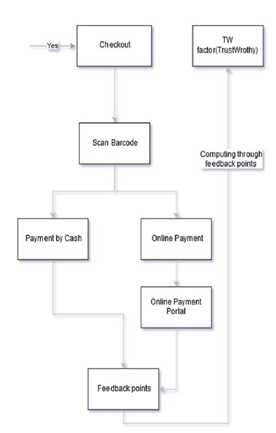

Fig.5 Checkout Portal

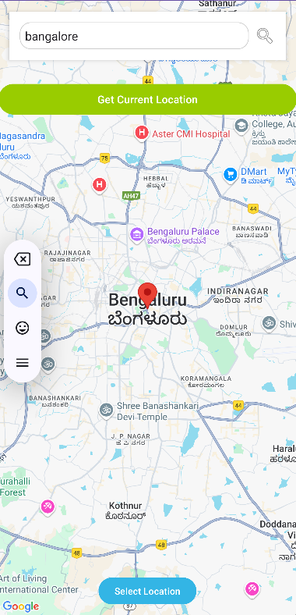

Google maps

**Technology Adoption**: Many farmers in rural areas may lack the digital literacy required to use such applications effectively. Moreover, they may not always have access to smartphones or stable internet connections.**Google Maps Integration** Used.

**Infrastructure Constraints**: In some regions, poor infrastructure can hinder the app’s ability to detect location and provide real-time updates on mandis and transaction costs.

**Regulatory and Pricing Issues**: Government regulations around agricultural pricing and mandi operations can sometimes make the app’s cost predictions less reliable. Mandi commissions and pricing policies may fluctuate, making it difficult to predict costs accurately.

**Scalability**: Scaling the app to cover all regions and crops across a diverse country with varied agricultural practices presents logistical challenges. Tailoring the app to specific regions might be necessary for better accuracy.



Cart section after crops sold

**Future Work**

**Blockchain for Transparency:** The integration of blockchain technology could ensure transparent transactions, allowing farmers to verify prices, reduce fraud, and build trust in the app's market recommendations.

**Regional Customization:** Expanding the app's features to support local languages, region-specific crops, and specific mandi regulations can make it more user-friendly and regionally applicable.

**Offline Functionality:** Developing offline capabilities would make the app accessible to farmers with limited or no internet connectivity, allowing them to use the app even in remote areas. Partnerships with Government and Agri-Enterprises:

IV.CONCLUSION

The Android application presented in this paper offers an effective solution for farmers by integrating real-time location data, mandi search, and transaction cost estimation into one platform. The use of Google Maps ensures precise market location identification, while Firebase allows seamless data storage and retrieval, ensuring that the app remains up-to-date. The transaction cost estimator is a key feature that can help farmers maximize their profitability by minimizing unnecessary expenses. By providing transparent, accessible market information, the app empowers farmers to make informed decisions, reducing reliance on middlemen and improving the overall efficiency of the agricultural market. Future developments could include the addition of real-time crop pricing, integration with other agricultural service platforms, and enhanced AI models to predict future market trends based on historical data.

V.REFERENCES

[1]. Poonia, A., Kumar, A., & Sharma, P. (2020). Mobile Applications for Agricultural Market Access. International Journal of Agricultural Technology, 16(3), 150-165.

[2]. Patel, R., & Desai, A. (2021). Application of Google Maps in Agriculture: Enhancing Market Linkages. Agricultural Informatics Journal, 8(2), 45-60.

[3]. Mishra, S., & Saini, V. (2019). Reducing Transaction Costs in Agricultural Markets through Digital Platforms. Journal of Agricultural Economics, 40(1), 110-123.

[4]. Mishra, S., & Saini, V. (2019). Reducing Transaction Costs in Agricultural Markets through Digital Platforms. Journal of Agricultural Economics, 40(1), 110-123.

[5]. [Aina Marie Joseph](https://ieeexplore.ieee.org/author/37089211564); [Nurfauza Jali](https://ieeexplore.ieee.org/author/37946673700); [Amelia Jati Robert Jupit](https://ieeexplore.ieee.org/author/37088125158); [Suriati Khartini Jali](https://ieeexplore.ieee.org/author/37089210652) “eMarket for Local Farmers” ,2021.

[6]. [Vaishnavi Desai](https://ieeexplore.ieee.org/author/37089232202); [Isha Ghiria](https://ieeexplore.ieee.org/author/37089234785); [Twinkle Bagdi](https://ieeexplore.ieee.org/author/37089233913); [Sanjay Pawar](https://ieeexplore.ieee.org/author/37085410066), “KRISHI BAZAAR: An E-Commerce Application For Direct Farmer-to- Consumer Trading“, 2022.

[7]. [Pranav Shriram](https://ieeexplore.ieee.org/author/37087100313); [Sunil Mhamane](https://ieeexplore.ieee.org/author/37086694902), “Android App to Connect Farmers to Retailers and Food Processing Industry“, 2020.

[8]. [Tejal Yadav](https://ieeexplore.ieee.org/author/37089841991); [Pooja Sable](https://ieeexplore.ieee.org/author/37089963853); [Dhananjay Kalbande](https://ieeexplore.ieee.org/author/37546318800), “SMART KISAN: A Mobile App for Farmers' Assistance in Agricultural Activities“, 2023.

[9]. [Malni Kumarathunga](https://ieeexplore.ieee.org/author/37088489482); [Rodrigo Calheiros](https://ieeexplore.ieee.org/author/37563549700); [Athula Ginige](https://ieeexplore.ieee.org/author/37586875000), “Technology-enabled online aggregated market for smallholder farmers to obtain enhanced farm-gate prices“, 2021.

[10]. [Joe Marie D. Dormido](https://ieeexplore.ieee.org/author/37088343772); [Alvin R. Malicdem](https://ieeexplore.ieee.org/author/37087656285), “AGRITECHNO: A Development of a Revolutionized Farmer Assisted Agricultural Product Forecasting Mobile App System”,2020.

[11]. [Faria Soroni](https://ieeexplore.ieee.org/author/37088892822); [Md. Amdadul Bari](https://ieeexplore.ieee.org/author/37086291337); [Mohammad Monirujjaman Khan](https://ieeexplore.ieee.org/author/37086229128), “GERAM BAZAR, A Mobile Application and Website Interface E-commerce“ , 2021.

[12]. M. Krishnakanth, G. Praneeth Kumar, Prerna Jotwani,：Crop Shop – An application to maximize profit for farmers, Jan.2019.

[13]. N. Viswanadham1 Sridhar Chidananda2, Mandi Electronic Exchange: Orchestrating Indian Agricultural Markets for Maximizing Social Welfare,Jan.2012

[14]. Sneha Iyer R1, Shruthi R2, Spry Farm: A Portal for Connecting Farmers and End Users,2021.

[15].Manisha Bhende, Mohini S. Avatade, Digital Market : E-Commerce Application For Farmers,2018.

[16] KiranShinde, Jerrin Andrei, AmeyOke “ Web Based Recommendation System for Farmers”march , 2015.

[17] Vikas Kumar, Vishal Dave, Rahul Bhadauriya, “ Krishi Mantra: Agricultural Recommendation System” Jan 2013.

[18] MansiShinde, Kimaya Ekbote, Sonali Ghorpade, Sanket Pawar, ShubhadaMone, “Crop Recommendation and Fertilizer Purchase System”2016.

[19] Vikas Kumar, Vishal Dave, RohanNagrani, Sanjay Chaudhary, MinalBhise, “Crop Cultivation Information System on Mobile” 2013.

[20] Sheetal Bhagawat, Sneha Ingle,” Survey Paper On E-mandi a Market Exhange Between Farmers and Enduser”,2019.

[21]<https://www.researchgate.net/publication/360411023_Implmenting_ECommerce_Mobile_and_Web_Application_for_Agricultural_Products_e-Farmers'_Hut>

[22]<https://www.researchgate.net/publication/357626416_Online_Platform_for_Agricultural_Produce_Livestock_Marketing>

[23]<https://www.researchgate.net/publication/322102368_Comparative_Study_of_Android-Based_M-Apps_for_Farmers>