DESIGN DOCUMENT
PS Ops Platform — Technician Panel
Document Type | Design Document (DD)
Module | Technician Panel — full workflow: Login, Job Assignment, Shift & Visit Location Tracking
Traces To | Technician Shift Management & GPS-Verified Visit Tracking FRD

1. Overview
This Design Document is the technical companion to the Technician Shift Management & GPS-Verified Visit Tracking FRD. Sections 2–5 document the technical design of the functionality as it exists in the codebase today (database tables, code modules, application flow, and API surface) so the design is traceable to real, verified source. Section 6 covers the design impact of the one proposed change carried in that FRD: widening the Visit-start geofence radius from 100 metres to 300 metres.
This revision extends Section 2 and Section 4 to cover the part of the workflow that happens before a shift or visit exists at all: the technician's login, and the Admin/Supervisor steps that turn a client request into a Job with a technician assigned to it. The tables and endpoints below are the ones a technician's day actually depends on, start to finish.
1.1 Traceability to the Functional Requirement
FRD Section | Addressed By (this document)
1.3 Scope (Shift capture, continuous tracking, geofence, Site config, Supervisor visibility) | Section 2 (Database), Section 3 (Code), Section 4 (Application Flow)
3.1 Functional Overview (checkpoint table) | Section 4.1 — mapped to the exact function/endpoint executing each checkpoint
3.4.1 Cached-location fallback | Section 3.2 — identifies the exact code branch implementing this
Login, Job creation & assignment (workflow context, not a numbered FRD section) | Section 2.1 (Database), Section 4.2 / 4.3 (Application Flow)
6 Proposed Behaviour (100m → 300m) | Section 6 — database, code, and API impact of the radius change
5 Business Rules | Section 5 — mapped to the endpoint enforcing each rule

2. Database Design
2.1 Tables Involved
The original version of this section covered four tables: two dedicated to shift/location tracking, and two pre-existing Site/Location tables the geofence check reads from. Getting a technician to the point where a shift or visit can even start depends on a longer chain — login, the client/site the work is at, and the booking → job → visit records an Admin and Supervisor create beforehand. The tables below are grouped the same way: Shift & Tracking first (unchanged from the original design), then the tables that carry the rest of the workflow.
Shift & tracking (original scope, unchanged)
technician_shifts
Column | Notes
id | UUID primary key
technician_id | FK to users.id
started_at | Set on Start Shift
start_latitude / start_longitude | Captured at Start Shift, no comparison performed
status | 'ACTIVE' or 'ENDED'
ended_at | Set on End Shift
end_latitude / end_longitude | Captured at End Shift, no comparison performed

technician_location_history
Column | Notes
shift_id | FK to technician_shifts.id — every stored point belongs to exactly one shift
technician_id | FK to users.id
latitude / longitude | One sampled point
accuracy | Raw device GPS metadata
source | Present in the schema and read by the history endpoint; not populated by the current write path

sites / locations (pre-existing, reused) — Geofencing reads Job → Site → Location: sites.location_id points to a locations row holding latitude/longitude. Full column detail for both is given below, since they are now also where a Job's address is set up.
Identity & access (new — technician login depends on these)
users
Column | Notes
id | BIGINT auto-increment primary key — this is the same ID every table above calls technician_id
email / password_hash | Login credentials checked by POST /api/auth/login; email is unique
role_id | FK to roles.id — the authoritative role (admin / supervisor / technician / client)
role | Legacy free-text role column, still read as a fallback in a few queries
branch_id | FK to branches.id — the branch a user belongs to, enforced on job assignment
contact_id | FK to contacts.id — set only for Client-role users
invite_status / invite_token / invite_expiry | Login is blocked while invite_status = 'INVITED'
is_active | Login is blocked (403) when false

roles / permissions / role_permissions
Column | Notes
roles.id, roles.name | Seeded roles: admin, supervisor, technician, client
permissions.id, permissions.name | One row per permission string, e.g. START_VISIT, CREATE_JOB
role_permissions.role_id, .permission_id | Join table the requirePermission() middleware checks on every route

branches
Column | Notes
id | UUID primary key
name | The organizational unit users, jobs, and sites are partitioned by

Client & site (new — where a Job points)
companies
Column | Notes
id | UUID primary key
group_id | FK to group_name.id — an umbrella over related companies
name / code / gst_number | The client organization's identifying details
type | 'CORPORATE', 'INDIVIDUAL', or 'RWA'

sites
Column | Notes
id | UUID primary key
company_id | FK to companies.id — the client this site belongs to
branch_id | FK to branches.id
location_id | FK to locations.id — the geocoded point the geofence check compares against
name / address / city / state | Site identifying details, set on creation in AdminCompanies.jsx

locations
Column | Notes
id | UUID primary key
latitude / longitude | The coordinates checkVisitGeofence() compares the technician's position against
formatted_address / provider_place_id | Populated by the Google Places map/autocomplete picker
city / state / postal_code / country | Geocoded address parts

NAMING NOTE
jobs.company_id and contacts.company_id are both foreign keys into sites.id, not companies.id — confirmed by the fk_jobs_company constraint and by an in-code comment in getMyVisits() (visits.controller.js): “j.company_id, -- actually site_id”. To reach the real company row from a Job you join jobs.company_id → sites.id → sites.company_id → companies.id.

Booking, job & visit (new — how a technician gets assigned work)
bookings
Column | Notes
id | UUID primary key
code | The client's original request reference
contact_id / company_id | Who asked, and which client
service_type / sub_services | What was requested
status | 'ACTIVE', 'CLOSED', or 'CANCELED'

jobs
Column | Notes
id | UUID primary key
code | Work order reference
booking_id | FK to bookings.id
status | 'CREATED' → 'NOT_STARTED' → 'IN_PROGRESS' → 'COMPLETED' (or PAUSED / CANCELED)
supervisor_id | The assigned Supervisor's user id — set by POST /api/jobs/assign
team | JSON array of assigned technician ids — set by the same endpoint
company_id | FK to sites.id (see naming note above), not companies.id
location_id | FK to locations.id
branch_id | FK to branches.id — must match the assigned supervisor/technicians
approval_status | 'PENDING', 'APPROVED', or 'REJECTED'

job_visits
Column | Notes
id | UUID primary key
job_id | FK to jobs.id — a Job can have several Visits
visit_number | Sequence number within the Job
scheduled_date | When the Visit is expected
status | 'SCHEDULED' → 'IN_PROGRESS' → 'AWAITING_APPROVAL' → 'COMPLETED' (or CANCELED / MISSED)
started_at / completed_at | Set by Start Visit / Approve Visit

visit_technicians
Column | Notes
visit_id | FK to job_visits.id
technician_id | FK to users.id — who is actually assigned to attend this specific Visit

visit_technicians, not jobs.team, is what the geofence and continuous-tracking endpoints join against when deciding whose location to check. A technician can be on a Job's team without being assigned to a given Visit, or vice versa.
supervisor_technicians
Column | Notes
supervisor_id | FK to users.id
technician_id | FK to users.id — unique per technician; a technician has at most one supervisor

3. Code Design
3.1 Backend Modules
File | Responsibility
backend/src/routes/auth.routes.js | Login — issues a JWT carrying { id, role, branch_id }; also signup/OTP and invite acceptance.
backend/src/routes/jobs.routes.js | createBooking (job creation), POST /assign (writes jobs.supervisor_id + jobs.team, branch-matching enforced), job status/comments/history.
backend/src/routes/sites.routes.js | Site creation — writes a locations row, then a sites row referencing it.
backend/src/routes/shifts.routes.js | Start/End Shift, current-shift check, live location ingestion (POST /location), online-technicians list, per-technician history, active-technicians list.
backend/src/controllers/visits.controller.js | Visit lifecycle (create, start, start-anyway, submit, approve, reschedule, cancel, assign technicians); owns VISIT_GEOFENCE_RADIUS_METERS, calculateDistanceMeters(), and checkVisitGeofence().
backend/src/utils/redis.js | Redis client used for the short-lived “latest known location” cache (key: technician:location:{id}, 1-hour TTL).

3.2 Key Backend Logic
- Login (POST /api/auth/login) — reads users joined to roles, rejects on invite_status = 'INVITED' or is_active = 0, compares the bcrypt hash, and signs an 8-hour JWT. No location involved.
- Job assignment (POST /api/jobs/assign) — requires every assigned supervisor and technician to share the same branch_id, then writes jobs.supervisor_id and jobs.team.
- VISIT_GEOFENCE_RADIUS_METERS — a single constant (currently 100) at the top of visits.controller.js; the one value the proposed change in Section 6 would update.
- calculateDistanceMeters(lat1, lon1, lat2, lon2) — Haversine formula, pure function, used only by checkVisitGeofence().
- checkVisitGeofence(visitId, technicianId, currentLocation, conn) — resolves the Visit's Job → Site → Location, resolves the technician's location (fresh fix if supplied, else falls back to the Redis-cached location — this is the exact code path behind FRD 3.4.1), computes distance, and returns { allowed, distanceMeters, radiusMeters } or an error shape ({ status, error }) for missing Visit / missing Site coordinates / missing technician location.
- Both startVisit and startVisitAnyway call checkVisitGeofence() and apply the same allowed/rejected handling — the radius constant and the fallback behaviour are shared by both entry points automatically.
3.3 Frontend Modules
File | Responsibility
frontend/src/pages/Login.jsx | Credential form → POST /api/auth/login → stores the JWT, routes by role.
frontend/src/pages/BookingsPage.jsx | Admin: turns a client booking into a Job.
frontend/src/pages/AdminTeamManagement.jsx | Admin: assigns a Supervisor and Technicians to selected jobs.
frontend/src/layouts/TechnicianLayout.jsx | Shift gate (renders ShiftPage vs. the Outlet), End Shift / logout-with-active-shift handling, the continuous watchPosition loop that posts to /api/shifts/location.
frontend/src/pages/ShiftPage.jsx | Start Shift screen — location capture and confirmation map.
frontend/src/pages/TechnicianDashboard.jsx | Pending/Today/Tomorrow visit list, backed by GET /api/visits/my.
frontend/src/components/JobCard.jsx | Per-visit card rendering (status badge, date/time, address).
frontend/src/pages/JobPage.jsx | Visit actions — getCurrentLocation(), startVisit(), startVisitAnyway(), submitVisit(); renders the OUTSIDE_GEOFENCE / “Job location is not configured” error messages.
frontend/src/pages/SupervisorDashboard.jsx | Supervisor: creates Visits under a Job, assigns technicians per visit, approves submitted visits.
frontend/src/pages/AdminCompanies.jsx | Site creation, including the map/place-autocomplete coordinate picker that populates locations.latitude/longitude.
frontend/src/pages/MapView.jsx | Admin/Supervisor live “online technicians” map, backed by GET /api/shifts/active.
frontend/src/pages/TrackingHistory.jsx | Admin per-technician, per-date GPS trail view, backed by GET /api/shifts/history/:technicianId.

4. Application Flow
4.1 Checkpoint → Implementation Map
Checkpoint | Frontend Trigger | Backend Endpoint | Backend Logic
Login | Login.jsx | POST /api/auth/login | Verifies credentials, issues JWT. No location involved.
Create Job | BookingsPage.jsx | POST /api/jobs | Creates bookings + jobs rows.
Assign Job | AdminTeamManagement.jsx | POST /api/jobs/assign | Writes jobs.supervisor_id + jobs.team; enforces same-branch.
Create Visit | SupervisorDashboard.jsx | POST /api/jobs/:jobId/visits | Creates a job_visits row under the Job.
Assign Technicians to Visit | SupervisorDashboard.jsx | PATCH /api/visits/:visitId/technicians | Replaces visit_technicians rows for the Visit.
Start Shift | ShiftPage.jsx → handleStartShift() | POST /api/shifts/start | Creates technician_shifts row, status ACTIVE, no comparison.
Start Visit | JobPage.jsx → startVisit() | PATCH /api/visits/:visitId/start | checkVisitGeofence() → job_visits.status = IN_PROGRESS on pass.
Start Anyway | JobPage.jsx → startVisitAnyway() | POST /api/visits/:visitId/start-anyway | Same geofence check, plus the “no other Visit already IN_PROGRESS” guard.
Continuous tracking | TechnicianLayout.jsx → watchPosition loop | POST /api/shifts/location | Refreshes the Redis cache every call; writes to technician_location_history only if moved ≥ 30 m.
Submit for Approval | JobPage.jsx → submitVisit() | PATCH /api/visits/:visitId/submit | Status update only — no location involved (per FRD 3.7).
Approve Visit | SupervisorDashboard.jsx | PATCH /api/visits/:visitId/approve | job_visits.status = COMPLETED.
End Shift | TechnicianLayout.jsx → handleEndShift() / logout() | POST /api/shifts/end | Marks technician_shifts ENDED, no comparison.
Supervisor live view | MapView.jsx | GET /api/shifts/active | Joins ACTIVE shifts with each technician's Redis-cached location.
Supervisor history view | TrackingHistory.jsx | GET /api/shifts/history/:technicianId?date= | Reads technician_location_history + Visits for the selected shift/date.

4.2 Admin / Supervisor Sequence
1. Admin creates a Company and a Site (AdminCompanies.jsx) → optionally sets coordinates via the map/place picker → POST /api/sites → written to locations, linked via sites.location_id.
2. Admin turns a client booking into a Job (BookingsPage.jsx) → POST /api/jobs → bookings, jobs.
3. Admin assigns a Supervisor and Technicians to the Job (AdminTeamManagement.jsx) → POST /api/jobs/assign → jobs.supervisor_id, jobs.team. Every assignee must share the supervisor's branch.
4. Supervisor opens the assigned Job and creates one or more Visits (SupervisorDashboard.jsx) → POST /api/jobs/:jobId/visits → job_visits.
5. Supervisor assigns which technicians attend a given Visit → PATCH /api/visits/:visitId/technicians → visit_technicians.
6. Supervisor/Admin opens MapView.jsx → GET /api/shifts/active → live pins for every technician with an ACTIVE shift.
7. Supervisor/Admin opens TrackingHistory.jsx for a technician and date → GET /api/shifts/history/:technicianId?date= → GPS trail + that day's Visits rendered together.
8. Once the technician submits a Visit, the Supervisor reviews and approves it → PATCH /api/visits/:visitId/approve → job_visits.status = COMPLETED. The Job itself completes once every Visit is COMPLETED/CANCELED.

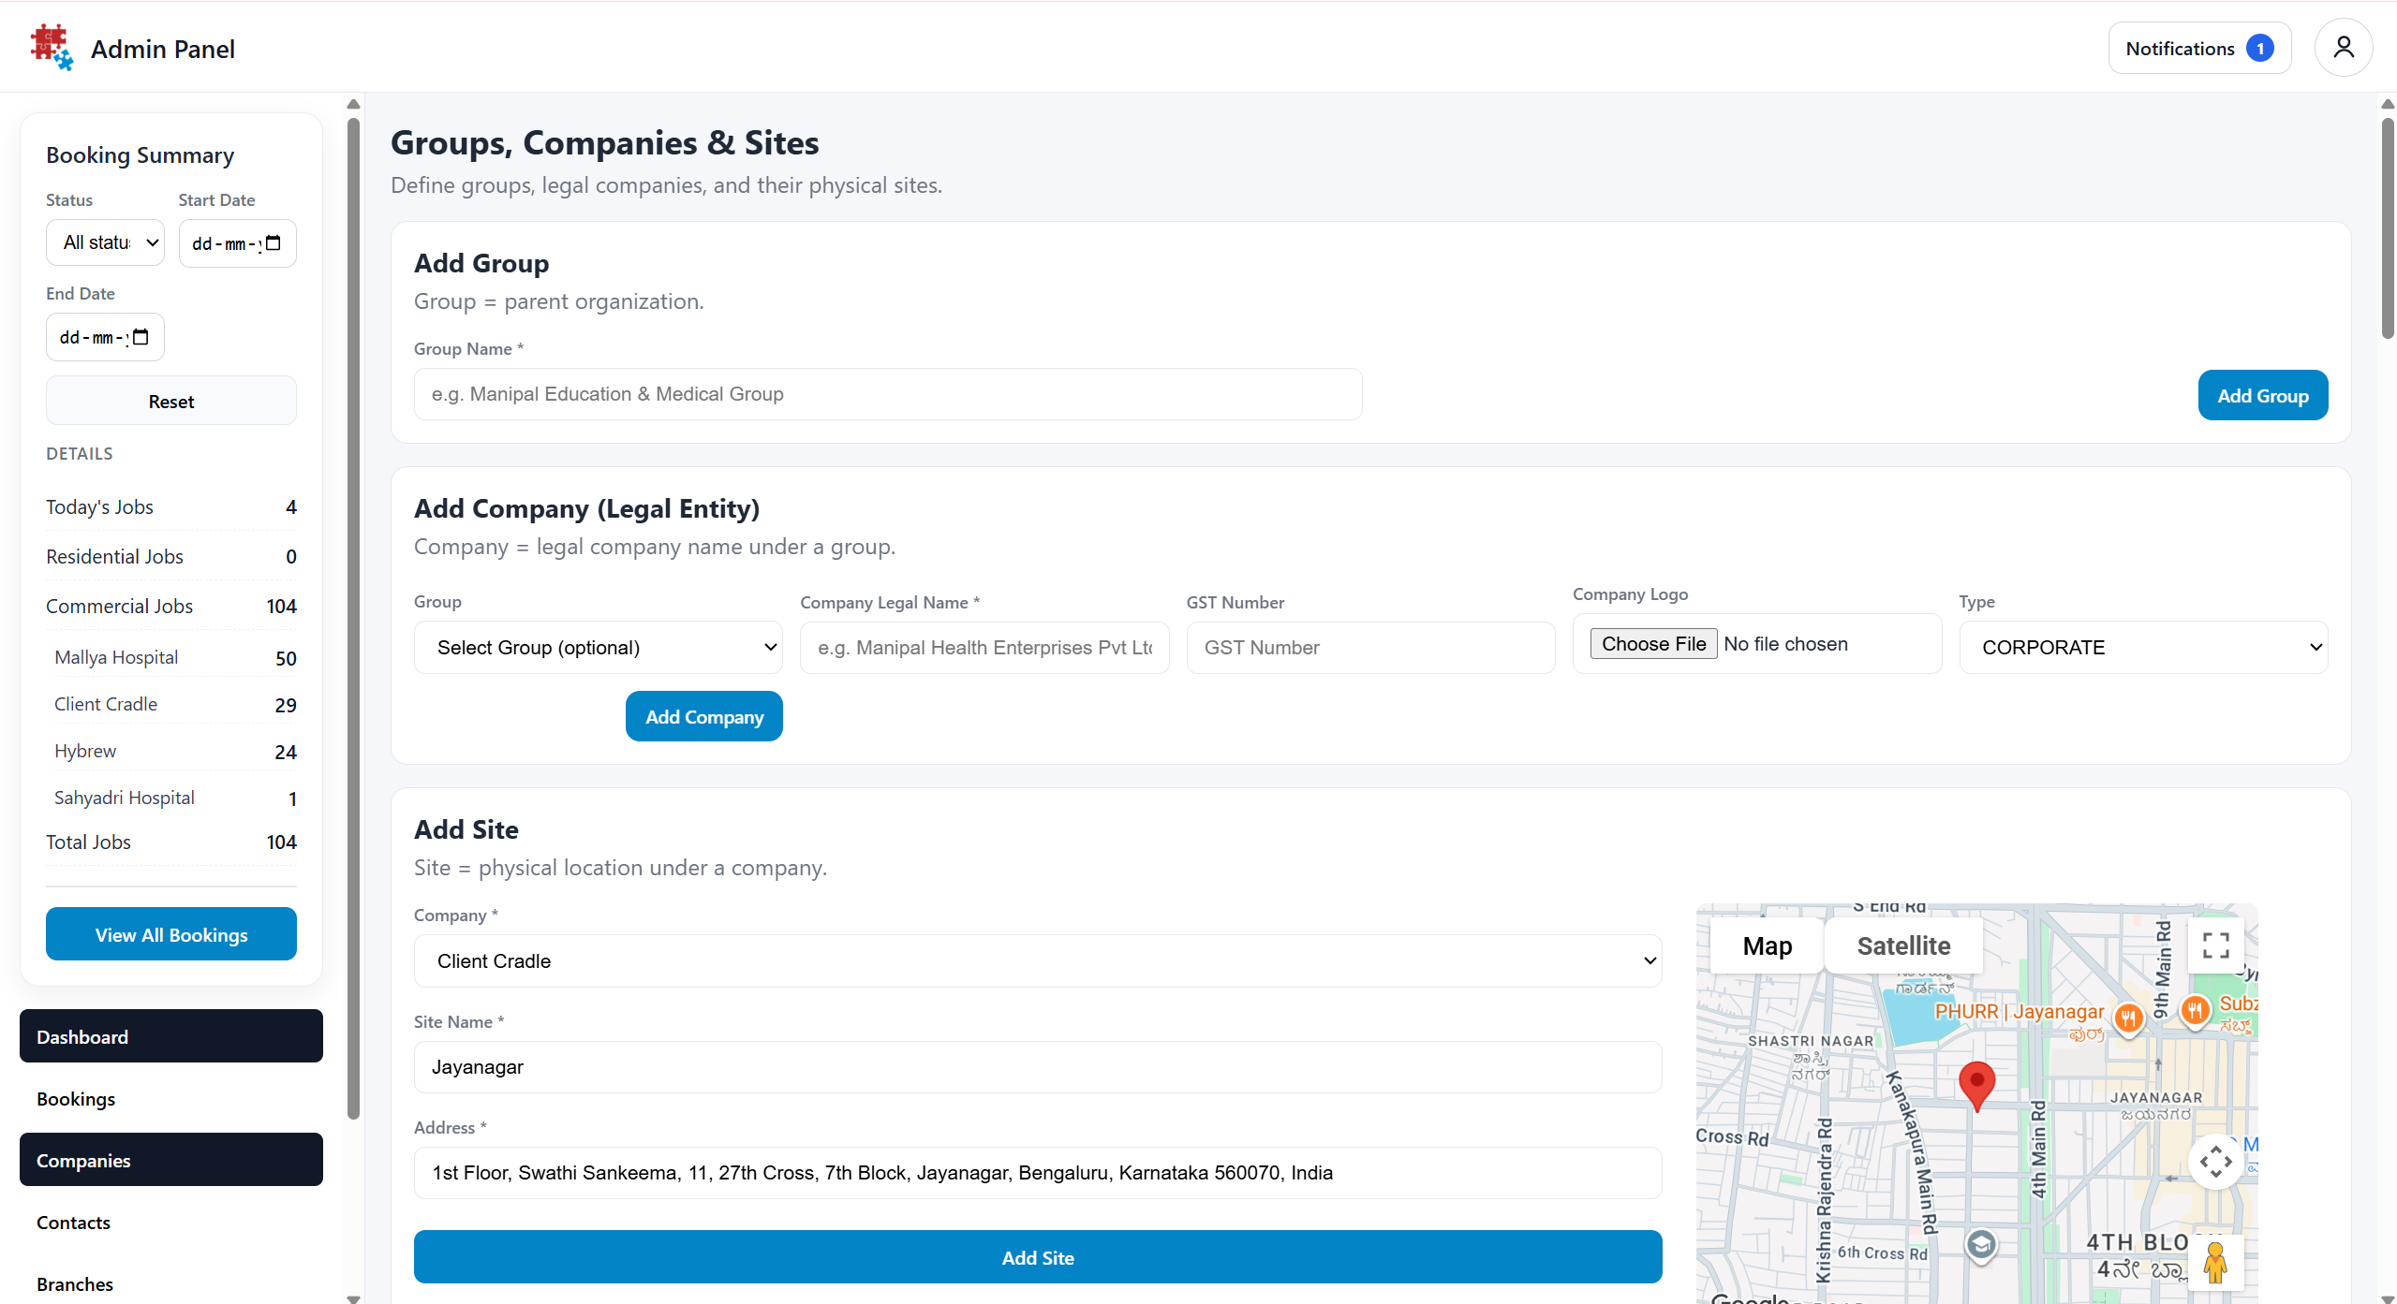ker ]
Screenshot — 1 — AdminCompanies: Site creation with map

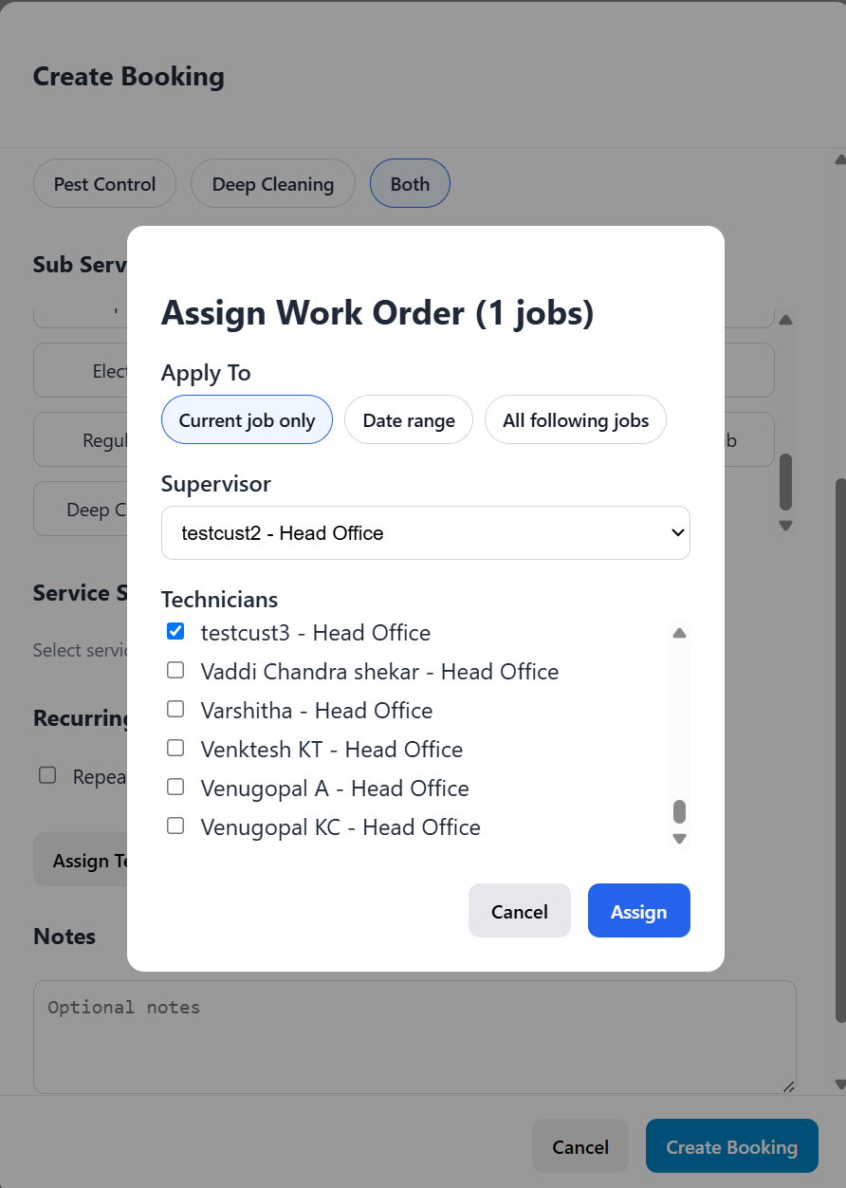
Screenshot — 2 — AdminTeamManagement: Supervisor + Technician assignment

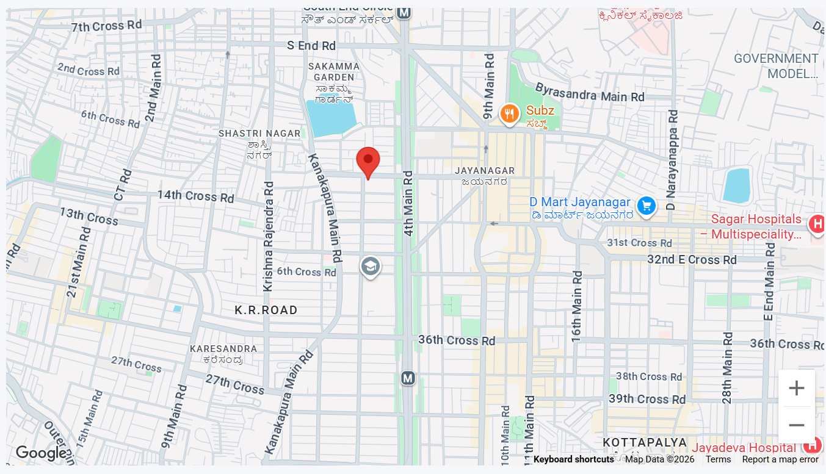
Screenshot — 3 — MapView: live technician map

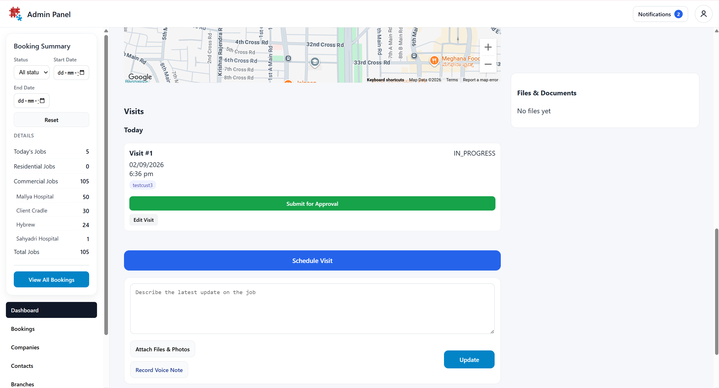
Screenshot — 4 — SupervisorDashboard: approving a submitted Visit

4.3 Technician End-to-End Sequence
1. Technician opens the app and logs in. POST /api/auth/login
2. TechnicianLayout mounts → GET /api/shifts/current
3. No active shift → ShiftPage renders → getCurrentLocation() → Start Shift button enabled.
4. POST /api/shifts/start → shift row created → TechnicianLayout re-renders with the Outlet (job list) instead of ShiftPage.
5. TechnicianDashboard loads GET /api/visits/my → JobCard list rendered.
6. Technician opens a Visit → taps Start → getCurrentLocation() → PATCH /api/visits/:id/start with lat/lng.
7. Backend checkVisitGeofence() resolves Site coordinates and compares — pass updates job_visits + jobs status; fail returns OUTSIDE_GEOFENCE or a configuration error, surfaced via alert() in JobPage.jsx.
8. While the Visit is IN_PROGRESS, TechnicianLayout's watchPosition effect posts to /api/shifts/location on each qualifying GPS update.
9. Technician taps Submit for Approval → PATCH /api/visits/:id/submit → status AWAITING_APPROVAL, tracking for that Visit ends the moment it's no longer active.
10. Technician ends Shift (menu action or logout prompt) → POST /api/shifts/end → shift ENDED → TechnicianLayout reverts to showing ShiftPage.

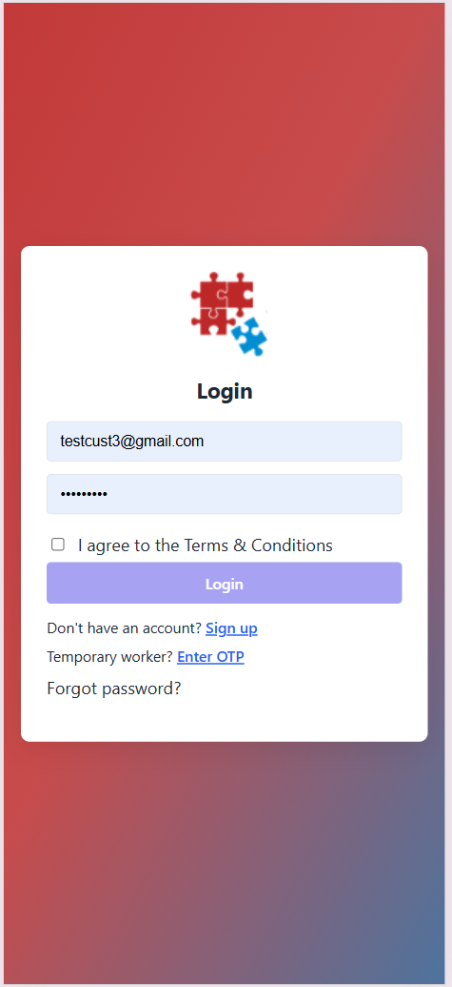
Screenshot 5— Login and Start Shift screen

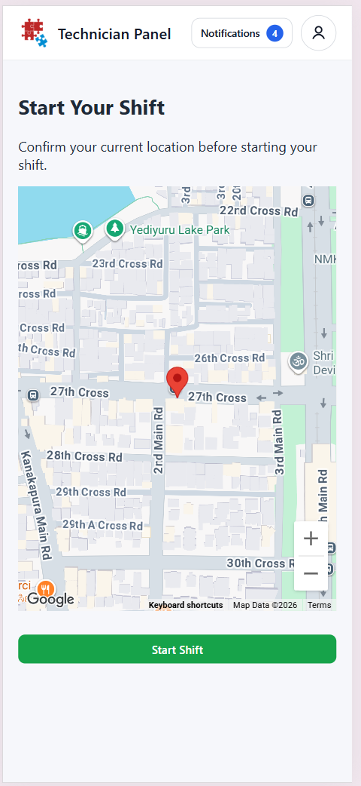
Screenshot 6 - Start Visit

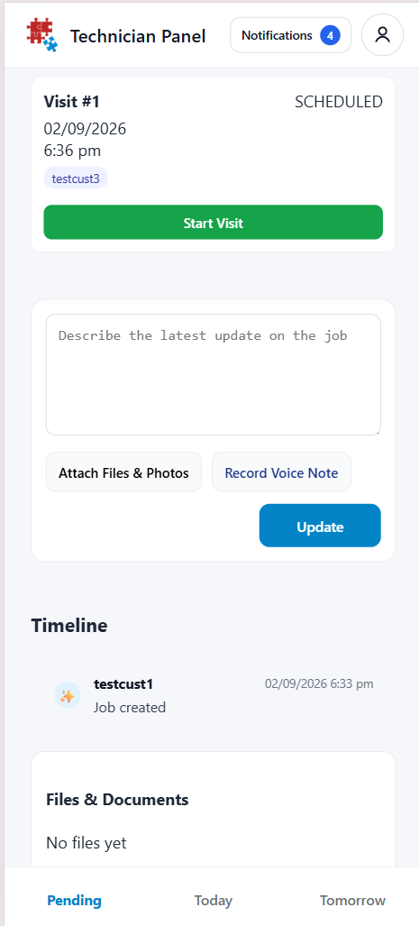
Screenshot — 7 — Continuous tracking indicator during an active Visit

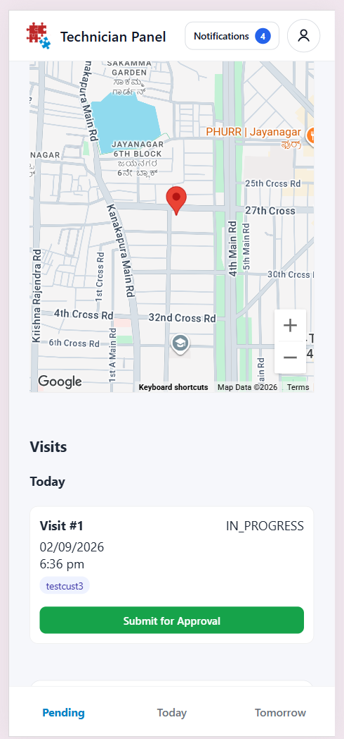
Screenshot —8— Submit for Approval and End Shift

5. Business Rule → Enforcement Point
FRD Rule # | Enforced In
0 — Login requires an accepted invite and an active account | auth.routes.js POST /login
0a — Supervisor and assigned technicians must share a branch | jobs.routes.js POST /assign — ensureUsersInBranch()
1 — Shift start/end requires a location fix | ShiftPage.jsx / TechnicianLayout.jsx — Start/End buttons disabled without a successful getCurrentPosition() call; backend also 400s if lat/lng missing
2,3 — 100m geofence / Site must be configured | checkVisitGeofence() in visits.controller.js
4 — One Visit IN_PROGRESS per Job | startVisitAnyway()'s explicit query for an existing IN_PROGRESS visit before allowing start
5,6 — 30s / 30m tracking throttle | TechnicianLayout.jsx (30s client-side throttle) + POST /api/shifts/location (30m server-side movement check before writing history)
7 — Tracking only while Shift + Visit both active | TechnicianLayout.jsx watchPosition effect, gated on shift && activeVisit
8 — No location on submit/approve/comment | Confirmed by absence of any location parameter in submitVisit, approveVisit, or the job comments/attachments handlers
9 — Job can't complete with unfinished Visits | PATCH /api/jobs/:id/status — hasPendingVisits check before allowing COMPLETED

6. Design Impact — Geofence Radius 100m → 300m
Per the FRD's Proposed Behaviour (6): the radius applied to Start Visit / Start Anyway increases from 100 to approximately 300 metres, applied globally, with the comparison logic and rejection-message pattern unchanged.
6.1 Database Impact
None. The radius is not stored data — it is a constant evaluated at request time. No table, column, or migration is required for the global version of this change.
6.2 Code Impact
File | Change
backend/src/controllers/visits.controller.js | Update the single constant: VISIT_GEOFENCE_RADIUS_METERS = 100 → 300 (or the final confirmed value — see Open Question A below). No other line changes, since both startVisit and startVisitAnyway already read this constant via checkVisitGeofence().
Frontend (JobPage.jsx) | No change required — the OUTSIDE_GEOFENCE alert already renders whatever radiusMeters the API returns, so the displayed “required radius” updates automatically once the backend constant changes.

6.3 API Impact
No endpoint signatures change. PATCH /api/visits/:visitId/start and POST /api/visits/:visitId/start-anyway keep the same request/response shape; only the radiusMeters value returned on an OUTSIDE_GEOFENCE rejection changes, reflecting the new constant.
6.4 Consistency Note
The separate Job Card Location Verification FRD/Design (proposed, pending review) reuses the same VISIT_GEOFENCE_RADIUS_METERS constant for its own new checks (Submit for Approval, technician Job status change). Changing the constant here changes it for that proposal too, since both would share the same shared geofence utility described in that Design Document's 3.1. No action needed now — flagged so the two proposals are not approved independently with conflicting radius assumptions.

7. Glossary
Term | Definition
checkVisitGeofence() | Backend function resolving a Visit's Site coordinates and comparing them to the technician's location; the single implementation of the geofence rule.
VISIT_GEOFENCE_RADIUS_METERS | The constant controlling the geofence radius; the value this document's Section 6 proposes changing.
Redis location cache | Short-lived (1-hour TTL) latest-known-location record per technician, keyed technician:location:{id}, used for live views and as the geofence fallback.
Job | A work order created by an Admin from a client Booking; carries the assigned Supervisor and technician team.
Visit | One on-site attendance against a Job; a Job can have several Visits.
Site | A physical, geocoded location belonging to a Company — referenced by jobs.company_id despite that column actually pointing at sites.id, not companies.id (see the naming note in §2.1).
Branch | The organizational unit users, jobs, and sites are partitioned by; assignment requires a Supervisor and their Technicians to share one.

