FUNCTIONAL REQUIREMENT DOCUMENT
Technician Shift Management & GPS-Verified Visit Tracking
PS Ops Platform

Document Type | Functional Requirement Document (FRD)
Module | Technician Panel – Shift & Visit Location Tracking
Status | Documenting Implemented Functionality
Date | 01 September 2026

Revision Notes — v1.0 → v1.1
Change | Reason
Added Section 3.4.1 — cached-location fallback for Visit-start check | Missed in v1.0: the geofence check can use the last cached location from Redis if no fresh fix is supplied, not only a fresh GPS fix.
Added Section 6.2 — Job-level status transition has no location check | Missed in v1.0: a technician can move a Job from NOT_STARTED to IN_PROGRESS via the job-status API with no presence verification at all, bypassing Start Visit's geofence entirely.
Added screenshot placeholder spaces throughout | Requested — spaces for the actual app screenshots to be inserted directly in Word.
Fixed numbered-list formatting | v1.0's numbered steps ran continuously across sections (6–12, then 13–21) instead of restarting at 1 per list; corrected in this revision.

1. Introduction

1.1 Purpose
This document describes the functional requirement and the proposed / implemented functionality for tracking a technician's on-duty status (Shift) and verifying their physical presence at a job site before allowing them to begin work on a Visit. It captures the business need, the actors involved, the step-by-step functional flow, the business rules governing location verification, and the data captured at each step.

1.2 Background
The PS Ops Platform assigns Jobs to Sites (customer locations) and schedules one or more Visits per Job, each assigned to one or more Technicians. Historically, there was no system-verified way to confirm that a technician was actually present at the customer's site when a job was marked as started, nor a formal attendance record for technician working hours. This feature introduces a Shift (attendance/clock-in) concept and a Geofence-based location check tied to Visit start, so that operational and attendance data can be trusted.

1.3 Scope
- Technician clock-in / clock-out (Shift) capture, including start and end location.
- Continuous, throttled GPS location capture for a technician while a Visit is in progress.
- Geofence validation comparing the technician's live location against the admin-configured Site location when a Visit is started.
- Admin-side Site location configuration (source of truth for the geofence).
- Supervisor / Admin visibility into technician online status, live location, and historical location trail.
Out of scope for this document: payroll computation, route optimisation, offline/no-signal location caching, and any change to the visit approval workflow beyond what is described here.

1.4 Actors
Actor | Role in this Functionality
Technician | Clocks in/out via Shift; starts, works, and submits Visits; is the subject of location tracking.
Admin / Branch Admin | Creates Companies and Sites and sets each Site's geo-coordinates (map pin) — the reference point used for geofencing.
Supervisor / Admin | Approves submitted Visits; monitors technician online status and live/historical location.
System | Captures, throttles, stores, and validates location data; enforces the geofence rule.

2. Business Requirement

2.1 Problem Statement
Operations needs assurance that (a) a technician's working hours are recorded accurately with a location-stamped start and end, and (b) a technician cannot mark a Visit as started unless they are physically present at the customer's site, preventing false or remote status updates.

2.2 Business Objectives
1. Maintain an auditable attendance record per technician (Shift), including start/end time and location.
2. Prevent a Visit from being started unless the technician is verified within an acceptable distance of the assigned Site.
3. Provide Supervisors/Admins real-time visibility of which technicians are on duty and where they currently are.
4. Provide a historical location trail per technician per day for audit and dispute resolution.
5. Keep the location-tracking footprint minimal — track continuously only while it is operationally meaningful (an active visit), not at all times.

2.3 Success Criteria
- A technician cannot access the Job/Visit list without an active Shift.
- A Visit cannot transition to IN_PROGRESS unless the technician's live location is within the configured radius of the Site's coordinates.
- Every Shift has a start and (on end) an end location on record.
- Supervisors/Admins can see, per technician, an online/offline flag, last known location, and a full day's GPS trail.

3. Proposed Functionality

3.1 Functional Overview
The functionality is built around two distinct location checkpoints, described below, plus a continuous tracking behaviour that runs only in between them.
Checkpoint | Location Captured | Compared Against | Effect
Start Shift | Technician's current device GPS (fresh fix) | Nothing — recorded as-is | Opens access to the Job/Visit list; begins the attendance record.
Start Visit | Technician's current device GPS (fresh fix, or last cached fix — see 3.4.1) | The Site's fixed coordinates, set by Admin | Visit allowed to start only if within 100 metres of the Site; otherwise rejected.
During Active Visit | Technician's device GPS, sampled continuously | N/A (informational trail) | Live location cached for supervisor view; persisted to history when moved ≥ 30 m.
End Shift | Technician's current device GPS (fresh fix) | Nothing — recorded as-is | Closes the attendance record and stops all tracking.

3.2 Shift (Attendance) Management
Functional behaviour:
- Technician is presented with a “Start Your Shift” screen showing a live map centred on their current device location, and is required to obtain a location fix before the Start Shift action is enabled.
- Starting a Shift records the technician ID, start timestamp, and start latitude/longitude, and marks the Shift as ACTIVE.
- Only once a Shift is ACTIVE does the technician gain access to their assigned Jobs and Visits (dashboard, job details, visit actions).
- Ending a Shift (from the profile menu, or automatically prompted on logout while a Shift is active) requires a fresh location fix and records the end timestamp and end latitude/longitude, marking the Shift as ENDED.
- If a technician attempts to log out while a Shift is still active, they are prompted to confirm; confirming automatically ends the Shift first (capturing end location) before logging out.
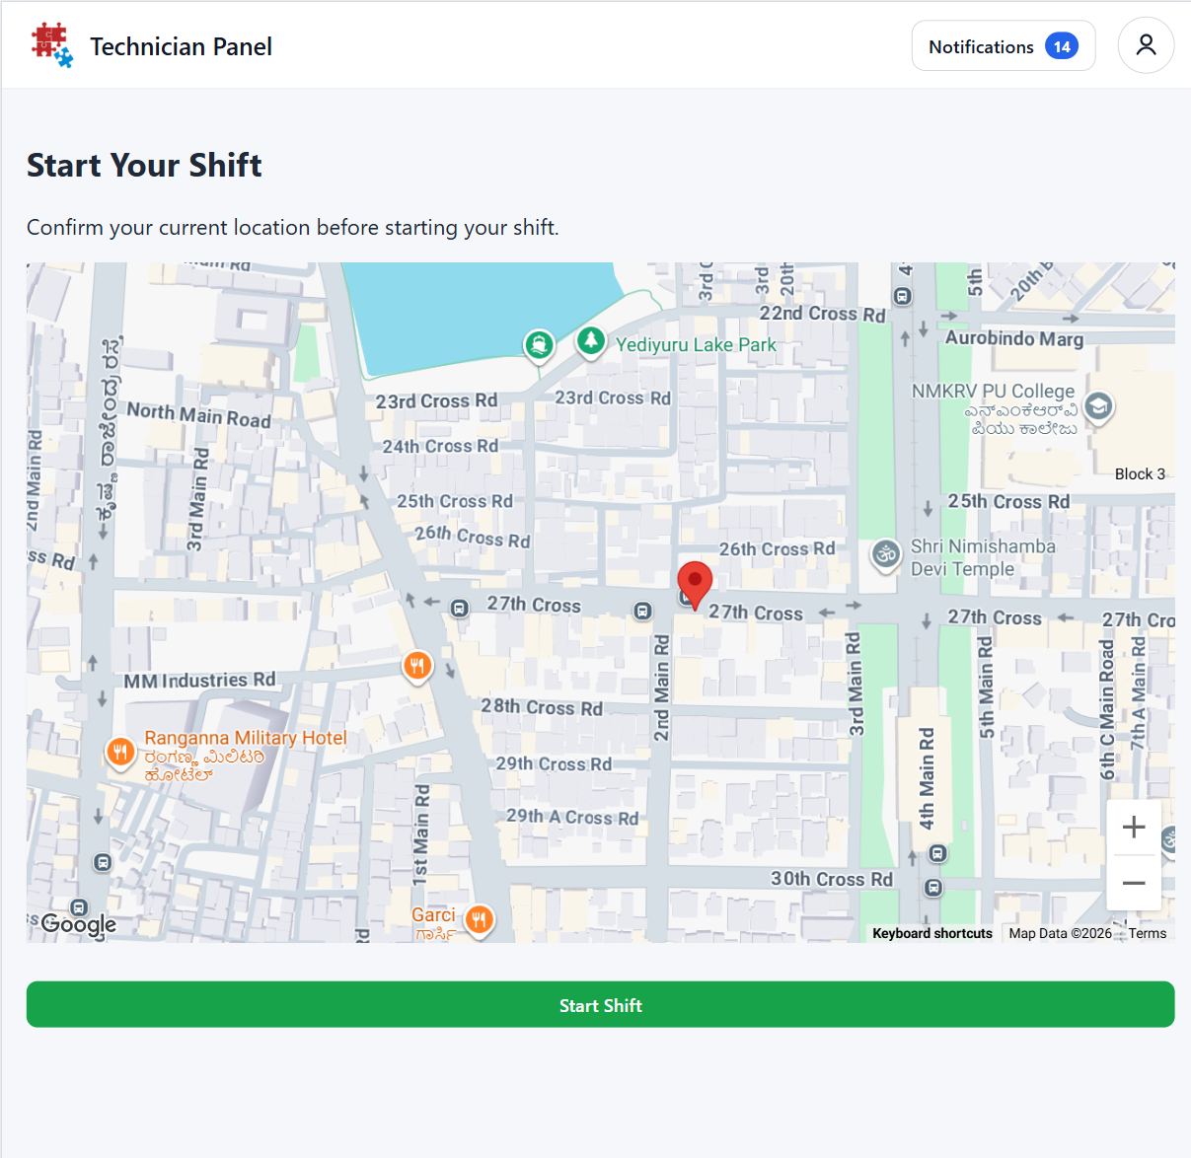

3.3 Site Location Configuration (Admin)
Functional behaviour:
- An Admin creates a Site under a Company, providing Site Name and Address (both mandatory).
- The Admin additionally sets the Site's precise geo-coordinates by selecting a location via a map/place-autocomplete control; these coordinates are stored against the Site and are what every Visit under Jobs at that Site will be geofenced against.
- This Site coordinate is currently an optional field at save time — a Site can be created without coordinates being set.

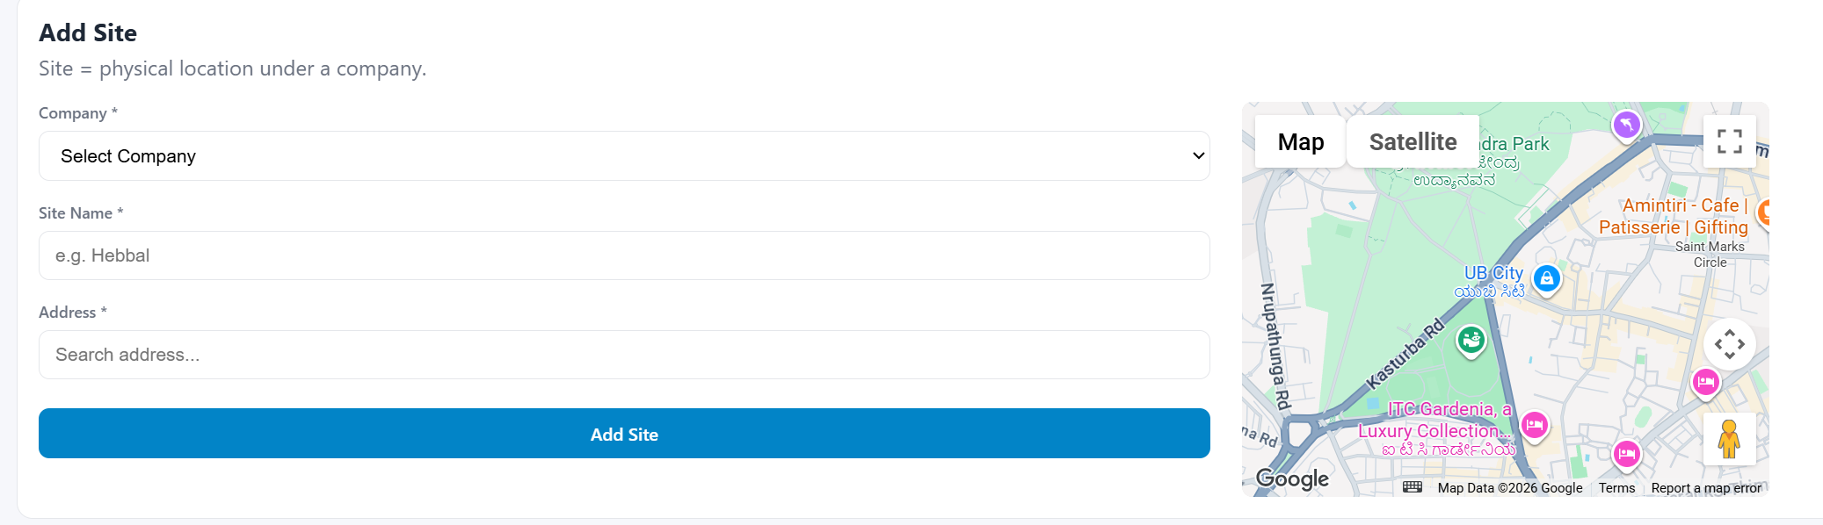

3.4 Visit Start — Geofence Verification
Functional behaviour:
1. Technician selects a Visit in SCHEDULED status (or a missed Visit, via “Start Anyway”) and taps Start.
2. The system requests a fresh device location fix from the technician.
3. The system looks up the Site coordinates associated with the Visit's Job.
4. The straight-line distance between the technician's current location and the Site's coordinates is calculated.
5. If the distance is within the configured radius (100 metres), the Visit transitions to IN_PROGRESS, the started-at timestamp is recorded, and the parent Job is moved to IN_PROGRESS if it was not already started.
6. If the distance exceeds the radius, the action is rejected and the technician is shown the actual distance and the required radius.
7. If the Site has no coordinates configured, the action is rejected with a “Job location is not configured” message rather than allowing an unverified start.

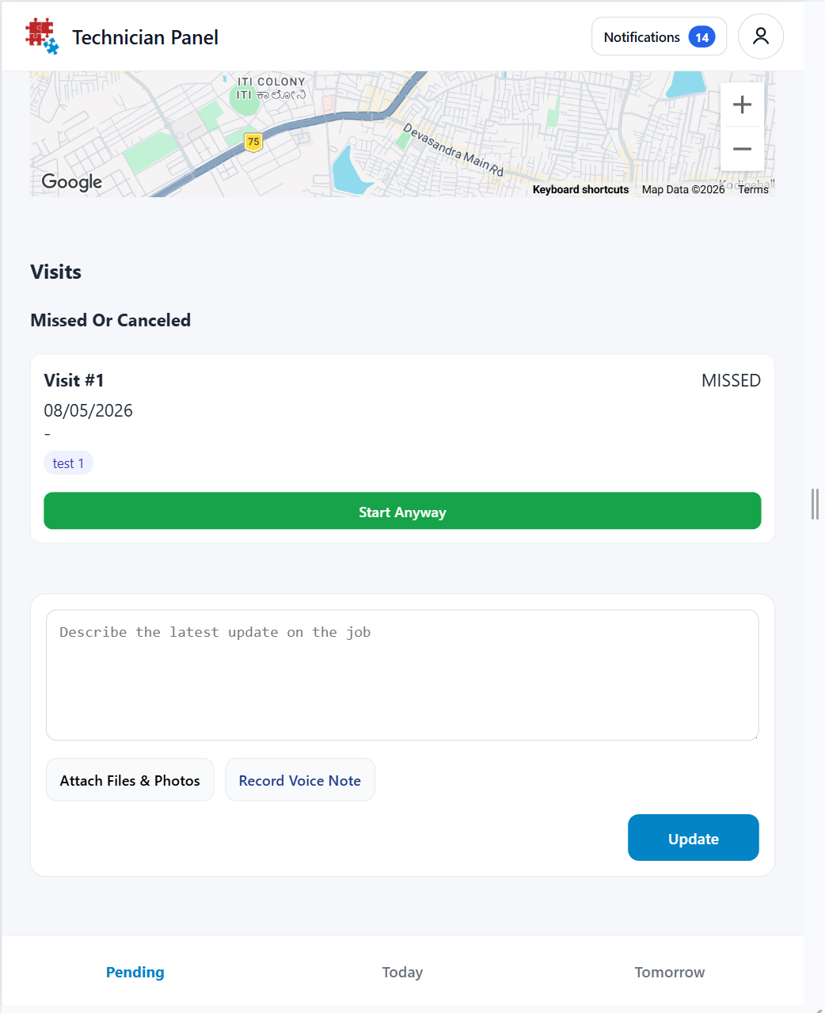

3.6 Supervisor / Admin Visibility
- A live “online technicians” view (Admin → Map) lists every technician with an active Shift, their shift start time, and their latest known location.
- Technicians without an active Shift appear as offline, along with their last shift's end time.
- A per-technician, per-date history view (Admin → Tracking History) reconstructs the full GPS trail for a selected day, alongside the Visits that occurred during that Shift — used for review and dispute resolution.

3.7 Visit Lifecycle Context
Visit start is one stage of the overall Visit lifecycle, which this functionality does not otherwise alter:
SCHEDULED → IN_PROGRESS → AWAITING_APPROVAL → COMPLETED
Only the SCHEDULED → IN_PROGRESS transition (Start Visit) carries a location/geofence requirement. Submitting for approval, approval itself, and adding comments/attachments to a Job carry no location requirement.

4. End-to-End Functional Flow

1. Technician logs in → system checks for an active Shift.
2. No active Shift → technician sees “Start Your Shift” with their live location on a map.
3. Technician taps Start Shift → current location captured → Shift created as ACTIVE → Job/Visit list unlocked.
4. Technician opens an assigned Visit and taps Start Visit (or Start Anyway for a missed one).
5. System captures a fresh location fix (or falls back to the last cached fix, per 3.4.1) and compares it to the Job's Site coordinates (set earlier by Admin).
6. Within 100 m → Visit moves to IN_PROGRESS; outside 100 m → blocked with distance shown; no Site coordinates → blocked with configuration error.
7. While the Visit is IN_PROGRESS, location is sampled continuously (throttled to 30 s) for live tracking and a movement-based history trail.
8. Technician taps Submit for Approval → Visit moves to AWAITING_APPROVAL (no location check).
9. Supervisor/Admin reviews and Approves → Visit moves to COMPLETED once all visits on the Job are finished, Job can then be completed.
10. Technician ends Shift (or logs out, which auto-ends it) → end location captured → Shift marked ENDED → tracking stops → access to Job list locked again until next Shift.

5. Business Rules

# | Rule
1 | A technician cannot view or act on assigned Jobs/Visits without an active Shift.
2 | Starting or ending a Shift requires a successful device location fix; the action is disabled/blocked without one.
3 | A Visit can only move from SCHEDULED (or MISSED) to IN_PROGRESS if the technician's live location is within 100 metres of the Job's Site coordinates.
4 | If a Site has no coordinates configured, Visit start is blocked rather than allowed unchecked.
5 | Only one Visit per Job may be IN_PROGRESS at a time.
6 | Live location updates are sent at most once every 30 seconds while a Visit is active.
7 | A location point is written to permanent history only when the technician has moved ≥ 30 metres from the last stored point.
8 | Continuous location tracking only runs while both a Shift and a Visit are simultaneously active.
9 | Submitting a Visit for approval, approving it, and adding Job comments/attachments carry no location requirement.
10 | A Job cannot be marked COMPLETED while any of its Visits remain unfinished.
11 | If no fresh location fix is supplied for a Visit-start request, the system falls back to the technician's last cached location before rejecting the check as unavailable (Added in v1.1, see 3.4.1).

6. Assumptions & Dependencies

- Technician's device has location services enabled and grants browser/app location permission; without it, Shift and Visit start are both blocked.
- Site coordinates set by Admin are accurate; geofencing is only as reliable as this configured reference point.
- Device GPS accuracy is assumed sufficient for a 100-metre radius check; dense urban or indoor environments may reduce accuracy.
- Continuous tracking requires the app to remain active/foregrounded on the technician's device during a Visit.

7. Glossary

Term | Definition
Shift | A technician's clocked-in attendance window, from Start Shift to End Shift, with location captured at both ends.
Visit | A single scheduled occurrence of work against a Job, assigned to one or more technicians, following the SCHEDULED → IN_PROGRESS → AWAITING_APPROVAL → COMPLETED lifecycle.
Site | A customer location under a Company, configured by an Admin with an address and (optionally) geo-coordinates.
Geofence | The 100-metre radius around a Site's coordinates within which a technician must be located to start a Visit.
Location Trail / History | The sequence of stored GPS points for a technician's Shift, used for live and historical location review.

— End of Document —

