1. Python Version/Dependencies
Version: Python 3.8
NOTE: The Python environment needs to be included in the windows PATH variable to use the python command in a console window from any directory on a computer. See this guide for more info.

Script Dependencies: numpy, matplotlib, pyteomics, scipy, lxml, sklearn, pandas, colorcet, wxPython, tqdm

2. Scripts
Run each script by opening a console window from within the MStat folder
Type “cmd” into the address bar after navigating to the MStat directory
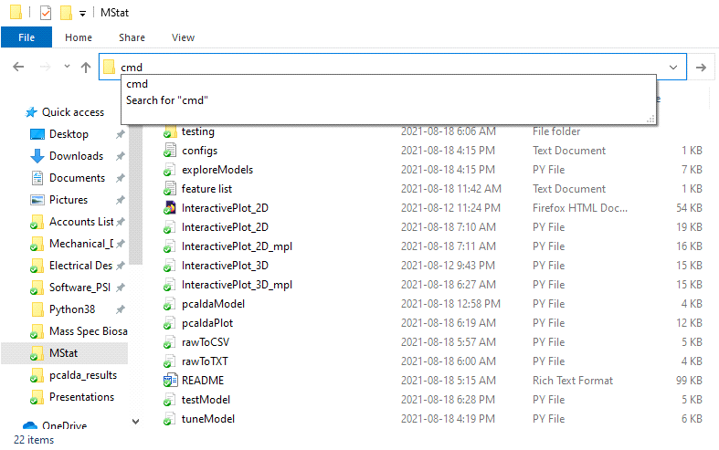
and in the console window type:
python script_name.py first_argument second_argument … nth_argument
or type python script_name.py help to see more info on a given script
NOTE: If an argument contains a space character then you must add double quotation marks around the argument (ex: csv_output/LTQ XL/mydata.csv → “csv_output/LTQ XL/mydata.csv”)

2.1 rawToCSV.py

2.1.1 Description
Converts RAW files from multiple directories/paths into CSV files. Folder selection dialogs appears when running the script. Multiple folders containing different classes of data can be selected at once by using "ctrl" + left click. Only a single output directory can be chosen to store the csv file. Data from all scans is summed and binned into a single mass spectrum for each RAW file. All the summed data will be combined into CSV format created in a target folder.
2.1.2 Console command
python rawToCSV.py <CSV name> <bin size> <min mass> <max mass> <run RAW conversion> <split train/test>
Arguments:
<CSV name> | (String) name of the CSV file output. No need to add .csv at the end. All RAW files in each path will be combined into a single CSV file in the csv_output folder.
<bin size> | (Float) bin size for adding all scans together in each RAW file.
<min mass> | (Float) max m/z value to consider. Constrained by m/z range observed in RAW files.
<max mass> | (Float) min m/z value to consider. Constrained by m/z range observed in RAW files.
<run RAW conversion>  <split train/test> | (Boolean) turn RAW file conversion on or off.  (Float) percentage of data to be put randomly into a testing file.

2.2 rawToTXT.py
2.2.1 Description
Converts RAW files in a single directory/path into TXT files containing all MS scans delineated into double row pairs (one row for m/z values and one row for corresponding intensity values). Each RAW file is converted into its own TXT file stored in the output folder created in the directory you gave. No additional data processing/formatting is done on the scan data.

2.2.2 Console command
python rawToTXT.py <path/to/RAW/files> <TXT name> <run RAW conversion>
Arguments:
<path/to/RAW/files> | (String) Directory with RAW data. Path can be relative or absolute.
<TXT name> | (String) Name to add to all TXT created for each RAW file. No need to add .txt at the end.
<run RAW conversion> | (Boolean) Turn RAW file conversion on or off.

2.3 TestModel.py

2.3.1 Description
Create a PCA + Classifier estimator using CSV source of training and testing data. A MODEL file can be created in the same directory which can be used again in this script. A performance report is printed after the model is built/tested.
NOTES:
• TIC normalization is always applied to MS data before any training/testing takes place.
• CSV data does not have to come from the csv_output folder
• Depending on the model, the fitting/validation step may take longer to complete

2.3.2 Console Command
python TestModel.py <train file.csv> <test file data mode> <pca dimension> <confidence threshold> <plot confusion matrix> <model file>
Arguments:
<path/train_file.csv> | (String) path and name of training CSV file including the extension ".csv" as well. Path can be relative or absolute.
<path/test_file_data mode> | (String) path and name of test CSV file including the extension ".csv" as well. Path can be relative or absolute.  OR  (Integer) 0 - generate random test group from first file  1 - generate random test group from first file + random noise points  2 - generate random test group from first file + held-out classes
<pca_dimension> | (Integer) number of dimensions for PCA analysis (must be less than or equal to number of data features)
<confidence_threshold> | (Float) confidence level to decide between class prediction and unknown sample
<plot_confusion_matrix> | (Boolean) select whether to plot a confusion matrix
<path/model_file> | (String) model file including extension ".model"  OR  "save" which creates a new model file

2.4 PCALDAPlot.py (OLD VERSION – use InteractivePlot scripts instead)

2.4.1 Description
Plot training and test data that are projected into the PCA-LDA subspace.

2.4.2 Console Command
python PCALDAPlot.py <model_data_name.csv> <test_data_name.csv> <pcalda_model.model>
Arguments:
<path/model_data_name.csv> | (String) first (training) CSV file including the extension ".csv" as well. Path can be relative or absolute.
<path/test_data_name.csv> | (String) second (test) CSV file which will be plotted and labelled with first CSV file. Path can be relative or absolute.
<path/pcalda_model.model> | (String) PCA-LDA model file. Path can be relative or absolute.

2.5 miPlot2D.py

2.5.1 Description
Plot training and optional test data that are projected into a 2D PCA-LDA subspace. With confidence ellipses estimated/plotted overtop of the model clusters.

2.5.2 Console Command
python miPlot2D.py <model_data_name.csv> <test_data_name.csv> <pcalda_model.model> <n_std>
Arguments:
<path/model_data_name.csv> | (String) first (training) CSV file including the extension ".csv" as well. Path can be relative or absolute.
<path/test_data_name.csv> | (String) OPTIONAL second (test) CSV file which will be plotted and labelled with first CSV file. Path can be relative or absolute.  Leave blank to plot only training data.
<path/pcalda_model.model> | (String) PCA-LDA model file. Path can be relative or absolute.
<n_std> | (Float) Number of standard deviations that the confidence ellipses should extend to

2.6 miPlot3D.py

2.6.1 Description
Plot training and optional test data that are projected into a 3D PCA-LDA subspace. With confidence ellipsoids estimated/plotted overtop of the model clusters.
2.6.2 Console Command
python miPlot3D.py <model_data_name.csv> <test_data_name.csv> <pcalda_model.model> <n_std>
Arguments:
<path/model_data_name.csv> | (String) first (training) CSV file including the extension ".csv" as well. Path can be relative or absolute.
<path/test_data_name.csv> | (String) OPTIONAL second (test) CSV file which will be plotted and labelled with first CSV file. Path can be relative or absolute.
<path/pcalda_model.model> | (String) PCA-LDA model file. Path can be relative or absolute.
<n_std> | (Float) Number of standard deviations that the confidence ellipsoids should extend to

2.7 miPlotPCA.py

2.7.1 Description
Plot training and optional test data that are projected into a 2D PCA subspace.
2.7.2 Console Command
python miPlotPCA.py <model_data_name.csv> <test_data_name.csv> <n_pca_dimensions>
Arguments:
<path/model_data_name.csv> | (String) first (training) CSV file including the extension ".csv" as well. Path can be relative or absolute.
<path/test_data_name.csv> | (String) OPTIONAL second (test) CSV file which will be plotted and labelled with first CSV file. Path can be relative or absolute.
<n_pca_dimensions> | (Integer) Number of pca dimensions

2.8 PCALDADist.py

2.8.1 Description
Plots how "close" (statistical distance) test data is to the different known classes of a given PCA-LDA model. A PCA-LDA model will assess the distance of a given point from all the known classes and chose the class with the smallest distance as its prediction. Distances closer to zero suggest higher confidence in the final prediction.
2.8.2 Console Command
python PCALDADist.py <model_data_name.csv> <test_data_name.csv> <pcalda_model.model>
Arguments:
<path/model_data_name.csv> | (String) first (training) CSV file including the extension ".csv" as well. Path can be relative or absolute.
<path/test_data_name.csv> | (String) second (test) CSV file which will be plotted and labelled with first CSV file. Path can be relative or absolute.
<path/pcalda_model.model> | (String) PCA-LDA model file. Path can be relative or absolute.

2.9 PlotRAW.py
2.9.1 Description
Convert files in directory to MZML format (if specified) and plot the TIC and average spectrum from a single file.
2.9.2 Console Command
python PlotRAW.py <file number> <test data name.csv> <run RAW conversion>
Arguments:
<file number> | (Integer) which file in the selected directory you want to plot.
<run RAW conversion> | (Boolean) turn RAW file conversion on or off.

3. CSV Format
Column labels/format for the CSV files created by the rawToCSV.py script is defined as follows. All subsequent scripts expect to read data from the CSV files with the same column names (see example_csv in the csv_output folder).
No column name (Row Index) | Label | Filename | Total (TIC) | Bin 1 | … | Bin M
… | ... | ... | ... | ... | ... | ...
n-1 | Label A | File1.raw | 1000 | 0 | ... | 45
n | Label B | File2.raw | 10000 | 12 | ... | 20
n+1 | Label A | File3.raw | 3000 | 6 | ... | 0
… | ... | ... | ... | ... | ... | ...

NOTE: Bin 1 through Bin N are the m/z values which MS data have been binned into when the CSV file was created. For example, if the user ran rawToCSV.py and chose to bin from 200D up to (but not including) 1000D with 0.5D steps the resulting column labels would be 200, 200.5, 201, …, 999, 999.5.

