

Vision and Mission of the Institute:

Vision of the Institute

To become one of the best institutions at the National and International level by incorporating innovative teaching -learning methods to enable the students to secure a high-value career, motivate to pursue higher education and research to serve the society

Mission of the Institute

- To bring out knowledgeable engineers and professionals in their field of specialization by having qualified and trained faculty members and staff besides necessary infrastructure and to create highly conducive teaching and learning environment .
- To work in close association with stakeholders by way of enhanced industry – institute interaction, to take up need based research and industry specific programmes.
- To organize co-curricular and extracurricular activities for character and personality development to produce highly competent and motivated engineers and professionals to serve and lead the society.

Department of Computer Science and Engineering

Vision of the Department of Computer Science and Engineering
To create computer professionals with a strong academic and technical background to achieve special distinction at the national and international arena and also to serve and lead the society.

Mission of the Department of Computer Science and Engineering
- Providing excellent learning opportunities for students in Computer Science and Engineering to meet the needs of Nation as a whole.
- Establishing centers of research in areas of the immediate needs to the society.
- Develop ICT based solutions for the development of the nation.

Programme Educational Objectives (PEOs)
PEO1: Graduates will be able to comprehend mathematics, science, engineering fundamentals, laboratory and work-based experiences to formulate and solve problems in Computer Science and Engineering and other related domains and will develop proficiency in computer based engineering and the use of computation tools.
PEO2: Graduates will be prepared to communicate and work effectively on the multidisciplinary engineering projects practicing the ethics of their profession with a sense of social responsibility.
PEO3: Graduates will recognize the importance of lifelong learning to become experts either as entrepreneurs or employees and to widen their knowledge in their domain.

Programme Outcomes (POs)
a. Ability to apply knowledge of mathematics, science and engineering principles to the problems in Computer Science and Engineering domain.
b. Ability to design and conduct experiments, as well as to analyze and interpret data.
c. Ability to use the techniques, skills, and modern engineering tools necessary for engineering practice.
d. Ability to design a system, component, or process to meet desired goals in their domain considering environmental, social and ethical aspects.
e. Ability to function on multidisciplinary teams.
f. Ability to identify, formulate and solve engineering problems.
g. Understanding of professional and ethical responsibility.
h. Ability to communicate effectively.
i. Ability to understand the impact of software solutions in a global, environmental and societal context.
j. Ability to realize the need to engage in life-long learning.
k. Knowledge of contemporary issues.
l. Ability to manage the projects in the relevant areas of Computer Science and Engineering and enhance research through engineering and management principles.

Ex No: 1 | ATM SYSTEM
Date : | ATM SYSTEM

1. INTRODUCTION TO PROJECT DEFINITION

What is ATM ?
The word ATM is an abbreviation used for automated teller machine used by bank clients to process access bank details through a machine which are derived from punched cards which cannot be reused later the development is technology let to invention of modern ATM cards which are reusable which use a magnetic strip to identity a person.
Project definition :
State Bank of INDIA is planning to introduce Automated teller machine system for its customer to provide continent withdrawal service everywhere even if the customer doesn’t come to bank .The most modern ATM’s the customer is identical by inserting a plastic ATM card with a magnetic stripe or a plastic ATM card with a magnetic stripe or a plastic smartcard with chip that contains a unique card number and some security information such as an exception data or [CVV] security It provided by the customer entering a personal identification number [PIN].
Using an ATM customer can access their bank account is order to make cash withdrawals and check their account balances.
The Function of the system are :
1. Login
2. Get Balance Information
3. Withdraw cash
4. Transfer Funds

2. SOFTWARE PROCESS OVERVIEW

DEFINITION:
In Software Engineering a software development process is the process of dividing software development work into distinct phases to improve design, product, management and project management. It also known as the software development life cycle .The methodology may include the pre definition of specific deliverables and artifacts that are created to develop or maintain an application.
Phases:
- Planning
- Analysis
- Design
- Development and Implementation
- Testing
- Maintenance

Planning :
Planning involves various aspects like fixing deadlines cost management and many other .In ATM machine the planning may include the location for our ATM machine the due date the mile stone etc.. It also includes the team mates and their responsive work.
Analysis:
Software system analysis is a file in which analysis continually learn new techniques and approaches to properly capture, maintain understand and develop more efficient and effective software systems.
In ATM machine the cost in audition like software used and amount spend on it.
RISK factors include security management and pin validation and preserving customers identity etc…
Design:
Software design is the process by which an agent creates a specification of a software artifact intended to accomplish goals using a set of primitive components and subject to constraints.

Development & Implementation:
Software development is the process of conceiving specifying , designing, programming , documenting , testing and bug fixing involved other software components.
Testing:
Software testing is an investigation conducted to provide stake holders with information about the quality to the software product or service interest software testing can also provide an objective independent view of the software to allow the business to appreciate and understand the risks of software implementation.
Maintenance:
It is the modification of a software product after delivery to correct faults to improve performance or other attributes.

3. PROJECT PLANNING

Project Planning:
Stages of software life cycle, Software Requirements Analysis are the first stage of the project which involves interaction with the customers to understand him/her needs requirements , information , required function , performance and interacting in HTML software.
- Design:
Beginning once software requirements have been analyzed and specified software design the first of three technical activities design generation and test that are required to build and verify the software.
- Development:
The design must be translated into a machine readable form. The coding step perform the task. In this stage the developer will actually code the program.
- Testing:
In this stage the test group of the development team using the cases and the fast data already prepared will test the programs.

- Acceptance Test:
This round of testing will be performed by the test group formed by the run software. This test group has to ensure that the developed software is warning as per their requirements.
- Data Creation:
For Software data is most important part data is information gathered by the analyst in non taken actual image in form of software.
- Implementation:
After making software it is uploaded into the system so users for whom software is developed can use the software
4.SOFTWARE REQUIREMENT SPECIFICATION

Software Requirement Specification:
A Software Requirement Specification(SRS) is a document that captures complete description about how the system is expected to perform. It is usually signed off at the end of requirements engineering phases.
Qualities of SRS:
- Correct
- Unambiguous
- Complete
- Consistent
- Ranked for importance and / or stability
- Verifiable
- Modifiable
- Traceable
Type of Requirements:
- Functional
- Performance
- Interface
- Maintainability
- Reliability
- Safety
- Quality
- Operational
- Resource

5. INTRODUCTION TO UML AND USECASE DIAGRAMS

An introduction United Modeling Language(UML) is a general purpose modeling language. The main aim of UML is defined as a standard way to visualize the way a system has been designed. It is quite similar to blue prints used in other fields of engineering.

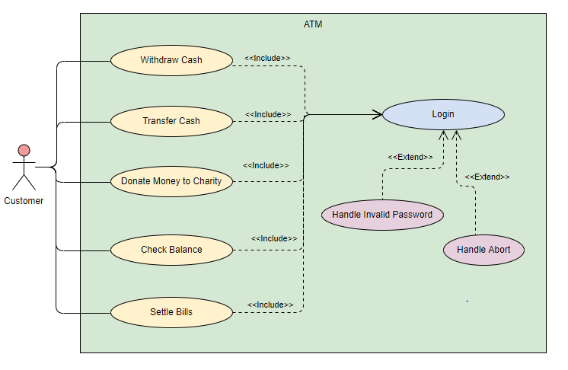

6.SYSTEM MODELING
An system conceptual model describes using one diagram (such as in object process methodology(OPM)) or several diagram types(such as in system modelling language(SYSML)) the various aspects of the system.
The conceptual model might include its requirements, behaviours, structure and properties.
- System modelling helps the analyst to understand the functionality of the given system and models are used to communicate with customers.
- Different models present the system from different perspectives.
- External perspective showing the systems context or environmental.
- Behavioural perspective showing the behaviour of the system.
- Structural perspective showing the system or data architecture.

7. FLOW OF EVENTS AND ACTIVITY DIAGRAMS
Flow of events are the steps required to perform within a use case.
Types of Flow of events:
1.Basic Flow of Events
2.Alternate Flow of Events
3.Exception Flow of Events
Basic flow of Events :
It is the most common pathway . It usually depicts a perfect situation, in which nothing goes wrong.
Eg : You get to the ATM and successfully withdraw money.
Alternate Flow of Events :
It is the pathway that is still considered a good pathway; it’s just not the most heavily travelled one.
Eg : You get to the ATM but could not withdraw money due to the insufficient funds in your account.
Exception Flow of Events :
Things don’t always go as planned. An exception is an error condition that is important enough to the application to capture.
Eg : You get to the ATM machine but your valid pin number is not accepted.
Activity Diagram
Activity diagram is another important diagram in UML to describe the dynamic aspects of the system. Activity diagram is basically a flowchart to represent the flow from one activity to another activity. Activity diagrams are often used in business process modelling. They can also describe the steps in a use case diagram. Activities modelled can be sequential and concurrent. In both cases an activity diagram will have a beginning (an initial state) and an end (a final state).
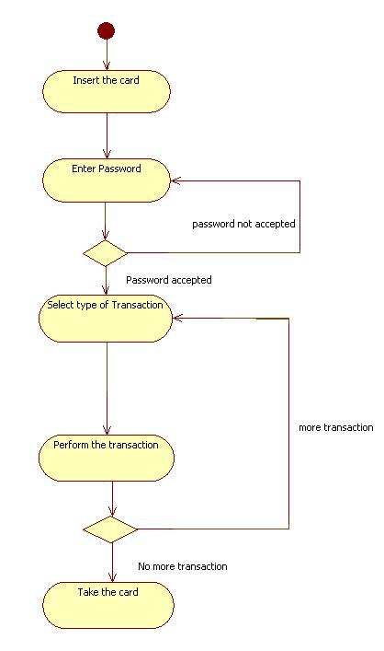

-

8.OBJECT ORIENTED ANALYSIS DEVELOPING CLASSES
In object oriented analysis there is an emphases on finding and describing the objects or concepts in the problem domain.
It defines and analyse the requirements necessary for success of a system. Object Oriented analysis is a process that groups items that interact with one another, typically by class, data or behaviour, to create a model that accurately represents the intended purpose of the system as a whole.
For Eg: An ATM management system, may include classes of user, Bank database, manager, ATM, etc...

ATM SYSTEM

Account
Withdrawal
Pin
-AccNo:int
+getAccountNo()
+execute()
-Amount:double
+execute()
-pin:int

Deposit
Bank
-Bankname:string
-Location:string

-Amount:double
+execute()

9 . INTERACTION DIAGRAM
Interaction diagrams are models that describe how a group of objects collaborate in some behavior - typically a single use-case. The diagrams show a number of example objects and the messages that are passed between these objects within the use-case. Interaction diagrams come in two forms, the first form is the sequence diagram and the second form of the interaction diagram is the collaboration diagram.
SequenceDiagrams:
A sequence diagram simply depicts interaction between objects in a sequential order i.e. the order in which these interactions take place. They're also called event diagrams.
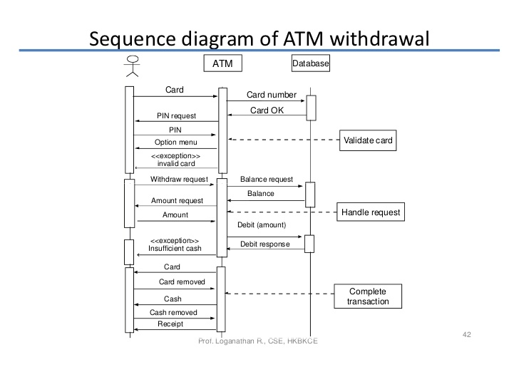
Collaboration diagram :
A collaboration diagram shows the objects and relationships involved in an interaction, and the sequence of messages exchanged among the objects during the interaction. In the collaboration diagram, the method call sequence is indicated by some numbering technique. The number indicates how the methods are called one after another.
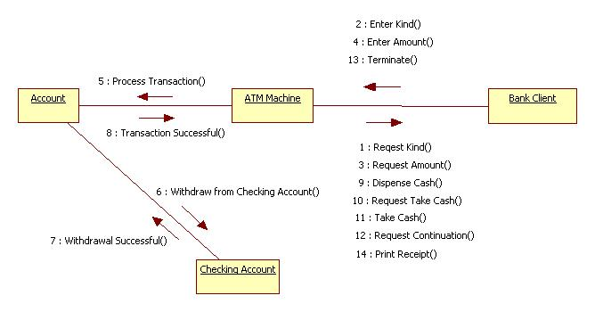
10 . SOFTWARE DIAGRAM
Software Diagram refers to a method for structured programming based on correspondences between data stream structures and program structure Jackson structure programing and data in terms of sequence , iterations and data selection
And as a consequence it is applied when designing a programs detailed control structure.

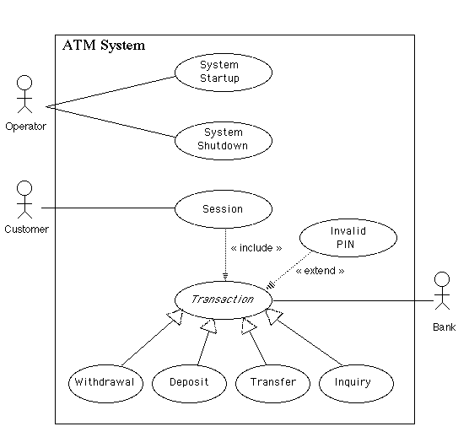
11 . SOFTWARE DESIGN AND STATE TRANSISTION DIAGRAM

Software Design is the process of conceptualize the software requirements into software implementation. This is the initial phase within the software development life cycle (SDK) shifting the concentration from the problem to the solution.
Software design includes all activities that said in the transformation from requirement specification to implementation major artifacts of the software design process include.
- Software required specification.
- High level diagram or design.
- Detailed Design.

State transaction diagrams describes all of the states that an object can have. The events under which an object changes state (transaction) the condition that must be fulfilled before the transistion will occur .
State transition diagrams are not useful for describing the collaboration between object that cause the transitions.
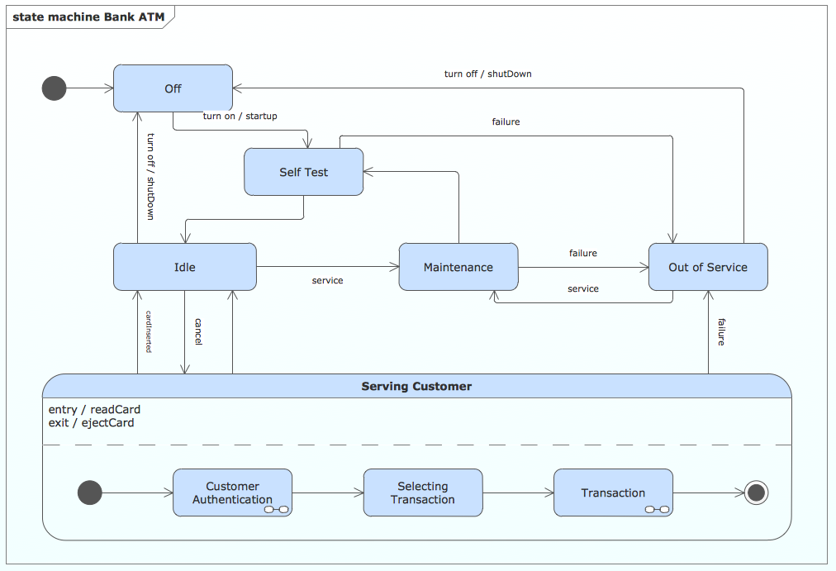

12 . COMPONENTS AND DEPLOYMENT

Components diagram are used to describe the components and deployment diagram shows how they are deployed in hardware .
Deployment diagram are used visualize the topology of the physical component are deployment .
Deployment diagram are used to control the following parameter.
Performance , scalability , maintainability portability.
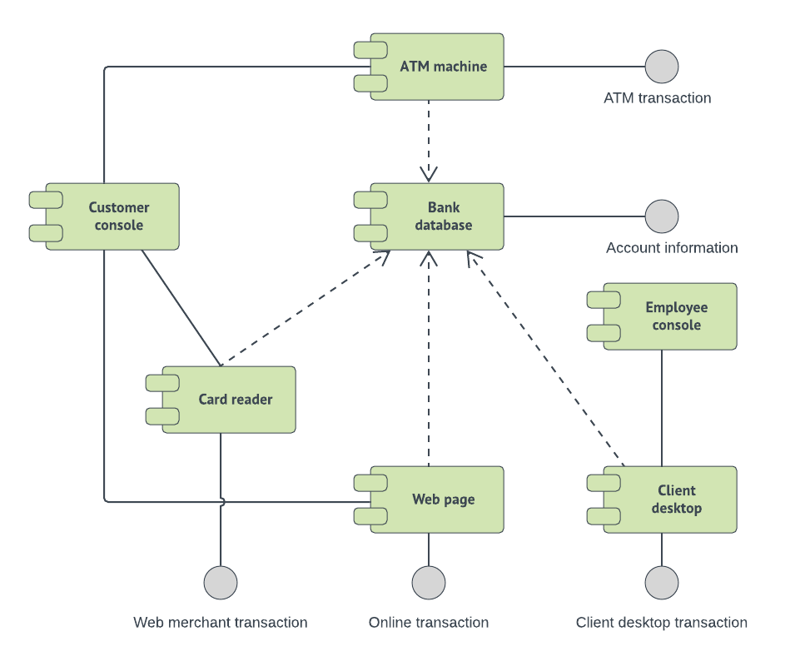

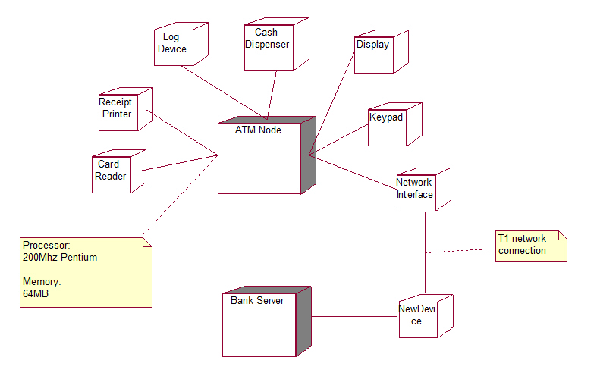
13.SOFTWARE TESTING
Software testing is an investigation conducted to provide stakeholders with information about the quality of the software product or service under test. Software testing can also provide an objective, independent view of the software to allow the business to appreciate and understand the risks of software implementation.
Test techniques include the process of executing a program or application with the intent of finding software bugs (errors or other defects), and verifying that the software product is fit for use.
Software testing involves the execution of a software component or system component to evaluate one or more properties of interest. In general, these properties indicate the extent to which the component or system under test
- Meets the requirements that guided its design and development,
- Responds correctly to all kinds of inputs,
- Performs its functions within an acceptable time,
- Is sufficiently usable,
- Can be installed and run in its intended environments, and
- Achieves the general result its stakeholders desire.
Testing levels:
1.Unit testing.
2.Integration Testing.
3.System testing.
4.operational acceptance testing

1.Unit testing:
Unit testing refers to tests that verify the functionality of a specific section of code, usually at the function level. In an object-oriented environment, this is usually at the class level, and the minimal unit tests include the constructors and destructor.^{41]}
These types of tests are usually written by developers as they work on code (white-box style), to ensure that the specific function is working as expected. One function might have multiple tests, to catch corner cases or other branches in the code. Unit testing alone cannot verify the functionality of a piece of software, but rather is used to ensure that the building blocks of the software work independently from each other.
Unit testing is a software development process that involves a synchronized application of a broad spectrum of defect prevention and detection strategies in order to reduce software development risks, time, and costs. It is performed by the software developer or engineer during the construction phase of the software development lifecycle. Unit testing aims to eliminate construction errors before code is promoted to additional testing; this strategy is intended to increase the quality of the resulting software as well as the efficiency of the overall development process.

2.Integration testing :
Integration testing is any type of software testing that seeks to verify the interfaces between components against a software design. Software components may be integrated in an iterative way or all together ("big bang"). Normally the former is considered a better practice since it allows interface issues to be located more quickly and fixed.
Integration testing works to expose defects in the interfaces and interaction between integrated components (modules). Progressively larger groups of tested software components corresponding to elements of the architectural design are integrated and tested until the software works as a system
3.System testing :
System testing tests a completely integrated system to verify that the system meets its requirements.For example, a system test might involve testing a logon interface, then creating and editing an entry, plus sending or printing results, followed by summary processing or deletion (or archiving) of entries, then logoff.

4.Operational acceptance testing :
Operational acceptance is used to conduct operational readiness (pre-release) of a product, service or system as part of a quality management system. OAT is a common type of non-functional software testing, used mainly in software development and software maintenance projects. This type of testing focuses on the operational readiness of the system to be supported, or to become part of the production environment. Hence, it is also known as operational readiness testing (ORT) or Operations readiness and assurance (OR&A) testing. Functional testing within OAT is limited to those tests that are required to verify the non-functional aspects of the system.
In addition, the software testing should ensure that the portability of the system, as well as working as expected, does not also damage or partially corrupt its operating environment or cause other processes within that environment to become inoperative.

14 . SOFTWARE DOCUMENT
Software documentation is written text or illustration that accompanies computer software or is embedded in the source code. It either explains how it operates or how to use it, and may mean different things to people in different roles.
Documentation is an important part of software engineering.
Types of documentation include:
- Requirements – Statements that identify attributes, capabilities, characteristics, or qualities of a system. This is the foundation for what will be or has been implemented.
- Architecture/Design – Overview of software. Includes relations to an environment and construction principles to be used in design of software components.
- Technical -Documentation of code, algorithms, interfaces, and APIs.
- End user- Manuals for the end-user, system administrators and support staff.
- Marketing - How to market the product and analysis of the market demand.

PREPRATION
LAB PERFORMANCE
REPORT
TOTAL
INITIAL OF FACULTY

Result:
Thus the case study of ATM system has been studied successfully.

Ex No: 2 | PAYROLL SYSTEM
Date : | PAYROLL SYSTEM

1.INTRODUCTION & PROJECT DEFINITION :
Payroll Management System is an important activity in any organization. The main objective of this project payroll management system is the manage the employees information of organization for a small group. It has to store all the records of every employee within the organization to assign work to person and right salary and perks to their eligible employees. It can also manage eligible employees information efficiently define the emduments , deductions, leave tax etc. , generate and manage the payroll process according to salary structure assigned to the employee etc. It keeps a track of employee attendance and on that basic it generates the monthly salary.
A payroll system calculates the amount you owe your employees based on factors such as the time they worked, their hourly wages or salaries, and whether they took vacation or holiday time during the pay period. The system adjusts gross pay by calculating and subtracting taxes and other withholding amounts. On payday, the system provides your employees with paper checks or payroll deposits and a summary of the information you used to calculate their gross and net wages.
Payroll reports can help a business manage one of its highest expenses - labor. A payroll system generates a multitude of reports for hourly and salaried employees. Many systems include reporting templates so managers can quickly and easily find out what their payroll costs are for any given period, and can check other important facts such as headcount, vacation balances, and the employees that are the highest and lowest earners.
Payroll Software often requires very little input from the employee. The Employee is required to input employee wage information and hours then the software calculate the information and performs with holding automatically.
2. SOFTWARE PROCESS OVERVIEW:
A software development process, also known as a software development lifecycle, is a structure imposed on the development of a software product. A software process is represented as a set of work phases that is applied to design and build a software product.The software that meets the specification is produced.
PHASE:
1.Planning
2.Analysis
3.Design
4.Development and Implementation
5.Testing
Planning:
Project planning is an organized and integrated management process, which focuses on activities required for successful completion of the project. It prevents obstacles that arise in the project such as changes in projects or organization's objectives, non-availability of resources, and so on. Project planning also helps in better utilization of resources and optimal usage of the allotted time for a project.
The other objectives of project planning are listed below.
- It defines the roles and responsibilities of the project management team members.
- It ensures that the project management team works according to the business objectives.
- It checks feasibility of the schedule and user requirements.
- It determines project constraints.

Analysis:
The steps involved in payroll processing typically include gathering employee time information for a selected time period, managing benefits & deductions, and distributing employee pay for that time period. Most companies use either a payroll software system for payroll, or else a third-party payroll processing service.
Here’s an overview of the steps to set up a brand new system for payroll processing.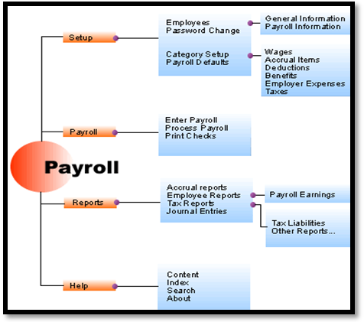
Employer Setup:
The word “Employer” can refer to two different scenarios. First, it can refer to a company in a database that processes its own payroll and issues its own payroll reports to tax entities and other parties. Some companies who have multiple entities for which to process payroll set up multiple companies for a single employer, though it is much more common for each company to be a separate employer.
The term “Employer” can also refer to a collection of companies in a system that process payroll but are part of a
Requirements - Place a checkmark to the left of each question when it is determined that the answer is “Yes.” This indicates that there is matches between the requirements trace ability matrix and the requirements addressed by this module.
Functionality - Place a checkmark to the left of each question when it is determined that the answer is “Yes.” This indicates that a complete narrative description of the module’s functionality is available, that a walk-through of the module’s design was conducted before the start of the programming, and that System Technical Lead approval was granted to begin the programming work.
Source Code - Place a checkmark to the left of the question when it is determined that a current copy of the program source listing has been placed in the folder.
Libraries, Directories, and Tables - Place a checkmark to the left of the question when it is determined that the program source code and copybook libraries and associated electronic tables are identified, and copies, as needed are in the folder.
Development Methodologies - Place a checkmark to the left of the question when it is determined that the programming methodology descriptions are all included in the folder.
Test Data - Place a checkmark to the left of each question when it is determined that the location and identity of all needed unit test data are included in the folder.
Test Analysis - Place a checkmark to the left of the question when it is determined that the unit has been thoroughly tested.
Sign-Off - Date and sign the certification for completion of coding and unit testing for the module.
If the same payroll processing entity. Payroll information is accumulated at the employer level. For example, an employee working in two different companies with the same database can receive one W-2 form.
During the setup of tax details, you will also set up workers’ compensation class codes. To determine which workers’ compensation class your company should choose, you should contact your accountant or legal professional who is knowledgeable about your company. As for unemployment, each employer is assigned its own unemployment rate, which is provided by the state.
Employer setup also involves telling the payroll system how many regular hours are in a week and in a day, how long a break is, etc. Set up minimum wage information that relates to your business. Next, move on to the setup of the earnings, deductions and benefits your company offers. Earnings tell the system the different types of earnings codes you have available for all employees, whether it’s hourly, salaried, piece work, bonus pay, overtime, etc.
Deductions/benefits codes define the benefits your company offers and other deductions for things like child support, insurance, etc. and how they are calculated, which will be used to calculate them for each employee. After setting up the employer within the payroll system, you are ready to begin adding employees, along with each employee’s personal information, which includes social security number, name and address information, and of course any optional information your company chooses to track for each employee. You will then choose pay information, and define how each employee will be paid, such as weekly, bi-weekly, monthly, etc. Tax information and workers’ compensation class codes are chosen, specific to each employee. Finally, the employee is set up for the method that will be used to pay them, whether it’s direct deposit, a printed check, pay card, or a combination of all three.
Tax Filing
When it comes to payroll, paying employees is the number one task, but filing payroll taxes is an extremely important measure that must be accurate and filed on time, or an employer can incur expensive penalties. There are a variety of ways to accomplish tax filing and make the process efficient. Some companies opt to use a payroll service, in which case, the filing is completely done for them, and the burden of remembering to file on time is taken off their shoulders. If filing is done internally, an employer may choose to purchase forms and print on the forms, or they may simply print the forms on plain paper, if the payroll system allows. Some systems may also allow for online payroll tax filing, which is becoming required by many states.
Once payroll is all set up, the job of processing payroll becomes a straightforward process. The process itself varies greatly among software systems and services, but the core of payroll processing involves collecting time information for applicable employees, selecting the employees to be paid, and printing checks or distributing direct deposit payments.
Design:
Software design is the process by which an agent creates a specification of a software artifact, intended to accomplish goals, using a set of primitive components and subject to constraints. Software design may refer to either "all the activity involved in conceptualizing, framing, implementing, commissioning, and ultimately modifying complex systems" or "the activity following requirements specification and before programming, a stylized software engineering process.
Software design usually involves problem solving and planning a software solution. This includes both a low-level component and algorithm design and a high-level, architecture design.
Software design is the process of implementing software solutions to one or more sets of problems.
One of the main components of software design is the software requirements analysis (SRA). SRA is a part of the software development process that lists specifications used in software engineering. If the software is "semi-automated" or user centered, software design may involve user experience design yielding a storyboard to help determine those specifications. If the software is completely automated (meaning no user or user interface), a software design may be as simple as a flow chart or text describing a planned sequence of events. There are also semi-standard methods like Unified Modeling Language and Fundamental modeling concepts. In either case, some documentation of the plan is usually the product of the design. Furthermore, a software design may be platform-independent or platform-specific, depending upon the availability of the technology used for the design.
The main difference between software analysis and design is that the output of a software analysis consists of smaller problems to solve. Additionally, the analysis should not be designed very differently across different team members or groups. In contrast, the design focuses on capabilities, and thus multiple designs for the same problem can and will exist. Depending on the environment, the design often varies, whether it is created from reliable frameworks or implemented with suitable design patterns. Design examples include operation systems, webpages, mobile devices or even the new cloud computing paradigm.
Software design is both a process and a model. The design process is a sequence of steps that enables the designer to describe all aspects of the software for building. Creative skill, past experience, a sense of what makes "good" software, and an overall commitment to quality are examples of critical success factors for a competent design. It is important to note, however, that the design process is not always a straightforward procedure; the design model can be compared to an architect’s plans for a house. It begins by representing the totality of the thing that is to be built (e.g., a three-dimensional rendering of the house); slowly, the thing is refined to provide guidance for constructing each detail (e.g., the plumbing lay). Similarly, the design model that is created for software provides a variety of different views of the computer software.

Development and implementation:
Payroll system development refers to the steps involved in setting up and processing payroll. It starts with basic decisions such as how often to pay employees and whether to use a manual or computerized system, and ends when you finish processing the first batch of payroll checks. Regardless of the system you ultimately decide to use, the development process is vital to ensuring that each payroll check processed is accurate and that your business complies with all applicable federal and state regulations.

Process Overview and Pre-Development Phase
Payroll system development can be easier to understand by grouping tasks into a series of development phases. These include pre-development activities, data collection, payroll processing, and payroll tax accounting and filing. Pre-development activities include researching Fair Labor Standards and laws for your state, as well as IRS and state tax rules and regulations. In addition, this phase involves reviewing payroll best practices and establishing internal controls that set the stage for developing a secure, efficient system. Final steps involve decisions about how often to pay employees and whether to record time and attendance manually or electronically.
Collecting and Organizing Data
Steps in the data collection phase include data collection policies and practices for both new hires and current employees. Procedures for new hires facilitate the collection and organization of initial paperwork such as W-4, I-9 employment eligibility verification, insurance and retirement plan forms, as well as procedures for submitting new-hire paperwork to the appropriate federal and state agencies. Drafting written procedures current employees must follow when modifying their personal, contact or tax information is also a requirement.
The data collection phase ends by establishing procedures for submitting and verifying employee timecard information.
Payroll Processing
Decisions regarding the type of payroll system and procedures for creating, printing and distributing paychecks are the main objectives of the payroll processing phase. For many small businesses, a computerized payroll system is the best choice, as it not only decreases processing time, but also increases accuracy. Options for distributing payroll include printing paychecks or directly depositing checks into an employee’s bank account. While each option has advantages and disadvantages, if your business has 10 or more employees on staff, you may find the direct-deposit option a more cost-effective option.
This will include a definitive test plan which will identify the major functions of the systems software and hardware to be tested as well as the required system outcomes. Secondly, the installation process and training plan summary will be identified. For this portion of the writing, a Gantt chart will be used to identify the steps and related resources needed to implement the system. A narrative explanation that will discuss the impacts of time and conversion will be included. A description of the training plan will also be outlined. The third section of this writing will summarize the company documentation plan.
This test will consist of one hundred deliveries and will be completed by the database administrator (DBA). When this test is completed with no errors in the delivery route reports, the next portion of the system can be tested. The test for the accounting system will use the same mock delivery schedule to ensure that all mileage amounts are correctly calculated. The DBA will also send data through the network to ensure that the mileage calculations are formatted properly to work with the accounting system. After the webpage has been created by the IT generalist and the DBA, several employees will be selected at random to test the security of the system. The intended results will be that no other employee's information can be accessed without the proper password, the information retrieved is correct, only pre-defined fields are available for editing, and edited fields are properly updated in the database. The next test will be a system test linking all parts of the data flow process from customer requests all the way through to uploading paychecks to the bank.
The payroll cycles that are being tested should reflect normal payroll cycles.
Running parallel testing during cycles in which there are numerous salary increases or several new hires may needlessly increase the likelihood of errors. Running parallel testing during cycles in which there are less than the standard number of payroll transactions, such as the holidays, may not give an adequate representation of how well the system will perform during normal payroll cycles.
The standard number of payroll cycles used for parallel testing is two. It is best for these two payroll cycles to be completed consecutively. This will ensure that all errors can be spotted, corrected and re-run immediately.
Organizations have different needs and capabilities, however, so the optimal time and methods for parallel testing may vary.
3)SOFTWARE PROJECT PLANNING:
The goal of the software is to allow employees to view their gross pay in a timely fashion and to reduce workload, manual errors and maintaining the employees records I an organized manner.
Definition:
Project planning is part of project management, which relates to the use of schedules such as Gantt charts to plan and subsequently report progress within the project environment.
Stages of project planning:
- Project Initiation.
- Project Planning.
- Project Execution.
- Project Monitoring and Control.
4)SOFTWARE REQUIREMENT SPECIFICATIONS:
A software requirements specification (SRS) is a description of a software system to be developed. It is modeled after business requirements specification(CONOPS), also known as a stakeholder requirements specification (StRS).[citation needed] The software requirements specification lays out functional and non-functional requirements, and it may include a set of use cases that describe user interactions that the software must provide.
Software requirements specification establishes the basis for an agreement between customers and contractors or suppliers on how the software product should function (in a market-driven project, these roles may be played by the marketing and development divisions). Software requirements specification is a rigorous assessment of requirements before the more specific system design stages, and its goal is to reduce later redesign. It should also provide a realistic basis for estimating product costs, risks, and schedules. Used appropriately, software requirements specifications can help prevent software project failure.
The software requirements specification document lists sufficient and necessary requirements for the project development.To derive the requirements, the developer needs to have clear and thorough understanding of the products under development.
This is achieved through detailed and continuous communications with the project team and customer throughout the software development process.
5)INTRODUCTION TO UML AND USE CASE DIAGRAM:
Use-Case Diagram:
An Introduction. Unified Modeling Language (UML) is a general purpose modelling language. The main aim of UML is define a standard way to visualize the way a system has been designed. It is quite similar to blueprints used in other fields of engineering
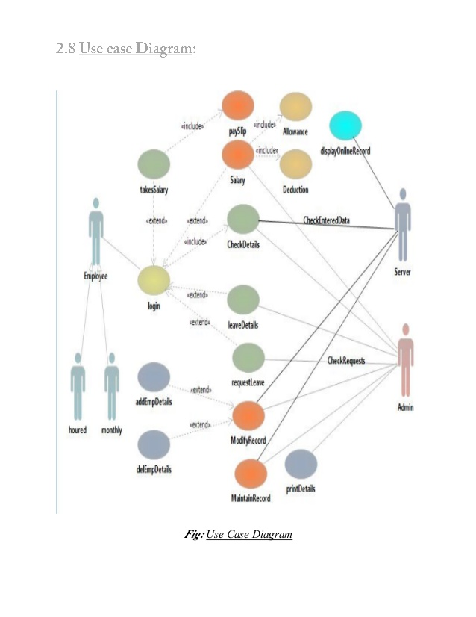

Fig:Use case diagram
6)SYSTEM MODELLING:
Systems modeling or system modeling is the interdisciplinary study of the use of models to conceptualize and construct systems in business and IT development.A common type of systems modeling is function modeling, with specific techniques such as the Functional Flow Block Diagram and IDEF0. These models can be extended using functional decomposition, and can be linked to requirements models for further systems partition. Contrasting the functional modeling, another type of systems modeling is architectural modeling which uses the systems architecture to conceptually model the structure, behavior, and more views of a system. The Business Process Modeling Notation (BPMN), a graphical representation for specifying business processes in a workflow, can also be considered to be a systems modeling language.
7)ACTIVITY AND FLOW OF EVENTS DIAGRAMS:
Flow of events are the steps required to perform within a use case. Now, with Visual Paradigm, you can define complex flow structure by specifying control flows, such as if, while and jump, within the steps. A use case diagram is a graphic depiction of the interactions among the elements of a system. A use case is a methodology used in system analysis to identify, clarify, and organize system requirements. The actors, usually individuals involved with the system defined according to their roles.
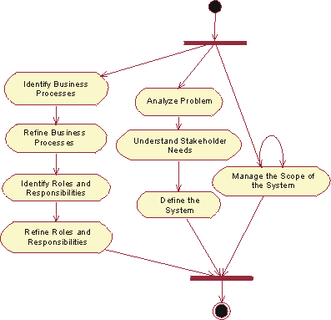

Fig: Activity diagram

8)OBJECT ORIENTED ANALYSIS:
Most basic component of OO Design. Objects are designed to do a small, specific piece of work. Objects represent the various components of a business system. Data items that differentiate one object of the class from another. Characteristics of an object that have values, named,self-contained blocks of code that typically operate.
9)ITERACTIVE DIAGRAMS:
Interaction diagrams are models that describe how a group of objects collaborate in some behavior - typically a single use-case. The diagrams show a number of example objects and the messages that are passed between these objects within the use-case. Interaction diagrams come in two forms, both present in the UML. The first form is the sequence diagram. In this form objects are shown as vertical lines with the messages as horizontal lines between them. This form was first popularized by Jacobson.

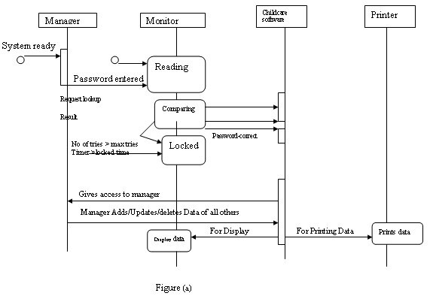
10)SOFTWARE DIAGRAMS:
Software Diagram refers to a method for structured programming based on correspondences between data stream structure and program structure. Jackson structured programming and data in terms of sequences, iterations and selections, and as a consequence it is applied when designing a program's detailed control structure.

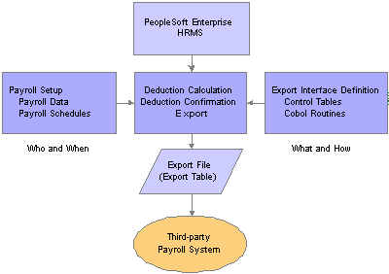

11)SOFTWARE DESIGN AND STATE TRANSISTION DIAGRAMS:
Software design is the process of envisioning and defining software solutions to one or more sets of problems. One of the main components of software design is the software requirements analysis (SRA). SRA is a part of the software development process that lists specifications used in software engineering. If the software is "semi-automated" or user centered, software design may involve user experience design yielding a storyboard to help determine those specifications. If the software is completely automated (meaning no user or user interface), a software design may be as simple as a flow chart or text describing a planned sequence of events. There are also semi-standard methods like Unified Modeling Language and Fundamental modeling concepts. In either case, some documentation of the plan is usually the product of the design. Furthermore, a software design may be platform-independent or platform-specific, depending upon the availability of the technology used for the design.
The main difference between software analysis and design is that the output of a software analysis consists of smaller problems to solve. Additionally, the analysis should not be designed very differently across different team members or groups. In contrast, the design focuses on capabilities, and thus multiple designs for the same problem can and will exist. Depending on the environment, the design often varies, whether it is created from reliable frameworks or implemented with suitable design patterns. Design examples include operation systems, web pages , mobile devices or even the new cloud computing paradigm.
State diagrams are used to give an abstract description of the behavior of a system. This behavior is analyzed and represented as a series of events that can occur in one or more possible states. Hereby "each diagram usually represents objects of a single class and track the different states of its objects through the system"

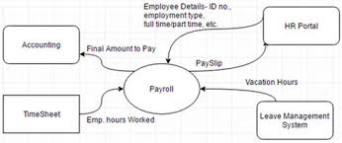\

The System Software process begins with the planning initiation step. In this step a software project manager is selected and resources and budget are allocated to the planning and replanning activities.
The Requirements Management (RM) Guidebook is an interfacing process to the SPP process. Requirements are the major driving force in SPP and therefore are a major interface to this process. Without requirements, you would not know what to plan or what to estimate. Initial software estimates and software activities are also developed in this step. The SSC San Diego Software Size, Cost, and Schedule Estimation process is an interfacing process.

12)COMPONENT AND DEPLOYMENT:
It describes the organization and wiring of physical components in a system. It is often drawn to help model implementation details and double check that every aspect of the systems required functions is covered by planning development.

13)SOFTWARE TESTING:
Based on this payroll software testing is critical it ensures that the new payroll software it accurately calculating the payroll.While the payroll output from both software need not be exactly same ,there should not be any unexplained large discompanies. Hence running a payroll software testing is to prevent any large discrepancies once the new payroll software goes alive ,thus ensuring that the transition to the new payroll software. Software testing is an investigation conducted to provide stakeholders with information about the quality of the software product or service under test.
In general, these properties indicate the extent to which the component or system under test meets the requirements that guided its design and development,responds correctly to all kinds of inputs,performs its functions within an acceptable time,is sufficiently usable,can be installed and run in its intended environments, and achieves the general result its stakeholders desire.
Testing levels:
- Unit testing.
- Integration testing.
- System testing.
- Operational acceptance testing

Unit Testing:
Unit testing refers to tests that verify the functionality of a specific section of code, usually at the function level. In an object-oriented environment, this is usually at the class level, and the minimal unit tests include the constructors and destructor.
Unit testing is a software development process that involves a synchronized application of a broad spectrum of defect prevention and detection strategies in order to reduce software development risks, time, and costs. It is performed by the software developer or engineer during the construction phase of the software development lifecycle. Unit testing aims to eliminate construction errors before code is promoted to additional testing; this strategy is intended to increase the quality of the resulting software as well as the efficiency of the overall development process.
Integration testing:
Integration testing is any type of software testing that seeks to verify the interfaces between components against a software design. Software components may be integrated in an iterative way or all together ("big bang"). Normally the former is considered a better practice since it allows interface issues to be located more quickly and fixed.Integration testing works to expose defects in the interfaces and interaction between integrated components (modules). Progressively larger groups of tested software components corresponding to elements of the architectural design are integrated and tested until the software works as a system
System testing:
System testing tests a completely integrated system to verify that the system meets its requirements.For example, a system test might involve testing a logon interface, then creating and editing an entry, plus sending or printing results, followed by summary processing or deletion (or archiving) of entries, then logoff.In addition, the software testing should ensure that the portability of the system, as well as working as expected, does not also damage or partially corrupt its operating environment or cause other processes within that environment to become inoperative.
14)SOFTWARE DOCUMENTATION:
To start the document plan, outline the purpose , scope and objectives. you must also describe the information to be escaped and how will you store, manage and share the other major part of the document focuses on who will help develop the documents and also guidelines on the style, format, security and sharing.
Software documentation is written text or illustration that accompanies computer software or is embedded in the source code. It either explains how it operates or how to use it, and may mean different things to people in different roles.
Types of documentation include:
- Requirements– Statements that identify attributes capabilities, characteristics, or qualities of a system. This is the foundation for what will be or has been implemented.
- Architecture/Design – Overview of software. Includes relations to an environment and construction principles to be used in design of software components.
- Technical – Documentation of code, algorithms, interfaces.
- End user – Manuals for the end-user, system administrators and support staff.
- Marketing – How to market the product and analysis of the market demand.

DOCUMENT OVERVIEW:
The document provides the user with a comprehensive description of the hardware and software provided in the matrix read system, including system description, detailed design features, software GUI and DLL drives description. Overview section gives a brief description of the system outlines its main features and application.

PREPRATION
LAB PERFORMANCE
REPORT
TOTAL
INITIAL OF FACULTY

Result:
Thus the case study of PAYROLL SYSTEM has been studied successfully.

Ex No: 3 | HOSPITAL MANAGEMENT SYSTEM
Date : | HOSPITAL MANAGEMENT SYSTEM

INTRODUCTION & PROJECT DEFINITION:
An integrated hospital management system(IHMS), also known as a, Hospital management System is an enterprise resource planning system for a Hospital, used to track patients and doctor details and their admission and mediaction details also about their payment levels, hospital tasks were performed manually and independently from one another. The next big innovation came with the advent of MARC standardsin the 1960s, which coincided with the growth of computer technologies Hospital automation was born. The 1970s can be characterized by improvements in computer storage, as well as in telecommunications. As a result of these advances, ‘turnkey systems on microcomputers, known more commonly as integrated hospital management systems (IHMS) finally appeared. With the evolution of the Internet throughout the 1990s and into the 2000s, IHMSs began allowing users to more actively engage with their libraries through OPACs and online web-based portals. Users could log into their patients accounts to reserve or appoint a particular doctor, as well as authenticate themselves for access to hospital (Doctors)-subscribed online databases. Inevitably, during this time, the IHMS market grew exponentially.By the mid to late 2000s, IHMS vendors had increased not only the number of services offered but also their prices, leading to some dissatisfaction among many smaller Hospitals. At the same time, open source IHMS was in its early stages of testing.
2. SOFTWARE PROCESS OVERVIEW:
Definition:
A software development process, also known as a software development lifecycle, is a structure imposed on the development of a software product. A software process is represented as a set of work phases that is applied to design and build a software product. The software that meets the specification is produced.
Phases:
1. Planning
2. Analysis
3. Design
4. Development &implementation.
5. Testing.
6. Maintanance

3.PROJECTPLANNING:
Project planning is part of project management, which relates to the use of schedules such as Gantt charts to plan and subsequently report progress within the project environment.
Stages of project planning:
- Project Initiation.
- Project Planning.
- Project Execution.
- Project Monitoring and Control.
1. Project Initiation:
The Project Initiation Phase is the 1st phase in the Project Management Life Cycle, as it involves starting up a new project. You can start a new project by defining its objectives, scope, purpose and deliverables to be produced. ... Only with a clearly defined scope and a suitably skilled team, can you ensure success. The project initiation phase is first phase of life cycle. This phase involves creating a complete plan for the project, specifying various activities that will be performed and assigning responsibilities to team members on the basis of their skill set.
2.Project Planning:
Project planning is part of project management, which relates to the use of schedules such as Gantt charts to plan and subsequently report progress within the project environment.
3. Project Execution:
After the project plan is made and the responsibilities assigned, the actual development of the project starts. The phase in which the actual development of the project takes place is known as the project execution phase
4. Project Monitoring and Control:
Project Monitoring refers to the process of keeping track of all project-related metrics including team performance and task duration, identifying potential problems and taking corrective actions necessary to ensure that the project is within scope, on budget and meets the specified deadlines.The Monitoring and Controlling Process Group consists of those processes required to track, review, and orchestrate the progress and performance of a project; identify any areas in which changes to the plan are required; and initiate the corresponding changes.

4.SOFTWARE REQUIREMENT SPECIFICATION:
A software requirements specification (SRS) is a description of a software system to be developed. It is modeled after business requirements specification (CONOPS), also known as a stakeholder requirements specification.The good requirement should have these 6 characteristics

- Complete
- Consistent
- Feasible
- Modifiable
- Unambiguous.
- Testable
5.INTRODUCTION TO UML AND USE CASE DIAGRAM:
An Introduction. Unified Modeling Language (UML) is a general purpose modelling language. The main aim of UML is define a standard way to visualize the way a system has been designed. It is quite similar to blueprints used in other fields of engineering.

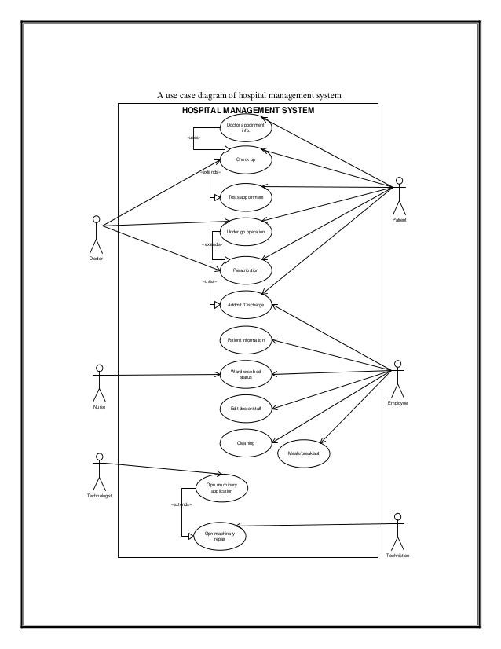

6. SYSTEM MODELLING:
System modeling is the interdisciplinary study of the use of models to conceptualize and construct systems in business and IT development. A common type of systems modeling is function modeling, with specific techniques such as the Functional Flow Block Diagram and IDEF0.
There are some modeling:
1. Functional modeling
2. System modelling
3. Business process modeling
1. Functional modelling:
A function model or functional model in systems engineering and software engineering is a structured representation of the functions within the modeled system or subject area.
2. System modelling:
A system architecture or system architecture is the conceptual model that defines the structure and behavior and more views of a system.
3.Business process modelling:
Business process modeling (BPM) in business process management and systems engineering is the activity of representing processes of an enterprise, so that the current process may be analysed, improved, and automated.

7.FLOW OF EVENTS AND ACTIVITY DIAGRAM :
Flow of events are the steps required to perform within a use case. Now, with Visual Paradigm, you can define complex flow structure by specifying control flows, such as if, while and jump, within the steps..
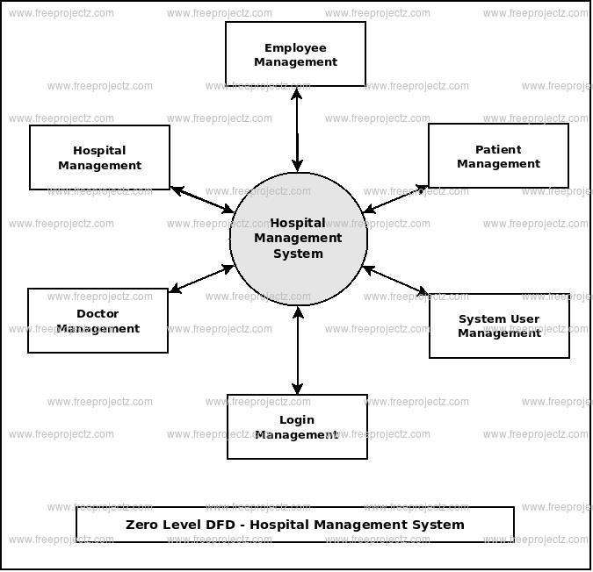

8.OBJECT ORIENTED ANALYSIS DISCOVERING CLASSES:
In general, analysis is the investigation of the problem and requirements.
Consider an Online hospital management system in which the patients can register their doctors and know their medications exactly

1.During object oriented analysis we can identify objects such as patients,doctors,nurses etc.

2.During implementation, say in Java, all these conceptual objects with their properties and behaviour are converted to classes with attributes and methods respectively.

9.INTERACTION DIAGRAM:
Interaction diagrams are models that describe how a group of objects collaborate in some behavior - typically a single use-case. The diagrams show a number of example objects and the messages that are passed between these objects within the use-case. Interaction diagrams come in two forms, both present in the UML. The first form is the sequence diagram. In this form objects are shown as vertical lines with the messages as horizontal lines between them.

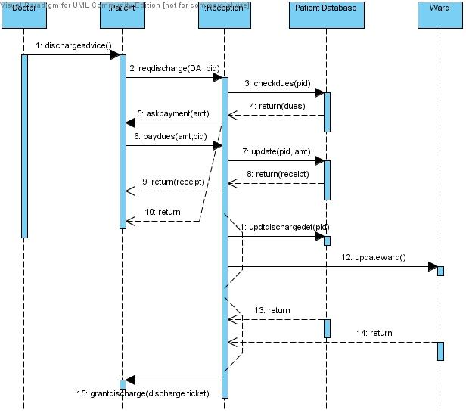

10.SOFTWARE DIAGRAM:
Software Diagram refers to a method for structured programming based on correspondences between data stream structure and program structure. Jackson structured programming and data in terms of sequences, iterations and selections, and as a consequence it is applied when designing a program's detailed control structure.

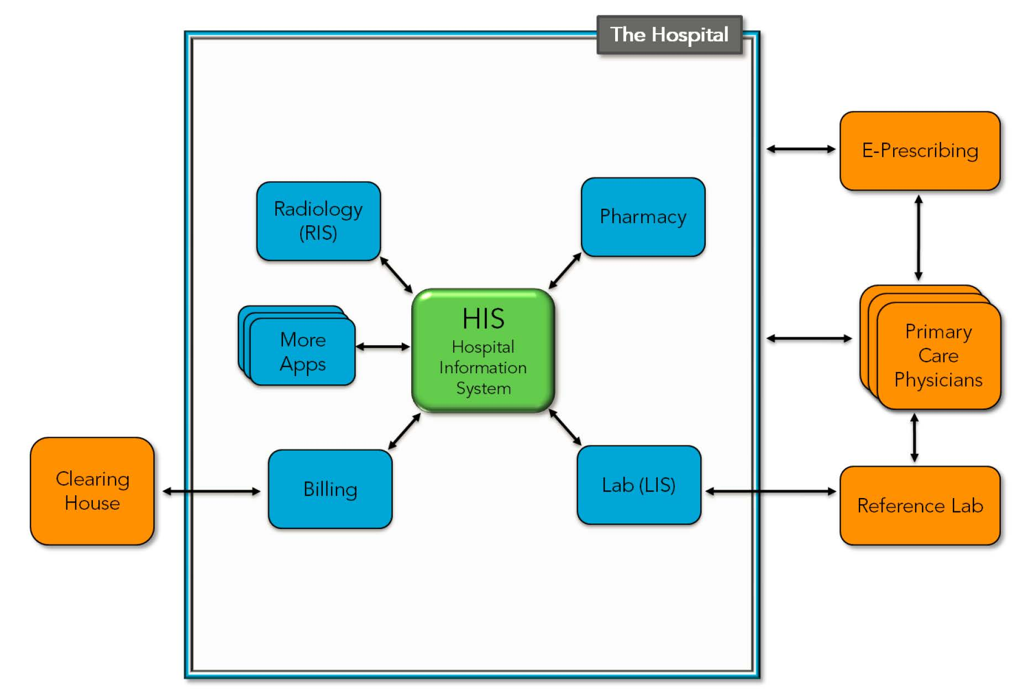

11.SOFTWARE DESIGN AND STATE TRANSITION DIAGRAM:

Software design is the process of envisioning and defining software solutions to one or more sets of problems. One of the main components of software design is the software requirements analysis (SRA). SRA is a part of the software development process that lists specifications used in software engineering. Additionally, the analysis should not be designed very differently across different team members or groups. In contrast, the design focuses on capabilities, and thus multiple designs for the same problem can and will exist. Depending on the environment, the design often varies, whether it is created from reliable frameworks or implemented with suitable design patterns. Design examples include operation systems, webpages, mobile devices or even the new cloud computing paradigm.
12.COMPONENT & DEPLOYEMENT:
Software deployment is all of the activities that make a software system available for use.The general deployment process consists of several interrelated activities with possible transitions between them. These activities can occur at the producer side or at the consumer side or both.. Therefore, "deployment" should be interpreted as a general process that has to be customized according to specific requirements or characteristics

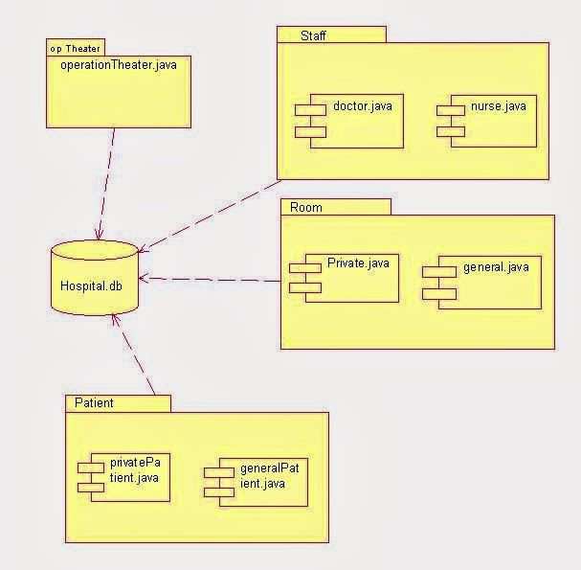

13.SOFTWARE TESTING:
Software testing is an investigation conducted to provide stakeholders with information about the quality of the software product or service under test.Software testing can also provide an objective, independent view of the software to allow the business to appreciate and understand the risks of software implementation. Test techniques include the process of executing a program or application with the intent of finding software bugs (errors or other defects), and verifying that the software product is fit for use.
14)SOFTWARE DOCUMENTATION:
To start the document plan, outline the purpose , scope and objectives. you must also describe the information to be escaped and how will you store, manage and share the other major part of the document focuses on who will help develop the documents and also guidelines on the style, format, security and sharing. It either explains how it operates or how to use it, and may mean different things to people in different roles.

PREPRATION
LAB PERFORMANCE
REPORT
TOTAL
INITIAL OF FACULTY

Result:
Thus the case study of HOSPITAL MANAGEMENT has been studied successfully.
Ex No: 4 | PASSPORT AUTOMATION SYSTEM
Date : | PASSPORT AUTOMATION SYSTEM

1.INTRODUCTION & PROJECT DEFINITION:
A passport is a travel document, usually issued by a country's government, that certifies the identity and nationality of its holder primarily for the purpose of international travel. Standard passports may contain information such as the holder's name, place and date of birth, photograph, signature, and other identifying information. Many countries are moving towards including biometric information in a microchip embedded in the passport, making them machine-readable and difficult to counterfeit. As of 2017, there are over 120 jurisdictions issuing these e-Passports. Previously issued passports usually remain valid until each expires.
A passport holder is normally entitled to enter the country that issued the passport, though some people entitled to a passport may not be full citizens with right of abode. A passport does not of itself create any rights in the country being visited or obligate the issue country in any way, such as providing consular assistance. Some passports attest to status as a diplomat or other official, entitled to rights and privileges such as immunity from arrest or prosecution.
2. SOFTWARE PROCESS OVERVIEW:
Definition:
A software development process, also known as a software development lifecycle, is a structure imposed on the development of a software product. A software process is represented as a set of work phases that is applied to design and build a software product.The software that meets the specification is produced.
Phases:
1. Planning
2. Analysis
3. Design
4. Development &implementation.
5. Testing.
6. Maintaince
3. PROJECT PLANNING:
Definition:
Project planning is part of project management, which relates to the use of schedules such as Gantt charts to plan and subsequently report progress within the project environment.
Software requirement analysis:
This is the first stage of the project which involves interaction with the customers to understand his/her needs requirements ,information requirement function performance and interacting in HTML software.

4.SOFTWARE REQUIREMENT SPECIFICATION:
A software requirements specification (SRS) is a description of a software system to be developed. It is modeled after business requirements specification (CONOPS), also known as a stakeholder requirements specification.The good requirement should have these 6 characteristics
- Complete
- Consistent
- Feasible
- Modifiable
- Unambiguous.
- Testable
5.INTRODUCTION TO UML AND USE CASE DIAGRAM:
An Introduction. Unified Modeling Language (UML) is a general purpose modelling language. The main aim of UML is define a standard way to visualize the way a system has been designed. It is quite similar to blueprints used in other fields of engineering.

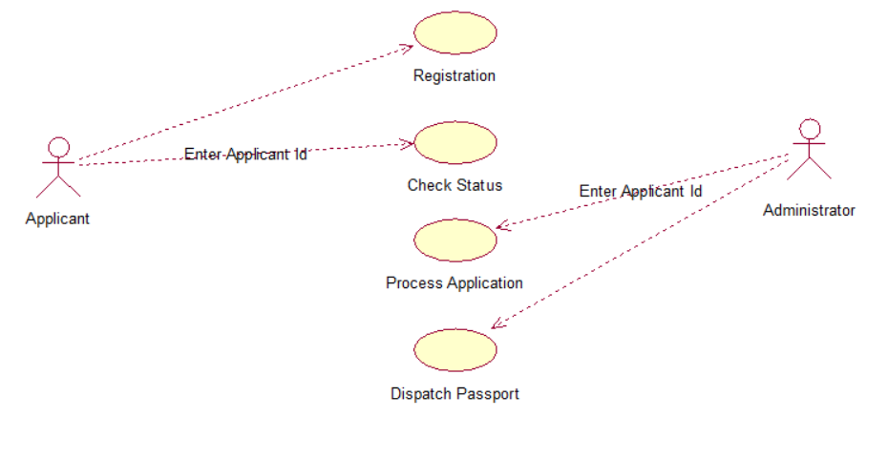
6. SYSTEM MODELLING:
System modeling is the interdisciplinary study of the use of models to conceptualize and construct systems in business and IT development. A common type of systems modeling is function modeling, with specific techniques such as the Functional Flow Block Diagram and IDEF0.
There are some modeling:
1. Functional modeling
2. System modelling
3. Business process modelling

7.FLOW OF EVENTS AND ACTIVITY DIAGRAM :
Flow of events:
Flow of events are the steps required to perform within a use case. Now, with Visual Paradigm, you can define complex flow structure by specifying control flows, such as if, while and jump, within the steps.. It is the sequence of events that happens in the software development process.
The event flow diagram consist of event rule groups and business steps. The main purpose of this diagram is to identify and develop the documentation.

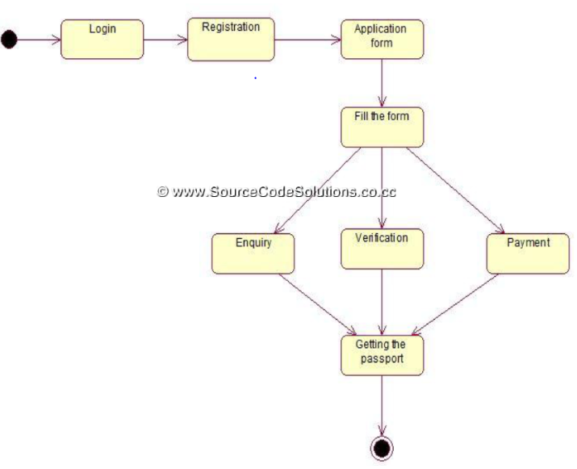

The events involved in passport management system is as follows:
- Login
- Registration
- Fill the form
- Enquiry
- Verification
- Payment
- Getting the passport

Activity diagram :

Activity diagram is another representation in UML to describe dynamic aspects of the system. Activity diagram is basically a flowchart to represent the flow from one activity to another activity. The activity can be described as an operation of the system. The control flow is drawn from one operation to another.
In the unified modeling language activity diagram are intended to model both computational and organizational process as well as the data focus intersecting with the related activities

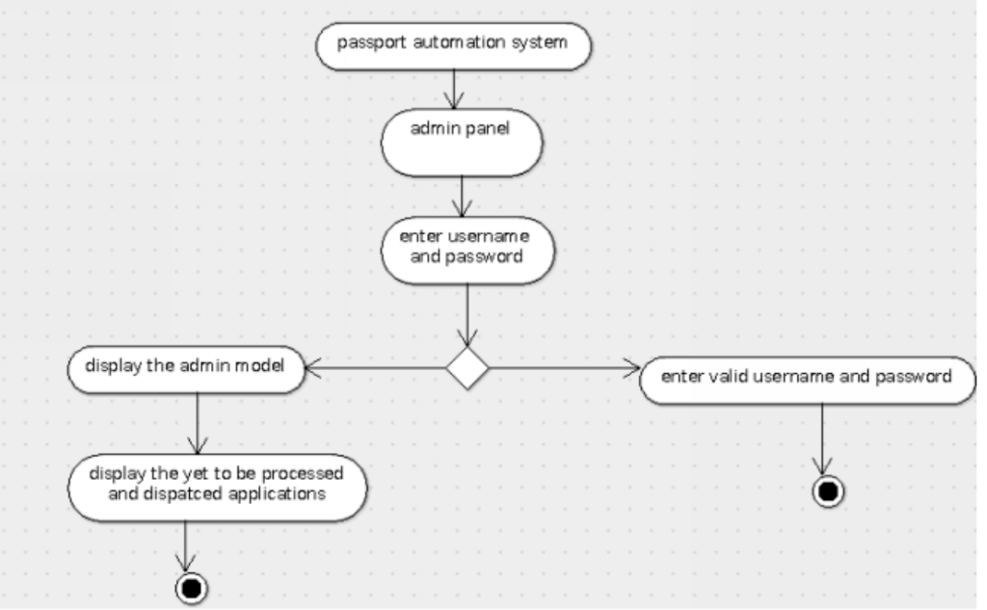

8.OBJECT ORIENTED ANALYSIS DISCOVERING CLASSES:
In general, analysis is the investigation of the problem and requirements.
In object-oriented software design(OOD),classes are templates for definingthe characteristics and operations of an object. Often classes and objects are used inter changeably, one synonymous with the other. In actuality a class is aspecification that an object implements.

1.During object oriented analysis we can identify objects such as applicant, application, registration, admin etc.

2.During object oriented design, we can create conceptual models with properties, behaviours and relationships for the objects identified during analysis

3.Finally, during implementation, say in Java, all these conceptual objects with their properties and behaviour are converted to classes with attributes and methods respectively.
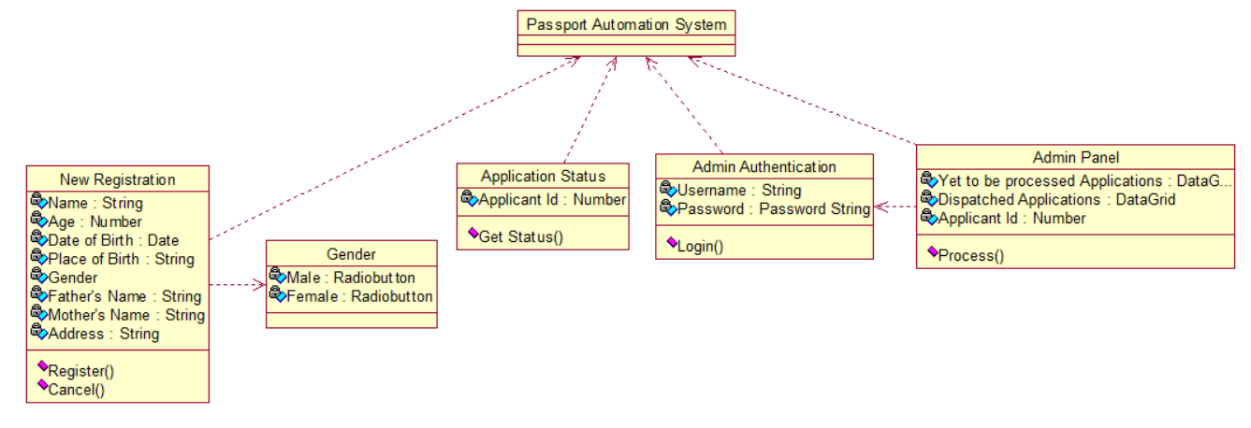
8. INTERACTION DIAGRAM:
Interaction diagrams are models that describe how a group of objects collaborate in some behavior - typically a single use-case. The diagrams show a number of example objects and the messages that are passed between these objects within the use-case. Interaction diagrams come in two forms, both present in the UML. The first form is the sequence diagram.

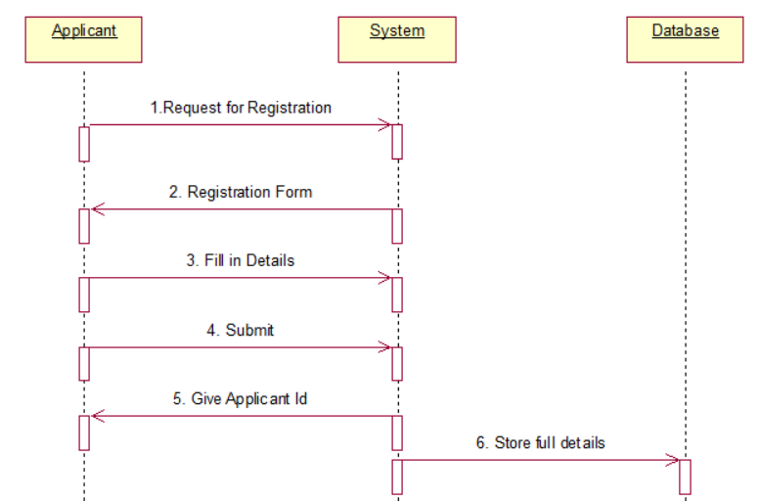
10. SOFTWARE DIAGRAM:
Software Diagram refers to a method for structured programming based on correspondences between data stream structure and program structure. Jackson structured programming and data in terms of sequences, iterations and selections, and as a consequence it is applied when designing a program's detailed control structure. Program flowchart is a diagram which uses a set of standard graphic symbols to represent the sequence of coded instruction feed into a computer,enabling it to perform specified logical and arithmetical operations. End event symbol stands for the result of a process.
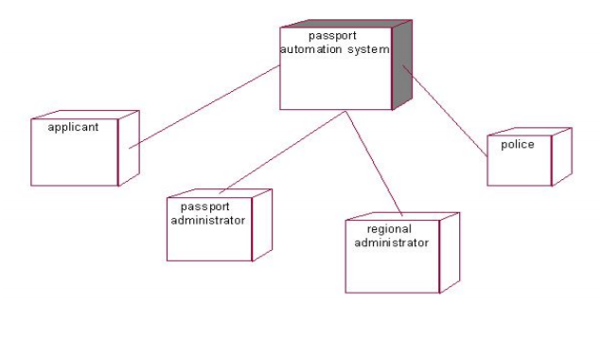
11.SOFTWARE DESIGN AND STATE TRANSITION DIAGRAM:
Software design:
Software design is the process by which an agent creates a specification of a software artifact, intended to accomplish goals, using a set of primitive components and subject to constraints. software design may refer to either “all the activity involved in conceptualizing, framing, implementing, commissioning and ultimately modify complex systems”.Software design usually involves problem solving and planning a software solution,this includes both a low-level component and algorithm design and algorithm design and a high-level architecture design.
state transition diagram:
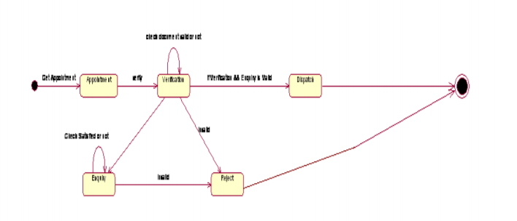

12. COMPONENT AND DEPLOYMENT:
The deployment of enterprise software involves many more roles, and those roles typically change as the application progresses from test (pre-production) to production environments. Component diagram are one of the two kind of diagram found in modeling the physical aspects of object oriented system.A component diagram shows the organization and inter relationship between a set of component.We use component diagram to visualize the static aspect of the physical component and their relationship and to specify their details for construction.Component diagram is essentially class diagram that focus on a system’s component.Here there are three components in passport automation system. They are applicants, system admin and authority.
Component diagram:

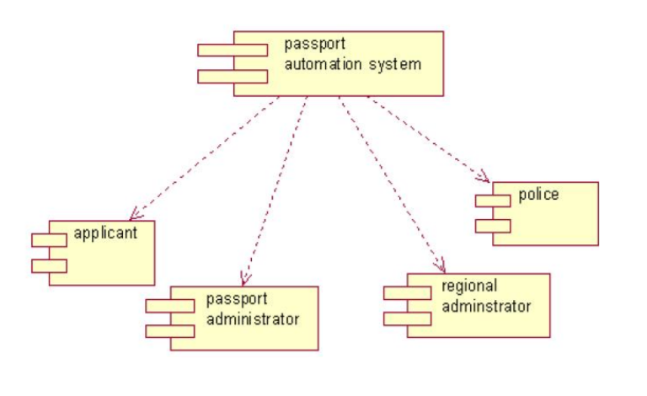
Deployment diagram:
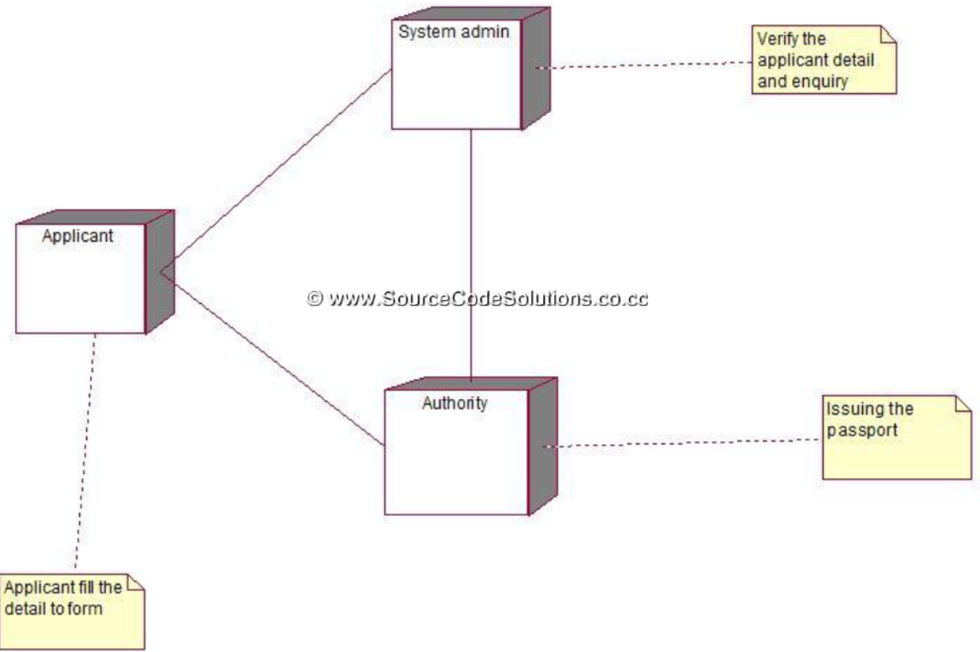

13. SOFTWARE TESTING:
Software testing is an investigation conducted to provide stakeholders with information about the quality of the software product or service under test. Software testing can also provide an objective, independent view of the software to allow the business to appreciate and understand the risks of software implementation. Test techniques include the process of executing a program or application with the intent of finding software bugs (errors or other defects), and verifying that the software product is fit for use.
14. SOFTWARE DOCUMENT:
Software documentation is a written text or illustration that accompanies computer software or is embedded in the source code. It either explains how it operates or how to use it. It may mean different things to people in different roles. Documentation is an important part of software engineering.

PREPRATION
LAB PERFORMANCE
REPORT
TOTAL
INITIAL OF FACULTY

Result:
Thus the case study of PASSPORT AUTOMATION SYSTEM has been studied successfully.

Ex No: 5 | LIBRARY MANAGEMENT SYSTEM
Date : | LIBRARY MANAGEMENT SYSTEM

INTRODUCTION & PROJECT DEFINITION:
An integrated library system (ILS), also known as a library management system (LMS), is an enterprise resource planning system for a library, used to track items owned, orders made, bills paid, and patrons who have borrowed. Prior to computerization, library tasks were performed manually and independently from one another. Selectors ordered materials with ordering slips, cataloguers manually catalogued sources and indexed them with the card catalog system (in which all bibliographic data was kept on a single index card), fines were collected by local bailiffs, and users signed books out manually, indicating their name on cards which were then kept at the circulation desk. The next big innovation came with the advent of MARC standardsin the 1960s, which coincided with the growth of computer technologies library automation was born.The 1970s can be characterized by improvements in computer storage, as well as in telecommunications. As a result of these advances, ‘turnkey systems on microcomputers, known more commonly as integrated library systems (ILS) finally appeared. With the evolution of the Internet throughout the 1990s and into the 2000s, ILSs began allowing users to more actively engage with their libraries through OPACs and online web-based portals. Users could log into their library accounts to reserve or renew books, as well as authenticate themselves for access to library-subscribed online databases. Inevitably, during this time, the ILS market grew exponentially.By the mid to late 2000s, ILS vendors had increased not only the number of services offered but also their prices, leading to some dissatisfaction among many smaller libraries. At the same time, open source ILS was in its early stages of testing.
2. SOFTWARE PROCESS OVERVIEW:
Definition:
A software development process, also known as a software development lifecycle, is a structure imposed on the development of a software product. A software process is represented as a set of work phases that is applied to design and build a software product.The software that meets the specification is produced.
Phases:
1. Planning
2. Analysis
3. Design
4. Development&implementation.
5. Testing.
6. Maintaince
3. PROJECT PLANNING:
Definition:
Project planning is part of project management, which relates to the use of schedules such as Gantt charts to plan and subsequently report progress within the project environment.
Stages of project planning:
- Project Initiation.
- Project Planning.
- Project Execution.
- Project Monitoring and Control.
4.SOFTWARE REQUIREMENT SPECIFICATION:
A software requirements specification (SRS) is a description of a software system to be developed. It is modeled after business requirements specification (CONOPS), also known as a stakeholder requirements specification. The good requirement should have these 6 characteristics
- Complete
- Consistent
- Feasible
- Modifiable
- Unambiguous.
- Testable
5.INTRODUCTION TO UML AND USE CASE DIAGRAM:
An Introduction. Unified Modeling Language (UML) is a general purpose modelling language. The main aim of UML is define a standard way to visualize the way a system has been designed. It is quite similar to blueprints used in other fields of engineering.
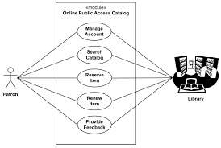

6. SYSTEMMODELLING:
System modeling is the interdisciplinary study of the use of models to conceptualize and construct systems in business and IT development. A common type of systems modeling is function modeling, with specific techniques such as the Functional Flow Block Diagram and IDEF0.
There are some modeling:
1. Functional modeling
2. Systemmodelling
3. Business process modelling
4. Enterprisemodelling

7.FLOW OF EVENTS AND ACTIVITY DIAGRAM :
Flow of events are the steps required to perform within a use case. Now, with Visual Paradigm, you can define complex flow structure by specifying control flows, such as if, while and jump, within the steps.

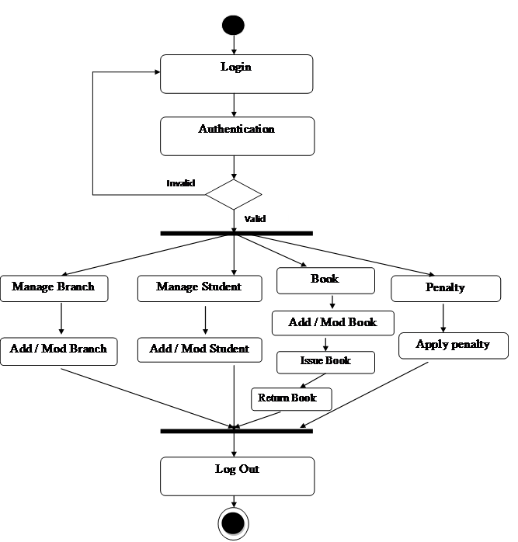

8.OBJECT ORIENTED ANALYSIS DISCOVERING CLASSES:
In general, analysis is the investigation of the problem and requirements.
Consider an Online Library Management System where users can register and become members, search the database of books, borrow books etc

1.During object oriented analysis we can identify objects such as User, Book, Library, UserManager, LibraryManager etc.

2.During object oriented design, we can create conceptual models with properties, behaviours and relationships for the objects identified during analysis. Library object will contain a list of books and functions to add, remove books. UserManager will contain a list of users and functions to add, remove, find and even block users. LibraryManager will be a helper object with functions to issue and return books. Book object will have details of book such as book id, name, author etc. and corresponding functions to get and set book the details. User object will have user id, name, membership type etc. and functions to get and set the user details.

3.Finally, during implementation, say in Java, all these conceptual objects with their properties and behaviour are converted to classes with attributes and methods respectively.

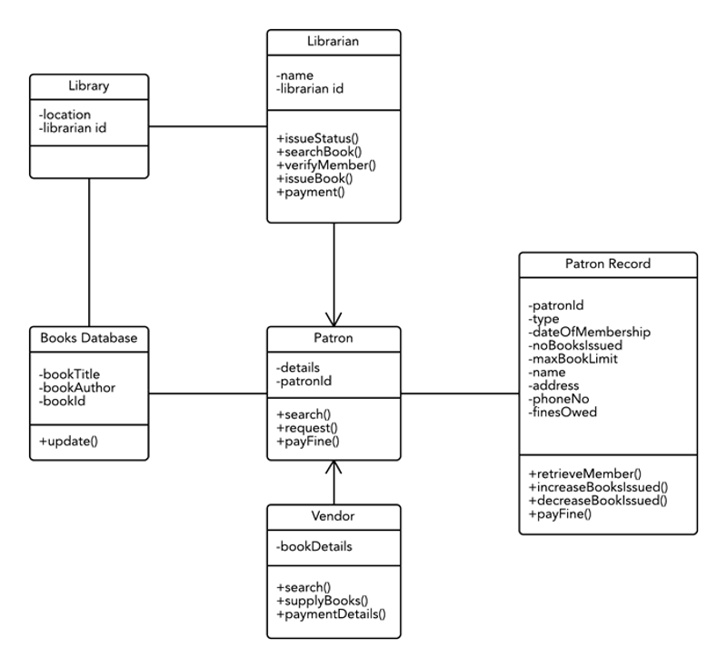

9.INTERACTION DIAGRAM:
Interaction diagrams are models that describe how a group of objects collaborate in some behavior - typically a single use-case. The diagrams show a number of example objects and the messages that are passed between these objects within the use-case. Interaction diagrams come in two forms, both present in the UML.
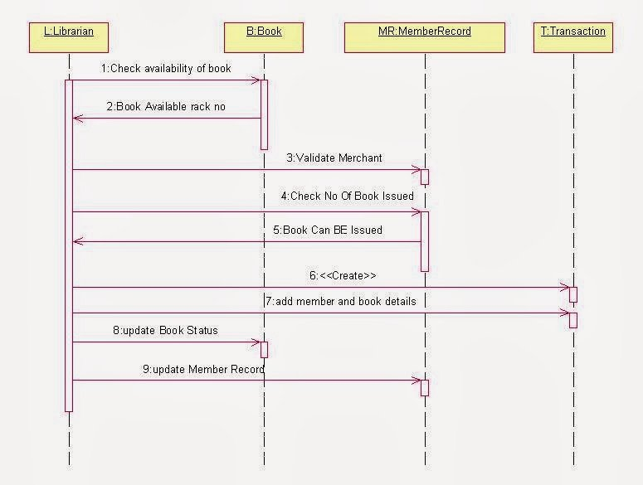
10.SOFTWARE DIAGRAM:
Software Diagram refers to a method for structured programming based on correspondences between data stream structure and program structure. Jackson structured programming and data in terms of sequences, iterations and selections, and as a consequence it is applied when designing a program's detailed control structure.IT world is extremely rational and logical. So what can be more precise than Software Diagrams to rate the results of work? Visual statistics is the best way to understand the data. This figure demonstrates the data flow diagram (DFD), which was created to describe the electronic system of custom purchase. This is the process of buying using electronic bar code scanning system. Such systems are used in large stores. The cashier scans the bar code, the system outputs the data on the price of the goods and carries out a purchase process. This DFD utilizes the Gane/Sarson notation. To create it The ConceptDraw DFD solution has been applied.It is so simple making the drawing process easier and faster. you just need to choose the right drawing software. ConceptDraw Arrows10 Technology - This is so easy and fast to draw any type of diagram with any degree of complexity.
11.SOFTWARE DESIGN AND STATE TRANSITION DIAGRAM:
State transition diagrams have been used right from the beginning in object-oriented modeling. The basic idea is to define a machine that has a number of states (hence the term finite state machine). The machine receives events from the outside world, and each event can cause the machine to transition from one state to another. The diagram indicates that a full bottle does not receive squirt events, and that an empty bottle does not receive cap events. Thus you can get a good sense of what events should occur, and what effect they can have on the object.
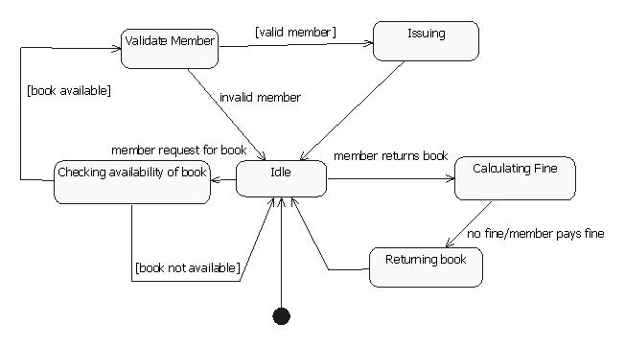

12.COMPONENT& DEPLOYMENT:
Software deployment is all of the activities that make a software system available for use.The general deployment process consists of several interrelated activities with possible transitions between them. These activities can occur at the producer side or at the consumer side or both. Because every software system is unique, the precise processes or procedures within each activity can hardly be defined. Therefore, "deployment" should be interpreted as a general process that has to be customized according to specific requirements or characteristics..A component diagram shows the organization and inter relationship between a set of component.We use component diagram to visualize the static aspect of the physical component and their relationship and to specify their details for construction.Component diagram is essentially class diagram that focus on a system’s component.

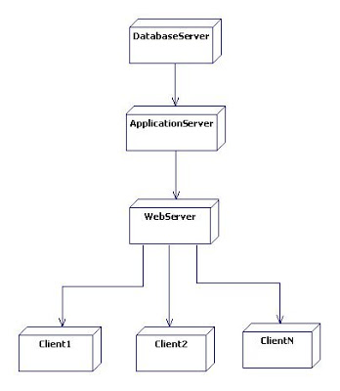
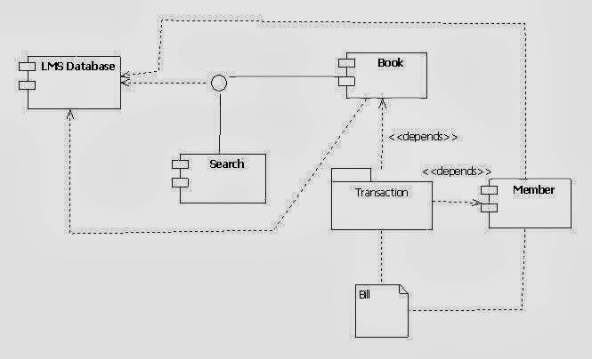

13.SOFTWARE TESTING:
Software testing is an investigation conducted to provide stakeholders with information about the quality of the softwareproduct or service under test.Software testing can also provide an objective, independent view of the software to allow the business to appreciate and understand the risks of software implementation. Test techniques include the process of executing a program or application with the intent of finding software bugs (errors or other defects), and verifying that the software product is fit for use.
14.SOFTWARE DOCUMENT:
Software documentation is written text or illustration that accompanies computer software or is embedded in the source code. It either explains how it operates or how to use it, and may mean different things to people in different roles.After we have completed the project we are sure the problems in the existing system would overcome. The “LIBRARY MANAGEMENT SYSTEM” process made computerized to reduce human errors and to increase the efficiency. The main focus of this project is to lessen human efforts. The maintenance of the records is made efficient, as all the records are stored in the ACCESS database, through which data can be retrieved easily. The navigation control is provided in all the forms to navigate through the large amount of records. If the numbers of records are very large then user has to just type in the search string and user gets the results immediately. The editing is also made simpler. The user has to just type in the required field and press the update button to update the desired field…The Books and Students are given a particular unique id no. So that they can be accessed correctly and without errors. Our main aim of the project is to get the correct information about a particular student and books available in the library.The problems, which existed in the earlier system, have been removed to a large extent. And it is expected that this project will go a long way in satisfying users requirements. The computerization of the Library Management will not only improves the efficiency but will also reduce human stress thereby indirectly improving human recourses.

PREPRATION
LAB PERFORMANCE
REPORT
TOTAL
INITIAL OF FACULTY

Result:
Thus the case study of LIBRARY MANAGEMENT SYSTEM has been studied successfully.

Ex No: 6 | AIRLINE RESERVATION SYSTEM
Date : | AIRLINE RESERVATION SYSTEM

INTRODUCTION & PROJECT DEFINITION:
The purpose of this SRS is to describe the requirements involved in developing a Airline Reservation System (ARS). The intended audience is any person who want to reserve or cancel tickets or to check the availability of Airline tickets. It can be used to check the availability of the flight tickets for the specified flight, destination and date of journey.
If the tickets ae available to the users needs and specification then they provide a facility to book the tickets. If the passenger wants to cancel the tickets he can use the cancellation module of the Airline Reservation System.It provides options for viewing different flights available with different timings for a particular date and provides custome with the facility to book a ticket,modify or cancel particular reservation but it does not provide the customer with details of cost of the ticket and it does not allow the customer to modify a particular pat of his reservation and he/she can modify all his details.
Airline Reservation System contains the details about flight schedules and its fare tariffs, passenger reservation and ticket records. It saves time as it allows online procedure as users no longer to wait in a queue to book the flight. It is automatically generated by the sever. Admin is the main authority who can do addition, deletion and modification of flights if required.
2. SOFTWARE PROCESS OVERVIEW:
Definition:
A software development process, also known as a software development lifecycle, is a structure imposed on the development of a software product. A software process is represented as a set of work phases that is applied to design and build a software product.The software that meets the specification is produced.
Phases:
- Planning
2. Analysis
3. Design
4. Development &implementation.
5. Testing.
6. Maintaince

3. PROJECT PLANNING:
Definition:
Project planning is part of project management, which relates to the use of schedules such as Gantt charts to plan and subsequently report progress within the project environment.
Software requirement analysis:
This is the first stage of the project which involves interaction with the customers to understand his/her needs requirements ,information requirement function performance and interacting in HTML software.
4.SOFTWARE REQUIREMENT SPECIFICATION:
A software requirements specification (SRS) is a description of a software system to be developed. It is modeled after business requirements specification (CONOPS), also known as a stakeholder requirements specification.The good requirement should have these 6 characteristics
- Complete
- Consistent
- Feasible
- Modifiable
- Unambiguous.
- Testable

5.INTRODUCTION TO UML AND USE CASE DIAGRAM:
An Introduction. Unified Modeling Language (UML) is a general purpose modelling language. The main aim of UML is define a standard way to visualize the way a system has been designed. It is quite similar to blueprints used in other fields of engineering.

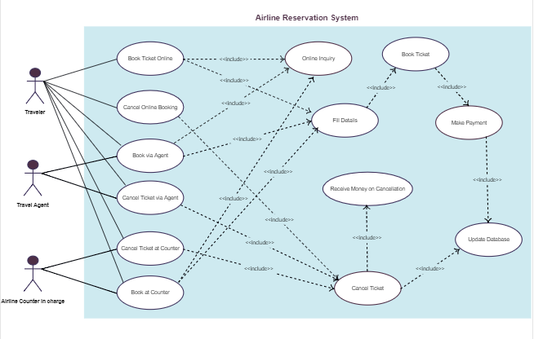
6. SYSTEM MODELLING:
System modeling is the interdisciplinary study of the use of models to conceptualize and construct systems in business and IT development. A common type of systems modeling is function modeling, with specific techniques such as the Functional Flow Block Diagram and IDEF0.
There are some modeling:
1. Functional modeling
2. System modelling
3. Business process modelling
4. Enterprise modelling

7.FLOW OF EVENTS AND ACTIVITY DIAGRAM :
Flow of events:
Flow of events are the steps required to perform within a use case. A use case diagram is a graphic depiction of the interactions among the elements of a system. A use case is a methodology used in system analysis to identify, clarify, and organize system requirements.The actors, usually individuals involved with the system defined according to their roles. It is the sequence of events that happens in the software development process.
The event flow diagram consist of event rule groups and business steps. The main purpose of this diagram is to identify and develop the documentation.

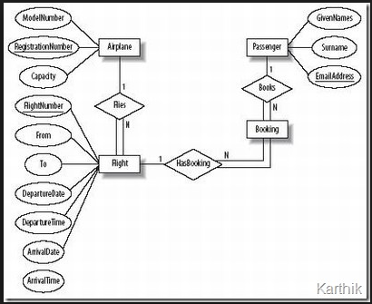

The events involved in passport management system is as follows:
- Login
- Registration
- Fill the form details
- Payment
- Verification
- Get the ticket

Activity diagram :

Activity diagram is another representation in UML to describe dynamic aspects of the system. Activity diagram is basically a flowchart to represent the flow from one activity to another activity. The activity can be described as an operation of the system. The control flow is drawn from one operation to another.
In the unified modeling language activity diagram are intended to model both computational and organizational process as well as the data focus intersecting with the related activities

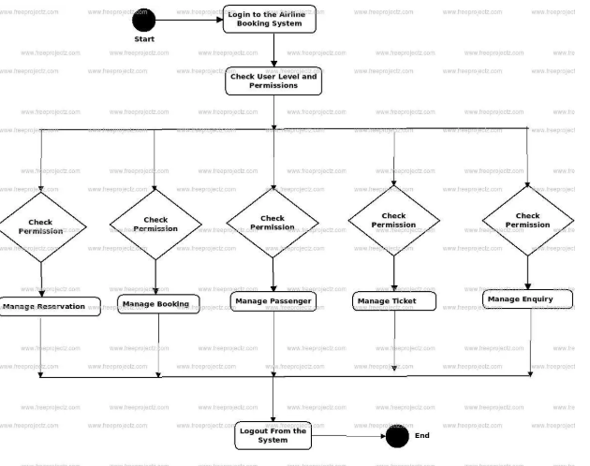

8.OBJECT ORIENTED ANALYSIS DISCOVERING CLASSES:
In general, analysis is the investigation of the problem and requirements.
In object-oriented software design(OOD),classes are templates for definingthe characteristics and operations of an object. Often classes and objects are used inter changeably, one synonymous with the other. In actuality a class is aspecification that an object implements.

1.During object oriented analysis we can identify objects such as applicant, application, registration, admin etc.

2.During object oriented design, we can create conceptual models with properties, behaviours and relationships for the objects identified during analysis

3.Finally, during implementation, say in Java, all these conceptual objects with their properties and behaviour are converted to classes with attributes and methods respectively.
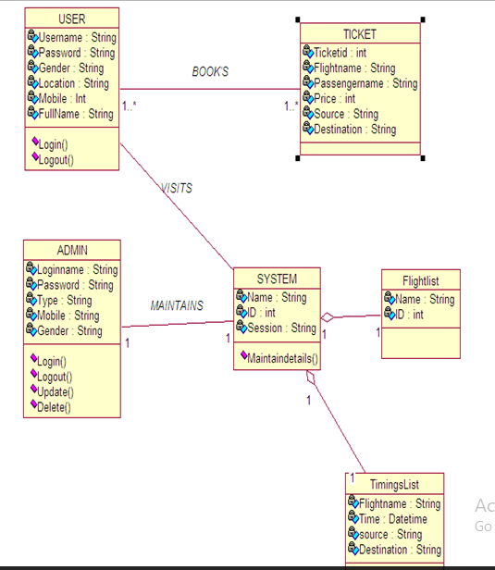

9. INTERACTION DIAGRAM:
Interaction diagrams are models that describe how a group of objects collaborate in some behavior - typically a single use-case. The diagrams show a number of example objects and the messages that are passed between these objects within the use-case. Interaction diagrams come in two forms, both present in the UML. The first form is the sequence diagram. In this form objects are shown as vertical lines with the messages as horizontal lines between them. This form was first popularized by Jacobson.

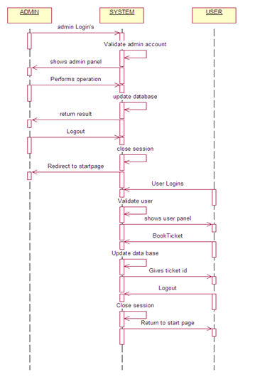

10. SOFTWARE DIAGRAM:
Software Diagram refers to a method for structured programming based on correspondences between data stream structure and program structure. Jackson structured programming and data in terms of sequences, iterations and selections, and as a consequence it is applied when designing a program's detailed control structure. Program flowchart is a diagram which uses a set of standard graphic symbols to represent the sequence of coded instruction feed into a computer,enabling it to perform specified logical and arithmetical operations. End event symbol stands for the result of a process.
11. SOFTWARE DESIGN AND STATE TRANSITION DIAGRAM:
State transition diagram:
A state diagram is a type of diagram used in computer science and related fields to describe the behavior of systems. State diagrams require that the system described is composed of a finite number of states; sometimes, this is indeed the case, while at other times this is a reasonable abstraction.

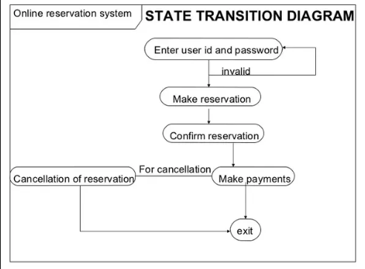
12. COMPONENT AND DEPLOYMENT:
A component diagram depicts how components are wired together to form larger components or software systems. They are used to illustrate the structure of arbitrarily complex systems.Software deployment is all of the activities that make a software system available for use. The general deployment process consists of several interrelated activities with possible transitions between them. These activities can occur at the producer side or at the consumer side or both.
Here there are three components in passport automation system. They are applicants, system admin and authority.The interface between people and system admin, from people to authority.

Component diagram:

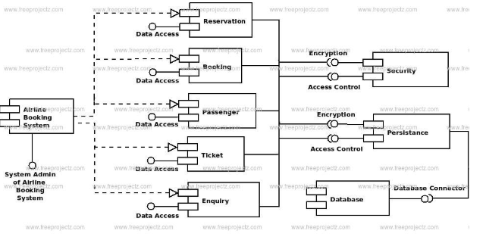

13. SOFTWARE TESTING:
The process or method of finding error/s in a software application or program so that the application functions according to the end user's requirement is called software testing.
Testing levels:
1.unit testing.
2.Integration Testing.
3.System testing.
4.operational acceptance testing
Software validation:
The process of evaluating software during or at the end of the development process to determine whether it satisfies specified requirements.
Software verification:
The process of evaluating software to determine whether the products of a given development phase satisfy the conditions imposed at the start of that phase.

14. SOFTWARE DOCUMENT:
Software documentation is a written text or illustration that accompanies computer software or is embedded in the source code. It either explains how it operates or how to use it. It may mean different things to people in different roles. Documentation is an important part of software engineering.

PREPRATION
LAB PERFORMANCE
REPORT
TOTAL
INITIAL OF FACULTY

Result:
Thus the case study of AIRLINE RESERVATION SYSTEM has been studied successfully.

Ex No: 7 | ONLINE EXAM REGISTRATION SYSTEMS
Date : | ONLINE EXAM REGISTRATION SYSTEMS

1.INTRODUCTION & PROJECT DEFINITION:
Online Examination system is very for Educational Institute to prepare an exam, safe the time that will take to check the paper and prepare mark sheet.The effective use of “ONLINE EXAM REGISTRATION SYSTEM” any Educational Institute or training centers can be use it to develop their strategy for putting the exam, and for getting better result in less time. It is being launched because a need for a destination that is beneficial for both Institutes and students. The project will enable educational institutes to conduct test and have automated checking of answers based on the response by the candidates.
Online Examination is very helpful to the users. The main aim of this project is to provide quick, immediate and easy way to appear the exam. It can provide special advantage to the student/applicants. The online examination system can automatically add the marks allocated in each question to determine the total mark of the question. A time limit can be set for each questions. It allows jumping to specific questions based on the previous answer. In this system limits the number of times a student can write a question. Login module help the user to login the site. For that he/she must type the username and password correctly. The login provision in this page help the already registered users to directly access the site and there is a link for registration to a user who is new to this site. Student module is mainly for the students. This help the student to register for the exam and answer the exam. For registration name, address, phone no, roll no, password should be enter and other are filled. This will provide result after the exam according to correct and wrong answer. Administrator module is mainly for the administrator. This will contain the creation of question paper, preview of already created question paper he/she must enter EXAM ID .NO: of questions , total time(in min), Marks per Questions, Option type. For showing the preview of already created question paper he/she must enter the correct the Exam ID.
2.SOFTWARE PROCESS OVERVIEW
Definition:
A software development process, also known as a software development lifecycle, is a structure imposed on the development of a software product. A software process is represented as a set of work phases that is applied to design and build a software product. The software that meets the specification is produced.
Phases:
1. Planning
2. Analysis
3. Design
4. Development &implementation.
5. Testing.
6. Maintenance
3. PROJECT PLANNING:
Definition:
Project planning is part of project management, which relates to the use of schedules such as Gantt charts to plan and subsequently report progress within the project environment.
4. SOFTWARE REQUIREMENT SPECIFICATION:
A software requirements specification (SRS) is a description of a software system to be developed. It is modeled after business requirements specification (CONOPS), also known as a stakeholder requirements specification. The good requirement should have these 6 characteristics
- Complete
- Consistent
- Feasible
- Modifiable
- Unambiguous.
- Testable
5.INTRODUCTION TO UML AND USE CASE DIAGRAM:
An Introduction. Unified Modeling Language (UML) is a general purpose modelling language. The main aim of UML is define a standard way to visualize the way a system has been designed. It is quite similar to blueprints used in other fields of engineering.
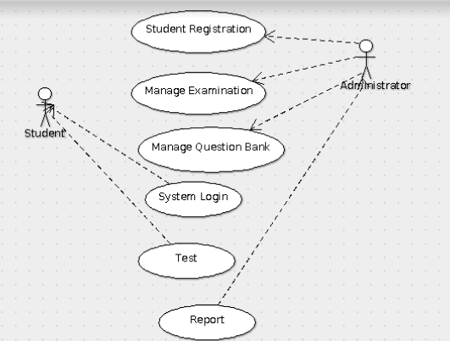

6. SYSTEM MODELLING:
System modeling is the interdisciplinary study of the use of models to conceptualize and construct systems in business and IT development. A common type of systems modeling is function modeling, with specific techniques such as the Functional Flow Block Diagram and IDEF0.
There are some modeling:
1. Functional modeling
2. System modelling
3. Business process modelling
4. Enterprise modelling

7.FLOW OF EVENTS AND ACTIVITY DIAGRAM :
Flow of events are the steps required to perform within a use case. Now, with Visual Paradigm, you can define complex flow structure by specifying control flows, such as if, while and jump, within the steps.A use case diagram is a graphic depiction of the interactions among the elements of a system. A use case is a methodology used in system analysis to identify, clarify, and organize system requirements.The actors, usually individuals involved with the system defined according to their roles.

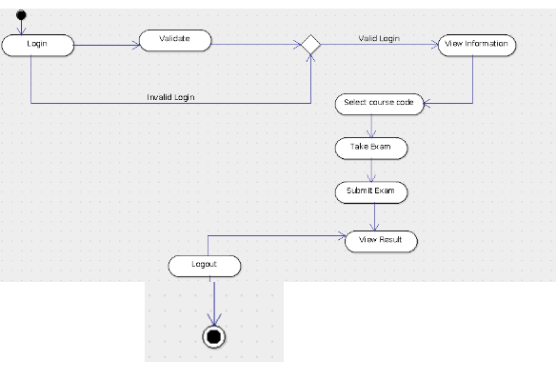

8.OBJECT ORIENTED ANALYSIS DISCOVERING CLASSES:
In general, analysis is the investigation of the problem and requirements.
Consider an Online Exam Registration System where student can register the examination and the administration given an exam id and password for writing the exam.
1.During object oriented analysis we can identify objects such as student,student registration details ,administration and so on
2.During object oriented design, we can create conceptual models with properties, behaviours and relationships for the objects identified during analysis. Exam Registration system object will contain a student registration id,name,password, address and correct details of the student. Administrator will contain a list of question bank,student details such as registration id, password and so on, test report. Administrator will be a helper object with functions to informing the exam date. Student object will have details of student name ,registration id, password and examination date.
3.Finally, during implementation, say in Java, all these conceptual objects with their properties and behaviour are converted to classes with attributes and methods respectively.
9.INTERACTION DIAGRAM:
Interaction diagrams are models that describe how a group of objects collaborate in some behavior - typically a single use-case. The diagrams show a number of example objects and the messages that are passed between these objects within the use-case. Interaction diagrams come in two forms, both present in the UML. The first form is the sequence diagram.
10.SOFTWARE DIAGRAM:
Software Diagram refers to a method for structured programming based on correspondences between data stream structure and program structure. Jackson structured programming and data in terms of sequences, iterations and selections, and as a consequence it is applied when designing a program's detailed control structure. IT world is extremely rational and logical. So what can be more precise than Software Diagrams to rate the results of work? Visual statistics is the best way to understand the data. This figure demonstrates the data flow diagram (DFD), which was created to describe the electronic system of custom purchase. This is the process of buying using electronic bar code scanning system. Such systems are used in large stores. The cashier scans the bar code, the system outputs the data on the price of the goods and carries out a purchase process. This DFD utilizes the Gane/Sarson notation.
- SOFTWARE DESIGN AND STATE TRANSITION DIAGRAM:
A state diagram is a type of diagram used in computer science and related fields to describe the behavior of systems. State diagrams require that the system described is composed of a finite number of states; sometimes, this is indeed the case, while at other times this is a reasonable abstraction.

12.COMPONENT & DEPLOYMENT:
Software deployment is all of the activities that make a software system available for use.The general deployment process consists of several interrelated activities with possible transitions between them. These activities can occur at the producer side or at the consumer side or both. Because every software system is unique, the precise processes or procedures within each activity can hardly be defined. Therefore, "deployment" should be interpreted as a general process that has to be customized according to specific requirements or characteristics.The complexity and variability of software products has fostered the emergence of specialized roles for coordinating and engineering the deployment process. For desktop systems, end-users frequently also become the "software deployers. " when they install a software package on their machine. The deployment of enterprise software involves many more roles, and those roles typically change as the application progresses from test (pre-production) to production environments. Component diagram are one of the two kind of diagram found in modeling the physical aspects of object oriented system. A component diagram shows the organization and inter relationship between a set of component. We use component diagram to visualize the static aspect of the physical component and their relationship and to specify their details for construction .Component diagram is essentially class diagram that focus on a system’s component.

DEPLOYMENT AND COMPONENTS

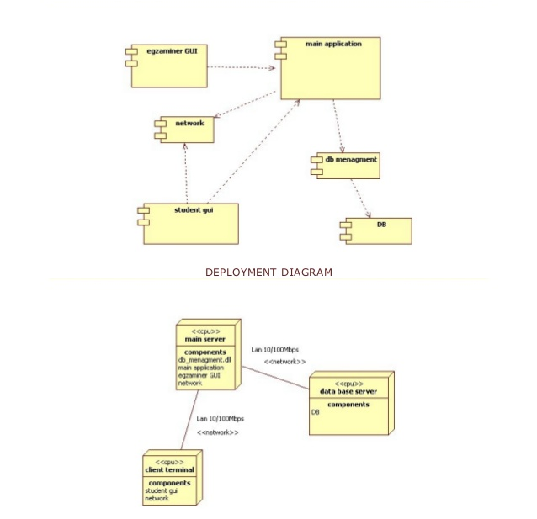

13.SOFTWARE TESTING:
The process or method of finding error/s in a software application or program so that the application functions according to the end user's requirement is called software testing.
Testing levels:
1.Unit testing.
2.Integration Testing.
3.System testing.
4.Operational acceptance testing

14.SOFTWARE DOCUMENT:
After we have completed the project we are sure the problems in the existing system would overcome. The “ONLINE EXAM REGISTRATION SYSTEM” process made computerized to reduce human errors and to increase the efficiency. The main focus of this project is to lessen human efforts. The maintenance of the records is made efficient, as all the records are stored in the ACCESS database, through which data can be retrieved easily. The navigation control is provided in all the forms to navigate through the large amount of records. If the numbers of records are very large then user has to just type in the search string and user gets the results immediately. The editing is also made simpler. The user has to just type in the required field and press the update button to update the desired field…The Administration and Students are given a particular unique id no. So that they can be accessed correctly and without errors. Our main aim of the project is to get the correct information about a particular student and examination date for the students.The problems, which existed in the earlier system, have been removed to a large extent. And it is expected that this project will go a long way in satisfying users requirements. The computerization of the Online Exam Registration System will not only improves the efficiency but will also reduce the time thereby indirectly improving human recourses.

PREPRATION
LAB PERFORMANCE
REPORT
TOTAL
INITIAL OF FACULTY

Result:
Thus the case study of ONLINE EXAM REGISTRATION SYSTEM has been studied successfully.

