A Project Report On

FORECASTING HOURLY ELECTRICAL ENERGY OUTPUT OF A POWER PLANT USING PARAMETRIC MODELS

Submitted in partial fulfillment of the requirements for the award of the degree of

BACHELOR OF TECHNOLOGY
in

INFORMATION TECHNOLOGY

Submitted By

G. BALA SAI KRISHNA | 18P31A1218
A. SATISH CHANDRA | 18P31A1204
P.SINDHU JAHNAVI | 18P31A1234
ANUBHAV KUMAR | 18P31A1244

Under the esteemed supervision of
Dr. B.SRINIVAS., M. Tech ., Ph.D .
Assistant Professor

DEPARTMENT OF INFORMATION TECHNOLOGY

ADITYA COLLEGE OF ENGINEERING & TECHNOLOGY
(AUTONOMOUS)
Approved by AICTE, New Delhi & Permanently Affiliated to JNTUK, Kakinada
Accredited by NAAC (A+) and NBA
Surampalem, Kakinada District, Andhra Pradesh - 533 437
2021-2025

ADITYA COLLEGE OF ENGINEERING & TECHNOLOGY
(AUTONOMOUS)
Approved by AICTE, New Delhi & Permanently Affiliated to JNTUK, Kakinada
Accredited by NAAC (A+) and NBA

DEPARTMENT OF INFORMATION TECHNOLOGY

CERTIFICATE

This is to certify that the project work entitled “FORECASTING HOURLY ELECTRICAL ENERGY OUTPUT OF A POWER PLANT USING PARAMETRIC
MODELS”, is a bonafide work carried out by G.B.Sai krishna (18P31A1218), A.Satish Chandra (18P1A1204), P.sindhu Jahnavi (18P31A1234), Anubhav Kumar (18P31A1244) in partial fulfillment of the requirements for the award of the degree of Bachelor of Technology in Information Technology from Aditya College of Engineering & Technology(A) during the academic year 2021-2025.

PROJECT GUIDE | HEAD OF THE DEPARTMENT
Dr. B.Srinivas.,M.Tech., Ph.D. | Mr. R. V. V. N. Bheema Rao.,M.Tech.,(Ph.D)
Assistant Professor | Assistant Professor

EXTERNAL EXAMINER

DECLARATION

We hereby declare that this project entitled “FORECASTING HOURLY ELECTRICAL ENERGY OUTPUT OF A POWER PLANT USING
PARAMETRIC MODELS”, has been undertaken by us and this work has been submitted to Aditya College of Engineering & Technology(A) in partial fulfilment of the requirements for the award of the degree of Bachelor of Technology in Information Technology.

We further declare that this project work has not been submitted in full or part for the award of any degree of this or in any other educational institutions.

Project Associates

G. B.Sai Krishna (18P31A1218)
A.Satish Chandra (18P31A1204)
P.Sindhu Jahnavi (18P31A1234)
Anubhav Kumar (18P31A1244)

ACKNOWLEDGEMENTS

It is with immense pleasure that we would like to express our indebted gratitude to my project supervisor, Mr./Mrs./Ms./Dr.XXXXXXX, _{Qualifications} who has guided us a lot and encouraged us in every step of project work, his valuable moral support and guidance has been helpful in successful completion of this Project.
We wish to express our sincere thanks to Mr. R.V.V.N. Bheema Rao _{MTech(Ph.D).}, Head of the Department of INFORMATION TECHNOLOGY, for his valuable guidance given to us throughout the period of the project work.
We feel delighted to thank Dr. P. S.V.V. Ravi Kumar _{M.Tech.,Ph.D.}, Dean (Academics) of Aditya College of Engineering and Technology (A) for his cooperation in completion of our project work.
We feel elated to thank Dr. A. Ramesh, _{MTech., Ph. D.}, Principal, of Aditya College of Engineering and Technology (A) for his encouragement and support in completion of our project and throughout our course.
We wish to express our sincere thanks to all faculty members, and lab programmers for their valuable guidance given to us throughout the period of the project.
We avail this opportunity to express our deep sense and heart full thanks to the Management of Aditya College of Engineering & Technology (A) for providing a great support to us by arranging the trainers, and facilities needed to complete our project and for giving us the opportunity to do this work.

G. B.Sai Krishna (18P31A1218)
A.Satish Chandra (18P31A1204)
P.Sindhu Jahnavi (18P31A1234)
Anubhav Kumar (18P31A1244)

ABSTRACT

Parametric models such as Linear regression, Polynomial regression, Linear Support Vector Machine are used to model numerous systems that have number of features. The main scope of this project is to apply these models on the Combined Cycle Power Plant to predict the electrical power output. This project which explains us the behavior of the parametric models and also validates the models with 10-fold Cross Validation method. For the Linear regression model, we made the assumptions –

Normality, Linearity, Homoscedasticity, Independence and Multicollinearity to validate the results of the model.

INDEX

CHAPTER PAGE NO

ABSTRACT i
LIST OF TABLES v

LIST OF FIGURES iv
- INTRODUCTION
  - Introduction 1
  - Purpose of the System 2
  - Scope of the System 2
  - Existing System 2
  - Proposed System 2
- REQUIREMENT ANALYSIS
  - Functional Requirements 3
  - Non-Functional Requirements 3
    - User Interface and Human Factors 4
    - Software Requirements 4
    - Hardware Requirements 4
    - Usability 4
    - Reliability 4
    - Performance 5
    - Physical Environment 5
    - Resource Requirements 5
    - Security Requirements 5
- SYSTEM ANALYSIS
  - Introduction 6
  - Use Cases 6
    - Actors 6
    - Use case diagrams 7
- SYSTEM DESIGN
  - Introduction 10
  - System Architecture 10
  - System Object Model 11
    - Introduction 11
    - Subsystems 12
  - Object Description 12
    - Objects 12
    - Class Diagrams 12
  - Dynamic Model 15
    - State Chart Diagrams 15
    - Sequence diagram 18
    - Communication Diagram 20
  - Static Model 22
    - Component Diagrams 22
    - Deployment Diagrams 23
- IMPLEMENTATION
  - Software Used 26
  - Source Code 51
- TESTING
  - Introduction 58
    - Levels of Testing 58
    - Software Testing Strategies 58
  - Test Cases 60
- OUTPUT SCREENS 61
- CONCLUSION 64
- FUTURE SCOPE 65
- BIBLIOGRAPHY 67

LIST OF FIGURES
S.NO NAME OF FIGURE PAGENO

- 3.2.2.1 Use case diagram for DEVELOPER 9
- 4.2.1 System Architecture 11
- 4.4.2.1 Class Diagram for working of application 14
- 4.5.1.1 State Chart Diagram 17
- 4.5.2.1 sequence Diagram 19
- 4.5.3.1 Communication diagram 21
- 4.6.1.1 Component Diagram 23
- 4.6.2.1 Deployment Diagram 25
- 5.1.1 Statistics of the Dataset 44
- 5.1.2 Boxplots of all features 44
- 5.1.3 Distribution plots of all features with KDE 45
- 5.1.4 Regression plots for all features with target feature (PE) 46
- 5.1.5 Linear Regression results 47
- 5.1.6 Residuals of Linear regression 47
- 5.1.7 Scatter plots for dependent features to target feature 48
- 5.1.8 Homoscedasticity plot 49
- 5.1.9 Auto Correlation Function (ACF) 49
- 5.1.10 (a) VIF of all features 50
  - VIF values after removing V 50
  - VIF values after removing AP 50
- 5.1.11 Polynomial Regression and Support Vector Machine results 50
- 7.1 RMSE value for models 61
- 7.2 R2 Core value for models 62
- 7.3 MSE value for models 63

LIST OF TABLES

S. NO NAME OF TABLE PAGENO
1. 6.2.1 Test Cases for User 60

CHAPTER 1 INTRODUCTION

INTRODUCTION
In a Combined Cycle Power Plant the electricity is generated by gas and steam turbines. This kind of plants generates more than 50 percent than the traditional power plant. Electricity generated by the power plant oscillates due to number of reasons including environmental conditions. Traditional mathematical models require high number of parameters to predict the actual system output. Instead of the mathematical models Machine Learning (ML) models can be used for better predictions even with few parameters.

The concept of ML is to make the computers to learn themselves by adopting a model instead of acting according to a program written by a programmer. The arrival of new data makes the customized ML models to understand, modify and improve themselves.

In ML, Supervised Learning is a method in which the machine learns through labeled data. Regression is a supervised learning method and it is modeled to predict a continuous feature. A multivariate regression problem is special case of regression problem with more than one input. In this we have implemented three parametric models – Linear regression, Polynomial regression and Linear Support

Vector Machine on the power plant dataset. The models accuracy is verified with 10- fold Cross Validation techniques to test whether they are over fitted or under fitted. In the literature we find few research papers which implemented ANN model to forecast the electrical energy of the power plants.

Purpose of the System

Machine learning (ML) is a convention of using specified algorithms to get data, acquire some knowledge from it and make a prediction about something in the future. In ML Regression algorithms are used to anticipate output values basing on the input attributes of a data set. A good ML algorithm results better predictions.

Scope of the System

    - Based on the Energy Generated from the plant to forecast using parametric models.
    - The aim is to apply these models on the Combined Cycle Power Plant to predict the electrical power output.
    - Code is generated and made the model more accurate for using to calculate the energy.

Existing System
In the existing system we are having the old mechanisms to calculate or forecast energy ,so it makes not accurate on the outcome and may vary energy from time to time.

Proposed System
Parametric models such as Linear regression, Polynomial regression, Linear Support Vector Machine are used to model numerous systems that have number of features. The aim of this project is to apply these models on the Combined Cycle Power Plant to predict the electrical power output. This explains the stochastic behavior of the parametric models and also validates the models with 10-fold Cross Validation method. For the Linear regression model, we made the assumptions – Normality, Linearity, Homoscedasticity, Independence and Multicollinearity to validate the results of the model.

CHAPTER 2 REQUIREMENTS ANALYSIS

REQUIREMENT ANALYSIS

Requirements analysis, also called requirements engineering, is the process of determining user expectations for a new or modified product. These features, called requirements, must be quantifiable, relevant and detailed. Requirements analysis is an important aspect of project management. Requirements can be architectural, structural, behavioural, functional and non-functional.

Functional Requirements
- Ease of Use: To promote efficiency and productivity in the development process.
- High Performance: To support real-time, large scale simulation.
- Maintainability: To minimize life-cycle cost.
- Scalability: To support new requirements and ever increasing scope.
- Scalability: To support new requirements and ever increasing scope.
- Cross-Platform Support: To support multiple operating systems to enable maximum selection of available hardware.
- pen Standards Support: To gain maximum leverage from existing and futuresimulation of code.

Non-Functional Requirements
A non-functional requirement is a specification that describes the system’s operation capabilities and constraints that enhance its functionality. We’ve covered different types of software requirements, based on Responsiveness, Usability, Security, Portability and other non-functional standards that are critical to the success of the software system.
- User Interface and Human Factor
- Software Requirements
- Hardware Requirements
- Usability
- Reliability
- Performance
- Physical Environment
- Resource Requirements

- Security Requirements

User Interface and Human Factor
User interface design focuses on the following key areas:
      - The design of interfaces between different software components.
      - The design of interfaces between the software and other nonhuman producers and consumers of information.
      - The design of the interface between a human and the computer.

Software requirements
The Software requirements of the system are mentioned below:
Operating System: Windows 8 or newer
Software: Jupyter Notebook
Language Used: Python
Libraries/Packages: Pandas,numpy,seaborn

Hardware Requirements
The Hardware requirements of the system are mentioned below:
CPU: Intel Core i3-8100
GPU: RX 570 (or GTX 1060 3GB)
RAM: 8GB DDR4
CPU Cooler: Stock (or Deepcool Gammaxx 400)
Operating System: Windows 10

Usability
This system is used for continuously monitoring or forecasting the energy that been generated from the energy plant and that used as input for the calculating accuracy for the parametric models.

Reliability
This system is used to make accuracy between different models, thus it has high
Reliability with value lying between 0 and 1.

Performance
As it makes use of different models that help us to make the system high having performance output.

Physical Environment
It is compatible with any system like a laptop & system.

Resource Requirements
Required software is to be installed like python idle, jupter notebook, and respected libraries pandas, numpy,sklearn are to be installed in our system to execute our project successfully.

Security Requirements
      - It is responsible for taking data, such as user preferences and descriptions of the items that can be recommended.
      - Predicting which items will be of interest to a given set of users.

CHAPTER 3 SYSTEM ANALYSIS

SYSTEM ANALYSIS

Introduction
System analysis is the process of gathering and interpreting facts, diagnosing problems and using the information to recommend improvements on the system. System analysis is a problem-solving activity that requires intensive communication between the system users and system developers.
System analysis is an important phase of any system development process. The system is studied to the minutest detail and analysed. The system analyst plays the role of an interrogator and dwells deep into the working of the present system. The system is viewed as a whole and the inputs to the system are identified. The outputs from the organization are traced through the various processing that the inputs phase through in the organization.
A detailed study of these processes is made by various techniques like Interviews,reviews, etc. The data collected by these sources is scrutinized to arrive to a conclusion.The conclusion is an understanding of how the system functions. This system is called the existing system.

Use cases

Actors
- Developer
- User

Use case Diagrams
Use case diagram is created to visualize the relationships between actors and usecases. A use case is a pattern of behaviour the system exhibits. Each use case is a sequence of related transactions performed by an actor and the system. Diagrammatically actor and use case are represented by stick figure and oval respectively.

Symbols


New Use Case
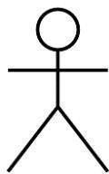

Actor

Relationships

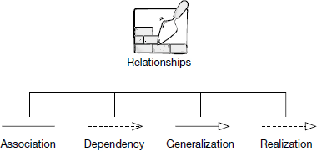

A use case diagram doesn't go into a lot of detail—for example, don't expect it to model the order in which steps are performed. Instead, a proper use case diagram depicts a high-level overview of the relationship between use cases, actors, and systems. Experts recommend that use case diagrams be used to supplement a more descriptive textual use case.
UML is the modeling toolkit that you can use to build your diagrams. Use cases are represented with a labeled oval shape. Stick figures represent actors in the process, and the actor's participation in the system is modeled with a line between the actor and use case. To depict the system boundary, draw a box around the use case itself.
- Use cases: Horizontally shaped ovals that represent the different uses that a user might have.
- Actors: Stick figures that represent the people actually employing the use cases.

- Associations: A line between actors and use cases. In complex diagrams, it is important to know which actors are associated with which use cases.
- System boundary boxes: A box that sets a system scope to use cases. All use cases outside the box would be considered outside the scope of that system. For example, Psycho Killer is outside the scope of occupations in the chainsaw example found below.
- Packages: A UML shape that allows you to put different elements into groups. Just as with component diagrams, these groupings are represented as file folders.
- Actors: The users that interact with a system. An actor can be a person, an organization, or an outside system that interacts with your application or system. They must be external objects that produce or consume data.
- System: A specific sequence of actions and interactions between actors and the system. A system may also be referred to as a scenario.
- Goals: The end result of most use cases. A successful diagram should describe the activities and variants used to reach the goal.

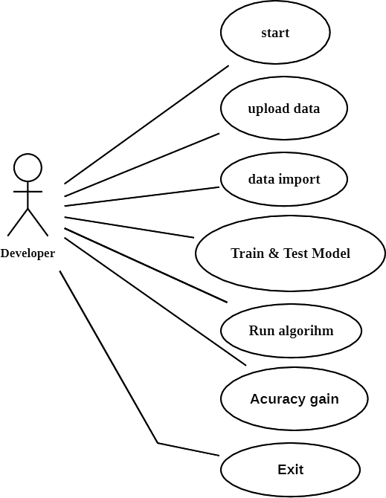
Fig:3.2.2.1 Usecase Diagram for Developer

CHAPTER 4 SYSTEM DESIGN

SYSTEM DESIGN

Introduction
An effective system development life cycle (SDLC) should result in a high qualitysystem that meets customer expectations, reaches completion within time and cost evaluations, and works effectively and efficiently in the current and planned informationtechnology infrastructure.
System Development Life Cycle (SDLC) is a conceptual model which includes policies and procedures for developing or altering systems throughout their life cycles.
System design is the process of defining the architecture, models, interfaces, anddata for a system to satisfy specified requirements. System design could be seen as the application of systems theory to product development. There is some overlap with the disciplines of system analysis, system architecture and system engineering.
The design phase describes how the system will fulfil the user requirements. To achieve this, we must create both logical and physical design. In this phase the system design functions and operations are described.

System Architecture
A system architecture or systems architecture is the conceptual model that defines the structure, behaviour, and more views of a system. An architecture description and representation of a system, organized in a way that supports reasoning about structures and behaviour of a system.

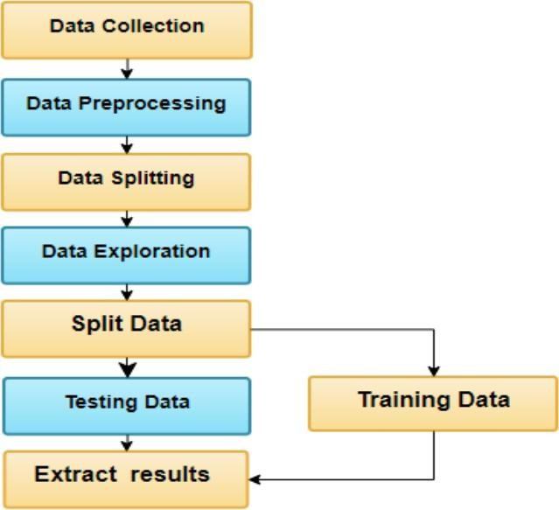

Fig: 4.2.1 System Architecture

System Object Model

Introduction

System object model (SOM) is an object- oriented library packaging technology developed by IBM that allows various programming languages to share class libraries, regardless of the language in which they were originally written. System object model was intended to be used as a solution to many of the interoperability and reuse problems that occur while sharing class libraries between object-oriented and non-object-oriented languages.
SOM was designed to be used across IBM’ s mainframe computers and desktops. It serves as an object-oriented model that can be distinguished from other models contained in object-oriented programming languages. SOM basically includes an interface definition a runtime environment with procedure calls and a set of enabling frameworks.

Subsystems

Modules

      - Juypter Notebook: Used to create and run the system application.

      - User: To calculate the parametric models.

Object Description
Object diagrams are derived from class diagrams so object diagrams are dependent upon class diagrams. Object diagrams so object diagrams are dependent uponclass diagrams. Object diagrams represent an instance of a class diagram. The basic concepts are similar for class diagrams and object diagrams. Object diagrams also represent the static view of a system but this static view is a snapshot of a system at a particular moment. Object diagrams are used to render a set of objects and their relationships as an instance.

Objects

Object is any entity that can be manipulated by the commands of programming languages such as value, variable, function, or data structure.

Class Diagrams

A class diagram showing the systems classes, their attributes, operations, and collaborations and the relationships among objects. The class diagrams is the main building lock of object oriented modelling. Class diagrams can also be used for data modelling. The classes in a class diagram represent both the main elements, interactions in the application and the classes to be programmed.

It represents the static view of an application. Class diagram is not only used for visualizing, describing, and documenting different aspects of a system .

The purpose of class diagram is to model the static view of an application. Class diagrams are the only diagrams which can be directly mapped with object- oriented languages and thus widely used at the time of construction.

UML diagrams like activity diagram, sequence diagram can only give the sequence flow of the application, however class diagram is a bit different. It is the most popular UML diagram in the coder community.
The purpose of the class diagram can be summarized as −

- Analysis and design of the static view of an application.
- Describe responsibilities of a system.
- Base for component and deployment diagrams.
- Forward and reverse engineering.
Class diagrams are the most popular UML diagrams used for construction of software applications. It is very important to learn the drawing procedure of class diagram.
Class diagrams have a lot of properties to consider while drawing but here the diagram will be considered from a top level view.
Class diagram is basically a graphical representation of the static view of the system and represents different aspects of the application. A collection of class diagrams represent the whole system.
The following points should be remembered while drawing a class diagram −

- The name of the class diagram should be meaningful to describe the aspect of the system.
- Each element and their relationships should be identified in advance.
- Responsibility (attributes and methods) of each class should be clearly identified
- For each class, minimum number of properties should be specified, as unnecessary properties will make the diagram complicated.
- Use notes whenever required to describe some aspect of the diagram. At the end of the drawing it should be understandable to the developer/coder.
- Finally, before making the final version, the diagram should be drawn on plain paper and reworked as many times as possible to make it correct.

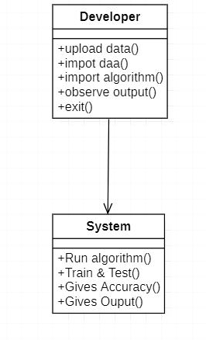
Fig. 4.4.2.1 Class Diagram for working of application

Dynamic Model

State Chart Diagram
An activity diagram is another important diagram in UML to describe the dynamicaspects of the system. An activity diagram is basically a flowchart to represent the flow from one activity to another activity. The activity can be described as an operation of thesystem. The control flow is drawn from one operation to another. This flow can be sequential, branched, or concurrent. Activity diagrams deal with all type of flow controlby using different elements such as fork, join, etc. The basic purposes of activity diagrams are similar to the other four diagrams. It captures the dynamic behaviour of thesystem. Other four diagrams are used to show the message flow from one object to another but the activity diagram is used to show message flow from one activity to another.
State Chart diagram is one of the five UML diagrams used to model the dynamic nature of a system. They define different states of an object during its lifetime and these states are changed by events. State Chart diagrams are useful to model the reactive systems. Reactive systems can be defined as a system that responds to external or internal events.
State Chart diagram describes the flow of control from one state to another state. States are defined as a condition in which an object exists and it changes when some event is triggered. The most important purpose of State Chart diagram is to model lifetime of an object from creation to termination.
State Chart diagrams are also used for forward and reverse engineering of a system. However, the main purpose is to model the reactive system.
Following are the main purposes of using State Chart diagrams −

- To model the dynamic aspect of a system.
- To model the life time of a reactive system.
- To describe different states of an object during its life time.
- Define a state machine to model the states of an object.

State Chart diagram defines the states of a component and these state changes are dynamic in nature. Its specific purpose is to define the state changes triggered by events. Events are internal or external factors influencing the system.
State Chart diagrams are used to model the states and also the events operating on the system. When implementing a system, it is very important to clarify different states of an object during its life time and State Chart diagrams are used for this purpose. When these states and events are identified, they are used to model it and these models are used during the implementation of the system.
If we look into the practical implementation of State Chart diagram, then it is mainly used to analyze the object states influenced by events. This analysis is helpful to understand the system behavior during its execution.
The main usage can be described as −

- To model the object states of a system.
- To model the reactive system. Reactive system consists of reactive objects.
- To identify the events responsible for state changes.
- Forward and reverse engineering
State Chart diagram is used to describe the states of different objects in its life cycle. Emphasis is placed on the state changes upon some internal or external events. These states of objects are important to analyze and implement them accurately.
State Chart diagrams are very important for describing the states. States can be identified as the condition of objects when a particular event occurs.
Before drawing a State Chart diagram we should clarify the following points −

- Identify the important objects to be analyzed.
- Identify the states.
- Identify the events.

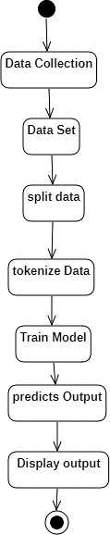
Fig. 4.5.1.1 State Chart Diagram

Sequence diagram
A sequence diagram is a type of interaction diagram because it describes how and in what order a group of objects works together. A sequence diagram shows object interactions arranged in time sequence. The interaction that takes place in collaboration that either realizes a use case or an operation. Sequence diagrams provide high level interactions between user of the system and the system, between the system and the other systems, or between subsystems.

Sequence diagrams can be useful references for businesses and other organizations.
Try drawing a sequence diagram to:

- Represent the details of a UML use case.
- Model the logic of a sophisticated procedure, function, or operation.
- See how objects and components interact with each other to complete a process.
- Plan and understand the detailed functionality of an existing or future scenario.

The following scenarios are ideal for using a sequence diagram:
- Usage scenario: A usage scenario is a diagram of how your system could potentially be used. It's a great way to make sure that you have worked through the logic of every usage scenario for the system.
- Method logic: Just as you might use a UML sequence diagram to explore the logic of a use case, you can use it to explore the logic of any function, procedure, or complex process.
- Service logic: If you consider a service to be a high-level method used by different clients, a sequence diagram is an ideal way to map that out.
- Sequence diagram Visio - Any sequence diagram that you create with Visio can also be uploaded into Lucidchart. Lucidchart supports .vsd and .vdx file import and is a great Microsoft Visio alternative. Almost all of the images you see in the UML section of this site were generated using Lucidchart.

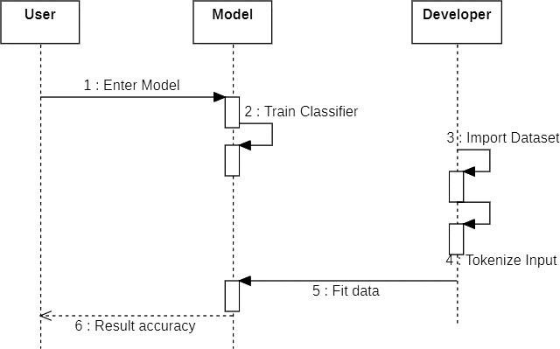

Fig 4.5.2.1 sequence diagram

Communication Diagram
The communication diagram and the sequence diagram are similar. They're semantically equivalent, that is, they present the same information, and you can turn a communication to a sequence diagram and vice versa. The main distinction between them is that the communication diagram arranges elements according to space, the sequence diagram is according to time.
Communication diagrams offer benefits similar to sequence diagrams, but they will offer a better understanding of how components communicate and interact with each other rather than solely emphasizing the sequence of events. They can be a useful reference for businesses, organizations, and engineers who need to visualize and understand the physical communications within a program. Try drawing a sequence diagram to:
- Model the logic of a sophisticated procedure, function, or operation.

- Identify how commands are sent and received between objects or components of a process.
- Visualize the consequences of specific interactions between various components in a process.
- Plan and understand the detailed functionality of an existing or future scenario.

A communication diagram offers the same information as a sequence diagram, but while a sequence diagram emphasizes the time and order of events, a communication diagram emphasizes the messages exchanged between objects in an application. Sequence diagrams can fall short of offering the "big picture.”
This is where communication diagrams come in and offer that broader perspective within a process.

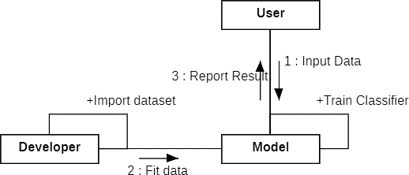

Fig 4.5.3.1 Communication diagram

Static Model

Component Diagram

UML Component diagrams are used in modelling the physical aspects of object oriented systems that are used for visualizing, specifying, and documenting component- based systems and also for constructing executable systems through forward and reverse engineering.
Component diagram is a special kind of diagram in UML. The purpose is also different from all other diagrams discussed so far. It does not describe the functionality of the system but it describes the components used to make those functionalities.
Thus from that point of view, component diagrams are used to visualize the physical components in a system. These components are libraries, packages, files, etc.
Component diagrams can also be described as a static implementation view of a system. Static implementation represents the organization of the components at a particular moment.
A single component diagram cannot represent the entire system but a collection of diagrams is used to represent the whole.
The purpose of the component diagram can be summarized as −

- Visualize the components of a system.
- Construct executables by using forward and reverse engineering.
- Describe the organization and relationships of the components.

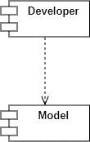

Fig. 4.6.1.1 Component Diagram

Deployment Diagram
Deployment diagrams are used to visualize the topology of the physical components of a system, where the software components are deployed. Deployment diagrams are used to describe the static deployment view of a system. Deployment diagrams consist of nodes and their relationships.

Deployment diagrams are important for visualizing, specifying, and documenting embedded, client/server, and distributed systems and also for managing executable systems through forward and reverse engineering.
A deployment diagram is just a special kind of class diagram, which focuses on a system's nodes. Graphically, a deployment diagram is a collection of vertices and arcs. Deployment diagrams commonly contain:
Nodes
3-D box represents a node, either software or hardware HW node can be signified with <<stereotype>>
Connections between nodes are represented with a line, with optional <<stereotype>> Nodes can reside within a node

A UML deployment diagram is a diagram that shows the configuration of run time processing nodes and the components that live on them. Deployment diagrams is a kind of structure diagram used in modeling the physical aspects of an object-oriented system. They are often be used to model the static deployment view of a system (topology of the hardware).

Deployment diagrams are important for visualizing, specifying, and documenting embedded, client/server, and distributed systems and also for managing executable systems through forward and reverse engineering.
A deployment diagram is just a special kind of class diagram, which focuses on a system's nodes. Graphically, a deployment diagram is a collection of vertices and arcs.

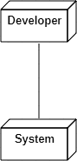

Fig. 4.6.2.1 Deployment Diagram

CHAPTER 5

IMPLEMENTATION

IMPLEMENTATION

Software Used

Visual Studio

Visual Studio is one of the most powerful IDE that works with all major programming languages like C#, Python and Java versions. It is maintained by Microsoft Corporation. This IDE is loaded with rich features and functionalities that, one can possibly imagine.

Features of Visual Studio

Visual Studio provides the most advanced features that the latest developers are looking for.

Code Editor

The Visual Studio has the best in class Code editor which supports multiple functionalities. It enables bookmarks in code to incorporate Quick Navigation. In addition to the normal text, VS also provides Incremental Search, Regex Search, Multi-item Clipboard, and Task-list. The Editor is also capable to support Code refactoring, Parameter Reordering, Variable and Method Renaming, Interface Extraction and many more user-friendly functionalities.

Debugger

The remarkable Debugger of the MS Visual Studio can work both as a Machine Level Debugger as well as a Source Level Debugger. It is capable to debug Mapped Code as well as Native Code. It is capable to compile any programming language that is supports VS. It is capable to attach itself to the currently running process to conduct
Monitoring and debugging producers on the code available.

Designer

Visual Studio includes a number of visual designers to help within the development of applications like WPF Designer, Windows Forms Designer, Class Designer, Web Designer etc.

Python is a widely used general-purpose, high level programming language. It was created by Guido van Rossum in 1991 and further developed by the Python Software Foundation. It was designed with an emphasis on code readability, and its syntax allows programmers to express their concepts in fewer lines of code.
Python is a programming language that lets you work quickly and integrate systems more efficiently.
There are two major Python versions: Python2 and Python3

- Python works on different platforms (Windows, Mac, Linux, Raspberry Pi, etc).
- Python has a simple syntax similar to the English language.
- Python has syntax that allows developers to write programs with fewer lines than some other programming languages.
- Python runs on an interpreter system, meaning that code can be executed as soon as it is written. This means that prototyping can be very quick.
- Python can be treated in a procedural way, an object-orientated way or a functional way.

The biggest strength of Python is huge collection of standard library which can be used for the following :
  - Machine Learning
  - GUI Applications (like Kivy, Tkinter, PyQt etc. )
  - Web frameworks like Django (used by YouTube, Instagram, Dropbox)
  - Image processing (like OpenCV, Pillow)
  - Web scraping (like Scrapy, BeautifulSoup, Selenium)
  - Test frameworks
  - Multimedia
There are more advantages of using Python Programming Language. Some of them are:

Extensive Libraries

Python downloads with an extensive library and it contain code for various purposes like regular expressions, documentation-generation, unit- testing, web browsers, threading, databases, CGI, email, image manipulation, and more. So, we don‘t have to write the complete code for that manually.

Extensible

As we have seen earlier, Python can be extended to other languages. You can write some of your code in languages like C++ or C. This comes in handy, especially in projects.

Embeddable

Complimentary to extensibility, Python is embeddable as well. You can put your Python code in your source code of a different language, like C++. This lets us add scripting capabilities to our code in the other language.

Improved Productivity

The language‘s simplicity and extensive libraries render programmers more productive than languages like Java and C++ do. Also, the fact that you need to write less and get more things done.

IOT Opportunities

Since Python forms the basis of new platforms like Raspberry Pi, it finds the future bright for the Internet Of Things. This is a way to connect the language with the real world.

Simple and Easy

When working with Java, you may have to create a class to print „Hello World‟. But in Python, just a print statement will do. It is also quite easy to learn,
understand, and code. This is why when people pick up Python, they have a hard time adjusting to other more verbose languages like Java.

Readable

Because it is not such a verbose language, reading Python is much like reading English. This is the reason why it is so easy to learn, understand, and code. It also does not need curly braces to define blocks, and indentation is mandatory. This further aids the readability of the code.

Object-Oriented

This language supports both the procedural and object-oriented programming paradigms. While functions help us with code reusability, classes and objects let us model the real world. A class allows the encapsulation of data and functions into one.

Free and Open-Source

Like we said earlier, Python is freely available. But not only can you download Python for free, but you can also download its source code, make changes to it, and even distribute it. It downloads with an extensive collection of libraries to help you with your tasks.

Portable

When you code your project in a language like C++, you may need to make some changes to it if you want to run it on another platform. But it isn‘t the same with Python. Here, you need to code.

only once, and you can run it anywhere. This is called Write Once Run Anywhere (WORA). However, you need to be careful enough not to include any system-dependent features.

Interpreted

Lastly, we will say that it is an interpreted language. Since statements are executed one by one, debugging is easier than in compiled languages.

Advantages of Python Over Other Languages

- Less Coding

Almost all of the tasks done in Python requires less coding when the same task is done in other languages. Python also has an awesome standard library support, so you don‘t have to search for any third-party libraries to get your job done. This is the reason that many people suggest learning Python to beginners.

Affordable

Python is free therefore individuals, small companies or big organizations can leverage the free available resources to build applications. Python is popular and widely used so it gives you better community support.

Python is for Everyone

Python code can run on any machine whether it is Linux, Mac or Windows. Programmers need to learn different languages for different jobs but with Python, you can professionally build web apps, perform data analysis and machine learning, automate things, do web scraping and also build games and powerful visualizations. It is an all-rounder programming language.

Disadvantages of Python
So far, we‘ve seen why Python is a great choice for your project. But if you choose it, you should be aware of its consequences as well. Let‘s now see the downsides of choosing Python over another language.

Speed Limitations

We have seen that Python code is executed line by line. But since Python is interpreted, it often results in slow execution. This, however, isn‘t a problem unless speed is a focal point for the project. In other words, unless high speed is a requirement, the benefits offered by Python are enough to distract us from its speed limitations.

Weak in Mobile Computing and Browsers

While it serves as an excellent server-side language, Python is much rarely seen on the client-side. Besides that, it is rarely ever used to implement smartphone-based applications. One such application is called Carbonnelle.

Design Restrictions

As you know, Python is dynamically-typed. This means that you don‘t need to declare the type of variable while writing the code. It uses duck-typing. But wait, what‘s that? Well, it just means that if it looks like a duck, it must be a duck. While this is easy on the programmers during coding, it can raise run- time errors.

Underdeveloped Database Access Layers

Compared to more widely used technologies like JDBC (Java DataBase Connectivity) and ODBC (Open DataBase Connectivity), Python‘s database access layers are a bit underdeveloped. Consequently, it is less often applied in huge enterprises.
This was all about the Advantages and Disadvantages of Python Programming Language.

History of Python :
What do the alphabet and the programming language Python have in common? Right, both start with ABC. If we are talking about ABC in the Python context, it's clear that the programming language ABC is meant. ABC is a general-purpose programming language and programming environment, which had been developed in the Netherlands, Amsterdam, at the CWI (Centrum Wiskunde & Informatica). The greatest achievement of ABC was to influence the design of Python. Python was conceptualized in the late 1980s. Guido van Rossum worked that time in a project at the CWI, called Amoeba, a distributed operating system. In an interview with Bill Venners1, Guido van Rossum said: "In the early 1980s, I worked as an implementer on a team

building a language called ABC at Centrum voor Wiskunde en Informatica (CWI). I don't know how well people know ABC's influence on Python. I try to mention ABC's influence because I'm indebted to everything I learned during that project and to the people who worked on it." Later on in the same Interview, Guido van Rossum continued: "I remembered all my experience and some of my frustration with ABC. I decided to try to design a simple scripting language that possessed some of ABC's better properties, but without its problems. So I started typing. I created a simple virtual machine, a simple parser, and a simple runtime. I made my own version of the various ABC parts that I liked. I created a basic syntax, used indentation for statement grouping instead of curly braces or begin-end blocks, and developed a small number of powerful data types: a hash table (or dictionary, as we call it), a list, strings, and numbers."

Machine Learning
Machine learning (ML) is a type of artificial intelligence (AI) that allows software applications to become more accurate at predicting outcomes without being explicitly programmed to do so. Machine learning algorithms use historical data as input to predict new output values.
Machine learning is important because it gives enterprises a view of trends in customer behavior and business operational patterns, as well as supports the development of new products. Many of today's leading companies, such as Facebook, Google and Uber, make machine learning a central part of their operations. Machine learning has become a significant competitive differentiator for many companies.
Classical machine learning is often categorized by how an algorithm learns to become more accurate in its predictions.

There are four basic approaches: supervised learning, unsupervised learning, semi-supervised learning and reinforcement learning. The type of algorithm data scientists choose to use depends on what type of data they want to predict.

- Supervised learning: In this type of machine learning, data scientists supply algorithms with labeled training data and define the variables they want the algorithm to assess for correlations. Both the input and the output of the algorithm is specified.
- Unsupervised learning: This type of machine learning involves algorithms that train on unlabeled data. The algorithm scans through data sets looking for any meaningful connection. The data that algorithms train on as well as the predictions or recommendations they output are predetermined.
- Semi-supervised learning: This approach to machine learning involves a mix of the two preceding types. Data scientists may feed an algorithm mostly labeled training data, but the model is free to explore the data on its own and develop its own understanding of the data set.
- Reinforcement learning: Data scientists typically use reinforcement learning to teach a machine to complete a multi-step process for which there are clearly defined rules. Data scientists program an algorithm to complete a task and give it positive or negative cues as it works out how to complete a task. But for the most part, the algorithm decides on its own what steps to take along the way.
What is Machine Learning :

Before we take a look at the details of various machine learning methods, let's start by looking at what machine learning is, and what it isn't. Machine learning is often categorized as a subfield of artificial intelligence, but I find that categorization can often be misleading at first brush. The study of machine learning certainly arose from research in this context, but in the data science application of machine learning methods, it's more helpful to think of machine learning as a means of building models of data.
Fundamentally, machine learning involves building mathematical models to help understand data. "Learning" enters the fray when we give these models tunable parameters that can be adapted to observed data; in this way the program can be considered to be "learning" from the data. Once these models have been fit to previously seen data, they can be used to predict and understand aspects of newly observed data. I'll leave to the reader the more philosophical digression regarding the extent to which this type of mathematical, model-based "learning" is similar to the "learning" exhibited by

the human brain. Understanding the problem setting in machine learning is essential to using these tools effectively, and so we will start with some broad categorizations of the types of approaches we'll discuss here.
Cross Validation
Learning the parameters of a prediction function and testing it on the same data is a methodological mistake: a model that would just repeat the labels of the samples that it has just seen would have a perfect score but would fail to predict anything useful on yet-unseen data. This situation is called overfitting. To avoid it, it is common practice when performing a (supervised) machine learning experiment to hold out part of the available data as a test set X_test, y_test. Note that the word “experiment” is not intended to denote academic use only, because even in commercial settings machine learning usually starts out experimentally. Here is a flowchart of typical cross validation workflow in model training. The best parameters can be determined by grid research techniques.
When evaluating different settings (“hyperparameters”) for estimators, such as the C setting that must be manually set for an SVM, there is still a risk of overfitting on the test set because the parameters can be tweaked until the estimator performs optimally. This way, knowledge about the test set can “leak” into the model and evaluation metrics no longer report on generalization performance. To solve this problem, yet another part of the dataset can be held out as a so-called “validation set”: training proceeds on the training set, after which evaluation is done on the validation set, and when the experiment seems to be successful, final evaluation can be done on the test set.

However, by partitioning the available data into three sets, we drastically reduce the number of samples which can be used for learning the model, and the results can depend on a particular random choice for the pair of (train, validation) sets.

A solution to this problem is a procedure called cross-validation (CV for short). A test set should still be held out for final evaluation, but the validation set is no longer needed when doing CV. In the basic approach, called k-fold CV, the training set is split into k smaller sets (other approaches are described below,

but generally follow the same principles). The following procedure is followed for each of the k “folds”:

- A model is trained using k−1 of the folds as training data;
- the resulting model is validated on the remaining part of the data (i.e., it is used as a test set to compute a performance measure such as accuracy).
The performance measure reported by k-fold cross-validation is then the average of the values computed in the loop. This approach can be computationally expensive, but does not waste too much data (as is the case when fixing an arbitrary validation set), which is a major advantage in problems such as inverse inference where the number of samples is very small.

Challenges in Machines Learning :

While Machine Learning is rapidly evolving, making significant strides with cybersecurity and autonomous cars, this segment of AI as whole still has a long way to go. The reason behind is that ML has not been able to overcome number of challenges. The challenges that ML is facing currently are −
Quality of data − Having good-quality data for ML algorithms is one of the biggest challenges. Use of low-quality data leads to the problems related to data preprocessing and feature extraction.
Time-Consuming task Another challenge faced by ML models is the consumption of time especially for data acquisition, feature extraction and retrieval.
Lack of specialist persons As ML technology is still in its infancy stage, availability of expert resources is a tough job.
No clear objective for formulating business problems Having no clear objective and well- defined goal for business problems is another key challenge for ML because this technology is not that mature yet.
Issue of overfitting & underfitting If the model is overfitting or underfitting, it cannot be represented well for the problem.
Curse of dimensionality Another challenge ML model faces is too many features of data points. This can be a real hindrance.

Difficulty in deployment Complexity of the ML model makes it quitedifficult to be deployed in real life.

Applications of Machines Learning :

Machine Learning is the most rapidly growing technology and according to researchers we are in the golden year of AI and ML. It is used to solve many real-world complex problems which cannot be solved with traditional approach. Following are some real-world applications of ML −
  - Emotion analysis

  - Sentiment analysis

  - Error detection and prevention

  - Weather forecasting and prediction

  - Stock market analysis and forecasting

  - Speech synthesis

  - Speech recognition

  - Customer segmentation

  - Object recognition

  - Fraud detection

  - Fraud prevention

  - Recommendation of products to customer in online shopping

How to Start Learning Machine Learning?

Arthur Samuel coined the term “Machine Learning” in 1959 and defined it as a “Field of study that gives computers the capability to learn without being explicitly programmed”.
And that was the beginning of Machine Learning! In modern times, Machine Learning is one of the most popular (if not the most!) career choices. According to Indeed, Machine Learning Engineer Is The Best Job of 2019 with a 344% growth and an average base salary of $146,085 per year.
But there is still a lot of doubt about what exactly is Machine Learning and how to start learning it? So this article deals with the Basics of Machine

Learning and also the path you can follow to eventually become a full-fledged Machine Learning Engineer. Now let‘s get started!!!

How to start learning ML?

This is a rough roadmap you can follow on your way to becoming an insanely talented Machine Learning Engineer. Of course, you can always modify the steps according to your needs to reach your desired end-goal!

Step 1 Understand the Prerequisites

In case you are a genius, you could start ML directly but normally, there are some prerequisites that you need to know which include Linear Algebra, Multivariate Calculus, Statistics, and Python. And if you don‘t know these, never fear! You don‘t need a Ph.D. degree in these topics to get started but you do need a basic understanding.

- Learn Linear Algebra and Multivariate Calculus

Both Linear Algebra and Multivariate Calculus are important in Machine Learning. However, the extent to which you need them depends on your role as a data scientist. If you are more focused on application heavy machine learning, then you will not be that heavily focused on maths as there are many common libraries available. But if you want to focus on R&D in Machine Learning, then mastery of Linear Algebra and Multivariate Calculus is very important as you will have to implement many ML algorithms from scratch.
- Learn Statistics

Data plays a huge role in Machine Learning. In fact, around 80% of your time as an ML expert will be spent collecting and cleaning data. And statistics is a field that handles the collection, analysis, and presentation of data. So it is no surprise that you need to learn it!!! Some of the key concepts in statistics that are important are Statistical Significance, Probability Distributions, Hypothesis Testing, Regression, etc. Also, Bayesian Thinking is also a very important part of ML which deals with various concepts like Conditional Probability, Priors, and Posteriors, Maximum Likelihood, etc.

- Learn Python

Some people prefer to skip Linear Algebra, Multivariate Calculus and Statistics and learn them as they go along with trial and error. But the one thing that you absolutely cannot skip is Python! While there are other languages you can use for Machine Learning like R, Scala, etc. Python is currently the most popular language for ML. In fact, there are many Python libraries that are specifically useful for Artificial Intelligence and Machine Learning such as Keras, TensorFlow, Scikit-learn, etc.

Step 2 Learn Various ML Concepts

Now that you are done with the prerequisites, you can move on to actually learning ML (Which is the fun part!!!) It‘s best to start with the basics and then move on to the more complicated stuff. Some of the basic concepts in ML are:

Terminologies of Machine Learning

  - Model – A model is a specific representation learned from data by applying some machine learning algorithm. A model is also called a hypothesis.
    - Feature – A feature is an individual measurable property of the data. A set of numeric features can be conveniently described by a feature vector. Feature vectors are fed as input to the model. For example, in order to predict a fruit, there may be features like color, smell, taste, etc.
    - Target (Label) – A target variable or label is the value to be predicted by our model. For the fruit example discussed in the feature section, the label with each set of input would be the name of the fruit like apple, orange, banana, etc.
    - Training – The idea is to give a set of inputs(features) and it‘s expected outputs(labels), so after training, we will have a model (hypothesis) that will then map new data to one of the categories trained on.
    - Prediction – Once our model is ready, it can be fed a set of inputs to which it will provide a predicted output(label).

Advantages of Machine learning :

- Easily identifies trends and patterns -

Machine Learning can review large volumes of data and discover specific trends and patterns that would not be apparent to humans. For instance, for an e-commerce website like Amazon, it serves to understand the browsing behaviors and purchase histories of its users to help cater to the right products, deals, and reminders relevant to them. It uses the results to reveal relevant advertisements to them.
- No human intervention needed (automation)

With ML, you don‘t need to babysit your project every step of the way. Since it means giving machines the ability to learn, it lets them make predictions and also improve the algorithms on their own. A common example of this is anti-virus softwares; they learn to filter new threats as they are recognized.
ML is also good at recognizing spam.

- Continuous Improvement

As ML algorithms gain experience, they keep improving in accuracy and efficiency. This lets them make better decisions. Say you need to make a weather forecast model. As the amount of data you have keeps growing, your algorithms learn to make more accurate predictions faster.
- Handling multi-dimensional and multi-variety data

Machine Learning algorithms are good at handling data that are multi- dimensional and multi-variety, and they can do this in dynamic or uncertain environments.
- Wide Applications

You could be an e-tailer or a healthcare provider and make ML work for you. Where it does apply, it holds the capability to help deliver a much more personal experience to customers while also targeting the right customers.

Disadvantages of Machine Learning

- Data Acquisition

Machine Learning requires massive data sets to train on, and these should be inclusive/unbiased, and of good quality. There can also be times where they must wait for new data to be generated.
- Time and Resources

ML needs enough time to let the algorithms learn and develop enough to fulfill their purpose with a considerable amount of accuracy and relevancy. It also needs massive resources to function. This can mean additional requirements of computer power for you.
- Interpretation of Results

Another major challenge is the ability to accurately interpret results generated by the algorithms. You must also carefully choose the algorithms for your purpose.

- High error-susceptibility

Machine Learning is autonomous but highly susceptible to errors. Suppose you train an algorithm with data sets small enough to not be inclusive. You end up with biased predictions coming from a biased training set. This leads to irrelevant advertisements being displayed to customers. In the case of ML, such blunders can set off a chain of errors that can go undetected for long periods of time. And when they do get noticed, it takes quite some time to recognize the source of the issue, and even longer to correct it.

How does supervised machine learning work?
Supervised machine learning requires the data scientist to train the algorithm with both labeled inputs and desired outputs. Supervised learning algorithms are good for the following tasks:

- Binary classification: Dividing data into two categories.

- Multi-class classification: Choosing between more than two types of answers.

- Regression modeling: Predicting continuous values.

- Ensembling: Combining the predictions of multiple machine learning models to produce an accurate prediction.

How does unsupervised machine learning work?
Unsupervised machine learning algorithms do not require data to be labeled. They sift through unlabeled data to look for patterns that can be used to group data points into subsets. Most types of deep learning, including neural networks, are unsupervised algorithms. Unsupervised learning algorithms are good for the following tasks:

- Clustering: Splitting the dataset into groups based on similarity.

- Anomaly detection: Identifying unusual data points in a data set.

- Association mining: Identifying sets of items in a data set that frequently occur together.
- Dimensionality reduction: Reducing the number of variables in a data set.

Parametric Models
A learning model that précises data with a set of parameters of fixed size is termed as a parametric model. Irrespective of the volume of the data given to a parametric model, it won’t change its attention on the number of parameters it requires. Examples of parametric learners include linear models like – Linear regression, Logistic regression and Linear Support Vector Machine (LSVM).

Linear Regression
Linear Regression determines a plane to minimize the Sum of Squared Errors (SSE) among the observed and predicted response [9]. Now we model Linear regression to predict the target variable PE. We will start with Simple linear regression which is used for forecasting continues result.
  - Simple linear regression works on only one independent variable
  - Multiple linear regression works on more than 1 independent variable. The following equation is used by the linear regression to calculate target feature
𝑦=𝛽0+𝛽1𝑥1+𝛽2𝑥2+...+𝛽𝑛𝑥𝑛 - (1)
where, 𝑦 is response, 𝛽0 is intercept, 𝛽1 is coefficient for 𝑥1 and 𝛽𝑛 is coefficient for
𝑥𝑛

Polynomial Regression
A variation to linear regression that makes regression models constructed on polynomial equations is called Polynomial regression. In this regression a polynomial is modeled based on the association between the input features and predictor variable.
The following equation is kth order polynomial model with one variable
𝑦=𝛽0+𝛽1𝑥+𝛽2𝑥 2+...+𝛽k𝑥k+ε - (2)

If xj = x j , j = 1, 2, 3, … k, the model is multiple linear regression model in k descriptive variables x1, x2, x3, …, xk . From this we can understand that linear regression model y = xβ + ε also contains the polynomial regression model.

Support Vector Machine (SVM)
This is a discriminative algorithm formally defined by a separating hyperplane. In SVM a hyperplane in a high dimensional space is built for classification and regression. The objective of the SVM algorithm is to generate the finest line or decision borderline that can discrete n-dimensional space into classes so that we can

simply put the novel data points in the correct class in the future. This concluded borderline is called a hyperplane. SVM selects the extreme points that help in generating the hyperplane. These extreme points are termed as Support Vectors, and because of this the algorithm is named as Support Vector Machine.

Metrics
Evaluation metrics for classification problems, such as accuracy, are not useful for regression problems. The metric accuracy used as a metric to evaluate classification problem is not used for regression problems. These problems need metrics for comparing continuous values. The three common evaluation metrics for regression problems are
Mean Square Error – the mean of the squared error and the formula is
Root Mean Square Error – the square root of the MSE and this states us how intense the data is around the line of the best fit.
R 2 Score – proportion of the variance in the dependent variable that is foreseeable from the independent variable and the formula is

Dataset and Visualizations Understanding Dataset
The dataset for this analysis is gathered from Combined Cycle Power Plant. The dataset is a collection of 6 years of power plant data with 9,568 records. The dataset has four independent features and one target feature. The description of the features is Hourly Average Temperature – AT, Ambient Pressure – AP, Relative Humidity – RH, Exhaust Vacuum – V, Net hourly electrical energy output of the power plant – PE.

The descriptive information of the dataset are shown in the Table 1. From Table 1 it is evident that all the features are continuous but ranges are varying. The data is to be normalized to 0 to 1 before applying any Machine Learning model to overcome the variations in the Mean and Standard deviation.

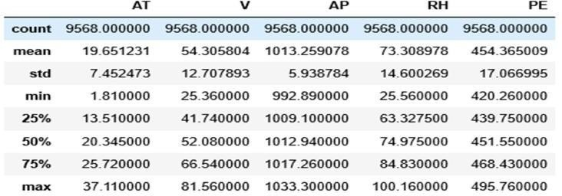

Fig: 5.1.1 Statistics of the Dataset

Visualization
Data Visualization plays a vital role to analyze datasets and to understand the insights of collected dataset. Data Visualization will make it easier to understand through various plots – Boxplot, Scatter plot, Distribution plot, Heat map, Correlation chart, Pair plot etc.
A Boxplot is a regular way of presenting the scattering of data built on a 5 number summary. The Boxplots of all the continuous features is presented

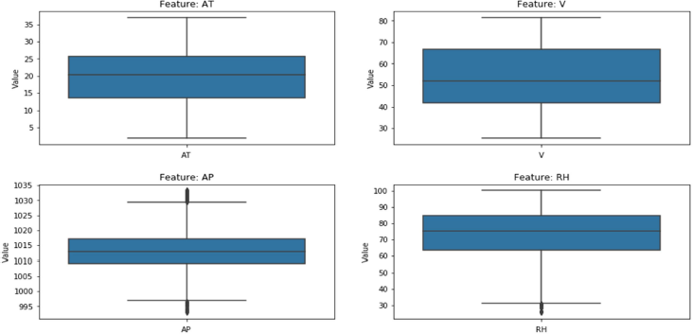

Fig: 5.1.2 Boxplots of all features
Distribution plot is a most convenient way to present the univariate distribution of a feature, which show data in histogram and fit a Kernel Density Estimate (KDE). A histogram is a tool that represents the distribution of data in the form bins along the

range of the data. The KDE is useful for plotting the shape of a distribution. The bell like curve in the plot shows the density which is a smooth form of the histogram. The y-axis is in terms of density, and the histogram is stabilized by default so that it has the same y-scale as the density plot.
The Distribution plots of the continuous features in comparison with target feature are shown
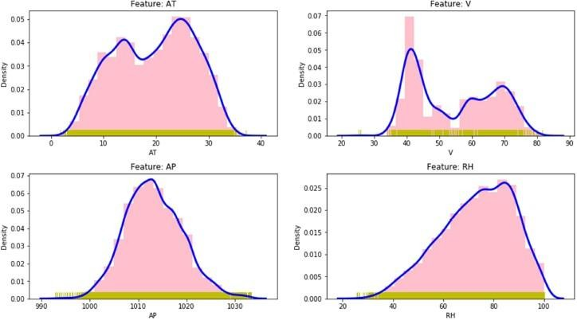

Fig: 5.1.3 Distribution plots of all features with KDE

Scatter plot presents the relationship between two continuous features. It illustrates how one feature affects the other feature in every fraction of the value of the data set. The scatter plots of all the features are presented

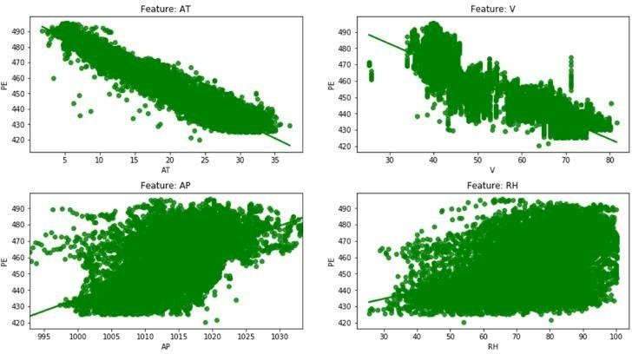

Fig: 5.1.4Regression plots for all features with target feature (PE) Dataset partition
The original dataset with dimension (9568, 5) is partitioned randomly into train set and test set in the 75:25 ratio. So, the train and test set dimension becomes (7176, 5) and (2392, 5) respectively. The following commands will partition the dataset into four partitions as x_train, y_train, x_test and y_test. x_train and x_test contain the all independent features of train and test set. y_train and y_test contain only the dependent feature of train and test set.
x = data[['AT', 'V', 'AP','RH']]

y = data['PE']

x_train, x_test, y_train, y_test = train_test_split(x, y, random_state=1)

Linear Regression

According to Equation 1, the predicted feature for the dataset is calculated using the following equation.
𝑦=𝛽0+𝛽1×𝐴𝑇+𝛽2×𝑉+𝛽3×𝐴𝑃+𝛽4×𝑅𝐻 --- Equation 3

The 𝛽 values are termed the model coefficients. These values are “learned” through the model fitting phase by means of the “least squares” measure [10-12]. Then, the fitted model can be used to create predictions. The coefficients and slop values of the fitted model are
Coefficient = 447.06297098687327

Slop values = [-1.97376045, -0.23229086, 0.0693515, -0.15806957]

Fig:5.1.5 Linear Regression results
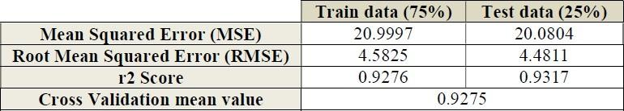

The results in Table shows that the model is giving approximately 93% accuracy for train, test data and also in 10 folds cross validation.
Linear regression is a parametric model. A Parametric model is a model that creates some expectations around the data for the purpose of modeling. We need to check the assumptions for linear regression to obtain good results with the data. The assumptions of Linear regression are
- Normality
- Linearity
- Homoscedasticity
- Independence
- Multicollinearity

Normality
In a linear regression model, the errors or residuals are generally distributed. If the resultant plot is linear, then the residuals are usually scattered. The plot in Fig shows a linear plot and this proves that the residual are distributed normally.

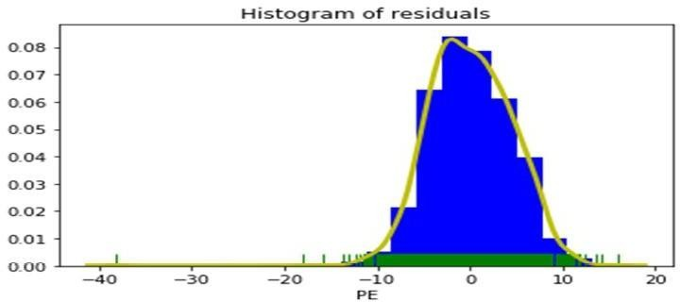

Fig: 5.1.6 Residuals of Linear regression

Linearity
This is an association of independent variables and response or target variable are linear. The linearity hypothesis can be verified using scatter plots. The plots in Fig shows that the data in all the features are almost linear to the target feature PE.

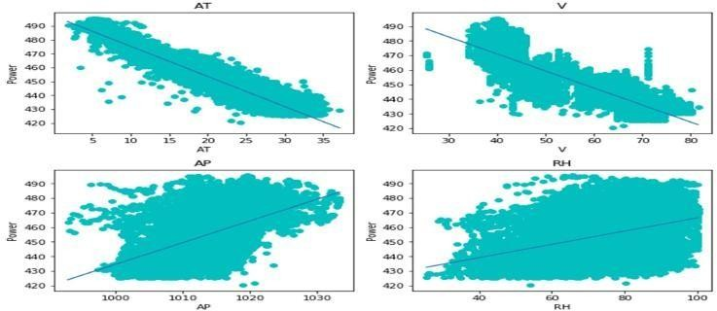

Fig: 5.1.7 Scatter plots for dependent features to target feature Homoscedasticity
This is to check for variability in the response variable is the same at all levels of exploratory variables. The residuals should be constant or with identical variance. If it is not constant across the error terms, then there is a chance of heteroscedasticity. Because of the existence of outliers, the non-constant variance across the error terms occurs. If there is a funnel shaped distribution, then consider a non-constant variance
i.e. Heteroscedasticity. The Fig shows the homoscedasticity plot between the predicted value and residuals. If there is no funnel shape distribution in the plot then this is an indication of homoscedasticity.

Independence

For linear regression it is required that the residuals have very slight or no autocorrelation in the data. If the residuals are dependent on each other, then Autocorrelation happens. Error (i+1) term is dependent of Error (i) term. This indicates that, the current residual value is dependent on the previous residual value. Presence of auto-correlation considerably decreases the R square value and increase the error of the model. We check auto-correlation using ACF(auto-correlation function) plot shown in Fig .

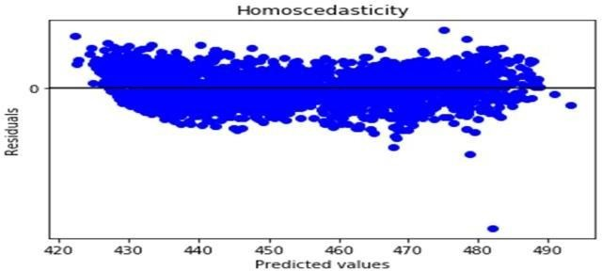

Fig:5.1.8 Homoscedasticity plot
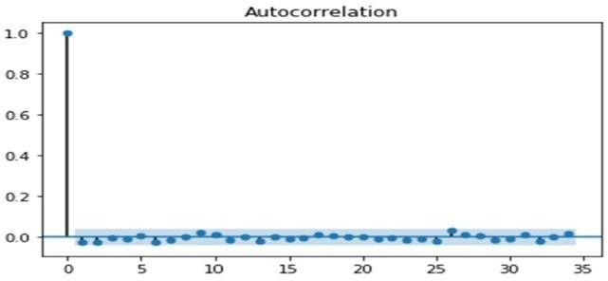
Fig:5.1.9 Auto Correlation Function (ACF)
Multicollinearity
Collinearity indicates whether the two features are highly correlated and having related information about the variance in a dataset. Correlation matrix is used to identify collinearity among features. But Multicollinearity is more difficult to detect because it emerges when three or more features in the dataset are highly correlated.
So, this is used to check whether the independent features are highly correlated with each other or not. The Variance Inflation Factor (VIF) is metric of collinearity among predictor features in multiple regression. The following Fig. 8 shows the initial VIF of all the predictor features and VIF after removing features with high VIF. Finally all the four features are to be included in the model.

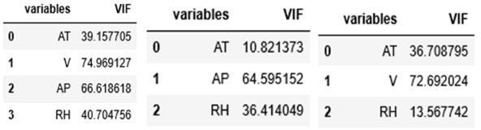
Fig: 5.1.10 (a) VIF of all features (b) VIF values after removing V (c) VIF values after removing AP

Polynomial Regression
Polynomial regression is considered to be a special case of linear regression. For the dataset the polynomial regression model is implemented with a degree of nine and the results for train and test data are presented in the Table 3 along with Cross Validation mean.
The measures that are considered for Linear regression are applicable for this also.

Linear Support Vector Machine (SVM)
Support Vector Machine (SVM) is a tool used for both regression and classification. SVM uses ML theory to maximize predictive accuracy and at the same time it automatically avoids over-fitto the data.

Fig: 5.1.11 Polynomial Regression and Support Vector Machine results
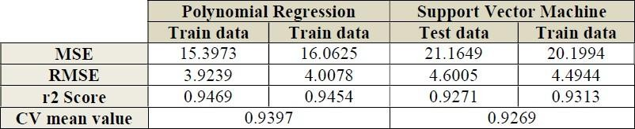

Source Code:
import pandas as pd import numpy as np import seaborn as sns
import matplotlib.pyplot as plt
%matplotlib inline import warnings
warnings.filterwarnings("ignore")

#data=pd.read_csv("C:/Users/sri/Desktop/Electrical Energy/energy.csv") data=pd.read_csv("E:/Personal/Research/Machine Learning/Forecasting Hourly Electrical Energy output of a Power plant using parametric models/energy.csv")

#data.head() #data.tail() #data.shape #data.isnull().sum() #data.dtypes #data.describe() #data.info() #data.count()
axes = ["axes1","axes2", "axes3","axes4" ] fig, axes = plt.subplots(2, 2, figsize=(15, 8)) x = data.columns
x = x[:-1]
fig.subplots_adjust(hspace=0.3)
for ax, feature, name in zip(axes.flatten(), range(0,9),x): sns.boxplot(y=data[name],ax=ax)
#kde_kws={"color": "B", "lw": 3},
#hist_kws={ "linewidth": 3,"alpha": 1, "color": "pink"}) ax.set(title="Feature: "+name.upper(),xlabel=name, ylabel="Value")

axes = ["axes1","axes2", "axes3","axes4" ] fig, axes = plt.subplots(2, 2, figsize=(15, 8)) x = data.columns
x = x[:-1]
fig.subplots_adjust(hspace=0.3)
for ax, feature, name in zip(axes.flatten(), range(0,9),x): sns.distplot(data[name],ax=ax,bins=20, rug=True, rug_kws={"color": "y"},
kde_kws={"color": "B", "lw": 3},
hist_kws={ "linewidth": 3,"alpha": 1, "color": "pink"})

ax.set(title="Feature: " + name.upper(), xlabel=name,ylabel="Density") axes = ["axes1","axes2", "axes3","axes4" ]
fig, axes = plt.subplots(2, 2, figsize=(15, 8)) x = data.columns
x = x[:-1]
fig.subplots_adjust(hspace=0.3)
for ax, feature, name in zip(axes.flatten(), range(0,9),x): sns.regplot(x=data[name],y=data["PE"],ax=ax,color="g") ax.set(title="Feature: "+name.upper(), xlabel=name, ylabel="PE")
x = data[['AT', 'V', 'AP','RH']]
y = data['PE']
from sklearn.model_selection import train_test_split
x_train, x_test, y_train, y_test = train_test_split(x, y, random_state=1) print(x_train.shape)
print(y_train.shape) print(x_test.shape) print(y_test.shape)
from sklearn.linear_model import LinearRegression linreg = LinearRegression()

linreg.fit(x_train, y_train) print(linreg.intercept_) print(linreg.coef_)

x_pred = linreg.predict(x_train) train_mse=[]
test_mse=[] train_rmse=[] test_rmse=[] train_r2score=[] test_r2score=[]

from sklearn import metrics
from sklearn.metrics import r2_score train_mse.append(metrics.mean_squared_error (y_train, x_pred)) train_rmse.append(np.sqrt(metrics.mean_squared_error(y_train, x_pred))) train_r2score.append(r2_score(y_train, x_pred))
print("Train MSE:", train_mse[0]) print('Train RMSE:',train_rmse[0]) print('Train R square:',train_r2score[0])

from sklearn.model_selection import cross_val_score scores = cross_val_score(linreg, x_train, y_train, cv=10) scores

print (scores.mean()) print(scores1.mean())

y_pred = linreg.predict(x_test)

test_mse.append(metrics.mean_squared_error (y_test, y_pred)) test_rmse.append(np.sqrt(metrics.mean_squared_error(y_test, y_pred))) test_r2score.append(r2_score(y_test, y_pred))
print("Train MSE:", test_mse[0]) print('Train RMSE:',test_rmse[0]) print('Train R square:',test_r2score[0])

y_pred = linreg.predict(x_test) error = y_test - y_pred
error

import seaborn as sns #sns.distplot(error) plt.title('Histogram of residuals')
sns.distplot(error, bins=20, rug=True, rug_kws={"color": "g"}, kde_kws={"color": "y", "lw": 3},
hist_kws={ "linewidth": 3,"alpha": 1, "color": "blue"}) power = data['PE']
features = data.drop('PE', axis = 1)

import numpy as np
import matplotlib.pyplot as plt plt.figure(figsize=(10, 8)) plt.subplots_adjust(hspace=0.3)
for i, col in enumerate(features.columns): plt.subplot(2, 2, i+1)
x = data[col] y = power
plt.plot(x, y, 'o',color="c")
plt.plot(np.unique(x), np.poly1d(np.polyfit(x, y, 1))(np.unique(x))) plt.title(col)
plt.xlabel(col) plt.ylabel('Power')

plt.plot(y_pred,error,'bo') plt.axhline(y='0',color='k') plt.xlabel('Predicted values') plt.ylabel('Residuals') plt.title ("Homoscedasticity")

import statsmodels.formula.api as smf
goldfeld_test = smf.ols('PE~AT+V+AP+RH',data=data).fit()

import statsmodels.stats.api as sms from statsmodels.compat import lzip name = ['F statistic', 'p value']
test = sms.het_goldfeldquandt(goldfeld_test.resid,goldfeld_test.model.exog) lzip(name,test)

from statsmodels.graphics.tsaplots import plot_acf

plot_acf(error)

from statsmodels.graphics.tsaplots import plot_pacf plot_pacf(error)

from statsmodels.api import OLS print(OLS(y_train,x_train).fit().summary())
# For information about this Multicollinearity refer the following website
# https://www.analyticsvidhya.com/blog/2020/03/what-is-multicollinearity/ # Import library for VIF
from statsmodels.stats.outliers_influence import variance_inflation_factor def calc_vif(X):
# Calculating VIF vif = pd.DataFrame()
vif["variables"] = X.columns
vif["VIF"] = [variance_inflation_factor(X.values, i) for i in range(X.shape[1])] return(vif)
X = data.iloc[:,:-1] calc_vif(X)

X = data.drop (["V","PE"],axis=1) calc_vif(X)

X = data.drop (["AP","PE"],axis=1) calc_vif(X)

# The following code is taken from the website
# https://stats.stackexchange.com/questions/155028/how-to-systematically-remove- collinear-variables-in-python
def calculate_vif_(X, thresh=100): cols = X.columns
variables = np.arange(X.shape[1]) dropped=True
while dropped: dropped=False
c = X[cols[variables]].values
vif = [variance_inflation_factor(c, ix) for ix in np.arange(c.shape[1])]

maxloc = vif.index(max(vif)) if max(vif) > thresh:
print('dropping \'' + X[cols[variables]].columns[maxloc] + '\' at index: ' + str(maxloc))
variables = np.delete(variables, maxloc) dropped=True

print('Remaining variables:') print(X.columns[variables])

return X[cols[variables]]

X = data.iloc[:,:-1] calculate_vif_(X)

from statsmodels.sandbox.regression.predstd import wls_prediction_std import statsmodels.api as sm

model = sm.OLS.from_formula('PE~AT+V+AP+RH',data=data) result = model.fit()
print(result.summary())

from sklearn.preprocessing import PolynomialFeatures

pr=PolynomialFeatures(degree=9) x_train_pr=pr.fit_transform(x_train) x_test_pr=pr.fit_transform(x_test)

lr=LinearRegression() lr.fit(x_train_pr,y_train) pr_x_pred=lr.predict(x_train_pr)
print(lr.intercept_) print(len(lr.coef_)) print(lr.coef_)

train_mse.append(metrics.mean_squared_error(y_train, pr_x_pred)) train_rmse.append(np.sqrt(metrics.mean_squared_error(y_train, pr_x_pred))) train_r2score.append(r2_score(y_train, pr_x_pred))
print('Train MSE:',train_mse[1]) print('Train RMSE:',train_rmse[1]) print('Train R square:',train_r2score[1]) x_pr.shape

from sklearn.model_selection import cross_val_score x = data[['AT', 'V', 'AP','RH']]
x_pr = pr.fit_transform(x)
scores = cross_val_score(lr, x_pr, y, cv=10) print (scores)
print ("Cross Validation Mean value:"+str(scores.mean()))

pr_pred=lr.predict(x_test_pr)

test_mse.append(metrics.mean_squared_error(y_test, pr_pred)) test_rmse.append(np.sqrt(metrics.mean_squared_error(y_test, pr_pred))) test_r2score.append(r2_score(y_test, pr_pred))
print('Test MSE:',test_mse[1]) print('Test RMSE:',test_rmse[1]) print('Test R square:',test_r2score[1]) from sklearn.svm import SVR
model_linear_svm = SVR(kernel='linear')

model_linear_svm.fit(x_train, y_train) pred_train = model_linear_svm.predict(x_train)
train_mse.append(metrics.mean_squared_error(y_train, pred_train)) train_rmse.append(np.sqrt(metrics.mean_squared_error(y_train, pred_train))) train_r2score.append(r2_score(y_train, pred_train))
print('Train MSE:',train_mse[2]) print('Train RMSE:',train_rmse[2]) print('Train R square:',train_r2score[2])

from sklearn.model_selection import cross_val_score scores = cross_val_score(model_linear_svm, x, y, cv=10)

print (scores) scores.mean()
pred_test = model_linear_svm.predict(x_test)

test_mse.append(metrics.mean_squared_error (y_test, pred_test)) test_rmse.append(np.sqrt(metrics.mean_squared_error(y_test, pred_test))) test_r2score.append(r2_score(y_test, pred_test))
print("Train MSE:", test_mse[2]) print('Train RMSE:',test_rmse[2]) print('Train R square:',test_r2score[2])
print (train_mse) print (test_mse)

barWidth = 0.25

bar1=train_mse bar2=test_mse

r1 = np.arange(len(bar1))
r2 = [x + barWidth for x in r1]

plt.bar(r1, bar1, color='b', width=barWidth, edgecolor='white', label='Train') plt.bar(r2, bar2, color='g', width=barWidth, edgecolor='white', label='Test')

plt.title('MSE values for models', fontweight='bold')
plt.xticks([r + barWidth-0.1 for r in range(len(bar1))], ['Linear Regression','Polynomial Regression','Support Vector Machine'])

plt.legend() plt.show()

print (train_rmse) print (test_rmse)

barWidth = 0.25

bar1=train_rmse bar2=test_rmse

r1 = np.arange(len(bar1))
r2 = [x + barWidth for x in r1]

plt.bar(r1, bar1, color='b', width=barWidth, edgecolor='white', label='Train') plt.bar(r2, bar2, color='g', width=barWidth, edgecolor='white', label='Test')

plt.title('RMSE values for models', fontweight='bold')
plt.xticks([r + barWidth-0.1 for r in range(len(bar1))], ['Linear Regression','Polynomial Regression','Support Vector Machine'])

plt.legend() plt.show()

print (train_r2score) print (test_r2score)

barWidth = 0.25

bar1=train_r2score bar2=test_r2score

r1 = np.arange(len(bar1))
r2 = [x + barWidth for x in r1]
plt.bar(r1, bar1, color='b', width=barWidth, edgecolor='white', label='Train') plt.bar(r2, bar2, color='g', width=barWidth, edgecolor='white', label='Test')

plt.title('R2 Score values for models', fontweight='bold')
plt.xticks([r + barWidth-0.1 for r in range(len(bar1))], ['Linear Regression','Polynomial Regression','Support Vector Machine'])

plt.legend() plt.show()

CHAPTER 6 TESTING

TESTING

Introduction
A test case is a specification of the inputs, execution conditions, testing procedure, and expected results that define a single test to be executed to achieve a particular software testing objective. The mechanism for determining whether a software program or system has passed or failed such a test is known as a test oracle. Insome setting, an oracle could be a requirement or use case. It may take a test case to determine that a software program or system is functioning correctly. Test cases are often referred to as test scripts, particularly when written. Written test cases are usuallycollected into test suites.

Levels of Testing

In order to uncover the errors present in different phases, we have the concept of levelsof testing. The basic levels of testing are
Client needs Acceptance Testing System Testing Design Integration Testing
Code Unit Testing

Software Testing Strategies

- Unit Testing

- Integration Testing

- Validation Testing

- System Testing

Unit Testing

Unit Testing is a level of software testing where individual units/ componentsof the software are tested. The purpose is to validate that each unit of the software performs as designed. A unit is the smallest testable part of any software. It usually has one or a few inputs and usually a single output. In

procedural programming, a unitmay be an individual program, function, procedure, etc. In object-oriented programming, the smallest unit is a method, which may belong to a base/ super class, abstract class or derived/ child class. (Some treat a module of an application as a unit. This is to be discouraged as there will probably be many individual units within that module.) Unit testing frameworks, drivers, stubs, and mock/ fake objects are used to assist in unit testing.

Integration Testing

Integration Testing is a level of software testing where individual units are combined and tested as a group. The purpose of this level of testing is to expose faults in the interaction between integrated units. Test drivers and test stubs are used to assist in integration Testing. Integration Testing is the second level of testing performed after Unit Testing and before System Testing.

Validation Testing

The process of evaluating software during the development process or at the end of the development process to determine whether it satisfies specified business requirements.
Validation Testing ensures that the product actually meets the client's needs. It can also be defined as to demonstrate that the product fulfills its intended use when deployed in an appropriate environment.

System Testing

System testing is a level of software testing where a complete and integrated software is tested. The purpose of this test is to evaluate the system’s compliance with the specified requirements. System testing is performed on the entire system in the context of either functional requirement specifications (FRS) or system requirement specification (SRS), or both. System testing tests not only the design but also the behaviour and even the believed expectations of the customer. It is also intended to test up to and beyond the bounds defined in the software or hardware requirements specification.

Test Cases

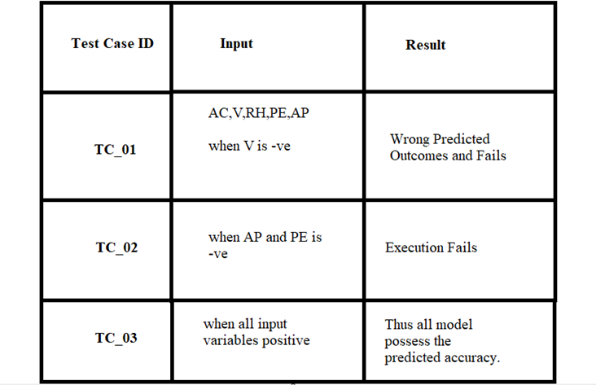

Table. 6.2.1 Test Cases for User

CHAPTER 7 OUTPUT SCREENS

OUTPUT SCREENS

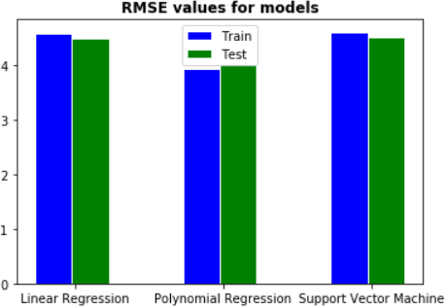
Fig: 7.1 RMSE value for models

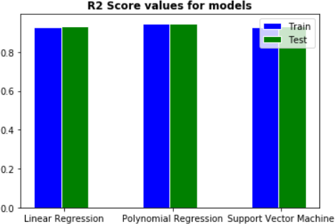

Fig: 7.2 R2 score values for models

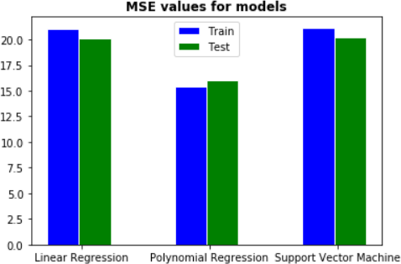

Fig: 7.3 MSE values for models

CHAPTER 8 CONCLUSION

CONCLUSION

We have consider the Combined Cycle Power Plant dataset to predict the hourly Electrical Energy output of a Power plant using three parametric models – Linear regression, Polynomial Regression and Linear Support Vector Machine with ten-fold Cross Validation. All the three models have given approximately 92% to 94% of accuracy Polynomial regression has given the highest accuracy for both train and test data. We have also validated the Linear regression with five assumptions – Normality, Linearity, Homoscedasticity, Independence and Multicollinearity.

This can be further extended by applying the other parametric models and also the non-parametric models such as Decision Tree, Random Forest and KNN.

CHAPTER 9 FUTURE SCOPE

FUTURE SCOPE

In Future To Extension of these we can use more no of variables for comparing and the calculating the Accuaracy Between the models. And we can also use different models for performing the parametric techniques. Where different models and usage of different variables can bring us to understand more about the outcome.
And there may be having of using different dataset as input for different energy plants, we have to update according to the ML upcoming parametric models. And we come across several information known to us. As in future we only depends upon the models differently used by the developer.

CHAPTER 10 BIBLIOGRAPHY

BIBLIOGRAPHY
- L. X. Niu and X. J. Liu, “Multivariable generalized predictive scheme for gas turbine control in combined cycle power plant,” 2008 IEEE Conference on Cybernetics and Intelligent Systems, 2008, pp. 791-796, doi: 10.1109/ICCIS.2008.4670947.

- Ramireddy, V. (2015) An Overview of Combined Cycle Power Plant. http://electricalengineering-portal.com/an-overview-of-combined-cycle-power- plant Kesgin U, Heperkan H (2005) Simulation of thermodynamic systems using soft computing techniques. Int J Energy Res 29:581–611

- Samani, A. (2018). Combined cycle power plant with indirect dry cooling tower forecasting using artificial neural network. Decision Science Letters , 7(2), 131-
142. Norvig, P.R. and Intelligence, S.A. (1995) A Modern Approach. Manufacturing Engineer, 74, 111-113.

- Lakshmi Sucharitha B., Raghavendran C.V., Venkataramana B. (2020) Predicting the Cost of Pre-owned Cars Using Classification Techniques in Machine Learning. In: Chillarige R.,

- Distefano S., Rawat S. (eds) Advances in Computational Intelligence and Informatics. ICACII 2019. Lecture Notes in Networks and Systems, vol 119. Springer.

- Moayedi, H., Jahed Armaghani, D. Optimizing an ANN model with ICA for estimating bearing capacity of driven pile in cohesionless soil. Engineering with Computers 34, 347–356 (2018).

- Khandelwal, M., Marto, A., Fatemi, S.A. et al. Implementing an ANN model optimized by genetic algorithm for estimating cohesion of limestone samples. Engineering with Computers 34, 307–317 (2018).

- G. Naga Satish, Ch. V. Raghavendran, M.D.Sugnana Rao, Ch.Srinivasulu, House Price Prediction Using Machine Learning, International Journal of Innovative Technology and Exploring Engineering, Vol. 8, Issue 9: 717-722, DOI: 10.35940/ijitee.I7849.078919, 2019
- Raghavendran, C. V., Satish, G. N., Krishna, V. and Basha, S. M. (2020). Predicting Rise and Spread of COVID-19 Epidemic using Time Series Forecasting Models in Machine Learning. International Journal on Emerging Technologies, 11(4): 56–61

- Ch. V. Raghavendran, G. Naga Satish, Rama Reddy T., B. Annapurna. (2020). Building Time Series Prognostic Models to Analyze the Spread of COVID-19 Pandemic. International Journal of Advanced Science and Technology, 29(3).

- K. Helini, K. Prathyusha, K. Sandhya Rani, Ch. V. Raghavendran. (2020). Predicting Coronary Heart Disease: A Comparison between Machine Learning Models. International Journal of Advanced Science and Technology, 29(3), 12635 - 12643

- Ch.V. Raghavendran1*, G. Naga Satish2 , Vempati Krishna3 , RVS Lalitha4 1,4Professor, Aditya College of Engineering & Technology, Surampalem, AP, India 2Professor, BVRIT HYDERABAD College of Engineering for Women, Hyderabad, Telangana, India

- Professor, TKR College of Engineering and Technology, Hyderabad, Telangana, India 1 raghuchv@yahoo.com, 2gantinagasatish@gmail.com, 3vempati.k@gmail.com, 4 rvslalitha@gmail.com

- V. and Basha, S. M. (2020). Predicting Rise and Spread of COVID-19 Epidemic using Time Series Forecasting Models in Machine Learning. International Journal on Emerging Technologies,.

- Advances in Computational Intelligence and Informatics. ICACII 2019. Lecture Notes in Networks and Systems, vol 119. Springer, Moayedi, H., Jahed Armaghani, D. Optimizing an ANN model with ICA

Website References

  - http://electricalengineering-portal.com/an-overview-of-combined-cycle-power- plant
  - https://doi.org/10.1007/s00366-017-0545-7
  - http://sersc.org/journals/index.php/IJAST/article/view/31524
  - http://sersc.org/journals/index.php/IJAST/article/view/30385
  - https://doi.org/10.1049/me:19950308.
  - https://doi.org/10.1007/s00366-017-0541-y

