**Dhvani**

**A device for people with speech disorder**

**Submitted By,**

**Pragathi Kelkar 4NM12EC099**

**Prajwal K Bhandary 4NM12EC100**

**Prajwal Sharma K 4NM12EC101**

**Prakash Tiwari 4NM12EC102**

**Submitted To,**

**Mr. Durga Prasad**

**Assistant Professor**

**Department of Electronics and Communication Engineering,**

**NMAMIT, Nitte.**

**Introduction:**

Voice is an identity for a person. There are people who have not heard their voice nor have they framed a sentence on their own. We are creating an electronic voice for people with this disability. This disability could be by birth and through some incidence in life. ‘Dhavni’ is a device for speech impaired people. This device will help people to frame sentence and it will speak for them. This device will make these people independent and can express their feelings, ask for things they want.

‘Dhvani’ has words of English language and people can frame sentences using this. In case they do not know the word they want to speak (for example, name of some dish), then there are pictures of some commonly used words (like cuisine, sport) with the help of which they can frame sentences. The screen reader in this device will utter the sentence.

**Theory:**

**Screen Reader:**

Screen Reader is the software application that interprets the alphanumeric characters, symbols and pictures displayed on the screen. Here the symbols typed by the user are converted to the appropriate sound file with the help of pre-loaded contents in its memory. The pictures used are converted to text and then converted to a sound file.

**Touch screen:**

Touch screen is an electronic display that enables the user to interact with the help of fingers/stylus. Here the work of mouse pointer carried out by the users’ finger. The user can react to the display by just touching the display.

**Speaker:**

Speaker is transducer that converts the electrical audio signal into respective sound. An alternating current electrical audio signal input is applied through the voice coil, a coil of wire suspended in a circular gap between the poles of a permanent magnet, the coil is forced to move rapidly back and forth due to Faraday's law of induction, which causes a paper cone attached to the coil to move back and forth, pushing on the air to create sound waves.

**Block Diagram:**

**User interface:**

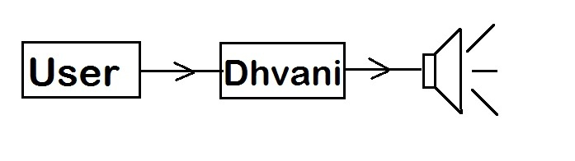

**Device:**

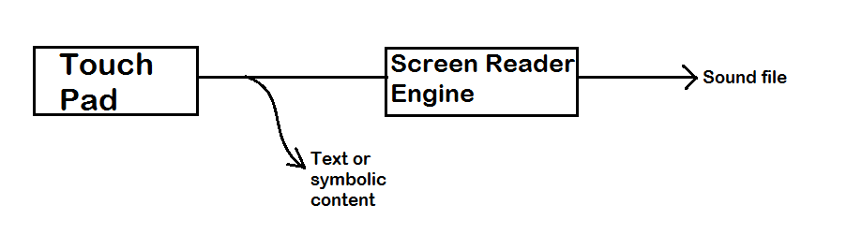

**Computer system:**

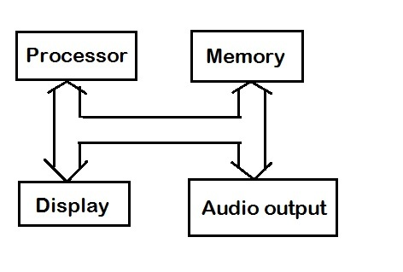

**Algorithm:**

The user enters what has to be uttered by the speaker with the help of touch screen.

The screen reader engine converts the symbols and pictures entered by the user to a sound file with help of information stored in the memory and pre-installed software

The sound is then sent to the audio output device and then the voice is heard.

**Working:**

‘Dhvani’ works with the principle of human computer interaction. Voice impaired people will use this device to interact with people with the help of electronic voice created by the speaker. The user will have a touchpad with which he can interact. Using this touch pad user can frame his sentences. In case the word is not known then we can use the picture present and frame the sentence.

The software installed in the device will help in framing sentence. The software will have words of English language pre-installed. When the user wants to talk something he will search for the words in the list and frame a complete sentence. There will also be clip art images stored in the software. If the user does not know word for something then he can always search in the clip art gallery. If we have a child as our user then this technique is going to be extremely useful. When a child wants to say its mother ‘I want to have Jalebi’. The child finds the words like I, want, to, have. But, it does not find ‘Jalebi’ which is a sweet. So, it goes to the sweet category in the clip art and tries to find the image of ‘Jalebi’ and completes the sentence. This makes the sentence ‘I want to have Jalebi’. Know this combination of words and image is converted to text format by the software. This sentence is then processed by the device and converts the text into voice using the screen reader. This information is then sent to the speaker which utters the sentence for them.

The user can adjust the volume depending on where the recipient is present. The user can also send an alert signal the recipient telling he wants to say something. This is helps in better interaction between groups of people.

**Advantages:**

1. User can speak independently.
2. It helps in interaction between people.
3. Helps in expressing themselves.

**Applications:**

1. For speech impaired people.
2. For children.
3. For old people with difficulty in expressing themselves.

**Conclusion:**

Dhvani will help speech impaired people. This device with better user interface can help people for better interaction with the device. Further improvements can be made in this device like the memory can keep track of most used words by the user and this would help the user to find the words quickly. Because this device has a very little hardware it is easy to carry.