**Nitte Mahalinga Adyanthaya Memorial Institute of Technology**

Department of Electronics and Communication Engineering

A Report on

**Water Level Indicator**

Team Members

Prajwal Bhandary 4NM12EC100

Prajwal Sharma K 4NM12EC101

Ashoka 4NM13EC403

Deepak Kumar 4NM13EC405



**Table of Contents:**

|  |  |  |
| --- | --- | --- |
| **Sl. No.** | **Topics** | **Page No.** |
| 1. | Aim and Introduction | 1 |
| 2. | Components and Pin Description | 2 |
| 3. | Circuit Diagram | 3 - 4 |
| 4. | Working | 5 |
| 5. | Conclusion | 6 |

**Aim:**

To design a water level indicator.

**Introduction:**

This circuit indicates the level of water in four stages and gives an alarm once the full level is reached. In this circuit analog switch 4066 is used which is a quad bilateral switch intended for the transmission or multiplexing of analog or digital signals. Analog switch 4066 has a much lower “ON” resistance, and “ON” resistance is relatively constant over the input-signal range.

Though water is a non conductor, salts dissolved in water makes it conductive. Thus the appropriate triggering pins are triggered in accordance with appropriate level. When the water is empty the wires in the tank are open circuited and the resistors pulls the switch low hence opening the switch and LEDs are OFF. When the water is full, the base of the transistor BC148 is pulled high by the water and this saturates the transistor, turning the buzzer ON.

1

**Components:**

1. Light Emitting Diodes (LED)
2. Transistor – BC148
3. Resistances – 180 kohm, 330 ohm
4. CMOS Bilateral Analog Switch (CD4066)
5. Piezoelectric Buzzer
6. Power Supply

**Pin Description of CMOS Bilateral Analog Switch (CD4066):**

**CD4066**

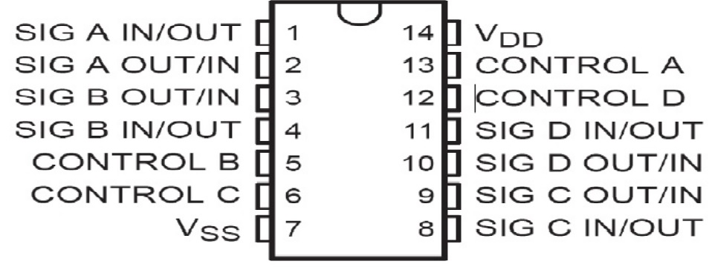

2

**Circuit Diagram:**

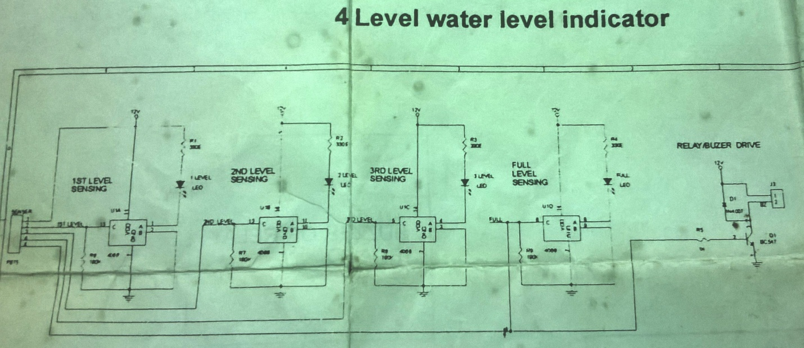

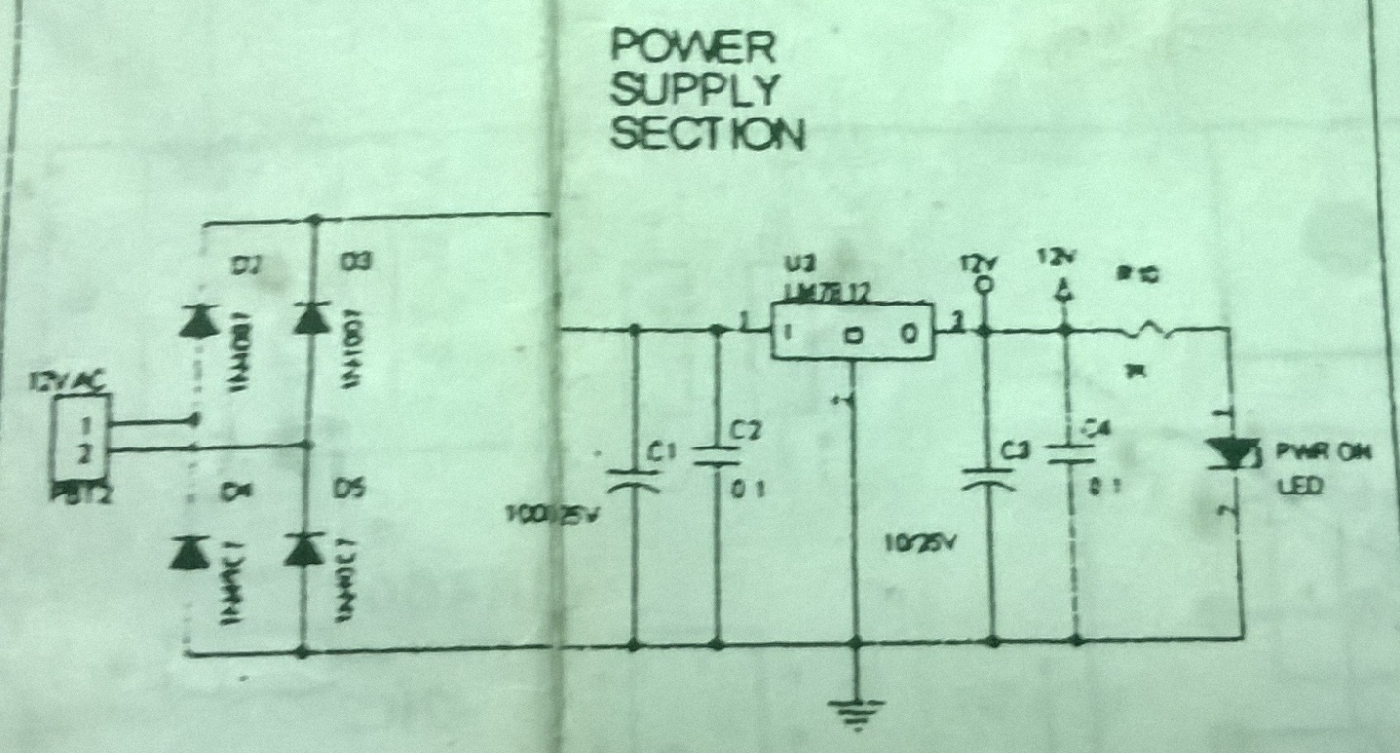

**Working:**

The circuit consists of analog switch 4066. The triggering pins 5, 6, 12 and 13 are triggered through the conducting property of water. Once the appropriate level is reached, the corresponding triggering pin gets triggered and the corresponding LEDs will glow as they get the ground path. Once the final level is reached, both the level full LED and the transistor gets the high level to trigger a buzzer or relay.

When the water comes in contact with the electrode tip, a conductive path is established between the sense electrode and the tank wall/reference electrode, which in turn makes the transistors conduct to glow LED and indicate the level of water. Arrange the probes in order on the water tank according to the depth required.

Below 25% of Probe: There is no conductive path between Ground Probe and other probes. Thus no LED glows because the circuit is not completed.

Between 25% and 50% of Probe: Water provides a conductive path between 25% Probe and Ground Probe. Thus switch S1 of the IC4066 activates the LED1.

Between 50% and 75% of Probe: Water provides a conductive path between 50% Probe and Ground Probe, which is in parallel with the 25% Probe and Ground Probe path. If this second path resistance is also within the range, then switch S2 of the IC4066 activates the LED2.

Between 75% Probe and full: Water provides a conductive path between 75% Probe and Ground Probe, which is in parallel with the 25% Probe – Ground Probe & 50% probe - ground path. If this third path resistance is also within the range, then switch S3 of the IC4066 activates the LED3.

When full: Water provides a conductive path between 75% Probe and Ground Probe, which is in parallel with the 25% Probe – Ground Probe & 50% probe - ground path. If this fourth path resistance is also within the range, then switch S4 of the IC4066 activates the LED4 and gives an alarm indicating the tank is full.

5

**Conclusion:**

Water level indicator circuit not only indicates the amount of water present in the overhead tank but also gives an alarm when the tank is full. This device starts ringing as soon as the water tank becomes full. It helps to check overflow and wastage of water by warning the customer when the tank is about to brim. The system provides visual water level indication with alarms at desired levels. It also provides automatic control of pumps at a remote location.

6