

Data Exchange Standard Documentation - Version 2020.1

Effective Date: 2/1/2020

Prepared by: StreamNet Project Regional Staff
Pacific States Marine Fisheries Commission

Bonneville Power Administration
Columbia River Inter-Tribal Fish Commission
Idaho Department of Fish and Game
Oregon Department of Fish and Wildlife
Montana Fish, Wildlife, and Parks
Pacific States Marine Fisheries Commission
U.S. Fish and Wildlife Service
Washington Department of Fish and Wildlife
Table Of Contents

I. Introduction 3
II. Data Exchange Standards 4
A. Location Coding 5
A1. LocMaster Table 6
A2. SupercodeStreams Table 9
An Explanation of "Supercodes" 9
B. Time Series (trend) Information 11
B1. Trend Table 12
B2. EscData Table 15
B3. HatchRetMain Table 19
B4. HatchRetDetail Table 20
B5. HatchDisposition Table 22
B6. SRData Table 24
B7. Age Table 24
B8. TrendGroup Table 27
B9. TrendXTrendGroup Table 28
C. Fish Distribution Information 29
C1. FishDist Table 29
D. Barrier Information 31
D1. Barrier Table 32
D2. FishBarrier Table 35
E. Map Catalog and Photograph Data 36
F. Reference Information 37
F1. Reference Table 38
F2. SuperReference Table 39
G. Habitat Restoration / Improvement Projects Data 40
H. Hatchery Facility Data 41
H1. Hatchery Table 42
H2. HatchWater Table 45
I. Dam Facility Data 46
I1. Dam Table 47
I2. DamXDamPurpose Table 48
I3. DamXDamType Table 49
III. Trend Data Compiler Decision Tree 50
Appendix A. "Too Many To Count" in the EscData table 51
Appendix B. Draft tables 52
Appendix C. Instructions and Definitions for the CategoryID Field 52
Appendix D. Glossary 54
Appendix E. Updating This StreamNet Data Exchange Standard Document 54
Appendix F. MS-Access 2010 Data Types 55

I. Introduction

This document describes data exchange standards for StreamNet. These standards describe in detail the data items (fields), data types, and coding conventions for the various tables containing data submitted to the regional database by participating agencies and tribes. The standards apply to data submitted on or after the effective date shown on the cover page of this document; adoption of the standards generally does not dictate resubmittal of data already in the regional database in order to bring existing data into the new standard. These exchange standards do not necessarily represent the final data structure of the data in the regional system, nor do they represent a comprehensive data dictionary for all data contained in the system. Rather, it provides a standardized method for agencies to share data at a regional level. Draft tables are found in a companion document (StreamNet Exchange Standard Documentation - Version 2015.1. Volume II: Draft Tables).

Data in a typical relational database are organized into groups (or tables) of information elements that describe various entities. In database design two types of things are usually defined as entities:

1. An object (person, place, or thing)
2. A process (transaction, occurrence, or activity)

Entities in a relational database are joined in some logical fashion by using table relationships. A table relationship is defined as “a path created by data that is used to integrate two tables together.”1 Conceptual database designs can be represented by entity-relationship (ER) diagrams, which portray the tables (or entities) in the database and the relationships that integrate them. An ER diagram is found at the beginning of each section in this document in order to assist with understanding the structure of the StreamNet database.

There are five major entities that characterize most data currently in the StreamNet database. The primary entity is referred to as a Trend (an informal shorthand term for a time series). A trend in the StreamNet database is an entity describing a time series of information composed of a specific data type (harvest, redd count, etc.), for a specific fish stock, at a specific location. For each trend entity there are usually multiple occurrences of the count over some time period (daily, weekly, annually, etc.). In StreamNet, this is known as the Count entity. Currently, there are two different count entity tables (one for escapement and harvest data, and one for hatchery return data). The trend and count tables are joined with a one to many relationship which relates the one trend entity to the many count data points associated with that trend. Each trend is associated with a specific location represented by the Location entity (a code for a stream, flat water body, point, or combination of these). Each trend is also associated with a particular dam or hatchery facility where applicable. Each count value is associated with a bibliographic reference by a Reference entity. Finally, there is the Age entity. For each particular count of fish (say 50 returning hatchery females), the age entity could contain multiple records, one for each age class represented in the return year portrayed in the count table. The overall structure is portrayed by the ER diagram shown in Figure 2.

II. Data Exchange Standards

The data exchange standards, displayed in Tables A1 through I3, are comprised of 4 columns. Field Name is the name of the field in the StreamNet database. Underlined field names indicate primary key designations. Field Description is a brief description of the field. Data Type specifies the field data type; a number included in this field indicates the maximum width of the entry, in characters. Codes/Conventions provides lookup codes and additional information for the various fields. Required fields are indicated by a bold Field Name and Data Type. If Data Type is both bold and italicized, then whether the field is required varies according to entries in other fields of the record -- refer to the Field Description column for rules on when the field is required.

The data types listed in the tables' Data Type column are Microsoft Access 2010 data types. Appendix F contains details regarding these data types. Due to lack of space, not all lookup codes are listed in this document. The full list is available upon request. You can also get the most up to date draft DES, the draft DES Volume II, and the DES revision procedure document in the same place.

MS-Access files are preferred for submitting data to StreamNet, but Microsoft SQL Server, dBASE, and delimited ASCII files are also acceptable - contact the StreamNet Database Manager at 503-595-3100 to discuss whether other file types may be acceptable.

A. Location Coding
To be useful, data in the StreamNet database must have accurate locations associated with them. This section contains the tables needed for submitting new locations.

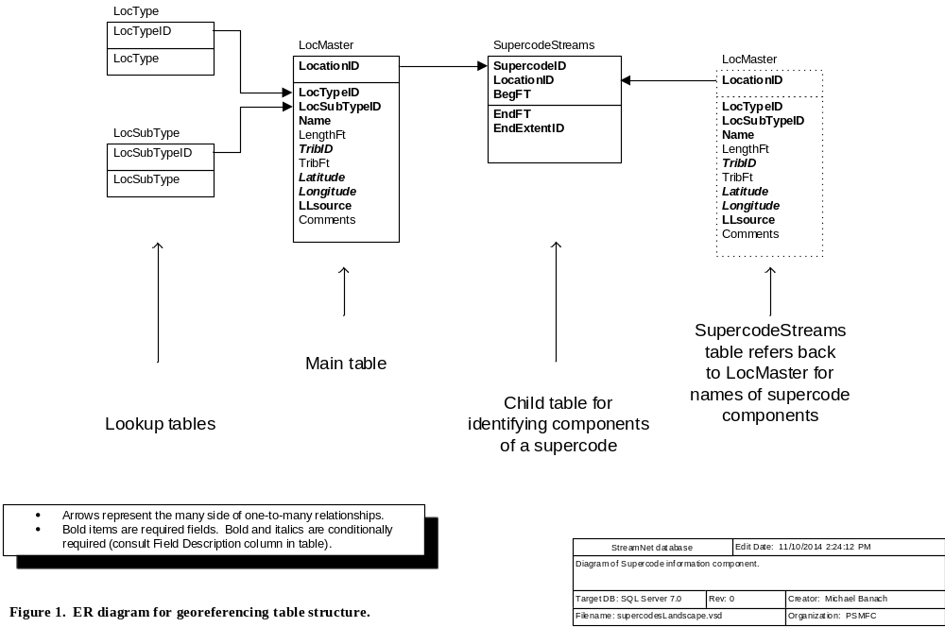

A1. LocMaster Table
This table houses the master list of all location codes used in StreamNet. Because they must all reside in this table, no two location codes can be the same, even if they represent different location types (stream; supercode; etc.). Use this table to submit new location information. It is not necessary to submit location codes that already exist in the StreamNet database. Datum for all locations is NAD83.
Field Name | Field Description | Data Type | Codes/Conventions for LocMaster Table
LocationID | The location code for the stream, lake, bay, reservoir, upland point, etc. See "LocationID" in the Glossary. | Text 13 | For dams and hatcheries the LocationID should be concatenated from the Longitude/Latitude or SiteLong/SiteLat fields from the Dam or Hatchery table.
LocationID |  | Text 13 | For supercodes use the ranges shown at the right. | 10,000-19,999 = WDFW  20,000-29,999 = CRITFC  30,000-39,999 = USFWS | 40,000-49,999 = IDFG  50,000-59,999 = ODFW | 60,000-69,999 = PSMFC  70,000-79,999 = CDFG  80,000-89,999 = MFWP
LocTypeID | Defines the general type of location. | Byte | 1 = Watercourse (Lotic/flowing water body represented by arcs in a hydrography layer in GIS)  2 = Standing water (Lentic/flat water body represented by a polygon in GIS)  3 = PointID (Location represented by a point in GIS; best if long/lat used to make point code.)  4 = Nonstream arc (Roads, power lines, etc.)  5 = Polygon (Use only if Code 2 is not appropriate.)  6 = Spatially ambiguous, non-specific location that can not be accurately represented in a GIS. (Non-GIS location type.)  7 = Supercode
LocSubTypeID | Code for the subtype of location. This code must match the LocTypeID field. | Integer | For LocTypeID=1, acceptable values are:  100 = 100-k stream  110 = 100-k ditch or canal  111 = Possible 100-k ditch  119 = Mixed-scale watercourse (combined 100 and higher resolution geometry)  120 = 24-k (or higher resolution) stream  130 = 24-k (or higher resolution) ditch or canal  131 = Possible ditch / canal  For LocTypeID=2, acceptable values are:  200 = 100-k wetland  210 = 24-k (or higher resolution) wetland  220 = 100-k natural lake or pond  230 = 24-k (or higher resolution) natural lake or pond  240 = 100-k constructed lake, pond, or reservoir  250 = 24-k (or higher resolution) constructed lake, pond, or reservoir  260 = Bay / estuary  270 = Marine area  280 = Pacific Ocean |  | For LocTypeID=3, acceptable values are:  300 = Ocean port  301 = Hatchery facility  302 = Dam  303 = Fish trap (other than a hatchery facility)  310 = Barrier  320 = Fish passage facility (e.g., ladder, screen)  330 = Culvert  340 = Bridge  350 = Mine / dredged site  360 = Spring  361 = Well  362 = Municipal water supply  364 = Channel not in current hydrography scale  365 = Channel improperly represented at current hydrography scale  399 = Site temporarily not associated with hydrography [Use for temporary PointIDs that are to be replaced by better location coding]  (continued on next page)
 |  |  | For LocTypeID=4, acceptable values are:  400 = Road  401 = Power line  For LocTypeID=5, acceptable values are:  500 = Upland area  501 = Entire HUC (can be at any HUC field level)  502 = Entire catchment (entire watershed not represented by a defined HUC)  503 = Island |  | For LocTypeID=6, acceptable values are:  600 = Unknown location within a HUC (HUC known, exact location is not)  601 = Unspecified location within a HUC (useful for "fuzzing" known locations)  621 = Alaska location  622 = California location  623 = Idaho location  624 = Oregon location  625 = Washington location  626 = Montana location  629 = Undetermined body of water  640 = Outside StreamNet hydro coverage  650 = Stream terminatesFor LocTypeID=7, acceptable values are:  98 = N/A
Name | Name of the stream, lake, bay, reservoir, barrier, dam, hatchery, port, etc. | Text 100 | If unnamed, fill in this field using this pattern:  Unnamed stream [LocationID]  Unnamed dam [LocationID]  Unnamed pond [LocationID]  etc.  For unnamed features, in order to help data end users understand the location, enter the name in the form "X Creek (LocationID), trib to Y Creek (LocationID), trib to Z Creek (LocationID)". Include as many steps as necessary until the last creek listed is a named stream or other identifiable feature. For example, "Unnamed stream (1155232459921), trib to Unnamed stream (1155216459825), trib to Selway River".
LengthFt | Length of stream, in feet. | Long int | This field used only for streams.
TribID | LocationID for the water body this location (stream, lake, supercode, etc.) flows into.  Required if LocTypeID = 1, otherwise optional (but encouraged). | Text 13 | TribID values must exist as a defined LocationID in the LocMaster table. For point locations, supercodes, other cases where a TribID is ambiguous or inappropriate, use one of the following codes as appropriate.  98 = Not applicable  6000 = Flows into Canada  6001 = Flows into California  6012 = Flows into Mexico  6002 = Flows into Nevada  6003 = Flows into Utah  6004 = Flows into Wyoming  6005 = (no outlet)  6006 = Flows into stream not represented in the regional hydrography  6013 = Flows into lake/pond/reservoir not represented in the regional hydrography  6030 = Flows into canal, ditch, or pipeline not represented in the regional hydrography |  | 6021 = Undetermined outlet in Alaska  6022 = Undetermined outlet in California  6023 = Undetermined outlet in Idaho  6026 = Undetermined outlet in Montana  6027 = Undetermined outlet in Nevada  6024 = Undetermined outlet in Oregon  6028 = Undetermined outlet in Utah  6025 = Undetermined outlet in Washington  6029 = Undetermined outlet in Wyoming  6032 = Undetermined canal/pipeline in California  6033 = Undetermined canal/pipeline in Idaho  6036 = Undetermined canal/pipeline in Montana  6037 = Undetermined canal/pipeline in Nevada  6034 = Undetermined canal/pipeline in Oregon  6035 = Undetermined canal/pipeline in Washington  Many more codes are already defined. Contact regional StreamNet personnel for assistance.
TribFt | The LocationID field (A) identifies the water body represented. The TribID field (B) identifies which water body the represented water body flows into. When B is a stream, this field is the measure from the mouth of B, in feet, to where A enters B. | Long int | Leave blank if TribID does not represent a routed stream.
Latitude | Latitude coordinate of point in decimal degrees (not degrees-minutes-seconds). Calculated using the 1983 North American Datum (NAD83).  Required for non-stream points (LocTypeID = 3). Not applicable for other location types. | Double | Use two digits left of the decimal point and at least four digits to the right of the decimal point. Up to six digits to the right of the decimal point are permitted.
Longitude | Longitude coordinate of point in decimal degrees (not degrees-minutes-seconds). Calculated using the 1983 North American Datum (NAD83).  Required for non-stream points (LocTypeID = 3). Not applicable for other location types. | Double | This is a negative number. Use three digits left of the decimal point and at least four digits to the right of the decimal point. Up to six digits to the right of the decimal point are permitted.
LLsource | Method by which the longitude and latitude values were determined.  Applies only to non-stream points (LocTypeID=3). Use N/A for other location types. | Text 3 | Only five options are possible:  GPS = Coordinates were determined by use of Global Positioning System, and datum is known to be NAD83.  DIG = Digitally-derived. Includes digitized coordinates, or those converted from other (non-GPS) projected data, and datum is known to be NAD83.  UNK = Unknown how lat/long values were determined, or datum = NAD83 cannot be confirmed.  CEN = Centroid coordinates derived from a feature that is represented as a polygon in StreamNet’s GIS.  N/A = Not applicable
Comments |  | Text 255
ID  (unique) | Value used by computer to identify a record. | Text 36 | This value is a globally unique identifier (GUID) exactly 36 characters long.  - When submitting a new record you may include this value or leave it blank. If you include this value then it will be used by the central system. If you leave it blank then a value will be created for you, and it will be sent back to your system where it must be incorporated.  When updating or deleting records this value must be included.
UpdDate | The date and time that the record was created or updated. For data obtained in electronic format from another source it can reflect the date and time of data capture or of conversion to StreamNet standards. | Datetime | This can be the time a record was created, the last time it was edited, or the last time it was QCd. This field tells the end user when the record was last modified at the source organization.
CompilerRecordID | Agency record ID maintained by the data submitter. | Text 36 | This field can be used in any way the compiler may find helpful. For example, it can be used to create a link between the Coordinated Assessments exchange network and an internal system such as ODFW's Salmon Tracker.

A2. SupercodeStreams Table
This table lists the individual component locations which, when combined, define a supercode. The records with common SupercodeID all belong to the same supercode.
Field Name | Field Description | Data Type | Codes/Conventions for SupercodeStreams Table
SupercodeID | Code which identifies a supercode. | Text 13 | For supercode ranges see the LocationID field of the LocMaster table.
LocationID | The location code for the stream, lake, bay, upland point, etc. that is a component of the supercode. See "LocationID" in the Glossary. | Text 13
BegFt | If LocationID is for a stream, the downstream measure, in feet, of the stream section that defines the boundary of the reach. For other location types enter -1. | Long int | Use "-1" if LocationID does not represent a stream.
EndFt | If LocationID is for a stream, the upstream measure, in feet, of the stream section that defines the boundary of the reach. For other location types enter -1. | Long int | Use "-1" if LocationID does not represent a stream.
EndExtentID | EndFt values that are very near the top end of a stream or near a state border can be ambiguous. Is the EndFt meant to indicate the top end of the stream or the state border, or is there a deliberate reason the EndFt value falls short of the top of the stream, or just shy or just over a state border? This field answers that question. | Byte | 0 = EndFt value is not meant to represent the top end of stream or a state border  1 = EndFt value is meant to represent the top of the stream  2 = EndFt value is meant to represent the state border  97 = Not yet determined
ID  (unique) | Value used by computer to identify a record. | Text 36 | This value is a globally unique identifier (GUID) exactly 36 characters long.  - When submitting a new record you may include this value or leave it blank. If you include this value then it will be used by the central system. If you leave it blank then a value will be created for you, and it will be sent back to your system where it must be incorporated.  When updating or deleting records this value must be included.
UpdDate | The date and time that the record was created or updated. For data obtained in electronic format from another source it can reflect the date and time of data capture or of conversion to StreamNet standards. | Datetime | This can be the time a record was created, the last time it was edited, or the last time it was QCd. This field tells the end user when the record was last modified at the source organization.
CompilerRecordID | Agency record ID maintained by the data submitter. | Text 36 | This field can be used in any way the compiler may find helpful. For example, it can be used to create a link between the Coordinated Assessments exchange network and an internal system such as ODFW's Salmon Tracker.

An Explanation of "Supercodes"
The majority of the time series (trend) data that StreamNet collects are from surveys done on an individual stream reach. These time series are georeferenced in a straightforward manner in the Trend table with a LocationID to identify the stream, and BegFt and EndFt measures to identify the downstream and upstream ends of the sampling location on that stream. Other time series data sets, however, are not amenable to this system because sampling was not done on a single reach of a single stream. These more complex locations have been dubbed "supercodes" for the RRN codes that were originally assigned to them under the 1:250,000 scale PNW Reach system. Originally supercodes were multistream areas such as "Upper Columbia River basin" or "Clackamas River and tributaries." Other, non-stream types of locations such as lakes, points, and bays were later included in supercodes because of the similar problem they presented for data management.

A new database structure was later devised under the 1:100,000 scale system that allows for the specific definition of the geographic extents of supercodes and nonstream data. This higher level of precision allowed for more accurate display of the data and an enhanced ability to query the data. This system was revised again in version 2003.1 of this document, and this approach has been continued in the currently-used mixed-scale hydrography. The following is a brief description of this newest database structure as it relates to supercodes.

For supercode areas, a SupercodeID is assigned and this SupercodeID is entered in the LocationID field of the LocMaster table. The LocTypeID field in the LocMaster table identifies this code as a supercode, while the Name field is used to give a descriptive name to the supercode. To link
the supercode to the several specific stream reaches, lakes, points, and other geographic features it represents, several entries are made in the SupercodeStreams table. For each entry, the SupercodeID is entered in the SupercodeID field, and the LocationID, BegFt, and EndFt fields identify an individual geographic component of the supercode. The LocationID field links back to the LocMaster table to identify an individual stream, lake, point, etc. As many entries are made in the SupercodeStreams table as are needed to include all the components of the supercode. Figure 1 illustrates the relationships between the tables discussed above.

A data management issue you will need to address is to ensure that duplicate supercodes are not defined for the exact same geographic extent. It is likely that your database management software will allow you to define more than one SupercodeID that relate to the same set of real-world reaches and lakes. An occasional review of your supercodes will help to find such duplicates and treat them appropriately.

B. Time Series (trend) Information
These tables house much of the data in the StreamNet system. Data types include dam/weir counts, estimates of spawning populations, peak/other spawning counts, redd counts, freshwater harvest, and hatchery returns. All these data types share a common data structure within the Trend table. The Count table structures vary between data types.
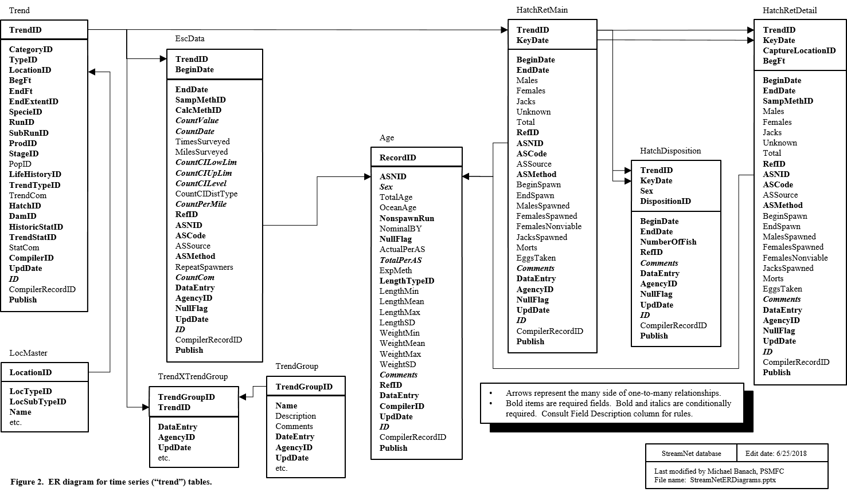

B1. Trend Table
This table contains the master records for time series data, including location, species / run / subrun of fish, data type, and general information about the trend. (The time-series records linked to these master records are found in the EscData, and HatchRetMain tables)
Field Name | Field Description | Data Type | Codes/Conventions for Trend Table
TrendID | This field uniquely identifies each time series. Will be assigned by state data compilers or regional data assemblers as appropriate. | Long int | 10,000-19,999 = MFWP  20,000-22,499 = CRITFC  22,500-24,999 = NPT  25,000-27,499=WST  27,500-29,999=YIN  200,000-209,999 = CTUIR  30,000-39,999 = USFWS |  |  |  |  |  | 40,000-49,999 = IDFG  50,000-59,999; 500,000-599,999 = ODFW  60,000-69,999 = PSMFC  70,000-89,999 = Not currently in use  90,000-99,999 = CDFG  100,000-199,999 = WDFW  (CCT range jointly managed by WDFW and CCT)
CategoryID  (Refer to Appendix C for detailed instructions) | The code for the major data type. Data types not listed to the right are not appropriate for use in this table. This field along with TypeID define what was measured. | Byte | 1 = Spawner counts  2 = Freshwater / estuary harvest  3 = Marine harvest  4 = Dam / nonhatchery weir counts  5 = Hatchery returns |  |  |  |  |  | 7 = Fish abundance estimates  8 = Spawner abundance estimates  9 = Redd counts  38 = Fish counts
TypeID | Code for the type of count in the trend. Answers the question, "what was counted?"  Links to Type table. | Integer | 99 = Unknown  101 = Redd count  102 = Redds per mile  103 = Peak redd count  104 = Total live fish  105 = Fish per mile  106 = Peak live fish  107 = Total live fish returned above hatchery  108 = Carcass  109 = Carcass per mile  110 = Peak carcass  111 = Fish days |  |  | 113 = Index of live fish  114 = Peak live & dead fish  115 = Resting hole count  116 = Total live and dead fish  117 = Peak per mile  118 = Fish per pool  202 = Treaty troll  203 = Ocean sport  204 = Estuary sport  205 = Freshwater sport  206 = Freshwater treaty  207 = Freshwater sport release  210 = Total sport, commercial & treaty |  |  |  |  | 211 = Total net: commercial & treaty  212 = Freshwater commercial  213 = Agency test fishery  216 = Estuary sport (jetty)  217 = Freshwater sport (snag)  223 = Estuary sport (private)  224 = Estuary sport (charter)  225 = Coastal gillnet  401 = Parr density (#/100m2)  402 = Total parr abundance estimate  501 = Freshwater: ocean age
LocationID | The location code of the stream, lake, hatchery, dam, supercode, etc. See "LocationID" in the Glossary. | Text 13 | Note for hatchery returns trends:  Often a hatchery receives fish from other sources. LocationID in this table comes from the LocationID field of the Hatchery table. In the hatchery return details table the CaptureLocationID field conveys where the fish were captured, which is not always the hatchery indicated in the Trend table.
BegFt | If LocationID is for a stream, the downstream measure, in feet, of the stream section that defines the boundary of this trend. For other location types enter -1. | Long int | Enter -1 if LocationID does not represent a stream.
EndFt | If LocationID is for a stream, the upstream measure, in feet, of the stream section that defines the boundary of this trend. For other location types enter  -1. | Long int | Enter -1 if LocationID does not represent a stream.  For the "Dam / nonhatchery weir counts" data category, EndFt = BegFt.
EndExtentID | EndFt values that are very near the top end of a stream or near a state border can be ambiguous. Is the EndFt meant to indicate the top end of the stream or the state border, or is there a deliberate reason the EndFt value falls short of the top of the stream, or just shy or just over a state border? This field answers that question. | Byte | 0 = EndFt value is not meant to represent the top end of stream or a state border  1 = EndFt value is meant to represent the top of the stream  2 = EndFt value is meant to represent the state border  97 = Not yet determined
SpecieID | Code for the fish species | Integer | For a complete list of SpecieID codes contact the regional StreamNet personnel. |  | Partial list:  1 = Chinook salmon  2 = Coho salmon  3 = Steelhead  4 = Sockeye salmon  5 = Chum salmon  6 = Pink salmon  39 = Mixed salmon  96 = Mixed anadromous salmonids  66 = Kokanee |  |  |  |  | 14 = Bull trout  10 = Brown trout  11 = Brook trout  9 = Rainbow trout  23 = Redband trout  111= Rainbow/redband/steelhead trout  17 = Coastal cutthroat trout  21 = Westslope cutthroat trout  8 = Cutthroat trout |  | 94 = Mixed lamprey  113 = Lamprey (unspecified)  122 = Pacific lamprey  120 = Western brook lamprey  15 = Lamprey: CODE DISCONTINUED  12 = White sturgeon  44 = Green sturgeon  98 = N/A  99 = Unknown
RunID | Code for the fish run.  For coastal cutthroat, use code 98. | Byte | 1 = Spring  2 = Summer  3 = Fall  4 = Winter |  | 12 = Odd year pink  13 = Even year pink  16 = Mixed  17 = Spring/summer  18 = Both summer & winter |  |  |  |  | 19 = Late  20 = Late fall  21 = Early  22 = Both early & late  23 = Summer/fall |  | 98 = N/A  99 = Unknown  If run not appropriate for the species, enter 98 = N/A.
SubRunID | Code for the fish subrun | Byte | 1 = A run  2 = B run  3 = S type - Early  4 = N type - Late |  | 5 = Tule  6 = Upriver bright  7 = S type & N type |  |  |  |  | 8 = Late run  9 = Early run  98 = N/A |  | 99 = Unknown  If subrun not appropriate for this species, enter 98 = N/A.
ProdID | Code for the production type of the fish. For redd counts, indicate the production type(s) of the fish that created the redds. | Byte | 1 = Hatchery  2 = Natural  3 = Mixed  99 = Unknown
StageID | Code for the life stage of the fish described in the trend.  For hatchery returns, always use code 29 (All stages) in this field. Differentiation into adults and jacks occurs in the HatcheryReturns table. | Byte | 1 = Egg (unspecified)  2 = Emergent fry or larvae  5 = Sub-yearling (age 0)  6 = Yearling (age 1)  7 = 2 year old migrant  8 = Jack or subadult | 9 = Adult  10 = Adults & jacks  13 = Fry (unspecified)  14 = Juvenile (unspecified)  16 = Smolt  17 = Carcass  18 = Parr |  |  |  | 19 = Presmolt  20 = Mini-jack (2 year old)  21 = Ages 1 and 2  22 = 2 year old  24 = Half-pounder  25 = Adults and half-pounders |  |  |  | 29 = All stages  30 = Not specified  31 = Adults and juveniles  98 = N/A  99 = Unknown
PopID | PopID from the Coordinated Assessments database. | Integer | Populate this field to associate this trend with a Coordinated Assessments population, and make this trend available as "related data" in the Coordinated Assessments query system (http://cax.streamnet.org/).
LifeHistoryID | Code for the life history strategy(s) of the species in the indicated reach. | Byte | 1 = Anadromous  2 = Year-round resident  3 = Fluvial/adfluvial |  |  |  |  |  |  | 4 = Fluvial/adfluvial and year-round resident  5 = Anadromous and year-round resident  99 = Unknown
TrendTypeID | This field is used to describe the relative importance of a survey within a major category (refer to CategoryID above). Links to TrendType table. | Byte | 1 = Index - Areas that have been surveyed consistently over a long period of time, and are generally used to index abundance at some geographic scale.  2 = Random - Areas that may be used to index abundance, but the survey sites are selected randomly from the available species' distribution and therefore, may not be conducted every year.  3 = Supplemental - Surveys that are typically selected to fill specific localized information needs and may or may not be conducted year to year either due to management decisions or due to environmental conditions.  4 = Spot Check - Surveys that are identical to supplemental areas except only a subset of a given area is sampled (e.g. select gravel bars, every 5th fish observed, every other pool, etc.) and these subset counts are used to enumerate fish for the entire survey area.  5 = Incidental - Trend data that are derived from a survey targeting a different species than the one being reported (example: while conducting a steelhead redd count survey, 2 adult lamprey are noted in the comments - the lamprey count would be reported as an incidental trend).  6 = Exploratory - Used to determine presence/absence or distribution of fish or redds. Exploratory trends typically are used to determine where to establish long-term index trends.  98 = N/A  99 = Unknown
TrendCom | This field is used to describe general information which applies to all years in the trend. These include information such as local or colloquial names for the system which may not be part of the official reach designation, periods of closure to fishing during which no data are available, and specific run or stock details which may not be captured using the standard species/run/production categories. | Memo
HatchID | The code for the hatchery that the trend is related to, if applicable. | Integer | 98 = N/A  For assigned HatchID range series please refer to the Hatchery table information, or for a complete list of HatchID codes contact the regional StreamNet personnel.
DamID | The code for the dam that the trend is related to, if applicable. | Long int | 98 = N/A  For assigned DamID range series please refer to the Dam table information, or for a complete list of DamID codes contact the regional StreamNet personnel.
HistoricStatID | The code for the status of data entry for the Trend. Field is intended to assist in future updates of the database - it indicates whether all known historical data for the Trend are in the StreamNet database. | Byte | 1 = All available historical data currently in StreamNet.  2 = Earliest available data not yet in StreamNet.  3 = Earliest available data in StreamNet, but one or more gaps exist between oldest and newest data in StreamNet: these data known to exist.  4 = Earliest available data in StreamNet, but one or more gaps exist between oldest and newest data in StreamNet: unknown if these data exist.  99 = Unknown
TrendStatID | The code for the trend status. This field is intended to assist in future updates of database - it indicates whether data will be produced in the future to add to this Trend. This field indicates the status of the most recent years of data, while the HistoricStatID field indicates the status of the oldest data for the trend. | Byte | 1 = Data currently collected for Trend table  2 = No data currently collected, but data may be collected in future  3 = Run of fish still exists, but data collection has ceased  4 = Run of fish extinct, data collection ceased  5 = Inactive aggregate trend; current data in independent trends  6 = Inactive independent trend; current data in aggregate trend |  |  |  |  |  |  | 7 = Most recent data have been requested but are not yet ready for exchange  8 = Production of these fish stopped at this hatchery  9 = Facility closed or removed  10 = Data collection discontinued  99 = Unknown
StatCom | A comment field elaborating on the TrendStat | Memo | Comments on TrendStat (e.g., "Run declared extinct in 1982.")
CompilerID | The code for the agency that put the data into the StreamNet standards and sent them to StreamNet, and is responsible for updates. Links to the Compiler table. | Byte | 1 = Washington Department of Fish and Wildlife  2 = Columbia River Inter-Tribal Fish Commission  3 = U.S. Fish and Wildlife Service  4 = Idaho Department of Fish and Game  5 = Oregon Department of Fish and Wildlife  6 = Pacific States Marine Fisheries Commission  7 = California Department of Fish and Game |  |  |  | 8 = Montana Fish, Wildlife, and Parks  9 = Umatilla Confederated Tribes  10 = Nez Perce Tribe  11 = Shoshone-Bannock Tribes  12 = Confederated Tribes of the Colville Reservation  14 = Yakama Indian Nation  15 = Warm Springs Tribes
UpdDate | The date and time that the record was created or updated. For data obtained in electronic format from another source it can reflect the date and time of data capture or of conversion to StreamNet standards. | Datetime | This can be the time a record was created, the last time it was edited, or the last time it was QCd. This field tells the end user when the record was last modified at the source organization.
ID  (unique) | Value used by computer to identify a record. | Text 36 | This value is a globally unique identifier (GUID) exactly 36 characters long.  - When submitting a new record you may include this value or leave it blank. If you include this value then it will be used by the central system. If you leave it blank then a value will be created for you, and it will be sent back to your system where it must be incorporated.  When updating or deleting records this value must be included.
CompilerRecordID | Agency record ID maintained by the data submitter. | Text 36 | This field can be used in any way the compiler may find helpful. For example, it can be used to create a link between the Coordinated Assessments exchange network and an internal system such as ODFW's Salmon Tracker.
Publish | Yes/no value indicating whether this record should be shared freely with all public users via the Exchange Network. If "No" then the record can only be accessed by using the apikey that created it. | Text 3 | Acceptable values: [Do not include comments in brackets.]  - Yes [Record will be shared with public via Exchange Network.]  - No [Record will not be shared with public via Exchange Network.]  Setting this value to "No" lets you test your systems and avoid having such test records be output on the public system.

B2. EscData Table
This table is a child of the Trend table and contains the (generally annual) child records for time series data for a variety of data types, including various fish and redd counts (except for hatchery returns), population estimates, and harvest data.

Field Name | Field Description | Data Type | Codes/Conventions for EscData Table
TrendID | Identifier for the unique time series that this record is associated with. Refer to Trend table information. | Long int | Refer to Trend table information.
BeginDate | The starting date for the count, for calendar year results, usually Jan 1st of that year. For run year, actual date is reported. | Datetime | mm/dd/yyyy
EndDate | The ending date for the count, for calendar year results, usually Dec 31st of that year. For run year, actual cut off date is reported. | Datetime | mm/dd/yyyy
SampMethID | The method used to physically sample the fish.  When NullFlag = Yes you can choose to use the normal SampMethID for the trend, or enter 98 (N/A). | Integer | 98 = N/A  99 = Unknown  101 = Fixed wing aerial  102 = Boat  103 = Dam  105 = Ground  106 = Helicopter  108 = Seine / electrofishing combination  109 = Hatchery rack / weir  110 = Rotary screw trap  111 = Weir / trap  112 = Sonar | 113 = In-stream PIT tag detector  114 = Snorkel  116 = Electrofishing  117 = Air / ground combination  201 = Commercial fish ticket  202 = Tribal fish ticket  203 = Punch card  204 = Postal survey  205 = Creel survey  206 = Air or lighthouse boat count  207 = Combination of methods  208 = Gillnet  209 = Gaffing |  | 210 = Hook and line  211 = Commercial & tribal fish tickets  212 = Punch card supplemented with creel survey statistics  213 = Aerial (unspecified aircraft)  214 = Boat and ground  215 = Sport fishing reward tags  216 = Seine  237 = See Comments  238 = Fyke net  239 = Fyke trap  240 = Environmental DNA  241 = Unmanned aerial vehicle
CalcMethID | The method by which the count was calculated.  When NullFlag = Yes you can choose to use the normal CalcMethID for the trend, or enter 98 (N/A).  Code 314 is often useful, and includes such straight-forward processes as addition, subtraction, multiplication, division, arithmetic mean, median, geometric mean, harmonic mean, weighted mean, mode, etc. | Integer | 98 = N/A  99 = Unknown  104 = Estimation - unknown type  115 = Estimation based on peak or redd count expansion  118 = Estimation based on dam count  119 = Weir count expansion  120 = Estimation based on juvenile population size  121 = Estimation based on spawning ground count  122 = Estimation based on carcass count expansion  123 = Estimation based on a combination of factors  124 = Estimation based on redd and carcass count expansions  301 = Weight derived estimate  302 = Book estimate  303 = Mark-recapture: Petersen estimate  304 = Actual physical counts (No expansion) |  | 305 = Mark-recapture -- unspecified type  306 = Mark-recapture: Shaefer method  307 = Mark-recapture: Jolly-Seber method  308 = Estimate based on historical data  309 = Mark-recapture: Ricker method  310 = Mark-recapture: Chapman method  311 = Mark-recapture: Bailey (1951) method  312 = Estimation based on creel survey expansion  313 = Depletion (regression) method  314 = Arithmetic calculation  315 = Run reconstruction  316 = Mark-recapture: Jolly-Dickson method  317 = Video count  318 = Estimation based on video count
CountValue | Value of what was counted, as per the TypeID field of the Trend table, unless the TypeID indicates a "per mile" data type. For "per mile" TypeID the "per mile" value is entered in the CountPerMile field, and this CountValue field is optionally filled with the counted value of what was counted.  - Required when NullFlag = No and CountPerMile is blank.  - Optional when NullFlag = No and CountPerMile is filled in.  - Must be null when NullFlag = Yes.  - If value is "Too many to count" then follow directions in Appendix A. | Single | As an example for when TypeID indicates a per mile count, where 56 redds were counted in 3.2 miles:  - TypeID in Trend table = 102 (Redds per mile)  - CountPerMile = 17.5  - MilesSurveyed = 3.2 (optional, but recommended it be filled)  - CountValue = 56 (optional, but recommended it be filled)  (This value is used for age data when available. CountValue is the number of fish the age data apply to. For example if CountValue=300 but only 100 fish were aged, 300 will show up as both the number for the trend and as the number of fish the age data apply to. For this reason, age data should be associated with fish or carcass counts, not with such things as redd counts.)
CountDate | The count date is used to identify the specific date from which a peak count was derived (i.e., if several surveys were conducted over a period of time, and the peak count is recorded here, the date for that specific peak count would be entered as the count date). | Datetime | mm/dd/yyyy  Should be entered for any Peak type count. If the information does not exist for a peak count record, then leave this field blank and place whatever is known about dates in the CountCom field. Also leave blank if NullFlag = Yes.
TimesSurveyed | The actual number of times the survey was conducted during the survey season. | Integer
MilesSurveyed | The actual miles surveyed. | Single | NOTE: Not be used for expansion counts.
CountCILowLim | The lower confidence limit (L₁) of the confidence interval (CI) of the value in the CountValue field. | Single | The fields CountCILowLim (this field) and CountCIUpLim define the confidence interval (CI) of the value in the CountValue field. Required if CountCIUpLim is not null. Must be null or <= CountValue or <=CountPerMile.  If both CountValue and CountPerMile are filled and a confidence interval is provided, be sure to indicate in the CountCom field whether the confidence interval applies to CountValue or CountPerMile.
CountCIUpLim | The upper confidence limit (L₂) of the confidence interval (CI) of the value in the CountValue field. | Single | The fields CountCILowLim and CountCIUpLim (this field) define the confidence interval (CI) of the value in the CountValue field. Required if CountCILowLim is not null. Must be null or >= CountValue or >= CountPerMile.
CountCILevel | The confidence level used to report the values in the CountCILowLim and CountCIUpLim fields. | Single | Expressed as a percentage in use, but stored here without the percent sign. Typical values for this field are 95 (for 95% confidence level) and 90 (for 90% confidence level). This value in this field is calculated as (100) (1 - α). [That is, 100 times the sum of 1 minus alpha.] Required if CountCILowLim is not null.
CountCIDistType | The type of distribution assumed when calculating the confidence interval for the CountValue field. | Text 30 | When used, most of the time the value in this field will be "Normal". However, any distribution type might appear that a biologist assumed when calculating the confidence interval. Also acceptable are entries such as "None assumed".
CountPerMile | The actual or computer-calculated count per mile for a survey area. This can be used for any “per mile” count (e.g. redds/mile, carcass/mile, etc.). | Single | NOTE: This would not be used for expansion counts.  Required when NullFlag = No and CountValue is blank. See other rules in the CountValue field above.
RefID | The unique StreamNet reference ID number that identifies the source document or database from which the count was obtained. | Long int | Refer to Reference table information.
ASNID | Age Structure Number ID - Provides link to age structure data in the Age table. | Long int | Refer to the Age table for assigned ranges. Enter '98' if no age data are available. An ASNID value used in this table should not be used in the HatchRetMain or HatchRetDetail table.
ASCode | Age Structure Code. If age structure information exists, indicates whether it was derived from the exact group of fish represented by this record. | Byte | 1 = Age structure was derived from this group of fish.  2 = Age structure was derived from a different group of fish.  98 = No age data available.
ASSource | If ASCode = 2, this field indicates group of fish used to determine the age structure for this record. | Text 100 | Indicate group of fish that was source of the age structure information.  Leave null if ASCode = 1 or 98.  If ASCode=2, fill in this field if possible.
ASMethod | Method by which ages were derived.  Use codes 1/3/5/6 if traditional ring reading was used, code 4 if chemical marks were used.  Enter 98 if NullFlag = Yes, or if ASCode = 98. | Byte | 1 = Scales  2 = Length-frequency analysis  3 = Otoliths  4 = Marks (fin clips, brands, tags, chemical marks, etc.)  5 = Bones |  | 6 = Spines  7 = Standardized length classes applied  97 = Combination of methods  98 = N/A  99 = Unknown
RepeatSpawners | Number of repeat spawners included in CountValue. | Integer | This number is the (perhaps estimated) number of fish that were determined to be part of the total number reported in the CountValue field. The number in this field is already included in CountValue. So, for example, if 95 first-time spawners and 5 repeat spawners were counted for a total of 100 fish, then the value in CountValue is 100 (the total number of fish) and the number in RepeatSpawners is 5.
CountCom | This field is used to document unusual conditions which may affect a particular annual abundance record. Provide additional data which may complement this record, and report the page number on which the number appears in a published reference, etc. Required if NullFlag=Yes. | Memo | For some data categories, a measurement may be incomplete but is still recorded as the best available. For example, if high water prevented full sampling of a smolt trap or spawning ground survey, then a partial count may be the best available. In such cases, recording here the difficulties encountered that affected the final count is appropriate.
DataEntry | Compiler's name. | Text 50 | The name of the person who entered the record. Including first and last names is preferred.
AgencyID | Unique StreamNet ID for the agency that entered the record. Required for new data. | Integer | 5 = Columbia River Inter-Tribal Fish Commission  6 = Confederated Tribes and Bands of the Yakama Indian Nation  90 = Confederated Tribes of the Colville Reservation  7 = Confederated Tribes of the Umatilla Indian Reservation  8 = Confederated Tribes of the Warm Springs Reservation of Oregon  10 = Idaho Department of Fish and Game  48 = Montana Fish, Wildlife & Parks  13 = Nez Perce Tribe  15 = Oregon Department of Fish and Wildlife  63 = Pacific States Marine Fisheries Commission  20 = Shoshone-Bannock Tribes  75 = Spokane Tribe of Indians  22 = U.S. Fish and Wildlife Service  24 = Washington Department of Fish and Wildlife  134 = Yakama Indian Nation
NullFlag | If Yes, this field indicates a null value for the defined time period: it is true that data were not collected. If set to Yes, enter in the CountCom field why data do not exist. | Text 3 | Acceptable values:  - Yes  - No
UpdDate | The date and time that the record was created or updated. For data obtained in electronic format from another source it can reflect the date and time of data capture or of conversion to StreamNet standards. | Datetime | This can be the time a record was created, the last time it was edited, or the last time it was QCd. This field tells the end user when the record was last modified at the source organization.
ID  (unique) | Value used by computer to identify a record. | Text 36 | This value is a globally unique identifier (GUID) exactly 36 characters long.  - When submitting a new record you may include this value or leave it blank. If you include this value then it will be used by the central system. If you leave it blank then a value will be created for you, and it will be sent back to your system where it must be incorporated.  When updating or deleting records this value must be included.
CompilerRecordID | Agency record ID maintained by the data submitter. | Text 36 | This field can be used in any way the compiler may find helpful. For example, it can be used to create a link between the Coordinated Assessments exchange network and an internal system such as ODFW's Salmon Tracker.
Publish | Yes/no value indicating whether this record should be shared freely with all public users via the Exchange Network. If "No" then the record can only be accessed by using the apikey that created it. | Text 3 | Acceptable values: [Do not include comments in brackets.]  - Yes [Record will be shared with public via Exchange Network.]  - No [Record will not be shared with public via Exchange Network.]  Setting this value to "No" lets you test your systems and avoid having such test records be output on the public system.

B3. HatchRetMain Table
This table contains hatchery return information and has a many to one relationship with the Trend table (via TrendID). This table houses information about the entire pool of fish coming to a hatchery for a year. The "pool" is defined by the hatchery, species, run, etc. in the Trend table, and includes all the fish from all capture locations. (Note about related age data: "Unknowns" in this table should equal the sum of "unknowns" in the Age table. Same for females. Males in the Age table should equal males+jacks here. Adding all the records in the Age table should equal the Total field here. Imperfect data will not match these expectations, but are allowable.)
Field Name | Field Description | Data Type | Codes/Conventions for HatchRetMain Table
TrendID | Refer to EscData table information. | Long int | Refer to Trend table information.
KeyDate | Earliest date fish are recorded or collection starts | Datetime | mm/dd/yyyy The key date is used to record the beginning of fish collection. Depending on the agency, this is either when the trap is opened or when the first fish is recorded.
BeginDate | Earliest date fish were recorded for the return year. | Datetime | mm/dd/yyyy
EndDate | Latest date fish were recorded for the return year. | Datetime | mm/dd/yyyy
Males | Number of adult males that arrived at the hatchery. Includes all fish from all capture locations. | Long int | If unknown, leave null.
Females | Number of adult females that arrived at the hatchery. Includes all fish from all capture locations. | Long int | If unknown, leave null. Includes Jennies.
Jacks | Number of jacks that arrived at the hatchery. Includes all fish from all capture locations. | Long int | If unknown, leave null.
Unknown | Number of unsexed fish that arrived at the hatchery. Includes all fish from all capture locations. | Long int | If unknown, leave null.
Total | Total number of fish that arrived at the hatchery. Includes all fish from all capture locations. | Long int | The sum of Males, Females, Jacks, Unknown. (The value in the Morts field is not added in here.) If Males, Females, Jacks, and Unknown are all zero, then enter zero here also. If unknown, leave null.  (This value is used for age data when available, and is the number of fish the age data apply to. For example if Total=300 but only 100 fish were aged, 300 will show up as both the number for the trend and as the number of fish the age data apply to.)
RefID | Refer to EscData table information. | Long int | Refer to Reference table information.
ASNID | Age Structure Number ID - Provides link to age structure data in the Age table. | Long int | Refer to the Age table for assigned ranges. Enter '98' if no age data are available. An ASNID value should generally be used in only one of the related tables (EscData, HatchRetMain, HatchRetDetail), though it is possible to be in both HatchRetMain and HatchRetDetail if all fish are from a single capture location.
ASCode | Age Structure Code. If age structure information exists, indicates whether it was derived from the exact group of fish represented by this record. | Byte | 1 = Age structure was derived from this group of fish.  2 = Age structure was derived from a different group of fish.  98 = No age data available.
ASSource | If ASCode = 2, this field indicates group of fish used to determine the age structure for this record. | Text 100 | Indicate group of fish that was source of the age structure information.  Leave null if ASCode = 1 or 98.  If ASCode=2, fill in this field if possible.
ASMethod | Method by which ages were derived.  Use codes 1/3/5/6 if traditional ring reading was used, code 4 if chemical marks were used.  Enter 98 if NullFlag = Yes, or if ASCode = 98. | Byte | 1 = Scales  2 = Length-frequency analysis  3 = Otoliths  4 = Marks (fin clips, brands, tags, etc.)  5 = Bones | 6 = Spines  7 = Standard length classes applied  97 = Combination of methods  98 = N/A  99 = Unknown
BeginSpawn | Earliest date fish were spawned. | Datetime | mm/dd/yyyy
EndSpawn | Latest date fish were spawned. | Datetime | mm/dd/yyyy
MalesSpawned | Number of adult males spawned. | Long int | This value is <= to the value in the Males field, unless the Males field is null or imperfect source data are available.
FemalesSpawned | Number of adult females spawned. | Long int | The value of FemalesSpawned + FemalesNonviable must be <= to the value in the Females field,  unless the Females field is null or imperfect source data are available.
FemalesNonviable | Number of adult females not spawned because nonviable. | Long int
JacksSpawned | Number of jacks spawned | Long int | This value must be <= to the value in the Jacks field, unless the Jacks field is null or imperfect source data are available.
Morts | Total morts | Long int | Because Morts indicates how many of the Total died, Morts must be <= the value in the Total field, unless the Total field is null or imperfect source data are available.
EggsTaken | Number of eggs taken | Long int | Total eggs collected from the spawned females, unless otherwise indicated. This is the number of eggs available for fertilizing, before culling, picking, eye-up, etc.
Comments | This field is used to document unusual conditions that may affect a particular hatchery return record. Provide additional data that may complement this record, and report the page number on which the number appears in a published reference, etc.  Required if NullFlag=Yes | Memo
DataEntry | Compiler's name. | Text 50 | The name of the person who entered the record. Including first and last names is preferred.
AgencyID | Unique StreamNet ID for the agency that entered the record. Required for new data. | Integer | For AgencyID codes please refer to the EscData table.
NullFlag | If Yes, this field indicates a null value for the defined time period: it is true that data were not collected. If set to Yes, enter in the Comments field why data do not exist. | Text 3 | Acceptable values:  - Yes  - No
UpdDate | The date and time that the record was created or updated. For data obtained in electronic format from another source it can reflect the date and time of data capture or of conversion to StreamNet standards. | Datetime | This can be the time a record was created, the last time it was edited, or the last time it was QCd. This field tells the end user when the record was last modified at the source organization.
ID  (unique) | Value used by computer to identify a record. | Text 36 | This value is a globally unique identifier (GUID) exactly 36 characters long.  - When submitting a new record you may include this value or leave it blank. If you include this value then it will be used by the central system. If you leave it blank then a value will be created for you, and it will be sent back to your system where it must be incorporated.  When updating or deleting records this value must be included.
CompilerRecordID | Agency record ID maintained by the data submitter. | Text 36 | This field can be used in any way the compiler may find helpful. For example, it can be used to create a link between the Coordinated Assessments exchange network and an internal system such as ODFW's Salmon Tracker.
Publish | Yes/no value indicating whether this record should be shared freely with all public users via the Exchange Network. If "No" then the record can only be accessed by using the apikey that created it. | Text 3 | Acceptable values: [Do not include comments in brackets.]  - Yes [Record will be shared with public via Exchange Network.]  - No [Record will not be shared with public via Exchange Network.]  Setting this value to "No" lets you test your systems and avoid having such test records be output on the public system.

B4. HatchRetDetail Table
This table contains hatchery return information and has a many to one relationship with the HatchRetMain table (via TrendID and KeyDate). This table houses information about fish coming to a hatchery from specific capture locations. In general you should use this table only if the fish coming to the hatchery (as listed in the HatchRetMain table) came from more than one location. (Notes about related age data: a) "Unknowns" in this table should equal the sum of "unknowns" in the Age table. Same for females. Males in the Age table should equal males+jacks here. Adding all the records in the Age table should equal the Total field here. Imperfect data will not match these expectations, but are allowable. b) Age data will only link to this table if age data specific to a capture site are available.)
Field Name | Field Description | Data Type | Codes/Conventions for HatchRetDetail Table
TrendID | Refer to EscData table information. | Long int | Refer to Trend table information.
KeyDate | Earliest date fish are recorded or collection starts | Datetime | mm/dd/yyyy The key date is used to record the beginning of fish collection. Depending on the agency, this is either when the trap is opened or when the first fish is recorded.
CaptureLocationID | Code for the location where fish were caught. Location code from LocMaster table for hatchery, trap, dam, or stream. Links to LocationID in LocMaster table. | Text 13 | Enter a LocationID.
BegFt | Used to indicate location on stream where fish were captured. Especially needed for long rivers such as the Columbia and Snake. | Long int | If CaptureLocationID represents a hatchery facility (fish swam into hatchery facility), then enter the BegFt value as recorded for that hatchery facility in the Hatchery table.  If CaptureLocationID represents a stream because fish were seined from a river, enter the distance from the mouth of the stream, in feet.  For captures at traps or dams enter -1.
BeginDate | Earliest date fish were recorded for the return year. | Datetime | mm/dd/yyyy
EndDate | Latest date fish were recorded for the return year. | Datetime | mm/dd/yyyy
SampMethID | The method used to capture the fish.  When NullFlag = Yes you can choose to use the normal SampMethID for the trend, or enter 98 (N/A). | Integer | The full list of codes can be found in the EscData table. The codes that are most likely useful for hatchery returns are shown here: |  | 98 = N/A  99 = Unknown  109 = Hatchery rack / weir  111 = Weir / trap | 208 = Gillnet  209 = Gaffing  216 = Seine  237 = See Comments
Males | Number of adult males captured at the location. | Long int | If unknown, leave null.
Females | Number of adult females captured at the location. | Long int | If unknown, leave null. Includes Jennies.
Jacks | Number of jacks captured at the location. | Long int | If unknown, leave null.
Unknown | Number of unsexed fish captured at the location. | Long int | If unknown, leave null.
Total | Total number of live fish captured at the location. | Long int | The sum of Males, Females, Jacks, Unknown. (The value in the Morts field is not added in here.) If Males, Females, Jacks, and Unknown are all zero, then enter zero here also. If unknown, leave null.
RefID | Refer to EscData table information. | Long int | Refer to Reference table information.
ASNID | Age Structure Number ID - Provides link to age structure data in the Age table. | Long int | Refer to the Age table for assigned ranges. Enter '98' if no age data are available. An ASNID value should generally be used in only one of the related tables (EscData, HatchRetMain, HatchRetDetail), though it is possible to be in both HatchRetMain and HatchRetDetail if all fish are from a single capture location.
ASCode | Age Structure Code. If age structure information exists, indicates whether it was derived from the exact group of fish represented by this record. | Byte | 1 = Age structure was derived from this group of fish.  2 = Age structure was derived from a different group of fish.  98 = No age data available.
ASSource | If ASCode = 2 then indicate group of fish used to determine the age structure for this record. | Text 100 | Indicate group of fish that was source of the age structure information.  Leave null if ASCode = 1 or 98.  If ASCode=2, fill in this field if possible.
ASMethod | Method by which ages were derived.  Use code 1/3/5/6 if traditional ring reading was used, code 4 if chemical marks were used.  Enter 98 if NullFlag = Yes, or if ASCode = 98. | Byte | 1 = Scales  2 = Length-frequency analysis  3 = Otoliths  4 = Marks (fin clips, brands, tags, etc.)  5 = Bones | 6 = Spines  7 = Standard length classes applied  97 = Combination of methods  98 = N/A  99 = Unknown
BeginSpawn | Earliest date fish were spawned. | Datetime | mm/dd/yyyy
EndSpawn | Latest date fish were spawned. | Datetime | mm/dd/yyyy
MalesSpawned | Number of adult males spawned | Long int | This value is <= to the value in the Males field, unless the Males field is null or imperfect source data are available.
FemalesSpawned | Number of adult females spawned | Long int | The value of FemalesSpawned + FemalesNonviable must be <= to the value in the Females field,  unless the Females field is null or imperfect source data are available.
FemalesNonviable | Number of adult females not spawned because nonviable. | Long int
JacksSpawned | Number of jacks spawned | Long int | This value must be <= to the value in the Jacks field, unless the Jacks field is null or imperfect source data are available.
Morts | Total morts | Long int | Because Morts indicates how many of the Total died, Morts must be <= the value in the Total field, unless the Total field is null or imperfect source data are available.
EggsTaken | Number of eggs taken | Long int | Total eggs collected from the spawned females, unless otherwise indicated. This is the number of eggs available for fertilizing, before culling, picking, eye-up, etc.
Comments | This field is used to document unusual conditions that may affect a particular hatchery return record. Provide additional data that may complement this record, and report the page number on which the number appears in a published reference, etc.  Required if NullFlag=Yes | Memo
DataEntry | Compiler's name. | Text 50 | The name of the person who entered the record. Including first and last names is preferred.
AgencyID | Unique StreamNet ID for the agency that entered the record. Required for new data. | Integer | For AgencyID codes please refer to the EscData table.
NullFlag | If Yes, this field indicates a null value for the defined time period: it is true that data were not collected. If set to Yes, enter in the Comments field why data do not exist. | Text 3 | Acceptable values:  - Yes  - No
UpdDate | The date and time that the record was created or updated. For data obtained in electronic format from another source it can reflect the date and time of data capture or of conversion to StreamNet standards. | Datetime | This can be the time a record was created, the last time it was edited, or the last time it was QCd. This field tells the end user when the record was last modified at the source organization.
ID  (unique) | Value used by computer to identify a record. | Text 36 | This value is a globally unique identifier (GUID) exactly 36 characters long.  - When submitting a new record you may include this value or leave it blank. If you include this value then it will be used by the central system. If you leave it blank then a value will be created for you, and it will be sent back to your system where it must be incorporated.  When updating or deleting records this value must be included.
CompilerRecordID | Agency record ID maintained by the data submitter. | Text 36 | This field can be used in any way the compiler may find helpful. For example, it can be used to create a link between the Coordinated Assessments exchange network and an internal system such as ODFW's Salmon Tracker.
Publish | Yes/no value indicating whether this record should be shared freely with all public users via the Exchange Network. If "No" then the record can only be accessed by using the apikey that created it. | Text 3 | Acceptable values: [Do not include comments in brackets.]  - Yes [Record will be shared with public via Exchange Network.]  - No [Record will not be shared with public via Exchange Network.]  Setting this value to "No" lets you test your systems and avoid having such test records be output on the public system.

B5. HatchDisposition Table
This table designates the final disposition of fish bodies processed at hatchery facilities. This table has a many to one relationship with the HatchRetMain table (via TrendID and KeyDate).
Field Name | Field Description | Data Type | Codes/Conventions for HatchDisposition Table
TrendID | Refer to EscData table information. | Long int | Refer to Trend table information.
KeyDate | Earliest date fish are recorded or collection starts | Datetime | mm/dd/yyyy The key date is used to record the beginning of fish collection. Depending on the agency, this is either when the trap is opened or when the first fish is recorded.
Sex | Sex of fish. | Byte | 1 = Male  2 = Female  3 = Male & Female | 4 = Jack  5 = Jenny  6 = Mini-Jack | 98 = N/A  99 = Unknown
DispositionID | Code used to denote ultimate disposition of the fish. | Long int | 1 = Returned to water body dead - same stream (nutrient enhancement)  2 = Returned to water body dead - other stream (nutrient enhancement)  3 = Returned downstream live  4 = Returned upstream live  5 = Returned to water body live  6 = Disposal - buried  7 = Disposal - paid to haul away  8 = Disposal - processed  9 = Disposal - freezer  10 = Disposal - dump  11 = Disposal - general  12 = Transfer to tribe- ceremonial/subsistence  13 = Transfer to tribe - harvest agreement  14 = Sold to tribe | 15 = Sold non-tribal  16 = Sold unknown  17 = Donation to tribe  18 = Donation non-tribal  19 = Donation to food bank  20 = Donation unknown  21 = Donation to prisons  22 = Donation to research  23 = Donation to USFWS's Eagle Program  24 = Transfer - outside agency  25 = Transfer - within agency  26 = Transfer - unknown  27 = No carcass  28 = Other [specify in comment field if possible]  29 = Outreach / Education  99 = Unknown
BeginDate | Earliest date fish were recorded for disposition. | Datetime | mm/dd/yyyy
EndDate | Latest date fish were recorded for disposition. | Datetime | mm/dd/yyyy
NumberOfFish | Number of fish (live or dead) removed from the Hatchery. | Long int
RefID | Refer to EscData table information. | Long int | Refer to Reference table information.
Comments | This field is used to document unusual conditions that may affect a particular record. Provide additional data that may complement this record, and report the page number on which the number appears in a published reference, etc. Required if NullFlag=Yes | Memo
DataEntry | Compiler's name. | Text 50 | The name of the person who entered the record. Including first and last names is preferred.
AgencyID | Unique StreamNet ID for the agency that entered the record. Required for new data. | Integer | For AgencyID codes please refer to the EscData table.
NullFlag | If Yes, this field indicates a null value for the defined time period: it is true that data were not collected. If set to Yes, enter in the Comments field why data do not exist. | Text 3 | Acceptable values:  - Yes  - No
UpdDate | The date and time that the record was created or updated. For data obtained in electronic format from another source it can reflect the date and time of data capture or of conversion to StreamNet standards. | Datetime | This can be the time a record was created, the last time it was edited, or the last time it was QCd. This field tells the end user when the record was last modified at the source organization.
ID  (unique) | Value used by computer to identify a record. | Text 36 | This value is a globally unique identifier (GUID) exactly 36 characters long.  - When submitting a new record you may include this value or leave it blank. If you include this value then it will be used by the central system. If you leave it blank then a value will be created for you, and it will be sent back to your system where it must be incorporated.  When updating or deleting records this value must be included.
CompilerRecordID | Agency record ID maintained by the data submitter. | Text 36 | This field can be used in any way the compiler may find helpful. For example, it can be used to create a link between the Coordinated Assessments exchange network and an internal system such as ODFW's Salmon Tracker.
Publish | Yes/no value indicating whether this record should be shared freely with all public users via the Exchange Network. If "No" then the record can only be accessed by using the apikey that created it. | Text 3 | Acceptable values: [Do not include comments in brackets.]  - Yes [Record will be shared with public via Exchange Network.]  - No [Record will not be shared with public via Exchange Network.]  Setting this value to "No" lets you test your systems and avoid having such test records be output on the public system.

B6. SRData Table

This table contains spawner - recruit data. Originally housing only data from the PATH project from the 1990s, this table now houses spawner - recruit data from multiple sources. [This table was removed from the DES for version 2016.1 because R/S data at the population scale are now collected in the "coordinated assessments" RperS table. This SRData table still exists in the database and can be easily restored to this DES if desired.]

B7. Age Table
This table stores population-level age structure information. It is a child of the EscData, HatchRetMain, and HatchRetDetail tables, linking via ASNID. Because the rules for which fields can/should be filled change based on several factors, the key field is an arbitrary number rather than a meaningful combination of data fields.
(Notes: a) Including records that represent zero fish is OK. For example, if a sample has records for TotalAge=2, 4, and 5, then including a record for TotalAge=3 with ActualPerAS=0 and TotalPerAS=0 is OK, but not required. This extra record can help complete the data set so that users don't wonder if data are missing. b) We do not yet have the ability to record data about repeat steelhead and sea-run coastal cutthroat
spawners.)
Field Name | Field Description | Data Type | Codes/Conventions for Age Table
RecordID | Key field for this table. | Long int | 1,000,000-1,999,999 = WDFW  2,000,000-2,999,999 = CRITFC |  |  |  | 3,000,000-3,999,999 = USFWS  4,000,000-4,999,999 = IDFG  5,000,000-5,999,999 = ODFW |  |  |  | 6,000,000-6,999,999 = PSMFC  7,000,000-7,999,999 = CDFG  8,000,000-8,999,999 = MFWP
ASNID | This field links the age data to the escapement / harvest / hatchery return data for a particular year.  An ASNID value should generally be used in only one of the related tables (EscData, HatchRetMain, HatchRetDetail), though it is possible to be in both HatchRetMain and HatchRetDetail if all fish are from a single capture location. | Long int | 98 = No age data available.  100,000-199,999 = WDFW  100,000,000-199,999,999 = WDFW  200,000-299,999 = CRITFC  200,000,000-299,999,999 = CRITFC |  |  |  | 300,000-399,999 = USFWS  300,000,000-399,999,999 = USFWS  400,000-499,999 = IDFG  400,000,000-499,999,999 = IDFG  500,000-599,999 = ODFW  500,000,000-599,999,999 = ODFW |  |  |  | 600,000-699,999 = PSMFC  600,000,000-699,999,999 = PSMFC  700,000-799,999 = CDFG  700,000,000-799,999,999 = CDFG  800,000-899,999 = MFWP  800,000,000-899,999,999 = MFWP
Sex | Sex of the fish aged.  Required unless NullFlag = Yes. | Byte | 1 = Male  2 = Female  3 = Male & Female |  |  |  | 4 = Jack  5 = Jenny  6 = Mini-Jack |  |  |  | 98 = N/A  99 = Unknown
TotalAge | Total age of the fish. | Integer | If unknown, leave null. (Normally we use “99" for unknowns, but some species can be that old so let's avoid ambiguity.)  If NullFlag=Yes, leave null. (Normally we use "98" for these, but again some species make that ambiguous.)
OceanAge | Ocean age of fish.  Subtracting this number from the year when the fish was sampled should provide the year the fish smolted. | Integer | If unknown, leave null.  If fish has never entered ocean, leave null.  If NullFlag=Yes, leave null. |  |  |  |  | This field applies only to salmon, steelhead, coastal cutthroat trout, and perhaps Pacific lamprey that have already entered the ocean. For some anadromous species such as sturgeon, and for resident species, only a total age is recorded.
NonspawnRun | First annulus after entering salt water is a "half-pounder" annulus (for steelhead) or "feeding run" annulus (for coastal cutthroat). For fish with OceanAge = 0, "True" in this field indicates the fish was on it's "half-pounder" or "feeding run" when sampled. | Byte | 0 = False  1 = True  98 = N/A  99 = Unknown | Half-pounder steelhead only occur in Oregon and California.  ODFW and WDFW will use this code for searun coastal cutthroats.  For everyone else, this value will always be "98" for all records.
 |  |  |  | Examples:  A) Steelhead that has not been to the ocean  TotalAge=3  OceanAge=null  NonspawnRun=N/A  B) Steelhead on its half-pounder run  TotalAge=3  OceanAge=0  NonspawnRun=True |  |  |  |  | C) The fish from example B, one year later  TotalAge=4  OceanAge=1  NonspawnRun=True  D) A steelhead same age as example C that did not have a half-pounder run  TotalAge=4  OceanAge=1  NonspawnRun=False
NominalBY | Nominal brood year: the calendar year in which the bulk of the eggs of a generation were deposited.  The actual calendar year that a particular population spawns may not match this value. For example, coho generally spawn in the fall, but a few populations of the same run-year don't spawn until February. This field is the "nominal" year because it assigns a value based on major spawning time for a whole run, keeping run-years together. So the February spawning coho get the same value in this field as a population that spawns 3 months earlier in November. See the Codes/Convention field for more information. | Integer | This varies by spawning guild, and maybe by run. Follow these rules:  - When length-frequency analysis is used for adult anadromous fish, brood year is probably unknown. Leave this field null in those instances. (Applies to: any anadromous fish, but this is most common in the Snake River basin.)  - In some species, spawning for the run-year begins before January 1 and continues into the next calendar year.  - For steelhead and coastal cutthroat trout, the brood year is considered the later year (spring). So if a steelhead is sampled summer 2003 and has 3 annuli, enter "2000" here.  - For coho, chum, and fall Chinook the brood year is considered the earlier year (fall). Most spawning is done before January 1, but some populations don't spawn until as late as March. However, these are still part of the run-year with those fish that spawned the previous fall. So if a coho is sampled summer 2003 and has 3 annuli, enter "1999" here.  - For species whose eggs hatch the same calendar year they are laid, there are no inherent problems. However, if you encounter a term such as "4 year old" for a fish with 3 annuli that is "in its fourth year of life," you need to recognize this means a fish with 3 annuli sampled in summer 2003 has a brood year of 2000, not 1999. (Applies to: rainbow trout, cutthroat trout, smallmouth bass, bluegill, yellow perch, white sturgeon, most minnows, most lampreys.)  - For fall-spawning fish, where eggs hatch the calendar year after they are laid, pay attention to whether the "ages" you have use the year of egg deposition (fall) or egg hatching (spring) as the zero point. Usually the age for these is counted from hatching (spring), and in these cases subtracting the age from the year sampled will not give the correct brood year. For example, a bull trout with 3 annuli sampled in summer 2003 may be called a "3" or an "age 3" or a "3 year old," but the egg was laid in 1999. For this fish you would enter 1999 in this field. (Applies to: bull trout, brook trout, kokanee, maybe some Pacific lamprey.)
NullFlag | "Yes" indicates no age analysis was done for the defined time period, so there are no age data to capture: it is true that the fish were not aged. If set to Yes, enter in the Comments field why age data do not exist (if you know). | Text 3 | Acceptable values:  - Yes  - No |  | Using "Yes" in this field means that the fish were not aged. That being the case, only a single record should be used for years when NullFlag = Yes, and the ActualPerAS and TotalPerAS fields for this single record should be null. (A value of 0 means no aged fish had that age, whereas null means no aging was done. Those are different concepts.)
ActualPerAS | Number of fish that were actually aged that match the Sex/TotalAge/OceanAge/NonspawnRun/NominalBY combination for the time period represented. | Integer | If 1000 fish are counted at a dam, and 200 of these are aged, and 50 match the sex/age combination for the record, and these 50 represent 250 of the original 1000, enter "50" in this field.
TotalPerAS | Number of fish of the whole population represented by this Sex/TotalAge/OceanAge/NonspawnRun/NominalBY combination for the time period represented.  Required unless NullFlag = Yes. | Long | If 1000 fish are counted at a dam, and 200 of these are aged, and 50 match the sex/age combination for the record, and these 50 represent 250 of the original 1000, enter "250" in this field.  When both AsCode=1 and weighted means are not used to apply ages back to the original 1000 fish, then adding all these up for a group should equal the value in EscData.CountValue or in HatchRetMain.Total.  When ASCode=2 or if the raw numbers are weighted when applied back to the original 1000 fish, then adding all these up for a group probably will not equal the value in EscData.CountValue or in HatchRetMain.Total. An entry in the Comments field may be appropriate to help the data user.
ExpMeth | Method used to expand the observed age data in the ActualPerAS field to create the value in the TotalPerAS field. | Text 30 | Describe how the value in the ActualPerAS field was used to calculate the value in the TotalPerAS field. Provide an entry such as "Straight proportion" or "Statistical model" or "Weighted by week". If all fish were aged and thus no expansion was needed, enter "N/A".
LengthTypeID | Type of lengths represented in the LengthMin, LengthMean, LengthMax, and LengthSD fields. | Byte | 1 = Total length  2 = Fork length |  |  | 3 = Mideye-hypural length  4 = Mideye-posterior scale (MEPS) length |  |  |  | 5 = Standard length  6 = Post-orbital to hypural (POH) length  98 = N/A
LengthMin | Minimum length recorded for the group. | Integer | All measured in millimeters.
LengthMean | Mean length recorded for the group. | Single
LengthMax | Maximum length recorded for the group. | Integer
LengthSD | Standard deviation of length recorded for the group. | Single
WeightMin | Minimum weight recorded for the group. | Long int | All measured in grams.
WeightMean | Mean weight recorded for the group. | Single
WeightMax | Maximum weight recorded for the group. | Long int
WeightSD | Standard deviation of weight recorded for the group. | Single
Comments | Additional information or comments.  Required if NullFlag=Yes | Memo
RefID | Refer to EscData table information | Long int | Refer to Reference table information.
DataEntry | Who originally put the data into electronic format. This is not necessarily a StreamNet person. This field can include more information also, to describe not only who entered the data, but who edited or reviewed data or transformed them into a usable format. This field helps with future QC. | Text 50 | The name of the person who entered the record. Including first and last names is preferred.
CompilerID | The code for the agency that put the data into the StreamNet standards and sent them to StreamNet, and is responsible for updates. Links to the Compiler table. | Byte | The compiling agency is one of the small group of agencies related to StreamNet. In instances where the person sending data to StreamNet is employed by one agency but functions within a different agency (common for PSMFC staff), the CompilerID reflects the agency the person functions within. See Trend table for codes.
UpdDate | The date and time that the record was created or updated. For data obtained in electronic format from another source it can reflect the date and time of data capture or of conversion to StreamNet standards. | Datetime | This can be the time a record was created, the last time it was edited, or the last time it was QCd. This field tells the end user when the record was last modified at the source organization.
ID  (unique) | Value used by computer to identify a record. | Text 36 | This value is a globally unique identifier (GUID) exactly 36 characters long.  - When submitting a new record you may include this value or leave it blank. If you include this value then it will be used by the central system. If you leave it blank then a value will be created for you, and it will be sent back to your system where it must be incorporated.  When updating or deleting records this value must be included.
CompilerRecordID | Agency record ID maintained by the data submitter. | Text 36 | This field can be used in any way the compiler may find helpful. For example, it can be used to create a link between the Coordinated Assessments exchange network and an internal system such as ODFW's Salmon Tracker.
Publish | Yes/no value indicating whether this record should be shared freely with all public users via the Exchange Network. If "No" then the record can only be accessed by using the apikey that created it. | Text 3 | Acceptable values: [Do not include comments in brackets.]  - Yes [Record will be shared with public via Exchange Network.]  - No [Record will not be shared with public via Exchange Network.]  Setting this value to "No" lets you test your systems and avoid having such test records be output on the public system.

B8. TrendGroup Table
This table defines a group of related trends. It has a one to many relationship to the TrendXTrendGroup table via TrendGroupID.
Field Name | Field Description | Data Type | Codes/Conventions for TrendGroup Table
TrendGroupID | Code to uniquely identify each trend group. | Long int | Assigned ranges are the same as for TrendID. See the Trend table for the assigned ranges.
Name | Short name for the Trend Group. Give a brief description that will be good for displaying online. | Text 255
Description | Greater detail about the Trend Group, if needed. | Memo
Comments | Comments about the Trend Group that are not the name nor the longer description, but may be useful. | Memo
DataEntry | Compiler's name. | Text 50 | The name of the person who entered the record. Including first and last names is preferred.
AgencyID | Unique StreamNet ID for the agency that entered the record. Required for new data. | Integer | For AgencyID codes please refer to the EscData table.
UpdDate | The date and time that the record was created or updated. For data obtained in electronic format from another source it can reflect the date and time of data capture or of conversion to StreamNet standards. | Datetime | This can be the time a record was created, the last time it was edited, or the last time it was QCd. This field tells the end user when the record was last modified at the source organization.
ID  (unique) | Value used by computer to identify a record. | Text 36 | This value is a globally unique identifier (GUID) exactly 36 characters long.  - When submitting a new record you may include this value or leave it blank. If you include this value then it will be used by the central system. If you leave it blank then a value will be created for you, and it will be sent back to your system where it must be incorporated.  When updating or deleting records this value must be included.
CompilerRecordID | Agency record ID maintained by the data submitter. | Text 36 | This field can be used in any way the compiler may find helpful. For example, it can be used to create a link between the Coordinated Assessments exchange network and an internal system such as ODFW's Salmon Tracker.
Publish | Yes/no value indicating whether this record should be shared freely with all public users via the Exchange Network. If "No" then the record can only be accessed by using the apikey that created it. | Text 3 | Acceptable values: [Do not include comments in brackets.]  - Yes [Record will be shared with public via Exchange Network.]  - No [Record will not be shared with public via Exchange Network.]  Setting this value to "No" lets you test your systems and avoid having such test records be output on the public system.

B9. TrendXTrendGroup Table
This table defines which trends are in a Trend Group. It has a many to one relationship to the Trend table via TrendID, and a many to one relationship to the TrendGroup table via TrendGroupID. By using this cross table we get a many to many relationship between Trend and TrendGroup, so that a TrendGroup can contain many trends, but also a single trend can belong to many TrendGroups.
Field Name | Field Description | Data Type | Codes/Conventions for TrendXTrendGroup Table
TrendGroupID | Foreign key to TrendGroup table. | Long Int
TrendID | Foreign key to Trend table. | Long int
DataEntry | Compiler's name. | Text 50 | The name of the person who entered the record. Including first and last names is preferred.
AgencyID | Unique StreamNet ID for the agency that entered the record. Required for new data. | Integer | For AgencyID codes please refer to the EscData table.
UpdDate | The date and time that the record was created or updated. For data obtained in electronic format from another source it can reflect the date and time of data capture or of conversion to StreamNet standards. | Datetime | This can be the time a record was created, the last time it was edited, or the last time it was QCd. This field tells the end user when the record was last modified at the source organization.
ID  (unique) | Value used by computer to identify a record. | Text 36 | This value is a globally unique identifier (GUID) exactly 36 characters long.  - When submitting a new record you may include this value or leave it blank. If you include this value then it will be used by the central system. If you leave it blank then a value will be created for you, and it will be sent back to your system where it must be incorporated.  When updating or deleting records this value must be included.
CompilerRecordID | Agency record ID maintained by the data submitter. | Text 36 | This field can be used in any way the compiler may find helpful. For example, it can be used to create a link between the Coordinated Assessments exchange network and an internal system such as ODFW's Salmon Tracker.
Publish | Yes/no value indicating whether this record should be shared freely with all public users via the Exchange Network. If "No" then the record can only be accessed by using the apikey that created it. | Text 3 | Acceptable values: [Do not include comments in brackets.]  - Yes [Record will be shared with public via Exchange Network.]  - No [Record will not be shared with public via Exchange Network.]  Setting this value to "No" lets you test your systems and avoid having such test records be output on the public system.

C. Fish Distribution Information
This section details the single table for fish distribution data.

C1. FishDist Table

NOTE: This table was replaced by spatial data submissions, though we still define the attribute data standards here.

As used here, the definition of generalized fish distribution is "areas of suitable habitat currently believed to be used by wild, hatchery, or naturalized fish populations, based on sampling and/or best biological judgment." "Current" is defined by each data-providing agency according to their own policies. The locations recorded in this table are extrapolations based on observing organisms at specific points; these extrapolations are specific to a taxon and life history. This table is for where species are found, but does not address where species are not found -- lack of a record does not imply that the species does not exist in a given reach.

Records in this table should not overlap spatially within a species/run/subrun/life history/basis combination. For example, if spawning and rearing occur for the same species/run/subrun/life history combination from 300 feet to 1000 feet from the stream mouth, and rearing and migration occur from the mouth to 300 feet, the data would appear as two records though both have "rearing" as a component of the use types:
1) UseType=Rearing and migration/BegFt=0/EndFt=300; and
2) UseType=Spawning and rearing/BegFt=300/EndFt=1000.
Field Name | Field Description | Data Type | Codes/Conventions for FishDist Table
SpecieID | Code for the fish species. | Integer | Refer to Trend table information.
RunID | Code for the fish run. | Byte | If run not appropriate for this species, enter 98 = N/A. Refer to the Trend table for other codes.
SubRunID | Code for the fish subrun. | Byte | If subrun not appropriate for this species, enter 98 = N/A. Refer to the Trend table for other codes.
LocationID | The location code of the stream, lake, etc. See "LocationID" in the Glossary. | Text 13 | [Note: Though not preferred, distribution data may be submitted in GIS format rather than by using this table. In such cases 1) all fields in this table must be part of the GIS files, and 2) the data must follow the rules of this table with the exception that LocationID, BegFt, and EndFt are not required.]
BegFt | The downstream measure in FEET of the presence of the species/run/subrun/life history in a stream. | Long int | Enter -1 if LocationID does not represent a stream.  [Not required if submitting data in GIS format.]
EndFt | The upstream measure in FEET of the presence of the species/run/subrun/life history in a stream. | Long int | Enter -1 if LocationID does not represent a stream.  [Not required if submitting data in GIS format.]
EndExtentID | EndFt values that are very near the top end of a stream or near a state border can be ambiguous. Is the EndFt meant to indicate the top end of the stream or the state border, or is there a deliberate reason the EndFt value falls short of the top of the stream, or just shy or just over a state border? This field answers that question. | Byte | 0 = EndFt value is not meant to represent the top end of stream or a state border  1 = EndFt value is meant to represent the top of the stream  2 = EndFt value is meant to represent the state border  97 = Not yet determined
LifeHistoryID | Code for the life history strategy(s) of the species in the indicated reach. | Byte | 1 = Anadromous  2 = Year-round resident  3 = Fluvial/adfluvial | 4 = Fluvial/adfluvial and year-round resident  5 = Anadromous and year-round resident  99 = Unknown
UseTypeID | Description of how fish use the indicated stream segment. | Byte | 1 = Spawning and rearing  2 = Rearing and migration  3 = Migration only  4 = Year-round use | 5 = Foraging  6 = Nodal (adult residence)  7 = Pioneer spawning (marginal habitat where fish may spawn but successful reproduction is deemed unlikely)  99 = Unknown
BasisID | Code for the basis upon which the extrapolated distribution information in this record rests. | Byte | 1 = Extrapolated from multiple surveys / observations  2 = Extrapolated from a single survey / observation  3 = Professional judgement |  | 4 = Anecdotal  99 = Unknown
Year | Year this record was last updated. | Integer | Enter 4-digit year.
RefID | Code for the reference in the StreamNet library. | Long int | Refer to Reference table information.
Comments |  | Memo
CompilerID | The code for the agency that put the data into the StreamNet standards and sent them to StreamNet, and is responsible for updates. Links to the Compiler table. | Byte | The compiling agency is one of the small group of agencies related to StreamNet. In instances where the person sending data to StreamNet is employed by one agency but functions within a different agency (common for PSMFC staff), the CompilerID reflects the agency the person functions within. See Trend table for codes.
UpdDate | The date and time that the record was created or updated. For data obtained in electronic format from another source it can reflect the date and time of data capture or of conversion to StreamNet standards. | Datetime | This can be the time a record was created, the last time it was edited, or the last time it was QCd. This field tells the end user when the record was last modified at the source organization.

D. Barrier Information
This section details tables for fish barriers. The ER diagram for fish barrier data is shown in the following figure.
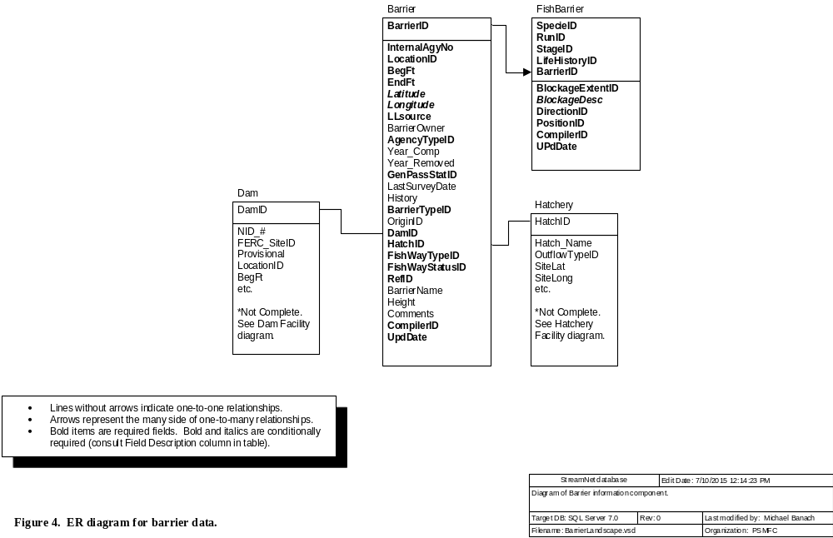

D1. Barrier Table
This table houses a list of barriers, and information about each barrier. Some "barriers" have artificial fishways or have otherwise been corrected, and now all fish are able to pass the barrier. At other times the severity may be unknown and a feature may not even be a barrier (i.e., is only a "potential barrier" and thus GenPassStatID=99). Tracking this information is important for people who will use these data. Therefore DO submit records for "barriers" that once blocked fish but no longer do, and for "potential barriers".
Field Name | Field Description | Data Type | Codes/Conventions for Barrier Table
BarrierID | This field uniquely identifies a barrier identified by a particular agency | Long int | 98 = N/A  101-50,000 = IDFG |  | 50,001-100,000 = ODFW  100,001-150,000 = WDFW |  | 150,001-200,000 = MFWP  200,001-250,000 = CRITFC  700,000-799,999 = CDFG
InternalAgyNo | Identifies a barrier in the database of the agency that provided the data to StreamNet -- i.e., the internal barrier identifier for WDFW, ODFW, CDFG, etc. This field ensures database updates are performed correctly, and lets data users communicate more clearly with the agencies providing the data. | Text 20
LocationID | The location code of the stream the barrier is on. See "LocationID" in the Glossary. | Text 13 | In general, a code for location types other than streams probably make no sense and should not be used. Points, however, may be useful if barriers have not yet been tied to streams.
BegFt | The beginning measure of the barrier in feet | Long int | Enter -1 if LocationID does not represent a stream.
EndFt | The ending measure of the barrier in feet | Long int | Enter -1 if LocationID does not represent a stream.
Latitude | Latitude coordinate of barrier in decimal degrees. Calculated using NAD83.  Required if LocationID does not represent a stream. | Double | Use two digits left of the decimal point and at least four digits to the right of the decimal point. Up to six digits to the right of the decimal point are permitted.
Longitude | Longitude coordinate of barrier in decimal degrees. Calculated using NAD83.  Required if LocationID does not represent a stream. | Double | This is a negative number. Use three digits left of the decimal point and at least four digits to the right of the decimal point. Up to six digits to the right of the decimal point are permitted.
LLsource | Method by which the longitude and latitude values were determined.  Required if LocationID does not represent a stream. | Text 3 | Only four options are possible:  GPS = Coordinates were determined by use of Global Positioning System, and datum is known to be NAD83.  DIG = Digitally-derived. Includes digitized coordinates, or those converted from other (non-GPS) projected data, and datum is known to be NAD83.  UNK = Unknown how lat/long values were determined, or datum = NAD83 cannot be confirmed.  N/A = Not applicable
BarrierOwner | The barrier owner | Text 100 | The owner of a barrier, and the owner of the land where a barrier sits, can be different. Up through version 2006.1 of this document we did not explicitly state which is expected here. Beginning with version 2009.1 this field is specifically for the owner of the barrier. So if an irrigation district owns a diversion on a stream on US Forest Service land, this field should contain the name of the irrigation district, not the US Forest Service.
AgencyTypeID | Code for the institutional status of the land owner (private, federal, state, etc.). Links to the AgencyType table. | Byte | 1 = Watershed council  2 = State government agency  3 = Local government agency  4 = Federal government agency  5 = Private landowner - corporate  6 = Private landowner - noncorporate  7 = Conservation group  8 = Other  9 = Conservation district  10 = Sporting group  11 = Job or volunteer program |  | 12 = Tribe or tribal organization  13 = Private contractor  14 = Private consultant  15 = Professional society  16 = College or university  17 = Primary or secondary school  18 = Natural Resource Commission  19 = Canadian national government  20 = Public utility  21 = Private |  | 22 = City  23 = County  24 = Water or irrigation district  25 = Sewer district  26 = Port district  27 = Park or recreation district  28 = Multiple / mixed  29 = Canadian provincial government  30 = Nonprofit organization  98 = N/A  99 = Unknown
Year_Comp | The year the barrier was completed. | Integer
Year_Removed | Year the barrier was removed (if applicable) | Integer
GenPassStatID | General status of severity of the barrier in terms of whether this barrier blocks movement of all the fish in the stream. | Byte | 1 = Is a complete passage barrier to all fishes at all times. (Example is 100-foot waterfall.)  2 = Is a barrier to at least some fish at some time.  3 = Passable -- not currently a barrier to any fish. (This includes past barriers that have since been corrected.)  99 = Unknown
LastSurveyDate | The most recent date on which the status of the barrier was evaluated. | Datetime | If the barrier has never been evaluated then leave this field null.
History | This field records information about the history of changes to the barrier. It may also include information about planned changes to the barrier. | Memo
BarrierTypeID | Code for the type of barrier | Byte | 1 = Dam  2 = Culvert  3 = Insufficient flow  4 = Water diversion  5 = Hatchery facility-related structure  6 = Falls |  | 7 = Cascades / gradient / velocity  8 = Debris jam  9 = Temperature  10 = Tidal gate  11 = Poor water quality  12 = Water diversion: screened |  | 13 = Water diversion: unscreened  14 = Utility crossing  15 = Flow measurement weir  16 = Grade control structure (sill)  97 = Other  99 = Unknown
OriginID | Code for whether the barrier is natural, human-caused, etc. | Byte | 1 = Natural  2 = Human-caused  3 = Mixed |  |  | 98 = N/A  99 = Unknown
DamID | The DamID code for BarrierTypeID = 1. | Long int | 98 = N/A  For assigned DamID range series please refer to the Dam table information, or for a complete list of DamID codes contact the regional StreamNet personnel.
HatchID | The HatcheryID code for BarrierTypeID = 5. | Integer | The HatchID from the Hatchery table for BarrierTypeID=5.  98 = N/A  For a complete list of HatchID codes please refer to the Hatchery table.
FishWayTypeID | Code for the type of fishway present to help fish pass the barrier.  Note about regular round culverts: In this database, regular round culverts are not considered a type of fishway. Use code 201, 205, or 210 when appropriate. Use code 101 for unmitigated round culverts. | Byte | 99 = Unknown  (Use "Unknown" when you don't know whether a fishway exists for the barrier)  101 = None  (Used when fishway known to be absent)  32 = Denil (Includes: Denil fishway; Alaska steeppass)  72 = Vertical slot  201 = Pool and weir  (Includes:  Pool and weir without orifice;  Pool and weir with orifice;  Pool and weir below culvert)  205 = Roughened channel  (Includes: Rock ramp; Artificial rapids; Roughened chute; Engineered steepened stream channel; Newberry riffles; Newberry weirs) | 207 = Mechanical / Trap and haul  (Includes:  Fish lift [same as elevator?];  Brail [what's that?];  Fish elevator;  Fish lock;  Hauling / trucking / barging;  Borland lock;  Borland fishpass;  Pumps)  210 = Culvert is designed for fish passage  (Includes:  Culvert with baffles, or otherwise designed for improved fish passage;  Culvert has roughened channel designed inside) |  | 211 = Climbing pass  (Includes:  Elver pass [for young eels, which we don't have in our part of the world);  Lamprey pass [is there such a thing?])  212 = Downstream bypass system  (Includes:  Guidance net;  Turbine intake screen;  Louvers [at turbine intake];  Bar racks [at turbine intake];  Bypass pipe / channel / chute / sluiceway;  Surface collector;  Diversion return pipe or channel) |  | 213 = Hybrid or multiple types  (Hybrid fishways are often a combination of weir and pool, vertical slot, or roughened channel fishways)  214 = Unspecified fishway  (Something is there, but we don't know what)  51 = Other  98 = N/A
FishWayStatusID | Code for the presence of fish passage facilities. | Byte | 1 = Barrier has no known fishway  2 = Fishway present and functioning  3 = Fishway present but needs work  4 = Fishway not wanted, conflicts with hatchery program  5 = Fishway not wanted, unspecified reason  6 = No fishway - mitigated by hatchery program |  |  | 7 = No fishway - mitigated by trap and haul  8 = No fishway - mitigation unspecified  9 = Abandoned fishway - no longer needed  10 = Present, status unknown  99 = Unknown
RefID | The primary reference number for the barrier | Long int | Refer to Reference table information.
BarrierName | Name of barrier, if applicable | Text 100
Height | Height of barrier in feet. | Single | For a culvert, height is measured from the stream surface below the culvert to the surface of the water at the outlet of the culvert. This varies by season, so if possible record in the Comments when the measure was made (base flow; a month; a season; etc.).
Comments | Special purposes, special conditions, etc. | Memo
CompilerID | The code for the agency that put the data into the StreamNet standards and sent them to StreamNet, and is responsible for updates. Links to the Compiler table. | Byte | The compiling agency is one of the small group of agencies related to StreamNet. In instances where the person sending data to StreamNet is employed by one agency but functions within a different agency (common for PSMFC staff), the CompilerID reflects the agency the person functions within. See Trend table for codes.
UpdDate | The date and time that the record was created or updated. For data obtained in electronic format from another source it can reflect the date and time of data capture or of conversion to StreamNet standards. | Datetime | This can be the time a record was created, the last time it was edited, or the last time it was QCd. This field tells the end user when the record was last modified at the source organization.

D2. FishBarrier Table
This table lists specific fish species/run/stages (SRS) whose migration is blocked by each barrier. Only species of management interest need be entered, though including all species is fine if desired. Enter a record for each SRS that is blocked by a barrier, or for which passage ability is unknown. Separate records should be used when passage differs between life stages within a species. For some barriers, a SRS of interest may be able to pass what is a barrier to other fish. In such cases, enter a record for the SRS that is blocked, using BlockageExtentID=1 or 2 or 99. Then if you wish you may enter records for those SRSs that are able to pass the barrier. Do not create "passable" records for a barrier unless there is also at least one record with BlockExtentID = 1 or 2 or 99.
Field Name | Field Description | Data Type | Codes/Conventions for FishBarrier Table
SpecieID | Code for the fish species blocked by the barrier. | Integer | Refer to Trend table information. Create records in this table only for specific taxa. That is, do not use codes such as 55 ("Miscellaneous freshwater species"), 93 ("Not specified"), 98("N/A"), 99 ("Unknown"), or 125 ("Other").
RunID | Code for the fish run blocked by the barrier. | Byte | If run not appropriate for this species, enter 98 = N/A. Refer to the Trend table for other codes.
StageID | Code for the life stage of the fish blocked by the barrier. | Byte | In this table, use only the following stages: | 9 = Adult  14 = Juvenile (unspecified) |  | 29 = All stages  30 = Not specified
LifeHistoryID | Code for the life history strategy(s) of the species in the indicated reach. | Byte | 1 = Anadromous  2 = Year-round resident  3 = Fluvial/adfluvial |  | 4 = Fluvial/adfluvial and year-round resident  5 = Anadromous and year-round resident  99 = Unknown
BarrierID | Links to specific barrier in Barrier table if BarrierID > 100. | Long int | Refer to Barrier table for ranges.
BlockageExtentID | Code describing the extent of the blockage for the particular species/run. | Byte | 1 = Complete barrier (Allows NO passage of the species/run/stage at ALL times. Example is a 50-foot waterfall.)  2 = Partial barrier (If used, the BlockageDesc field must be filled in to tell what is meant by "partial.")  3 = Passable -- not a barrier (This code is used when: the species/run/stage for the current record can pass, but blockage extent is complete or partial or unknown for another species/run/stage. For example, a waterfall may be a complete barrier to fall Chinook (code 1), but be completely passable to winter steelhead (code 3) because the water level is higher during the winter.  99 = Unknown/undetermined
BlockageDesc | Use this field to describe what "partial" means. You can also use it to provide further information about complete barriers, or about barriers above the current distribution of the species. Be as explicit as possible.  Required if BlockageExtentID=2. | Memo | Try to use consistent language between records with the same applicable conditions.
DirectionID | Direction of travel impeded by the barrier. | Byte | 1 = Upstream  2 = Downstream  3 = Upstream and downstream  99 = Unknown
PositionID | Location of barrier in relation to species/run distribution. | Byte | 1 = Upstream of current distribution of species/run  2 = Defines upstream end of species/run in the stream.  3 = Within species/run distribution.  4 = Defines downstream end of species/run in the stream.  5 = Downstream of current distribution of species/run  99 = Unknown |  | Code #1 is used to identify barriers upstream from current distribution. Whether to identify such barriers at all, and if so then for how far upstream, is up to each state to decide. The purpose of records with PositionID=1 is to help with modeling the effects of barrier removal. Such records should be limited to the reasonable future distribution. Identifying the next barrier(s) upstream may be a good general rule.
CompilerID | The code for the agency that put the data into the StreamNet standards and sent them to StreamNet, and is responsible for updates. Links to the Compiler table. | Byte | The compiling agency is one of the small group of agencies related to StreamNet. In instances where the person sending data to StreamNet is employed by one agency but functions within a different agency (common for PSMFC staff), the CompilerID reflects the agency the person functions within. See Trend table for codes.
UpdDate | The date and time that the record was created or updated. For data obtained in electronic format from another source it can reflect the date and time of data capture or of conversion to StreamNet standards. | Datetime | This can be the time a record was created, the last time it was edited, or the last time it was QCd. This field tells the end user when the record was last modified at the source organization.

E. Map Catalog and Photograph Data

These tables store data about photographs, maps, and other images. [This section was removed from the DES for version 2016.1 because we no longer pursue this type of data. These tables still exist in the database and can be easily restored to this DES if desired.]

F. Reference Information
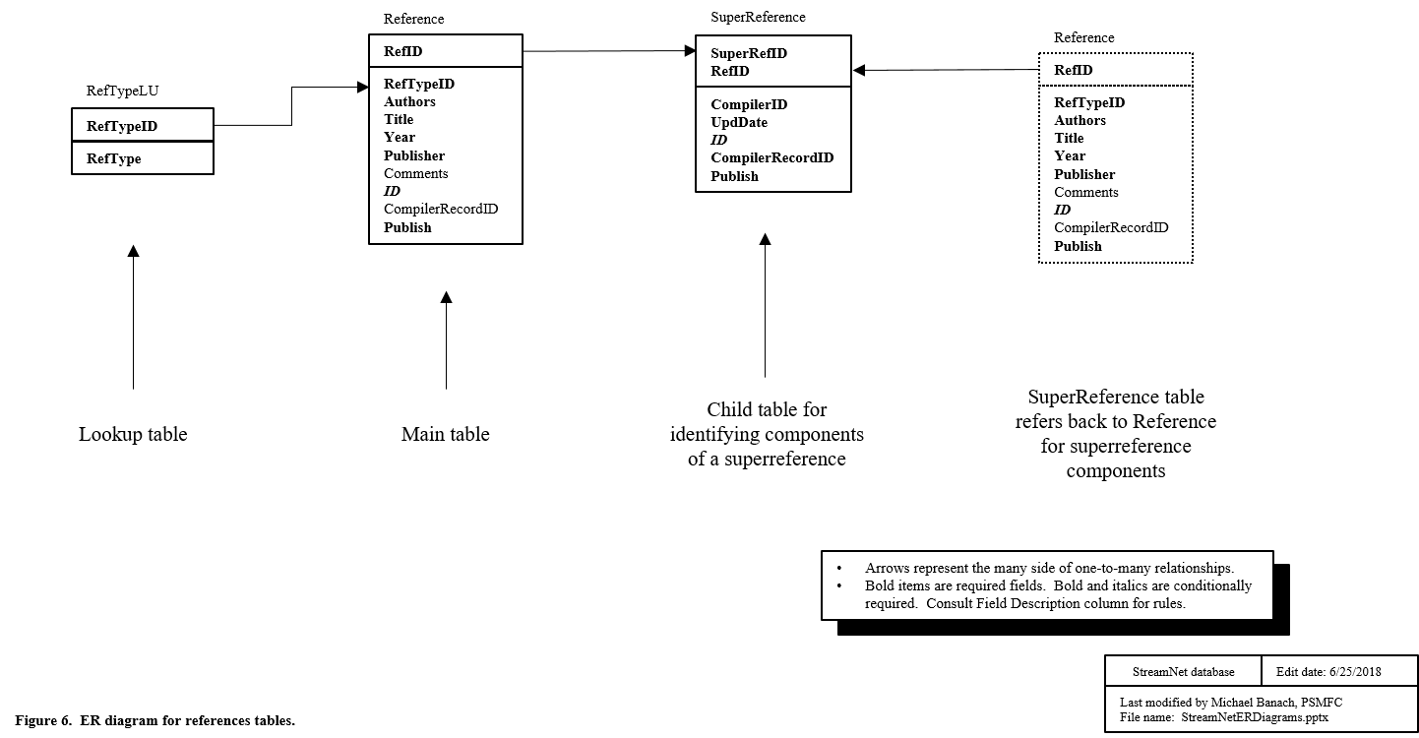

F1. Reference Table
This table stores information about reference documents used to develop the StreamNet database.
Field Name | Field Description | Data Type | Codes/Conventions for Reference Table
RefID | Unique StreamNet reference ID number | Long int | Not applicable = 98  Pre-Data Exchange - 0 - 1,000  WDFW = 10,000-19,999; 100,000-199,999  CRITFC = 20,000-29,999  CTUIR = 200,000 - 209,999  NPT = 210,000 - 219,999  WST = 220,000 - 229,999  YIN = 230,000 - 239,999 | Colville Tribes = 299,001-299,999  USFWS = 30,000-39,999; 300,000-399,999  IDFG = 40,000-49,999; 400,000-499,999  ODFW = 50,000-59,999; 500,000-599,999  PSMFC = 60,000-69,999; 600,000-699,999  MFWP = 70,000-89,999; 700,000-799,999  CDFG = 90,000-99,999; 800,000-899,999
RefTypeID | Indicates whether the reference is a single document or multiple documents. | Byte | 1 = Single reference document  2 = Multiple reference documents | If RefTypeID = 2, then:  - the RefID for this record must be used at least twice in the SuperReference table  - Suggested entries for the Authors, Title, Year, and Publisher fields are shown below.
Authors | Author(s) | Memo | Example: Anderson, Duane A.  For superreferences (RefTypeID=2), simply entering "Multiple" in this field is suggested.
Title | Title | Memo | Full title of document  For superreferences (RefTypeID=2), simply entering "Multiple titles" in this field is suggested.
Year | Year published, year of draft, year data source was created or updated, year communication took place, etc. | Text 40 | Ideally, this is the year a document was published or a personal communication occurred. If unknown, give the best approximate year available and point out the uncertainty in the Comments field.  For superreferences (RefTypeID=2), do one of the following:  - enter the year of the most recent item document  - enter the range of years of the document (e.g., "1996-2001")  - enter "Multiple"
Publisher | Publisher | Memo | Document printer. e.g.: Bonneville Power Administration, Portland, OR;  Washington Department of Fish and Wildlife, Olympia, WA  For superreferences (RefTypeID=2), simply entering "Multiple" in this field is suggested.
SourceURL | URL where an electronic copy of the document can be obtained. | Text 2083 | This field tells the Library where to download documents in electronic format. It replaces our former practice of sending hard copy documents.
Comments |  | Memo | Any pertinent comments about the reference.
ID  (unique) | Value used by computer to identify a record. | Text 36 | This value is a globally unique identifier (GUID) exactly 36 characters long.  - When submitting a new record you may include this value or leave it blank. If you include this value then it will be used by the central system. If you leave it blank then a value will be created for you, and it will be sent back to your system where it must be incorporated.  When updating or deleting records this value must be included.
CompilerRecordID | Agency record ID maintained by the data submitter. | Text 36 | This field can be used in any way the compiler may find helpful. For example, it can be used to create a link between the Coordinated Assessments exchange network and an internal system such as ODFW's Salmon Tracker.
Publish | Yes/no value indicating whether this record should be shared freely with all public users via the Exchange Network. If "No" then the record can only be accessed by using the apikey that created it. | Text 3 | Acceptable values: [Do not include comments in brackets.]  - Yes [Record will be shared with public via Exchange Network.]  - No [Record will not be shared with public via Exchange Network.]  Setting this value to "No" lets you test your systems and avoid having such test records be output on the public system.
UpdDate | The date and time that the record was created or updated. | Datetime | This can be the time a record was created, the last time it was edited, or the last time it was QCd. This field tells the end user when the record was last modified at the source organization.

F2. SuperReference Table
This table lists the individual component references which, when combined, define a superreference. The records with common SuperRefID all belong to the same superreference.
Field Name | Field Description | Data Type | Codes/Conventions for SuperReference Table
SuperRefID | Code which identifies a superreference. | Long int | See Reference table for code ranges. Use the same range for SuperRefID as you use for RefID.  Though a special kind, a "superreference" is a reference. Also, this table is a child table of the Reference table. Therefore, every SuperRefID used in this table must first be used in the RefID field of the Reference table.
RefID | Unique StreamNet reference ID number | Long int | See Reference table for code ranges.
CompilerID | The code for the agency that put the data into the StreamNet standards and sent them to StreamNet, and is responsible for updates. Links to the Compiler table. | Byte | The compiling agency is one of the small group of agencies related to StreamNet. In instances where the person sending data to StreamNet is employed by one agency but functions within a different agency (common for PSMFC staff), the CompilerID reflects the agency the person functions within. See Trend table for codes.
UpdDate | The date and time that the record was created or updated. | Datetime | This can be the time a record was created, the last time it was edited, or the last time it was QCd. This field tells the end user when the record was last modified at the source organization.
ID  (unique) | Value used by computer to identify a record. | Text 36 | This value is a globally unique identifier (GUID) exactly 36 characters long.  - When submitting a new record you may include this value or leave it blank. If you include this value then it will be used by the central system. If you leave it blank then a value will be created for you, and it will be sent back to your system where it must be incorporated.  When updating or deleting records this value must be included.
CompilerRecordID | Agency record ID maintained by the data submitter. | Text 36 | This field can be used in any way the compiler may find helpful. For example, it can be used to create a link between the Coordinated Assessments exchange network and an internal system such as ODFW's Salmon Tracker.
Publish | Yes/no value indicating whether this record should be shared freely with all public users via the Exchange Network. If "No" then the record can only be accessed by using the apikey that created it. | Text 3 | Acceptable values: [Do not include comments in brackets.]  - Yes [Record will be shared with public via Exchange Network.]  - No [Record will not be shared with public via Exchange Network.]  Setting this value to "No" lets you test your systems and avoid having such test records be output on the public system.

G. Habitat Restoration / Improvement Projects Data

This section details tables for habitat restoration / habitat improvement projects. These tables store data about activities that have occurred on the ground in order to improve fish habitat. [This section was removed from the DES for version 2016.1 because we no longer pursue this type of data. Tables from this section still exist in the database and can be easily restored to this DES if desired.]

H. Hatchery Facility Data
This data category includes information about existing hatchery facilities.
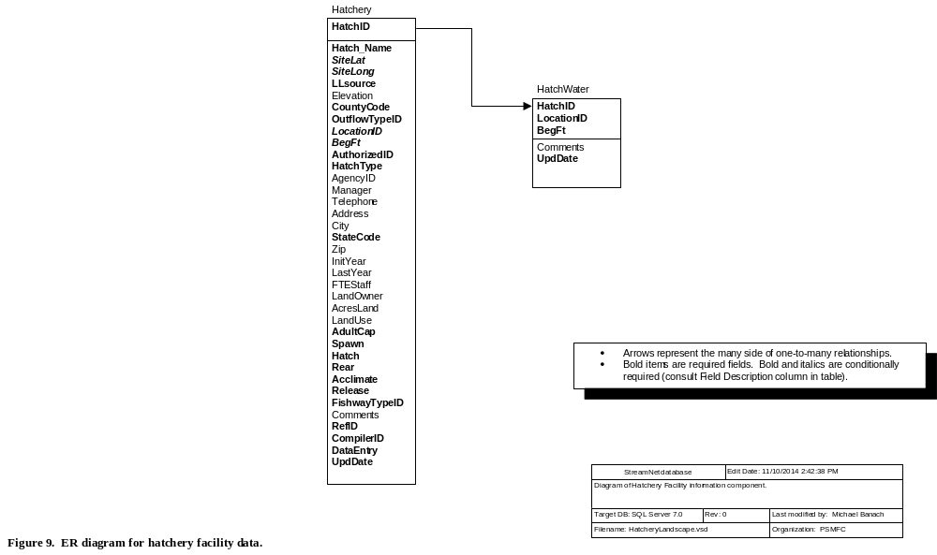

H1. Hatchery Table
This table contains information about hatchery facilities. It also houses codes used in the HatchRelData and HatchRetData tables. "Facility" is defined as an immobile, permanent or semi-permanent fish culture station. (Note: Due to overlapping geographic responsibilities, state, federal, and tribal agencies must coordinate to prevent duplicate entries. The StreamNet regional database manager must ensure that deleted records are replaced appropriately.)
Field Name | Field Description | Data Type | Codes/Conventions for Hatchery Table
HatchID | The unique hatchery ID number for the facility. | Integer | 98 = N/A  2,000-2,999 = CRITFC  Codes 4000-4999 reserved for IDFG.  Codes 610-709, 6000-6999 reserved for WDFW.  Codes 558-599, 5000-5999 reserved for ODFW.  Codes 710-729, 800-899 reserved for MFWP.  Codes 730-769 reserved for CDFG.
Hatch_Name | The name of the hatchery | Text 100
SiteLat | Latitude of the hatchery site in decimal degrees (not degrees-minutes-seconds). Calculated using the 1983 North American Datum (NAD83).  Required unless OutflowTypeID=98. | Double | Use two digits left of the decimal point and at least four digits to the right of the decimal point. Up to six digits to the right of the decimal point are permitted.
SiteLong | Longitude of the hatchery site in decimal degrees (not degrees-minutes-seconds). Calculated using the 1983 North American Datum (NAD83).  Required unless OutflowTypeID=98. | Double | This is a negative number. Use three digits left of the decimal point and at least four digits to the right of the decimal point. Up to six digits to the right of the decimal point are permitted.
LLsource | Method by which the longitude and latitude values were determined.  Required for non-stream points (LocTypeID=3). Not applicable for other location types. | Text 3 | Only five options are possible:  GPS = Coordinates were determined by use of Global Positioning System, and datum is known to be NAD83.  DIG = Digitally-derived. Includes digitized coordinates, or those converted from other (non-GPS) projected data, and datum is known to be NAD83.  UNK = Unknown how lat/long values were determined, or datum = NAD83 cannot be confirmed.  CEN = Centroid coordinates derived from a feature that is represented as a polygon in StreamNet’s GIS.  N/A = Not applicable
Elevation | Elevation of the hatchery in feet | Integer
CountyCode | Concatenated ANSI state code plus ANSI county code for the county where the hatchery is located. For example: ANSI state code for California=06 and ANSI county code for Inyo County is 027, so "06027" would be used in StreamNet for this county. | Text 5 | For state ANSI codes see the StateCode field further down in this table. For county ANSI codes refer to https://www.census.gov/library/reference/code-lists/ansi.html. (State and county ANSI codes are the same as the state and county FIPS codes.)  XX000 = N/A [where XX = StateCode]  XX999 = Unknown [where XX = StateCode]
OutflowTypeID | Code for the water body class to which the hatchery's water is primarily discharged. | Byte | 4 = No outflow to any fresh or marine water body.  8 = Outflow to stream  9 = Outflow to standing water [lakes, reservoirs, marine waters]  98 = N/A. Use when HatchID represents N/A or a collection of facilities (98, 347, 603, or similar).  99 = Unknown
LocationID | Usually the LocationID of the stream the hatchery is on, but see the Codes/Conventions column for further information.  Required unless OutflowTypeID=4 or 98. | Text 13 | Contact regional data manager for various codes for "Unknown"  If OutflowTypeID = 4 or 98:  LocationID =Null;  BegFt = Null;  If OutflowTypeID = 8:  LocationID = The appropriate code for the stream;  BegFt = Measure in feet from the mouth of the stream identified in the LocationID field to the main hatchery outflow;  If OutflowTypeID = 9:  LocationID = The appropriate code for the lake/reservoir/etc.;  BegFt = -1
BegFt | Location of the hatchery along a stream (generally the main outflow or fish ladder location).  Required if OutFlowTypeID=8. | Long int | Refer to notes under LocationID field above for conventions for filling in this field.
AuthorizedID | The legislation or program that authorized the hatchery construction  Links to the Authorized table. | Byte | 1 = Mitchell Act  2 = Northwest Power Act / Fish & Wildlife Program of the NPPC  3 = LSRCP (Lower Snake River Compensation Plan)  4 = Federal Power Act / FERC mitigation  5 = State statute or program  6 = Tribal statute or program |  | 7 = Dingle-Johnson  8 = Grand Coulee Mitigation  9 = Other federal statute or program  10 = Other  11 = Idaho Power Mitigation  98 = N/A  99 = Unknown
HatchType | The general life-history pattern of species raised at this hatchery as of Spring 1999 | Integer | 1 = Anadromous fish  2 = Resident fish |  | 3 = Both resident and anadromous  98 - N/A  99 = Unknown
AgencyID | Code for the management agency responsible for the hatchery. Cross reference to Agency lookup table. | Integer | For AgencyID codes please refer to the EscData table.
Manager | The name of the hatchery manager | Text 30
Telephone | Phone number for hatchery | Text 12 | Preferred format is this pattern: "503-595-3100".
Address | Mailing address of the hatchery | Text 50
City | The town where mail is received | Text 20
StateCode | ANSI state code for the mailing address of the facility. | Text 2 | 06 = California  16 = Idaho  41 = Oregon | 53 = Washington  30 = Montana  00 = N/A  99 = Unknown |  | (State ANSI codes are the same as the state FIPS codes.)
Zip | The zip code | Text 10
InitYear | The year the hatchery went into operation | Integer | "Operated" is defined as water flowing through the facility for fish culture purposes
LastYear | If not currently in operation, the last year the hatchery operated | Integer | "Operated" is defined as water flowing through the facility for fish culture purposes
FTEStaff | The number of Full Time Equivalent (FTE) staff on location | Single
LandOwner | Owner of the land where the hatchery is located | Text 100
AcresLand | The total acreage owned and available for hatchery use (not only the acres in use) | Single
LandUse | Percentage of acres actually in use by the hatchery | Single
AdultCap | Does this facility have the infrastructure for capturing adults? | Byte | 0 = False  1 = True  99 = Unknown
Spawn | Does this facility have the infrastructure for adult spawning (egg collection)? | Byte | 0 = False  1 = True  99 = Unknown
Hatch | Does this facility have the infrastructure for holding eggs until hatching? | Byte | 0 = False  1 = True  99 = Unknown
Rear | Does this facility have the infrastructure for rearing fish? | Byte | 0 = False  1 = True  99 = Unknown
Acclimate | Does this facility have the infrastructure for prerelease acclimation? | Byte | 0 = False  1 = True  99 = Unknown  (This field should contain "False" if "Release" field contains "False." Also, this item refers to relatively short-term holding of fish, unlike the essentially unlimited time suggested in the "Rear" field.)
Release | Does this facility have the infrastructure for directly releasing fish to a natural water body? | Byte | 0 = False  1 = True  99 = Unknown
FishWayTypeID | Code describing the type of fishway. | Byte | Refer to Barrier table.
Comments | Special purposes, special conditions, etc. | Memo | Comments are helpful when OutflowTypeID = 5, 6, or 7, or if outflow is to more than one stream.
RefID | The primary reference number for the source of the hatchery information | Long int | Refer to Reference table information.
CompilerID | The code for the agency that put the data into the StreamNet standards and sent them to StreamNet, and is responsible for updates. Links to the Compiler table. | Byte | The compiling agency is one of the small group of agencies related to StreamNet. In instances where the person sending data to StreamNet is employed by one agency but functions within a different agency (common for PSMFC staff), the CompilerID reflects the agency the person functions within. See Trend table for codes.
DataEntry | Who originally put the data into electronic format. This is not necessarily a StreamNet person. This field can include more information also, to describe not only who entered the data, but who edited or reviewed data or transformed them into a usable format. This field helps with future QC. | Text 50 | The name of the person who entered the record. Including first and last names is preferred.
UpdDate | The date and time that the record was created or updated. For data obtained in electronic format from another source it can reflect the date and time of data capture or of conversion to StreamNet standards. | Datetime | This can be the time a record was created, the last time it was edited, or the last time it was QCd. This field tells the end user when the record was last modified at the source organization.

H2. HatchWater Table
This table links to the Hatchery table via the HatchID field and holds the hatchery water source data. It has a many to one relationship with the Hatchery table.
Field Name | Field Description | Data Type | Codes/Conventions for HatchWater Table
HatchID | The ID number of the hatchery. Cross reference to Hatchery table | Integer | For a complete list of HatchID codes please refer to the Hatchery table.
LocationID | The code for the water body or other water source that is a water supply for the hatchery.  See "LocationID" in the Glossary for further notes. | Text 13 | A LocationID is used even for such water sources as wells and municipal water supplies. Create a PointID for such sources and submit them in the LocMaster table.
BegFt | Distance in feet from the mouth of the stream | Long int | If the LocationID field does not represent a stream, then enter -1.
Comments | Enter any appropriate comments about the water supply. | Memo
UpdDate | The date and time that the record was created or updated. For data obtained in electronic format from another source it can reflect the date and time of data capture or of conversion to StreamNet standards. | Datetime | This can be the time a record was created, the last time it was edited, or the last time it was QCd. This field tells the end user when the record was last modified at the source organization.

I. Dam Facility Data
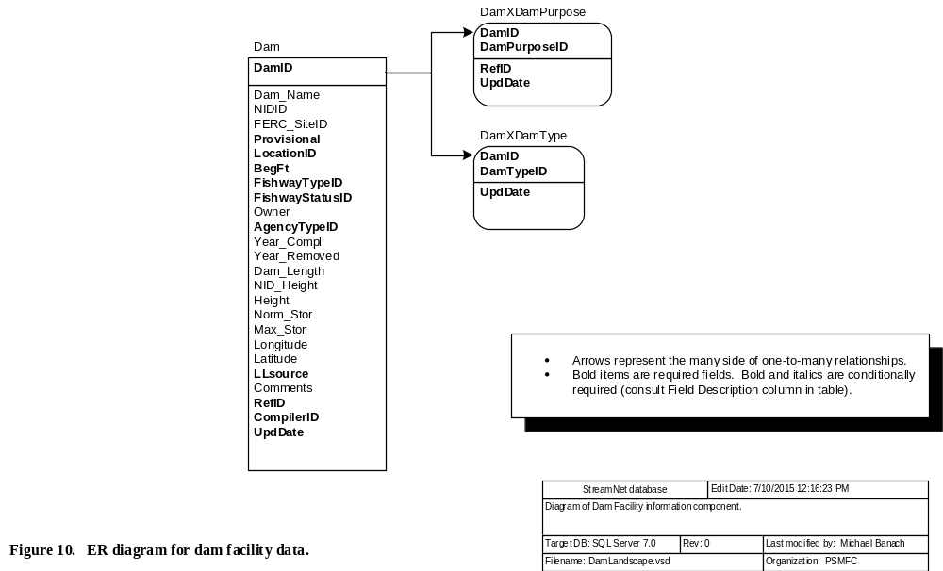

I1. Dam Table
This table contains information about dams in the Pacific Northwest.
Field Name | Field Description | Data Type | Codes/Conventions for Dam Table
DamID | The DamID number for the dam  The mailing address of the dam determines which state is responsible for updates. | Long int | 98 = N/A  0 - 9,999 = National Inventory of Dams  10,000-19,999 = WDFW  20,000-29,999 = CRITFC  30,000-39,999 = USFWS | 40,000-49,999 = IDFG  50,000-69,999 = ODFW  70,000-79,999 = MFWP  90,000-99,999 = CDFG | For a complete list of DamID codes please refer to the Dam table.
Dam_Name | The name of the dam. | Text 65
NIDID | National Inventory of Dams ID number. | Text 7
FERC_SiteID | Federal Energy Regulatory Commission number authorizing the dam. | Text 12
Provisional | If yes, indicates the assigned measure along the stream may not be the exact location of the dam. | Text 3 | Acceptable values:  - Yes  - No
LocationID | The LocationID of the stream the dam is on, or the point representing the dam location.  See "LocationID" in the Glossary for further notes. | Text 13
BegFt | Distance of the dam from the mouth of the stream (in feet). | Long int | Enter -1 if LocationID does not represent a stream.
FishwayTypeID | Code describing the type of fishway. | Byte | Refer to Barrier table.
FishwayStatusID | Code describing presence or status of fish passage facilities at dam. | Byte | Refer to Barrier table for codes.
Owner | The dam owner. | Text 100
AgencyTypeID | Code for the institutional status of the dam owner (Private, Federal, State, etc.). Links to the AgencyType table. | Byte | Refer to the Barrier table for codes.
Year_Compl | The year the dam was completed. | Integer
Year_Removed | Year the dam was removed (if applicable). | Integer
Dam_Length | Dam crest length in feet (length of dam along stream surface). | Single
NID_Height | The maximum of dam, structure, or hydraulic height in feet from the National Inventory of Dams. | Single
Height | Height of dam in feet from a source other than the National Inventory of Dams. | Integer
Norm_Stor | The normal storage capacity of the reservoir in acre feet. | Single
Max_Stor | The maximum storage capacity of the reservoir in acre feet. | Single
Longitude | Longitude of the project in decimal degrees (not degrees-minutes-seconds). Calculated using the 1983 North American Datum (NAD83). | Double | This is a negative number. Use three digits left of the decimal point and at least four digits to the right of the decimal point. Up to six digits to the right of the decimal point are permitted.
Latitude | Latitude of the project in decimal degrees (not degrees-minutes-seconds). Calculated using the 1983 North American Datum (NAD83). | Double | Use two digits left of the decimal point and at least four digits to the right of the decimal point. Up to six digits to the right of the decimal point are permitted.
LLsource | Method by which the longitude and latitude values were determined.  Required for non-stream points (LocTypeID=3). Not applicable for other location types. | Text 3 | Only five options are possible:  GPS = Coordinates were determined by use of Global Positioning System, and datum is known to be NAD83.  DIG = Digitally-derived. Includes digitized coordinates, or those converted from other (non-GPS) projected data, and datum is known to be NAD83.  UNK = Unknown how lat/long values were determined, or datum = NAD83 cannot be confirmed.  CEN = Centroid coordinates derived from a feature that is represented as a polygon in StreamNet’s GIS.  N/A = Not applicable
Comments | Comments related to the dam. | Memo
RefID | The primary reference number for the source of the Dam information. | Long int | Refer to Reference table information.
CompilerID | The code for the agency that put the data into the StreamNet standards and sent them to StreamNet, and is responsible for updates. Links to the Compiler table. | Byte | The compiling agency is one of the small group of agencies related to StreamNet. In instances where the person sending data to StreamNet is employed by one agency but functions within a different agency (common for PSMFC staff), the CompilerID reflects the agency the person functions within. See Trend table for codes.
UpdDate | The date and time that the record was created or updated. For data obtained in electronic format from another source it can reflect the date and time of data capture or of conversion to StreamNet standards. | Datetime | This can be the time a record was created, the last time it was edited, or the last time it was QCd. This field tells the end user when the record was last modified at the source organization.

I2. DamXDamPurpose Table
This table contains information about the defined purposes of the dam. There is a many to one relationship with the Dam table via the DamID field. There should be at least one record in this table for each record in the Dam table, if possible.
Field Name | Field Description | Data Type | Codes/Conventions for DamXDamPurpose Table
DamID | The DamID number for the dam. | Long int | 98 = N/A  For assigned DamID range series please refer to the Dam table information, or for a complete list of DamID codes refer to the Dam table.
DamPurposeID | The uses or purposes of the project (hydropower, water supply, recreation, etc.). | Byte | 1 = Irrigation  2 = Hydroelectric  3 = Flood control and storm water management  4 = Navigation | 5 = Water supply  6 = Recreation  7 = Fire protection, stock, or small farm pond  8 = Fish And wildlife pond | 9 = Debris control  10 = Tailings  11 = Other  12 = Water quality  99 = Unknown
RefID | The primary reference number for the source of the Dam information. | Long int | Refer to Reference table information.
UpdDate | The date and time that the record was created or updated. For data obtained in electronic format from another source it can reflect the date and time of data capture or of conversion to StreamNet standards. | Datetime | This can be the time a record was created, the last time it was edited, or the last time it was QCd. This field tells the end user when the record was last modified at the source organization.

I3. DamXDamType Table
This table contains information about the defined types of the dam. There is a many to one relationship with the Dam table via the DamID field. There should be at least one record in this table for each record in the Dam table, if possible.
Field Name | Field Description | Data Type | Codes/Conventions for DamXDamType Table
DamID | The DamID number for the dam. | Long int | 98 = N/A  For assigned DamID range series please refer to the Dam table information, or for a complete list of DamID codes refer to the Dam table.
DamTypeID | The dam type (earth, rockfill/gravity, arch, etc.). | Byte | 1 = Buttress  2 = Concrete gravity  3 = Concrete  4 = Rockfill | 6 = Masonry  7 = Multi-arch  8 = Non required  9 = Other | 10 = Gravity  11 = Rolled concrete  12 = Earth  13 = Stone | 14 = Timber crib  15 = Arch  99 = Unknown
UpdDate | The date and time that the record was created or updated. For data obtained in electronic format from another source it can reflect the date and time of data capture or of conversion to StreamNet standards. | Datetime | This can be the time a record was created, the last time it was edited, or the last time it was QCd. This field tells the end user when the record was last modified at the source organization.

III. Trend Data Compiler Decision Tree

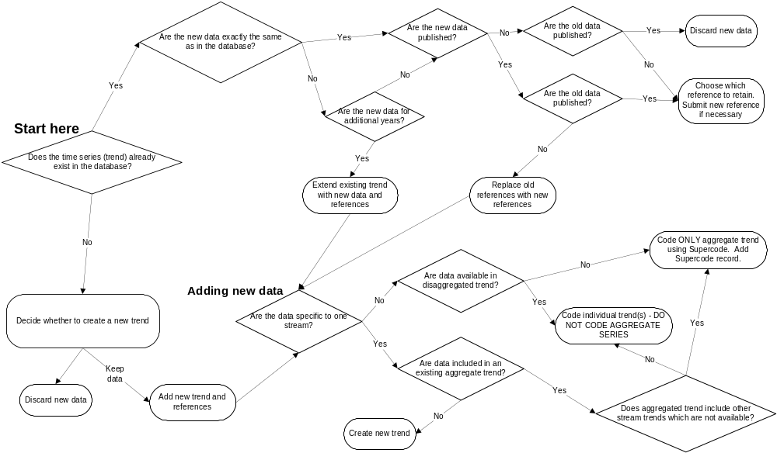

Appendix A. "Too Many To Count" in the EscData table

Sometimes, the results of a survey may be that there were too many fish or redds to effectively count them. In such instances, there may be no real estimate reported, but instead something like "Too many to count" or an equivalent phrase is used to characterize the number of fish or redds. This statement may (or may not) be accompanied by a wild guess/informal estimate of the actual number that the author doesn't feel confident about. This circumstance presents us with a special problem, because while the survey was done and did produce results, the result will not fit into our numeric CountValue field. In such cases, do the following in the EscData table:
- NullFlag is "No" (because the survey was done);
- CountValue is null (because you don't have a number to report);
- CountPerMile is null (because you don't have a number to report);
- In CountCom, very briefly explain why there is no value available. This explanation should include the sampling year or date, and must be immediately preceded and followed by the six characters "[TMTC]" (without the quotation marks). This explanation can be at the beginning, end, or middle of CountCom. Keep it short, because it will be displayed on graphs by the query system. For example, the CountCom might contain the following text, and will produce the graph shown:
Weather was blah blah blah. [TMTC]Too many redds to count in 1971 because high returns resulted in superimposed redds.[TMTC] More blah blah blah.

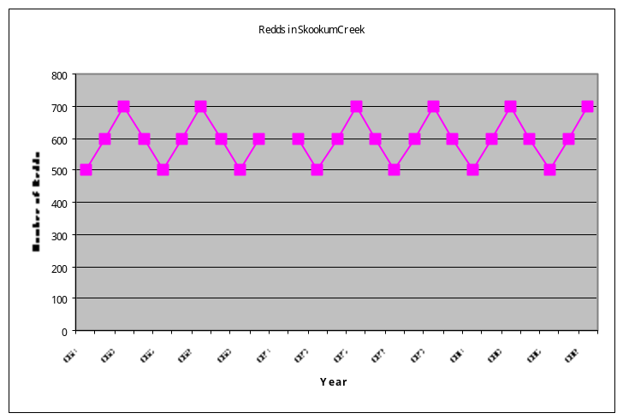
?
?Too many redds to count in 1971 because high
returns resulted in superimposed redds.

Equivalent directions for other tables have not been developed. If you encounter this need for other tables, contact the DES document editor.

Appendix B. Draft tables

Draft tables are no longer housed in this document. To view the draft tables, refer to the companion document entitled Exchange Standard Documentation - Version 2015.1. Volume II: Draft Tables
(file name is StreamNetExchangeStandard2015-1Volume2.doc).

Appendix C. Instructions and Definitions for the CategoryID Field

The CategoryID field found in the Trend table requires some additional clarification and usage guidance. CategoryID is used as the major data category in the StreamNet database and on-line query system. Code definitions and usage guidelines are shown in Table Appendix C1.

Table Appendix C-1. Data category definitions and usage guidelines
Code and Data Category Name | Data Category Definition and Usage Guideline | Census, Estimate, or Index ¹ | Examples
1 = Spawner counts | Counts of living and/or dead fish on spawning grounds. "Spawners" are defined as sexually mature fish on the spawning grounds. Apply to peak type counts and other simple spawner counts that are not actual population estimates. A "peak count" is defined as either a one time spawning ground survey done at the presumed peak of the run, or the highest value recorded over multiple surveys. (While these are actually quite different, because of differences in usage around the Northwest we group them here.) Sampling method is often "Ground"; count type is often "Peak live & dead fish." | Index | - Live and/or dead fish count on spawning grounds.  - May be single count, "peak", sum, etc.  - Live and/or dead fish count/mile on spawning grounds.  - May be single count, "peak", sum, etc.
9 = Redd counts | Counts of redds, or a calculated redd or redd/mile estimate. Apply to any type of redd count. Sampling method is usually "Ground" or by boat or from the air; count type is always "Redd count" or "Peak redd count" or "Redds per mile." Note that even if total redd number is estimated, that estimate remains an index of fish abundance. | Index | - Redd count  - Redds / mile  Each of the above may be single counts, "peak" counts, sums, etc.
8 = Spawner abundance estimates | Estimate of the total number of mature fish on spawning grounds in an area of management interest, NOT simple index counts. Prespawning mortalities may be included in the estimate or not; either is acceptable, and ideally such information is in the data. This estimate is at a scale different than the populations defined for ESA status reviews. Statistical techniques for estimating total population size (such as mark-recapture) will have been employed. "Spawners" are defined as sexually mature fish on the spawning grounds. Life stage must be "spawners". Sampling methods are varied and often combinations of methods; count type should always be Total Live Fish. | Estimate | - Estimated number of fish on spawning ground.  - Estimated number of fish that spawned.
2 = Freshwater / estuary harvest | Estimates of the number of fish harvested in freshwater and estuary areas of management interest, NOT simple index counts. Statistical techniques for estimating total harvest (such as expansion from effort and catch efficiency estimates) will have been employed. Apply to all freshwater and estuary harvest trends. Sampling method is often "Punch card" or "Postal survey" for sport harvest and "Commercial fish ticket" for commercial harvest; count type is usually "Freshwater sport" for sport harvest and "Freshwater commercial" for commercial harvest. | Estimate
4 = Dam / nonhatchery weir counts | Simple counts of fish at a dam or weir. These are indexes of abundance, NOT estimates of total abundance. Statistical techniques for total population estimates (such as mark-recapture) were not employed. Apply to a dam count or weir count that is not part of a hatchery operation. Sampling method is either "Dam" or "Weir/trap"; count type is usually "Total live fish" or "Index of live fish." For this data category, which is counts of fish at a particular point in a stream, the value of Trend.EndFt should equal Trend.BegFt. | Index | - Fish count at a dam.  - Fish count at a weir (not at a hatchery)  Each of the above may be sums, or simple expansions may be done to account for unsampled time.
5 = Hatchery returns | The total count of fish that return to and/or are brought to a hatchery facility. Apply to all hatchery return trends. Sampling method is not used; count type is usually "Total live fish." | Census
38 = Fish counts | Simple counts of fish, expressed as number of fish or as density estimates (#/m² or #/m³). May be any life stage other than spawners (sexually mature fish on the spawning grounds). These are indexes of abundance, NOT estimates of total abundance. Statistical techniques for total population estimates (such as mark-recapture) were not employed. | Index | - Fish counts  - May be single counts, sum, etc.  - Fish density  Common methods employed are electrofishing, seining, snorkeling, gill nets, screw traps.
7 = Fish abundance estimates | Estimate of the total number of fish in an area of management interest, NOT simple index counts. This estimate is at a scale different than the populations defined for ESA status reviews. Statistical techniques for estimating total population size (such as mark-recapture) will have been employed. May be any life stage other than spawners (sexually mature fish on the spawning grounds). | Estimate | - Estimated number (standing stock) of fish in a defined area of management interest.  - Estimated number of fish moving past a sampling site.

¹ "Census" means all fish were actually counted. Because the actual number is known, no estimate was necessary and confidence limits were not necessary.
"Estimate" means statistical techniques for estimating total fish numbers were employed. Confidence limits may have been calculated.
"Index" means statistical techniques for total fish numbers, such as mark-recapture, were not employed. Index counts are used when census counts and total estimates are not available. No confidence limits.

Appendix D. Glossary

Aggregate trend: Data collection methods sometimes change, with the same basic information collected with two different levels of detail at different times. An aggregated trend is defined for such an occurrence, and is the trend with less detailed information. For example, redds may initially be counted for an entire stream. In later years the count may be split into two separate numbers, perhaps above and below a tributary. In this example, the aggregate trend is for the entire stream, while "independent trends" are defined for the reaches above and below the tributary.

Independent trend: A regular trend. Compare to "aggregate trend."

LocationID: A standard and unique code, usually 13 digits, that identifies an individual stream, point, standing water body, supercode, hatchery, dam, or some other location. LocationID values for hatcheries should be made by concatenating the SiteLong and SiteLat fields (each to 4 decimal places, longitude in front, using NAD83), and for dams should be made by concatenating the Longitude and Latitude fields (4 decimal places, longitude in front, using NAD83). LocationID codes are unique: only one stream, flat water, supercode, point, hatchery, or dam can be represented by a LocationID. That is, two locations cannot share a LocationID even if they are of different location types.

PointID: A standard and unique 13-digit code that identifies a point location that is not associated with a stream. These are often upland points not associated with any stream, or a location on a stream that has not yet tied to the hydrography. PointIDs are not created when data can instead be tied to a stream or lake or marine water body. To create a PointID, concatenate the decimal-degree longitude and latitude of the point (each to four decimal places, longitude in front, using NAD83), then remove negative signs and decimal points. For example, a point at 47.923685 latitude and -118.089256 longitude would be assigned a PointID of "1180892479236".

Appendix E. Updating This StreamNet Data Exchange Standard Document

The purpose of this document is to serve as a guide to data managers and data entry personnel associated with the StreamNet project. Items in this document which represent changes from the previous version must be implemented in the databases and associated tools of data submitters, and of the regional StreamNet database managers. A number of tasks must be completed to fully implement a change to this document. A general, non-exhaustive outline of the tasks and procedures necessary for proposing and implementing changes to this document is shown in a companion document (.pdf format) entitled StreamNet Data Exchange Format: Development/Revision Procedure. This document is distributed with this exchange standard, and is also available at ftp://ftp.StreamNet.org/pub/StreamNet/Projman_files/ExchangeFormat/CurrentDraft. The file name is 'DES-Change-Process.pdf.'

Appendix F. MS-Access 2010 Data Types

MS-Access 2010 Data Type | Purpose | Characteristics | Storage Required Per Record
Currency | Numbers.  Appropriate for numbers other than currency. | Zero to 15 digits to the left of  the decimal point and zero to 4 digits to the right. | 8 bytes
Date/Time | Date and time. | Years 100 through 9999.  This data type stores date AND time -- it is not possible  to store one without the other.  A date with no time is interpreted as 00:00 in the morning.  A time with no date is interpreted as 12/30/1899.  Calculations among records recognize and use these  default values in calculations, so must be accounted  for when using the data. | 8 bytes
Memo  Equivalent to SQL Server  nvarchar(4000) field. | Long text entries. | Up to 4,000 characters in length. | 2 bytes / character for Unicode.  1 byte / character if Unicode compression enabled and  entry is under 4,096 characters.
Memo*  Equivalent to SQL Server  nvarchar(max) field. | Long text entries. | Essentially unlimited length.  Indicated with an asterisk in the tables above. | 2 bytes / character for Unicode.  1 byte / character if Unicode compression enabled and  entry is under 4,096 characters.
Number (Byte) | Whole numbers from 0 to 255. | Integers only: no decimal places.  No negative numbers. | 1 byte
Number (Decimal) | Numbers from -9.999 X 10²⁷ to 9.999²⁷. | Decimal places and negative numbers allowed.  Up to 28 significant digits. | 12 bytes
Number (Integer) | Whole numbers from -32,768 to 32,767. | Integers only: no decimal places. | 2 bytes
Number (Long Integer) | Whole numbers  –2,147,483,648 to 2,147,483,647. | Integers only: no decimal places. | 4 bytes
Number (Single) | Floating point numbers  –3.402823 X 10³⁸ to 3.402823 X 10³⁸. | Up to 7 significant digits. | 4 bytes
Number (Double) | Floating point numbers  –1.79769313486231 X 10³⁰⁸ to 1.79769313486231 X 10³⁰⁸. | Up to 15 significant digits. | 8 bytes
ReplicationID | Globally unique identifier (GUID). | Creates a (presumably) unique value to identify a record. | 16 bytes
Text | Text.  (Including numbers not used in calculations.) | Up to 255 characters in length.  Maximum allowed length can be shorter than 255. | 2 bytes / character for Unicode.  1 byte / character if Unicode compression enabled.
Yes/No | Storage of values that can have only one of two values.  Yes/No; On/Off; True/False. | Cannot be null. Must be one of the 2 values.  It is not possible to indicate such things as  "Not applicable" or "Unknown". | 1 bit

Saunders, Kimberly M., 1992. The Relational Database Advisor: Elements of PC Database Design. Windcrest Books.

