 “Promoting the widespread adoption of global sustainable tourism standards to ensure the tourism industry continues to drive conservation and poverty alleviation”

BUSINESS PLAN

Contact:
Erika Harms
Executive Director
eharms@unfoundation.org
Phone: (703) 887-9040

WASHINGTON, DC – June 20, 2011
This Business Plan is confidential and is not for distribution beyond the recipient of the document.

TABLE OF CONTENT
EXECUTIVE SUMMARY 2
BACKGROUND 4
VISION 6
MARKET ANALYSIS 8
COMPETITIVE ANALYSIS 17
STRATEGY 20
ORGANIZATION 22
PROGRAMS 28
COMMUNICATIONS 41
FINANCIAL SUSTAINABILITY 46
APPENDIX 53

EXECUTIVE SUMMARY
BUSINESS CONCEPT
The Global Sustainable Tourism Council (GSTC) is a global membership council and serves as the international body for promoting the increased knowledge, understanding and adoption of sustainable tourism practices. The GSTC fosters sustainable tourism through the adoption of universal sustainable tourism principles; compiling, adapting and creating the tools and training to engage in sustainable tourism practices; and increasing the demand for sustainable tourism products and services. The GSTC is intended to serve as an umbrella organization, endorsed by the United Nations (UN), hosting businesses, governments, non-governmental organizations, academia, and communities engaged in and striving to achieve sustainable tourism. At the core of its work is the GSTC Criteria.

CURRENT SITUATION
GSTC is a strategic coalition of partners under the umbrella of the UN. It is registered in the United States as a non-for-profit corporation. The GSTC was born out of the merger of two initiatives: the Partnership for Global Sustainable Tourism Criteria (GSTC Partnership) and the Sustainable Tourism Stewardship Council (STSC) The GSTC will copy write, manage and update the Global Sustainable Tourism Criteria (the Criteria).

CURRENT SUCCESS FACTORS
- Empowered membership with diverse tourism sector representation
- Early adopters within certifications, businesses and governments
- Strategic partnerships
- Proven record in standard setting processes
- Committed volunteer members

FUTURE SUCCESS FACTORS
- Retention
- Financial sustainability
- Value for members
- Strong brand equity

CURRRENT CHALLENGES
- Small staff for ambitious objectives
- Lack of funding and limited donor interest
- Lack of industry participation
- Willingness by certifications and businesses to pay for accreditation, membership and royalties
- Ability to demonstrate the value add for the investment in GSTC

FINANCIAL SITUATION
The GSTC operates with an annual budget estimated at US $1,000,000. The UN Foundation has contributed US $1,176,117.30 to date. Membership dues are expected to generate $100,000 in 2011 and double in 2012. It is estimated that the operations cost of the GSTC for the first three years will be close to $3 million US dollars total. Funding for specific programs is variable and will be undertaken as resources are available.

DURATION OF THE PLAN: 2010-2012
This plan is designed for 3 years and should be reviewed and revised early in year 3. It is projected it will take the GSTC at least 3 years to establish itself and transition into an operational organization. The plan is complemented by the GSTC Operational Manual.

BACKGROUND
The Global Sustainable Tourism Council (GSTC) is an initiative introduced in September of 2010 through the merger of the Partnership for Global Sustainable Tourism Criteria (GSTC Partnership) and the Sustainable Tourism Stewardship Council (STSC).
The Partnership for Global Sustainable Criteria (GSTC Partnership)
The Partnership for Global Sustainable Tourism Criteria (GSTC Partnership) was a coalition of more than 50 organizations that worked together to foster increased understanding of sustainable tourism practices and the adoption of universal sustainable tourism principles. The Partnership was initiated by the Rainforest Alliance, the United Nations Environment Programme (UNEP), the United Nations Foundation (UN Foundation), and the United Nations World Tourism Organization (UNWTO). Through the development of a set of universal, globally accepted criteria the partnership took the first step toward standardizing a common language for sustainable tourism. Once the criteria were launched in October 2008, the GSTC Partnership focused on engaging all tourism stakeholders – from purchasers to suppliers to consumers – to adopt the criteria.
The Sustainable Tourism Stewardship Council (STSC)
Initiated in 2001, the STSC was designed to enhance the sustainability of tourism operations by ensuring better environmental and social performance, and improved economic benefits to local communities and to certified businesses worldwide. The STSC initiative proposed the development of a mechanism to accredit certifying bodies or certification programs based on their performance and help ensure that certification is being conducted in an objective and transparent manner. Through accreditation, certification programs would be able to demonstrate their capacity to undertake certification and, thus, build credibility with both consumers and businesses. The STSC had envisioned the development of a “seal of approval” to programs meeting its accreditation requirements, monitor compliance with such requirements, guide the establishment and development of new certification programs, and promote the concept and practice of sustainable tourism to an ever-widening audience.

Merger of the GSTC Partnership and the STSC
Considering the broad overlap of goals, and the role of the Global Sustainable Tourism Criteria as the foundation for proposed STSC accreditation standard, the STSC Temporary Executive Board together with the GSTC Partnership Steering Committee agreed that the two efforts should merge into one single body – the Global Sustainable Tourism Council. Launched in 2010, the GSTC serves as the international body for fostering the increased knowledge and understanding of sustainable tourism practices, the adoption of universal sustainable tourism principles, and the promotion of sustainable tourism accreditation, products and services.
Global Sustainable Tourism Criteria
The Global Sustainable Tourism Criteria (the Criteria) are the minimum requirements that any tourism business should reach in order to protect and sustain the world’s natural and cultural resources while ensuring tourism meets its potential as a tool for conservation and poverty alleviation. As a minimum baseline, and not a maximum, the Criteria should be adapted and expanded to the specific conditions of each region of the world and each industry sector, as the key issues for sustainability will have different emphasis under differing conditions. To develop the Criteria, the GSTC Partnership consulted with sustainability experts and the tourism industry and reviewed more than 60 existing certification and voluntary sets of criteria already being implemented around the globe. In all, more than 4,500 criteria were analyzed and the resulting draft criteria received comments from over 2000 stakeholders.

VISION | MISSION |OBJECTIVES | GOALS
VISION
Tourism achieves its role as a driver of conservation, preservation of destinations and their natural and cultural heritage as well as socio-economic benefits for all stakeholders.

MISSION
To be the agent of change in the world of sustainable tourism by fostering the increased knowledge, understanding, adoption and demand for sustainable tourism practices.

OBJECTIVES
Increase knowledge and understanding of sustainable tourism practices.
Goal 1: Create GSTC courses on sustainability for business
Goal 2: Training to help certification programs go through accreditation
Goal 3: Build training modules for academia

Facilitate the adoption and promotion of universal sustainable tourism principles.
Goal 1: Manage current GSTC Criteria including revisions, adaptations and policing
Goal 2: Create or adapt new criteria for other tourism sectors
Goal 3: Evaluate and recognize standards, as well as accredit certification programs that use recognized sustainable tourism standards (accreditation)

Build demand for sustainable travel.
Goal 1: Build a GSTC database of recognized standards and accredited certification programs, businesses, and activities
Goal 2: Work with distributors to facilitate access to sustainable products and services
Goal 3: Partner with UN agencies and corporations to implement sustainable procurement policies
Goal 4: Partner with 10 DMOs to develop regional programs

MARKET ANALYSIS
TRAVEL AND TOURISM MARKET
The tourism industry is the fastest growing industry in the world. It is responsible for 5% of world GDP and 8% of all employment. According to UNWTO, international tourist arrivals were estimated at 880 million in 2009, generating over 235 million jobs. Tourism for developing countries is significant as they receive approximately 30% of global tourism expenditures.
Nevertheless, the tourism industry was not exempt from the consequences of the financial crisis that hit in 2008. The demand for travel reduced dramatically in 2008, particularly in the USA, Europe and Japan. Especially affected were business travel, meetings and events, while leisure travel experienced a moderate decline. The crisis has led to a series of strategies in the industry that will have important consequences for sustainability. Amongst those strategies are: minimizing fixed assets and reducing fixed costs; moving away from ownership to management; centralizing sourcing processes and bundling; seeking high volume or niche markets. Financing for the industry has also declined and rates have been raised.
The UNWTO forecasts international arrivals will reach 1.6 billion by 2020 (See Appendix, Graph 1). The top three receiving regions will be Europe (717 million), East Asia and the Pacific (397 million) and the Americas (282 million) followed by Africa, Middle East and South Asia. This has important implications for destinations that will see a doubling of inbound travelers.

SUSTAINABLE TOURISM MARKET
While the concept of sustainability has been adopted as general practice in many other industries, the tourism industry has lagged behind. Yet, because of its characteristics the tourism industry can be a valuable player to help achieve the Millennium Development Goals (MDGs), a set of eight goals adopted by the countries of the world in 2000 to reduce extreme poverty.
The tourism industry has looked increasingly towards adoption of environmental practices, driven mainly by the increased scrutiny of the industry and its impact on climate change, particularly, but not solely, to the airline industry. Leading this effort are UNWTO, UNEP and the World Economic Forum (WEF), recently joined by WTTC, convening the industry to dictate clear statements on their positions on climate change.
Until recently, a niche market, ecotourism, has mainly driven sustainability in tourism. Ecotourism was defined by TIES in 1990 as "Responsible travel to natural areas that conserves the environment and improves the well-being of local people." This movement introduced the concepts of environmental preservation and socio-cultural responsibility. At present, however, large tour operators and conventional hotel chains, as well as the MICE sector (Meetings, Incentives, Conferences, Events) have begun to consider sustainability as a key element of their business strategies and competitiveness.
Governments have yet to take a concerted stand on sustainable tourism. While some national sustainable tourism development strategies and regulatory frameworks seek to incorporate sustainability into their policies, most of the efforts in this area occur at a state or province level.
One of the drivers of change, before the economic crisis, was the media. The media’s attention to sustainability issues raised awareness and in turn had led to increased sales and development of new sustainable tourism products. Tourism businesses were increasingly becoming aware and pressured with the need to address environmental, socio-cultural and economic issues. However, the media do not have a base for recognizing sustainable providers and therefore the array of “sustainable tourism” definitions is wide. The Media need guidance to recognize sustainable tourism providers, sustainable tourism certification programs and to understand the basic principles of sustainability in order to report success as well as draw attention to negligence.
The tourism industry has the potential to be a driver of change. As outlined above, through the implementation of the GSTC, the industry will play an important role in achieving MDG Goal 7 – Environmental Sustainability. But more so, providing over 200 million direct jobs, a number that could double in the next 10 years, the industry can help achieve MDG Goal 1 – Reducing by half poverty and hunger. Ensuring a living wage and employing more women, as well as using local and community service providers, can grow the overall impact at a destination level, exponentially.

SUSTAINABLE TOURISM AND CERTIFICATION
Certified tourism businesses represent a very small percentage of the overall tourism industry. By 2007, total certified tourism products were estimated to be between 6000 and 10,000. In Latin America there were 168 certified accommodations and tour operators; and globally there were fewer than 15,000 certified tourism businesses and products (CESD, 2007). This represents a very small fraction of tourism businesses and provides limited opportunity for consumers to become loyal to a brand. While in certain regions, such as Europe, certifications play an important role, this trend has not picked up globally.
There is a proliferation of tourism certification programs and by its latest count, the GSTC is aware of 127 certification programs globally.
The role of certification programs is to:
- raise the bar in sustainability practices;
- provide independent assurance that claims are genuine;
- inform and influence consumer choice;
- enable sustainability to be promoted as a market asset, through the use of logo or seal;
- set an agenda for businesses to follow; and,
- help enterprises identify weaknesses and areas of opportunity.

While the market recognizes sustainability as an important element, particularly its environmental criteria, the majority of certifications have failed to make a business case for themselves at an international scale. In regions where travelers are more conscious, like Europe, or where governments have taken an active participation, like Costa Rica and South Africa, certification programs have a stronger position in the tourism industry. But even in these countries there are concerns about the value added and market benefit of certification.
In addition to the skepticism of the value of certification, there is confusion and distrust in the market place about the legitimacy of such programs. Certification programs range from using strict to lax standards, from affordable to expensive, and have varying degrees of auditing. It is critical to build consumer confidence in travel industry certification programs. Therefore, a full accreditation program designed to “certify the certifiers” must be created.
The objectives for accreditation are:
- raise the bar in terms of sustainability requirements;
- improve the credibility of certification programs and raising their profile;
- foster business to business relationships between certified services and purchasers;
- reduce consumer confusion and skepticism;
- raise awareness of sustainability standards.

CONSUMER BEHAVIOR
Market trends show a change in consumer behavior and attention towards living more environmentally sound lives. These trends impact the tourism industry alongside other industries. This provides an opportunity for the GSTC to drive change. Studies indicate that consumers continue to be more conscious in their purchasing habits despite the 2008 economic downturn. And, while cost is the main driver for travel decisions, there is an increasing expectation towards greener options and more experiential, authentic travel. Consumers are particularly interested in cultural authenticity and a clean, safe environment.

Increased consumer awareness
The rise in global communication networks, online travel booking and advertising has led to consumers being more empowered than ever to make decisions based on all of their needs, including those based on their concern for the planet. They are better equipped to find tour operators and destinations that speak to their particular needs.

In September of 2009, worldwide internet users were estimated at nearly 2 billion (See Appendix, Table 4). The majority of users are located in Asia (42.6% of total), Europe (24.1% of total) and North America (14.6% of total). The minority of users is located in Latin America/ Caribbean (10.3 % of total), Africa (3.9% of total), Middle East (3.3% of total) and Oceania/Australia (1.2% of total) (Internet World Stats, 2009). In particular, market research indicates that an overwhelming percentage of travelers in the U.S. use the internet as a source of information and planning for their travel. (Hitwise, 2010).

KEY STAKEHOLDERS (TARGET MARKET)
Primary Stakeholders:
Tourism businesses and associations: The tourism industry has a direct impact on a destination, the environment and people. Businesses that seek to be sustainable usually do so to improve the bottom line, position themselves in a niche, charge additional resources, or because leadership or employees believe it is the right thing to do. The GSTC will target the leaders and early adaptors in the industry, engage them as strategic partners and promote the GSTC. GSTC will work through associations to reach out to a wider industry audience.

Certification Programs: Through certification programs, businesses can learn about sustainable tourism requirements and be guided in the process of changing their business practices. Once the business complies with pre-established sustainability requirements, the programs will grant a certification as a guarantee that such sustainability requirements are met by a business. Certification programs are the main target audience for accreditation, a key component of the work of the GSTC.

Travelers: Messaging and education of travelers is critical to build demand for sustainable products and services. While travelers acknowledge the willingness to travel in a more sustainable way, mostly what they mean is a smaller environmental footprint or a carbon offset alternative. Seldom do they visualize socioeconomic and cultural impacts in the category of sustainability. They are also less willing to pay additionally to travel responsibly. A starting point for the GSTC should be the LOHAS sector and alignment with companies that have consumer outreach with the ability to promote sustainable travel. Such companies include credit cards, insurance, travel distributors, travel media as well as some larger tourism companies like airlines and cruise lines.

Other key stakeholders:
Multinational organizations, academia, governments, vocational training institutions, non-governmental organizations, donors and communities are also relevant stakeholders of the GSTC. All are drivers of change and should be integrated into the process of promoting sustainable tourism. Since the target audience is broad, the GSTC will take a phased approach to engage them.

OTHER SUSTAINABLE TOURISM INITIATIVES
The Global Sustainable Tourism Council was born of a coalition between two global, multi-stakeholder, UN-led initiatives. As such it has been perceived by its members as an umbrella organization for promoting sustainable tourism practices, engaging many and diverse organizations.

The GSTC seeks to align closely with stakeholders in the tourism industry to engage businesses, governments and donors believing partnership is the key to success. Four key groups have been identified: other UN Type II partnerships, associations, sustainable tourism organizations and certifications, and national or regional accreditation systems.

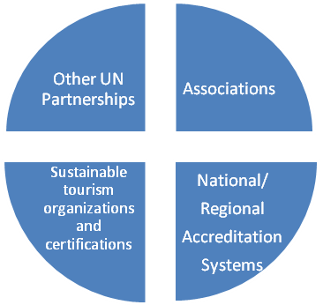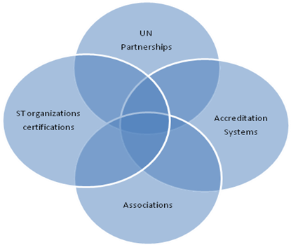

The following organizations represent key partners within the sectors described above. Establishing relationships with these organizations allows a more efficient use of resources and deter from any competitive approach:
The Global Partnership for Sustainable Tourism (GPST): A UN CSD Type II Partnership, whose main objective is to “mainstream sustainability into all aspects of tourism policies, development, and operation”, will be implemented within the public and private realms. The GPST will focus on policies and replicating successful projects in different regions of the world. The GPST has adopted the GSTC Criteria as the baseline language for its programs.

World Tourism and Travel Council (WTTC): A leading global organizations in tourism, WTTC holds a strong constituency and has a proven track record of delivering accurate and needed information to the industry. Comprised of the top 100 CEO’s of leading tourism businesses, WTTC holds a niche market that can drive change. Over past few years, and in close partnership with UNWTO and the WEF, WTTC challenged their members to take a stand on climate change. Most recently they have taken that momentum and used it to look into expanding their impact on sustainability issues. For instance, the WEF Report Low Carbon Travel and Tourism Sector has recommended that the accommodation sector use the GSTC as a sustainability measurement which can help them adopt emissions abatement options. WTTC endorsed the GSTC criteria and has always been open to collaboration. The GSTC and WTTC can build upon two main pillars: information sharing and accreditation. Substantial data on the impacts of sustainable tourism is not available.

United Nations World Tourism Organization (UNWTO): The UNWTO has declared sustainability one of its core pillars. While UNWTO is an active member of the GSTC and has endorsed the GSTC mission, its membership is less aware of the role GSTC can play to promote sustainable tourism. GSTC and UNWTO should work together to position GSTC as one of the core vehicles to achieve the goals UNWTO is envisioning for sustainable tourism. GSTC can provide the support to its sustainability committee and work with the Secretary General to achieve one its main pillars of the “Road to Recovery”.

National and International Accreditation Bodies: Many countries have established credible national accreditation bodies that are members of the International Accreditation Forum. In addition, there are three international accreditation bodies that are members of the ISEAL Alliance. Most of these bodies follow international best practices in accrediting certification bodies to ensure credibility. The GSTC intends to train and outsource accreditation to those bodies that follow international best practices and GSTC requirements for accrediting those certification bodies that use a GSTC-recognized sustainable tourism standard.

STRATEGY
STRATEGY STATEMENT
The GSTC is the driver of change in implementing sustainable practice throughout the tourism sector through collaboration with relevant stakeholders.

KEYS TO SUCCESS
- Establishing a transparent, inclusive, multi-stakeholder process in standards setting and accreditation;
- Providing access to widely available tools and training capacity to implement the standards;
- Close collaboration with product suppliers, governments and tourism boards to ensure market demand and promotion of sustainable product.
- Recognizing that at the core of the GSTC are its criteria, defining a clear deliverable product.

OTHER SUCCESS FACTORS
- UN engagement: Keeping the GSTC under the UN umbrella provides the process, the neutrality and weight of a globally recognized organization.
- Associations play an important role in growing GSTC’s constituency, allowing access to a broad constituency through one communication vehicle.
- Distributors enable a platform to recognize and promote sustainable product at a scale that did not exist before.
- Building a financially sustainable model

CHALLENGES
- The biggest challenge facing the GSTC is the lack of resources to build its operational capacity. It operates mainly with the volunteer support of its members and through the financial support of the UN Foundation.
- The staff is small and needs to cover a wide geographic area.
SWOT ANALYSYS
STRENGTH  - Multi-stakeholder initiative  - Global  - UN support  - Diversity and regional representation  - Leadership by key organizations  - Based on GSTC Participatory consensus building process  - Committed and engaged global constituency that has defied time zones and distance to remain connected | WEAKNESS  - Not enough industry engagement  - Costly operation particularly on the accreditation component  - Not enough staff to meet all requirements  - Decisions are difficult to reach due to diverse interests and consensus requirements, leading sometimes to outdated actions  - Perceived as only being accreditation focused  - Poor and fragmented communication with external stakeholders, which has led to confusion (and concern) over what GSTC does/does not intend to do
OPPORTUNITIES  - Need for a common language  - Increased need for transparency and credibility around sustainability and corporate social responsibility claims given the growth in “green-washing”  - Increased recognition for sustainable practices  - Build on the diverse partnership to implement a comprehensive approach to sustainable tourism  - Increased interest by governments to implement sustainable programs and policies  - Distributor and government relationships provide opportunities for access to market  - Increased movement of consumers to sustainable lifestyles  - Global concern regarding climate change is focusing the market on sustainability issues. | CHALLENGES  - Raise necessary financial resources  - Competing fees with certification programs and local accreditation systems  - Not a donor environment, due to loss of funds or more restrictions on giving  - Ensure balance, diversity and regional representation  - Obtain buy-in from large tourism companies, while remaining relevant for small and medium enterprises.  - UN engagement diluted due to its promotion of many other initiatives  - Changing the perception that GSTC is another certification  - Industry does not perceive the value of certification.  - Lack of understanding of the concept of sustainable tourism  - Little change in consumer patterns related to sustainable tourism

ORGANIZATION
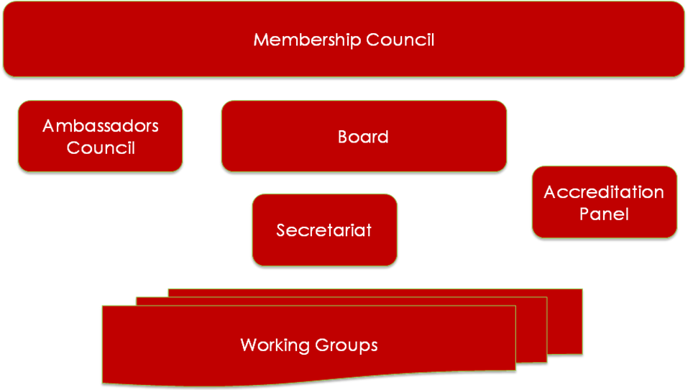

The Global Sustainable Tourism Council is a membership-based not-for-profit, non-governmental organization, which represents diverse stakeholders in tourism, through its membership council.
A Board of Directors manages the GSTC and is responsible for governance oversight of the council’s mandate, program of work, and operations (including staffing, budget, and administrative affairs). An Ambassadors’ Council of influential individual leaders in the field or financial contributors will be established to provide visibility and support to the GSTC Board. Working groups, chaired by a board member, will manage the strategic planning and implementation of each of the core areas.
A semi-autonomous Accreditation Panel chaired by an expert who is not part of the GSTC Board manages the Accreditation program. The Accreditation Panel work is defined by the accreditation business plan.
The organization is managed by a Secretariat comprised of an Executive Director and supporting staff who manage the implementation of the mission and business plan of the organization, aid the growth of the organization, and, with support of the board, raise the necessary resources to continue the operations and programs of the GSTC.
The operation and governance of the organization is detailed in two documents: the By-Laws of the organization and an Operational Manual.

PROGRAMS (WORKING GROUPS)
The implementation of the objectives of the GSTC will be done through 5 main program areas. In addition to these programs, others may be created as necessary. Accreditation will exist with some independence from the GSTC and will be led by an Accreditation Panel.
INTERNATIONAL STANDARD SETTING
The GSTC strives to promote sustainable tourism through a common language and one of its key objectives is to facilitate the adoption and, when needed, the creation, of universal principles for sustainable tourism. The standard setting strategy will focus on the management and revision of the current version of the Global Sustainable Tourism Criteria (GSTC Criteria) and the creation or adaptation and distribution of additional criteria, standards and relevant indicators.
The process for consultation on the development and adaptation of criteria will adhere to the ISEAL code of conduct and follow a multi-stakeholder approach, striving to include a balanced constituency from key industry branches as well as relevant UN agencies, industry associations, selected industry members, academia, and NGOs.

Objectives
Establish a credible international standard setting protocol
Goal 1: Capture the lessons learned from the initial consultation process
Goal 2: Develop a protocol for standard setting for the GSTC

Adapt or create relevant standards for destinations and all applicable tourism industry sectors.
Goal 1: Identify and prioritize other sectors for criteria creation by Q2 2012
Goal 2: Begin criteria creation process for other sectors by Q3 2012
Goal 3: In coordination with the Destinations Working group, develop a destination standard by Q4 2012

Manage and regularly update the criteria
Goal 1: Revise current GSTC Criteria by Q3 2011
Goal 2: Complete GSTC Criteria revisions and publish by Q4 2011
Goal 3: Identify timeline for next GSTC Criteria revision

EDUCATION AND TOOLS
Education and tools are at the core of the Global Sustainable Tourism Council. To achieve its three main objectives GSTC must provide the necessary tools to support businesses, their staff and policy implementers to achieve the goal of sustainable tourism.
The Education and tools Working Group, in coordination with other working groups, will drive the change towards sustainable practices and behavior. The Working Group will develop curricula for academia and vocational training institutes, programs for NGO’s, training courses for businesses and governments and support certifications in their efforts towards accreditation.

Objectives
Provide education materials and tools to business, associations, certification programs and governments to help them implement sustainable tourism programs or achieve accreditation.
Goal 1: Build and maintain an online digital resource library
Goal 2: Develop and build GSTC-aligned general educational materials and modules
Goal 3: Develop education material for accreditation
Goal 4: Develop educational materials/modules on using the GSTC Self-Assessment tool
Goal 5: Develop GSTC Criteria-specific training materials

Make the GSTC part of the curricula of universities, training schools, GSTC Member businesses and other programs.
Goal 1: Develop and distribute two sets of GSTC curricula. One targeted to undergraduates and entry-level tourism professionals, and the other to post-graduate and upper management.
Goal 2: Build partnerships with local trainers to embed GSTC training and capacity-building materials into their programs
Goal 3: Develop traveler education tools and materials for use by GSTC members to educate their customers.

MARKET ACCESS
The GSTC will provide business-to-business solutions that will allow tourism businesses that align themselves with the GSTC to reach greater market potential and market share. The ultimate goal is to create demand for sustainable product. To influence consumer demand and increase general trust in sustainable certification, the GSTC aims to work with distributors, promoters of tourism product and governments to ensure supply and market positioning for sustainable product.
The market access strategy is being designed to provide value specifically to certification programs and tourism businesses. Following the completion of the GSTC accreditation program, the market access working group will continue to focus on bringing the GSTC to market in such a way that certification groups, businesses and travelers alike can gain confidence and clarity on sustainable tourism offerings.

Objectives
Create a realizable market incentive for businesses to pursue sustainable operations
Goal 1: Create and implement a resource center to recognize accredited and verified product through distribution channels.
Goal 2: Establish relationships with distribution companies, travel agencies, tourism boards, associations and other to actively promote GSTC accredited product.
Goal 3: Evaluate traveler’s feedback.
Goal 4: Engage multilateral organizations, corporations and governments to establish procurement strategies favoring sustainable tourism products and provide the necessary tools for implementation.
Goal 5: Promote sustainable tourism products through Tourism Boards and Destination Management Organizations (DMOs).
Goal 6: Adapt market access tools for small enterprises and community-based tourism and work with IGOs to facilitate access to necessary portals.

DESTINATIONS
The GSTC Criteria initially focused on the impact of hotel and tour operator operations; therefore very little work has been done to create standards for destinations. The Destinations Working Group, working in coordination with the International Standards Working Group, will develop baseline criteria that will follow the same best practices as outlined by ISEAL and protocols developed by the International Standards Working Group. Destination standards differ from business-oriented standards in that cumulative impacts of all the businesses and activities in the destination are considered and that a destination management organization (DMO) usually implements policy recommendations. Hence the orientation of destination criteria is quite different from the other, individual business-oriented criteria for other tourism sectors that GSTC is developing.

Objectives
Create baseline criteria for destinations
Goal 1: Develop criteria that minimize the environmental and socio-cultural impacts to particular destinations, while increasing socio-economic and environmental health of those regions.
Goal 2: Develop best practices training materials, in coordination with the Education and Tools working group, to support destinations in their efforts towards sustainable tourism.

COMMUNICATIONS
OVERVIEW
Over the first 18-24 months communications efforts will focus on reaching out to travel industry business and associations, academia, NGOs and destinations. These strategic groups will encourage GSTC membership growth, disseminate educational materials and increase sustainable product development. Following this first phase, the GSTC will widen its focus to include consumer awareness and education resulting in increased demand for sustainable tourism products and services.
Given limited financial and human resources, the GSTC will depend heavily on low cost media outreach solutions including social media, advertising partnerships and earned media placements. The GSTC will also leverage the Board and membership to extend our messaging reach and provide access to strategic partnerships.
Measurement of the communication strategy progress will be a top priority. Directional success will be measured using social media measuring tools, funding levels, increased membership numbers and member engagement.

COMMUNICATIONS STRATEGIC PRIORITIES
- Building GSTC brand equity
- Ensure that brand guidelines and policies are enforced
- Secure positive media coverage for GSTC programs, projects and members
- Provide GSTC-branded education and tools
- Engage in low-cost social media channels
- Develop co-advertising partnerships with member organizations
- Develop sponsorship opportunities for member and non-member organizations
- Develop a GSTC brand ambassador program
- Attend and present at key events that raise GSTC visibility and showcase the organization’s relevance

- Position the GSTC as the subject matter expert on sustainable tourism
- Partner with Education and Tools Working Group to promote our comprehensive web-based resource center
- Create an “experts” program consisting of GSTC Executives and Board Members who will be promoted to press, event organizers and other outlets
- Host monthly webinars to be made available publicly on the GSTC website
- Develop a media relations plan

- Position the value proposition to support membership growth, sponsorship and paid services
  - Create and maintain an online platform for GSTC member networking and discussions
  - Develop marketing materials for member recruitment
  - Actively promote GSTC member successes
  - Establish partnerships with Educational institutions to develop case studies and white papers on program and project successes
  - Collaborate with the Accreditation Panel to develop an Impact Assessment study
  - Actively promote GSTC educational programs to industry

- Provide relevant and timely information to the GSTC membership to help them implement sustainable tourism practices.
  - Launch revised public-facing GSTC website (gstcouncil.org)
  - Improve navigation and usability of Members Only section
  - Create and distribute monthly GSTC newsletter
  - Create and maintain a GSTC blog
  - Use social media outlets to quickly disseminate relevant information

- Building demand for sustainable tourism and tourism products
  - Target consumer-focused travel publications for GSTC and/or GSTC member story placement
  - Collaborate with the Market Access Working Group to ensure wide distribution of GSTC Accredited products and services
  - Develop consumer-focused promotional contests via social media outlets
  - Develop public service announcements to educate the public on the value of traveling sustainably

KEY MESSAGES

Phase 1: Industry, Business Associations and NGOS (18-24 months)

The GSTC is the leading expert in Sustainable Travel & Tourism. The GSTC Secretariat, Board and membership represent some of the most respected and knowledgeable names in Sustainability and Tourism. These include the UNWTO, UNEP, Sabre Holdings, Amadeus, Melia, Fairmont, GAP Adventures, ATTA, Rainforest Alliance and many more. The GSTC is the guardian of the Global Sustainable Tourism Criteria and its mission is to mainstream sustainable tourism through educational programs, member outreach and accreditation of sustainable tourism standards.

The Criteria represent the first globally accepted minimum baseline language for the tourism industry. The Criteria represent what everyone can reasonably do to make their businesses or organizations sustainable. It is critical that sustainable tourism standards and certification programs integrate the Global Sustainable Tourism Criteria as a starting position only. Their individual mandate is augmentation of that baseline to fulfill local and regional needs.

The GSTC Criteria support the Millennium Development Goals, specifically Poverty Alleviation and Environmental Sustainability. Sustainable tourism provides economic lift to destinations by encouraging tourism dollars to stay in the local communities. In addition, local hiring practices in management and other livable wage positions contribute to the multiplier effect, which results in poverty reduction. Sustainable tourism helps to protect our natural resources through energy, water and waste management practices. It also helps safeguard our cultural heritage by respecting indigenous customs and supporting education on local traditions.

Phase 2: Consumers (18+ months)
Sustainable tourism has the power to drive positive change. Your tourism dollars have more impact than you may think. When you stay at a hotel or hire a tour operator that has been certified by a GSTC Accredited organization you can trust that your money is going to support the local economy and protect nearby natural resources. This includes energy and water saving programs, waste-reduction programs, the hiring of local residents, and the protection cultural traditions.

Take your values on vacation. You recycle at home, turn off lights, compost, take public transit, support community events, throw your trash in a can or any number of other actions that align with your values. You can take these same values with you while on vacation. Just look for certified hotels and tour operators that work with GSTC Accredited programs. GSTC Accreditation means your hotel or tour operator has made a true commitment to sustainability.

Look for the GSTC Accreditation seal when booking your next trip. Take your values on vacation. Over the past two years the Global Sustainable Tourism Council has partnered with leading travel industry companies, multiple United Nation programs and other organizations like Rainforest Alliance to create a rigorous set of criteria that hotels and tour operators must follow to call themselves ‘sustainable.’ Look for the GSTC Accreditation seal or ask your hotel if they are certified by a GSTC Accredited organization.

SWOT
Strengths  - Ability to leverage brand recognition of UN organizations  - Respected leadership and subject matter experts  - Strong board of directors  - Momentum of message  - Cross sector support | Weaknesses  - Low brand recognition  - Complex message  - Limited resources for outreach  - Limited consumer awareness
Opportunities  - Accreditation program launch  - GSTC Criteria version 2 launch  - Global ambassador program  - Partner Advertising programs  - Rio +20  - CVB and DMO partnerships | Threats  - Vocal opposition from skeptics  - Limited funding for marketing programs  - Global economic pressures

Methods of Engagement
GSTC Website
Newsletter
Blog
Member forum engagement
Social Media (Facebook, Twitter, LinkedIn)
Video vignettes
Webinars
Media relations including press relations, and media roundtables
Speaking engagements
GSTC Marketing materials (with focus on electronic distribution)
Partner advertising and promotional materials
Partner sponsorship opportunities
PRESS STRATEGY
Media relations will be key, especially as the Communications plan enters Phase 2. The Communications team will work over the next twelve months to develop and strengthen key media relationships, get placement on editorial calendars and work to provide much needed content to media outlets. The goal is to become the go-to source for all inquiries regarding sustainable tourism. The Secretariat and Board Members will be prepared and made available to the media as subject matter experts through our “Experts” program. This will aid in providing accurate and timely information.

MEASUREMENT AND EVALUATION
The communications strategy will be measured and evaluated in order to improve effectiveness of messaging and audience targeting. A successful strategy will ultimately result in a large GSTC membership base, increased funding for the organization, increased product and service sales for GSTC Members and a more educated and action-oriented consumer. Beyond GSTC Membership numbers and funding levels, the remaining outcomes prove difficult to directly attribute to any one action. The Communications team will rely on the following monthly metrics to provide directional information on strategy impact.

Metrics:
- Facebook Fans
- LinkedIn Group Members
- Tweets /Retweets
- Blog comments
- Member forum engagement
- Earned media placements (number of articles, blogs, posts, tweets, etc that profile or mention the GSTC Council, GSTC Criteria or our spokespeople)
- Web traffic

FINANCIAL SUSTAINABILITY
The GSTC is seeking to build an organization that achieves self-sustainability in its operations. The model is based on a combination of membership revenue, sponsorships and accreditation fees. In addition to this mix, the GSTC will develop tools and training courses that will provide additional income. Finally, the GSTC has the capacity, through its network, to reach out to a broad constituency to promote sustainable tourism and therefore can collaborate with donor agencies securing funding to implement programs and projects that further the mission of GSTC.

EXPENSES
Expenses for the GSTC can be grouped in operating expenses and program specific budgets. No start-up expenses are required, as the UN Foundation will provide space and resources.
- Operating expenses: The UN Foundation is covering through an in kind contribution many of the expenses. An allocation of resources by UNF covers the operating expenses until early 2012.
- Program expenses: These are program specific expenses and derive from each of the working group strategies, including accreditation. Programmatic costs are variable costs and therefore will only be incurred if financial resources have been allocated.

INCOME
The GSTC’s main revenue generation is projected to derive from the following sources:
- Membership Fees: The GSTC will establish a membership fee based on revenue and member category. An average of $500 membership has been used to calculate the revenue, based on the projections of current applications.
- Royalties: The use of the logo by interested businesses and certifications will generate a revenue source. For FSC and MSC this is their main revenue source generating - to date - close to 80% of revenue for FSC. This model is not quite applicable to GSTC as there are also certification logos to consider. Royalties will be detailed in the accreditation manual, but are not expected until 2013
- Accreditation fees: Based on the model selected by the accreditation business plan and the manual, this may be an income generation for GSTC. These will be detailed in the accreditation manual.
- Services and products: This includes training courses, publications, listings and others proposed by the different working groups.
- Sponsorships: GSTC will seek sponsors in support of events and publications. Primary targets for sponsorships will be members or those interested in selling products and services to our members (i.e. consulting or architectural firms, recycled carpets, bio cleaning products). Sponsorship regulations will be determined in the Operational Manual.
- Grants: To establish the GSTC it will need to seek grant support to cover the initial operating expenses until revenue streams are established. These are grants for core funding of the organization. Resources for core funding will mainly derive from multilateral or bilateral donor agencies. A fundraising strategy is detailed below.
- In-kind contributions: The UN Foundation currently funds office space, staff and other operational expenses.

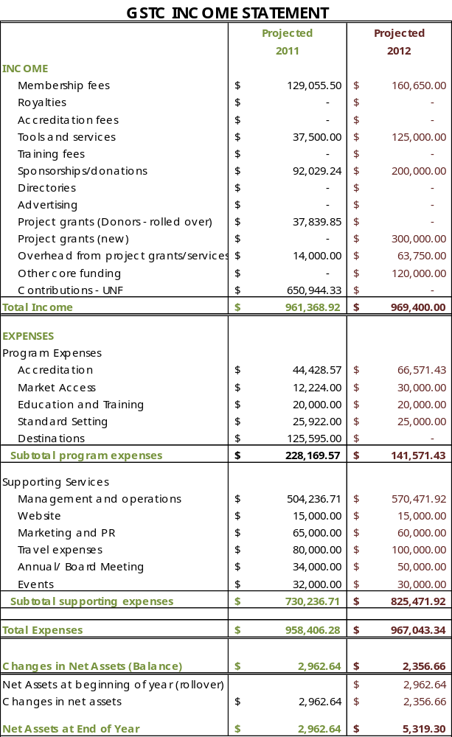
FUNDRAISING
The GSTC seeks to build an organizational model that will ensure self-sustainability in the long run. Building the organization will require financial support in four areas: maintaining the operations; setting up the programs; establishing the accreditation process; and, supporting members and constituencies to achieve sustainability.

- Setting up and maintaining the organization:
The operation costs of GSTC are estimated at $ 3 million for the first 3 years. In year 3 GSTC is expected to cover more than 50% of the operations with revenue generating sources.
Operation costs are forecasted to be covered by support from the UN Foundation, membership fees and donations. The UN Foundation has agreed to support the operations of the GSTC for 2 years. This translates into a contribution of over $ 1 million for 2 years. Other contributions have come from UNEP ($100,000) and other private donors.
- Setting up the programs
The GSTC will implement its objectives through four program areas. These areas, in particular education and market access, have attracted the interest of multi-nationals, foundations, and businesses. GSTC was able to attract targeted funding from Expedia, Travelocity and Tauck. Some of those resources are still available to continue agreed upon programs in education and market access. The Inter-American Development Bank (IDB) has been the main supporter of the accreditation program. Programmatic priorities can also attract foundations and private sector.
- Supporting members and constituencies to achieve sustainability
To accomplish the mission and objectives, the GSTC will need to demonstrate its ability to support its members and key constituencies. Financial support may be needed to develop programs for achieving conservation and poverty alleviation, working with small or community based enterprises, and, promoting sustainability and accreditation. Donors have highlighted these areas as the most appealing to fund. Bi-laterals, multi-laterals, governments, foundations and individuals would be the primary funders.

The fundraising strategy will be implemented through the following steps:
  - Identify a portfolio of prospective donors at a global level, including multilateral agencies, bilateral agencies, government agencies, foundations, corporations and individuals.
  - Research their particular funding areas, requirements, and processes.
  - Clearly define the value proposition of the GSTC and the value to the particular donors.
  - Define a donor policy to recognize the type of donor GSTC can accept and establish the due diligence process. This will be outlined in the Operational Manual.
  - Prepare the necessary documents to solicit possible donors, including one pagers, concept papers, letters or proposals.
  - Cultivate and solicit selected donors:
    - Solicitation will be initiated by the direct contact if available; otherwise, a letter will be sent signed by the Chair.
    - If an in-person meeting is secured, either the Executive Director or the Board member closest to the prospect would take the meeting.
    - The Secretariat will conduct the follow up.
    - If a proposal is required, the Secretariat will develop the proposal.
Donor management and recognition:
GSTC has to establish clear guidelines for receipt of donor funds, overheads, reporting, and donor recognition. This will be detailed in the Operational Manual.

APPENDIX
Table 1: Global GDP Growth (Percent; quarter-over-quarter, annualized)
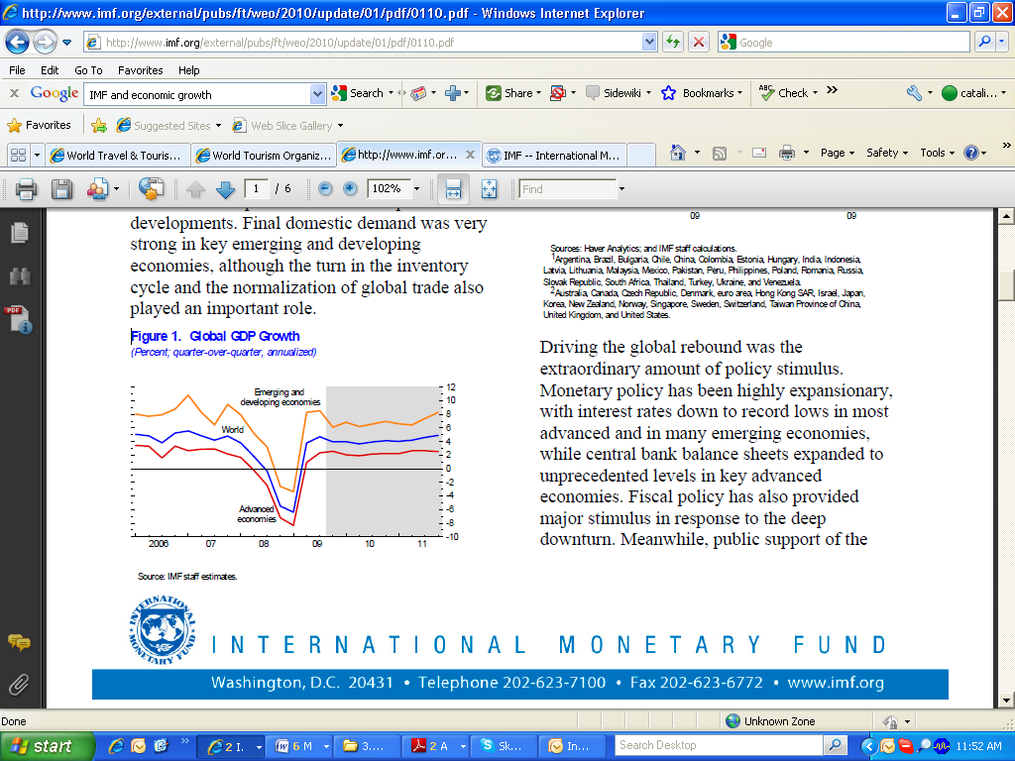
Source: IMF staff estimates in World Economic Outlook (WEO) Update, 2010

Table 2: International Tourism Forecasted Growth in 2010
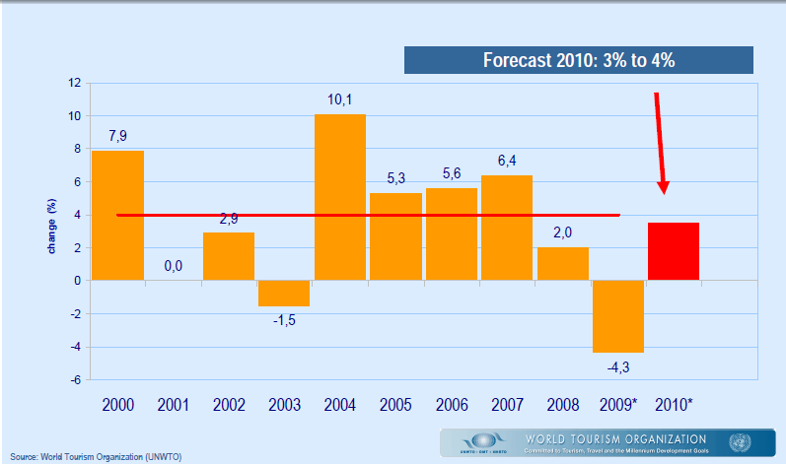
Source: UNWTO, 2010

Table 3: International Tourism 2009 – full year forecast
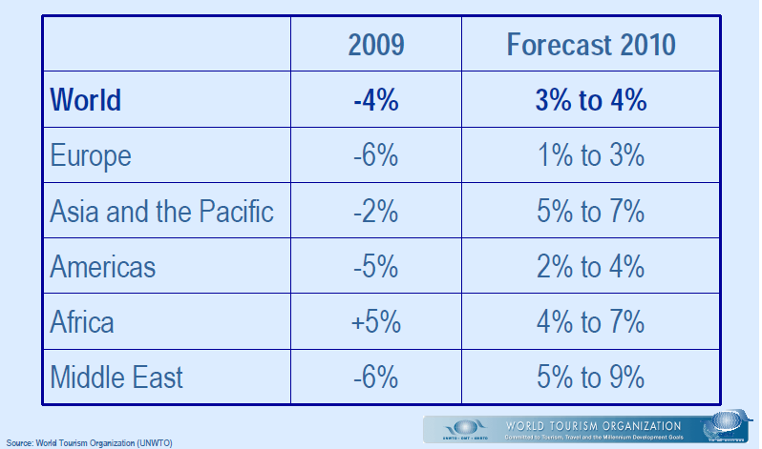
Source: UNWTO, 2010

Graph 1: UNWTO Travel Forecast 2020
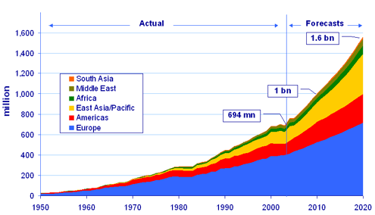
Source: UNWTO, 2010

Table 4: Internet Users in the World by Geographic Regions
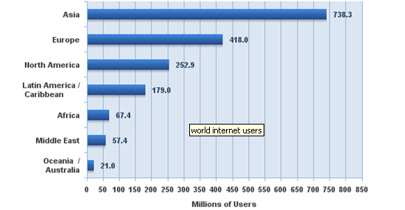
Source: Internet World Stats, 2009

