

Request for Proposal

Host Destination Sponsor of the

4th Annual

GSTC Membership Council Meeting

& Open Forum 2013

*(Revised June 4, 2012)*

Contact:

Liza Agudelo

Senior Program Manager

[lagudelo@unfoundation.org](mailto:eharms@unfoundation.org)

Phone: +1 202 887 9040

**Leading Sustainable Travel and Tourism**

The Global Sustainable Tourism Council and its members are leading the efforts in sustainability, bringing together expert and leaders; the GSTC Annual Meeting represents the epicenter of professionals who are driving this momentum.

We are seeking Host Destinations that are committed to the topic and can host some of the most forward thinking people and companies from around the globe on the issue of sustainable tourism, helping disseminate our common vision as well as introducing and reinforcing the destination’s commitment and success in the field of sustainable tourism.

Please take a moment to read through the GSTC Annual Meeting & Open Forum RFP and become a part of the movement.

**About the GSTC Annual Meeting & Open Forum (AM/OF)**

The GSTC AM/OF is a gathering of sustainable travel and tourism professionals and GSTC members dedicated to mainstreaming sustainable tourism globally. The AM/OF provides both members and non-members the opportunity to learn about priority areas of the GSTC as well as advances in areas ranging from sustainable destinations, consumer trends to technology. Members are informed about the work the GSTC has accomplished over the past year, learn about future developments and have the opportunity to provide input to help shape the direction of the organization.

**The GSTC Annual Meeting offers an opportunity for:**

*Knowledge Exchange*

Through inspiring speakers and training courses, the GSTC provides an opportunity to get updated information and trends in the sustainability and tourism arena and provides a forum for discussion and exchange.

*Driving Change*

Leaders in the field convene to be active participants in shaping and driving the sustainability agenda.

*Visibility*

It allows companies, destinations, governments and experts to showcase their contributions to sustainable people to a global audience and media.

*Networking*

The Annual Event and Open Forum bring together membership and other sustainable tourism leaders to discuss trends, business opportunities, exchange experiences and build partnerships.

**Opportunities for the Host Destination**

The Global Sustainable Tourism Council attracts sustainability leaders from around the globe, and thus offers a great opportunity for the host destination not only to showcase its sustainability practices, but also to engage and educate audiences and present sustainable businesses to a global audience.

GSTC members range from UN agencies, distribution companies, tour operators, travel agents, academia and businesses that will learn about the destination and open opportunities to promote or invest in it.

*Specific Host Destination Benefits:*

In addition to the exposure to sustainability leaders, the GSTC offers special recognition for the sponsorship of the Host Destination including:

* Prime recognition as the Destination Host on all marketing communications prior to, during and post event. This includes ample exposure through press releases, blogs, and social media; recognition in GSTC annual report and relevant presentations
* Recognition in the GSTC home page as well as in the annual event website from the day the location is announced and through the completion of the event,
* One year GSTC membership including opportunity to attend GSTC Member Meeting
* Recognition in 3 editions of the GSTC Newsletter, at least two articles – announcement and event coverage – and 3 logo placements
* Opportunity to submit an article for a special edition, event-specific of the GSTC Newsletter
* Opportunity to host a complimentary event, invite key stakeholders and present to the attending audience
* Speaking opportunity at the Open Forum
* Guest invitations to Open Forum and Gala Dinner
* Invitation to dine with the Board for up to 3 people
* Opportunity to co-design the Open Forum Agenda with suggested guest speakers
* Inclusion in all social media posts regarding the event (Facebook, Twitter, LinkedIn)
* Opportunity to provide 2 guest blog posts for the GSTC blog
* 10 passes to training courses

**Audience**

The GSTC AM/OF attracts a diverse travel industry audience from around the globe. Many are fully committed to sustainable tourism while others are exploring what sustainable travel and tourism could mean to their organization. At the time of this RFP, the GSTC had 221 members (see breakdown by category and region below), which represents a 70% growth rate over a 9-month period. We are targeting a 50% growth rate for 2013 resulting in approximately 330 members by June 2013.

In addition to members, the GSTC AM/OF attracts a non-member audience interested in learning more about sustainable travel and tourism as well as the organization. The 2011 Annual Meeting showed that for every member who attended the meeting in Barcelona there were 1.5 non-members. We expect approximately the same tendency in Washington DC 2012.

Therefore, based on past attendance, expectations for the 2013 meeting are ~330 participants. This number will be greatly influenced by the destination selected and state of the global economy.

**GSTC Board of Directors**

Members of the GSTC Board come from a diverse industries and regions representing all aspects of the travel and tourism field.

**Charles Arden-Clarke** – United Nations Environmental Program; Paris, France

**Dr. Kelly Bricker** – University of Utah; Salt Lake City, USA

**Luigi Cabrini** – United Nations World Tourism Organization; Madrid, Spain

**Richard Edwards** – Green Spot Travel; Toronto, Canada

**Herbert Hamele** – ECOTRANS; Saarbrücken, Germany

**Hervé Houdré** – InterContinental New York/Barclay; New York, USA

**Leilani Latimer** – Sabre Holdings; San Francisco, USA

**Clara Torres** – Mexico Tourism Board; New York, USA

**Rick Parnell** – United Nations Foundation; Washington DC, USA

**Fabian Roman** – Fundacion Plan 21; Buenos Aires, Argentina

**Ronald Sanabria** – Rainforest Alliance; San Jose, Costa Rica

**Dr. Anna Spenceley** – STAND; Johannesburg, South Africa

**Shannon Stowell** – Adventure Travel Trade Associations (ATTA); Seattle, USA

**Jiwei Xu** – Mt. Huangshan Scenic Area; Huangshan, China

**Jamie Sweeting** – Royal Caribbean Cruise Lines; Miami, Florida

**Jane Ashton** – TUI Travel; London, UK

**Judy Kepher-Gona** – Basecamp Foundation; Nairobi, Kenya

**Steve Noakes** – University of Queensland; Gold Coast, Australia

**Santiago Soler** – Inter American Development Bank; Washington DC, USA

**Evaluation Criteria**

The GSTC Annual Meeting committee and Secretariat will select the GSTC AM/OF Host Destination Sponsor (“Host Destination Sponsor”). **Proposals will be assessed based on the following criteria and supporting documents:**

*Host Destination Sponsor:*

1. Compelling reason for having the GSTC in the destination – *how does the meeting benefit from the destination? How does the destination benefit from the meeting?*
2. Capacity for the destination to attract local, regional and international delegates.
3. Proximity to airport with frequent international flights, as well as accessibility to other modes of transport.
4. Capacity and preparedness to involve the local community, industry and government.
5. Capacity to promote the meeting to local, state and national media, organizations and industry.
6. Capacity to secure financial contributions and in‐kind support for the meeting,
7. **A security deposit of USD 25,000.00, which will be recognized as a Platinum Sponsor**. If the destination brings in a different platinum sponsor the funds will be reimbursed

*Proposed Meeting Venue:*

1. Green credentials and sustainability practices by the meeting center and accommodations.
2. Meeting venue capacity suitable for the specific needs and requirements of the GSTC.
3. High quality audiovisual technology in each room including projector, monitor, tele-conferencing capabilities and telephone.
4. Accommodation ranging from 4 to 5 stars within easy access of the meeting center.

**Key Expectations for the Host Destination**

*Sustainable City, State or Providence*

The GSTC seeks to work with a city, state or providence that has proved to be a leader in sustainability practices, and a destination that supports sustainable tourism initiatives.

*History of Successful Meeting*

GSTC seeks a prospective host with credible experience and history of successful meetings.

*Opportunities for Off‐site Experiences*

Local tours and field sessions, showcase the destination’s premier sustainable travel activities, are a critical part the meeting.

**Host Destination Sponsor Responsibilities**

In collaboration with GSTC, the Host Destination Sponsor is expected to fulfill the following responsibilities:

* Develop strategies for relevant media outreach and PR efforts
* Develop and manage local sustainability examples
* Market the meeting locally through relevant channels

*Local Engagement*

GSTC looks to the Host Destination Sponsor to coordinate with local stakeholders from different sectors. The Host Destination Sponsor would be responsible for developing local sustainable tourism initiatives, supporting local and regional marketing and outreach, and driving local sponsorship efforts. Active involvement of key destination partners can greatly enhance the quality of the meeting.

*Media Outreach & PR*

The Host Destination Sponsor is expected to provide assistance in media outreach and PR efforts for the meeting:

* Utilizing existing media contacts to identify leading travel media experts to participate in media‐related panels during the meeting
* Offering a media familiarization trip to journalists and editors attending to the meeting
* Securing relevant media sponsor and partner support
* Live streaming, podcasting, Facebook support

*Welcoming reception or dinner*

The Host Destination Sponsor will host a dinner or reception in which they will present their destination, introduce their initiatives and allow an interaction between GSTC members and key personalities they would like to expose to the GSTC and its membership. The venue for such an event would be a place of cultural relevance or environmental importance.

*Attendance of Tourism Authorities*

The Host Destination Sponsor is expected to secure participation from the maximum tourism authorities to address the Open Forum or participate at any of the other events.

*Sponsorship Guarantee*

The Host Destination Sponsor is expected to provide counterpart funding of USD 25,000.00 before the destination can be publicly recognized as the meeting venue. This is a security deposit that will represent the destination’s commitment to the event**. This contribution will need to be paid before August 24, 2012** and will award the destination with Platinum category sponsorship recognition. The Destination will be publicly announced at the 2012 Annual Event.

**Requirements for Proposed Meeting Venue**

*Sustainable Venue*

The GSTC AM/OF is to be hosted in a sustainable venue. The venue should provide proof of sustainability preferably through certification, verification or policies. The venue should also be willing to provide a back of the house sustainability tour to interested meeting attendees.

*Meeting Space Capacity*

The prospective meeting venue must have plenary rooms that can accommodate up to 330 people (theater style), and workshop facilities sufficient for 2‐3 concurrent break‐outs with a capacity for an average of 30 people each (classroom or theater style).

*Local & Organic Food*

The prospective venue should also provide or accommodate professional catering services. In line with supporting local businesses and sustainable practices, ideal caterers should be flexible to include locally produced and organic foods in the menus.

*Concessions*

GSTC requests the following concessions or the equivalent:

* Complimentary meeting room rentals including AV requirements;
* Shipment of meeting‐related packages/boxes received on complimentary basis;
* Complimentary internet access for all meeting attendees;
* 6 complimentary rooms for GSTC staff
* Reduced F&B pricing.

**Proposed Meeting Space Requirements**

|  |  |  |  |  |  |
| --- | --- | --- | --- | --- | --- |
| **Date** | **Start Time** | **End Time** | **Description** | **Setup** | **# of people** |
| Sunday-Friday | 7:00 | 23:30 | Office (24-hr hold) | Office | 5 |
| Monday | 7:00 | 19:00 | GSTC Board Meeting | Meeting Room | 25 |
| Monday | 12:30 | 14:00 | Board Lunch | Rounds of 10 | 25 |
| Monday | 20:00 | 22:00 | Cocktail Reception | Reception | 175 |
| Tuesday | 7:00 | 19:00 | Open Forum | Theater | 330 |
| Tuesday | 7:00 | 19:00 | Speaker ready room | Green Room | 5 |
| Tuesday | 10:30 | 11:45 | AM Coffee Break | Reception | 250 |
| Tuesday | 12:30 | 14:00 | Lunch/Keynote | Rounds of 10 | 250 |
| Tuesday | 15:30 | 16:14 | PM Coffee Break | Reception | 250 |
| Tuesday | 20:00 | 23:00 | Members Dinner | Rounds of 10 | 200 |
| Wednesday | 7:00 | 19:00 | Council Meeting | Existing Room | 200 |
| Wednesday | 7:00 | 19:00 | Speaker ready room | Green Room | 5 |
| Wednesday | 10:30 | 11:45 | AM Coffee Break | Reception | 100 |
| Wednesday | 12:30 | 14:00 | Lunch/Keynote | Rounds of 10 | 100 |
| Wednesday | 14:30 | 3:30 | Breakout 1 | Class Room | 50 |
| Wednesday | 14:30 | 3:30 | Breakout 2 | Class Room | 50 |
| Wednesday | 15:30 | 16:14 | PM Coffee Break | Reception | 100 |
| Wednesday | 4:30 | 17:30 | Breakout 3 | Class Room | 50 |
| Wednesday | 17:45 | 18:30 | Closing Remarks | Existing Room | 100 |
| Thursday | 7:30 | 13:00 | Working Group #1 | Meeting room | 12 |
| Thursday | 7:30 | 13:00 | Working Group #2 | Meeting room | 12 |
| Thursday | 7:30 | 13:00 | Working Group #3 | Meeting room | 12 |
| Thursday | 7:30 | 13:00 | Working Group #4 | Meeting room | 12 |
| Thursday | 7:30 | 13:00 | Working Group #5 | Meeting room | 12 |

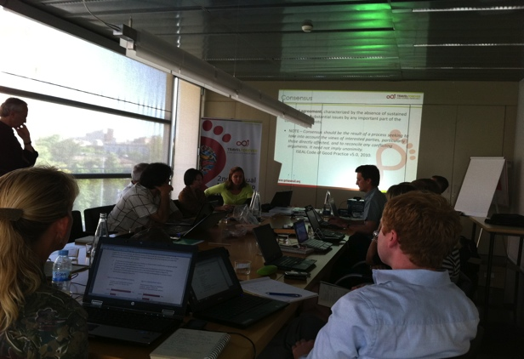 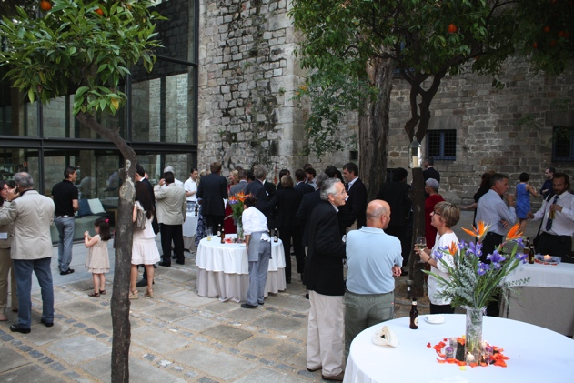

GSTC Board Meeting Welcome Cocktail

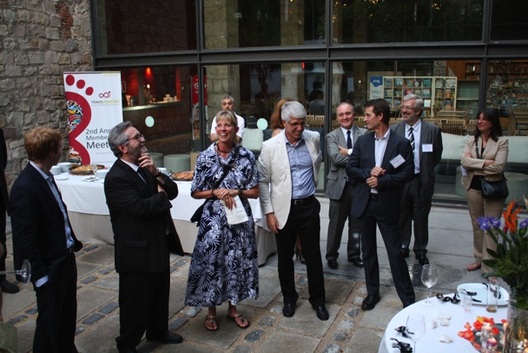 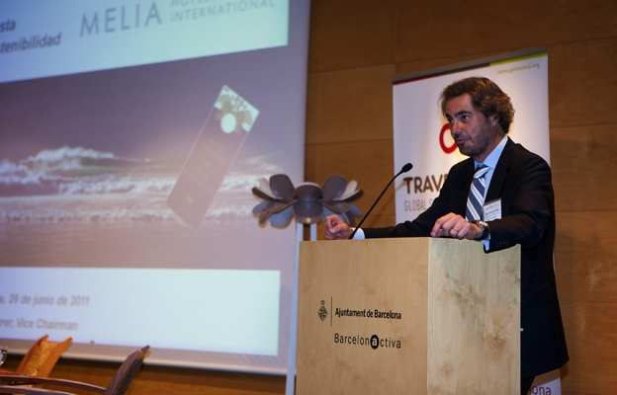

Welcome Cocktail Address Sebastiån Escarrer, Melia

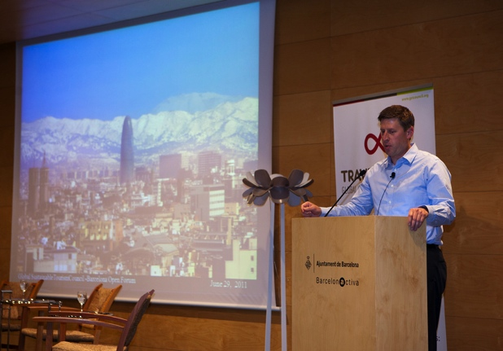 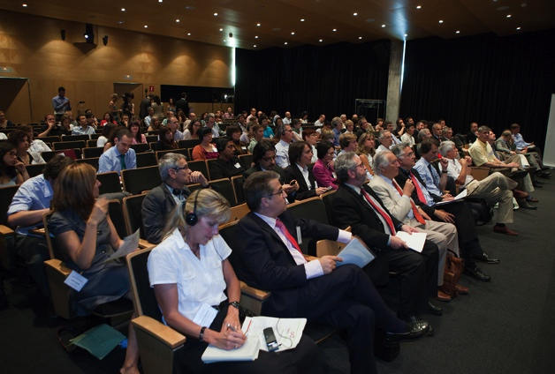

Shannon Stowell, ATTA GSTC Open Forum Audience

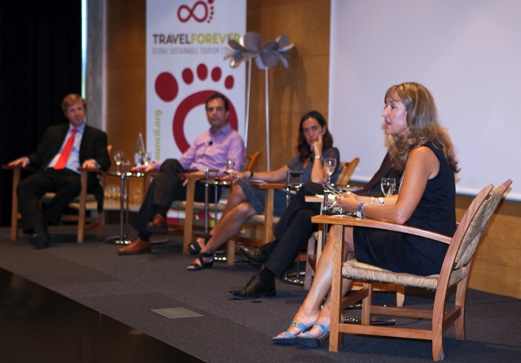 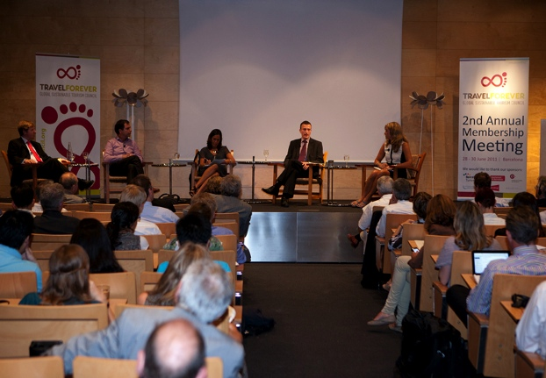

Sustainable Business Panel Discussion Sustainable Business Panel Discussion

**PROPOSAL INFORMATION FORM**

Please complete all fields on this Proposal Information Form and checklist, and submit this form along with a comprehensive proposal in response to the questions outlined in the GSTC AM/OF Host Destination Sponsor RFP Questions and sponsor opportunities (sections I through III, all required).

Please send the proposal, along with all attachments, electronically to: [lagudelo@unfoundation.org](mailto:lagudelo@unfoundation.org). The deadline for submission is **Friday, July 20, 2012**. The GSTC AM/OF 2013 Destination Host will be selected by **August 6, 2012**. All those submitting credible proposals will receive email notification of the selection result. Sponsorship guarantee will need to be deposited by **August 24, 2012**.

|  |  |
| --- | --- |
| **Contact Information for Submitting Host Destination Sponsor** | |
| Name: |  |
| Job Title: |  |
| Organization: |  |
| Website: |  |
| Email: |  |
| Phone: |  |
| City: |  |
| State: |  |
| Country: |  |

|  |  |
| --- | --- |
| **Proposed Meeting Location** | |
| Proposed Meeting Venue Name: |  |
| Website: |  |
| Additional Information on Proposed Meeting Venue: |  |

|  |  |
| --- | --- |
| **What makes your destination a strong candidate to host the GSTC AM/OF?** | |
| Elaborate on the strengths of your destination: |  |

1. **RFP Information Checklist**

**Please check all of the boxes that apply**

|  |  |
| --- | --- |
|  | Our destination is a leader in sustainability practices (e.g. environmental management, cultural impact, community programs) |
|  | Explain: |
|  | Our destination has credible experience and history hosting successful meetings |
|  | Please cite examples of last 3 years: |
|  | We can host a local tour and/or field session to showcase our destinations premiere sustainable tourism activities |
|  | Identify at least 3 sites of natural and cultural importance: |
|  | We can coordinate and manage local, regional and national media outreach |
|  | Explain how: |
|  | We can market the meeting locally through relevant channels |
|  | Please indicate which: |
|  | Our venue is located conveniently to an international airport |
|  | Indicate flights, estimated airline costs from main airports like Madrid, Frankfurt, Paris, LA, NY, Tokyo, or any relevant cities based on your location: |
|  | Indicate time from venue to airport and transportation available |
|  | We can provide **free** transportation from and to the venue if not easily available |
|  | Our venue is located conveniently to several 4 to 5 star hotels |
|  | List which and if you already have a collaboration. Certified hotels are preferred: |
|  | We will drive local sponsorship efforts for the GSTC Annual Meeting |
|  | Please list possible candidates: |
|  | Our meeting venue is sustainable |
|  | Explain: |
|  | Our meeting venue is certified |
|  | Explain: |
|  | Our meeting venue has sustainable policy or program |
|  | Explain: |
|  | Our meeting venue is willing to commit to GSTC alignment prior to the event |
|  | Explain: |
|  | Our venue can/will provide back of house tours for GSTC members |
|  | Explain: |
|  | Our venue meets the space requirements outlined in the RFP |
|  | * Meeting rooms and required capacities |
|  | * Microphones |
|  | * Video/telephone conferencing capabilities |
|  | * Internet access (broadband) |
|  | * Translation services |
|  | Catering and food service will be sources from local and organic sources as available |
|  | Destination/venue will provide the following concessions or the equivalent: |
|  | * Complimentary meeting rooms and rentals including AV requirements |
|  | * Complimentary rooms for up to 6 GSTC staff |
|  | * Discounted rooms for participants |
|  | * Shipment of meeting‐related packages/boxes received on complimentary basis |
|  | * Complimentary internet access for all meeting attendees |
|  | * Reduced F&B pricing |
|  | Venue for cocktail and dinner is of cultural relevance or environmental importance (ex, WH site, park, historic monument, community market, etc. |
|  | Explain: |

1. **GSTC Host Destination Sponsor RFP Questions**

In your proposal, please address the entire set of questions below. Use additional pages as necessary

*Host City Profile*

**Q:** What are some of the proposed host destination’s key appeals to prospective meeting participants?, Please include ideas for potential pre‐ and post‐meeting local tours and field trips that would highlight the destination and local community’s commitment to sustainability.

**A:**

*Meeting Venue*

**Q:** What makes the proposed meeting venue an attractive choice for the GSTC membership? How will this venue fulfill the meeting’s capacity and program requirements (microphones, video/telephone conferencing capabilities Internet access (broadband), translation services)? Please provide additional information on the venues’ sustainability practices and credentials.

**A:**

*Meeting Activities*

**Q:** What innovative opportunities would your destination offer for the meeting? Please outline your ideas on possible activities – such as evening receptions, networking functions, local tours and community events – that would raise the profile of the meeting and improve attendee experience.

**A:**

*Past Meetings*

**Q:** Please provide up to three examples of meetings and events hosted by your organization in the past two years. Which industries and sectors were represented? How many attendees? What sustainable practices were implemented? Did these events receive significant media coverage?

**A:**

*Financial Contribution*

**Q:** Please describe potential local and/or regional sponsors and partners that you expect would participate in and provide support for the meeting in your destination. Please be as specific as possible when outlining local sponsorship leads (please identify potential sponsorship opportunities in the Sponsorship section below).

**A:**

*Promotion of the Meeting*

**Q:** Please outline your plan for the promotion of the GSTC AM/OF 2013, particularly in the local region, including potential media partners. What marketing tools would you employ to ensure maximum exposure? How would you utilize your organization’s social media platforms and connections?

**A:**

*Local Logistics & Transportation*

**Q:** Please provide a detailed description of the local logistics involved in hosting the meeting. Please be specific about distances, to and from the nearest airport(s), transportation options available in the area, and any details of lodging facilities and the meeting venue that GSTC organizers should be aware of.

**A:**

*Lodging Options*

**Q:** Please list suggested lodging options for meeting participants.

**A:**

*Food*

**Q:** Please outline projected food costs and potential F&B supplier(s) and/or in‐kind sponsor(s).

**A:**

1. **Annual Event Sponsorship Levels**

Please identify potential levels of sponsorship available in your destination:

|  |  |
| --- | --- |
|  | **PLATINUM SPONSOR: USD $25,000.00 and above**   * Priority placement of logo on website, newsletter, banners, material, presentations * Acknowledgement at open forum, members meeting and dinner * Speaking opportunity/introduction at the opening ceremony * Mention in press release and social media * Four (4) complementary registrations * Gala Dinner table for10 guests * Possibility to speak in panel of choice if expert in the subject matter * Video of the company (3 min) played during the Open Forum * Booth space * Sponsor recognition for any staff attending on badge or placard |
|  | Potential sponsors: |
|  | **GOLD SPONSOR: USD 15,000.00 and above**   * Secondary placement of logo on website, newsletter, banners, material, presentations * Acknowledgement at open forum, members meeting and dinner * Social media inclusion * Two (2) complementary registrations * Gala Dinner table for 10 guests * Booth space * Sponsor recognition for any attending staff on badge or placard |
|  | Potential sponsors: |
|  | **SILVER SPONSOR: USD 10,000.00 and above**   * Tertiary logo inclusion on website, newsletter, banners, presentations and other materials * Acknowledgement at open forum, members meeting and dinner * Social media inclusion * One (1) complementary registration * Four (4) Gala Dinner invitations * Opportunity to distribute promotional material * Sponsor recognition for any attending staff on badge or placard |
|  | Potential sponsors: |
|  | **Gala Dinner: USD 15,000.00**  This opportunity allows your organization to design the theme of and entertainment for the Gala Dinner and provides an attentive audience for remarks by an executive from your organization.  Benefits of sponsorship include:   * Logo on all conference material * One (1) reserved table (10 seats) * Four (4) complimentary event registrations * Speaking time (12 minutes) during dinner * Speaker’s bio and photo in the meeting program * Option for sampling at dinner (sponsors is responsible for placement) * Logo inclusion on meeting signage and event page on website Mention in press release |
|  | Potential sponsors: |
|  | **Lunch: USD 9,000.00**  Put your executive in front of a captive audience. This is an excellent venue for you to share your organization’s views and perspectives on the future direction of the industry, announce new initiatives, etc.  Benefits of sponsorship include:   * Logo on all conference material * One (1) reserved table for sponsor and registered guests * Two (2) complimentary event registrations * Speaking time (12 minutes) during lunch * Speakers bio and photo in the meeting program * Option for sampling at lunch (sponsors is responsible for placement) * Logo inclusion on meeting signage and event page on website |
|  | Potential sponsors: |
|  | **Networking Cocktail Reception: USD 8,000.00**  The reception will be held on the first evening for all attendees. Sponsor can distribute a brochure or giveaway and will have three minutes podium time. Sponsor’s logo will be displayed on event signage in the public areas of the conference facility. Logo inclusion on event page on website and with other sponsors at event. |
|  | Potential sponsors: |
|  | **Local Tour: USD 5,000.00**  The local tour, organized by the host destination, provides a view into the practical nature of sustainable tourism. Meeting attendees are treated to a guided tour of sustainability in action in the host destination.  Benefits of sponsorship include:   * Logo recognition on GSTC website * Logo recognition on tour description page * Logo recognition with other sponsors at event * Welcoming remarks by the Executive Director * Five (5) invitations for the tour |
|  | Potential sponsors: |
|  | **Breakfast: USD 5,000.00**  Put your executive in front of a captive audience. This is an excellent venue for you to share your organization’s views and perspectives on the future direction of the industry, announce new initiatives, etc.  Benefits of sponsorship include:   * Logo on all conference material * One (1) reserved table for sponsor and registered guests * Two (2) complimentary event registrations * Speaking time (12 minutes) during breakfast * Speaker’s bio and photo in the meeting program * Option for sampling at breakfast (sponsors is responsible for placement) * Logo inclusion on meeting signage and event page on website |
|  | Potential sponsors: |
|  | **Internet Café/WiFi/Business Center: USD 5,000.00**  ***Exclusive Sponsorship***  We are surrounded by technology and we can no longer do our jobs without being “connected.” Help meeting attendees keep connected by sponsoring the Internet Café/Business Center including free WiFi for meeting attendees.  Benefits of sponsorship include:   * Premium location in meeting foyer * Desks or high tables for easy work set up * Hi-speed, wireless internet will be available in the Internet Café * Sponsor’s own pull-up banners will be positioned at the kiosk location * Sponsor is invited to provide décor to make this area unique and engaging for delegates to visit * Logo inclusion in all printed conference collateral material, event signage * One (1) complimentary full-conference staff registration |
|  | Potential sponsors: |
|  | **Registration Service: USD 3,500.00**  Provide all registration services and be recognized by logo/link on registration page and registration signage. Sponsor receives logo placement on front cover as well as inside front and outside back cover of meeting program for full-page advertisement. Includes the registration list, which gives the contact information of all pre-registered attendees, a great resource for reaching attendees after the conference. |
|  | Potential sponsors: |
|  | **Badge Lanyard/Holder: USD 3,000.00 (exclusivity)**  Usually a heavy yarn or other woven fabric, badge lanyards put your organization’s logo eye level for the duration of the meeting. Sponsor is responsible for production cost of the lanyards. |
|  | Potential sponsors: |
|  | **Coffee Breaks (4 total): USD 2,500.00**  Coffee breaks will be held twice a day (1x morning / 1x afternoon) and give attendees a chance to network. Coffee breaks will last 20-30 minutes.  Benefits of sponsorship include:   * One (1) complimentary registration * Logo prominently featured on coffee break signage * Logo inclusion on event page on website and with other sponsors at event |
|  | Potential sponsors: |
|  | **Registration Bag: USD 2,500.00**  One of the most highly visible sponsorships, the registration bag is given to all attendees upon their arrival at the annual meeting. Sponsor receives one side of the bag for logo or advertisement (GSTC logo is on the reverse side). |
|  | Potential sponsors: |
|  | **Meeting Program/Flash Drive: USD $2,000.00**  Included in all registration bags, the meeting Program includes logistical and seminar information. Sponsor is given inside front and outside back cover for an ad, plus logo placement on the front cover. |
|  | Potential sponsors: |
|  | **Education Seminars: USD 2,000.00 per session**  **Exclusive Education Sponsorship: USD 12,000.00**  The GSTC Annual Meeting and Open Forum is designed to be an educational experience for our members. We therefore provide education seminars on topics that cover the spectrum of sustainable tourism. Each day three to four education seminars will be held.  Benefits of sponsorship include:   * Logo on all conference material * One (1) complimentary event registration * Opportunity to introduce each education session (four minutes) * Logo on opening slide at education session * Option to place a brochure or giveaway on education session attendee chairs (sponsor is responsible for placement) * Logo on meeting signage and GSTC website * Opportunity to provide trainer for content for session |
|  | Potential sponsors: |
|  | **Sponsor a delegate: USD 2,000.00**  There are amazing people working in sustainability, implementing practices, opening businesses that could benefit from the annual meeting but do not have the resources to attend. You can sponsor such a delegate.  Benefits of sponsorship include:   * Logo recognition on GSTC website * Picture and story of the delegate and sponsor on newsletter and web * Logo recognition with other sponsors at event |
|  | Potential sponsors: |
|  | **Exhibit booth: USD 1,500.00**  The exhibit space will be open both days of the conference. Dedicated visitation hours will allow today’s top travel suppliers the ability to showcase their current and future market offers.  Benefits of sponsorship include:   * 10 x 10 exhibit space * Skirted table and 2 chairs * Signage * Listing in exhibitor review * Listing on GSTC website w/ link to exhibitor website |
|  | Potential sponsors: |
|  | **Registration Bag Insert: USD 1,250.00 (no exclusivity)**  Insert an item, digital brochure or giveaway, into the official meeting registration bag. Sustainable and waste-free items are recommended such as edibles, chocolate, beach balls, cookbooks, and CD’s. |
|  | Potential sponsors: |
|  | **Gala Dinner Table: USD 900.00 per table**  Take the opportunity to showcase your organization to current and potential clients or business partners. Host a table at the Gala Dinner.  Benefits of sponsorship include:   * Table top logo signage * Name recognition on Gala Dinner invitation * Ten (10) seats/invitation |
|  | Potential sponsors: |