In order to compute the energy flux convergence/divergence term



in PSOM we need to use the velocity values that satisfy the incompressibility condition. This is so because the energy equation is obtained by multiplying the momentum equations by the velocity vector. Then the term

if

since



To this end I have used the volume fluxes across the cell faces per unit time U (uf), V (vf), and W (wf) as following. For the 2D case of a Gulf-Stream like front with density distribution

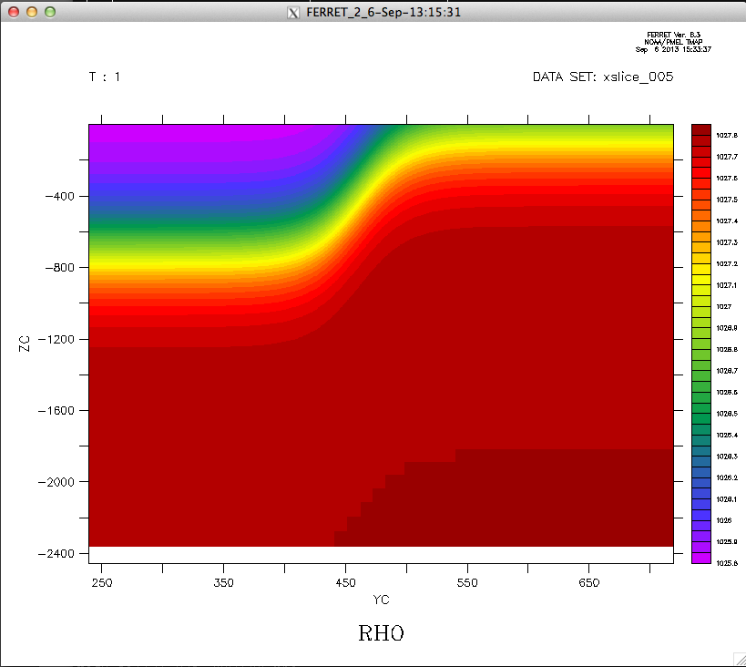

and pressure distribution (units are Pa),

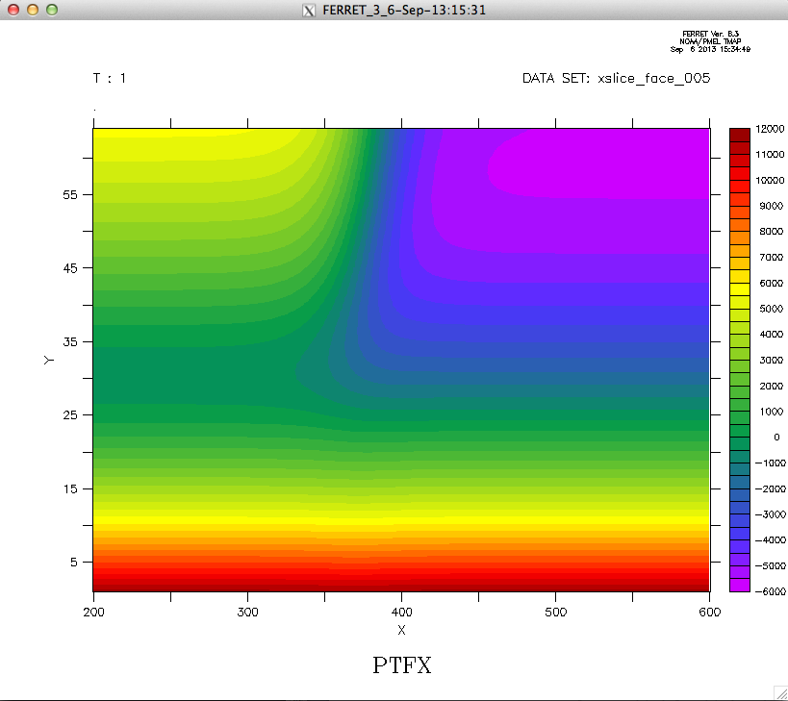



I have computed as

dufpdx= uf(i,j,k)\*ptfx(i,j,k)- uf(i-1,j ,k )\*ptfx(i-1,j ,k )

dvfpdy= vf(i,j,k)\*ptfy(i,j,k)- vf(i ,j-1,k )\*ptfy(i ,j-1,k )

dwfpdz= wf(i,j,k)\*ptfz(i,j,k)-wf(i ,j ,k-1)\*ptfz(i ,j ,k-1)

dum1(i,j,k)=(dufpdx+dvfpdy+dwfpdz)/Jac(i,j,k)/TL

where ptfx, ptfy, and ptfz are pressure values at east, north, and z faces, respectively. The dimensional counterpart of dufpdx has units of

and dividing by the cell volume at cell center (Jac) we obtain



which has units of energy.



The resulting distribution of at time t=2.4h is

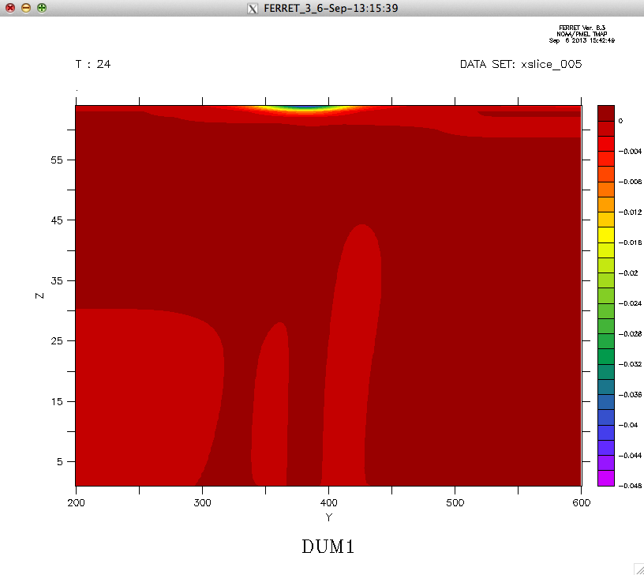

The values range from 0 to -0.048 W/m3. The minimum occurs at the surface where there’s a strong wind forcing and decreases below the Ekman layer. In the paper of Nagai, the vertically integrated energy flux divergence ranges from -0.025 to 0.025 W/m2, which makes me feel confident about the values I am obtaining.

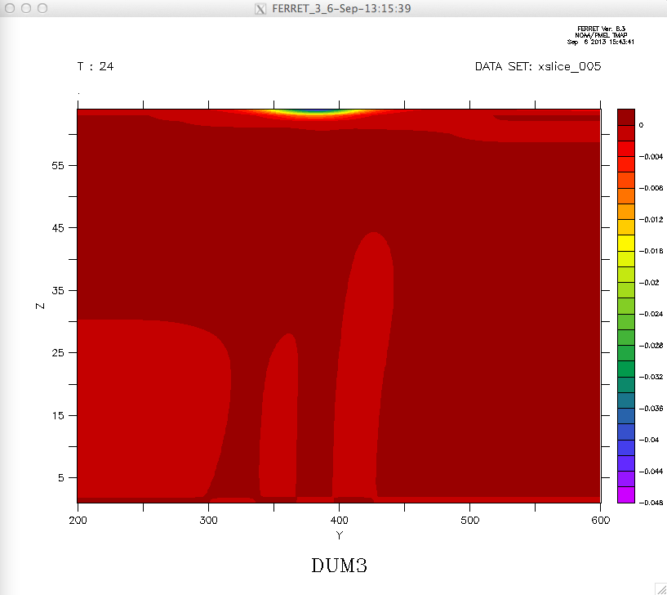This distribution is equivalent to that of computed as

Udpdx =0.5\*(uf(i,j,k)+uf(i-1,j ,k ))\*(ptfx(i,j,k)-ptfx(i-1,j ,k ))

vdpdy =0.5\*(vf(i,j,k) +vf(i ,j-1,k ))\*(ptfy(i,j,k)-ptfy(i ,j-1,k ))

wdpdz=0.5\*(wf(i,j,k)+wf(i ,j ,k-1))\*(ptfz(i,j,k)-ptfz(i ,j ,k-1))

dum3(i,j,k)=(udpdx+vdpdy+wdpdz)/Jac(i,j,k)/TL

Distribution at time t=2.4h:

,

Since , which is computed as

dufdx= (uf(i,j,k)-uf(i-1,j ,k ))

dvfdy= (vf(i,j,k)-vf(i ,j-1,k ))

dwfdz= (wf(i,j,k)-wf(i ,j ,k-1))

dum2(i,j,k)=(dufdx+dvfdy+dwfdz)/Jac(i,j,k)/TL

Distribution at time t=2.4h:

