Exercise-01:

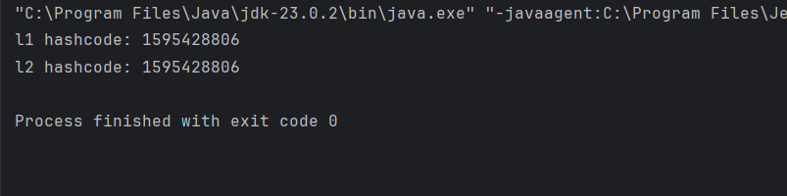

Exercise-02:

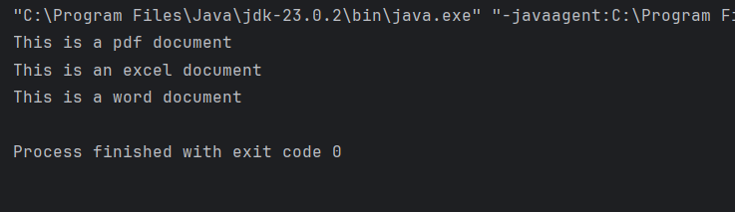

Exercise-03:

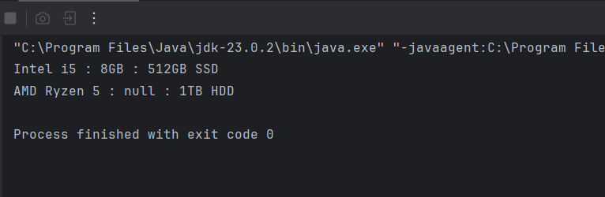

Exercise-04:

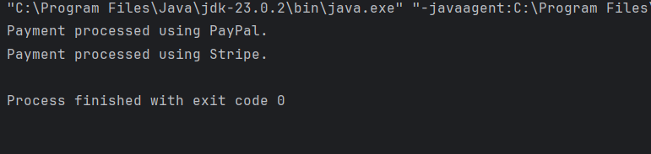

Exercise-05:

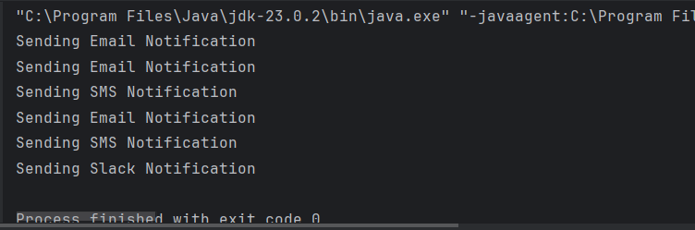

Exercise-06:

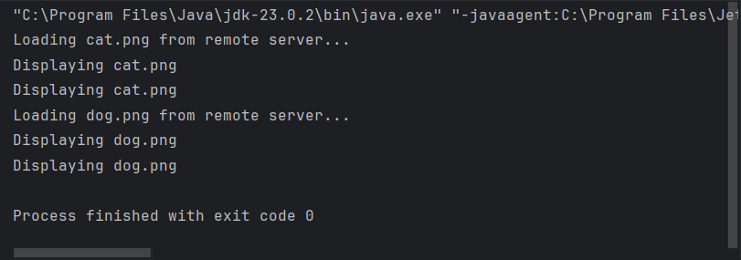

Exercise-07:

