Public Services and Procurement Canada

Indy Agent and Service Wrapper Protocol
Detailed Design Document
author: Stephen Klump
date: 2017-11
version: 0.43

Table of Contents
1 Introduction 3
2 Interactions 5
2.1 Bootstrap Operations 5
2.2 Claim Load, Claim Request, and Claims Reset Operations 6
2.3 Proof Operations 7
2.4 Helper Operations 8
3 Input Forms and Responses 9
3.1 Bootstrap Messages 9
3.2 Claim Load, Claim Request, and Claims Reset Messages 14
3.3 Proof Messages 18
3.4 Error Responses 21
4 Protocol Composition 22
4.1 Bootstrap Protocol Exchanges 22
4.2 Claim Load, Claim Request, and Claims Reset Protocol Exchanges 30
4.3 Proof and Verification Request Protocol Exchanges 34
4.4 SRI Completion Sequence 36
5 Detailed Design 38
5.1 Django RESTful Service Wrapper 38
5.2 Code 39
6 Installation 45
6.1 Prerequisites 45
6.2 Virtual Environment and pytest 45
6.3 Docker 45
6.4 Start indy Pool Network 45
6.5 Install Demonstration from Repository 46
6.6 Install libindy Shared Library 46
7 Configuration 47
7.1 Common Configuration 47
7.2 Per-agent Configuration 47
8 Operation 48
8.1 The Node Pool 48
8.2 Environment Variables 48
8.3 Test Harnesses 49
8.4 Agent Service Wrapper Processes 50
8.5 Actuation 50
9 Deficiencies 51
9.1 Node Pool 51
9.2 Predicates 51
9.3 Revocation 51
9.4 Multiple schemata 51
9.5 Wallet persistence 51
9.6 Track indy-sdk Updates 51

Introduction
As part of the technology demonstrator project using Hyperledger indy to explore the use of the distributed ledger with PSPC Supplier Registration Information (SRI), the design specifies agents with service wrapper APIs to facilitate interoperability.
This engineering document motivates and details a design specification. Stemming from a proposal for protocol and message formats comprising agent interactions, the text specifies the implementation of their respective missives to the distributed ledger through the indy-sdk. The SRI agent offers a RESTful API to handle communication involving its functionality.
The current state of the project aims to fulfil a demonstration use case enabling collaboration between the SRI and the British Columbia government’s The Org Book project, underpinning its Verified Organization Network (VON) as Illustration 1 depicts.
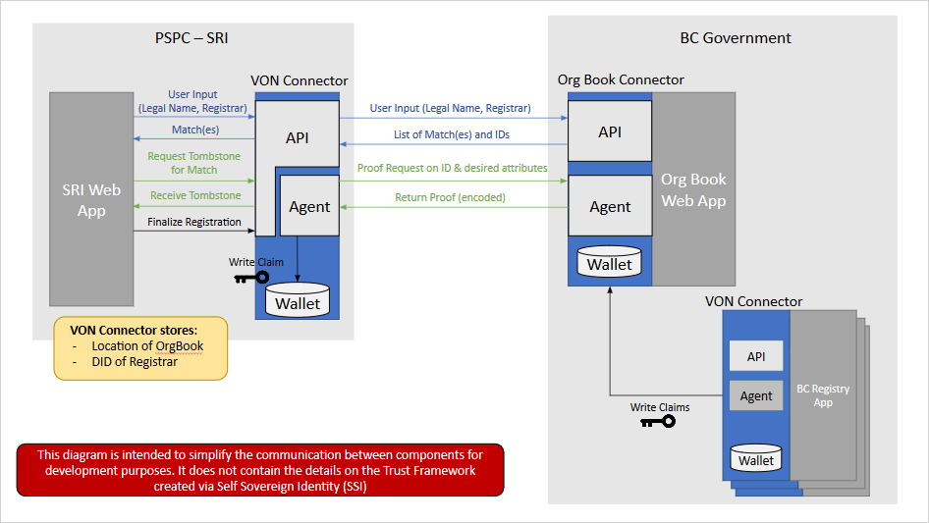Illustration 1: Use Case for Demonstration
The indy-sdk mechanism presents role engineering model for agents specifying issuers, provers, and verifiers. The W3C model, roughly in alignment, uses issuers, holders, and verifiers. For the current target demonstration, the high level design casts:
- the BC Registry as an issuer
- the BC Org Book as, for BC Registry-issued claims, both
  - a W3C claims holder and
  - an indy-sdk prover
- the PSPC-SRI as:
  - a verifier of claims for which the BC Org Book is an indy-sdk prover
  - an issuer, W3C claims holder, and indy-sdk and prover for SRI-issued claims.
In addition to the above roles, the high level design calls for a trust anchor agent to act as:
- the origin, sending schema to the ledger
- the agent registrar, sending agent cryptonyms to the ledger
The SRI agent service wrapper offers bootstrap, claim, and helper operations. In addition, the configuration of the django application realizing the (RESTful API) SRI agent service wrapper also informs the agent, but these details are outside the scope of this document for the present.
The remainder of this work introduces the interactions of the SRI agent service wrapper protocol, presents detailed specifications of the message formats informing them, demonstrates the use of these messages in implementing the agent service wrapper API calls, and discusses the code base processing them.

Interactions
This section introduces the interactions with the SRI agent service wrapper. Of interest are bootstrap operations; claim load, claim request, and claims reset operations; and proof operations.

Bootstrap Operations
This section specifies bootstrap operations that the RESTful API realizing the SRI agent service wrapper offers. The URL path for all bootstrap operations is api/v0/<message-type>, where <message-type> represents the input message type.

Agent Attribution on Distributed Ledger
This section specifies messages regarding the bootstrapping of agent information to and from the distributed ledger.

POST: Look up Agent Cryptonym
To check an agent cryptonym's current representation on the distributed ledger, a client POSTs an agent-nym-lookup message to the API. The JSON response contains the agent's current DID and verification key as written to the distributed ledger.

POST: Send Agent Cryptonym
To prompt the registration of an agent as a trust anchor on the distributed ledger, a client POSTs a agent-nym-send message to the API; the JSON response content is an empty production.

POST: Look up Agent Endpoint
To check an agent endpoint's current representation on the distributed ledger, a client POSTs an agent-endpoint-lookup message to the API. The JSON response contains the agent's current endpoint information as written to the distributed ledger.

POST: Send Agent Endpoint
To prompt the registration of an agent as a trust anchor on the distributed ledger, a client POSTs a agent-endpoint-send message to the API; the JSON response content is an empty production. Note that only an agent can send its own endpoint data to the ledger.

POST: Send Schema
To prompt the issue of a new schema, a client POSTs a schema-send message to the schema originator agent via the service wrapper API; the JSON response content includes the schema.
The high level design does not yet specify the issuer of schema for use within the demonstration; this engineering paper suggests that it be the steward who anchors the agents on the distributed ledger.

POST: Lookup Schema
To have an agent initialize with a schema from the distributed ledger, a client POSTs a schema-lookup message to the API; the JSON response content specifies the schema as it appears on the ledger.
The high level design does not specify the client to perform this bootstrap operation; it could be a configuration item for the django application or it could be a custom application prodding the agent.

POST: Send Claim Definition
To prompt an issuer to create a claim definition on a schema and write it to the ledger, a client POSTs a claim-def-send message to an issuer agent via the service wrapper.

POST: Set Master Secret
To generate a master secret at the agent acting as an indy-sdk prover, the a client POSTs a master-schema-set message to the API; the JSON response content is empty.

Claim Load, Claim Request, and Claims Reset Operations
This section specifies operations prompting the loading (issue, storage), retrieval, and deletion of claims on an SRI agent in the role of a W3C claims holder. The URL path for all bootstrap operations is api/v0/<message-type>, where <message-type> represents the input message type.

Claim Load
The claim loading protocol involves three principal exchanges: claim hello, claim creation, and claim storage.

POST: Claim Hello
An initial hello interaction allows for zero or more a claim issue and storage operations on a given schema and claim definition. Directly or by proxy, the service wrapper API for a W3C claim holder responds to a POSTed claim-hello message with a JSON encoded claim request. The client uses this claim request in further interactions perfecting claim creation and storage.

POST: Claim Create
A client POSTs a claim-create message to the service wrapper API for an agent acting as an indy-sdk issuer. The response is a JSON formatted claim to specify in perfecting claim storage.

POST: Claim Store
The holder (prover) agent, directly or by proxy, accepts a client’s POSTed claim-store message. The JSON response has no content.

Claim Request
The RESTful API realizing the service wrapper for an agent serving as a W3C claims holder responds, directly or by proxy, to a client’s POSTed claim-request message with JSON content encoding a proof request and all matching claims currently in its wallet.

Claims Reset
The claim reset operation serves to throw away the wallet of an agent acting as a claims holder and to start a new one in its stead. This process allows the demonstration to return to base line and continue from there, avoiding duplication of the same claim in the holder's wallet. This operation should be considered a stand-in for proper claim revocation, which is a work in progress for the indy-sdk. As it stands, a single message of this type destroys all claims from all issuers in the wallet – it is a big hammer for demonstration purposes only. If revisiting this functionality, at least it should take a claims filter and/or an issuer of choice against which to perform claim deletion.

Proof Operations
This section specifies the operations involved in creating and verifying proof of claims. The URL path for all bootstrap operations is api/v0/<message-type>, where <message-type> represents the input message type.

Proof Request, by Filter or by Claim UUID
The RESTful API realizing the service wrapper for an indy-sdk agent acting as an indy-sdk prover responds, directly or by proxy, a client’s POSTed proof-request message with JSON content encoding a proof and its corresponding proof request.
Alternatively, the service wrapper for an agent serving as an indy-sdk prover responds, directly or by proxy, to a client’s POSTed proof-request-by-claim-uuid message with JSON content encoding a proof and its corresponding proof request.

Verification Request
The RESTful API realizing the service wrapper for an indy-sdk agent acting as an indy-sdk verifier responds, directly or by proxy, a client’s POSTed verification-request message with JSON content encoding a boolean specifying whether the proof presented verifies.

Helper Operations
The RESTful API realizing the service wrapper for an agent exposes helper calls via GET.

Get Transaction
The API takes to a GET request on path api/v0/txn/<seq-no>, where <seq-no> represents the transaction number in the URL, and uses the agent to find the corresponding transaction on the distributed ledger. It JSON encodes the item in its response. In the event that no transaction corresponds to the input sequence number, the wrapper respond with a JSON empty production ({}).

Get DID
The API takes a GET request on path api/v0/did to respond with the JSON-encoded DID of the underlying agent on the indy network.In the event that the agent still requires configuration with its DID, the wrapper respond with a JSON empty production ({}).

Input Forms and Responses
This section specifies the construction of JSON-encoded form content to specify to, and JSON responses from, the POST methods of the RESTful API realizing the bootstrap operations, claim load and request operations, and proof operations introduced above.
Throughout the remainder of this section,
- items in grey are optional
- json-str represents a delimited JSON string
- json-int represents an undelimited JSON integer
- json-list represents a delimited JSON list
- json-dict represents a delimited JSON dict
- json-bool represents an undelimited JSON boolean
- json-null represents an undelimited JSON null.

Bootstrap Messages
This section specifies JSON form content to POST to bootstrap API calls, and the responses to expect.

Message agent-nym-lookup
Any agent can respond to messages of this type

Input
Messages of this type must take the form:
{
"type": "agent-nym-lookup",
"data": {
"agent-nym": {
"did": json-str
}
}
}
The did component of the agent-nym json-dict specifies the DID of the agent to retrieve from the ledger.

Output
The service wrapper responds with JSON content representing the agent cryptonym:
{
"dest": json-str,
"seqNo": json-int,
"verkey": json-str,
"txnTime": json-int,
...,
"identifier": json-str
}
where the dest content holds the agent DID, verkey content holds its verification key, and identifier content holds the DID of the agent that sent the transaction to the distributed ledger.

Message agent-nym-send
Only the trust anchor may respond to messages of this type

Input
Messages of this type must take the form:
{
"type": "agent-nym-send",
"data": {
"proxy-did": json-str,
"agent-nym": {
"did": json-str,
"verkey": json-str
}
}
}
If proxy-did is specified and distinct from the underlying agent's DID, the agent acts as a proxy. It discovers the endpoint for the agent with the specified DID, posts the request to that agent's service wrapper API, and returns the response. In this way, any agent on the network can act as a single point of entry to further agents it requires to complete chains of transactions comprising a multi-stage protocol operation.
The did and verkey components of the agent-nym json-dict specify the DID and verification key to write to the ledger.

Output
The service wrapper responds with empty JSON content:
{
}

Message agent-endpoint-lookup
Any agent may respond to messages of this type.

Input
Messages of this type must take the form:
{
"type": "agent-endpoint-lookup",
"data": {
"agent-endpoint": {
"did": json-str,
}
}
}
The did component of the agent-endpoint json-dict specifies the DID of the agent to retrieve from the ledger.

Output
The service wrapper responds with JSON content representing the agent endpoint:
{
"host": json-str,
"port": json-int,
}

Message agent-endpoint-send
An agent may only send its own endpoint attribution to the ledger in accepting messages of this type.

Input
Messages of this type must take the form:
{
"type": "agent-endpoint-send",
"data": {
"proxy-did": json-str
}
}
If proxy-did is specified and distinct from the underlying agent's DID, the agent acts as a proxy. It discovers the endpoint for the agent with the specified DID, posts the request to that agent's service wrapper API, and returns the response. In this way, any agent on the network can act as a single point of entry to further agents it requires to complete chains of transactions comprising a multi-stage protocol operation.
The high level design does not specify the client to perform this bootstrap operation; it could be a configuration item for the django application or it could be a custom application prodding the agent.

Output
The service wrapper responds with empty JSON content:
{
}

Message schema-send
A client uses this message type to prompt the origin (the high level design nominates the trust anchor) to send a schema to the ledger, and to install it for use at the receiving agent.

Input
Messages of this type must take the form:
{
"type": "schema-send",
"data": {
"schema": {
"issuer-did": json-str,
"name": json-str,
"version": json-str
},
"attr-names": json-list
}
}

Output
The service wrapper responds with JSON content in the form:
json-dict
with the schema to use in further messaging that requires it.

Message schema-lookup
A client uses this message type to prompt an agent to retrieve schema from the ledger, and to install it for use.

Input
Messages of this type must take the form:
{
"type": "schema-lookup",
"data": {
"schema": {
"issuer-did": json-str,
"name": json-str,
"version": json-str
}
}
}

Output
The service wrapper responds with JSON content in the form:
json-dict
with the schema to use in further messaging that requires it. If such a schema does not exist on the ledger, the service wrapper responds with an empty JSON production.

Message claim-def-send
A client uses this message type to prompt an agent acting as an issuer to create a claim definition, store it in its wallet, and send it to the ledger.

Input
Messages of this type must take the form:
{
"type": "claim-def-send",
"data": {
"schema": {
"issuer-did": json-str,
"name": json-str,
"version": json-str
}
}
}
If schema is specified, it overrides any schema that the responding agent may already have loaded. This rough-in is not well supported at present, since the high level design for the demonstration target calls for one monolithic schema.

Output
The service wrapper responds with empty JSON content:
{
}

Message master-secret-set
A client uses this message type to prompt a prover agent to label a master secret for future use in proofs.

Input
Messages of this type must take the form:
{
"type": "master-secret-set",
"data": {
"label": json-str
}
}

Output
The service wrapper responds with empty JSON content:
{
}

Claim Load, Claim Request, and Claims Reset Messages
This section specifies JSON form content to POST to API calls prompting claim operations.

Message claim-hello
A client uses this message type to prompt an issuer to initiate a claims sequence with an agent acting as a W3C holder (recall that the high level design casts the Org Book agent as both an indy-sdk prover and a W3C holder).

Input
Messages of this type must take the form:
{
"type": "claim-hello",
"data": {
"proxy-did": json-str,
"schema": {
"issuer-did": json-str,
"name": json-str,
"version": json-str
},
"issuer-did": json-str
}
}
If proxy-did is specified and distinct from the underlying agent's DID, the agent acts as a proxy. It discovers the endpoint for the agent with the specified DID, posts the request to that agent's service wrapper API, and returns the response. In this way, any agent on the network can act as a single point of entry to further agents it requires to complete chains of transactions comprising a multi-stage protocol operation.
If schema is specified, it overrides any schema that the responding agent may already have loaded. This rough-in is not well supported at present, since the high level design for the demonstration target calls for one monolithic schema.

Output
The service wrapper responds with JSON content in the form:
json-dict
with the claim request to use in further claim messaging to the holder (prover) agent.

Message claim-create
A client uses this message type to prompt an issuer (agent) to create a claim.

Input
Messages of this type must take the form:
{
"type": "claim-create",
"data": {
"claim-req": json-dict,
"claim-attrs": json-dict
}
}
The content of claim-req comes from the initial claim-hello response.
The json-dict content of claim-attrs comprises the attribute-value pairs representing the content of the claim, json-str to json-str, json-int, json-bool, or json-null. All attribute names must come from the schema as per the attr-list content of the schema-claim-def-send message bootstrapping the active schema onto the indy network. At present, all claims must include all attributes – all attributes are mandatory.

Output
The service wrapper responds with JSON content in the form:
json-dict
with the claim created, for use in further protocol interactions.

Message claim-store
A client uses this message type to prompt a W3C holder (agent) to store a claim. Recall that the high level design casts the Org Book agent as both a W3C holder and an indy-sdk prover.

Input
Messages of this type must take the form:
{
"type": "claim-store",
"data": {
"proxy-did": json-str,
"claim": json-dict
}
}
If proxy-did is specified and distinct from the underlying agent's DID, the agent acts as a proxy. It discovers the endpoint for the agent with the specified DID, posts the request to that agent's service wrapper API, and returns the response.
The content of claim comes from the corresponding claim-create response.

Output
The service wrapper responds with empty JSON content:
{
}

Message claim-request
A client uses this message type to request a claim by filter from an agent acting as a W3C holder (recall that the high level definition casts the Org Book agent as both a W3C holder and an indy-sdk prover).

Input
Messages of this type must take the form:
{
"type": "claim-request",
"data": {
"proxy-did": json-str,
"schema": {
"issuer-did": json-str,
"name": json-str,
"version": json-str
},
"claim-filter": {
"attr-match": json-dict,
"predicate-match": [
{
"attr": json-str,
"p_type": 'GE',
"value": json-int
}, ...
]
}
}
}
If proxy-did is specified and distinct from the underlying agent's DID, the agent acts as a proxy. It discovers the endpoint for the agent with the specified DID, posts the request to that agent's service wrapper API, and returns the response.
If schema is specified, it overrides any schema that the responding agent may already have loaded. This rough-in is not well supported at present, since the high level design for the demonstration target calls for one monolithic schema.
The json-dict content of attr-match comprises the attribute-value pairs, json-str to json-str, representing the attributes of interest and the values to match in selecting claims, matching conjunctively ('and'). All attribute names must come from the schema as per the attr-list content of the schema-send message bootstrapping the active schema onto the indy network. An empty json-dict instructs the operation to retrieve all claims in the W3C claims holder's wallet.
The json-list content of predicate-match specifies zero or more json-dict elements, each specifying a predicate to match. The responding agent applies these predicates conjunctively ('and') to its filter to retain only claims of interest. An empty json-list instructs the operation not to apply predicates in its filter criteria. Note that at present, the code base does not support predicates well: specify an empty list for the target demonstration.

Output
The service wrapper responds with JSON content in the form:
{
"proof-req": json-dict,
"claims": [
json-dict,
json-dict,
...
json-dict
]
}
with the proof-req value holding the proof request to use in subsequent messages and values, and the claims lists all claims matching the input criteria. In case there are several claims, the claims_for() and prune_claims_json() utilities in util.py, within the agent code base, can help triage them to isolate the claim of interest; the actuator can then specify its claim-uuid in a POSTing proof-request-by-claim-uuid message type to an agent acting as an indy-sdk prover.

Message claims-reset
A client uses this message type to prompt a W3C holder (agent) to reset its wallet, which eliminates all claims from all issuers. Recall that the high level design casts the Org Book agent as both a W3C holder and an indy-sdk prover. Recall also that this message type is for demonstration purposes only, as a stand-in for a finer control and/or revocation support.

Input
Messages of this type must take the form:
{
"type": "claims-reset",
"data": {
}
}

Output
The service wrapper responds with empty JSON content:
{
}

Proof Messages
This section specifies JSON form content to POST to API calls prompting proof operations.

Proof Request Messages
There are two ways to request proof: by claim-filter and by claim-uuid.

Message proof-request
An agent uses this message type to request proof from an agent given a filter known to resolve to a single claim in the holder/prover's wallet.

Input
Messages of this type must take the form:
{
"type": "proof-request",
"data": {
"proxy-did": json-str,
"schema": {
"issuer-did": json-str,
"name": json-str,
"version": json-str
},
"claim-filter": {
"attr-match": json-dict,
"predicate-match": [
{
"attr": json-str,
"p_type": 'GE',
"value": json-int
}, ...
]
}
}
}
If proxy-did is specified and distinct from the underlying agent's DID, the agent acts as a proxy. It discovers the endpoint for the agent with the specified DID, posts the request to that agent's service wrapper API, and returns the response.
If schema is specified, it overrides any schema that the responding agent may already have loaded. This rough-in is not well supported at present, since the high level design for the demonstration target calls for one monolithic schema.
The json-dict content of attr-match comprises the attribute-value pairs, json-str to json-str, representing the attributes of interest and the values to match in selecting claims. All attribute names must come from the schema as per the attr-list content of the schema-claim-def-send message bootstrapping the active schema onto the indy network. An empty json-dict instructs the operation to retrieve all claims in the W3C claims holder's wallet.
The json-list content of predicate-match specifies zero or more json-dict elements, each specifying a predicate to match. The responding agent applies these predicates conjunctively ('and') to its filter to retain only claims of interest. An empty json-list instructs the operation not to apply predicates in its filter criteria. Note that at present, the code base does not support predicates well: specify an empty list for the target demonstration.

Output
The service wrapper responds with JSON content in the form:
{
"proof-req": json-dict,
"proof": json-dict
}
with the proof-req value holding the proof request to use in subsequent messages and values, and the proof content houses its corresponding proof.

Message proof-request-by-claim-uuid
An agent uses this message type to request proof from an agent given a claim-uuid corresponding to a claim in the holder/prover's wallet. The actuator can identify the claim-uuid in selecting the correct claim from a potential multiplicity that the holder agent (service wrapper API) returned as a response to a claim-request; the claims_for() utility in wrapper_api/agent/util.py can make the triage available for presentation.

Input
Messages of this type must take the form:
{
"type": "proof-request-by-claim-uuid",
"data": {
"proxy-did": json-str,
"schema": {
"issuer-did": json-str,
"name": json-str,
"version": json-str
},
"claim-uuid": json-str
}
}
If proxy-did is specified and distinct from the underlying agent's DID, the agent acts as a proxy. It discovers the endpoint for the agent with the specified DID, posts the request to that agent's service wrapper API, and returns the response.
If schema is specified, it overrides any schema that the responding agent may already have loaded. This rough-in is not well supported at present, since the high level design for the demonstration target calls for one monolithic schema.
The json-str content of claim-uuid specifies the claim-uuid for claim of interest.

Output
The service wrapper responds with JSON content in the form:
{
"proof-req": json-dict,
"proof": json-dict
}
with the proof-req value holding the proof request to use in subsequent messages and values, and the proof content houses its corresponding proof.

Message verification-request
A client uses this message type to attempt to verify a proof.

Input
Messages of this type must take the form:
{
"type": "verification-request",
"data": {
"proxy-did": json-str,
"schema": {
"issuer-did": json-str,
"name": json-str,
"version": json-str
},
"proof-req": json-dict,
"proof": json-dict
}
}
If proxy-did is specified and distinct from the underlying agent's DID, the agent acts as a proxy. It discovers the endpoint for the agent with the specified DID, posts the request to that agent's service wrapper API, and returns the response.
If schema is specified, it overrides any schema that the responding agent may already have loaded. This rough-in is not well supported at present, since the high level design for the demonstration target calls for one monolithic schema.
The json-dict content of proof-req and proof come from the corresponding proof-request response.

Output
The service wrapper responds with JSON content in the form:
json-bool
according to whether the agent verifies the proof input as valid.

Error Responses
For error responses to all message types, the service wrapper API will respond with JSON content in the form:
{
"error-code": json-int,
"message": json-str
}

Protocol Composition
This section outlines the composition of protocol message formats into the protocols realizing the demonstration in scope.

Bootstrap Protocol Exchanges
This section outlines the bootstrap protocol exchanges for agents in scope, beginning with the Trust Anchor. Note that the (django) RESTful service wrapper API itself completes the bootstrap protocol on behalf of each agent that it wraps.

Trust Anchor Agent
The following illustration depicts the bootstrap protocol exchange for the trust anchor agent. The particulars of the process stem from its roles as the trust anchor and (schema) origin. Note that the trust anchor runs before any others for the demonstration.

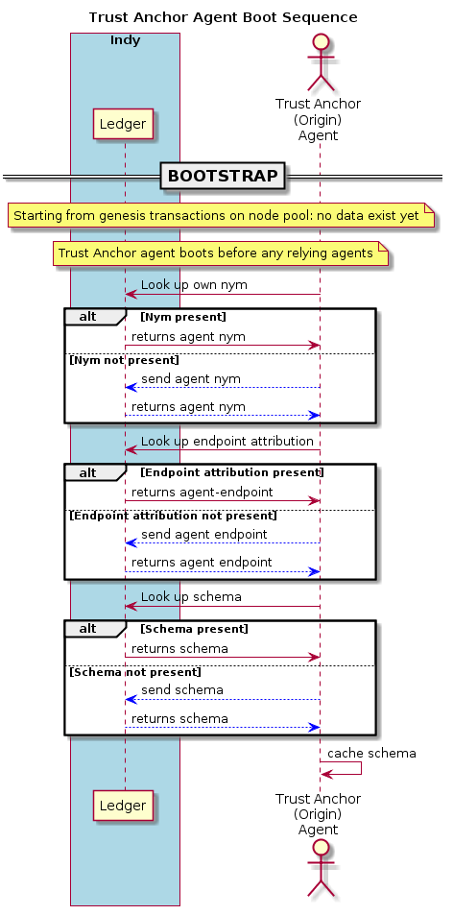Illustration 2: Boot Sequence - Trust Anchor Agent

The Org Book Agent
The following illustration depicts the bootstrap protocol exchange for the org book agent. The particulars of the process stem from its role as a holder/prover of claims.

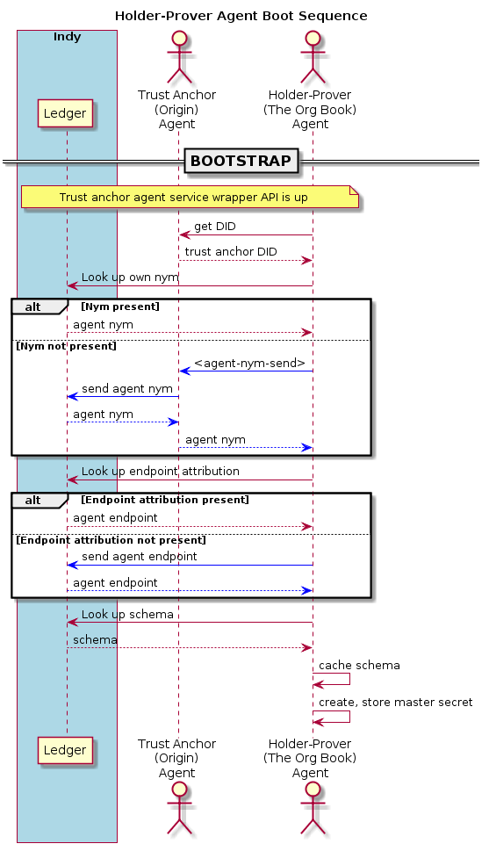Illustration 3: Boot Sequence - The Org Book

BC Registrar Agent
The following illustration depicts the bootstrap protocol exchange for the BC Registrar agent. The particulars of the process stem their role as an issuer of claims.

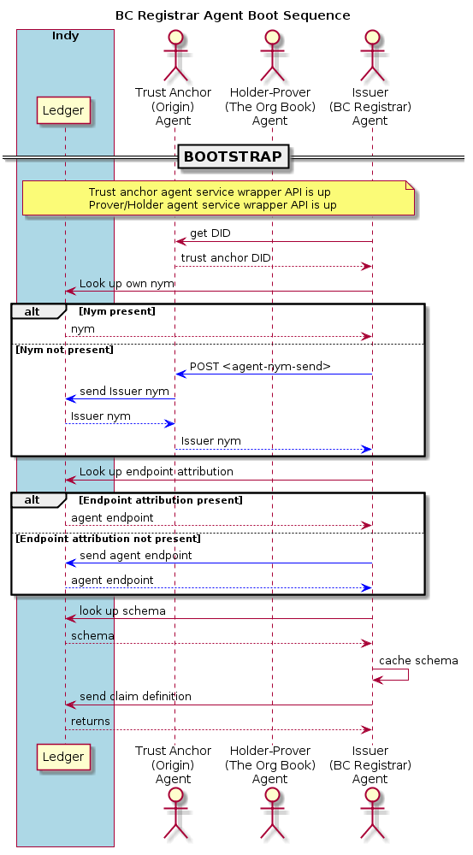Illustration 4: Bootstrap Sequence - BC Registrar Agent

SRI Agent
The following illustration depicts the bootstrap protocol exchange for the SRI agent. The particulars of the process stem their role as an issuer, holder/prover, and verifier of claims.

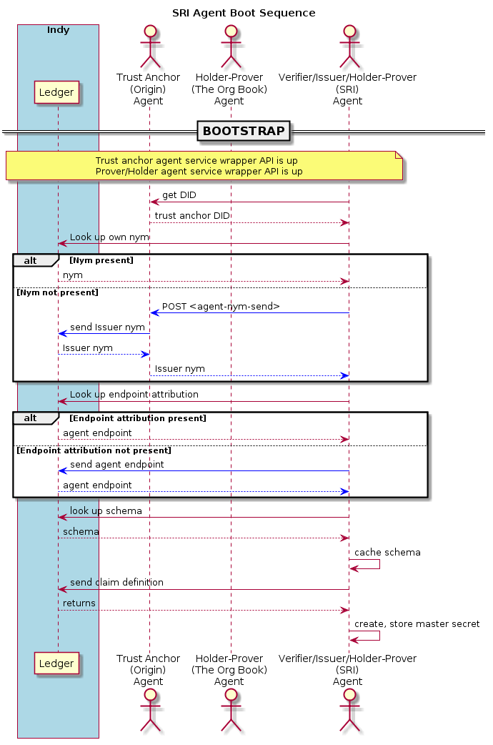Illustration 5: Boot Sequence - SRI Agent

Claim Load, Claim Request, and Claims Reset Protocol Exchanges
This section outlines the protocol exchanges realizing claim load, claim request, and claims reset.

Claim Load
The claim load protocol exchange creates claims at the issuer and stores them at the holder/prover. The VON loader software should actuate the process against the BC registrar agent and the org book agent. Time permitting, the demonstration may also include an additional actuator to prompt the SRI agent to issue claims noting the completion of the supplier registration process – in this case, the SRI software itself should act as the actuator.
The following illustration depicts the claim load protocol exchange.
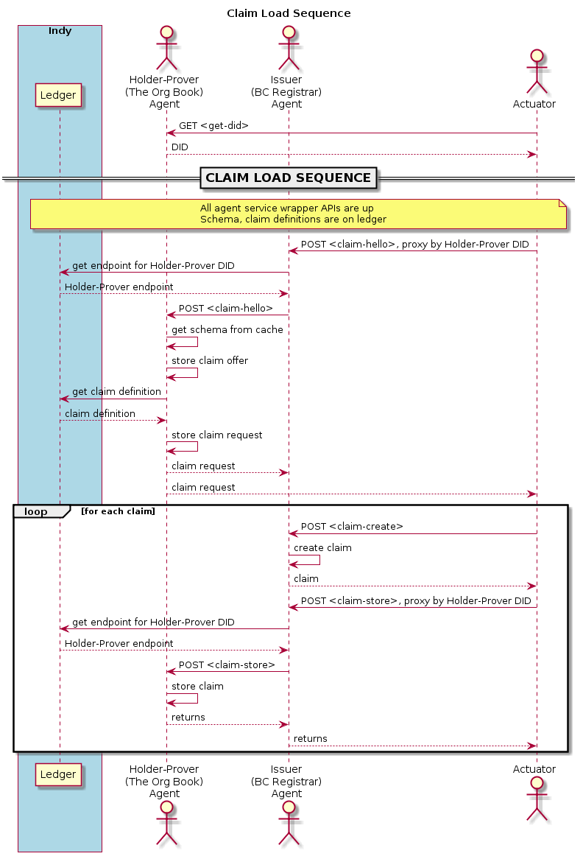Illustration 6: Claim Load Sequence

Claim Request
The claim request protocol exchange actuates a verifier agent (for the demonstration, the SRI agent) to retrieve claims from the org book agent as a holder/prover.
The following illustration depicts the claim request protocol exchange.
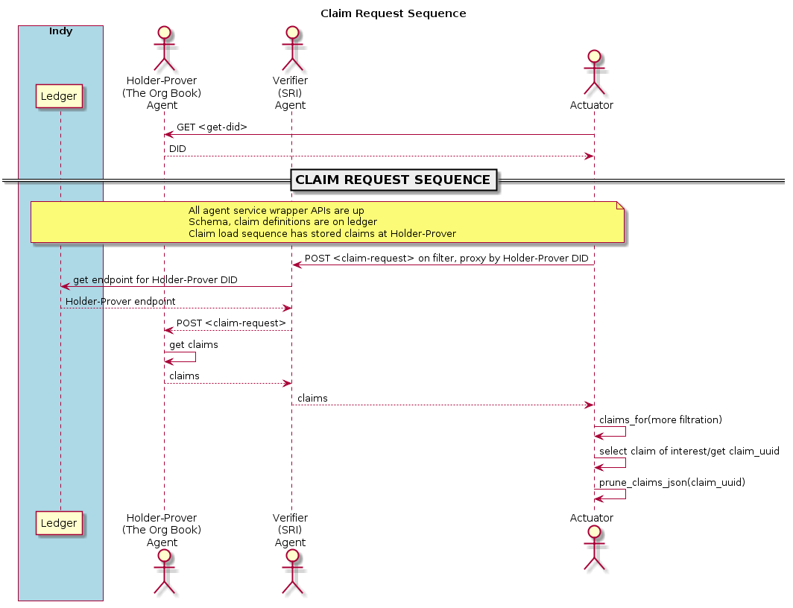Illustration 7: Claim Request Sequence

Claims Reset
The claims reset protocol exchange actuates the holder/prover to dispose of its current wallet and restart action on another one. This operation may be necessary to reset the holder/prover to baseline without having to restart every operating agent's service wrapper API on its machine – note that the indy-sdk uses a shared library to track wallet content, and so restarting would otherwise require the restart of all django RESTful API harnesses.
Note that this operation is for demonstration only: it is insecure.
The following illustration depictes the claims reset protocol exchange.
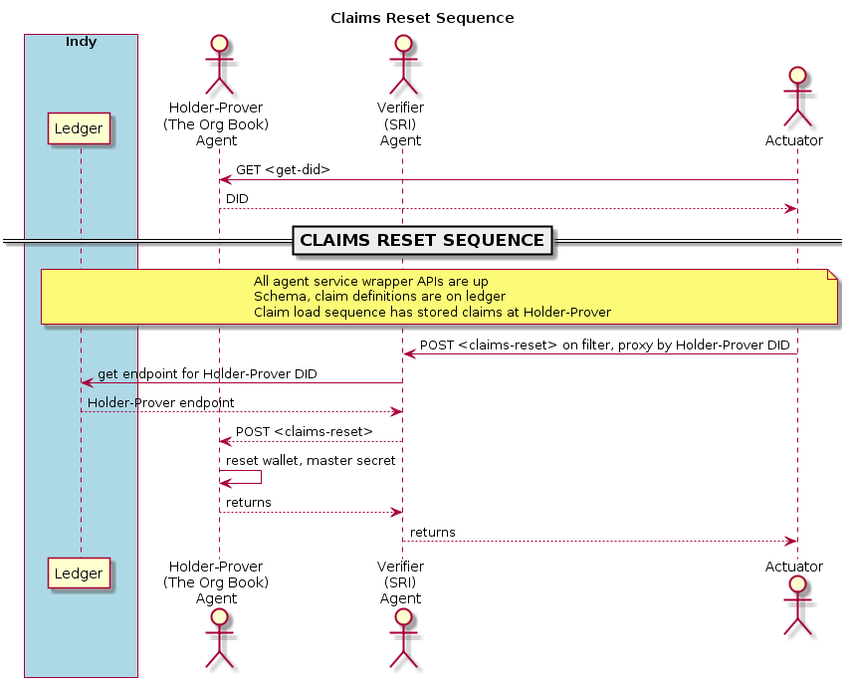Illustration 8: Claims Reset Sequence

Proof and Verification Request Protocol Exchanges
The proof request protocol exchange actuates a verifier agent (for the demonstration, the SRI agent) to retrieve claims of interest from the holder/prover in the org book agent.
The verification request protocol exchange actuates a verifier agent to interact with the distributed ledger to verify a proof that arises from the proof.
The following illustration depicts the proof request and verification request protocol exchanges.

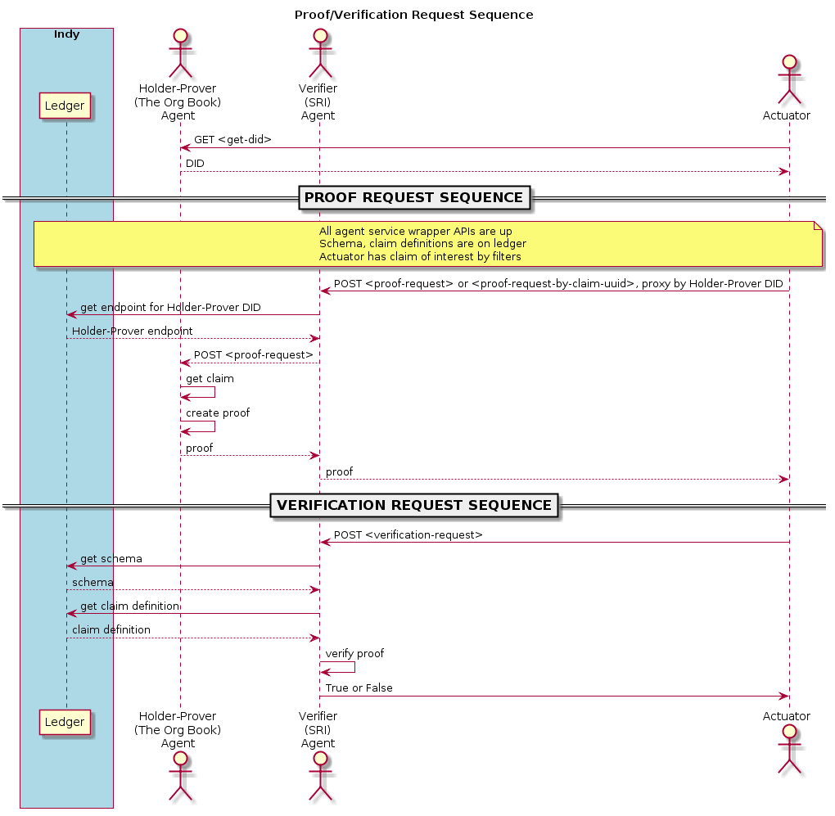Illustration 9: Proof Request and Verification Request Sequences

SRI Completion Sequence
To complete the registration of a supplier, the demonstration assembles data from revealed attributes of the proof from The Org Book and any germane particulars of the SRI completion. The actuator then prompts the SRI agent to create a new claim from this data and to store it. The actuator prompts the SRI agent to create a proof on this claim and finally to verify it.
The following illustration depicts this protocol exchange.
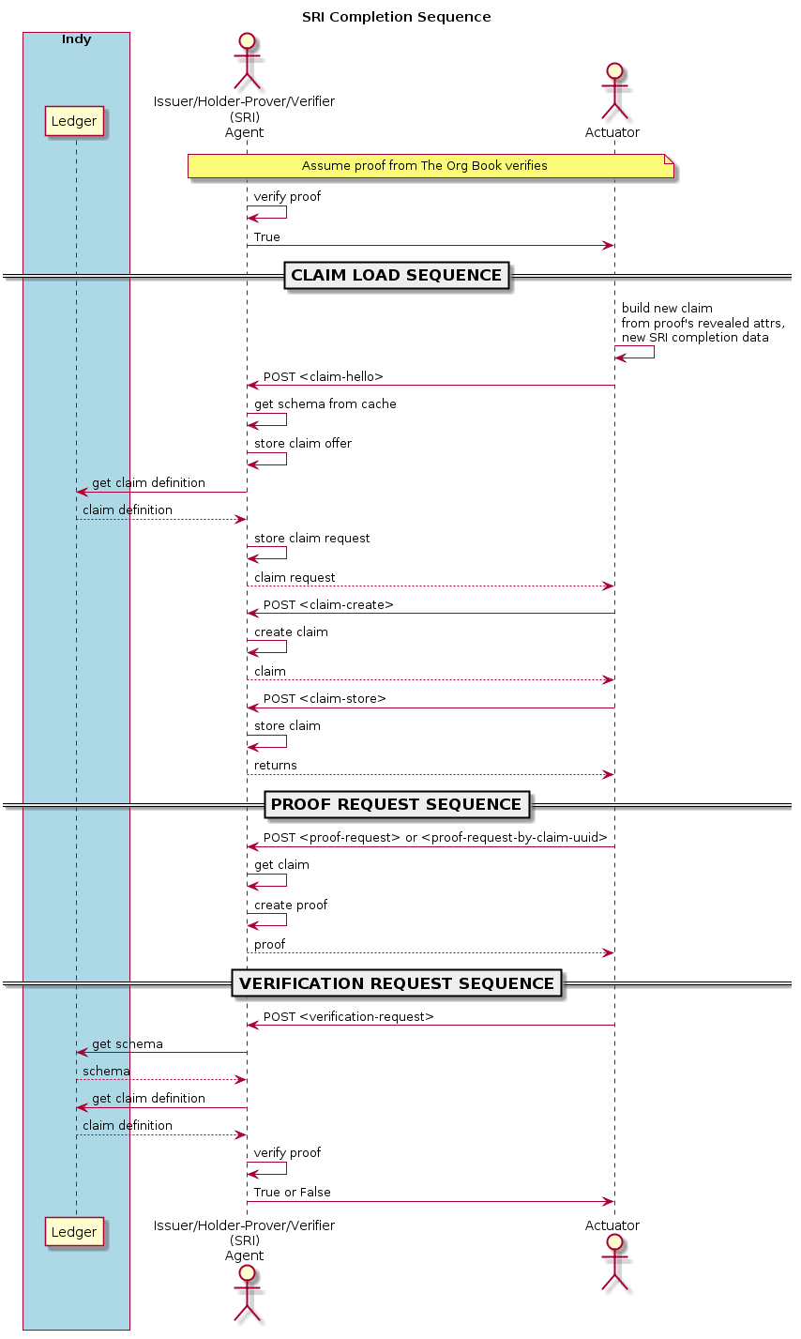Illustration 10: SRI Completion Sequence

Detailed Design
This section specifies the detailed design elements comprising the demonstration functionality, from RESTful service wrapper API through indy-sdk toolkit invocation.
The main components are the django RESTful service wrapper and the python class hierarchy.

Django RESTful Service Wrapper
This section outlines the wiring of the RESTful service wrapper.

Bootstrap
This section discusses the bootstrap process of the django RESTful service wrapper API implementation.

Configuration
The django bootstrap process configures the elements common to all agent profiles from wrapper_api/config/config.ini, and supplements them with per-agent-profile configuration items in its designated file within directory wrapper_api/config/agent-profile/.
Common configuration elements include schema name and version, trust anchor host and port, and genesis transaction file.
Per-agent-profile configuration elements include the agent role, the cryptographic seed, and host and port information. The prover agent also configures a master secret (label).

Agent Bootstrap Actuation
Once configured per agent profile, the django implementation actuates the bootstrap protocol exchanges as per section 4.1.

Housekeeping
The bootstrap process finally engages housekeeping activity, storing its configuration and agent object in the django cache and registering cleanup hooks on python shutdown. For the demonstration, the django implementation uses a simple RAM cache to keep agents alive between calls.

URL Wiring
The RESTful API implements helper requests as HTTP GET calls and all others as HTTP POST calls to its lone ServiceWrapper class view. It exposes a URL named for each message type in section 3, and delegates directly to the class view. The ServiceWrapper view calls the applicable underlying agent method – there is a GET method for each helper type, and a single POST method taking all others.
Upon taking a POST call, the view writes the agent to the cache again, as the call process may change the state of the agent en passant (e.g., claims-reset).

Code
This section provides the design for code implementing agent service wrapper API duty.

Class Hierarchy
This section discusses the class hierarchy to which the RESTful agent service wrapper API delegates messages for processing. The following illustration depicts the class hierarchy implementing the design; futher subsections elaborate.
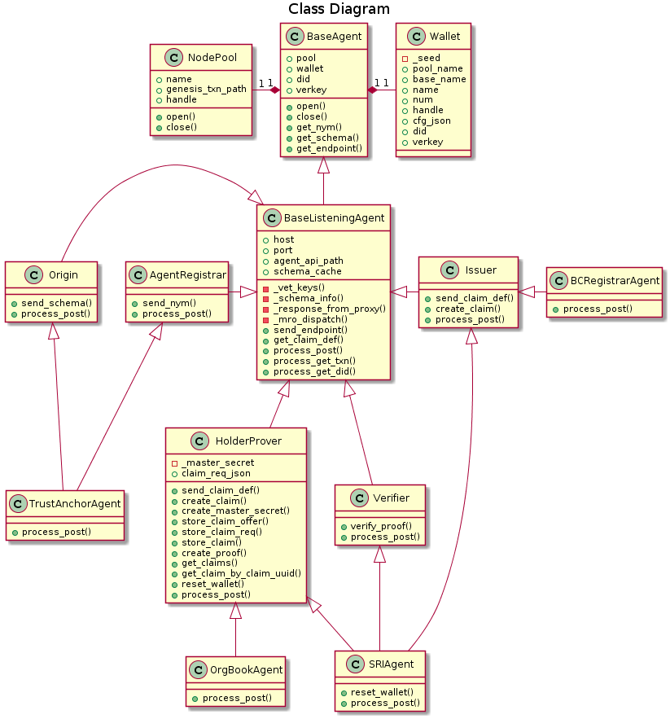Illustration 11: Agent Class Menagerie

Node Pool
The NodePool class encapsulates the indy-sdk node pool. It resides in wrapper_api/agent/nodepool.py.
Its initializer stores a pool name for use with indy-sdk and the path to a file with a (copy of the) genesis transactions.
The context manager methods set up and tear down the pool within the indy-sdk. On opening, the indy-sdk creates control files on the pool name in directory $HOME/.indy_client/pool/ and returns a pool handle, which the the NodePool object retains for future indy-sdk interaction. On closing, the instance directs the indy-sdk to invalidate the handle and delete its control files.

Wallet
The Wallet class encapsulates the indy-sdk wallet. It resides in wrapper_api/agent/wallet.py.
Its initializer takes the name of the pool on which the wallet operates, a cryptographic seed, and naming and configuration parameters. Its operation stores these parameters as instance variables.
The context manager methods set up and tear down the wallet within the indy-sdk. On opening, the indy-sdk creates control files on the wallet name in directory $HOME/.indy_client/pool/ and returns a wallet handle, which the the Wallet object retains for future indy-sdk interaction. On closing, the instance directs the indy-sdk to invalidate the handle and delete its control files.

Agents
This section outlines the design of the classes implementing agent functionality. Agents implementing purely indy-sdk concepts on behalf of the agent service wrapper API reside in file wrapper_api/agent/agent.py; agents of use principally for the demonstration in scope reside in file wrapper_api/agent/demo_agent.py.

BaseAgent
The BaseAgent class holds references to the node pool and a wallet for use within indy-sdk.
Its property methods make DID, verification, and public keys available via the instance's wallet.
Its context manager methods engage the underlying counterparts of the Wallet and NodePool classes.
Its get_nym(), get_schema(), and get_endpoint() methods fetch and return the nym, schema, and endpoint attribution respectively for the agent from the distributed ledger via the indy-sdk.

BaseListeningAgent
The BaseListeningAgent class builds on the BaseAgent to implement functionality common to agents that listen and respond to requests. Operationally, instances of this class have endpoint attribution on the distributed ledger.
The initializer takes a host, port and the agent API path prefix (e.g., api/v0).
Its _response_from_proxy() method handles all proxy dispatch. Its operation reads the DID of an agent to which to proxy a request, looks up the corresponding endpoint attribution from the ledger, strips out the proxy DID from the request, and posts the resulting message to the endpoint, returning the result to the caller.
The _mro_dispatch() class method uses Python's native introspection capacity to return a data structure built from the method resolution order – subclasses use it to discover which class should take a POSTed message to process. It returns a list from BaseListeningAgent through the current descendant class inclusively.
The send_endpoint() method sends endpoint attribution to the distributed ledger.
The get_claim_def() method retrieves a claim definition from the distributed ledger. The method resides in the BaseListeningAgent class because both Verifier and HolderProver implementations require it.
The process_post() method takes POSTed forms and vets their content, fulfilling them locally if common to all agent profiles or proxying them if specified to their endpoints.
The proceess_get_txn() and process_get_did() methods perform helper functionality as the agent service wrapper API wires it via HTTP GET.

Derived Mixins
The AgentRegistrar class responds via process_post() to messages of type agent-nym-send.
The Origin class responds via process_post() to messages of type schema-send.
The Issuer class responds via process_post() to messages of type claim-def-send or claim-def-create.
The HolderProver class responds via process_post() to messages of type master-secret-set, claim-hello, claim-request, proof-request, claim-store, and claims-reset.
The Verifier class responds via process_post() to messages of type verification-request.

Demonstration Agent Classes
The TrustAnchorAgent, SRIAgent, OrgBookAgent, and BCRegistrarAgent classes of file wrapper_api/agent/agent.py use the derived mixins above with the _mro_dispatch() mechanism of the BaseListeningAgent class to process and respond to POSTed protocol messages as the agent service wrapper API wires them.

Utility Functions
This section outlines utilities available within the package. Utility functions reside in file wrapper_api/agent/util.py.

Function ppjson()
Function ppjson() takes a JSON serialized or serializable structure and returns a pretty-print.

Functions encode() and decode()
The encode() and decode() functions convert raw attribute values to a form that the indy-sdk can use in issuing claims, creating proofs, and in verifying proofs.
The indy-sdk operates on (string representations of) integers only – hence, an encoding step must map raw attribute values to integers.

Motivation: Predicates Need int32 Null Encoding
The indy-sdk requires any attributes that might be used in (future) predicate proofs be non-negative 32-bit integers, such that the encoded value equals the raw value.

Solution: binhex + maxint32
The encode() function leaves non-negative 32-bit integers (or their string representation) alone, encoding them to their string representations. It transforms all other input via UTF-8, binhex, and adding 2³² before outputting the corresponding string representation.
The decode() function reverses the process – necessarily, any non-trivial encoding must result in a value that cannot correspond to a 32-bit integer.

Functions claims_for() and prune_claims_json()
Utility claims_for() takes a claims structure as the indy-sdk returns it, and applies a filter with attribute-value pairs to retain only claims of interest. It returns a dict mapping claim-uuid strings to human-readable claim-like structures. User intervention may select the claim(s) of interest by claim-uuid. Subsequently, the actuator can pass the claim-uuid strings corresponding to claims of interest, and the original indy-sdk claims structure, into function prune_claims_json() to build a claims structure, with only those claims of interest, suitable for use with indy-sdk via the agent classes of the demonstration.

Function revealed_attrs
Utility revealed_attrs() takes an indy-sdk proof of a single claim and returns its revealed attributes, as a dict mapping attribute names to lists of corresponding values, plain and encoded. The actuator may call this utility to build proof of one claim into another that stems from it.

Installation
This section specifies the installation process of the demonstration. It assumes an Ubuntu-based distribution on 16.04 or higher.

Prerequisites
On the host, issue:
$ sudo apt update
$ sudo apt upgrade
$ curl -sSf https://static.rust-lang.org/rustup.sh | sh
$ sudo apt install -y build-essential pkg-config cmake libssl-dev libsqlite3-dev libsodium-dev
to install Rust and indy-sdk prerequisites.

Virtual Environment and pytest
Set up python 3.5 virtual environment and site packages as follows:
$ sudo apt install python3.5 python3-pip virtualenv
$ mkdir ~/venv
$ virtualenv -p /usr/bin/python3.5 ~/venv/py35
$ . ~/venv/py35/bin/activate
(py35) $ pip install base58
(py35) $ pip install pytest
(py35) $ pip install pytest-asyncio
to set up and activate the python 3.5 virtual environment in $HOME/venv/py35/, and to install python site packages.

Docker
This section specifies the installation of docker. At the prompt, issue:
$ sudo apt install linux-image-extra-$(uname -r) linux-image-extra-virtual
$ sudo apt install apt-transport-https ca-certificates curl software-properties-common
$ curl -fsSL https://download.docker.com/linux/ubuntu/gpg | sudo apt-key add -
$ sudo add-apt-repository "deb [arch=amd64] https://download.docker.com/linux/ubuntu $(lsb_release -cs) stable"
$ sudo apt update
$ sudo apt install docker-ce

Start indy Pool Network
Download indy-sdk for its indy_pool_network dockerfile and create the indy pool (network) on docker:
$ cd ~
$ git clone https://github.com/hyperledger/indy-sdk.git
$ docker network create --subnet 10.0.0.0/8 indy_pool_network
$ cd ~/indy-sdk
$ docker build --build-arg pool_ip=10.0.0.2 -f ci/indy-pool.dockerfile -t indy_pool .
$ docker run -d --ip=10.0.0.2 --net=indy_pool_network indy_pool
$ cd libindy
$ RUST_TEST_THREADS=1 TEST_POOL_IP=10.0.0.2 cargo test
to complete the tests demonstrating interoperation of indy-sdk with the shared library.

Install Demonstration from Repository
On the host system, clone the demonstration from its repository:
$ cd ~
$ git clone https://github.com/PSPC-SPAC-buyandsell/demo-agent.git
$ . ~/venv/py35/bin/activate
(py35) $ pip install -Ur demo-agent/service_wrapper_project/requirements.txt
to install the demonstration and set up its required python site packages in the virtual environment.
The agent service wrapper API is a django application called wrapper_api within the django framework. The demonstration comprises four instances of the service wrapper API (trust anchor, SRI agent, the Org Book agent, BC Registrar agent), plus a test harness to prove the concept of operations.

Install libindy Shared Library
Move the libindy shared library object from the demonstration installation into the /usr/lib library path:
$ cd ~
$ cd demo-agent
$ sudo mv usr-lib/libindy.so /usr/lib
$ rm -rf usr-lib

Configuration
The configuration of the demonstration includes data common to all agent profiles, and data particular to the agent.

Common Configuration
The configuration data common to all agents resides in file service_wrapper_project/wrapper_api/config.ini. Common configuration includes:
- the name and version of the schema for use within the demonstration
- the host and port of the trust anchor
- the path to the genesis transaction file of the node pool.
Be sure to fix the genesis transaction path in particular to fit the installation.

Per-agent Configuration
The per-agent configuration data resides in an .ini file within service_wrapper_project/wrapper_api/config/ named after its agent profile (bc-registrar, sri, the-org-book, trust-anchor). Per-agent configuration includes:
- the role of the agent (BC-Registrar, SRI, The-Org-Book, Trust-Anchor)
- the cryptographic seed for the agent
- the host and port of the service wrapper
- for prover agents, the master secret label.

Operation
This section specifies the invocation of the demonstration components and prerequisites.

The Node Pool
The node pool must be running for the (django) agent service wrapper API processes to execute, as well as for test harnesses test_pool.py, test_agent.py and test_wrapper.py. The test_wallet.py test harness does not need the node pool to be running.
This section specifies the starting and stopping of the node pool. Note that because the demonstration uses a docker container set up as a docker network for the node pool, stopping and restarting the pool restores it to its initial state as of its genesis transactions.

Starting
To start the node pool, issue
$ docker run -d --ip=10.0.0.2 --net=indy_pool_network indy_pool
at the bash prompt to start the container realizing the docker network.

Stopping
To stop the node pool, issue
$ docker rm $(docker stop $(docker ps -aq))
at the bash prompt to stop and remove the container.

Environment Variables
The following environment variables inform agent service wrapper API processes and test harnesses:
- RUST_LOG – the log level for indy-sdk's underlying rust wrapper of the cryptographic library
- LD_LIBRARY_PATH – specifies the location to find the indy-sdk shared library binary object (not required if the operator has copied it to /usr/lib/)
- TEST_POOL_IP – specifies the test pool IP address for the indy-sdk
- AGENT_PROFILE – specifies the profile of the agent to the service wrapper API; choose trust-anchor, sri, the-org-book, or bc-registrar

Test Harnesses
This section specifies the operation of the test harnesses within service_wrapper_project/wrapper_api/tests/. These tests run on the pytest framework.
Become familiar with the conftest.py code, upon which the test harness relies to populate fixtures and inform test operation. In particular, there are two invocations of rmtree() in the path_temp() and path_home() fixtures that an operator will comment in and out with typical use. Commenting it out of the path_home() fixture will stop the test harness from interfering with indy-sdk-driven code running outside the test harness – including the agent service API wrappers.

Wallet
This test harness exercises the opening and closing of Wallet objects.
To operate test harness test_wallet.py, activate the virtual environment and change to the service_wrapper_project/wrapper_api/tests/ directory; then issue at the prompt:
(py35) $ RUST_LOG=error TEST_POOL_IP=10.0.0.2 pytest -s test_wallet.py

Node Pool
This test harness exercises the opening and closing of NodePool objects.
To operate test harness test_pool.py, activate the virtual environment and change to the service_wrapper_project/wrapper_api/tests/ directory; then issue at the prompt:
(py35) $ RUST_LOG=error TEST_POOL_IP=10.0.0.2 pytest -s test_pool.py

Agents
This test harness exercises the low-level and request-processing APIs of Agent objects, as they collaborate within the demonstration.
To operate test harness test_agents.py, activate the virtual environment and change to the service_wrapper_project/wrapper_api/tests/ directory; then issue at the prompt:
(py35) $ RUST_LOG=error TEST_POOL_IP=10.0.0.2 pytest -s test_agents.py

Wrapper
This test harness exercises the agent service wrapper API installations as django implements them, to produce the demonstration in scope.
To operate test harness test_wrapper.py, all four agent service wrapper API implementations must be running a priori. If they are not running, start them as per section 8.4 below.
Within the test harness terminal, be sure that conftest.py is not set to remove the home indy-sdk directory tree (comment out the rmtree() call as above) and issue:
(py35) $ RUST_LOG=error TEST_POOL_IP=10.0.0.2 pytest -s test_wrapper.py

Agent Service Wrapper Processes
Within four separate terminal windows, activate the virtual environment and change to the service_wrapper_project/ directory and issue:

(py35) $ RUST_LOG=error TEST_POOL_IP=10.0.0.2 AGENT_PROFILE=trust-anchor python manage.py runserver --settings=config.settings.local 0.0.0.0:9700 --noreload
for the Trust Agent anchor, and wait for the start sequence to complete. Then, at the other terminals, enter:
(py35) $ RUST_LOG=error TEST_POOL_IP=10.0.0.2 AGENT_PROFILE=sri python manage.py runserver --settings=config.settings.local 0.0.0.0:9701 –noreload
for the SRI agent,
(py35) $ RUST_LOG=error TEST_POOL_IP=10.0.0.2 AGENT_PROFILE=the-org-book python manage.py runserver --settings=config.settings.local 0.0.0.0:9702 –noreload
for the Org Book agent, and
(py35) $ RUST_LOG=error TEST_POOL_IP=10.0.0.2 AGENT_PROFILE=bc-registrar python manage.py runserver --settings=config.settings.local 0.0.0.0:9703 –noreload
for the BC Registrar agent. Wait for all agents to come up before continuing. These terminals will not accept further input as they scroll logs for their respective processes.

Actuation
At present, the actuator is the django application startup sequence for bootstrapping and the test_wrapper.py test harness for subsequent interaction.
To wire the agent service wrapper API as a end to a more human-usable display, see the form_json() and url_for() helpers in the test_wrapper.py test harness, for use with the JSON templates in directory service_wrapper_project/wrapper_api/protocol/. These templates implement the input forms specified above in section 3, modulo interpolation with data available at run time as per the sequence diagrams in section 4.

Deficiencies
This section notes candidates for areas for future improvement within the code base, which necessarily includes some compromises to meet deadlines while providing minimum acceptable demonstration functionality.

Node Pool
The current setup uses the (docker-based) node pool and network that ships with indy-sdk, including the trust anchor built into its genesis transaction.
The node pool should operate on an OpenShift platform open to the Internet. The trust anchor should be generated in-house, under local governance.

Predicates
At present, claim requests and proof requests accept specification only by attribute value, although the indy-sdk does support predicates in this regard (e.g., age of majority). The agent code should support predicates in specification of claims and proofs.

Revocation
The demonstration should support revocation as the indy-sdk toolkit rolls it out.

Multiple schemata
At present, the demonstration supports one schema and one schema originator at the trust anchor. This conceit data particular to SRI and data particular to the BC Registrar applications into the same schema, which is awkward.
Some code changes would be necessary in the agents affected, and the optional schema specification in some message formats would become mandatory.

Wallet persistence
At present, wallet persistence is through sqlite3, which does not survive the process. The demonstration should persist wallet content to a database.

Track indy-sdk Updates
The indy-sdk toolkit continues to evolve, and the demonstration should continue to track its progress.

