Public Services and Procurement Canada

VON Anchor v1.x Series
Design Document
author: Stephen Klump
date: 2018-07
version: 3.02

Table of Contents
1 Introduction 1
1.1 History: VON Agent, Indy Agent, VON Anchor 1
1.2 Scope 1
1.3 Taxonomy 1
1.4 Version Numbering 3
1.5 Overview 3
1.6 References 3
2 Anchor Interactions 4
2.1 Bootstrap Operations 4
2.2 Credential Operations 10
2.3 Proof Operations 17
3 Detailed Design 23
3.1 Packaging 23
3.2 VON Anchor Code 24
4 Installation 51
4.1 Install Package von_base 51
4.2 Test VON Base 52
4.3 Install Package von_anchor 52
5 VON Anchor Unit Tests 53
5.1 Prerequisites 53
5.2 Test Harness Operation 54
5.3 Cleanup on Abends 56

Introduction
The VON anchor presents a set of useful abstractions and conveniences by which developers may use the indy-sdk toolkit to interact with the sovrin distributed ledger.

History: VON Agent, Indy Agent, VON Anchor
As part of the technology demonstrator project using Hyperledger indy to explore the use of the distributed ledger with PSPC Supplier Registration Information (SRI), the original von_agent (v0 series) design specified anchors with service wrapper APIs to facilitate interoperability, including the capacity to relay messages to other agents. An appendix includes a synopsis of the original technology demonstrator project.
As the SRI integration exercise developed, it adopted an intermediary layer (initially, The Org Book and Permitify, then VON-X) to engage the SRI agent rather than using agent-to-agent communication directly. The agent design dropped its inter-agent communication layer via the provisional VON protocol and the VON agent became headless, serving primarily as a back-end conduit to the distributed ledger for the intermediary layers as they developed.
Then, the design an indy (contrast VON) agent emerged, implementing a communications framework between indy-sdk trust anchors facilitating write operations to the distributed ledger. To disambiguate these projects, the VON agent became the VON anchor circa v1.6.
The current generation of von_anchor (v1.x series) design allows interoperability with the Hyperledger indy distributed ledger via the indy-sdk toolkit, without prejudice to any particular use case – it is not geared specifically to SRI integration. In addition to (Government of Canada) integration of the SRI system with the indy distributed ledger, the British Columbia Government is currently using the anchors to facilitate a variety of use cases such as The Org Book, Permitify, and VON-X.

Scope
This engineering document motivates and details a design specification. Stemming from typical use cases regarding VON anchor interaction via service wrapper APIs, the text specifies the design implementing delivery of their respective payloads to the Hyperledger indy distributed ledger.

Taxonomy
This section introduces abstractions at project level and at anchor level.

Project Level
Throughout this project, "VON anchor" refers to the layer implementing the trust anchor technology using the indy-sdk; "VON connector" refers to a service wrapper API accepting transport layer messages and delegating them to its underlying VON anchor (potentially, among other back ends). "VON-X" is a BC Government initiative to generalize communications between anchors (e.g., from an issuer of credentials to a holder-prover, or from a holder-prover to a verifier).

Anchor Level
The indy-sdk mechanism presents a role engineering model for anchors specifying issuers, provers, and verifiers. The W3C model, roughly in alignment, uses issuers, holders, and verifiers. The design of the von_anchor toolkit includes the following demonstration anchors:
- the Trustee anchor as:
  - the smith consecrating all anchors on the distributed ledger including itself
- the (PSPC) SRI anchor as:
  - a verifier for proofs of credentials that the BC Registrar anchor issues
  - an issuer and verifier for proofs of credentials that the SRI anchor issues
  - a schema origin for credentials that it issues
- the PSPC Org Book anchor as, for credentials that the SRI anchor issues:
  - a W3C credential holder
  - an indy-sdk prover
- the BC Registrar anchor as:
  - an issuer of BC Registrar credentials
  - a schema origin for credentials that it issues
- the BC Org Book anchor as, for BC Registrar credentials, both
  - a W3C credential holder
  - an indy-sdk prover.
In the context of the Alice story of https://github.com/hyperledger/indy-sdk/blob/master/doc/getting-started/getting-started.md, the von_anchor toolkit would allow for the development of:
- the Steward anchor as an anchor smith
- a Government anchor as an origin of schemata for transcripts and job certificates
- a Faber anchor as the issuer of transcripts (credentials)
- an Acme anchor as the issuer of job certificates (credentials)
- an Alice anchor as an indy-sdk prover (W3C holder) of a transcript and job certificate
- a Thrift Bank anchor as a verifier.

Version Numbering
Since version 1.6, the von_anchor major and minor version numbers (i.e., x.y in x.y.z) of any given release track the version that its corresponding indy-sdk (master development version) anticipates. Note that indy-sdk version numbering, has
x.(y-1).z-dev-nnn < x.y.z.rc-n <= x.y.z
for any release x.y.z, where, to date, z has always been zero. For example, releases 1.5.0-dev-nnn follow release 1.5 but precede release candidate 1.6.0-rc-n and release 1.6.0. Any corresponding von_anchor releases would take version number series 1.6.z. The micro (i.e., z in x.y.z), and any numbers beyond, count only VON anchor increments, and have no relation to any external information.

Overview
The remainder of this work:
- introduces typical interactions involving demonstration anchors,
- presents detailed design notes,
- presents instructions for installation and testing.

References
[VT] - "The von_tails External Tails File Server". Public Services and Procurement Canada, 2018. https://github.com/PSPC-SPAC-buyandsell/von_tails/blob/master/doc/von-tails.doc

Anchor Interactions
This section introduces typical interactions involving demonstrator VON anchors. The following subsections discuss:
- bootstrap operations,
- credential operations (credential load, credential revoke, credential request, credentials reset), and
- proof operations (creation, verification).
Actuation
The high level design does not specify the client (actuator) to prompt VON anchor operations; it could be a configuration item for a Web application or it could be a custom application prodding one or more anchors via their respective wrapper APIs. For example, the test/test_anchors.py test harness of the von_anchor package offers a (crude) sample actuator.

Bootstrap Operations
This section specifies VON anchor bootstrap operations.

Trustee VON Anchor Boot Sequence
The node pool's genesis transactions must specify the trustee VON anchor's cryptonym (nym), or that of an ancestral trustee that registered (possibly, transitively) the trustee of interest. At boot time, the anchor must check for its own nym on the distributed ledger. If not present, it must write it to the ledger – however, this check is a formalism since the genesis transactions should include its cryptonym.
The following figure illustrates the boot sequence for a trustee VON anchor.
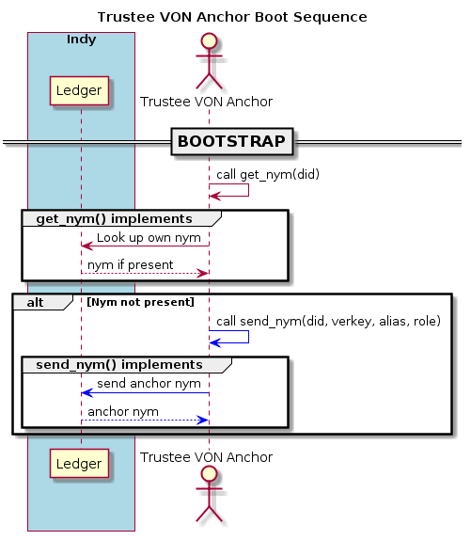Illustration 1: Trustee VON Anchor Boot Sequence

Issuer Anchor Boot Sequence
At present, for simplicity, the design of von_anchor automatically sets up all issuer anchors (creating credentials) as origin anchors (defining schemata).
At boot time, the issuer anchor must check the ledger for its own nym; if absent, it must prompt the trustee VON anchor (via its service wrapper API) to write it to the ledger.
The anchor must look up each schema and associated credential definition for which it is responsible as an origin and issuer (respectively). It must create and send all such absent productions to the ledger. If creating a new credential definition with revocation support, the call to send the credential definition creates an initial revocation registry (plus a corresponding tails file) and writes the registry state with its initial entry to the ledger at this time.
The following figure illustrates the boot sequence for an issuer anchor.
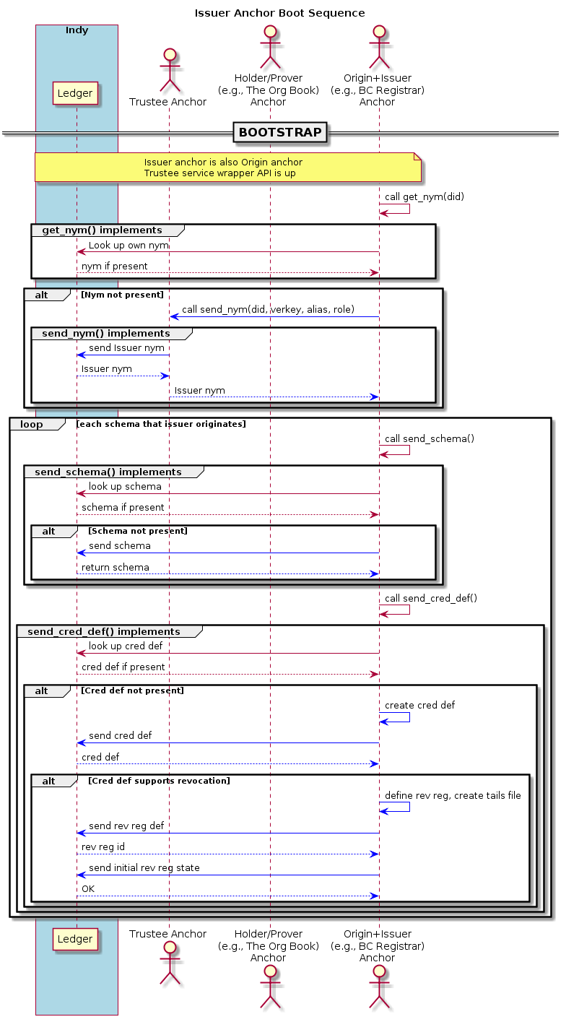Illustration 2: Issuer Anchor Boot Sequence

Holder-Prover Anchor Boot Sequence
Recall that indy-sdk condenses the W3C holder and prover roles.
The holder-prover anchor may operate on-line (with the distributed ledger available via the node pool) or off-line.
At boot time, if on-line, the holder-prover anchor must check the ledger for its own nym; if absent, it must prompt the trustee VON anchor to write it to the ledger. If off-line, its configuration should prod the operation to load the schema, credential definition, and revocation caches (of sections 3.2.1.5, 3.2.1.6, and 3.2.1.7) with archived content. Since all anchors in a process share these caches, a holder-prover anchor operating off-line should be the only anchor in the process.
On boot, the anchor must set its link secret, which it uses to create proofs.
The following figure illustrates the (on-line) boot sequence for a holder-prover anchor.
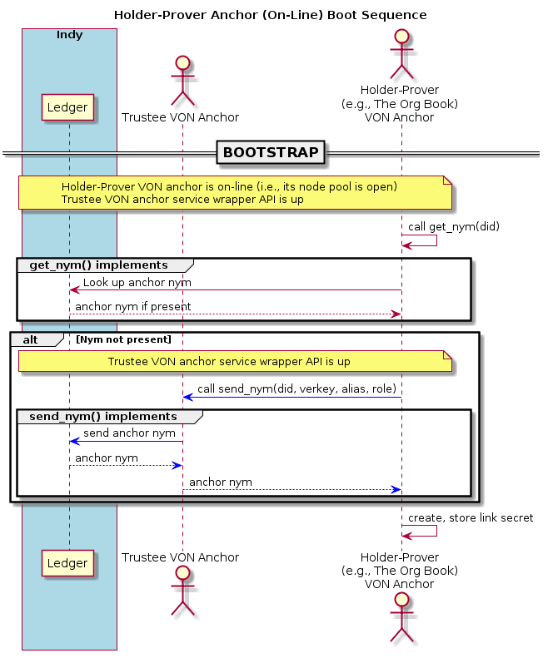Illustration 3: Holder-Prover Anchor (On-Line) Boot Sequence

Verifier Anchor Boot Sequence
The verifier anchor may operate on-line (with the distributed ledger available via the node pool) or off-line.
At boot time, if on-line, the verifier anchor must check the ledger for its own nym; if absent, it must prompt the trustee VON anchor to write it to the ledger. If off-line, its configuration should prod the operation to load the schema, credential definition, and revocation caches (of sections 3.2.1.5, 3.2.1.6, and 3.2.1.7) with archived content. Since all anchors in a process share these caches, a verifier anchor operating off-line should be the only anchor in the process.
The following figure illustrates the (on-line) boot sequence for a verifier anchor.
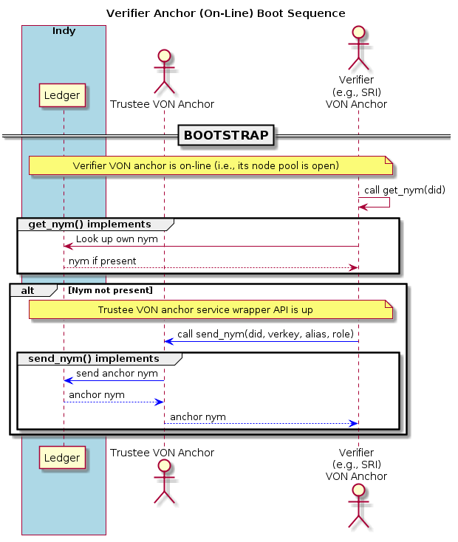Illustration 4: Verifier Anchor (On-Line) Boot Sequence

Credential Operations
This section introduces VON anchor interactions regarding credentials.

Credential Load
This section outlines the interactions required to prompt an issuer anchor to create credentials for storage at a holder-prover anchor.
The actuator must call on the issuer anchor to create a credential offer, based on the distributed ledger's transaction number for the schema underpinning the credential (via the issuer's corresponding credential definition). The anchor creates and returns the credential offer.
Then the actuator must prompt the holder-prover anchor to create a credential request on the credential offer; the anchor creates the request and returns it with some associated metadata that the actuator must retain for the duration of the credential load sequence.
For each credential, the actuator must prompt the issuer anchor to create it on the credential offer, the credential request, and the attribute name/value pairs comprising the content. The issuer anchor returns the credential, with its credential revocation identifier if the credential definition supports revocation. The actuator then must prompt the holder-prover anchor to store the credential (passing the metadata from the credential offer). At this point, the implementation on holder-prover anchor checks whether it has any required tails file in its tails tree (see section 3.2.1.1). If it does not, it raises an exception and the actuator must fetch it from the issuer and supply it for a subsequent attempt.
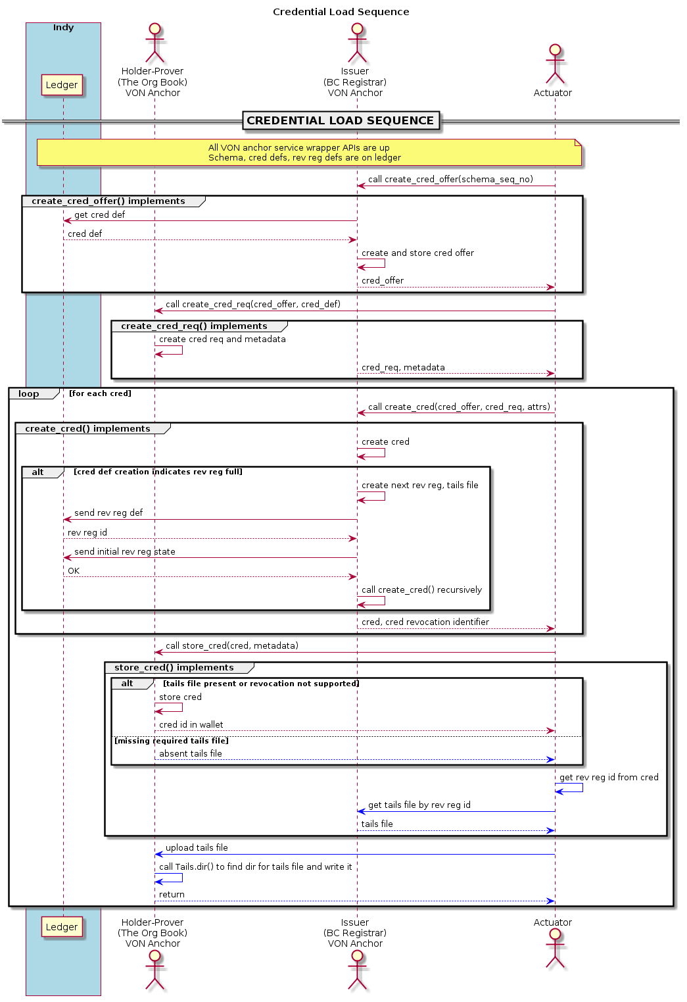Illustration 5: Credential Load Sequence

Credential Revoke
This section outlines the interactions required to prompt an issuer to revoke a credential.
The actuator must isolate the revocation information, comprising a revocation registry identifier and a credential revocation identifier, for the credential of interest. If the holder-prover is pliable, the actuator can get the credential directly (see section 2.2.3); alternatively, the service may store such metadata at credential creation time.
The actuator must call on the issuer anchor to revoke the credential by its revocation information. The issuer implementation updates the revocation registry state on the ledger and returns the transaction time in epoch seconds.
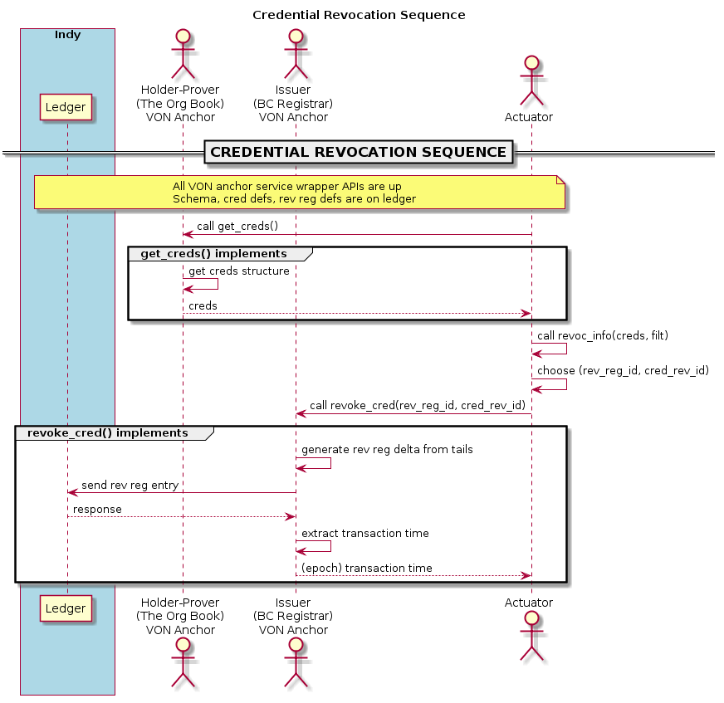Illustration 6: Credential Revocation Sequence

Credential Request
This section outlines the interactions required to prompt an issuer to request credentials.
The actuator must call upon the holder-prover anchor to get credentials by desired filtration parameters:
- coarsely, by components of schema identifier and/or credential definition identifier:
  - credential identifier definition (including issuer DID, schema sequence number)
  - credential issuer DID
  - schema identifier (including origin DID, name, version)
  - schema origin DID
  - schema name
  - schema version
- by attribute value filtration
- by credential identifier in the wallet (a.k.a. referent in credential info context).
The implementation on the holder-prover anchor fetches and filters credentials from its wallet as requested, and returns credentials structures accordingly. The utilities provide further filtration and display options, to facilitate user selection, credential tree pruning, and refinement via feedback to augment filtration in further calls to get credentials from the holder-prover anchor.
Note that no filtration can isolate credentials by revocation status at this stage: all credentials in a wallet are subject to return, whether revoked or not. Issuers publish revocation updates to the ledger, not to any holder-prover's wallet.
The following figure illustrates.
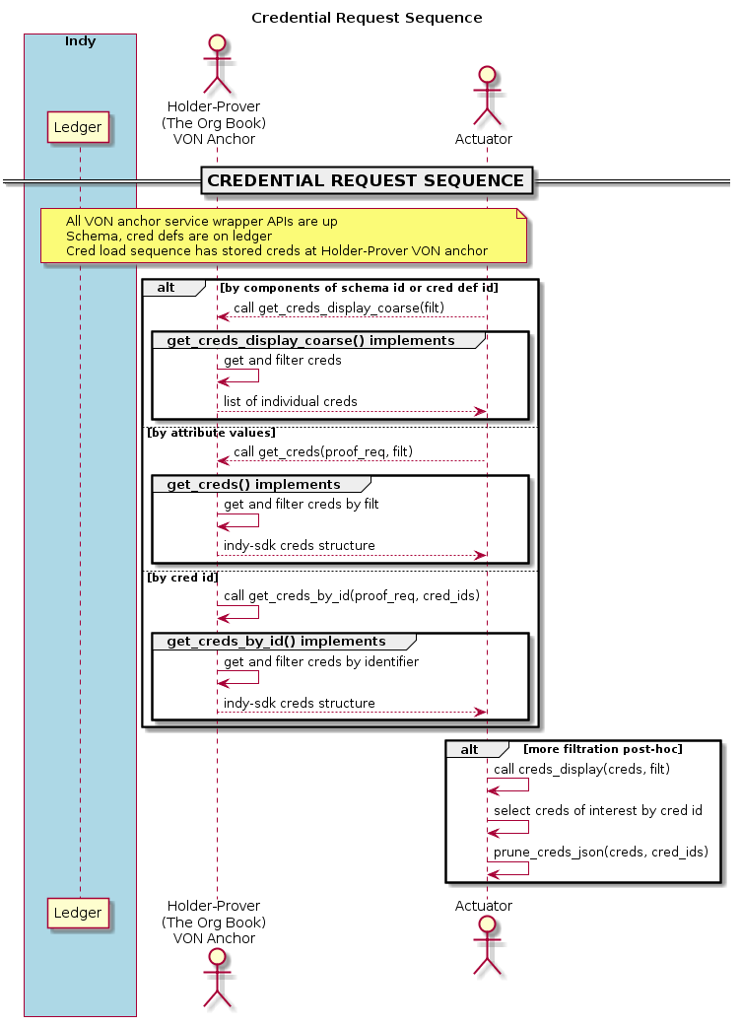Illustration 7: Credential Request Sequence

Credentials Reset
This section outlines the interactions required to prompt an issuer to reset a holder-prover wallet, effectively deleting it and starting another on the same link secret.
The actuator must call upon the holder-prover anchor to reset its wallet; the implementation on the holder-prover anchor completes the operation and returns.
The following figure illustrates.
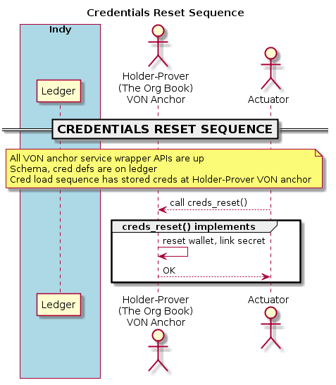Illustration 8: Credentials Reset Sequence

Proof Operations
This section introduces anchor interactions regarding proofs: proof creation and proof verification.

Proof Sequences
This section outlines the interactions required to marshal a tails file to a holder-prover anchor, and to create a proof.
Tails File Marsalling
To marshal a tails file from its issuer anchor to a holder-prover anchor that requires it, the actuator must have a credential on a credential definition supporting revocation, or else the revocation registry identifier itself. The actuator may use a utility to get revocation information out of a creds structure, including revocation registry identifier and credential revocation identifier.
The actuator calls the issuer anchor's service wrapper to locate and download the tails file corresponding to the revocation registry identifier – although the anchor as currently implemented can provide its location, the service wrapper must complete the download process to the actuator. Alternatively [VT] presents the von_tails package, which includes an external tails file server and synchronization scripts to expedite this process.
The actuator then calls the holder anchor's service wrapper to upload the tails file to the holder-prover anchor. The holder-prover anchor can provide the service wrapper with the location to write the tails file so it may find it and synchronize as required, but at present the anchor leaves the work of uploading the file itself to the service wrapper layer.
Both downloading and uploading the tails files present interesting achievable goals for integration into the emerging VON-X layer.
Proof Creation
The actuator calls upon the holder-prover anchor to build indy-sdk proof request and requested credentials structures. Alternatively, the actuator may craft these structures manually, but using the builders guarantees that they exhibit a sensible configuration that VON anchor proof creation supports.
The actuator calls upon the holder-prover anchor to create proof on a proof request, an indy-sdk credentials structure, and an indy-sdk requested credentials structure. Note that the _BaseAnchor class provides helpers to build indy-sdk proof request and requested credentials structures, and the test code demonstrates their use.
The holder-prover anchor implementation then gets (from the distributed ledger or, where possible, from the caches) such schemata and credential definitions as are required for proof, plus any revocation registry definitions. If any tails files are required and not present in its tails tree, the holder-prover anchor raises an exception noting the absent tails file; the actuator must marshal it to the holder-prover anchor (or await synchronization as per [VT]) as above. Otherwise, the implementation consults the distributed ledger to get the revocation registry deltas to the timestamp in the requested credentials structure, and constructs revocation registry states as required to create a proof (however, some credential definitions may not support revocation; such credential definitions require no tails files content nor revocation registry states to contribute to the proof).
Finally, the holder-prover returns the proof to the actuator.
The following figure illustrates the proof sequences above.
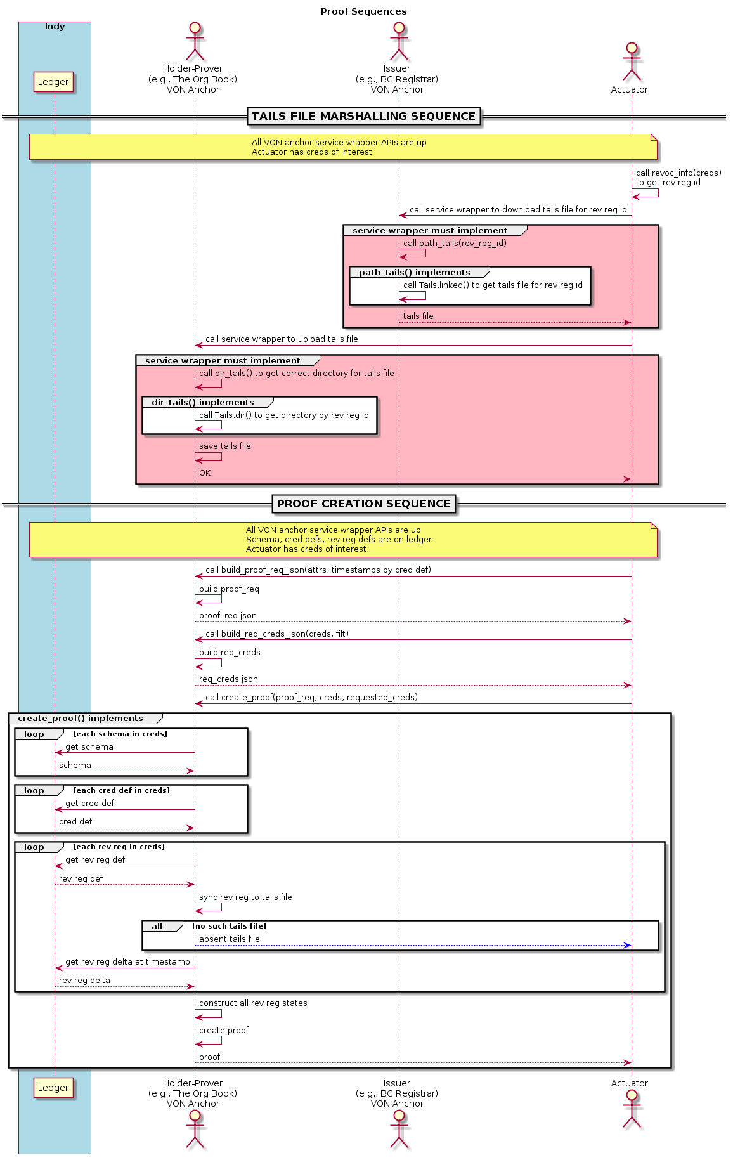Illustration 9: Proof Sequences

Verification Sequence
This section outlines the interactions required to verify a proof.
The actuator calls upon the verifier anchor to verify a proof against a proof request. The verifier anchor implementation consults the distributed ledger (or the caches) to get such schemata, credential definitions, and revocation information from the ledger as the proof identifies, then passes the information to the indy-sdk to verify the proof as true or false. It returns the result to the actuator.
The following figure illustrates.
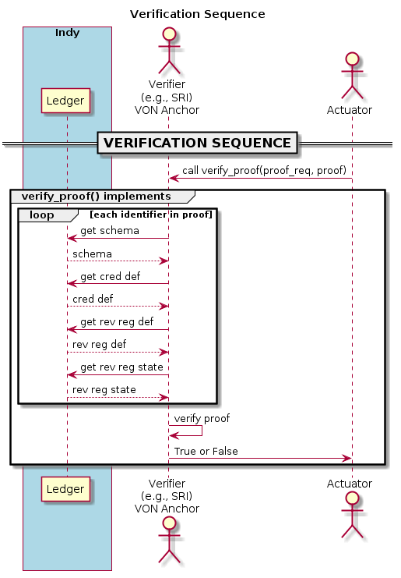Illustration 10: Verification Sequence

Detailed Design
This section provides design notes for von_base and von_anchor packaging and code bases.

Packaging
This section discusses the packaging of the demonstrator project into von_base and von_anchor. The following illustration shows the demonstration packages and their content; further subsections elaborate.
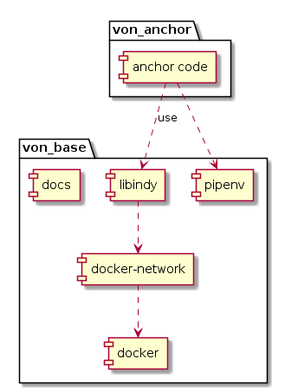Illustration 11: Package Diagram

VON Base
The von_base package encapsulates:
- the (archived and compressed) libindy.so shared library
- the pipenv virtual environment
- the docker components that the indy-sdk uses
- a docker network for von_conx, a (derelict) VON connector reference implementation.
In addition, the package holds this design document and advice on how to migrate the version of indy-sdk library underpinning the von_anchor code base.

VON Anchor
The VON anchor package comprises the layer using the indy-sdk to implement the anchor code base (see section 3.2) for all actors in scope. The (pure python) von_anchor package, available through pip from pypi.python.org, implements the VON anchor.

VON Anchor Code
This section provides the design for VON anchor code: class menagerie, utility functions, and exception hierarchy.

VON Anchor Class Hierarchy
This section discusses the VON anchor class hierarchy, which drives indy-sdk operations. The following illustration depicts the design; futher subsections elaborate.
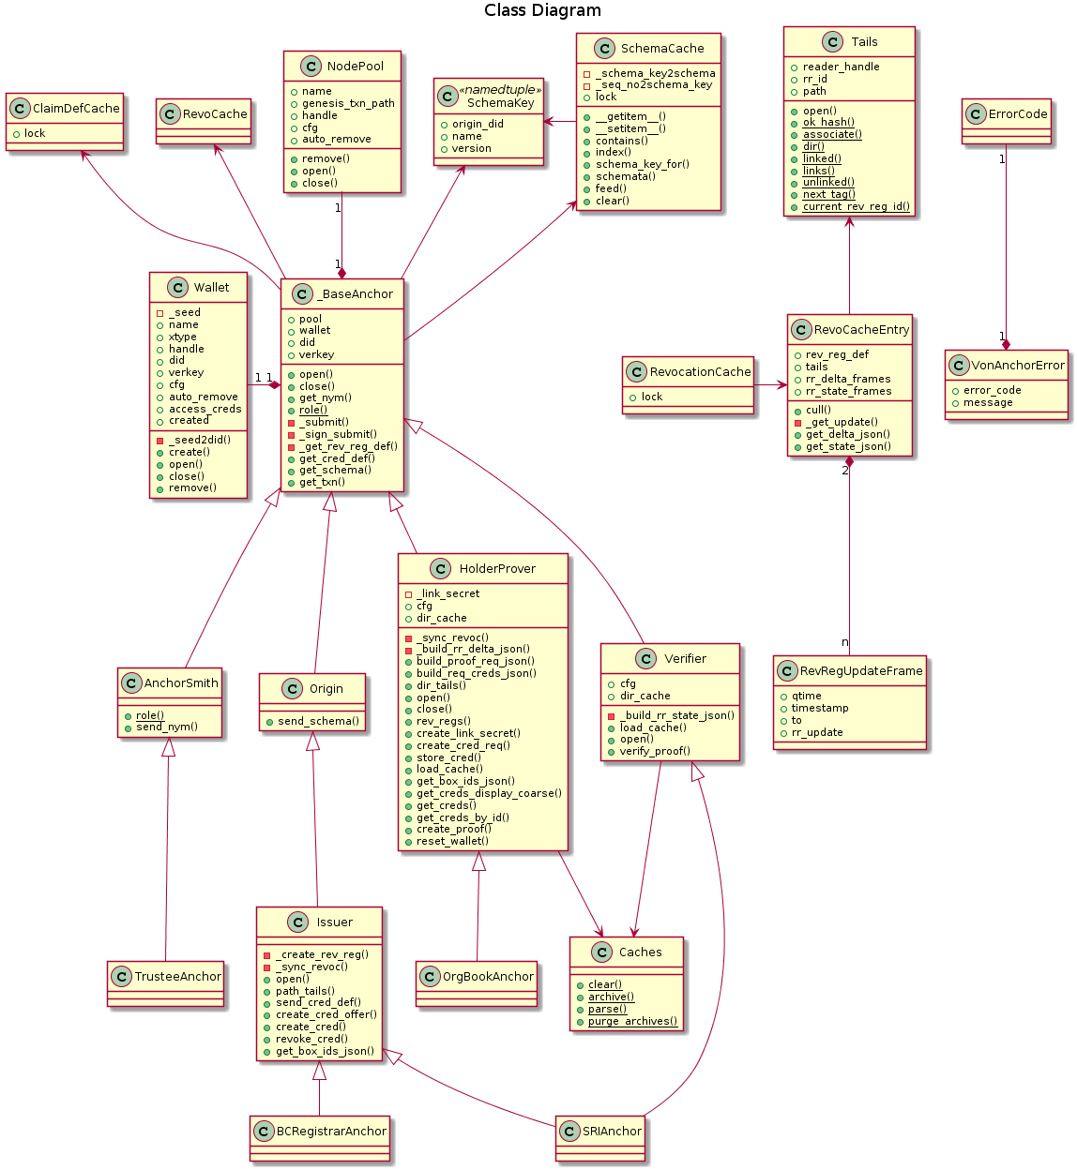Illustration 12: Class Diagram

Tails
The Tails class forms an abstraction layer to manage tails file for issuer and holder-prover anchors. Principally, it heads a directory tree with tails files, and retains associations between revocation registries and their respective tails files.

Revocation Registries
A revocation registry comprises metadata regarding a credential definition, in addition to specifying the revocation strategy (whether new credentials issue, non-revoked, by default or on demand), the revocation accumulator, and the associated tails file. Issuer anchors write revocation registry definitions and states to the distributed ledger.
In addition to delimiters and numeric identifier type markers (both invariant), each revocation registry has an identifier that comprises its issuer DID, its credential definition identifier, and a trailing tag specific to the revocation registry.
The convention for von_anchor revocation registry tags is to begin on tag (stringified) 0 and increment with each new revocation registry on any given credential definition. In this way, Tails operation can discover the current revocation registry for a new credential, and default to the next tag on creation of a new revocation registry.

Tails Files
The issuer anchor uses the indy-sdk library to create a tails file to back a new revocation registry. Tails file generation requires an issuer anchor's private key. A tails file contains (randomly generated, enormous) factors multiplying into a revocation accumulator for as many potential credentials as the capacity of the revocation registry. Once generated, tails files are invariant and public. Note that [VT] presents the von_tails package, which includes an external tails file server and synchronization scripts to make them available.
Tails files are potentially enormous and expensive to generate – so much so that using an underlying libindy.so compiled for debug produces unacceptable performance for credential definitions supporting revocation. Tails file generation time scales linearly on the size of the revocation registry; hence, one expects every credential definition that supports revocation to produces many revocation registries. Revocation registry identifiers include a trailing tag to disambiguate between revocation registries for any given credential definition.

Tails Tree
Given that an issuer anchor may support many credential definitions, and that a credential definition may entail many (possibly, thousands of) revocation registries, a Tails tree splits a base directory by credential definition, and houses tails files in their respective subdirectories by their respective credential definition identifiers.
The figure illustrates the structure of the tails tree.
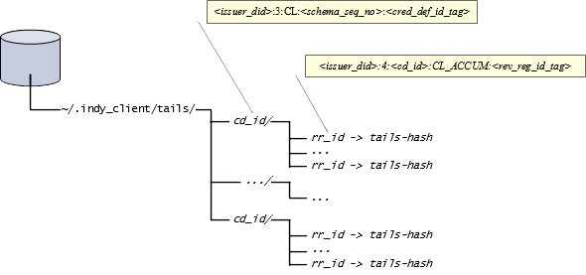Illustration 13: Tails Directory

Association
The indy-sdk library requires each tails file name to match the hash of its respective content as indy-sdk computes it. However, this convention provides no intrinsic label to associate which revocation registry produces which tails file – the only such association resides on the ledger, from revocation registry to tails hash. As such, the Tails class retains an association through local symbolic links, revocation registry identifier to tails file, on disk. On restart, an issuer or holder-prover anchor uses this association to re-establish which tails files belong to which revocation registries.

Instance Methods
The Tails class includes an initializer taking a base directory for the tails tree, a credential definition identifier for its associated revocation registry, and a tag (defaulting to the current, greatest numerically valued, tag on a symbolic link to a tails file in the subdirectory for the input credential definition identifier). The initializer finds the symbolic link and its tails file, and creates a configuration JSON object for indy-sdk handling of the tails file, and it sets a place holder for the indy-sdk tails file reader handle. If the operation does not find the link and the tails file, it raises AbsentTailsFile.
The (asynchronous) open() method opens the tails file reader via indy-sdk, setting the instance's reader handle.
The reader_handle(), rr_id(), and path() methods implement properties to query the indy-sdk reader handle, revocation registry identifier association, and path to the tails file of the current object.
Effectively, the only use of the instance methods is to ensure that required files are present (on initialization), to use the tails file reader, and to query either side of the (symbolic link to tails file) association. As the indy-sdk does not currently provide a means to close the tails file reader, the Tails file instance goes into a revocation cache entry that all anchors share, thus minimizing the number of open tails file handles.

Static Methods
The ok_hash() method returns whether an input string represents, by composition alone, a candidate for a tails hash.
The associate() method creates a symbolic link in its proper subdirectory to associate the revocation registry identifier and its tails file. Anchors use this method in synchronizing revocation registries.
The dir() method returns the subdirectory corresponding to the input credential definition identifier. The service wrapper API for a holder-prover anchor should use this method in uploading a tails file, to write it to the location where the Tails initializer can find it.
The linked() method takes a base directory and a revocation registry identifier, and returns the path to its associated tails file.
The links() method takes a base directory and an optional issuer DID, and returns a set of paths to all symbolic links under the base directory, retaining only those issued against the issuer DID if specified. Recall that revocation registry identifiers name every symbolic link in this tree.
The unlinked() method finds all tails files in the tree without associations via symbolic link. A tails file has no association until its issuer anchor associates it with its revocation registry identifier (immediately after creation). Neither does it have an association when a holder-prover anchor's service wrapper uploads it to its location in the tails tree – the holder-prover's revocation registry synchronization Note that the synchronization scripts in [VT] perform the association on download to the holder-prover.
The next_tag() method returns the next tag name available for a new revocation registry identifier on an input credential definition identifier, plus a size suggestion for the revocation registry. Given the expense of tails file creation, there is naturally a tension between the creation of large revocation registries for seldom-used credential definitions (too much compute time initially), against the creation of small revocation registries for often-used credential definitions (too many revocation registries and tails files). As such, the default behaviour of the von_anchor package is to begin with an initial revocation registry size of 256, doubling with each new revocation registry to a maximum of 4096.
The current_rev_reg_id() method returns the current (with highest value tag, numerically) revocation registry identifier for the input credential definition identifier. With no tag specified, the initializer uses this method to determine the current revocation registry per credential definition identifier, for new credential issue.

RevRegUpdateFrame
A revocation registry update frame f retains cached information about deltas or states for a revocation registry:
- a ledger timestamp time f.timestamp, preceding or matching
- a requested timestamp f.to, preceding or matching
- a query timestamp f.qtime (for bookkeeping), and
- a revocation registry update, representing a delta or state (dict).
The revocation registry identifier is extrinsic; the revocation cache entry itself retains it in its revocation registry definition as per section 3.2.1.3.
Note that a query at a given time must be for a timestamp in the past or present, and the ledger timestamp for the most recent update on the ledger corresponds to a revocation or credential issuer, and hence it must precede the requested timestamp (since an issuer anchor neither issue nor revoke in the future); i.e.,
f.timestamp <= f.to <= f.qtime
for all frames f.

RevoCacheEntry
Each revocation cache entry, implemented in von_anchor/cache.py, retains:
- a revocation registry definition,
- its associated Tails instance, and
- two managed lists of frames, housing revocation registry deltas (for proof creation) and updates (for proof verification).
The revocation cache entry implementation exposes methods get_delta_json() and get_state_json() as wrappers for workhorse _get_update_json() to retrieve its revocation registry's delta or state frame for a requested query interval (fro, to), in epoch seconds, past or present. The query interval represents goalposts on the window of interest for a revocation update; any information in that interval suffices.
The diagram illustrates actionable state cases; further elaboration follows.
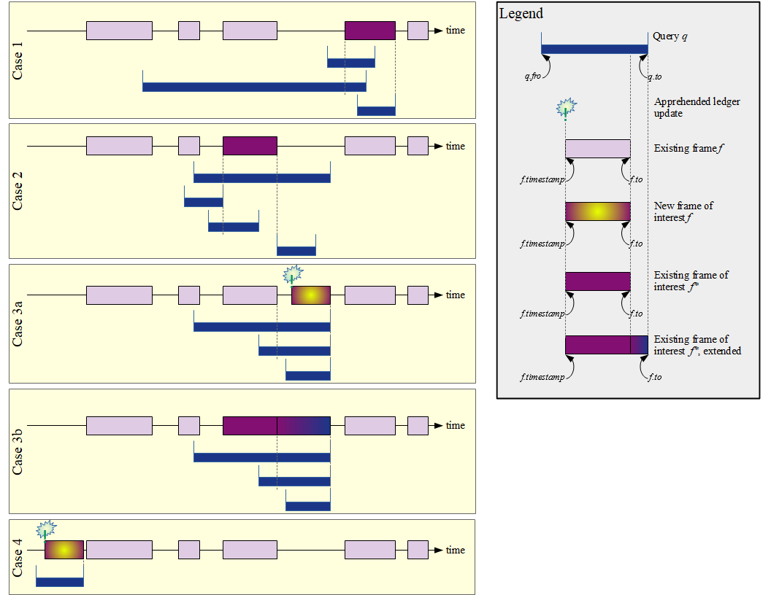Illustration 14: Querying Revocation Cache Update Frames

Case 1: Prior Request for Posterior Update Got Frame on Earlier Timestamp
If a frame f exists in the list where interval [f.timestamp, f.to] spans q.to for query q (i.e., f.timestamp <= q.to <= f.to), then any new update between this frame and the call's requested timestamp would represent a retroactive issue or revocation, which indy-sdk does not support. The frame satisfies the update request: the execution updates its query time and returns its revocation registry update along with the ledger timestamp.

Non-Case: Prior Request for Posterior Update Got Frame on Exact Timestamp
Consider the case where the case 1 above does not apply, but the list has a frame with the ledger timestamp matching q.to for query q and the frame's requested timestamp strictly precedes q.to.
Consider such a frame f in the list.
Since the above case does not apply, f.to < q.to.
But f.timestamp <= f.to, as per section 3.2.1.2.
Hence f.timestamp <= f.to < q.to == f.timestamp,
and we have f.timestamp < f.timestamp, a contradiction.

Case 2: Existing Frame Satisfies Query Interval
If case 1 above does not apply but there is a maximal (by timestamp) frame f with q.fro <= f.to and f.timestamp <= q.to, the frame satisfies the query interval. The execution returns the corresponding update, but does not extend the frame to q.to: an update may exist on the ledger after f.to, but it is not of interest to the current request, since the current frame is satisfies the query.

Case 3: Prior Request Got Frame on Earlier Timestamp
If neither case 1 nor case 2 above apply but maximal (by timestamp) frame f exists in the list with f.timestamp <= q.to, the execution isolates the frame and calls back to build a revocation registry update from f.to through q.to.
If the builder callback returns a new update on a ledger timestamp not yet known to the revocation cache, the operation creates a new frame on it, adds it to the list, and prunes old list entries if need be.
Otherwise, the update exhibits the same ledger timestamp as frame f: there is no new update and the frame can serve through the requested time q.to. The operation extends the frame accordingly; i.e., it sets f.to = q.to, then returns it along with its ledger timestamp.

Case 4: No Prior Request Got Frame on Earlier Ledger Timestamp
If the query's requested timestamp q.to precedes any cached frame's ledger timestamp f.timestamp, the execution calls back to build a revocation registry update from inception to the requested timestamp q.to. It creates a new frame on it, adds it to the list and prunes old list entries if need be. It returns the frame's revocation registry update and the ledger timestamp.

Pruning Heuristic
The revocation cache prunes registry update frame lists, when they exceed 80 frames, to retain the 48 most recent frames by query time. Given a typical maximum revocation registry size of 4096, the motivation is to hover the cache size about the the square root of this figure.
In case of (say) about 16 million drivers licences, this could yield up to 4000 revocation registries on a credential definition. Since each registry update frame list (json-deserialized) requires about 300 bytes per frame, this heuristic sets a maximum memory requirement of about 10MB per credential definition for revocation registry delta cache operation.

Schema Key
The content of a SchemaKey named tuple instance specifies a schema unambiguously through its origin_did, name, and version slots. Historically, the indy-sdk ledger used schema keys to identify schemas before migrating to schema identifiers. At present, the von_anchor design retains it principally to help disambiguate calls to get a schema via _BaseAnchor.get_schema() as per section 3.2.1.11.

Schema Cache
The von_anchor package defines singletons for caching schemata, claim definitions, and revocation registries in von_anchor/cache.py. The singleton construction allows all anchors running in a process to share the caches; for example, if an issuer anchor sends a credential definition to its cache, then a holder-prover in the same process may use the cache to get it without going to the ledger. Each class has a (re-entrant) lock to manage access.
The SchemaCache class allows for storage and retrieval by sequence number, by schema identifier, or by SchemaKey instance, reducing network chat with the distributed ledger.
The schemata() method lists all schemata in the instance.
The feed() method takes a list of schemata to add to the cache. If a schema on an incoming sequence number is already in the cache, the operation logs a warning and demurs: it is not possible for an archived schema to represent an update on one already in the live cache.
The clear() method clears the cache.

Credential Definition Cache
The CredDefCache derives from simple dict and offers a class-wide (re-entrant) lock. It indexes credential definition data by credential definition identifier, reducing network chat with the distributed ledger.
All anchors share a common credential definition cache; hence, any anchor in the process benefits from any other anchor's contribution.

Revocation Cache
The RevoCache derives from simple dict and offers a class-wide (re-entrant) lock. It indexes definitions, associated Tails instances, and update frames (on deltas and states) for revocation registries, reducing network chat with the distributed ledger and open file handles (recall that indy-sdk does not allow for the closing of a tails file reader at present).
The revocation cache additionally offers the dflt_interval() instance method, computing a default non-revocation interval by credential definition identifier on the current content of the revocation cache. This interval is the latest interval touching all revocation registries against the input credential definition identifier; the following figure illustrates.
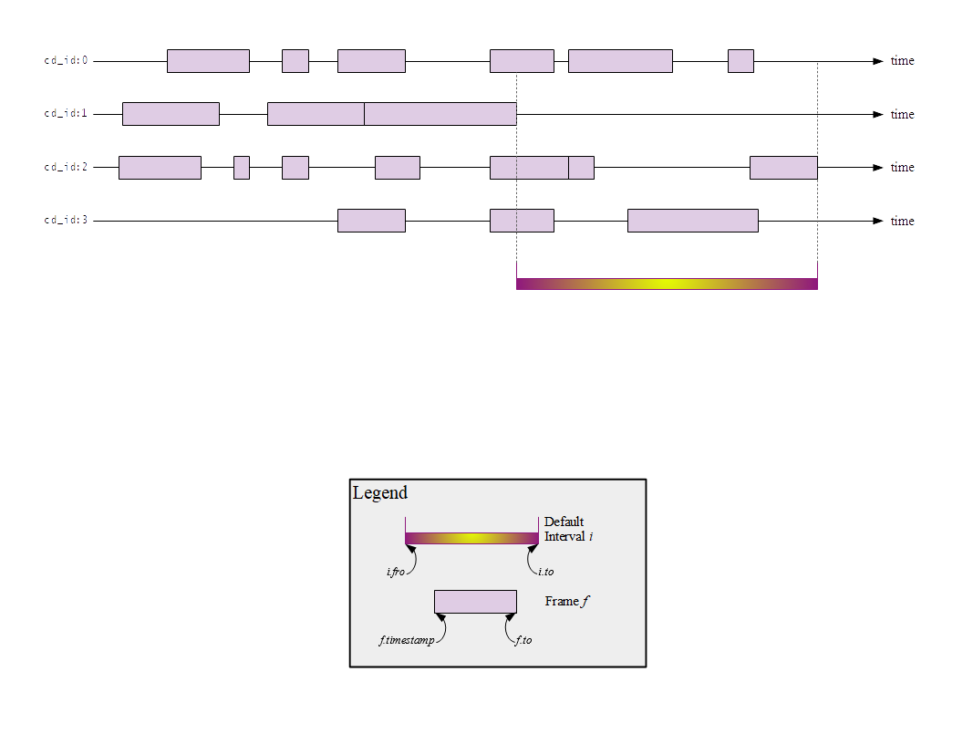Illustration 15: Revocation Cache Default Interval Computation per Credential Definition Identifier
All anchors share a common credential definition cache; hence, any anchor in the process benefits from any other anchor's contribution.

Caches Utility Class
The Caches class collects static methods to operate on all caches in unison, primarily for archival and parsing to inform off-line, cache-only operations. Note that all anchors share all caches, and so the anchor that invokes these methods should be the only one in the process.
The clear() method clears all caches.
The archive() method writes a cache archive to a subdirectory, named for the current timestamp in epoch seconds, of an input base directory.
The parse() method takes a base directory and timestamp (defaulting to the most current subdirectory name); its operation feeds the caches with the content in the archived files in that subdirectory. Note that since the distributed ledger only augments and never removes content, it is not possible for a cache archive to update a live cache if the cache has content for the same item: in this case, the operation logs a warning and demurs.
The purge_archives() method deletes old archived cache files, optionally preserving the most recent.

Node Pool
The NodePool class encapsulates the indy-sdk node pool. It resides in von_anchor/nodepool.py.
Its initializer stores a pool name for use with indy-sdk and the path to a file with a (copy of the) genesis transactions; it also takes an optional configuration dict supporting the auto_remove key; set its value True to instruct the node pool implementation to delete serialized indy-sdk configuration data on exit.
The context manager methods set up and tear down the pool within the indy-sdk. On opening, the indy-sdk creates control files on the pool name in directory $HOME/.indy_client/pool/ and returns a pool handle, which the the NodePool object retains for future indy-sdk interaction. On closing, the instance directs the indy-sdk to invalidate the handle and delete its control files (if so configured).

Wallet
The Wallet class encapsulates the indy-sdk wallet. It resides in von_anchor/wallet.py.
Its initializer takes:
- a cryptographic seed,
- the wallet name,
- a storage type (default None),
- an optional configuration dict supporting:
  - the auto_remove key (set its value True to instruct the wallet implementation to delete serialized indy-sdk configuration data on exit),
  - any further properties to pass through to the indy-sdk for its own wallet configuration; and
- an optional access credentials dict.
A distinct asynchronous create() call prompts the wallet object to bootstrap the wallet as an object in the underlying indy-sdk (if it does not yet exist, serialized per its wallet type). When creating a new DID from seed for its user, the implementation writes the seed to metadata.
The context manager methods set up and tear down the wallet within the indy-sdk. On opening, the indy-sdk opens its control files (per its wallet type) and returns a wallet handle, which the the Wallet object retains for future indy-sdk interaction. On closing, the instance directs the indy-sdk to invalidate the handle and delete its control files (if so configured).
An internal _seed2did() utility first tries to retrieve the DID from a matching seed in metadata. If there is none, it uses a temporary wallet on the default (lightweight) wallet type to prompt the indy-sdk to convert the seed to a corresponding DID. The open()/__aenter__() context manager methods, as well as the create() method when the wallet already exists, use this utility to get the DID without overwriting it in the wallet, then to populate the verification key from this DID. Abstaining from overwriting the DID on every open allows for future support of key update without mysteriously clobbering the current key every time.

Anchors
This section outlines the design of the classes implementing anchor functionality. Anchor source code resides in von_anchor/anchor/. Anchors of use principally for the demonstration in scope reside in file von_anchor/anchor/demo.py.; the remainder of the source code implements purely indy-sdk concepts.

_BaseAnchor
The _BaseAnchor class implements essential functionality that defines an anchor: it holds references to a wallet and the node pool for use within indy-sdk; it implements calls common to all anchors of all kinds.
Its property methods make an instance's pool and wallet available; convenience methods delegate to the wallet to make its DID and verification keys available.
Its context manager methods engage the underlying counterparts of the Wallet class.
The class's _submit() and _sign_submit() methods encapsulate boilerplate to submit requests and return responses against the indy-sdk ledger. Both methods raise ClosedPool if operating off-line (holder-prover and verifier anchors off-line must operate entirely from caches) or BadLedgerTxn on a request that the indy-sdk cannot process; _sign_submit() raises CorruptWallet on a signed request that appears to use a wallet for node pool distinct from the anchor's current one.
Its get_nym() method fetches and return the anchor's cryptonym from the distributed ledger via the indy-sdk.
Its _get_rev_reg_def() method gets a revocation registry definition from the ledger. Typically the result comes from the revocation cache; if it goes to the ledger, the implementation populates the cache before returning. Under ordinary use, actuators do not need to call this method; issuer, holder-prover, and verifier anchors call it internally.
Its (static) role() method returns the TRUST_ANCHOR indicator, sufficing for all subclasses except AnchorSmith.
Its get_schema() and get_cred_def() methods retrieve schema and credential definitions the ledger. Typically the result comes from its cache; if it goes to the ledger, the implementation populates the applicable cache before returning.
The get_txn() method returns a distributed ledger transaction's content by sequence number.

AnchorSmith
The AnchorSmith class exposes send_nym() to fulfill calls to send a cryptonym to the ledger.
Its (static) role() method returns the TRUSTEE indicator.

Origin
The Origin class exposes send_schema() to fulfill calls to send a schema to the ledger. First, its operation checks if the schema is present already; if so, it logs an error and returns it. Otherwise, it sends the schema to the ledger and adds it to the schema cache before returning it.

Issuer
The Issuer class, by design, inherits from Origin. It has its own initializer and open() methods to manage and to synchronize its tails tree content (revocation registry identifiers to tails files). Actuators need not call its _create_rev_reg() and _sync_revoc() methods; it uses them internally as required to create new revocation registries and tails files, and to synchronize their associations.
Its open() method synchronizes its revocation registries, configuring reader handles in indy-sdk for opening when required and setting their Tails objects in the revocation cache if need be.
It exposes the path_tails() method to inform its service wrapper API of the path to a tails file for a given revocation registry identifier.
Its send_cred_def() method attempts to create a credential definition, given a schema and boolean indicating revocation support, and to send it to the distributed ledger. The operation creates a subdirectory for the credential definition identifier in the tails directory, even if the credential definition does not support revocation, against a future need for box identifier collection. First, it checks whether credential definition already exists on the ledger and in the wallet, and behaves as per the following table:
Credential Definition Presence |  | Wallet
 |  | Absent | Present
Distributed Ledger | Absent | Create in wallet, send to distributed ledger | Raise CorruptWallet: anchor wallet does not correspond to anchor's node pool
Distributed Ledger | Present | Create in wallet, log warning (private key operations not possible), and carry on: sometimes anchors have many roles and so public key operations may suffice for the session (e.g., forensic scenario) | Log info (reuse existing cred def)
Table 1: Issuer Send Credential Definition: State and Behaviour
Its create_cred_offer() method creates and returns a credential offer for a schema on a given sequence (transaction) number. Note that the schema sequence number is the last token in a credential definition identifier.
Its create_cred() method takes an indy-sdk credential offer structure, an indy-sdk credential request structure, and a dict of attribute names and values comprising the credential to issue. The operation finds the requisite credential definition from the credential offer and the distributed ledger (typically, from the cache). If the credential definition supports revocation, the operation creates a new revocation registry if the current one is full, and issues the credential. It returns a triple with the new credential and, if the credential definition supports revocation, its credential revocation identifier and the ledger timestamp of its revocation registry delta entry.
Its revoke_cred() method revokes a credential by revocation registry identifier and credential revocation identifier, updating the revocation registry state on the distributed ledger and returning the time of the ledger transaction in epoch seconds.
Its get_box_ids_json() method collects and returns box identifiers (schema identifiers, credential definition identifiers, and revocation registry identifiers) for all credential definitions and credentials that the issuer has issued. This operation can be useful for a verifier going off-line to seed its cache before doing so (potentially, via the emerging VON-X layer).

HolderProver
The HolderProver class has its own initializer method to set up a place holder for its link secret, to set its directory for cache archives, and to set any configuration parameters. Actuators need not call its _sync_revoc() nor _build_rr_delta_json() methods; the implementation uses them internally as required to create manage tails file associations, and to build revocation registry delta structures (as a callback per section 3.2.1.3).
It implements properties for access to its configuration and cache directory.
Its configuration dict, specified on initialization, has boolean settings for keys parse-cache-on-open and archive-cache-on-close.
Its open() method synchronizes its tails file associations (in case of a new tails file download) and, if its configuration sets parse-cache-on-open, feeds the caches with its most recent archive.
Its close() method synchronizes its tails file associations (in case of a new tails file download) and, if its configuration sets archive-cache-on-close, populates the shared caches with enough data to prove all credentials in its wallet before archiving cache content to file.
Because these operations could monopolize the (shared) caches, it is best for an off-line holder-prover to be the only anchor in its process. The following figure illustrates the process of priming a holder-prover anchor for off-line operation.
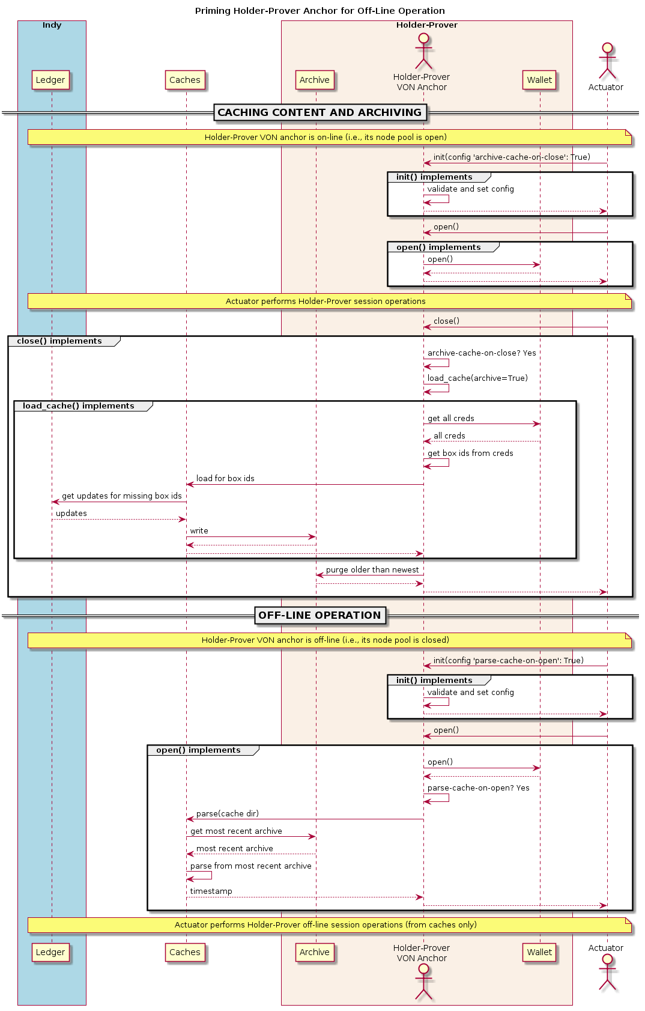Illustration 16: Priming Holder-Prover Anchor for Off-Line Operation
The class's build_proof_req_json() helper takes a specification construct, and a cache_only boolean. It returns an indy-sdk proof_request structure (JSON encoded). The specification construct is a dict on credential definition identifiers. Each key is a credential definition identifier; its value is a dict mapping:
- 'attrs' to a list of attributes of interest
  - if the key is absent, request all attributes
  - if the key is present but the value is null or empty, request no attributes (i.e., only predicates)
- 'minima' to a dict of lower bound values to request (by predicate) per attribute
  - if the key is absent or the value is null or empty, request no predicates
- 'interval' to a single timestamp of interest, in integer epoch seconds, or to a pair of integers marking the boundaries of a non-revocation interval; if absent,
  - request the present moment if the credential definition supports revocation and cache_only is set,
  - request the default cache non-revocation interval as per section 3.2.1.7 if the credential definition supports revocation and cache_only is clear,
  - omit if the credential definition does not support revocation.
Its build_req_creds_json() helper builds an indy-sdk requested credentials structure. It takes an indy-sdk credentials structure and an optional filter to apply, plus an additional optional boolean specifying default behaviour for that filter as follows:
- an absent filter parameter means no filter: request all credentials
- otherwise, request any credential on a credential definition identifer that is not present in the filter if and only if the boolean is set (True).
The filter itself maps credential definition identifiers to criteria for attribute values and minima to include in the requested credentials via the following specifications per credential definition identifier:
- 'attr-match' to a dict mapping attribute names to values to match
  - if the key is absent or the value is null or empty, match everything
- 'minima' to a dict of lower bound values to respect (by predicate) per attribute
  - if the key is absent or the value is null or empty, match everything.
Its dir_tails() method returns the path to the subdirectory of the tails tree where an incoming tails file should go - the service wrapper layer must implement the upload itself.
Its rev_regs() method returns a list of revocation registry identifiers for which the anchor has associated tails files, creating such associations for newly landed tails files without (so that an actuator may poll this method to find a listing for a tails file as soon as it lands). A service wrapper layer (or possibly VON-X) may use this to determine whether it needs a tails file for an upcoming operation.
Its create_link_secret() method sets the link secret, for proof creation, in the wallet.
Its create_cred_req() method creates a credential request for an input credential offer and credential definition. It returns the credential request and its associated metadata.
Its store_cred() method stores a credential in the wallet. It returns the credential identifier as it appears in the wallet.
Its get_creds_display_coarse() method returns a human-readable synopsis of credentials in the wallet, filtered coarsely (or not at all) by components of schema identifier and/or credential definition identifier. Its operation returns a list of credentials, not a true indy-sdk credentials structure. The actuator may use this facility iteratively with a human user to identify credentials of interest by attribute and predicate filter, or by wallet identifier (a.k.a. referent), to pass into get_creds() or get_creds_by_id() and hence to retrieve a proper indy-sdk credentials structure.
Its get_creds() method returns a tuple on a set of wallet credential identifiers and an indy-sdk credentials structure on credentials of interest. It takes an indy-sdk proof request structure and an optional filter to apply, plus an additional optional boolean specifying default behaviour for that filter as follows:
- an absent filter parameter means no filter: include all credentials
- otherwise, include any credential on a credential definition identifer that is not present in the filter if and only if the boolean is set (True).
The filter itself maps credential definition identifiers to criteria for attribute values and minima to include in the requested credentials via the following specifications per credential definition identifier:
- 'attr-match' to a dict mapping attribute names to values specifying credentials to include
  - if the key is absent or the value is null or empty, do not filter by attribute value
- 'minima' to a dict of lower bound values to require per attribute in credentials to include
  - if the key is absent or the value is null or empty, do not filter by attribute minimum.
The class's get_creds_by_id() method takes an indy-sdk proof request and wallet credential identifiers (a.k.a. referents) of interest. The operation returns an indy-sdk credentials structure on those specified credential identifiers.
Note a credential's revocation status does not affect whether any anchor returns it via the methods above.
Its create_proof() method creates a proof for input indy-sdk proof request, credentials, and requested-credentials structures.
Its reset_wallet() method allows the service wrapper layer to delete the wallet and start a new one of the same type, setting link secret to the prior value.

Verifier
The Verifier class has its own initializer method to set its directory for cache archives and to set any configuration parameters. Actuators need not call its _build_rr_state_json() method; the implementation uses it internally as required to build revocation registry state structures (as a callback per section 3.2.1.3).
It implements properties for access to its configuration and cache directory.
Its configuration dict, specified on initialization, has a boolean setting for key parse-cache-on-open and a box-ids structure (i.e., a dict of lists on keys schema_id, cred_def_id, and rev_reg_id) for key archive-on-close.
Its open() method, if its configuration sets parse-cache-on-open, feeds the caches with its most recent archive.
Its close() method, if its configuration has content for archive-on-close, populates the shared caches for all specified box identifiers before archiving cache content to file.
Because these operations could monopolize the (shared) caches, it is best for an off-line verifier to be the only anchor in its process. The following figure illustrates the process of priming a verifier anchor for off-line operation.
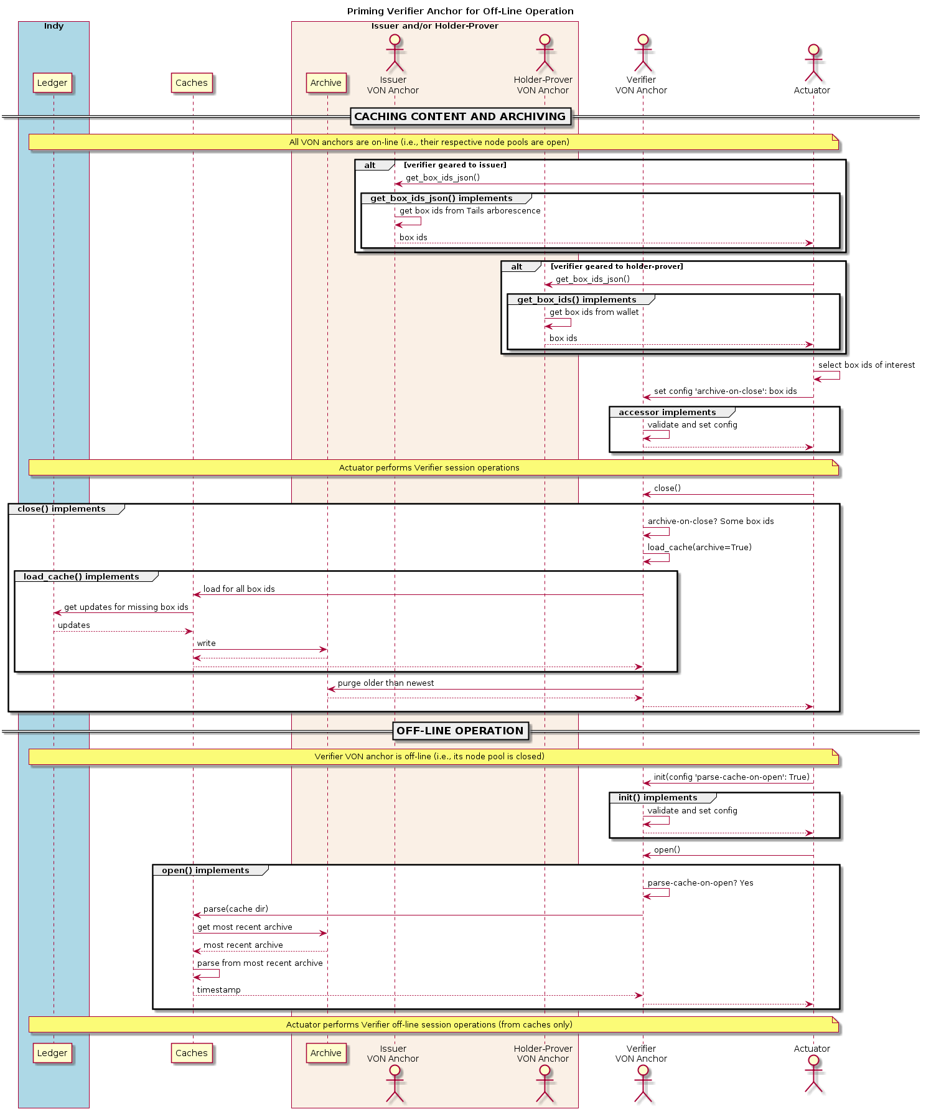Illustration 17: Priming Verifier Anchor for Off-Line Operation
The Verifier class exposes the verify_proof() method to verify an input proof against its proof request. It returns True or False.

Demonstration Anchor Classes
The TrusteeAnchor, SRIAnchor, OrgBookAnchor, and BCRegistrarAnchor of file von_anchor/anchor/demo.py use the derived mixins above to create their respective demonstration VON anchor classes.

Configuration Validation
The validate_config.py file includes code to validate configuration objects via JSON schema for Issuer, Verifier, and NodePool and instances.
Wallet configuration depends on the implementation per wallet type – the wallet initializer itself validates that any auto-remove configuration value is boolean. The current implementation retains this class as a means of configuration validation in anticipation of upcoming indy-sdk wallet development, whereupon it can take on wallet configuration validation.

Utility Functions
This section outlines utilities available within the package. Utility functions reside in files von_anchor/util.py and von_anchor/codec.py.

Function ppjson()
File von_anchor/util.py exposes function ppjson(). This utility takes a JSON serialized or serializable structure and returns a pretty-print. If the structure is not compatible with JSON, it returns a python pretty-print instead. An optional parameter allows a maximum length, at which the operation truncates the output (excluding three characters for a terminating ellipsis).

Identifier Wranglers
File von_anchor/util.py exposes several functions to work with indy-sdk identifiers (plus SchemaKey of section 3.2.1.4).
Identifiers for indy-sdk schemata, credential definitions, and revocation registry definitions take forms as per the following table.
Identifier Type | Format | Example
Schema identifier | <origin-did>:2:<name>:<version> | V4SGRU86Z58d6TV7PBUe6f:2:gvt:1.0
Credential definition identifier | <issuer-did>:3:CL:<schema-seq-no>:<tag> | V4SGRU86Z58d6TV7PBUe6f:3:CL:13:0
Revocation registry identifier | <issuer-did>:4:<cred-def-id>:CL_ACCUM:<tag> | V4SGRU86Z58d6TV7PBUe6f:4:V4SGRU86Z58d6TV7PBUe6f:3:CL:13:0:CL_ACCUM:0
Table 2: Identifiers Forms within indy-sdk
The schema_id() function returns a schema identifier on the input origin DID, schema name, and schema version.
The schema_key() function returns a SchemaKey named tuple corresponding to the input schema identifier.
The cred_def_id() function returns a credential definition identifier on input issuer DID and schema sequence number. Recall that a schema may root a credential definition for any issuer anchor.
The cred_def_id2seq_no() function returns the schema sequence number from an input credential definition identifier.
The rev_reg_id() function returns a revocation registry identifier on input credential definition identifier and tag. Recall that a credential definition may root a revocation registry per issuer and tag.
The rev_reg_id2cred_def_id() function returns the credential definition identifier embedded in the input revocation registry identifier.
The rev_reg_id2tag() function returns the tag of an input revocation registry identifier.
The rev_reg_id2cred_def_id__tag() convenience function returns the a tuple with the credential definition identifier, and the tag, embedded in the input revocation registry identifier.
The ok_did(), ok_schema_id(), ok_cred_def_id(), and ok_rev_reg_id() functions return whether, on composition alone, their respective input strings represent acceptable DIDs, schema identifiers, credential definition identifiers, and revocation registry identifiers.

Wranglers for indy-sdk Credential and Proof Data Structures
File von_anchor/util.py houses several functions to work with indy-sdk credential and proof data structures for display, triage, and filtration.
Utility box_ids() takes an indy-sdk credentials structure and an optional list of wallet credential identifiers (a.k.a. referents; default all credentials). It returns a python dict mapping each input credential identifier to its box identifier dict (schema identifier, credential definition identifier, revocation registry identifier). This operation can be useful in choosing credentials of interest.
Utility prune_creds_json() takes an indy-sdk credentials structure and a set of wallet credential identifiers (a.k.a. referents). It returns an indy-sdk credentials JSON structure on pruned of any credentials that the input set does not identify. This operation can be useful in narrowing the focus of a set of credentials for proof – recall that indy-sdk can create proof on at most one credential per credential definition at a time.
Utility creds_display() takes an indy-sdk credentials structure, an optional filter, and an optional inclusivity toggle. The filter is a python dict mapping schema identifiers to their own python dicts, each mapping an attribute name of the schema to a value. Should the credentials structure include credentials on more than one schema, the inclusivity toggle informs the operation whether to include those that the filter does not cite (default, True) or not (False). The output is a python dict mapping credential identifiers to human-readable credential synopses; e.g.,
{
"5820a07c-d92e-4ba3-8d8b-0799ee4338ec": {
"cred_def_id": "Q4zqM7aXqm7gDQkUVLng9h:3:CL:15:0",
"schema_id": "Q4zqM7aXqm7gDQkUVLng9h:2:bc-reg:1.0",
"referent": "5820a07c-d92e-4ba3-8d8b-0799ee4338ec",
"attrs": {
"endDate": "None",
"orgTypeId": "2",
"effectiveDate": "2012-12-01",
"legalName": "Tart City",
"busId": "11144444",
"id": "3",
"jurisdictionId": "1"
},
"rev_reg_id": "Q4zqM7aXqm7gDQkUVLng9h:4:Q4zqM7aXqm7gDQkUVLng9h:3:CL:15:0:CL_ACCUM:0",
"cred_rev_id": "3"
},
"c28b99dc-d800-3cf6-808f-913ba8b90fee": {
"cred_def_id": "Q4zqM7aXqm7gDQkUVLng9h:3:CL:15:0",
"schema_id": "Q4zqM7aXqm7gDQkUVLng9h:2:bc-reg:1.0",
"referent": "c28b99dc-d800-3cf6-808f-913ba8b90fee",
"attrs": {
"endDate": "None",
"orgTypeId": "2",
"effectiveDate": "2018-12-01",
"legalName": "Flan Nebula",
"busId": "11198765",
"id": "4",
"jurisdictionId": "1"
},
"rev_reg_id": "Q4zqM7aXqm7gDQkUVLng9h:4:Q4zqM7aXqm7gDQkUVLng9h:3:CL:15:0:CL_ACCUM:0",
"cred_rev_id": "4"
},
...
}
for display and triage. This operation can be useful for an actuator to work with a human operator to choose credentials of interest (dict values), isolate their credential identifiers (dict keys), and feed them back to prune_creds_json(), for example
Utility revoc_info() takes an indy-sdk credentials structure and an optional filter mapping attribute names to values. It returns a python dict mapping revocation data pairs (revocation registry identifier, credential revocation identifier within the revocation registry) to the (stringified representations of) attributes of credentials matching the input filter; e.g.,
{
('Q4zqM7aXqm7gDQkUVLng9h:4:Q4zqM7aXqm7gDQkUVLng9h:3:CL:15:0:CL_ACCUM:0', '3'):
{
'busId': '11144444',
'effectiveDate': '2012-12-01',
'endDate': 'None',
'id': '3',
'jurisdictionId': '1',
'legalName': 'Tart City',
'orgTypeId': '2'
},
('Q4zqM7aXqm7gDQkUVLng9h:4:Q4zqM7aXqm7gDQkUVLng9h:3:CL:15:0:CL_ACCUM:0', '4'):
{
'busId': '11198765',
'effectiveDate': '2018-01-01',
'endDate': 'None',
'id': '4',
'jurisdictionId': '1',
'legalName': 'Flan Nebula',
'orgTypeId': '2'
},
...
}
for an actuator to work with a human to isolate a credential of interest to revoke by its revocation data.
Utility revealed_attrs() takes an indy-sdk proof and returns its revealed attributes, credential by credential, as a python dict mapping each credential definition identifier to its attribute names and their corresponding (decoded) values in the proof; e.g.,
{
"Q4zqM7aXqm7gDQkUVLng9h:3:CL:16:0": {
"effectivedate": "2012-12-01",
"enddate": null,
"id": 3,
"busid": "11144444",
"orgtypeid": 2,
"jurisdictionid": 1,
"legalname": "Tart City"
}
}
for an actuator to build proof of one credential into another that stems from it (recall that an indy-sdk proof can have at most one credential per credential definition). Mapping attributes from the credential definitions in the proof to relying credential definitions must be an exercise for the actuator (or possibly the VON-X layer), but note that indy-sdk canonicalizes attribute names in proofs (also, credential offers) – the canon() utility of section 3.2.3.4 may be of interest in navigating this detail.

Codec Utilities
File von_anchor/codec.py houses utilities for encoding and decoding indy-sdk attributes. Recall that indy-sdk operates elliptic curve cryptography on (immense) numeric input, and hence its callers must (invertibly) map all attribute values to non-negative integers for processing. Each attribute in indy-sdk structures carries a dict mapping raw and encoded keys to their respective values.
The cred_attr_value() convenience method takes a raw value and returns its indy-sdk mapping to its raw and encoded values.
The canon() convenience method canonicalizes an attribute name to its indy-sdk representation inside proofs and credential offers. This canonicalization is simple: it eliminates internal spaces and converts to lower case.
The encode() and decode() functions convert raw attribute values to a form that the indy-sdk can use in issuing credentials, creating proofs, and in verifying proofs.

Motivation: Predicates Need int32 Encoding
The indy-sdk requires any attributes that might be used in predicate proofs be 32-bit integers, such that the encoded value equals the raw value.

Solution: binhex + maxint32
The encode() function leaves (signed) 32-bit integers alone, encoding them to their string representations. It reserves 2³¹, 2³¹+1, and 2³¹+2 as sentinels for None, False, and True respectively, prepending the marker digit 2 to booleans as per below. It transforms all other input via UTF-8, binhex, and adding 2³¹ before outputting the corresponding string representation and prepending a digit marking the original type:
- 1 for strings
- 2 for booleans
- 3 for integers
- 4 for floating points
- 9 for any other (stringifiable) type.
The decode() function reverses the process and coerces the output into the type that its marker digit identifies – necessarily, any non-trivial encoding must result in a value that cannot correspond to a 32-bit integer.

Exception Hierarchy
This section outlines the Exception descendants that the von_anchor package defines. Each exception class descends from VonAnchorError, which itself inherits Exception, and each exception class encapsulates a simple error code and message.
Exception Class | Error Code | Semantics | Example
CredentialFocus | 1003 | Anchor attempting to prove zero credentials, or more than one credentials per credential definition | Actuator posts a get-proof form with credential filter resolving to multiple credentials for a single credential definition, or to no credentials at all
AbsentLinkSecret | 1005 | Anchor attempts to perform operation requiring link secret which is not set | Actuator calls holder-prover anchor to create credential request, but anchor has no link secret set
CorruptWallet | 1006 | Anchor wallet includes references to a ledger that no longer exists | Developer resets the distributed ledger and runs an anchor with an existing wallet from prior ledger instance.
AbsentSchema | 1007 | Anchor cannot find specified schema on ledger (or cache) | Verifier anchor attempts to verify proof that refers to a credential definition on a schema from a ledger to which the anchor's wallet does not pertain
AbsentCredDef | 1008 | Anchor cannot find specified specified credential definition on ledger (or cache) | Holder-prover anchor attempts to create a credential request against a credential definition from a ledger to which the anchor's wallet does not pertain
AbsentTails | 1009 | Anchor cannot find tails file that it requires | Holder-prover anchor attempts to store credential that specifies a revocation registry for which anchor has no tails file
CorruptTails | 1010 | Issuer failed to create tails file | Issuer anchor attempts to create new revocation registry, but indy-sdk fails to create tails file
BadRevocation | 1011 | Issuer cannot revoke credential as requested | Issuer anchor attempts to revoke credential that is already revoked, or that another anchor issued
BadLedgerTxn | 1012 | Distributed ledger transaction failed | Origin anchor attempts to send new schema to distributed ledger, but node pool is not responding
BadRevStateTime | 1013 | Revocation registry state timestamp predates revocation registry creation | Holder-prover anchor attempts to create proof on credential with non-revocation timestamp predating its registry creation (indy-sdk cannot)
AbsentInterval | 1014 | Credentials missing non-revocation interval, but credential definition supports revocation | Holder-prover anchor attempts to create proof on credentials that omit non-revocation interval, but credential definition supports revocation
AbsentRevReg | 1015 | Revocation registry not present on distributed ledger | Verifier anchor receives proof citing revocation registry that does not exist on the distributed ledger
BadIdentifier | 1016 | Encountered bad tails hash, DID, schema id, cred def id, rev reg id | Holder-prover anchor attempts to create proof on credentials citing bad cred def id
AbsentWallet | 3000 | Wallet cannot open as its control files do not exist | Anchor attempts to open a wallet that is not yet created
ClosedPool | 4000 | Pool is closed but operation needs it open | Anchor attempts to call a node pool for ledger data, but the pool is not open
CacheIndex | 5000 | Schema cache, credential definition cache, or revocation cache has no entry at given index | Anchor attempts to retrieve schema for a transaction number or schema key that it has not yet cached
JSONValidation | 9000 | JSON schema is corrupt or JSON form does not match schema | Node pool configuration dict missing required properties
Table 3: Exception Particulars

Installation
This section specifies the installation process of the demonstration. It assumes an Ubuntu-based distribution on 16.04 or higher.

Install Package von_base
On the host, issue:
$ sudo apt update
$ sudo apt upgrade
$ cd
$ git clone https://github.com/PSPC-SPAC-buyandsell/von_base.git
$ cd von_base
$ sudo ./setup
$ exit
to install the von_base package and then exit (to pick up docker group membership). The operation:
- installs operating system packages
- creates the pipenv virtual environment in the operator's home directory
- installs docker and docker-compose
- builds the indy node pool image (in case the installation will not include von_conx, which also does so)
- creates the indy_pool_network and von_conx_network docker networks
- installs the libindy.so binary to /usr/lib/.
Once this installation process completes (it takes a long time), the von_base package itself becomes extraneous except to hold this document for reference. All installed binary content is extrinsic to the package.
Before proceeding with any docker operations within the same shell, logout
$ exit
and log back in again as the operator at the prompt to pick up the new docker group assignment. Test the state of the installation with the test script as per section Error: Reference source not found

Test VON Base
The test harness checking successful installation of the von_base package resides at von_base/test/test_base. It is a bash script echoing 0 if the installation appears successful and a non-zero return code otherwise. To run the test, issue at the prompt:
$ cd
$ cd von_base/test
$ pipenv run test_base

Install Package von_anchor
This section allows for the independent installation of the von_anchor package. Note that some relying packages may include this step in their own installations; if so, this step will not be necessary.

From pypi to pipenv Virtual Environment
On the host, issue:
$ cd
$ pipenv install von_anchor
to install the von_anchor package in the pipenv virtual environment. This operation installs only python source code.

Full installation from github
On the host, issue:
$ cd
$ git clone https://github.com/PSPC-SPAC-buyandsell/von_anchor.git
$ pipenv install -r von_anchor/requirements.txt
to install the von_anchor package complete with test code and requirement setup in the pipenv virtual environment.

VON Anchor Unit Tests
This section specifies the invocation of the unit tests of the full (from github) von_anchor installation, to validate its fitness.

Prerequisites
This section specifies the prerequisites to satisfy after installing the VON anchor, prior to executing its unit tests.

Environment Variables
Export the following environment variables to operate the test von_anchor unit tests:
- RUST_LOG=error – the log level for indy-sdk's underlying rust wrapper of the cryptographic library
- PIPENV_MAX_DEPTH=16 – instructs pipenv to search up to 16 superdirectories to find its environment specification before constructing a new one in the local directory
- TEST_POOL_IP=10.0.0.2 – specifies the test pool IP address (default 10.0.0.2)

Node Pool
This section discusses the operation of the node pool, which operates the distributed ledger, defaulting to the indy-sdk indy_pool docker container that implements the indy_pool_network docker network. The von_base package, on installation, builds this implementation on the host.
Note that if using the default implementation, stopping and restarting the docker container implementing the node pool restores it to its pristine state after its genesis transactions. This action invalidates any wallet content generated over a prior iteration of node pool life.
The subsections below discuss when the node pool must be operating, and how to start it and stop it.

Necessity of Operation
The von_anchor test harnesses test_pool.py and test_anchors.py require the node pool to be running. The test_wallet.py, test_codec.py and test_cache.py test harnesses do not need the node pool to be running.

Starting
To start the node pool, issue
$ docker run -d --ip=10.0.0.2 --net=indy_pool_network indy_pool
at the bash prompt to start the container realizing the indy_pool_network docker network on a docker container running the indy_pool docker image. Recall that von_base installs this configuration on setup.

Checking
To check whether the default docker node pool is running, issue at the prompt:
$ docker ps --filter ancestor=indy_pool --filter status=running --no-trunc | sed '1,1d' | awk '{print $1}'
and check the result; a docker hash implies that pool is operational.
To check whether an external node pool is running, attempt to connect to one of its ports (typically, 9701-9708):
$ telnet <test-pool-ip> 9702
where <test-pool-ip> represents the IP address.

Stopping
To stop the default docker node pool, issue
$ docker rm $(docker stop $(docker ps -aq))
at the bash prompt to stop and remove the container.
Stopping an external node pool is out of scope for the demonstration.

Test Harness Operation
This section specifies the operation of the VON anchor test harnesses. These tests run on the pytest framework. The remainder of this section assumes:
- the installation of von_base as per section 4.1
- the successful test of von_base as per section 4.2
- the installation of von_anchor as per section 4.3
- the fulfilment of prerequisites as per section 5.1 (node pool necessity depends on choice of unit test).

Codec
This test harness exercises the utility to encode and decode claim attribute values for indy-sdk processing.
To operate test harness test_codec.py, issue at the prompt:
$ cd
$ cd von_anchor/test
$ pipenv run pytest -s test_codec.py

Cache Operation and Thread Safety
This test harness ensures that the schema cache can index by schema key or by transaction number.
Additionally, it exercises the cache lock mechanism's thread safety (note that all caches share the strategy, testing any one tests them all), sending 64 threads to compete in a simulation of getting and caching 5 distinct values, where writing a value to the cache for the first time sleeps 3 seconds. If the cache lock is thread-safe, the operation should get caught waiting exactly once per cache write; the operation asserts that the total elapsed time of operation is strictly less than twice (per cache write).
To operate test harness test_cache.py, issue at the prompt:
$ cd
$ cd von_anchor/test
$ pipenv run pytest -s test_cache.py

Node Pool
This test harness exercises the opening and closing of NodePool objects.
To operate test harness test_pool.py, check that the node pool is operational as per section 5.1.2.3 (starting it if necessary as per section 5.1.2.2), then issue at the prompt:
$ cd
$ cd von_anchor/test
$ pipenv run pytest -s test_pool.py

Wallet
This test harness exercises the opening and closing of Wallet objects.
To operate test harness test_wallet.py, check that the node pool is operational as per section 5.1.2.3 (starting it if necessary as per section 5.1.2.2), then issue at the prompt:
$ cd
$ cd von_anchor/test
$ pipenv run pytest -s test_wallet.py

Anchors
This test harness exercises the low-level and request-processing APIs of anchors, their successful restart on an existing node pool, revocation cache maintenance on their credential and proof creation, and their non-lockout in competition for cache locks.
To operate test harness test_anchors.py, ensure that the node pool is operational as per section 5.1.2.3 (start it if necessary as per section 5.1.2.2) and then issue at the prompt:
$ cd
$ cd von_anchor/test
$ pipenv run pytest -s test_anchors.py

Cleanup on Abends
The indy-sdk maintains state with files in the /.indy_client/ tree under the temporary and home directories.
If an abnormal exit corrupts files in this tree, then on the next startup of objects that indy-sdk resolves to the same file names, indy-sdk will raise an exception. The indy-sdk can survive a corrupt file in the temporary directory, but sometimes not in the home directory.
To clear such a jam, an operator can issue the following sequence at the prompt:
$ rm -rf ~/.indy_client
and then stop and start the node pool as per sections 5.1.2.4 and 5.1.2.2.
- Original Demonstration Synopsis
This section outlines the original use case motivating the von_agent v0.x series.
First, an actuator prompted a BC registrar agent (as an issuer), through a RESTful wrapper API, to produce claims from its database content, then to forward them by proxy to a BC Org Book agent (as a holder/prover) for storage via its own RESTful wrapper API.
Next, an actuator prompted an SRI agent (as a verifier) to fetch credentials (formerly known as claims at that time) from the BC Org Book agent by proxy, on behalf of an entity registered in BC that was enrolling into the SRI program. The actuator prompted the SRI agent to proxy to the BC registrar to get proof on the claims matching tombstone data identifying the entity of interest; the SRI agent verified the proof.
Then, the actuator extracted attributes of interest from the entity's BC registration and used the SRI agent (as an issuer) to augment them into SRI credentials (claims) to forward to a PSPC Org Book agent (as a holder/prover) store in its own wallet.
Finally, the actuator prompted the SRI agent to proxy to the PSPC Org Book agent (as a holder/prover) to create a proof the proof on this credential (claim), which the SRI agent would (as a verifier) verify.
The following illustration depicts the demonstration use case.
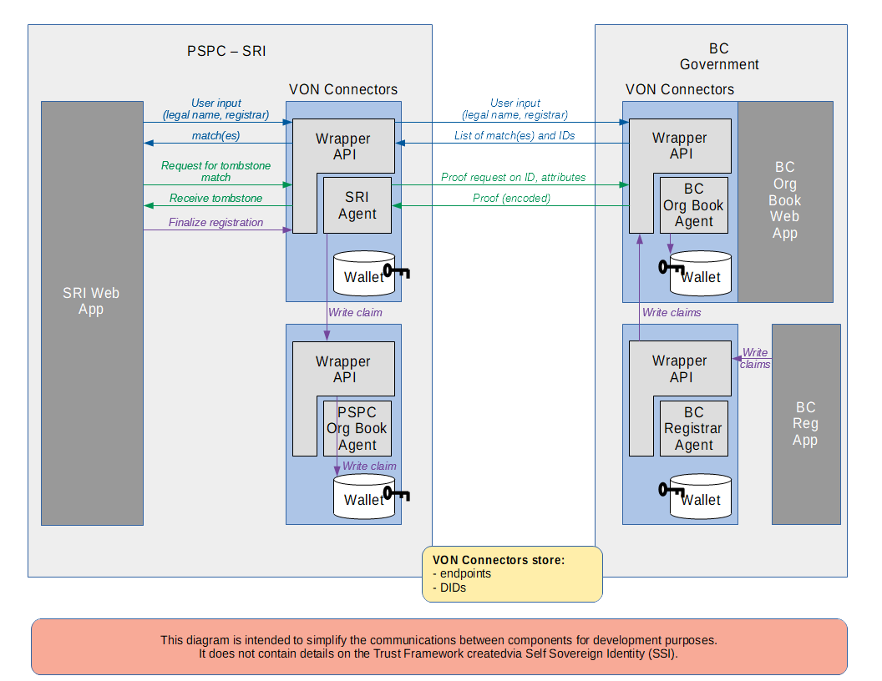Illustration 18: Original Demonstration Use Case for von_agent 0.x Series

