Public Services and Procurement Canada

Demonstration - von_conx
Engineering Document
author: Stephen Klump
date: 2018-04
version: 0.00

Table of Contents
1 Introduction 1
1.1 Demonstration Use Case 1
1.2 Overview 2
1.3 References 2
2 Startup and Shutdown 3
2.1 Startup 3
2.2 Shutdown 3
3 Demonstration 5
3.1 Get DIDs 5
3.2 Get Schema Attributes 6
3.3 Create a Claim Offer 8
3.4 Store the Claim Offer 10
3.5 Create the Claim 12
3.6 Store the Claim 13
3.7 Request a Claim 15
3.8 Request a Proof (by Filter) 16
3.9 Request a Proof by Referent 18
3.10 Verify a Proof 20

Introduction
As part of the technology demonstrator project using Hyperledger indy to explore the use of the distributed ledger with PSPC Supplier Registration Information (SRI), the design specifies agents with service wrapper APIs to facilitate interoperability. The von_conx project implements a reference connector to the Verifiable Organization Network (VON), verifying and using proofs from one claim holder/prover agent to create, issue, and store its own claims on its own holder/prover agent for further verification downstream.

Demonstration Use Case
The current state of the project aims to fulfil a demonstration use case enabling collaboration between the SRI and the British Columbia government’s The Org Book project, underpinning its Verifiable Organization Network (VON) as Illustration 1 depicts and [VA+C] elucidates in detail.
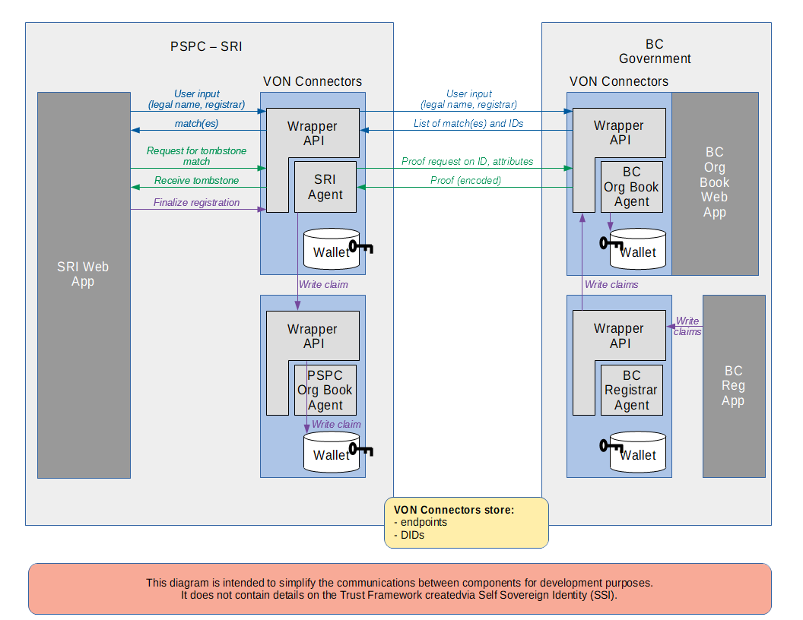Illustration 1: Use Case for Demonstration

Overview
The remainder of this work outlines the execution and operation flow for a demonstration of the von_conx offering via its openAPI implementation.

References
[VA+C] "VON Agent and Connector – Detailed Design Document". Public Services and Procurement Canada, 2018. https://github.com/PSPC-SPAC-buyandsell/von_base/blob/master/doc/agent-design.doc

Startup and Shutdown
This section outlines the startup and shutdown of the von_conx demonstration. It assumes that the operator has completed the installation and configuration of the offering as per [VA+C].

Startup
To start the agents on the indy pool network, the operator changes to the von_conx installation directory and issues:
$ cd ./docker
$ ./manage stop
$ ./manage start
The execution occupies the terminal window; the operator must wait for all agents to output a record noting that their Sanic components are "Goin' Fast" on their respective hosts and ports. Note that Issuers (sri, bc-registrar) require minutes to start as they must generate claim definitions cryptographically.
The startup process always begins from scratch on manage start, removing any extant containers from prior operations. To continue from existing containers, the operator may use
$ ./manage bg
instead (as the test harness does), which resumes the operation of any existing containers in the shell's background; the operator may follow a container's docker logs via
$ docker logs -f <docker_agent_1>
where <docker_agent_1> represents the agent container (not image) of interest.

Shutdown
To stop the agents on the indy pool network, the operator changes to the von_conx installation directory and issues:
$ cd ./docker
$ ./manage stop
Alternatively, if the docker containers are operating in the terminal's foreground, the operator may simply issuer control-C and wait for graceful shutdown.
To stop and remove all containers, the operator may issue:
$ ./manage rm
if docker-compose started all containers running on the terminal; in the of external containers operating (for example, the indy pool),
$ ./manage hose
stops and removes all operating docker containers.

Demonstration
This section specifies the demonstration of the von_conx RESTful service wrapper API, once all agents are running. The principal demonstration use case is to issue and load a claim, then to request the claim and its corresponding proof, and finally to verify the proof. Note that [VA+C] includes several images to follow the use case.
To begin, the operator launches a Web browser and opens tabs for each agent's openAPI landing page; by default, at the addresses below:
Agent | openAPI Landing URL
trust-anchor | http://<host-ip>:8990/swagger
sri | http://<host-ip>:8991/swagger
pspc-org-book | http://<host-ip>:8992/swagger
bc-org-book | http://<host-ip>:8993/swagger
bc-registrar | http://<host-ip>:8994/swagger
Table 1: Default Agent openAPI Landing URLs
Where <host-ip> represents the IP address of the installation host for von_conx.

Get DIDs
The operator should use the openAPI presentation layer to visit each agent in turn and get its DID
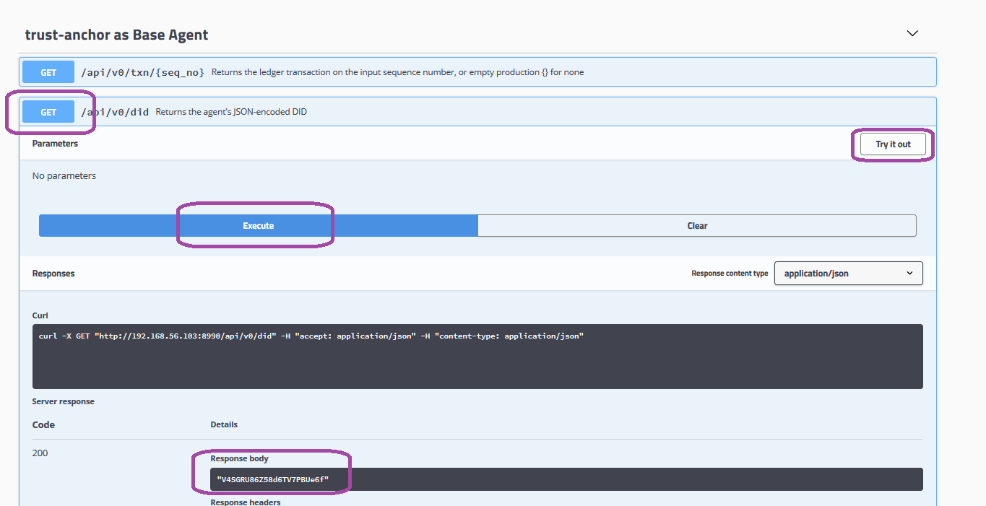
as per the image above:
- expand the GET /api/v0/did API call
- click Try it out (the button turns red and changes its text to Cancel)
- click Execute
- copy the DID (without the double-quotes) from the Response body control.
Record all agents against their respective DIDs to a file for future copy and paste.

Get Schema Attributes
The operator should visit any agent's openAPI presentation layer and get the attributes of schema bc-reg version 1.0, as the bc-registrar agent defines it (on startup)
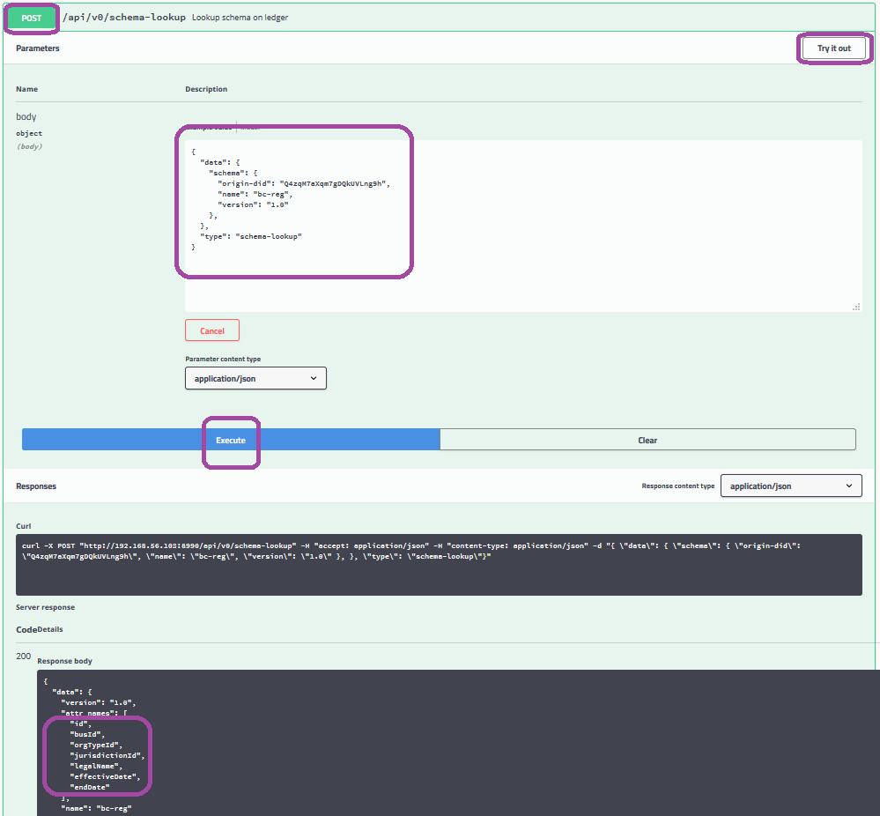Illustration 2: Get Schema Attributes
as per the image above:
- expand the POST /api/v0/schema-lookup API call
- click Try it out (the button turns red and changes its text to Cancel)
- Within the model,
  - delete the proxy-did key and value
  - specify the following values in the schema object:
    - the bc-registrar's DID for the origin-did
    - bc-reg for the name
    - 1.0 for the version
- click Execute
- copy the attr_names values from the Response body control.
Save the attribute names to a file to create a claim on them later.

Create a Claim Offer
The operator should visit the bc-registrar agent's openAPI presentation layer and create a claim offer
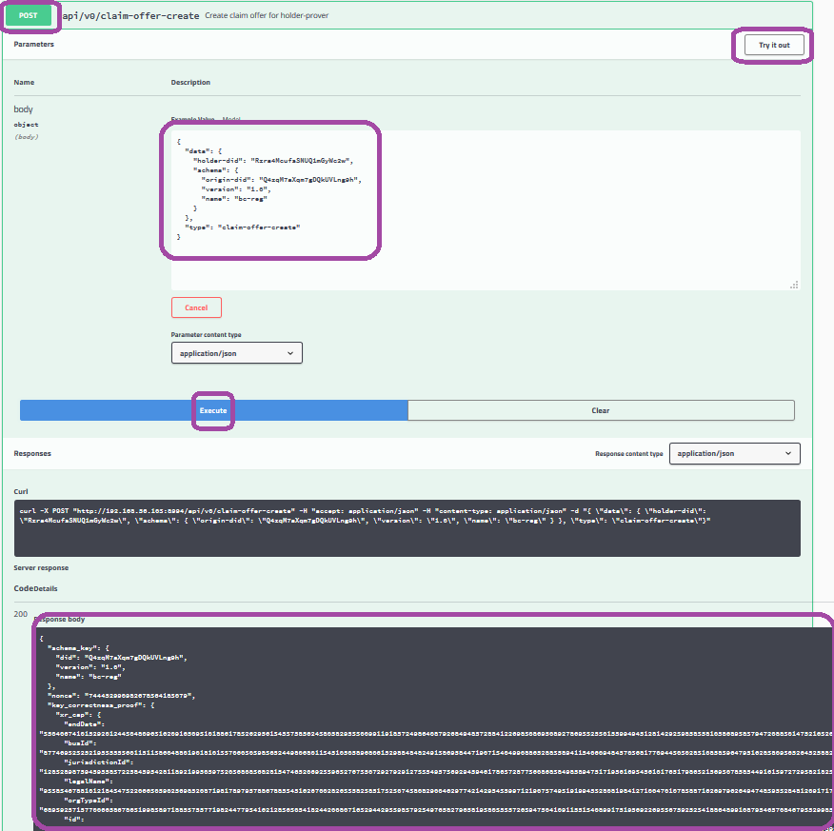Illustration 3: Create a Claim Offer
as per the image above:
- expand the POST /api/v0/claim-offer-create API call
- click Try it out (the button turns red and changes its text to Cancel)
- Within the model,
  - delete the proxy-did key and value
  - paste the bc-org-book's DID into the holder-did value
  - specify the following values in the schema object:
    - the bc-registrar's DID for the origin-did
    - bc-reg for the name
    - 1.0 for the version
- click Execute
- copy the entire content of the Response body control: this is the claim offer.

Store the Claim Offer
Under the bc-registrar's openAPI bc-registrar as Holder-Prover by Proxy tag, proxy to the bc-org-book to store the claim offer
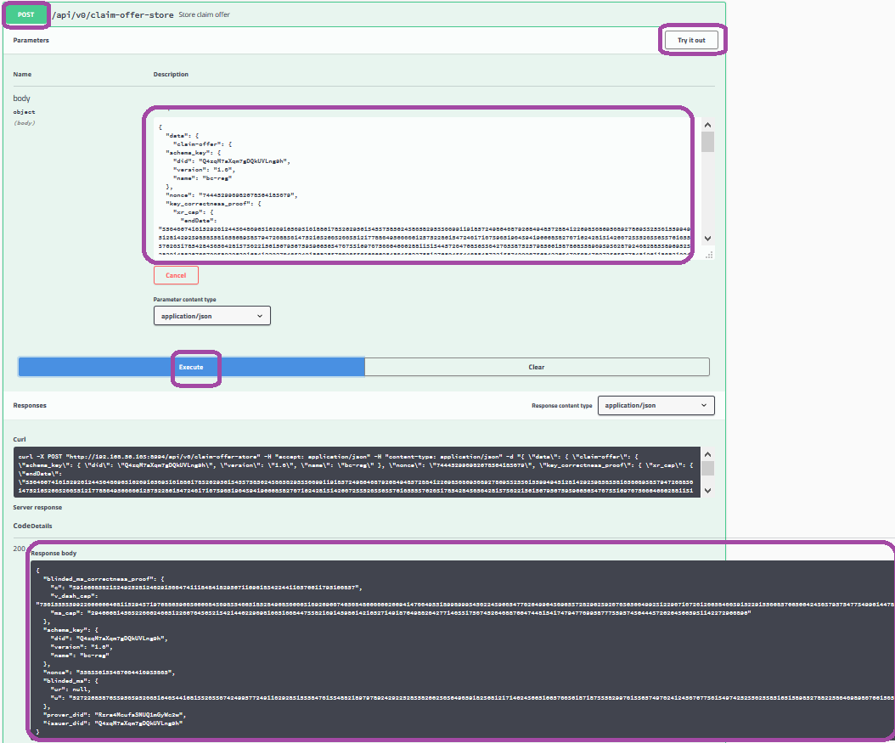Illustration 4: Store Claim Offer
as per the image above:
- expand the POST /api/v0/claim-offer-storeAPI call
- click Try it out (the button turns red and changes its text to Cancel)
- Within the model,
  - paste the bc-org-book's DID into the proxy-did value
  - paste the claim offer from section 3.3 into the claim-offer value, replacing the default empty production
- click Execute
- copy the entire content of the Response body control: this is the claim request.

Create the Claim
The operator should visit the bc-registrar agent's openAPI presentation layer and create a claim against the attributes copied above in section 3.2
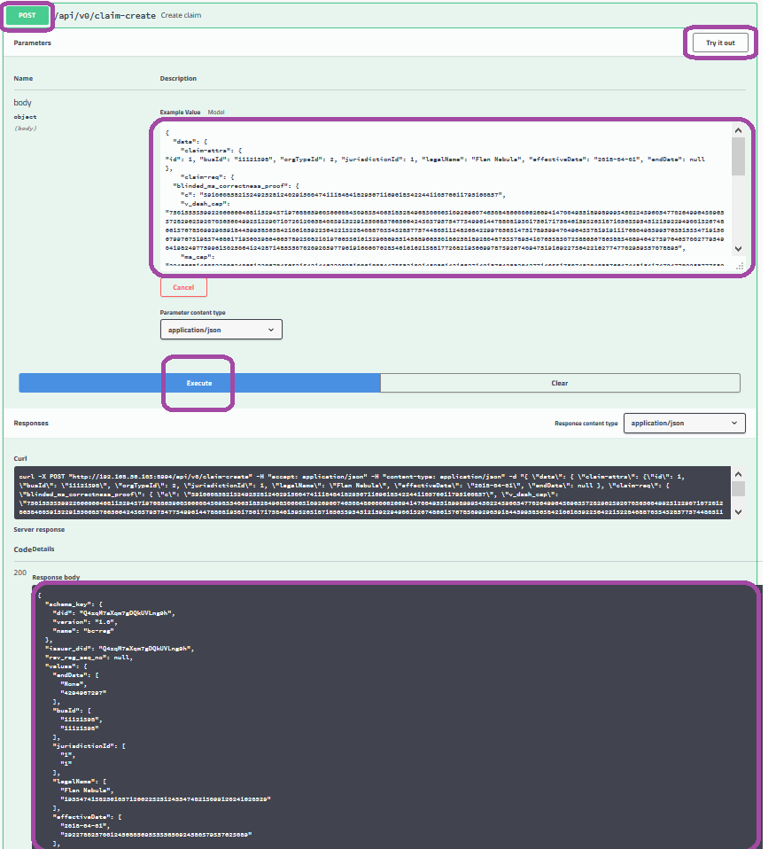Illustration 5: Create Claim
as per the image above:
- expand the POST /api/v0/claim-create API call
- click Try it out (the button turns red and changes its text to Cancel)
- Within the model,
  - delete the proxy-did key and value
  - paste the claim request (from section 3.4) into the claim-req value
  - specify the all claim attributes of the schema (from section 3.2), and a valid JSON value for each, within the claim-attrs value (e.g., {"id": 1, "busId": "11121398", "orgTypeId": 2, "jurisdictionId": 1, "legalName": "Flan Nebula", "effectiveDate": "2018-04-01", "endDate": null})
- click Execute
- copy the entire content of the Response body control: this is the claim.

Store the Claim
Under the bc-registrar's openAPI bc-registrar as Holder-Prover by Proxy tag, proxy to the bc-org-book to store the claim
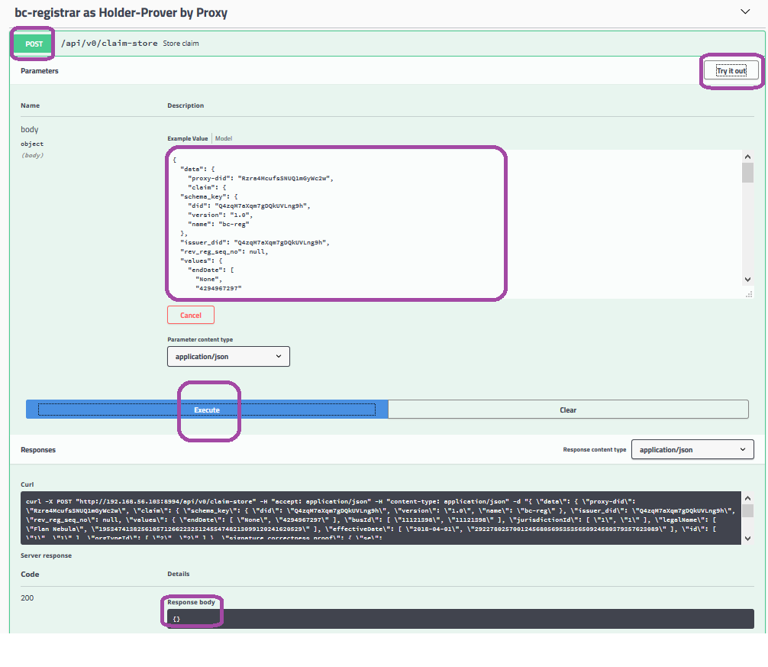Illustration 6: Store Claim
as per the image above:
- expand the POST /api/v0/claim-store API call
- click Try it out (the button turns red and changes its text to Cancel)
- Within the model,
  - paste the bc-org-book's DID into the proxy-did value
  - paste the claim from section 3.5 into the claim value, replacing the default empty production
- click Execute
- check that the Response body control contains an empty JSON production and indicates a 200 success code.

Request a Claim
Under the bc-registrar's openAPI bc-registrar as Holder-Prover by Proxy tag, proxy to the bc-org-book to request a claim
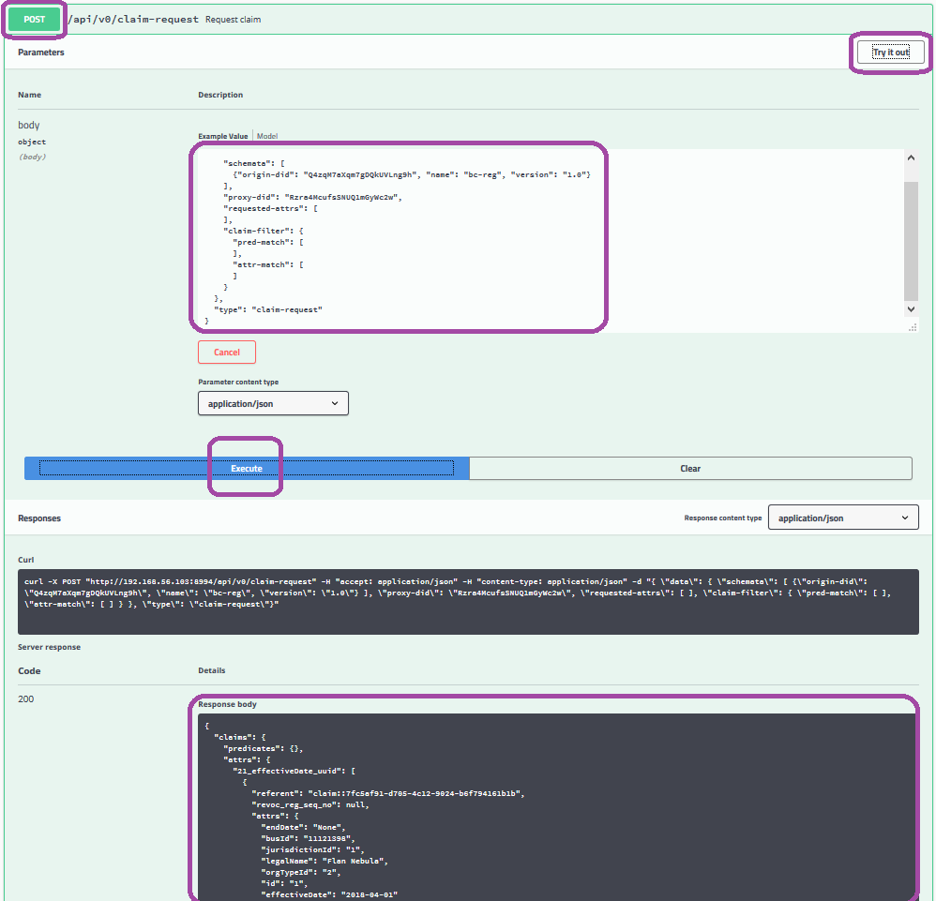Illustration 7: Request Claim
as per the image above:
- expand the POST /api/v0/claim-request API call
- click Try it out (the button turns red and changes its text to Cancel)
- Within the model,
  - paste the bc-org-book's DID into the proxy-did value
  - specify the following values in the schemata array item:
    - the bc-registrar's DID for the origin-did
    - bc-reg for the name
    - 1.0 for the version
  - specify empty arrays as values for the requested-attrs, pred-match, and attr-match keys, replacing their single empty JSON production array item default values
- click Execute
- from the Response body control, find and copy the referent value corresponding to the claim of interest.

Request a Proof (by Filter)
Under the bc-registrar's openAPI bc-registrar as Holder-Prover by Proxy tag, proxy to the bc-org-book to request a proof for a claim (by the same filter applied to retrieve the claim of interest above)
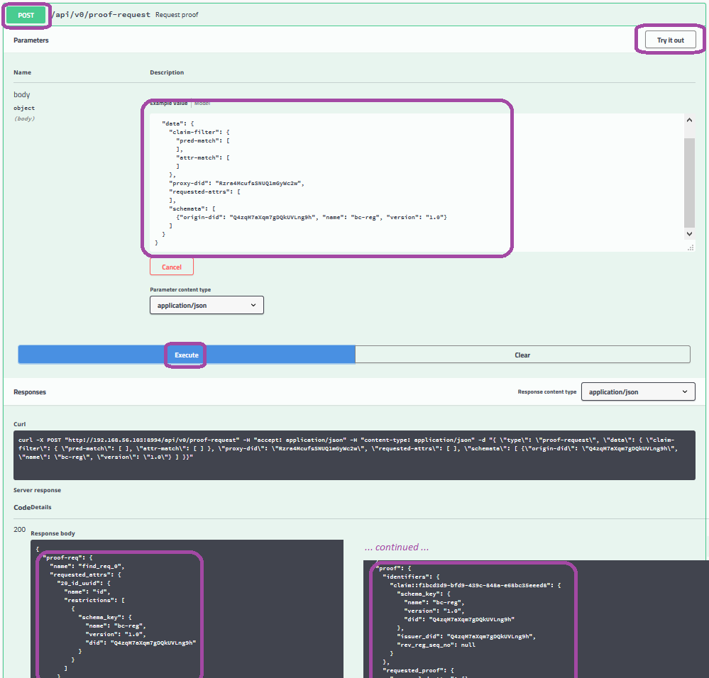Illustration 8: Request a Proof (by Filter)
as per the image above:
- expand the POST /api/v0/proof-request API call
- click Try it out (the button turns red and changes its text to Cancel)
- Within the model,
  - paste the bc-org-book's DID into the proxy-did value
  - specify the following values in the schemata array item:
    - the bc-registrar's DID for the origin-did
    - bc-reg for the name
    - 1.0 for the version
  - specify empty arrays as values for the requested-attrs, pred-match, and attr-match keys, replacing their single empty JSON production array item default values
- click Execute
- from the Response body control, find and copy the proof-request and proof values corresponding to the claim of interest.

Request a Proof by Referent
Under the bc-registrar's openAPI bc-registrar as Holder-Prover by Proxy tag, proxy to the bc-org-book to request a proof for a claim by referent
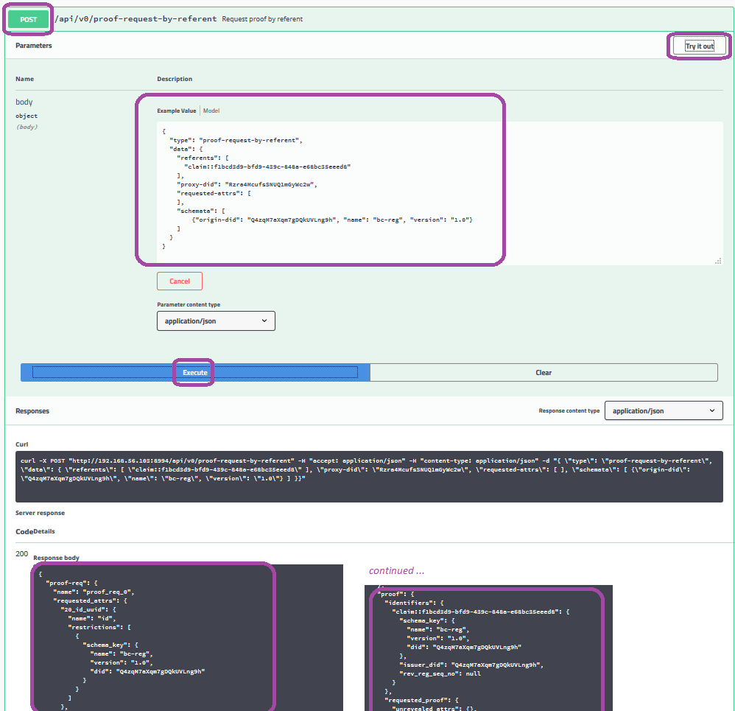Illustration 9: Proof Request by Referent
- expand the POST /api/v0/proof-request-by-referent API call
- click Try it out (the button turns red and changes its text to Cancel)
- Within the model,
  - paste the bc-org-book's DID into the proxy-did value
  - specify the following values in the schemata array item:
    - the bc-registrar's DID for the origin-did
    - bc-reg for the name
    - 1.0 for the version
  - specify an empty array as the value for the requested-attrs key, replacing their single empty JSON production array item default values
  - specify the referent of the claim of interest that the response identifies from section 3.7
- click Execute
- from the Response body control, find and copy the proof-request and proof values corresponding to the claim of interest.

Verify a Proof
Under the bc-registrar's openAPI bc-registrar as Verifier by Proxy tag, proxy to the bc-org-book to verify a proof
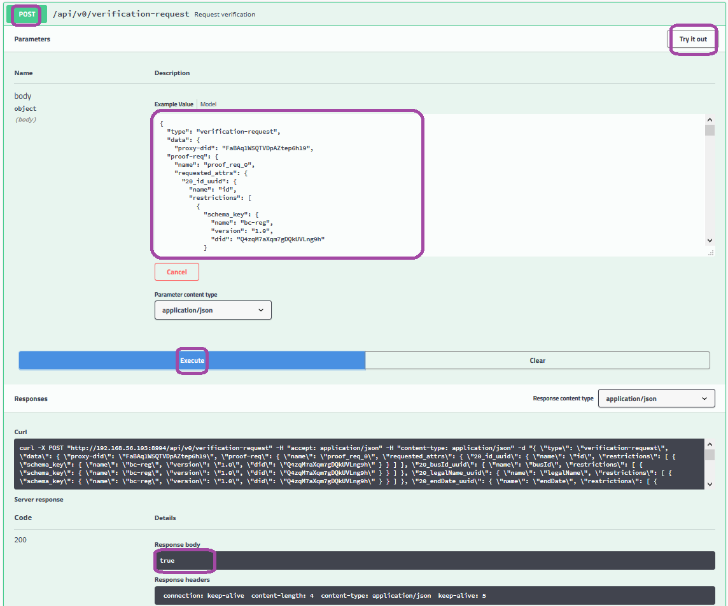Illustration 10: Verify a Proof
as per the image above:
- expand the POST /api/v0/verification-request API call
- click Try it out (the button turns red and changes its text to Cancel)
- Within the model,
  - paste the sri's (not the bc-org-book's!) DID into the proxy-did value
  - specify the proof-request and proof values as the response from either section 3.8 (by filter) or 3.9 (by referent) for their respective keys
- click Execute
- from the Response body control, find and the truth value of the specified proof on its proof request.

