Public Services and Procurement Canada

The von_tails External Tails File Server
Engineering Document
author: Stephen Klump
date: 2018-08
version: 0.02

Table of Contents
1 Introduction 1
1.1 Overview 1
1.2 References 1
2 Design Notes 2
2.1 Components 2
2.2 Directory Structure 2
2.3 Server Application Programming Interfaces. 3
2.4 Data Flow 4
3 Installation and Configuration 7
3.1 Download Project 7
3.2 Build Tails File Server 7
3.3 Deploy Source and Create Log Directory 7
3.4 Prepare Virtual Environment 7
3.5 Integrate with cron 8
4 Operation 9
4.1 Tails Server 9
5 Deficiencies 11
5.1 Server Security 11
5.2 Synchronization Script Granularity 11
5.3 Test Harness 11

Introduction
As part of the technology demonstrator project using Hyperledger indy to explore the use of the distributed ledger with PSPC Supplier Registration Information (SRI), the design specifies anchors to issue, store, prove, and verify revocable credentials.
Issuing revocable credentials creates (immutable) tails files against revocation registries stemming from their respective credential definitions. Issuer anchors create tails files as required, and holder-provers refer to them in creating non-revocation proof. The process of synchronizing tails files between issuer and holder-prover anchors is beyond the scope of the indy-sdk and the von_anchor project [VA] realizing the anchors to create and read these tails files. The von_tails project provides a reference implementation of a tails file server external the anchors using tails files and a synchronization script to upload from issuers and download them to holder-provers as they become available.

Overview
The remainder of this work outlines the design, installation, integration, operation, and known deficiencies of the external tails file server for issuer and holder-prover anchors.

References
[VA] "VON Anchor – Detailed Design Document". Public Services and Procurement Canada, 2018. https://github.com/PSPC-SPAC-buyandsell/von_base/blob/master/doc/anchor-design.doc

Design Notes
This section provides design notes on the content of the von_tails package.

Components
The package includes a server component and synchronization scripts.

Server
The server side includes a containerized tails file server, implemented in python via Sanic.

Synchronization Scripts
The synchronization scripts src/sync.py and src/multi_sync.py synchronize tails directories on the anchor host against a remote tails file server. Script src/sync.py performs one iteration of the synchronization process; src/multi_sync.py performs several iterations of the synchronization process, spaced evenly over a single minute.

Directory Structure
This section outlines the directory structure in use on the tails file server.
The illustration introduces the structure; further discussion elaborates.
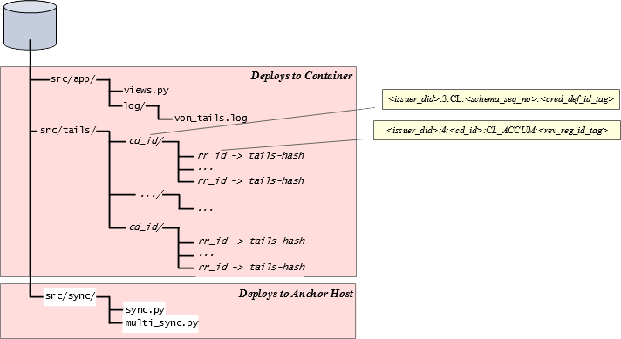Illustration 1: Directory Structure

Application: Deploying to Container
The server application builds on the (python) Sanic framework, mapping URLs to source code in src/app/views.py.
The application serves tails files from src/tails/ tree, split by credential definition identifier and linked by revocation registry identifier as per [VA].
Application logs append to the log in src/app/log/von_tails.log.

Synchronization Scripts: Deploying to Anchor Hosts
The src/sync.py and src/multi_sync.py scripts deploy to the host running issuer or holder-prover hosts, for invocation on cron jobs.

Server Application Programming Interfaces.
The table outlines the API calls that the tails server implements.
Call | Method + URL Pattern | Parameter Value | Notes | Return Content
Post new tails file | POST /tails/<rr_id> | Revocation registry identifier | Attach (multipart/form-data) file named for tails hash | Empty string
Get tails file | GET /tails/<rr_id> | Revocation registry identifier |  | (Binary) tails file named for tails hash
List tails files | GET /tails/list/<ident> | 'all' | Lists all revocation registry identifiers for which server has corresponding tails files | JSON array of revocation registy identifiers
List tails files | GET /tails/list/<ident> | Revocation registry identifier | Lists revocation registry identifier only if server has corresponding tails file | JSON array of revocation registy identifiers
List tails files | GET /tails/list/<ident> | Credential definition identifier | Lists revocation registry identifiers for which server has corresponding tails files | JSON array of revocation registy identifiers
List tails files | GET /tails/list/<ident> | Issuer DID | Lists revocation registry identifiers for which server has corresponding tails files | JSON array of revocation registy identifiers
Delete tails files | DELETE /tails/del/<ident> | 'all' | Deletes all revocation registry identifiers for which server has corresponding tails files | Empty string
Delete tails files | DELETE /tails/del/<ident> | Revocation registry identifier | Deletes revocation registry identifier only if server has corresponding tails file | Empty string
Delete tails files | DELETE /tails/del/<ident> | Credential definition identifier | Deletes revocation registry identifiers for which server has corresponding tails files | Empty string
Delete tails files | DELETE /tails/del/<ident> | Issuer DID | Deletes revocation registry identifiers for which server has corresponding tails files | Empty string
Table 1: Server API Calls

Data Flow
The diagram introduces the data flow of the design; further discussion elaborates.
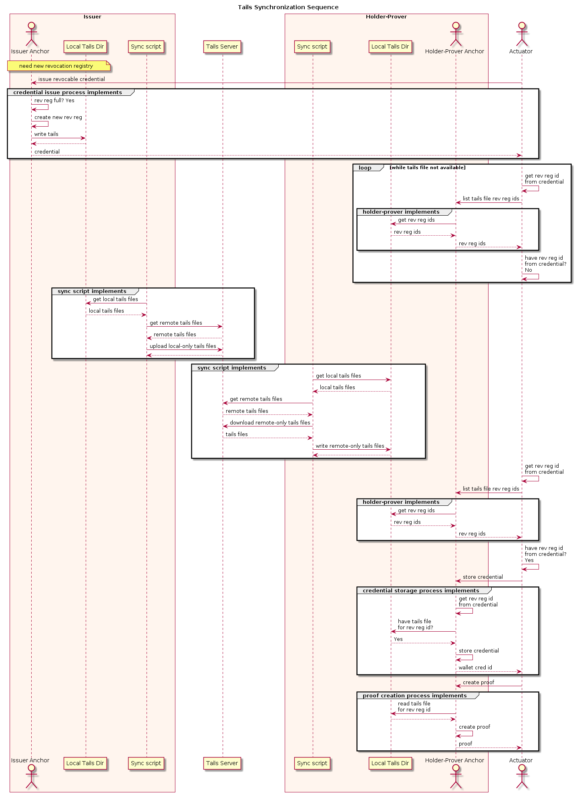Illustration 2: Tails Synchronization Sequence
The sequence begins when the actuator prompts the issuer anchor (via its service wrapper API) to issue a new revocable credential, but the issuer must create a new revocation registry.
In the process of issuing the credential, the issuer creates the revocation registry, which generates a corresponding tails file and writes it to local storage. The issuer returns the credential to the actuator via the anchor's service wrapper API; the credential includes a revocation registry identifier.
The actuator polls the holder-prover anchor (via its service wrapper API) periodically for its known tails files by revocation registry identifier, looping until the list includes the one that the new credential specifies.
Running frequently over cron, the synchronization script on the issuer anchor's server polls locally and remotely for tails files, and discovers the new local tails file. The process uploads the file to the remote tails file server.
Meanwhile, also running over cron, the synchronization script on the holder-prover anchor's server polls locally and remotely for tails files. Once the new tails file appears on the tails file server, the synchronization process downloads it to the holder-prover anchor's local storage.
The actuator, polling the holder-prover for its tails files by revocation registry identifier, gets a list indicating the availability of the tails file to the holder-prover anchor. The actuator calls the holder-prover, via its service wrapper API, to store the credential. The anchor stores the credential in its wallet (at this point, not having the corresponding tails file available would raise an exception).
At a future time, the actuator prompts the holder-prover anchor, via its service wrapper API, for proof involving the credential. The anchor uses the tails file in creating the non-revocation component of the proof.

Installation and Configuration
This section outlines the installation process of the tails file server and synchronization scripts.

Download Project
To download the project to a host, the operator issues:
$ git clone https://github.com/PSPC-SPAC-buyandsell/von_tails.git
at the command prompt. This creates a von_tails installation directory in place with software for the tails file server and synchronization scripts.

Build Tails File Server
Building the tails file server composes a docker container locally, listening on the port that environment variable HOST_PORT_VON_TAILS specifies (default 8808).
From the von_tails installation directory, The operator issues at the prompt:
$ cd docker
$ ./manage build
to create the docker image standing up the tails file server.

Deploy Source and Create Log Directory
The operator copies the src/sync/ directory from the von_tails installation directory to the issuer and holder-prover anchor hosts, to a location where pipenv will pick up the anchor's virtual environment. The operator creates a directory for logs if one is not already present. For example,
$ cd /home/operator
$ mkdir -p von_tails
$ cd von_tails
$ scp operator@192.168.56.119:./von_tails/sync .
$ mkdir -p log
could deploy the synchronization scripts from a tails file server host to an anchor host running the anchor, with all components on all hosts running as user operator.

Prepare Virtual Environment
On the issuer and holder-prover anchor hosts, the operator ensures that the pipenv virtual environment includes required packages. For example,
$ cd /home/operator/von_tails
$ pipenv install -r sync/requirements.txt
to apply the requirements if the operator installed the sync/ directory in the /home/operator/von_tails/sync/ location as above.

Integrate with cron
The operator then updates the cron configuration on each host to engage the src/sync/multi_sync.py script every minute, directing it to fire a synchronization operation to the frequency desired (e.g., 20 times per minute or every 3 seconds) and specifying the log location.
A sample cron configuration record for an issuer follows:
* * * * * /bin/bash -l -c 'export PIPENV_MAX_DEPTH=16; cd /home/operator/von_tails/sync; pipenv run python multi_sync.py 20 /home/operator/.indy_client/tails 192.168.56.119 8088 issuer >> /home/operator/von_tails/log/anchor-sync.log 2>&1'
and for a holder-prover:
* * * * * /bin/bash -l -c 'export PIPENV_MAX_DEPTH=16; cd /home/operator/von_tails/sync; pipenv run python multi_sync.py 20 /home/operator/.indy_client/tails 192.168.56.119 8088 prover >> /home/operator/von_tails/log/anchor-sync.log 2>&1'

Operation
This section discusses the operation of the tails file server and synchronization scripts.

Tails Server
This section outlines the startup and shutdown of the tails server.

Stop and Start
To stop and start the tails file server in the foreground, the operator changes to the von_tails installation directory and issues:
$ cd ./docker
$ ./manage stop
$ ./manage start
The execution occupies the terminal window; the tails file server is ready when the operation outputs a record noting that their Sanic is "Goin' Fast" on the configured and port.
The startup process always begins from scratch on manage start, removing any extant containers from prior operations.
To start the tails file server in the background, the operator may use
$ ./manage bg
instead, which starts the tails file server (or resumes operation from any existing containers) in the shell's background.
The operator may follow the tails file server container's docker logs via
$ docker logs -f <docker_von_tails_1>
where <docker_von_tails_1> represents the agent container (not image) of interest.

Container Shutdown and Removal
To stop the tails server container, the operator changes to the von_tails installation directory and issues:
$ cd ./docker
$ ./manage stop
Alternatively, if the docker containers are operating in the terminal's foreground, the operator may simply issuer control-C and wait for graceful shutdown.
To stop and remove all containers, the operator may issue:
$ ./manage rm
at the prompt.

Synchronization Scripts
Script src/sync.py performs one iteration of the synchronization process. An operator may call this script for a one-time manual synchronization operation. Its command-line arguments represent:
- the topmost tails directory for the VON anchor
- the tails server hostname or IP address
- the tails server port
- the synchronization role:
  - issuer to upload local-only tails files from within the tails directory to the server
  - prover to download remote-only tails files from the server to the tails directory.
Script src/multi_sync.py performs several iterations of the synchronization process, spaced evenly over a single minute: the number of such iterations appears as the first parameter, preceding those that it passes to the src/sync.py script.
A new iteration of the synchronization process only starts if one is not already running – typical operation will not overlap iterations.
This script's intended use is integration via cron, as per section 3.3.

Deficiencies
The project is a reference implementation of an external tails file server. Its current state is provisional, with several candidate areas for future development.

Server Security
There is no control over what entities can upload to the tails file server, on revocation registries built on what credential definition identifiers nor what issuer DIDs. While tails files are public, a denial of service attack could masquerade as an issuer and upload authoritative-looking bogus tails files to the server. Issuers then would not be able to upload legitimate tails files on the same revocation registry identifiers. Holder-provers would download and use these bad tails files, impeding the proof creation process.
In addition, although the synchronization scripts do not engage it, the tails file server offers a tails file deletion API. This API may present a denial of service attack until issuer synchronization scripts engage and re-upload local-only tails files. If an attacker invokes the deletion API continuously, the attack would tie up resources on the issuer anchor host and make downloads to the holder-prover anchor host unreliable.

Synchronization Script Granularity
At present, synchronization scripts operate on the entire tails directory structure. Not all holder-provers may be interested in tails file updates from all issuers using a tails file server.

Test Harness
At present, there are no formal unit tests included. A full test suite should engage all tails server API calls to ensure correct processing in all possible tails directory states.

