**CR2019-0775**

**Expected output to confirm script execution:**

The following folder should be found under **“Enterprise Workspace/_System Administration”**

GCwide_ActiveView_Volume

From the “**Enterprise Workspace/_System Administration/GCwide_ActiveView_Volume”**

The following ActiveView Object should be present :

Global_Constants

Mobile_Browse

Mobile_BrowseAdd

Mobile_DocumentAddVersion

Mobile_DocumentAudit

Mobile_DocumentDelete

Mobile_DocumentOverview

Mobile_DocumentRename

Mobile_DocumentReserve

Mobile_DocumentUnreserve

Mobile_DocumentOverviewVersion

Mobile_DocumentVersions

Mobile_Footer

Mobile_Header

Clicking the function arrow and selecting ***constants*** on ***Global_Constants*** should display the constants listed below the screenshot

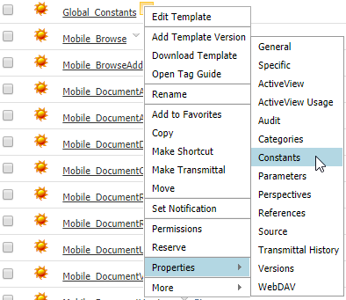

|  |
| --- |
| MOBILE_FOOTER_NODEID = (Mobile_Footer ID)  MOBILE_HEADER_NODEID = (Mobile_Header ID)  BANNER_ENV_NAME = DEV  ORG_PROD_BANNER_TEXT_ENG = 0  ORG_PROD_BANNER_TEXT_FRA = 0  ORG_HEADER_LOGO_TEXT_ENG = 0  ORG_HEADER_LOGO_TEXT_FRA = 0  ORG_SUPPORT_EMAIL = 0  ORG_SUPPORT_PHONE = 0  ORG_SUPPORT_URL_ENG = 0  ORG_SUPPORT_URL_FRA = 0  ORG_FIP_IMG_ID_ENG = 0  ORG_FIP_IMG_ID_FRA = 0  ORG_FIP_IMG_STYLE = width: 100%; height: auto;  ORG_FIP_ALT_ENG = 0  ORG_FIP_ALT_FRA = 0 |

Clicking the function arrow and selecting ***constants*** on the following objects should display a link to the **Global_Constant** Object

Mobile_Browse

Mobile_BrowseAdd

Mobile_DocumentAddVersion

Mobile_DocumentAudit

Mobile_DocumentDelete

Mobile_DocumentOverview

Mobile_DocumentRename

Mobile_DocumentReserve

Mobile_DocumentUnreserve

Mobile_DocumentOverviewVersion

Mobile_DocumentVersions

Mobile_Footer

Mobile_Header

