**Department of Industrial and Systems Engineering**

**Indian Institute of Technology, Kharagpur**

**Sub: QDC Laboratory (IM 39005)**

**Group 6**

* Mudavath Madhu – 22IM10024
* Niket Kumar – 22IM10025
* P S Pritish Kumar Mahali – 22IM10026
* Papula Anurag – 22IM10027

**Experiment no:** 9

**Date of Experiment/Data Collection:** 28th Oct 2024

**Date of Submission:** 5th Oct 2024

**Title of the Experiment –**

**AI/ML Techniques for CUSUM Chart Preparation**

**Objectives of the Study:**

1. To explore state-of-the-art machine learning (ML) tools for object detection
2. Identify object characteristics using image processing
3. CUSUM Chart

**Measuring Instruments/Apparatus/Software Required:**

Hardware:

1. Conveyor belt

2. Hikvision camera

3. ESP 32 motor control unit

4. Wifi Router

5. Workstation

6. Washer

AI/ML Tools:

1. Yolo V8

2. Roboflow

3. Byte track

Coding platform:

Python (Google colab and desktop)

Connectivity Tools:

1. Rest API

Measurement Tools:

1. Vernier caliper

**Methodology**

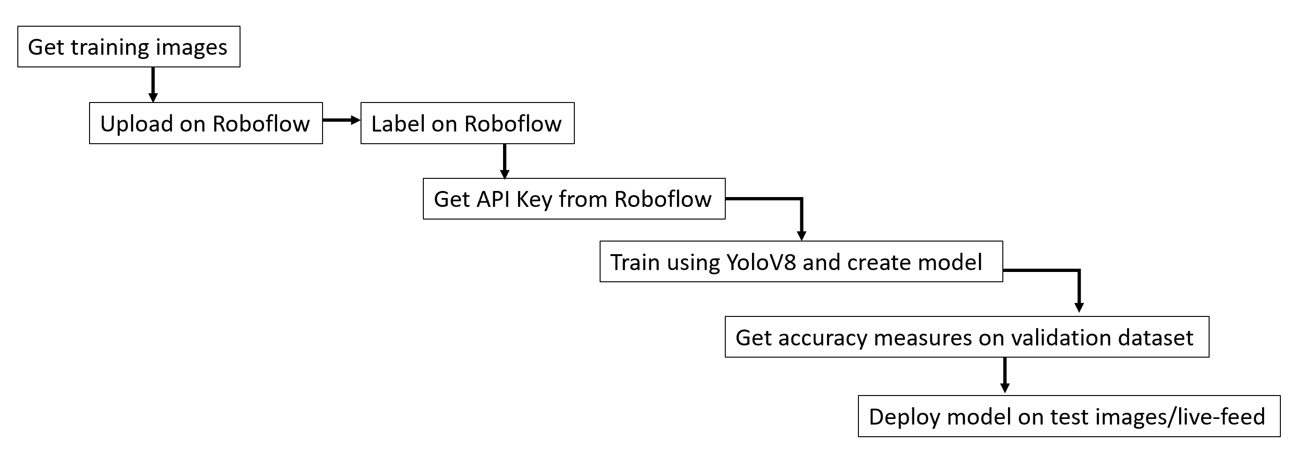

**Measurement:**

|  |  |  |  |
| --- | --- | --- | --- |
| Washer ID | Diagonal (px) | Diameter (mm) | Frame Count |
| 1 | 74.73643 | 28.04895 | 1225 |
| 2 | 74.73205 | 28.04721 | 1267 |
| 3 | 73.61019 | 27.60094 | 1269 |
| 4 | 87.48996 | 33.12231 | 1264 |
| 5 | 74.4347 | 27.92892 | 1261 |
| 6 | 88.9461 | 33.70156 | 1259 |
| 7 | 74.58221 | 27.9876 | 1270 |
| 8 | 73.4562 | 27.53968 | 1273 |
| 9 | 82.27782 | 31.04892 | 1261 |
| 10 | 74.26014 | 27.85949 | 1268 |
| 11 | 74.45353 | 27.93641 | 1303 |
| 12 | 74.57586 | 27.98508 | 1260 |
| 13 | 89.84019 | 34.05723 | 1185 |
| 14 | 74.00119 | 27.75647 | 1284 |
| 15 | 87.37468 | 33.07645 | 1257 |
| 16 | 74.13007 | 27.80774 | 1268 |
| 17 | 74.54598 | 27.97319 | 1270 |
| 18 | 83.21009 | 31.41977 | 1257 |

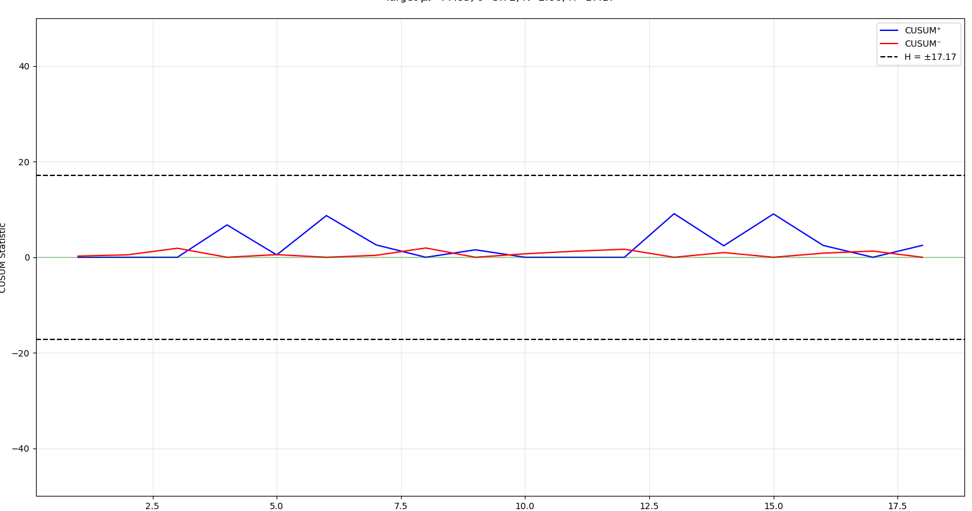**Tasks**

1. Recall the model created for Experiment No. 5. Use the model to detect objects from the video file “output_roi.avi”.

2**.** Upload a video file on the MS Teams channel demonstrating detection of washers using YOLO V8, in the video, show green bounding boxes for washers with outer diameters within specification limits, and red bounding boxes for non-conforming washers.

3. Create a tabular CUSUM chart with the collected data and identify the instance from which the process started producing non-conforming units. Assume $μ_{0}=$ average of first 10 values, σ=standard dev of first 10 values, the magnitude of shift we want to detect is .

4. Write a python program for generation of CUSUM chart, indicating control limits, and origin of shift in the process.

##################