**Report**

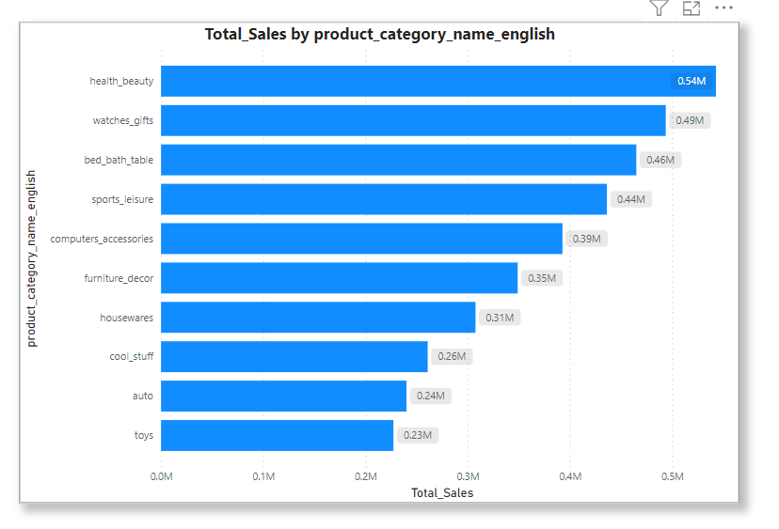

The stacked bar plot above displays the total sales for each product category. Here are a few observations:

* **Health and Beauty** category has the highest sales, followed closely by **Watches and Gifts**.
* **Computers and Accessories** category, although still significant, shows comparatively lower sales among the top categories shown.

With this data, we can analyse trends, forecast future sales, or evaluate the performance of different product categories.

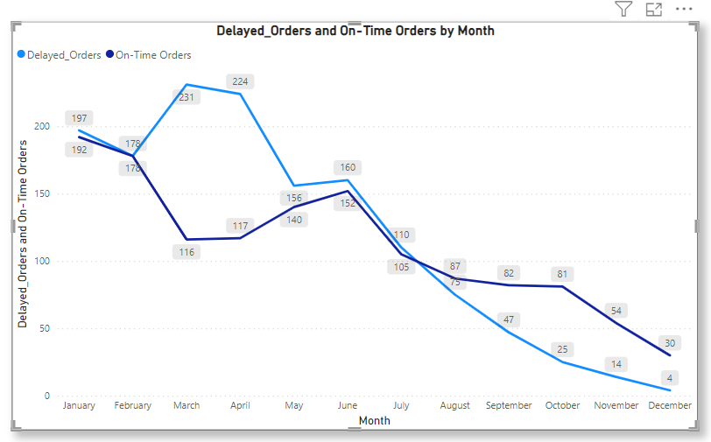

The line graph illustrates the monthly distribution of delayed and on-time orders. Here are some insights and observations:

**Peak Delays:** March and April show significant peaks in delayed orders, with March having the highest number of delays for the year. This could be due to specific operational challenges or seasonal demand increases.

**Consistency in On-Time Orders:** On-time deliveries are relatively consistent across several months, with a notable dip in March and April, coinciding with the spike in delays. This suggests that factors affecting delays in these months could be impacting overall delivery performance.

**End of Year Performance:** Both delayed and on-time orders seem to stabilize towards the end of the year, with a decrease in delays and a slight increase in on-time deliveries, suggesting possible improvements in processes or a reduction in overall order volume.

**Low Volume Start:** The year starts with fewer orders in both categories in January and February, which gradually increase. This trend might indicate seasonal variation in sales and order placements.

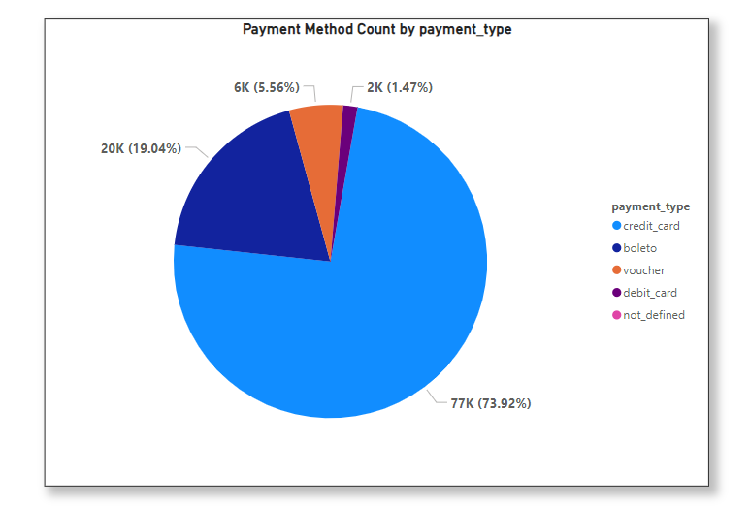

Here are some insights and observations:

**Credit Card Dominance:** Credit card is by far the most preferred payment method (73.92%), accounting for the majority of transactions. This suggests high consumer confidence in credit transactions and possibly the availability of credit benefits like rewards or instalment plans.

**Alternative Payment Methods:**

* **Boleto:** The second most used payment method (19.04%). Its significant usage indicates a substantial customer base that prefers or requires direct bill payment methods.
* **Voucher:** Usage is moderate, (5.56%) indicating a niche market or specific scenarios where vouchers are issued or preferred, such as gift transactions or promotional strategies.
* **Debit Card:** Surprisingly, the usage of debit cards is relatively low (1.47%), which could suggest customer preferences for credit due to deferred payment or reward benefits.

**Not Defined:** This category has negligible usage, which might represent data errors, testing entries, or incomplete transaction records.

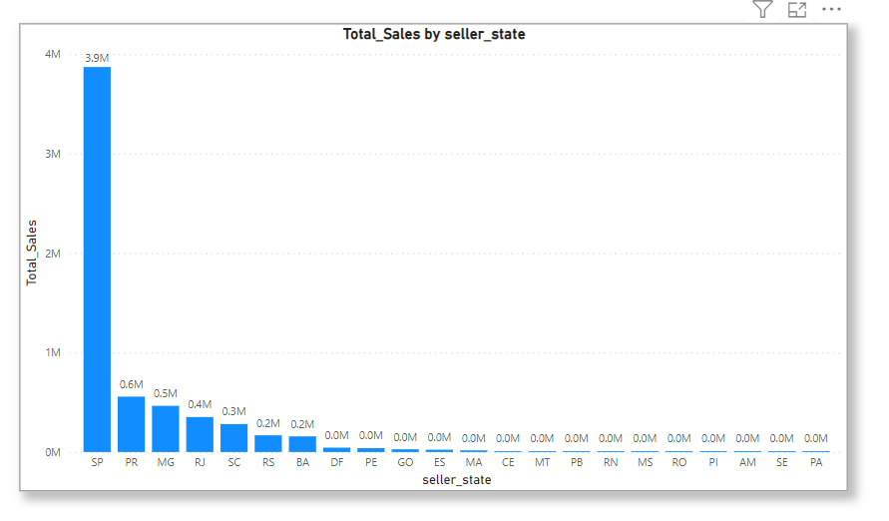

Here are some observations and potential insights:

**Dominance of SP:** São Paulo (SP) leads in sales by a substantial margin, indicating it as a major hub for business. This could be due to a larger customer base, more sellers, or both.

**Top Performing States:** The next highest states are Paraná (PR) and Minas Gerais (MG), followed by Rio de Janeiro (RJ) and Santa Catarina (SC). These states appear to be significant markets as well.

**Lower Sales in the North and Northeast:** States like Amazonas (AM), Sergipe (SE), and Pará (PA) have the lowest total sales, which might reflect differences in economic activity, population, or internet penetration rates.

**Regional Disparities:** The disparity between the highest sales in SP and the lowest in other states suggests regional differences in economic activity. Companies may need to tailor their strategies accordingly, considering factors such as logistics, local demand, and purchasing power.

**Middle Performers:** States like Bahia (BA), Rio Grande do Sul (RS), and the Federal District (DF) show moderate performance. Analysing factors contributing to sales in these areas could provide insights for increasing sales in states with similar demographics and economic conditions.

**Growth Opportunities:** States with lower sales figures might represent untapped markets or areas where the company could expand its footprint. Investments in marketing, distribution networks, or partnerships could be considered to enhance market presence.

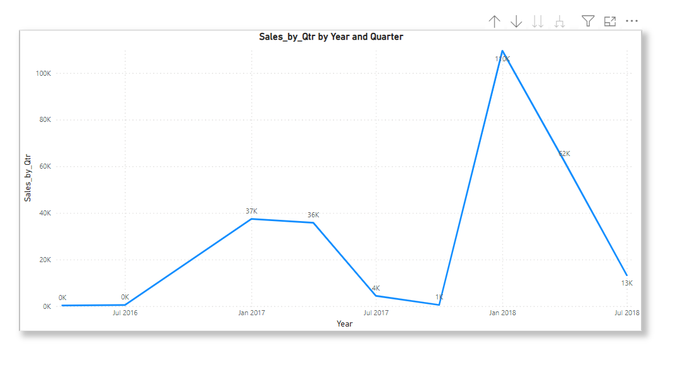

Here are some observations and potential insights:

**Sales Variability:** There's a wide range in the sales figures across different quarters, suggesting variability in sales performance. For instance, sales in the first quarter of 2016 are significantly higher than in any other quarter.

**Sales Trend:** It appears there may be an overall decreasing trend in sales when looking at the figures starting from 2017. However, there's an increase in the first quarter of 2018 that breaks this pattern.

**Potential Data Errors:** The very first row with sales of over 5.7 million appears to be missing the year and quarter data, which could be an error or an aggregate figure. The magnitude of this number suggests it could be a total of all quarters.

**Seasonal Trends:** There may be seasonal effects at play, which could be analysed by looking at the performance of the same quarters over different years. For instance, is Qtr 1 consistently higher?

**Quarterly Growth:** Comparing quarters within the same year, for example, Qtr 2 to Qtr 3 in 2017, could show how sales are growing or shrinking across the year.