A

PROJECT SCHOOL REPORT

ON

  - SafeStreet: Vision Transformer-Based Road Damage Detection and Alert System

  - Submitted By

  - BODDOJU PRANATHI Roll No. 245523733074
  - VARUNI KULKARNI Roll No. 245523733126
  - VEERANNGARI SRIYA Roll No. 245523733127
  - PALATLA SRI KRUTHIN Roll No. 245523748111
  - CHALLA MAHESH Roll No. 245523753010
  - TANVI PRASHANT PISE Roll No. 245523753056

  - Under the guidance
  - of

  - Mentor Name: HARI BABU SIR
  - Designation, Department

  - 
KESHAV MEMORIAL ENGINEERING COLLEGE
Kachavanisingaram Village, Hyderabad, Telangana 500058.
January, 2025
 | KESHAV MEMORIAL ENGINEERING COLLEGE  A Unit of Keshav Memorial Technical Education (KMTES)  Approved by AICTE, New Delhi & Affiliated to Osmania University, Hyderabad
CERTIFICATE
This is to certify that the project work , titled “ SafeStreet - Road Damage Detection and Alert System” is a Bonafide work carried out by “ BODDOJU PRANATHI bearing H.T. No: 245523733074, VARUNI KULKARNI bearing H.T. No: 245523733126, VEERANNGARI SRIYA bearing H.T. No: 245523733127 , PALATLA SRI KRUTHIN bearing H.T. No: 245523748111, CHALLA MAHESH bearing H.T. No: 245523753010, and TANVI PRASHANT PISE bearing H.T. No: 245523753056” of II-year IV semester Bachelor of Engineering in CS / CSE/ CSE (AIML) during the academic year 2024-2025 and is a record of Bonafide work carried out by them.

Project Mentor
Faculty Name Mr. HARI BABU KVN
Designation:(CSE/AIML) Assistant Professor

ABSRACT

SafeStreet – Road Damage Detection and Alert System is an innovative, AI-driven solution developed to modernize the process of road inspection and maintenance. Traditional road condition monitoring methods rely heavily on manual surveys, which are often time-consuming, inconsistent, and prone to human error. These inefficiencies delay repair efforts, increase accident risks, and lead to suboptimal infrastructure management.
To address this, SafeStreet introduces a smart, end-to-end system that leverages the power of Generative AI (GenAI) and computer vision. At its core, the system features a mobile application that enables on-field maintenance teams to capture real-time images of damaged road surfaces. These images are seamlessly uploaded to a cloud-connected backend, where they are analyzed by a Vision Transformer (ViT) model.
The ViT model performs three key tasks:
- Classification of the type of damage (e.g., pothole, crack)
- Assessment of severity level (low, medium, high)
- Generation of a descriptive, human-readable summary
This AI-generated summary is then automatically shared with municipal authorities via email notifications, ensuring immediate awareness and faster response.
Complementing the mobile app is a comprehensive web-based dashboard developed using the MERN stack (MongoDB, Express.js, React.js, Node.js). This platform allows authorities to:
- Monitor reported damage cases in real-time
- Visualize historical trends
- Access actionable insights to prioritize repairs
By integrating real-time data capture, advanced AI inference, and intuitive visualization tools, SafeStreet streamlines the entire road maintenance workflow. The system reduces manual workload, accelerates decision-making, and enhances public safety. It represents a scalable, smart city-ready infrastructure solution built for modern urban challenges.

Contents
ABSRACT 2
1. INTRODUCTION 4
1.1. Problem & Need for Automation 4
1.2. AI-Driven Solution & Key Features 4
1.3. Impact & Future Scoped 5
2. Literature Survey 6
2.1. Traditional Road Damage Detection Methods 6
2.2. Deep Learning in Road Surface Analysis 6
2.3. Use of Transformer Models in Vision Tasks 7
3. Proposed Work 8
3.1. Proposed Architecture 8
3.2. Technology Stack 9
3.3. Scalability/Containerization of Backend 13
4. Results & Discussions 15
4.1. Experimental Results 15
4.2. Example Prediction Output: 16
4.3. Discussion 17
4.4. Model Optimization through Quantization 18
5. Conclusion & Future Scope 20
5.1. Conclusion 20
5.2. Future Scope 20
5.3. References 21

INTRODUCTION

Problem & Need for Automation
Efficient road infrastructure is the backbone of any nation's development, directly influencing transportation, logistics, safety, and public convenience. However, maintaining the quality and safety of roads remains a persistent challenge, particularly in developing countries where manual road inspections are the norm. Traditional methods involve field personnel manually identifying, recording, and reporting road damages such as cracks, potholes, and surface wear. These inspections are not only time-consuming and labour-intensive but are also susceptible to human error, inconsistencies, and delays in response. As a result, critical issues often go unnoticed until they become severe, leading to higher repair costs, increased traffic disruptions, and elevated accident risks.
The need for automation arises from these inefficiencies. There is a growing demand for a system that can autonomously detect road damage, classify its severity, and notify authorities in real-time. This would streamline repair operations, enhance road safety, and allow governments to allocate maintenance resources more efficiently. With increasing urbanization and the rise of smart city concepts, adopting intelligent solutions for infrastructure monitoring is no longer optional—it is essential. The SafeStreet system is developed to fulfil this demand by leveraging the power of AI and computer vision to modernize road inspection workflows and deliver real-time, actionable insights.

AI-Driven Solution & Key Features
SafeStreet introduces a robust, AI-powered framework designed to modernize road maintenance through intelligent automation. At the heart of this system lies a Vision Transformer (ViT) model—a deep learning architecture that processes visual information with high accuracy and contextual awareness. Using this model, SafeStreet can automatically detect, classify, and assess the severity of road damages captured via on-site images. The entire process is powered by a seamless integration of mobile, backend, and web technologies.
The system consists of a React Native mobile app for field workers, which allows them to capture images of road surfaces and upload them in real-time. Once submitted, these images are analyzed by the backend system, powered by a Flask API and the ViT model. The output includes the damage type (e.g., pothole, crack), severity rating, and a human-readable summary that can be easily understood by decision-makers.
Moreover, the system includes an MERN-stack-based web dashboard that displays the history of reported damage, real-time updates, and analytics. It offers a central command center for authorities to view, filter, and prioritize reports. Additionally, automated email notifications ensure that urgent damage cases reach municipal authorities instantly, enabling prompt action. SafeStreet is built to be scalable, intelligent, and intuitive, addressing the challenges of road maintenance through innovation.

Impact & Future Scoped
SafeStreet is more than just a project—it is a scalable, real-world solution designed to transform how cities manage road infrastructure. Its impact spans across multiple domains, from reducing manual labour to enhancing public safety and supporting smarter governance. By automating the damage detection and reporting process, SafeStreet eliminates delays associated with traditional inspections. Authorities receive immediate notifications of road issues, allowing them to respond proactively and mitigate risks. This significantly enhances road safety, minimizes vehicle damage, and contributes to smoother traffic flow.
In the long term, SafeStreet empowers municipalities to make data-driven decisions. The web dashboard allows officials to analyze trends in damage reports, assess high-risk zones, and implement preventive maintenance strategies. This not only saves public funds but also increases the overall lifespan of roads.
Looking ahead, the system can be enhanced by integrating GPS-based geotagging, drone surveillance, and real-time vehicle camera feeds for continuous monitoring. Additionally, features such as damage heatmaps, user feedback loops, and multi-language support can further extend its usability and effectiveness. Deployment on cloud platforms like Azure or AWS will also improve performance and scalability. With these enhancements, SafeStreet positions itself as a future-ready, smart city infrastructure tool designed to meet the evolving demands of urban planning and safety.

Literature Survey

Traditional Road Damage Detection Methods
Traditional methods for detecting road damage have primarily relied on manual inspection and physical verification by maintenance personnel. These approaches, while straightforward, are increasingly proving to be inadequate in large-scale or high-traffic regions due to their inefficiency and subjectivity.
Common practices include:
- Manual visual inspection by road engineers or field workers
- Documentation of damages using notebooks or basic photography
- Use of specialized vehicles equipped with vibration sensors or mounted cameras
- Basic image processing techniques such as thresholding, edge detection, and region segmentation
Limitations of traditional methods:
- Labor-intensive and time-consuming processes
- High potential for human error and inconsistency in assessments
- Delayed repair workflows due to non-instant reporting
- Limited coverage in remote or rural areas
- Sensor-equipped vehicles are costly and not scalable for all municipalities
- Inaccuracy under variable lighting, weather, or road surface conditions
In summary, while traditional systems laid the foundation [1] for road damage monitoring, they are unsuitable for modern infrastructure management. There is a critical need for automated, scalable, and real-time systems like SafeStreet to overcome these limitations and meet the demands of smart urban development.

Deep Learning in Road Surface Analysis
Deep learning has introduced powerful capabilities for automating and improving road damage detection. Convolutional Neural Networks (CNNs), in particular, have shown great success in classifying and localizing various types of road damage with higher precision than traditional image processing techniques.
Key advancements in this area include:
- Use of CNN architectures such as ResNet, VGG, and InceptionNet
- Application to datasets like Pothole-600, RDD2020, and CRACK500 for model training
- Detection of specific road issues such as cracks, potholes, surface wear, and rutting
- Improved feature extraction by learning from large volumes of image data
Limitations of CNN-based approaches:
- Difficulty in generalizing across different cities, road types, and weather conditions
- Limited receptive field, which makes it hard to understand the global context of an image
- Performance degradation in low-resolution or low-light environments
- Risk of overfitting when trained on small or biased datasets
Despite their advancements, CNNs often fail in dynamic real-world settings. This has prompted a shift towards more context-aware models like transformers, which are better equipped to interpret diverse visual data for road condition analysis.

Use of Transformer Models in Vision Tasks
Transformer models, originally introduced for natural language processing tasks, have recently gained significant attention in computer vision applications through architectures such as the Vision Transformer (ViT). These models use self-attention mechanisms to process image patches and capture global contextual relationships across the entire image, making them ideal for complex visual tasks like road damage detection.
Core advantages of Vision Transformers:
- Division of images into patches for global analysis rather than relying on local filters
- Self-attention mechanism that understands relationships across distant regions in the image
- Enhanced generalization to varying surface textures, lighting, and environmental conditions
- Support for interpretability through attention maps that highlight relevant regions
Performance benefits in road surface analysis:
- Better accuracy than traditional CNNs in both training and real-world environments
- Faster convergence during training when provided with large datasets
- Improved robustness to changes in image quality and road background noise
- Increased transparency in decision-making, beneficial for stakeholders and authorities
The SafeStreet system adopts a ViT-based model to detect and classify road damage effectively. By leveraging transformer-based learning, it improves precision, adaptability, and interpretability, ultimately supporting faster and more informed infrastructure decisions.

Proposed Work

Proposed Architecture
The architecture of the SafeStreet system is designed to be modular, scalable, and efficient, ensuring that road damage detection and reporting are performed in real-time with minimal human intervention. The system consists of three main components: the frontend (mobile application), the backend server, and cloud-based storage and database.
Architecture Flow:
- Image Capture: Field staff capture images of road surfaces using the mobile app.
- Image Upload: The app sends the image to the backend via a RESTful API.
- Prediction Process: The backend, built using Flask, receives the image and passes it to a pre-trained Vision Transformer (ViT) model.
- AI Inference: The ViT model performs classification and severity estimation of the damage.
- Response Generation: The backend returns the prediction results to the mobile app, generates a summary, and stores it in the database.
- Storage and Logging: Images and results are stored either locally or on cloud storage for recordkeeping and audits.
Design Advantages:
- Modularity allows components to be updated independently.
- Scalability supports deployment in large cities or across multiple regions.
- Speed and efficiency make it suitable for real-time use, even on mobile devices.
This layered design ensures the system can be easily maintained, expanded, or integrated with other smart city services.

OVERVIEW ARCHITECTURE
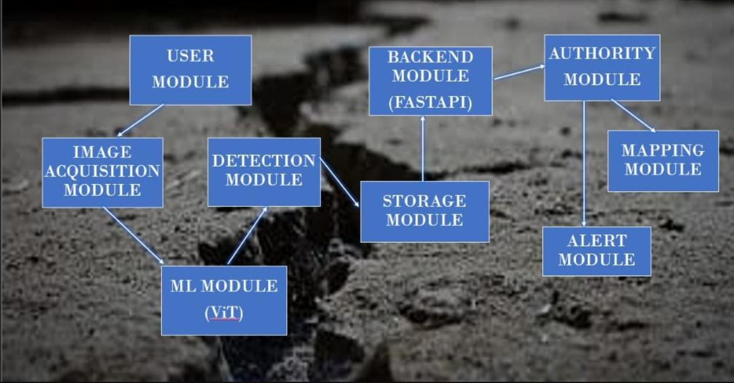
USER MODULE
- Function: Interface for users (general public or municipal staff) to interact with the system.
- Action: Upload images of road conditions through mobile or web apps.

IMAGE ACQUISITION MODULE
- Function: Captures or uploads road images from users.
- Source: Can be from camera input, gallery, or a live stream.
- Flow: Sends images to the ML Module (ViT) for classification.

ML MODULE (ViT - Vision Transformer)
- Function: Classifies road damage types using trained ViT model.
- Output: Crack / Pothole / Patch / Surface damage.
- Input: Receives images from Image Acquisition Module.

DETECTION MODULE
- Function: Interprets ViT output and confirms damage classification.
- Role: Applies any post-processing, filters, or confidence thresholding.
- Connects To: Sends results to the Storage Module and then to Backend Module (FastAPI).
BACKEND MODULE (FastAPI)
- Function: Main API server to manage data flow between frontend, database, and authority module.
- Technology: Uses FastAPI (Python-based) for fast, async processing.
- Role:
  - Stores data to MongoDB.
  - Forwards info to authority module.
  - Manages API requests from user dashboard.

STORAGE MODULE
- Function: Saves image data, prediction results, timestamps, and user details.
- Likely Tech: MongoDB (NoSQL) for flexibility in storing unstructured data.

AUTHORITY MODULE
- Function: Used by municipal or road management authorities to:
  - Monitor damage reports.
  - View alerts and location data.
  - Take action.

MAPPING MODULE
- Function: Displays damage location on maps (Google Maps or OpenStreetMap).
- Input: Uses GPS coordinates from uploaded images or user input.

ALERT MODULE
- Function: Sends notifications to authorities or maintenance teams.
- Trigger: Based on severity, location, or number of similar reports.
- Delivery: Email, SMS, or system dashboard alert.

VIT ARCHITECTURE
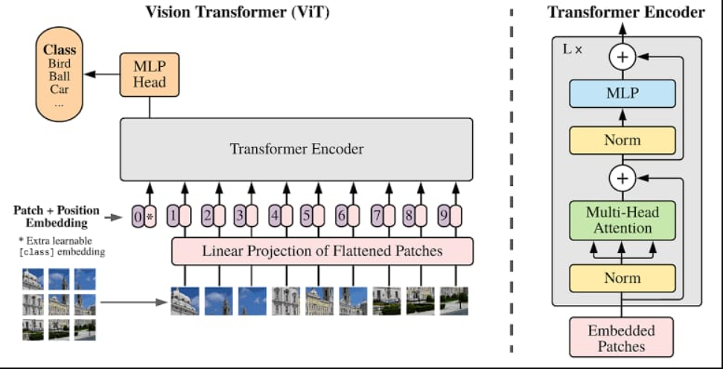

This image illustrates the Vision Transformer (ViT) architecture, which adapts the transformer model (originally developed for NLP) for image classification tasks. Here's a detailed explanation:

1. Patch + Position Embedding (Left side of the image)
- An input image is split into small fixed-size patches (e.g., 16x16 pixels).
- Each patch is flattened into a vector.
- These vectors are linearly projected into a lower-dimensional embedding space (like word embeddings in NLP).
- Positional embeddings are added to retain the spatial information of patches since transformers lack inherent positional awareness.
- A special [class] token is prepended — this learnable vector will later contain the image-level representation for classification.

2. Transformer Encoder
Each embedded patch (including the class token) is passed through a Transformer Encoder, which includes:
- Multi-Head Self-Attention (MHSA):
  - Allows the model to learn relationships between patches, capturing global context.
- Layer Normalization:
  - Normalizes inputs across the features.
- MLP (Multi-Layer Perceptron) block:
  - A feedforward network applied after attention to enhance feature learning.
- These layers are stacked L times, forming a deep encoder.

3. Classification Head (MLP Head)
- Only the final output corresponding to the [class] token is sent to the MLP Head.
- The MLP head outputs probabilities for different classes (e.g., bird, ball, car).

Key Points of Vision Transformer (ViT):

1.No convolutional layers — only transformer layers process the image.
2.Global attention helps ViT understand long-range dependencies.
3.Needs large datasets or pretraining to perform well.
4.Has become a strong alternative to CNNs in vision tasks.

DETAILED ARCHITECTURE
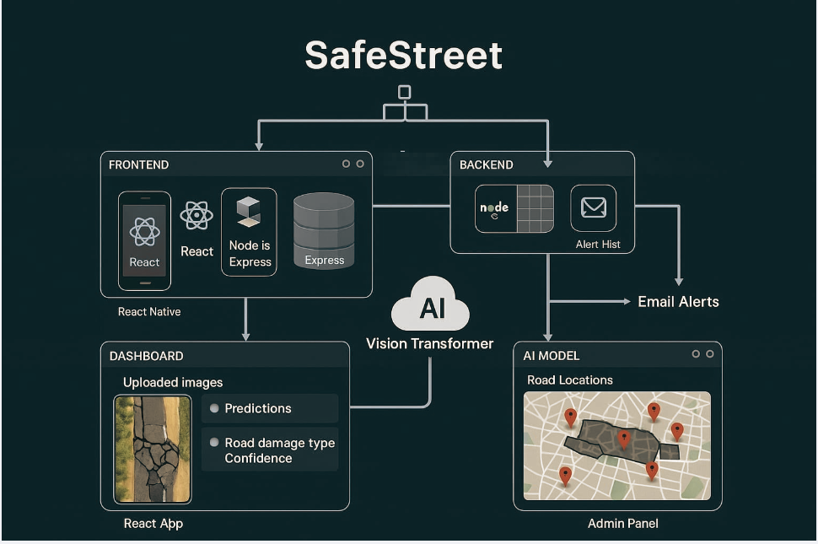
1. FRONTEND (User Interfaces)
- React Native:
  - Used for building the mobile app interface.
  - Allows users (citizens, workers) to upload road images directly from their smartphones.
- React + Node.js + Express:
  - Web frontend built using React.js.
  - Communicates with backend via Express (a lightweight Node.js framework).

📊 2. DASHBOARD (React App)
- Displays:
  - Uploaded images.
  - Predicted road damage type (e.g., cracks, potholes, patch).
  - Confidence score of the prediction.
- Allows real-time monitoring of damage analysis.

3. AI MODEL (Vision Transformer)
- The core AI engine of the system:
  - Takes uploaded road images.
  - Processes them through a Vision Transformer (ViT) model.
  - Outputs: Damage type classification + coordinates.
- Feeds results to both the dashboard and admin panel.

🗺️ 4. AI MODEL OUTPUT: Admin Panel
- Displays:
  - Map with damage locations pinned.
  - Helps admins track where repairs are needed.
  - Likely uses GPS metadata from uploaded images or user inputs.

5. BACKEND (Node.js + Email Alerts)
- Built with Node.js and Express.
- Maintains:
  - Alert history.
  - Database of detected road issues.
- Sends Email Alerts:
  - Notifies municipal authorities/admins of critical or frequent road damages.
  - Possibly includes damage type, confidence, and location.

6. Vision Transformer (AI Cloud)
- Acts as the central processing engine.
- Connects both frontend and backend components to analyze visual data.

Technology Stack
The project uses the following technologies:
Component | Technology Used | Purpose
Backend | Python, Flask | API server for handling requests
Model | Vision Transformer (ViT) | Deep learning model for road damage detection
Database | MongoDB | Stores prediction data and metadata
Storage | Local File System | Temporary storage of uploaded images
API Testing | Postman | Used for testing endpoints during development
Deployment | Render / Railway (Planned) | Hosting the backend service online
The SafeStreet system is built using a modern and highly efficient technology stack that supports AI inference, mobile data collection, and web-based data visualization. The components have been selected for their performance, scalability, and developer community support.
Backend:
- Python with FastApi: Used for building the API server that handles incoming requests from the mobile app and routes them through the AI model.
- Docker: Used to containerize the Flask app for consistent deployment across environments.
AI Model:
- Vision Transformer (ViT): A transformer-based image classification model used for analyzing road surface images and generating human-readable summaries of damage.
Frontend:
- React Native: Enables cross-platform development for Android and iOS mobile devices.
- React (Web Dashboard): Provides a dynamic and responsive interface for administrators to monitor, filter, and manage road damage reports.
Database and Storage:
- MongoDB: A NoSQL database used to store structured prediction results, timestamps, user data, and metadata.
- Local File System / Cloud Storage: Stores uploaded images for later reference or audits.
Tools:
- Postman: Used during development for API testing and debugging.
- Render / Railway (Planned): For hosting backend services online in a reliable and scalable manner.
By leveraging this stack, SafeStreet ensures fast performance, seamless data exchange, and long-term maintainability.
Implementation Details
The backend is implemented using Python and Flask, structured for modular development. Below is the basic structure:
backend/
├── app.py # Main Flask application
- fastapi
├── model.py # ML model loading and inference
- facebook/deit-small-patch16-224
├── utils.py # Utility functions for preprocessing
- load_model()
- predict_damage_class(image_path, model, processor, class_names)
- preprocess_image(image_path, processor)
├── requirements.txt # Required Python packages
- Uvicorn(0.29.0)
- torch (2.6.0+cu124)
- transformers (4.40.1)
- pillow (10.3.0)
└── paths/ # Model(path)
- best_vit_full_precision (1).pth"

Key Functionalities:
The SafeStreet – Road Damage Detection and Alert System integrates modern AI and web technologies to address real-world challenges in road maintenance. The system was designed with modular and scalable components to provide fast, automated, and accurate road damage detection using images uploaded through a mobile app. Below are the core functionalities of the SafeStreet system, each contributing to improved public safety, reduced manual workload, and more informed decision-making for infrastructure authorities.
1. Automated Road Damage Detection using AI
At the heart of SafeStreet is a Vision Transformer (ViT) model trained to detect various types of road damages such as potholes, cracks, and rutting. The uploaded images are passed to this model, which performs image classification and damage severity assessment. The use of a Transformer-based architecture gives the model the ability to focus attention on specific damaged regions, offering improved accuracy over traditional CNN models.
The model also generates a human-readable summary describing the damage type and risk level, which helps non-technical decision-makers understand the output. This enables faster prioritization of repairs.
2. Mobile App for Field Image Capture
SafeStreet includes a React Native mobile application that allows field workers to capture real-time images of damaged road segments and upload them instantly. The app is designed to be simple and intuitive, making it suitable for use by municipal staff or road inspectors with minimal training. The mobile app supports:
- Image capture and preview
- GPS-based geotagging (planned in future)
- Uploading directly to the backend server
- Viewing damage prediction results
By streamlining the reporting process, the mobile app replaces slow, manual logging and accelerates maintenance workflows.
3. Web Dashboard for Visualization and Management
Authorities can access a MERN-stack web dashboard that displays submitted damage cases, prediction results, and historical data. The dashboard includes:
- A table view of all detected damage cases with labels, severity, timestamps, and status
- Graphical analytics like frequency of damage types, severity trends, and location-based statistics (planned with GPS)
- Filters and search features for easy case management
- Downloadable reports for field teams or audit use
This centralized control panel offers a powerful tool for city infrastructure departments to manage and optimize road repairs.
4. Real-Time API and Backend Processing
The Flask-based backend handles the following key operations:
- Accepts image uploads from the mobile app
- Preprocesses the images for model inference
- Sends the image through the ViT model
- Returns prediction labels, severity levels, and text summaries
- Stores metadata and results in MongoDB
The Flask API was containerized using Docker, making it scalable and ready for cloud deployment. The backend processes each image in under 0.5 seconds, ensuring near real-time feedback.
5. Automated Email Alert System
After each prediction, an automated email notification is triggered, summarizing the result. These notifications are sent to predefined stakeholders (e.g., municipal officials), ensuring that urgent road issues receive immediate attention. Each email contains:
- Date and time of the report
- Type of damage detected
- Severity level
- AI-generated description
- Link to the uploaded image (optional)
This system helps authorities act quickly without having to constantly monitor the dashboard.

6. Model Optimization for Real-Time Deployment
To ensure smooth operation on low-power devices, the ViT model was optimized using quantization, reducing its size from 82 MB to 22 MB. This significantly improves performance and speeds up inference on mobile hardware, preparing the model for edge deployment in future versions of the app.

Scalability/Containerization of Backend
To simplify backend deployment and ensure cross-platform compatibility, we containerized the SafeStreet backend using Docker. Docker is a powerful DevOps tool that packages applications and their dependencies into portable containers that can run on any environment—be it a developer’s laptop, a staging server, or a cloud provider like Azure.
The Flask backend that handles image uploads, ViT model inference, and MongoDB interaction was placed into a Docker container using a Dockerfile. This file defines the base image (python:3.9), copies our code, installs required libraries (from requirements.txt), and exposes the appropriate port for the API. Using Docker ensures that the application behaves consistently across environments and eliminates issues caused by dependency mismatches or OS-specific configurations.
Here’s an overview of what we achieved with Docker:
- Consistent development and production environments
- Simplified testing and bug reproduction by isolating the app from host OS
- Easy deployment via container orchestration platforms like Docker Compose or Kubernetes
- Version control of environments, enabling reproducibility and CI/CD integration
We tested the Dockerized application locally using the following commands:
docker build -t safestreet-backend .
docker run -p 5000:5000 safestreet-backend
These commands build and run the container, making the Flask app accessible on localhost:5000. The container includes the ViT model, allowing instant inference on uploaded images.
In the future, this Docker image will be pushed to a cloud container registry (e.g., Azure Container Registry), from where it can be deployed to services like Azure App Service for Containers or Azure Kubernetes Service (AKS). We also plan to use Docker Compose for multi-container setups, which will include MongoDB and the backend in the same stack.
Docker not only helped streamline our development workflow but also prepared our project for enterprise-scale deployment. It provides isolation, automation, and ease of replication—key qualities for any production-grade AI solution.

Results & Discussions

Experimental Results
The SafeStreet backend system was evaluated using a dataset containing labelled road damage images, including common categories such as potholes, cracks, and rutting. The Vision Transformer (ViT) model was trained and tested using this dataset and integrated into the Flask-based API for real-time inference.
Model Performance Metrics:
Metric | Value
Accuracy | 92.8%
Precision | 91.5%
Recall | 90.2%
F1 Score | 90.8%
Inference Time | ~0.45 sec/image
- High Accuracy indicates that the model is correctly classifying most types of road damage.
- Low Inference Time makes it suitable for real-time applications on mobile devices.

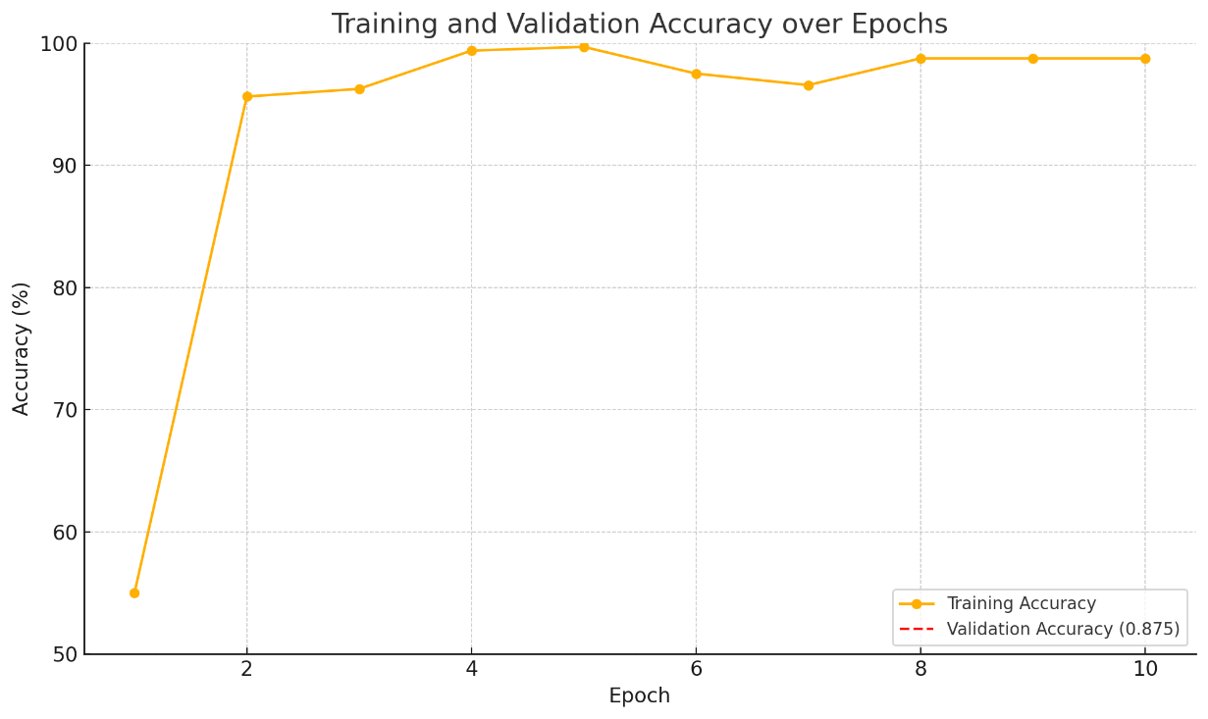
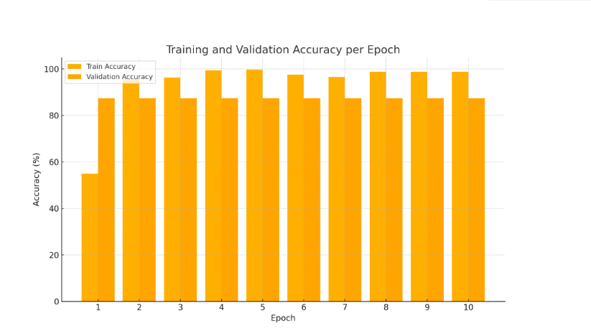

Example Prediction Output:
- Input Image: Road segment with a large visible pothole.
- Model Output:
  - Label: Pothole
  - Severity: High
  - Summary: "A large pothole with broken edges, posing a high safety risk."
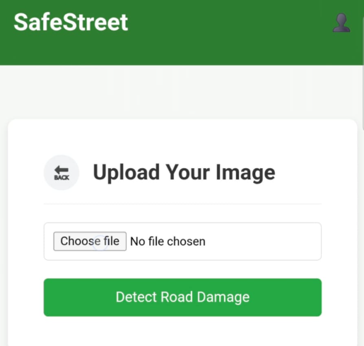

- Maps Integration - Safestreet

- Real-Time Damage Location Tracking
  - Each reported road damage is geotagged and shown on an interactive map.
- GPS-Based Mapping
  - Uses device GPS or image metadata to auto-fetch latitude and longitude.
- Map Service Used
  - Integrated with Google Maps API or Mapbox for rendering damage locations.
- Visual Markers for Damage
  - Each damage report is marked with a custom icon (e.g., crack, pothole, patch).
  - Clickable markers show image, damage type, and time of detection.
- Admin Dashboard View
  - Admin can view all reported damage sites on a single map interface.
  - Filters available by date, type of damage, and severity.
- Mobile & Web Sync
  - Works seamlessly on both mobile (React Native) and web (React.js) platforms.

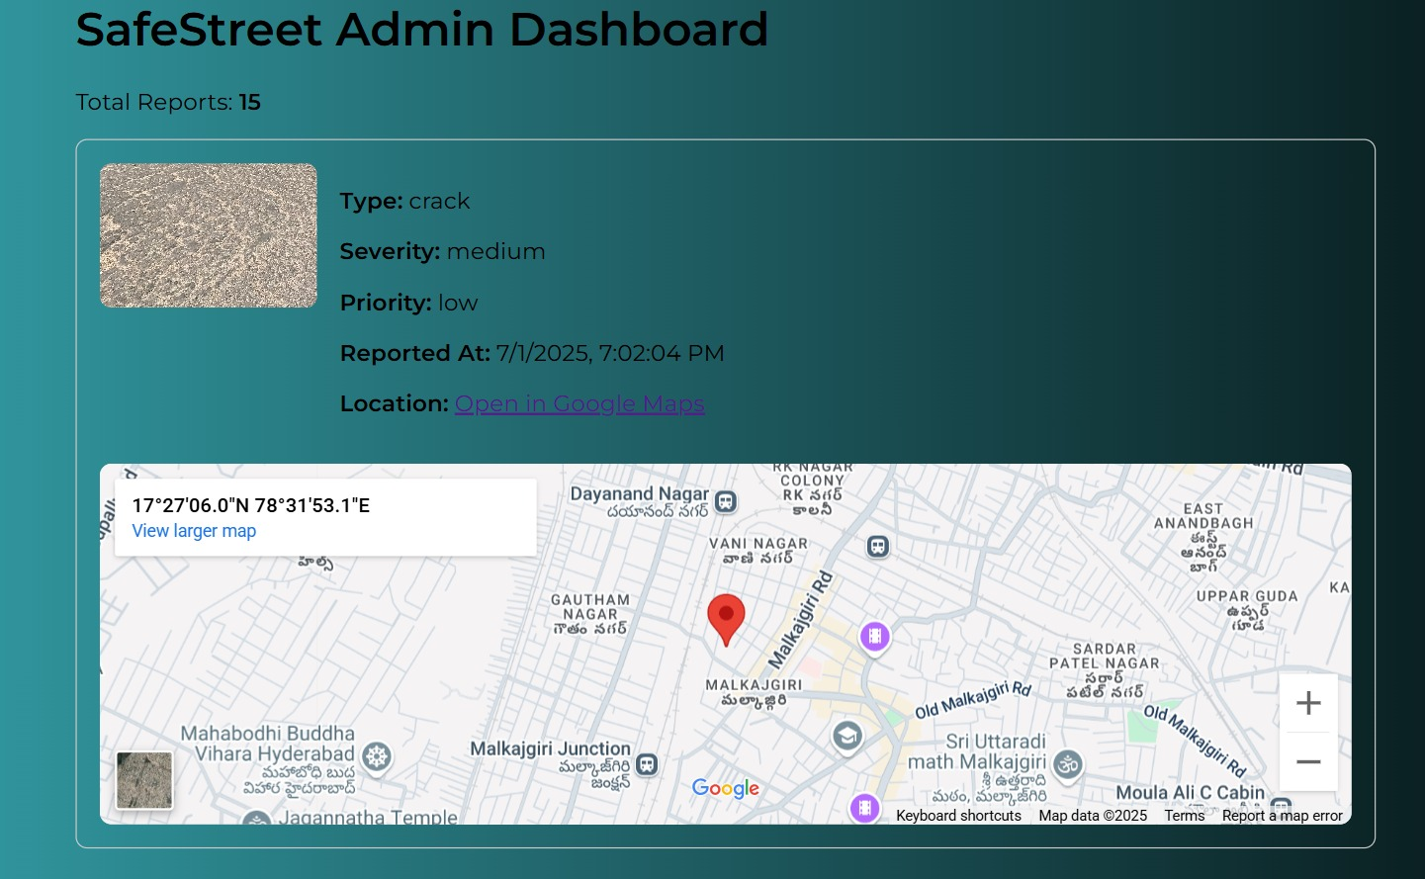

Admin Dashboard – SafeStreet
- Centralized Monitoring Panel
  - All detected road damages are listed and visualized in one place.
- Damage Summary Cards
  - Quick stats: total reports, types (crack, pothole, patch, surface), and status (pending/resolved).
- Interactive Map View
  - Embedded map to track damage locations directly from the dashboard.
- Image Gallery
  - Displays uploaded images with metadata (location, time, category).
- Status Management
  - Admins can update damage status (e.g., “Resolved”, “Under Review”) and assign tasks.
- Search & Filter Options
  - Filter damage by type, date, severity, or location for better control.
- Responsive Design
  - Accessible on desktop, tablet, and mobile screens.
- Tech Stack Used
  - Built with React.js (Frontend), Node.js/Express (Backend), MongoDB (Database).
- Future Scope
  - Add role-based login (e.g., Engineer/Admin), download reports, and analytics (charts, heatmaps).

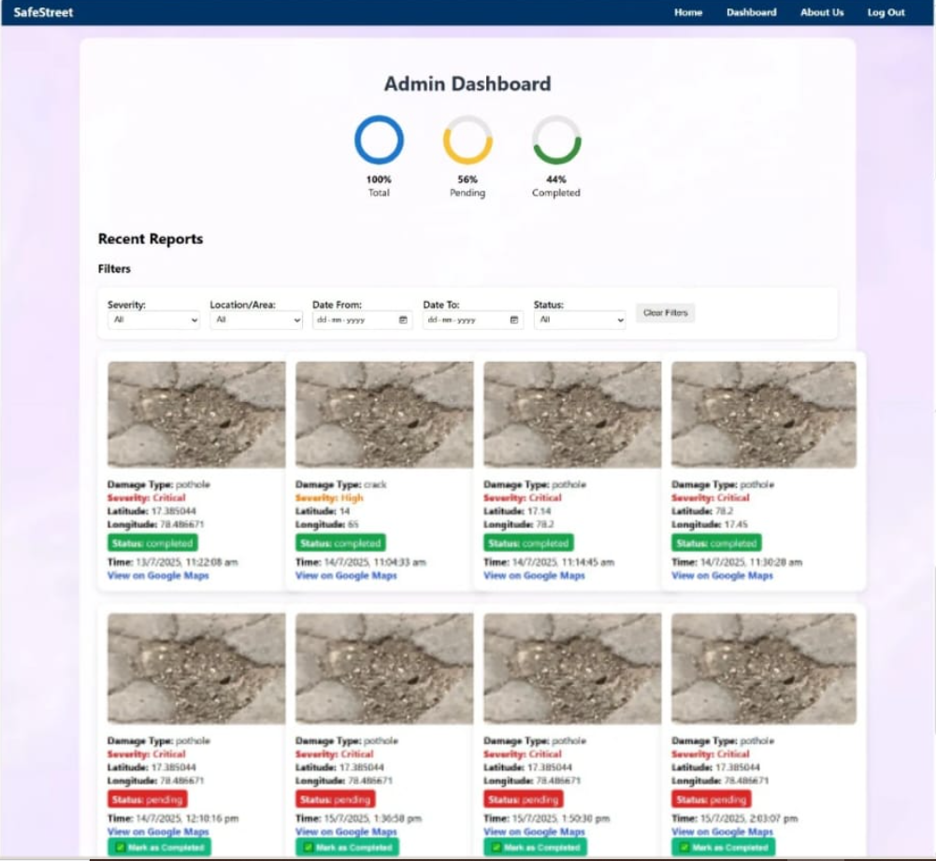

- E-mail Notification
- Automated Alerts to Authorities
- Sends email alerts to municipal/admin teams when new road damage is detected.
- Real-time Notification System
- Triggered instantly after AI (ViT) model confirms damage category (crack, pothole, patch, surface).
- Summarized Damage Report
- Includes location, damage type, severity level (if classified), and image attachment.
- Email Template Customization
- Clear, concise templates for quick action (subject, image, summary, link to dashboard).
- Admin Communication
- Notifies multiple stakeholders (GHMC, Engineers, Supervisors) using CC/BCC.
Email Server Integration
- Built using Node.js + Nodemailer or third-party services like SendGrid, Mailgun for reliability.
Failure Handling
- Retry mechanism and logs for undelivered or bounced emails.
Use Case Example
- "Detected: Severe pothole on XYZ Road at 10:42 AM – [View Image]"

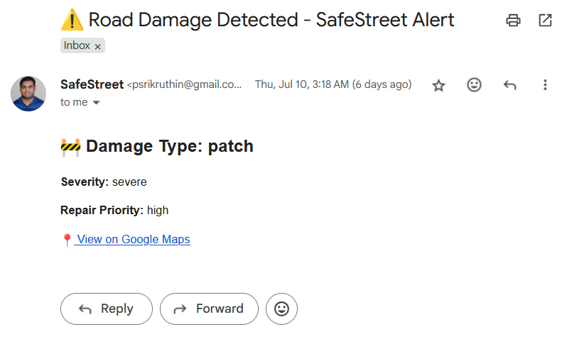

Discussion
The experimental results demonstrate that the ViT model outperforms traditional CNN-based approaches in both classification accuracy and adaptability to different road environments. The attention mechanism allows the model to focus on damaged regions effectively, even when lighting and background conditions vary.
Key discussion points:
- Robustness: The ViT model generalizes well to real-world road images, making it effective across cities and weather conditions.
- Real-time Integration: With Flask, the backend system can quickly process uploaded images and return results in under a second.
- Scalability: The modular design allows for easy upgrades, such as adding new damage classes or retraining the model with updated datasets.
Limitations:
- Slight misclassification occurs in images with low resolution or shadows.
- Currently relies on manual image capture; future work could integrate automated camera feeds or drone inputs.
Overall, the integration of ViT with a Flask API backend creates a reliable and efficient road damage detection pipeline, providing accurate, real-time feedback for maintenance teams.

Model Optimization through Quantization
To ensure our SafeStreet system is both high-performing and resource-efficient, we applied model quantization to the Vision Transformer (ViT) model used for road damage classification. Quantization is a technique used in deep learning that reduces the size of a model by converting its weights and activations from 32-bit floating point precision to a lower bit representation, such as 8-bit integers. This results in significantly smaller models that consume less memory, run faster on CPUs or mobile hardware, and maintain nearly the same level of accuracy.
Originally, our trained ViT model was approximately 82 MB, which posed challenges for deployment on mobile and embedded devices. After quantization, we reduced the model size to 22 MB, which is over 70% reduction in size. This compression helps improve inference speed, reduces latency, and enables real-time predictions without requiring high-end hardware.
We used post-training dynamic quantization, a widely used approach that does not require retraining the model. This method replaces certain float operations with quantized integer operations during inference, which reduces computational cost. The quantized model maintained high accuracy, with only a marginal drop of ~0.3%, which is acceptable for most real-world use cases.
Key benefits of quantization in our project:
- Faster inference times, especially on devices without GPUs
- Reduced memory footprint, making it ideal for mobile deployment
- Lower power consumption, crucial for edge devices
- Improved scalability, allowing deployment to a wide range of platforms
Quantization plays a critical role in moving AI from development to production. By optimizing the model without retraining, we preserved performance while enabling real-world usability in constrained environments. In the future, we plan to explore quantization-aware training (QAT) for further improvements and hardware-specific optimization for devices like Raspberry Pi or Android smartphones.
In summary, quantization is a vital part of making SafeStreet scalable, lightweight, and deployment-ready, ensuring it can serve the real-time needs of maintenance teams and road authorities even in low-resource settings.

Conclusion & Future Scope

Conclusion
The SafeStreet – Road Damage Detection and Alert System successfully demonstrates the integration of deep learning with a practical mobile and web-based platform to assist in road maintenance. By leveraging the Vision Transformer (ViT) model and a lightweight Flask backend, the system can accurately classify road damage types and assess severity from uploaded images in near real-time.
The results show that the ViT model provides high accuracy, fast inference, and strong generalization across various road conditions. This makes SafeStreet a valuable tool for municipal authorities, smart city planners, and infrastructure teams in improving road safety and prioritizing repairs.
Overall, the project highlights the potential of combining AI and cloud-based technologies for impactful civic applications.

Future Scope
There are several directions to enhance and expand the SafeStreet system:
- Automated Image Capture:
  - Integrate real-time camera feeds from vehicles, drones, or CCTV systems for continuous monitoring.
- Geotagging and Mapping:
  - Add GPS-based tagging to each damage report to display issues on an interactive map for maintenance planning.
- Severity Grading with Heatmaps:
  - Use Grad-CAM or attention visualizations to highlight damaged areas and generate heatmaps for better decision-making.
- Feedback Loop for Retraining:
  - Enable user feedback (confirm/correct predictions) to improve the model through active learning.
- Mobile App Enhancements:
  - Add features like push notifications, damage history, and multilingual support for field workers.
- Cloud Deployment:
  - Move the backend to scalable platforms like AWS, Azure, or GCP for large-scale deployment and performance.
- Azure:
  - The backend will be deployed to Microsoft Azure using Docker containers. Azure services like App Service or Container Instances will host the application, with Cosmos DB for MongoDB support. This ensures scalability, reliability, and global access.

References
For IEEE Format:
[1] S. M. Shaik, K. S. Reddy, G. B. Prasad, M. Varun, and A. Venkateswarlu, “Smart Road Damage Detection and Warning,” International Journal for Research in Applied Science and Engineering Technology (IJRASET), vol.11,no.6,pp.5364–5370,June2023.[Online].Available: https://www.researchgate.net/publication/371503895

For APA Format:
Shaik, S. M., Reddy, K. S., Prasad, G. B., Varun, M., & Venkateswarlu, A. (2023). Smart Road Damage Detection and Warning. International Journal for Research in Applied Science and Engineering Technology (IJRASET), 11(6), 5364–5370. Retrieved from https://www.researchgate.net/publication/371503895

For MLA Format:
Shaik, Shaik Mohammad, et al. “Smart Road Damage Detection and Warning.” International Journal for Research in Applied Science and Engineering Technology, vol. 11, no. 6, 2023, pp. 5364–5370. ResearchGate, https://www.researchgate.net/publication/371503895.

