宏观与跨资产专题 Macro & Cross-Asset Special v20261015-0757
数据快照 20261015-0757 (SGT)。来源: FRED、Yahoo Finance。非投资建议。

1. 结论摘要 (INFERENCE)
- 通胀: CPI 同比 +3.7% (2026-09-01)，核心CPI +2.6%，核心PCE +3.0% (2026-08-01)——仍高于2%目标。
- 政策利率上限 4.0% (2026-10-14)；10Y 5.21%；10Y实际利率 2.88%；2s10s 0.37%。
- 美元净流动性代理 ≈ 5,867 bn USD (WALCL−RRP−TGA)。
- 套息压力 Carry Stress: CALM (USD/JPY 1个月 +1.7%，VIX 16.9)。
- 高收益利差 HY OAS 3.16%；芝加哥金融条件指数 NFCI -0.494（负=宽松）。

2. 传导链 Transmission chain
通胀/就业 → FOMC 反应函数 → 2Y → 10Y(含期限溢价/财政) → 实际利率 → WACC → 成长股估值倍数；BOJ → JGB → USD/JPY 速度 → 套息平仓 → 全球流动性。

3. 市场心理与资金 (证据要求)
- 本版可用证据: 跨资产价格(见热力图)、VIX、信用利差。CFTC持仓/基金经理调查/期权偏度 UNAVAILABLE（未接入），因此不对”机构定位”作断言。
- 反身性观察: 若AI龙头上涨同时HYG下跌 → 脆弱的风险偏好。

4. AI 生产率 → 通胀 → Fed (专题框架)
AI Capex ↑ → 生产率 ↑ → 单位劳动成本 ULC ↓ → 核心通胀 ↓ → Fed 更鸽 (鸽派路径)；或 AI Capex ↑ → 电力/建设/芯片需求过热 → 通胀 ↑ → Fed 更鹰 (过热路径)。证据: 11/5 生产率与成本(BLS, CONFIRMED)、ECI 10/30。

5. 跨资产表 (DATA)
资产 | 代码 | 最新 | 日期 | 1D | 1W | 1M | 1Y
S&P 500 | ^GSPC | 7,718.940 | 2026-10-14 | -1.1% | -1.1% | +1.8% | +16.0%
Nasdaq-100 | ^NDX | 29,950.816 | 2026-10-14 | -2.0% | -3.9% | +3.5% | +21.0%
PHLX Semiconductor｜费城半导体 | ^SOX | 11,684.383 | 2026-10-14 | -4.3% | -10.6% | +4.6% | +73.8%
VIX 波动率 | ^VIX | 16.870 | 2026-10-14 | +10.5% | +11.9% | -1.9% | -18.3%
13W T-Bill | ^IRX | 4.085 | 2026-10-14 | +0.7% | +1.2% | +3.2% | +6.0%
5Y UST | ^FVX | 4.992 | 2026-10-14 | -0.3% | -0.6% | +3.4% | +36.9%
10Y UST 收益率 | ^TNX | 5.190 | 2026-10-14 | -0.5% | -1.6% | +3.9% | +28.1%
30Y UST | ^TYX | 5.525 | 2026-10-14 | -0.7% | -2.4% | +3.0% | +19.3%
DXY 美元指数 | DX-Y.NYB | 102.229 | 2026-10-14 | +0.0% | -0.0% | +2.6% | +3.0%
USD/JPY 美元/日元 | JPY=X | 157.917 | 2026-10-15 | -0.3% | -0.1% | +1.7% | +3.5%
EUR/USD | EURUSD=X | 1.120 | 2026-10-15 | -0.0% | -0.0% | -2.9% | -3.6%
WTI 原油 | CL=F | 94.780 | 2026-10-14 | +0.7% | +7.4% | -10.4% | +59.3%
Gold 黄金 | GC=F | 4,129.500 | 2026-10-14 | -1.1% | -0.3% | -4.7% | -0.1%
Copper 铜 | HG=F | 6.612 | 2026-10-14 | -1.0% | +0.2% | +3.8% | +29.6%
Bitcoin | BTC-USD | 81,518.094 | 2026-10-14 | -1.9% | -1.2% | -3.4% | +11.6%
Nikkei 225 日经 | ^N225 | 67,777.523 | 2026-10-13 | -1.8% | -3.1% | +3.8% | +49.4%
TAIEX 台湾加权 | ^TWII | 48,341.309 | 2026-10-13 | -1.9% | -2.8% | +2.5% | +84.5%
KOSPI 韩国综合 | ^KS11 | 6,035.350 | 2026-10-13 | -5.5% | -13.8% | -13.2% | +73.8%
HY Credit ETF 高收益债 | HYG | 76.810 | 2026-10-14 | -0.4% | -0.5% | -1.6% | +1.3%
20Y+ UST ETF | TLT | 78.890 | 2026-10-14 | +0.7% | +2.3% | -1.9% | -8.9%
Semis ETF | SMH | 564.740 | 2026-10-14 | -4.0% | -9.6% | +4.2% | +66.7%

6. FRED 宏观表 (DATA)
指标 | 代码 | 最新 | 日期
CPI | CPIAUCSL | 336.298 | 2026-09-01
Core CPI | CPILFESL | 338.896 | 2026-09-01
Core PCE | PCEPILFE | 130.455 | 2026-08-01
PPI Final Demand | PPIFIS | 157.411 | 2026-08-01
Unemployment Rate | UNRATE | 4.200 | 2026-09-01
Nonfarm Payrolls | PAYEMS | 159,044.000 | 2026-09-01
AHE | CES0500000003 | 37.810 | 2026-09-01
Initial Claims | ICSA | 197,000.000 | 2026-10-03
Real GDP | GDPC1 | 24,408.011 | 2026-04-01
Fed Funds Upper | DFEDTARU | 4.000 | 2026-10-14
2Y UST | DGS2 | 4.790 | 2026-10-13
10Y UST | DGS10 | 5.210 | 2026-10-13
10Y-2Y | T10Y2Y | 0.370 | 2026-10-14
10Y Breakeven | T10YIE | 2.350 | 2026-10-14
10Y Real Yield | DFII10 | 2.880 | 2026-10-13
HY OAS | BAMLH0A0HYM2 | 3.160 | 2026-10-13
Fed Balance Sheet | WALCL | 6,747,560.000 | 2026-10-07
ON RRP | RRPONTSYD | 0.201 | 2026-10-14
TGA | WTREGEN | 880,253.000 | 2026-10-07
Chicago NFCI | NFCI | -0.494 | 2026-10-02
Japan 10Y (monthly) | IRLTLT01JPM156N | 2.940 | 2026-08-01

7. 风险与证伪
- 若核心PCE连续3个月月率≤0.2% → “高通胀粘性”假设被证伪。
- 若USD/JPY在1个月内下跌>5% → 套息压力升级、科技股倍数受压。 ## 8. Source Ledger FRED series IDs as listed (latest observation dates in table); Yahoo Finance daily closes snapshot 20261015-0757. ## 9. Assumption Register Carry rule thresholds (ASSUMPTION); net-liquidity proxy definition (METHOD).

图片报告 Image Report
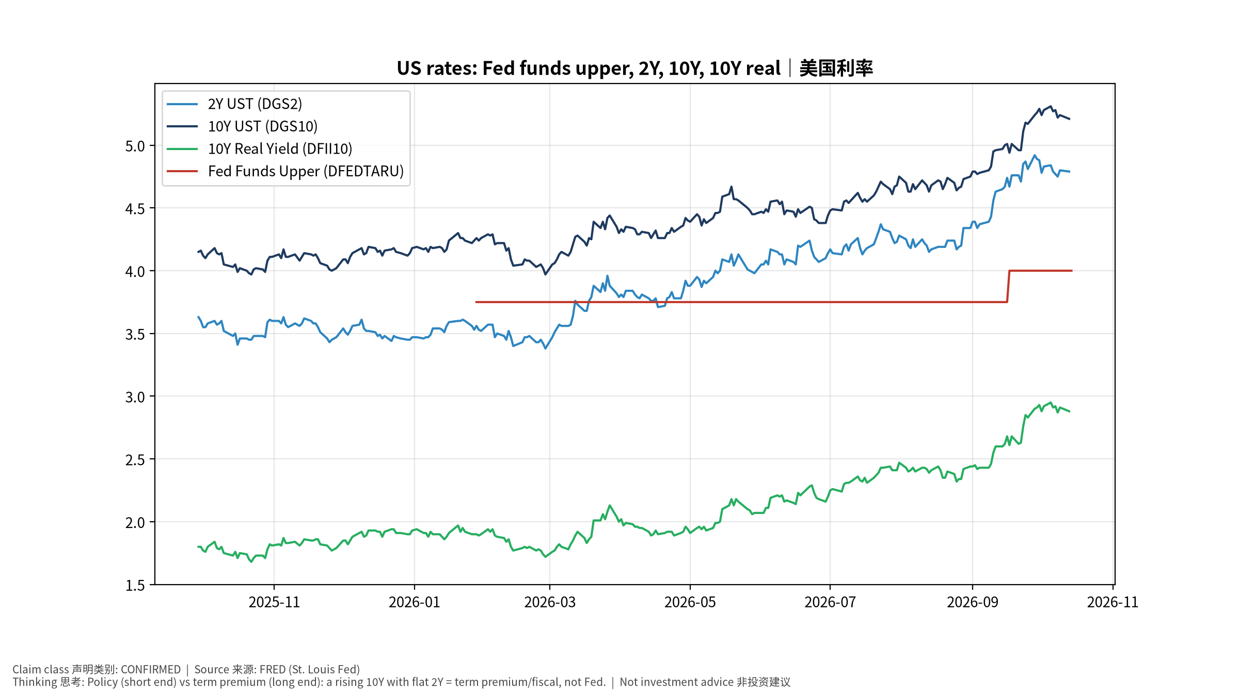
macro_1_rates
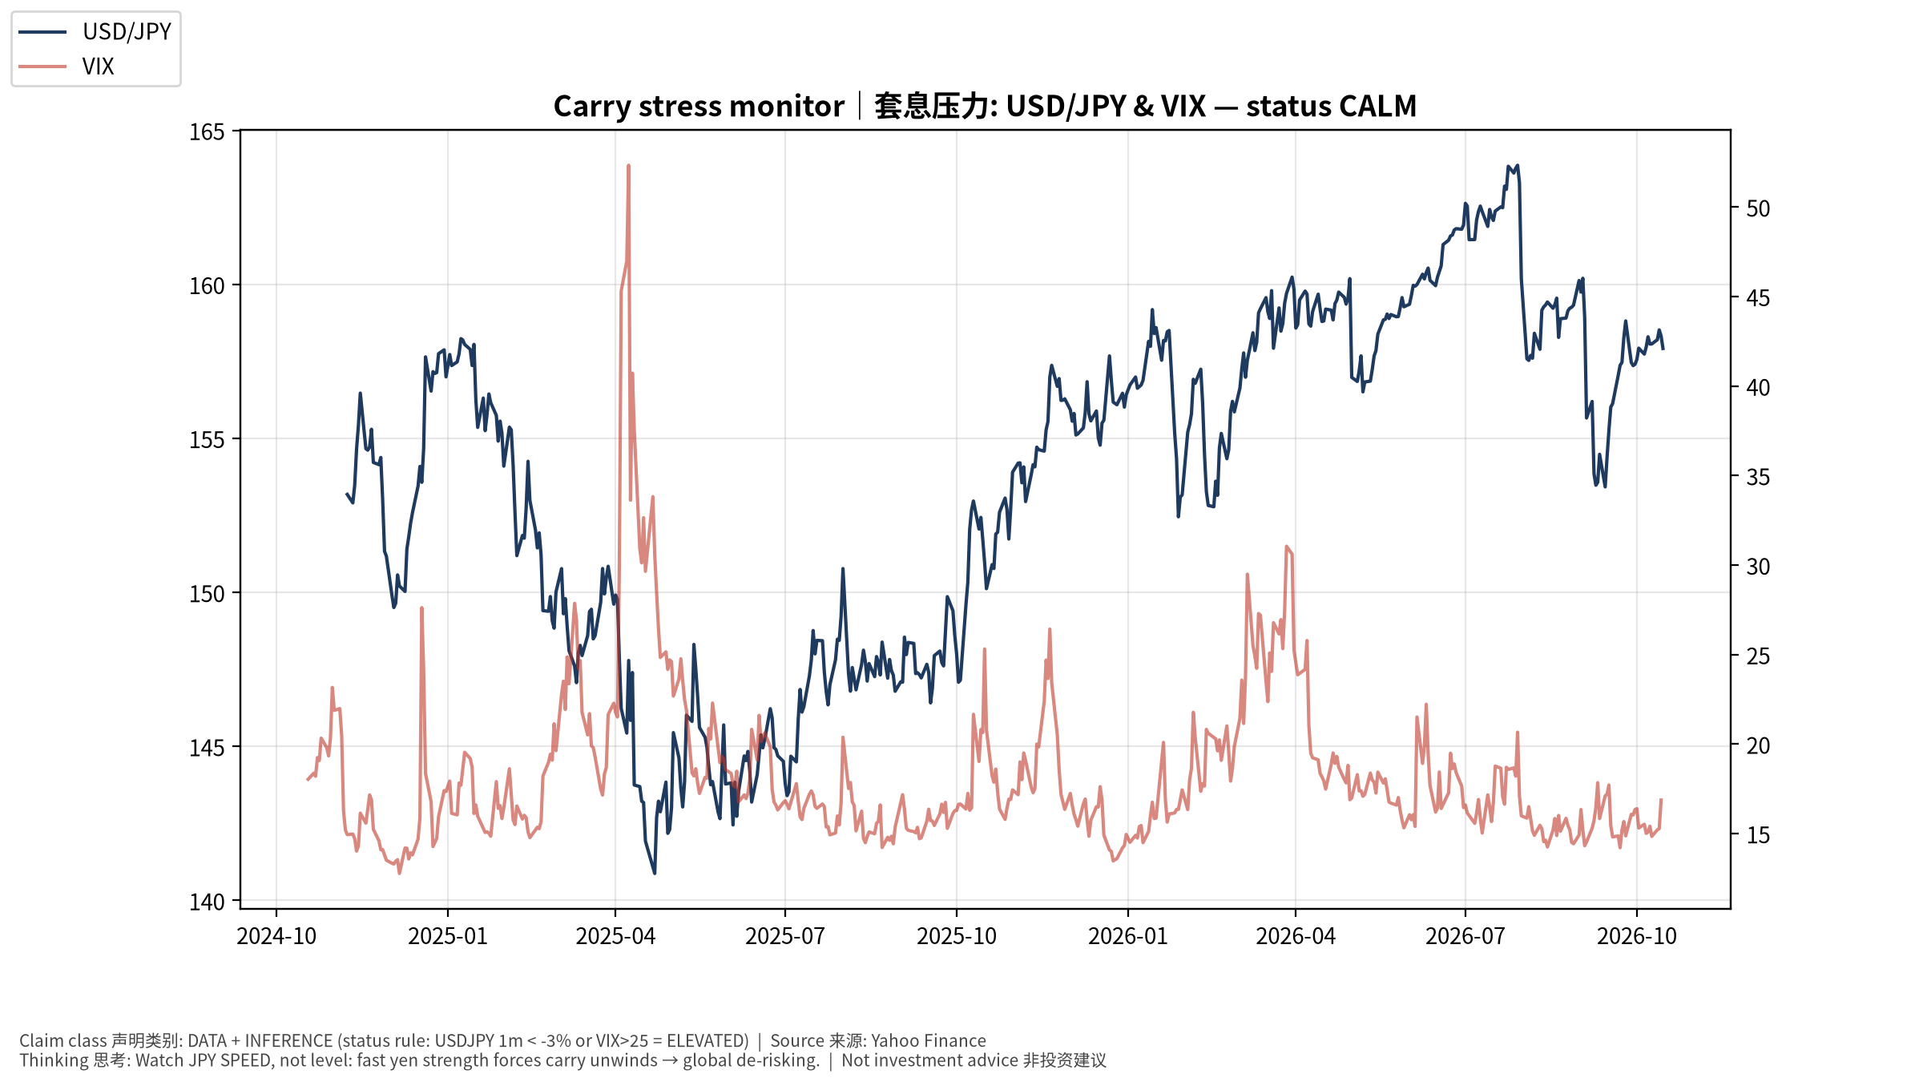
macro_2_carry
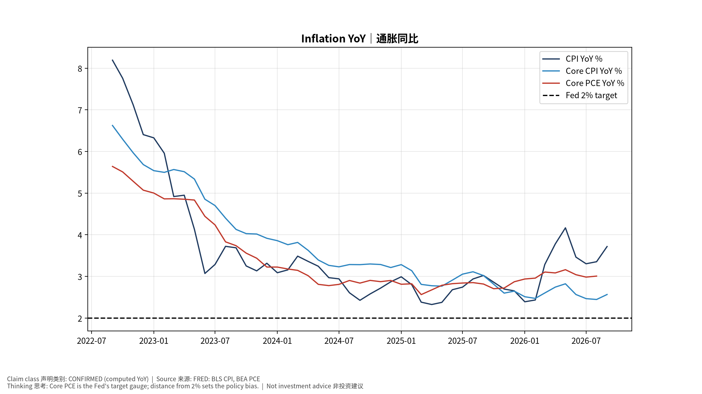
macro_3_inflation
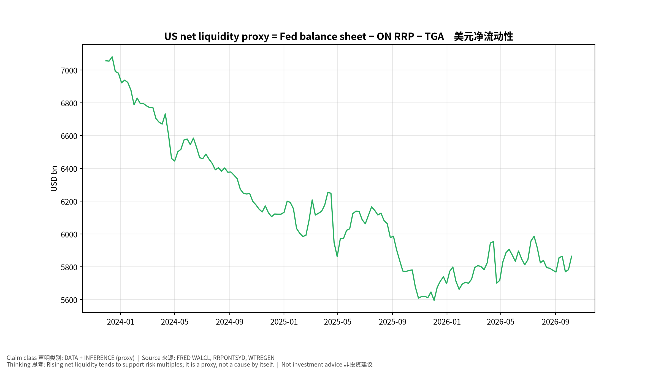
macro_4_liquidity
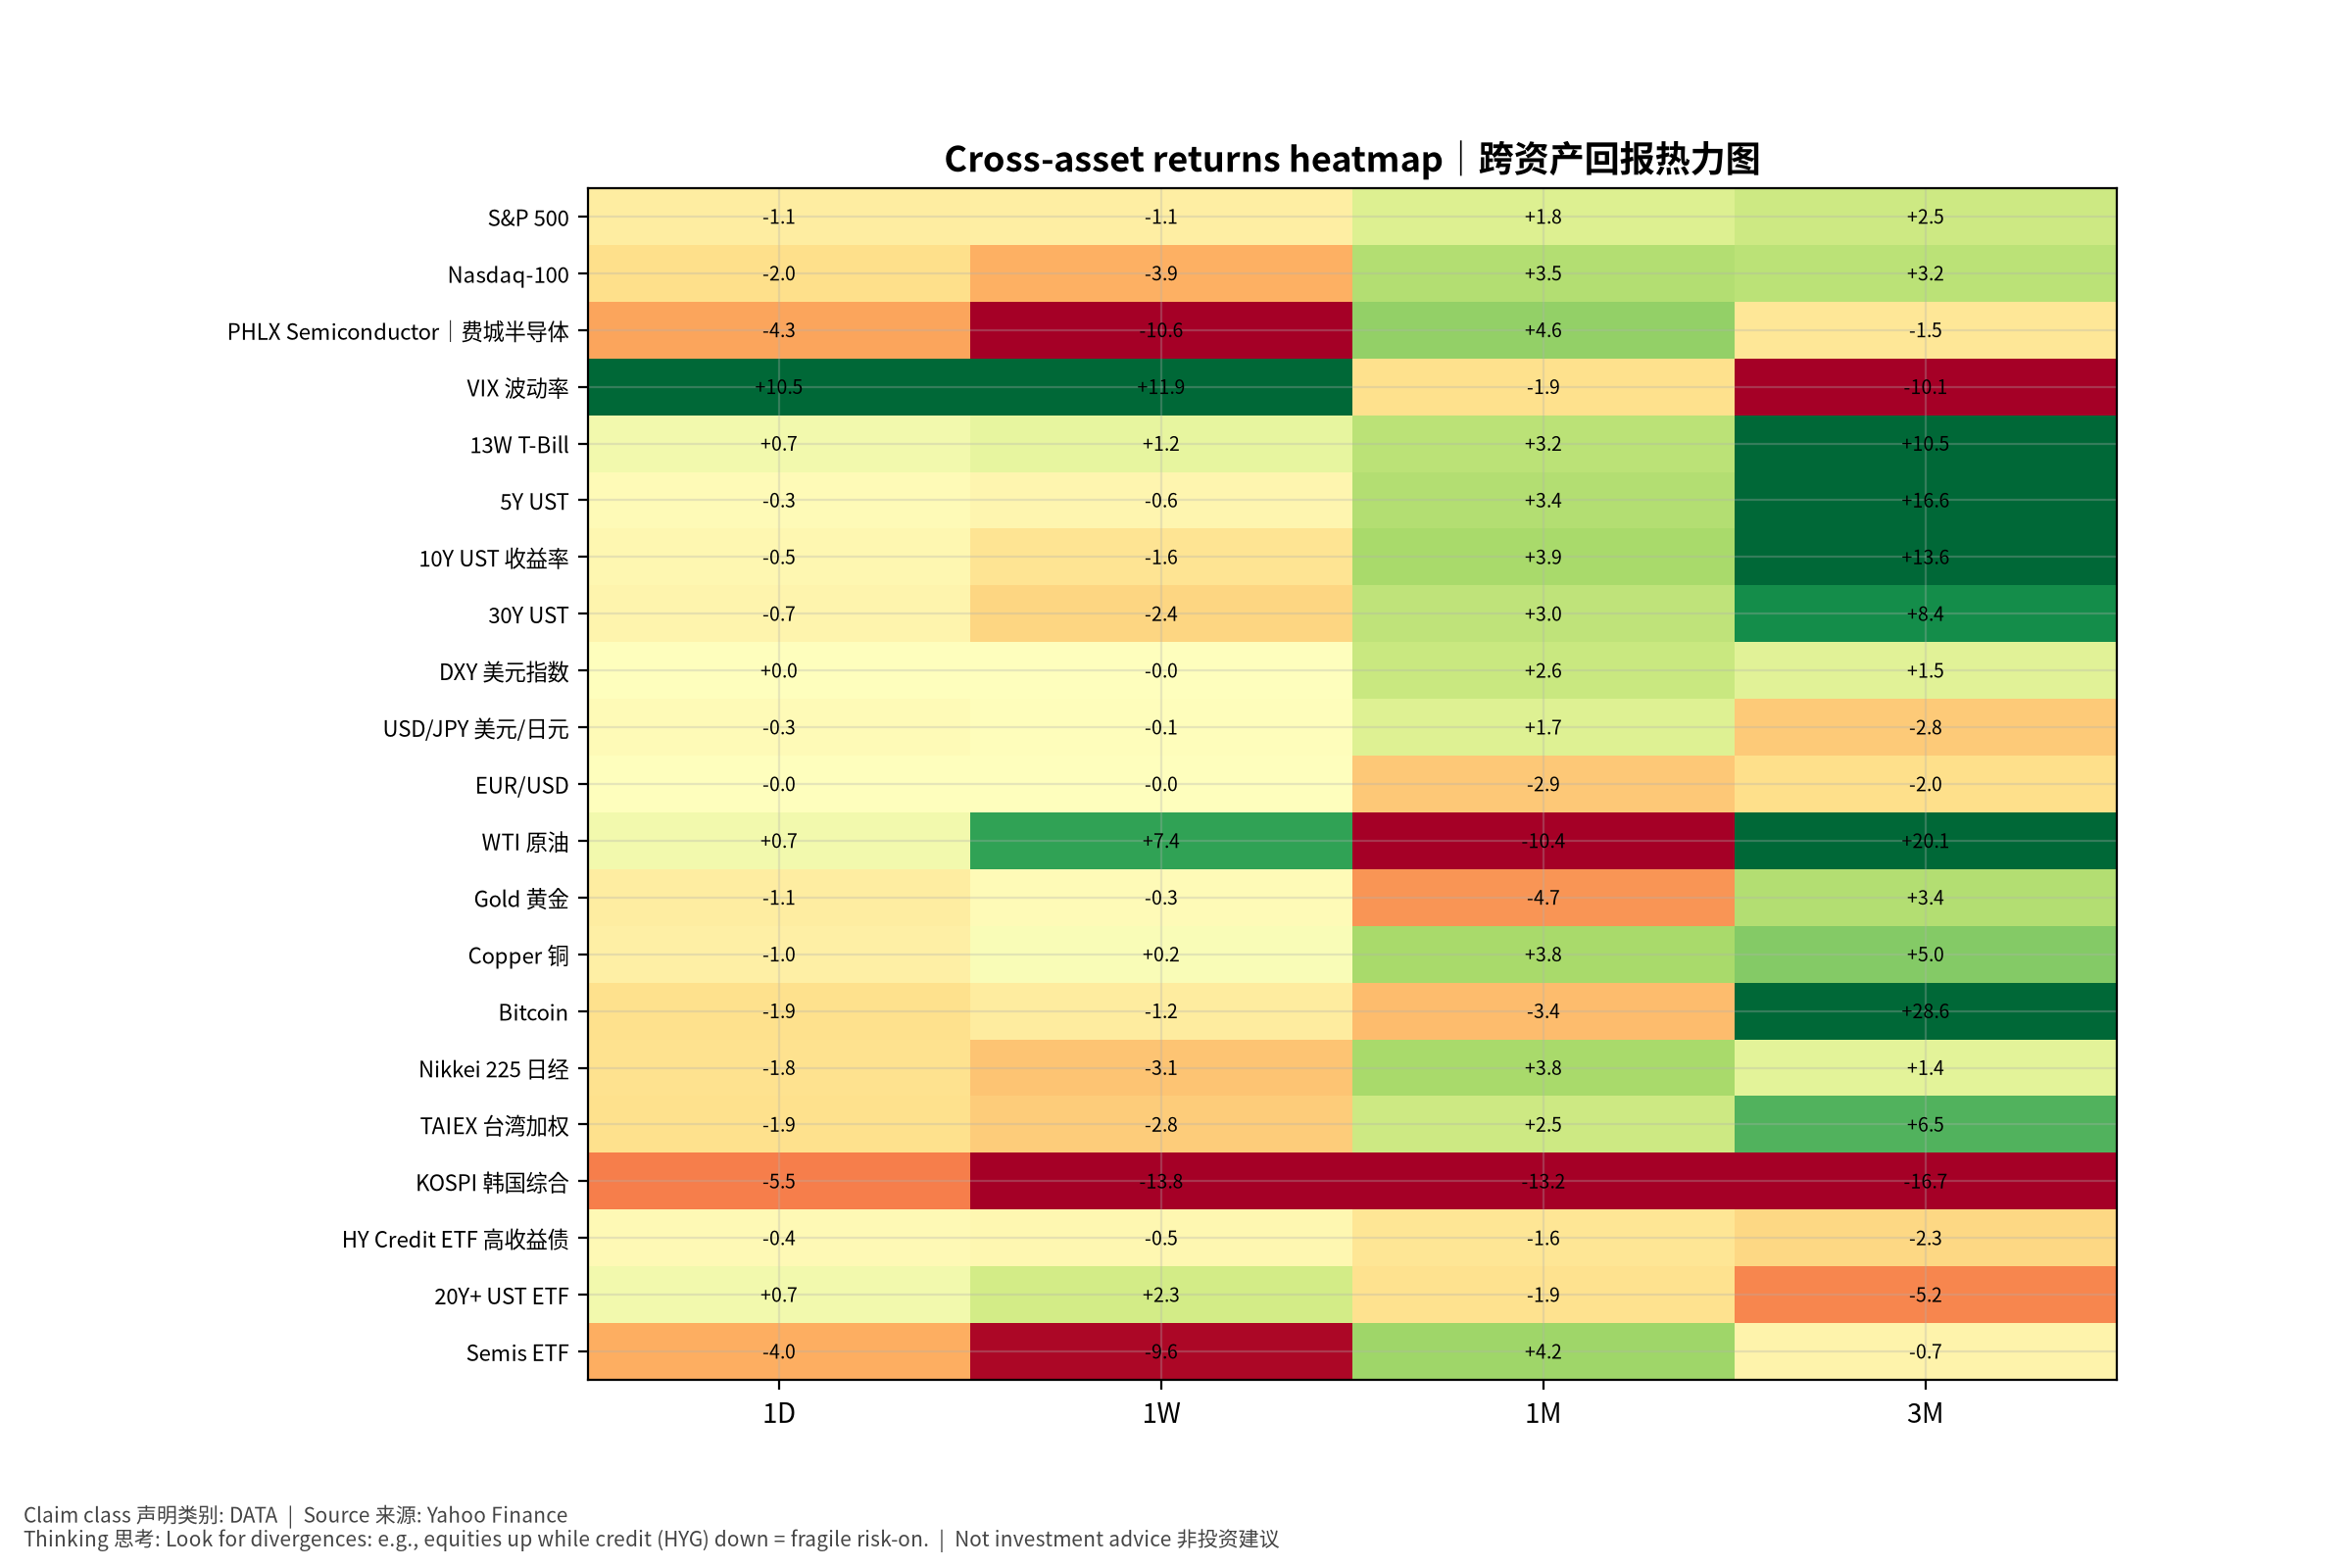
macro_5_crossasset

Macro & Cross-Asset Special (English) v20261015-0757
- Inflation: CPI YoY +3.7%, core CPI +2.6%, core PCE +3.0% — above 2%.
- Fed funds upper 4.0%; 10Y 5.21%; 10Y real 2.88%; 2s10s 0.37%.
- Net liquidity proxy ≈ 5,867 bn USD. Carry stress: CALM (USD/JPY 1M +1.7%, VIX 16.9).
- Positioning claims are withheld: CFTC/fund-manager survey/option skew feeds are UNAVAILABLE in v1.
- AI productivity → inflation → Fed: two competing paths (dovish productivity vs overheating); key evidence Nov 5 Productivity & Costs, Oct 30 ECI.
- Falsifiers: core PCE ≤0.2% m/m for 3 months; USD/JPY −5% in a month. Tables: see Chinese section (bilingual labels).

