台日韩题材雷达 TW/JP/KR Theme Radar v20261015-0757
快照 20261015-0757；等权篮子；评分 = 0.5×1W + 0.3×1M + 0.2×3M (ASSUMPTION)。分类到技术/制程/产品层级(L2)。非投资建议。

1. 题材排名 Theme ranking
市场 | 题材L1 | 成分数 | 1W | 1M | 3M | 评分 | 状态
KR | Battery 电池 | 1 | +8.2% | +13.7% | +34.6% | +15.1 | STRONG 强
JP | Test 测试 | 1 | -3.5% | +23.0% | +38.5% | +12.8 | STRONG 强
TW | Optical 光通信 | 2 | +1.1% | +2.4% | +55.4% | +12.3 | STRONG 强
TW | PCB 印刷电路板 | 1 | +0.0% | +20.6% | +24.1% | +11.0 | STRONG 强
JP | Power Grid 电网 | 1 | +2.6% | +12.9% | +22.7% | +9.7 | STRONG 强
TW | Thermal 散热 | 2 | -6.3% | -0.4% | +64.9% | +9.7 | STRONG 强
TW | PCB/ABF Substrate 载板 | 2 | -7.3% | +26.4% | +23.2% | +8.9 | STRONG 强
TW | ASIC/SoC 芯片设计 | 3 | -5.4% | +8.1% | +44.7% | +8.7 | STRONG 强
TW | Advanced Packaging 先进封测 | 1 | +0.4% | +14.9% | +16.5% | +8.0 | STRONG 强
TW | CCL 覆铜板 | 2 | -4.5% | +13.5% | +18.0% | +5.4 | STRONG 强
TW | Networking 网通 | 1 | +0.0% | +4.3% | -9.4% | -0.6 | NEUTRAL 中性
TW | Foundry 晶圆代工 | 1 | -3.7% | +1.9% | +3.2% | -0.6 | NEUTRAL 中性
TW | AI Server ODM 服务器代工 | 4 | -4.3% | -3.9% | +12.9% | -0.7 | NEUTRAL 中性
JP | Materials 材料 | 1 | -2.3% | +8.3% | -11.6% | -1.0 | NEUTRAL 中性
JP | SPE 半导体设备 | 4 | -8.1% | +15.7% | -11.3% | -1.6 | NEUTRAL 中性
JP | Robotics 机器人 | 2 | -2.0% | +5.8% | -19.6% | -3.2 | WEAK 弱
KR | PCB 印刷电路板 | 1 | -15.7% | -1.0% | +21.1% | -3.9 | WEAK 弱
JP | Optical 光通信 | 2 | -9.9% | +0.9% | +1.5% | -4.4 | WEAK 弱
TW | Power 电源 | 1 | -12.9% | +6.6% | -3.8% | -5.2 | WEAK 弱
TW | Memory 存储 | 2 | -7.8% | -7.4% | +3.8% | -5.3 | WEAK 弱
JP | PCB/ABF Substrate 载板 | 1 | -15.4% | -1.9% | +7.7% | -6.7 | WEAK 弱
JP | ASIC/SoC 芯片设计 | 1 | -12.4% | +7.3% | -24.8% | -9.0 | WEAK 弱
JP | Components 被动元件 | 1 | -15.0% | +5.7% | -20.5% | -9.9 | WEAK 弱
KR | Components 被动元件 | 1 | -18.0% | -2.1% | -8.0% | -11.2 | WEAK 弱
KR | Advanced Packaging 先进封测 | 1 | -21.8% | -13.2% | +0.9% | -14.6 | WEAK 弱
JP | AI Platform/Capital AI 资本 | 1 | -15.0% | -21.4% | -7.0% | -15.3 | WEAK 弱
KR | Power Gen 发电 | 1 | -14.8% | -24.3% | -5.2% | -15.8 | WEAK 弱
KR | Autos/Robotics 汽车/机器人 | 1 | -9.9% | -19.2% | -29.2% | -16.6 | WEAK 弱
KR | Defense/Space 国防航天 | 1 | -17.7% | -19.6% | -11.6% | -17.0 | WEAK 弱
KR | Memory 存储 | 2 | -17.3% | -18.7% | -25.8% | -19.4 | WEAK 弱
KR | Power Grid 电网 | 3 | -21.0% | -23.7% | -20.9% | -21.8 | WEAK 弱
JP | Memory 存储 | 1 | -21.6% | -22.7% | -43.4% | -26.3 | WEAK 弱

2. 个股明细 (技术/制程/产品 L2)
市场 | 题材L1 | 细分L2 | 代码 | 1D | 1W | 1M | 3M
TW | Foundry 晶圆代工 | N3/N2 先进制程 + CoWoS | 2330.TW | +0.0% | -3.7% | +1.9% | +3.2%
TW | ASIC/SoC 芯片设计 | Custom ASIC / 手机SoC | 2454.TW | -1.1% | -9.0% | -5.2% | +22.3%
TW | ASIC/SoC 芯片设计 | Custom ASIC 设计服务 | 3661.TW | -2.8% | -5.7% | -2.8% | +6.6%
TW | ASIC/SoC 芯片设计 | ASIC 设计服务 | 3443.TW | +1.9% | -1.6% | +32.4% | +105.1%
TW | AI Server ODM 服务器代工 | GB/VR rack 整机 | 2317.TW | +1.2% | -5.1% | -3.2% | +3.2%
TW | AI Server ODM 服务器代工 | L10-L11 rack | 2382.TW | +0.0% | -3.1% | -3.9% | -11.4%
TW | AI Server ODM 服务器代工 | Hyperscaler 白牌 | 6669.TW | -3.6% | -7.6% | -9.8% | +28.6%
TW | AI Server ODM 服务器代工 | L6-L10 | 3231.TW | +0.0% | -1.3% | +1.1% | +31.2%
TW | Advanced Packaging 先进封测 | OSAT / CoWoS-like | 3711.TW | +0.9% | +0.4% | +14.9% | +16.5%
TW | PCB/ABF Substrate 载板 | ABF 载板 | 3037.TW | +0.4% | -9.5% | +19.2% | +35.6%
TW | PCB/ABF Substrate 载板 | ABF 载板 | 8046.TW | -0.7% | -5.0% | +33.6% | +10.9%
TW | CCL 覆铜板 | 高速 CCL (M8/M9) | 2383.TW | -0.5% | -7.9% | +2.7% | +11.6%
TW | CCL 覆铜板 | 高速 CCL | 6274.TWO | +4.8% | -1.1% | +24.4% | +24.4%
TW | PCB 印刷电路板 | AI server PCB/HDI | 2368.TW | +7.7% | +0.0% | +20.6% | +24.1%
TW | Thermal 散热 | 液冷 cold plate / 3D VC | 3017.TW | +1.1% | -10.0% | -4.2% | +57.3%
TW | Thermal 散热 | 液冷 CDU/manifold | 3324.TWO | +1.0% | -2.6% | +3.5% | +72.5%
TW | Power 电源 | AI rack PSU / HVDC | 2308.TW | +0.6% | -12.9% | +6.6% | -3.8%
TW | Optical 光通信 | InP 磊晶 epi wafer | 3081.TWO | +5.7% | -1.4% | +1.8% | +64.9%
TW | Optical 光通信 | 光收发模块/CPO | 4979.TWO | +9.9% | +3.5% | +3.0% | +45.9%
TW | Networking 网通 | 800G/1.6T 交换机 | 2345.TW | +0.5% | +0.0% | +4.3% | -9.4%
TW | Memory 存储 | DRAM 利基 | 2408.TW | -1.5% | -8.5% | -6.7% | +7.3%
TW | Memory 存储 | DRAM/NOR 利基 | 2344.TW | +2.2% | -7.0% | -8.1% | +0.3%
JP | SPE 半导体设备 | 刻蚀/涂布显影 | 8035.T | -2.7% | -12.2% | +8.3% | -18.1%
JP | Test 测试 | SoC/HBM ATE | 6857.T | -0.0% | -3.5% | +23.0% | +38.5%
JP | SPE 半导体设备 | Dicing/Grinding (HBM) | 6146.T | -0.8% | -11.3% | +8.8% | -18.5%
JP | SPE 半导体设备 | EUV mask inspection | 6920.T | -1.6% | -2.5% | +28.6% | +5.5%
JP | SPE 半导体设备 | 清洗设备 | 7735.T | -2.1% | -6.5% | +17.0% | -14.2%
JP | ASIC/SoC 芯片设计 | Socionext ASIC | 6526.T | +0.8% | -12.4% | +7.3% | -24.8%
JP | PCB/ABF Substrate 载板 | ABF 载板 (Ibiden) | 4062.T | -1.2% | -15.4% | -1.9% | +7.7%
JP | Materials 材料 | 硅晶圆/光刻胶 | 4063.T | +1.7% | -2.3% | +8.3% | -11.6%
JP | Optical 光通信 | 光纤/光缆 (Fujikura) | 5803.T | +2.6% | -11.2% | -5.0% | +5.7%
JP | Optical 光通信 | 光纤+电线 (Sumitomo Elec) | 5802.T | +1.1% | -8.6% | +6.8% | -2.6%
JP | Memory 存储 | NAND (Kioxia) | 285A.T | -3.2% | -21.6% | -22.7% | -43.4%
JP | Power Grid 电网 | 变压器/电网 (Hitachi) | 6501.T | +0.8% | +2.6% | +12.9% | +22.7%
JP | AI Platform/Capital AI 资本 | SoftBank/ARM/Stargate | 9984.T | +0.8% | -15.0% | -21.4% | -7.0%
JP | Components 被动元件 | MLCC | 6981.T | -1.1% | -15.0% | +5.7% | -20.5%
JP | Robotics 机器人 | Fanuc 工业机器人 | 6954.T | +0.9% | +0.5% | +6.9% | -8.8%
JP | Robotics 机器人 | Yaskawa 伺服/机器人 | 6506.T | -2.6% | -4.5% | +4.6% | -30.4%
KR | Memory 存储 | DRAM/HBM/Foundry (Samsung) | 005930.KS | +0.0% | -14.7% | -13.9% | -16.5%
KR | Memory 存储 | HBM 领先 (SK hynix) | 000660.KS | -1.7% | -20.0% | -23.5% | -35.1%
KR | Advanced Packaging 先进封测 | TC Bonder (Hanmi) | 042700.KS | -5.0% | -21.8% | -13.2% | +0.9%
KR | Components 被动元件 | MLCC/FC-BGA (SEMCO) | 009150.KS | +0.8% | -18.0% | -2.1% | -8.0%
KR | PCB 印刷电路板 | 高多层 PCB (Isu Petasys) | 007660.KS | -5.1% | -15.7% | -1.0% | +21.1%
KR | Power Grid 电网 | 变压器 (HD Hyundai Electric) | 267260.KS | -3.0% | -20.5% | -27.7% | -33.3%
KR | Power Grid 电网 | 配电 (LS Electric) | 010120.KS | -1.1% | -18.5% | -16.2% | -6.4%
KR | Power Grid 电网 | 变压器 (Hyosung Heavy) | 298040.KS | -0.8% | -23.9% | -27.2% | -22.9%
KR | Power Gen 发电 | 燃机/核电 (Doosan Enerbility) | 034020.KS | -1.1% | -14.8% | -24.3% | -5.2%
KR | Defense/Space 国防航天 | Hanwha Aerospace | 012450.KS | +0.4% | -17.7% | -19.6% | -11.6%
KR | Autos/Robotics 汽车/机器人 | Hyundai Motor/Boston Dynamics | 005380.KS | -0.5% | -9.9% | -19.2% | -29.2%
KR | Battery 电池 | LGES ESS | 373220.KS | +2.9% | +8.2% | +13.7% | +34.6%

3. 美股联动 US read-across
- Memory: MU ↔ 000660.KS/005930.KS/285A.T；Foundry: TSM ↔ 2330.TW；Optical: LITE/COHR/GLW ↔ 5803.T/3081.TWO/4979.TWO；Power grid: PWR/EME ↔ 267260.KS/6501.T；ASIC: AVGO/MRVL ↔ 3661.TW/2454.TW；SPE: AMAT/KLAC ↔ 8035.T/6857.T/6146.T。 ## 4. 教学 Teaching 题材轮动 (rotation｜轮动) = 资金从一个篮子转向另一个。看”1W强但3M弱”=新启动；“3M强但1W弱”=可能拥挤后降温。证伪: 美股对应龙头财报不及预期而亚洲篮子仍上涨 → 题材脱离基本面。 English: rotation = money moving between baskets; strong 1W/weak 3M = new leadership; strong 3M/weak 1W = possible crowding unwind. ## Source Ledger Yahoo Finance local-exchange daily closes, snapshot 20261015-0757. Theme mapping = analyst classification (pipeline/universe.py).
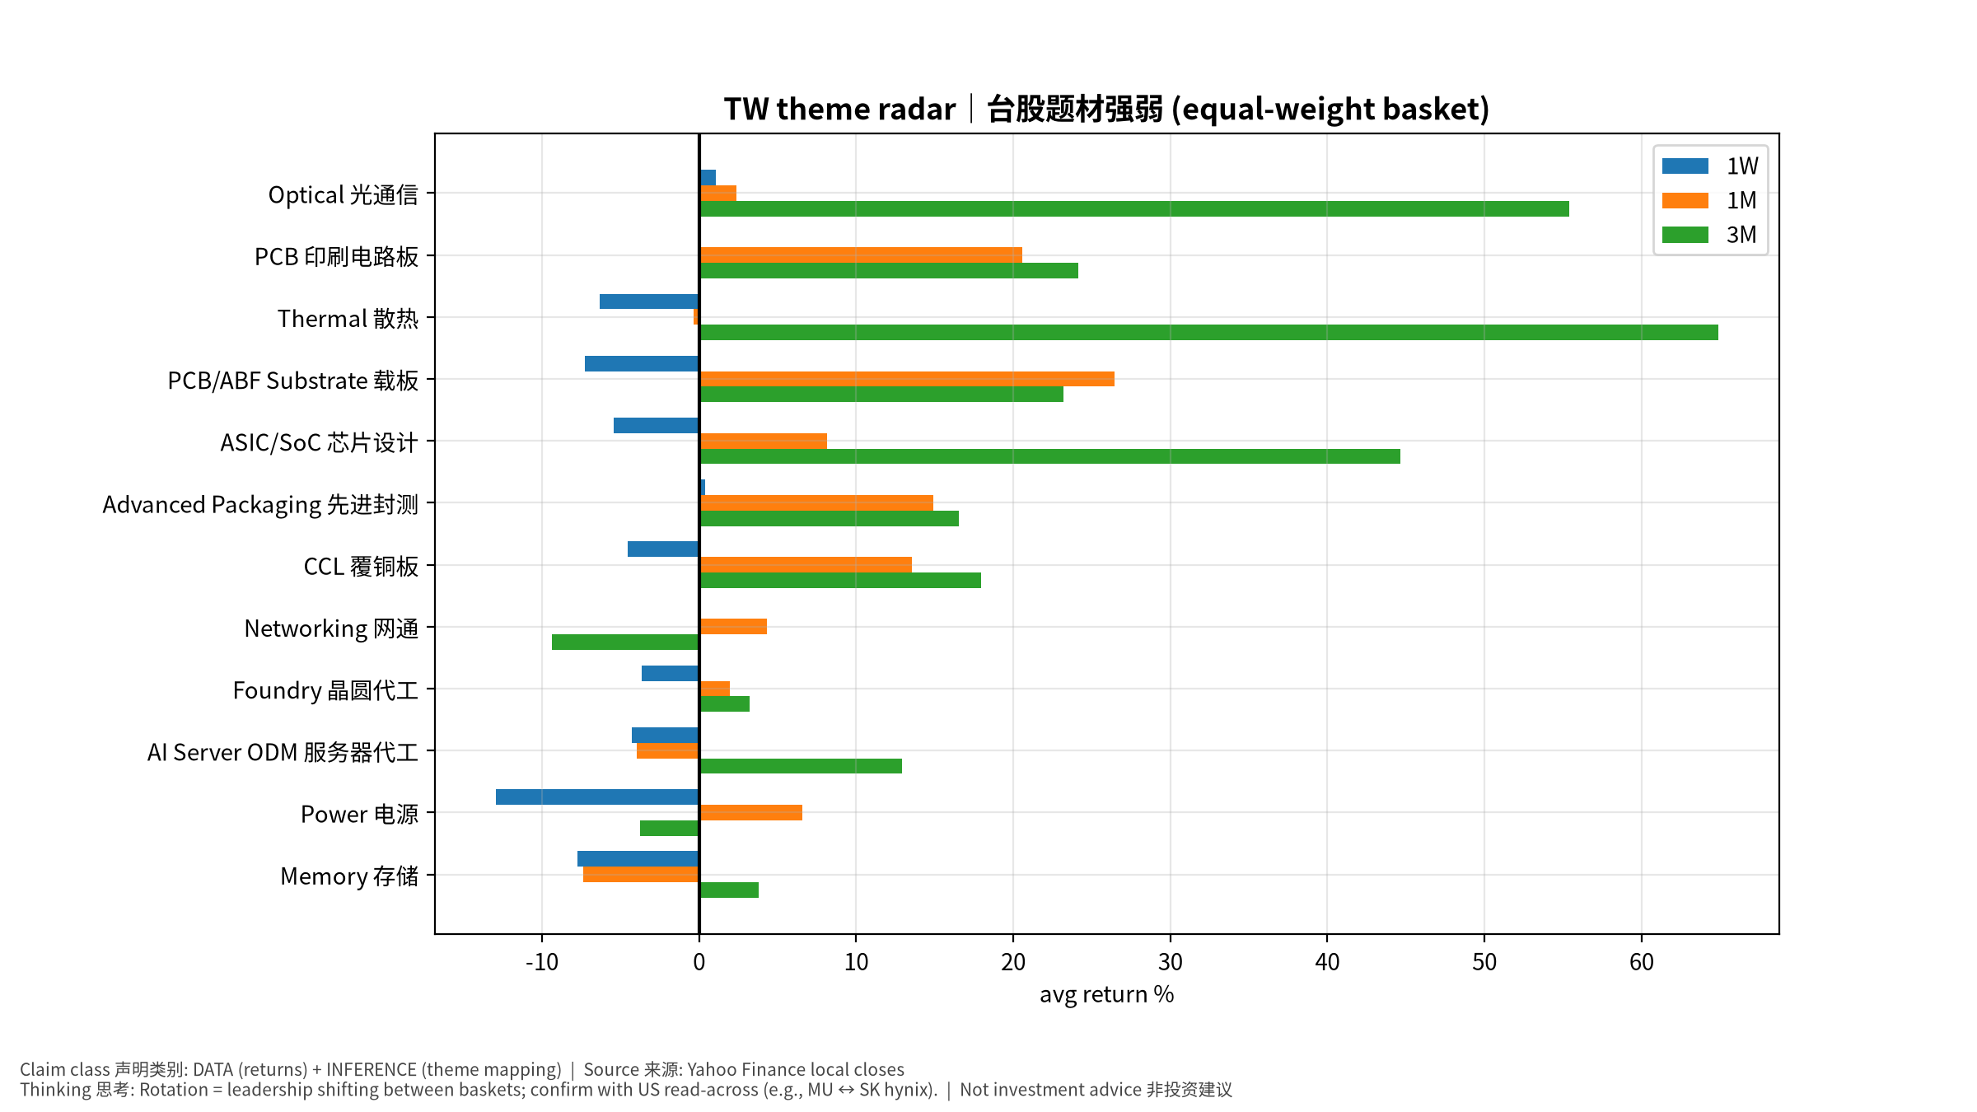
TW
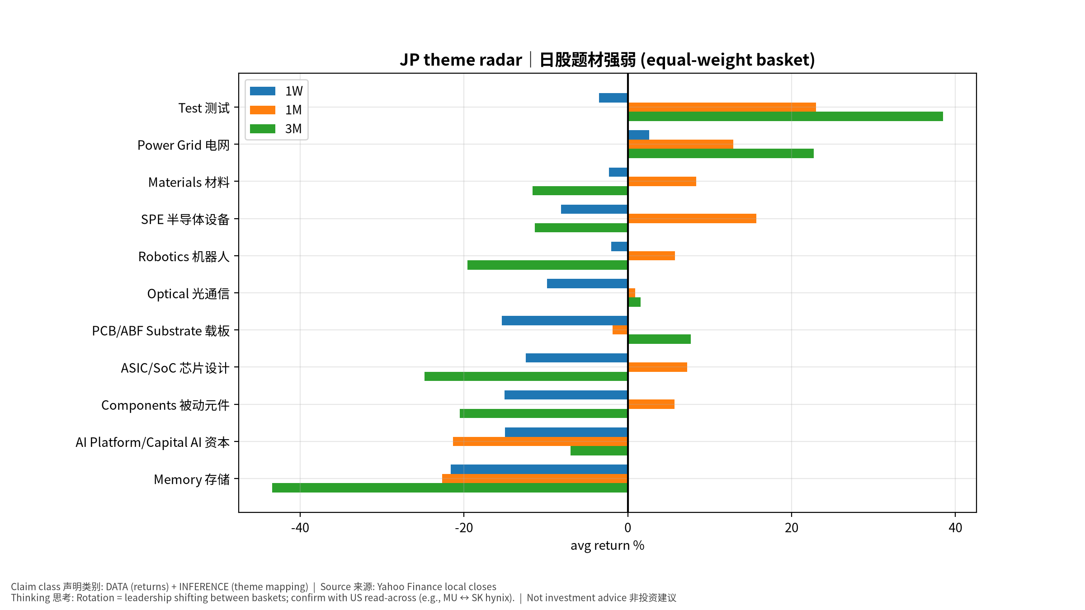
JP
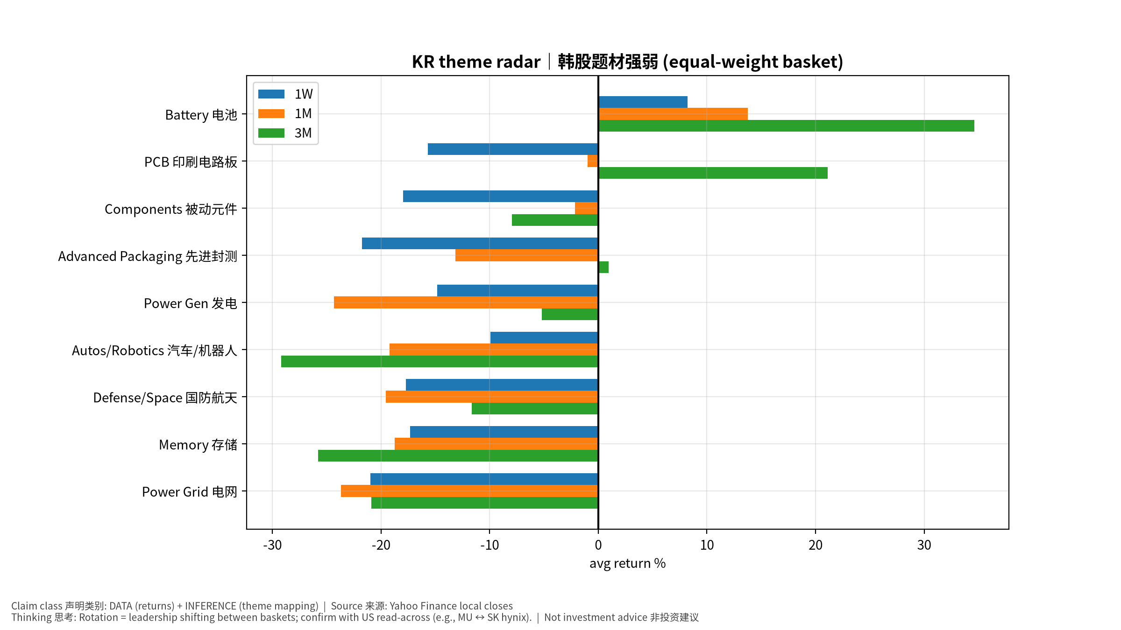
KR

