INTC Intel Corporation — 个股深度研究 (专业中文版) v20261014-0758
数据截至 2026-10-14 07:58 SGT｜价格 $102.81｜市值 543.5 bn USD｜财报货币 USD｜非投资建议。事实=CONFIRMED/DATA；推断=INFERENCE；假设=ASSUMPTION/HYPOTHESIS。

1. 投资论点 Investment Thesis (HYPOTHESIS)
英特尔是政府+NVDA+软银入股支撑的转型故事；价值取决于代工能否获得外部大客户与CPU份额止血，属于高不确定性的期权型标的。
- 多头驱动: 14A external anchor customer; server CPU demand from agentic AI; margin recovery｜14A外部大客户；Agent AI拉动服务器CPU；毛利修复
- 空头驱动: Foundry losses persist; share loss to AMD/ARM; dilution｜代工持续亏损；份额流失；股权稀释
- 证伪条件 Falsifiers: No major external 14A commitment; foundry operating loss not narrowing; GM <40%｜无14A外部承诺；代工亏损不收窄；毛利率<40%

2. 产品、客户与收入模式
- 主题 Theme: x86 CPU + foundry turnaround x86+代工转型
- 业务分部 Segments: Client computing 客户端；Data center & AI 数据中心；Intel Foundry 代工；Altera/Mobileye/other 其他
- 公司描述 (DATA, Yahoo/公司申报): Intel Corporation designs, develops, manufactures, markets, sells, and services computing and related end products and services in the United States, Ireland, Israel, and internationally. It operates through three segments: CCG, DCAI, and Intel Foundry. The company offers client computing group products, including client and commercial CPUs, discrete client GPUs, edge computing, and connectivity products; data center and AI products, such as server CPUs, discrete GPUs, and networking products; and semiconductors comprising wafer fabrication, substrates, and other related products and services. It also provides driving assistance and self-driving solutions; and develops and manufactures multi-beam mask writing tools. The company sells its products through sales organizations, distributors, resellers, retailers, and OEM partners. It serves original equipment manufacturers, original design
- 主要客户: PC OEMs, cloud/enterprise servers, US government (CHIPS), foundry prospects (NVDA investment, others)｜PC厂、服务器、美国政府、潜在代工客户

3. 行业、竞争、监管与供应链 (ANALYST FRAMEWORK)
- 供应商/上游: ASML (High-NA EUV), equipment, TSMC (outsourced tiles)｜ASML、设备商、台积电(外包)
- 竞争者 (含业外): AMD, ARM-based CPUs, TSMC/Samsung in foundry｜AMD、ARM CPU、台积电/三星
- 瓶颈/监管: 18A/14A yield & external customers, capex funding, execution｜18A/14A良率与外部客户、资本开支资金、执行力
- 关键KPI: GM%, foundry op loss, 18A yield commentary, DCAI revenue, capex｜毛利率、代工亏损、18A良率、DCAI收入、Capex
- 零部件现货/合约价: 本版未接入付费价格源(TrendForce/DRAMeXchange等)——标注 UNAVAILABLE，在KPI监控中以定性方式跟踪。

4. 历史财务与现金流 (CONFIRMED, 季度, USD)
季度 | 收入 | 毛利 | 营业利润 | 净利润 | FCF | 营业利润率
2026-06-30 | 16.1 bn USD | 6.5 bn USD | 2.0 bn USD | -11.0 bn USD | 4.5 bn USD | 12.2%
2026-03-31 | 13.6 bn USD | 5.3 bn USD | 0.9 bn USD | -3.7 bn USD | -2.5 bn USD | 6.9%
2025-12-31 | 13.7 bn USD | 4.9 bn USD | 0.6 bn USD | -0.6 bn USD | 0.8 bn USD | 4.0%
2025-09-30 | 13.7 bn USD | 5.2 bn USD | 0.9 bn USD | 4.1 bn USD | 0.1 bn USD | 6.3%
2025-06-30 | 12.9 bn USD | 3.5 bn USD | -1.3 bn USD | -2.9 bn USD | -1.5 bn USD | -10.0%
资产负债: 现金 29.7 bn USD；总负债 50.5 bn USD；净现金 -20.8 bn USD。TTM FCF 2.8 bn USD（FCF率 5.0%）。

5. 最新财报: 实际 vs 一致预期 vs 指引
季度 | EPS实际 | EPS一致预期 | 超预期%
2025-09-30 | 0.23 | 0.00705 | 31.6241
2025-12-31 | 0.15 | 0.08264 | 0.8151
2026-03-31 | 0.29 | 0.01313 | 21.0868
2026-06-30 | 0.42 | 0.21584 | 0.94589996
- 管理层指引 Guidance: 自动数据源不含指引——UNAVAILABLE（待从公司IR新闻稿录入）。
- 下次财报日 (Yahoo, TENTATIVE 直至公司确认): 2026-10-30；本季EPS一致预期 0.39202（36位分析师）；收入一致预期 16.4 bn USD。

6. 未来2/4/6/8季度驱动与价格合理性
期限 | 情景 | 期限价格现值 | 相对现价
2Q | Bear | $6.22 | -93.9%
2Q | Base | $16.51 | -83.9%
2Q | Bull | $28.41 | -72.4%
4Q | Bear | $6.66 | -93.5%
4Q | Base | $18.47 | -82.0%
4Q | Bull | $32.68 | -68.2%
6Q | Bear | $7.06 | -93.1%
6Q | Base | $20.43 | -80.1%
6Q | Bull | $37.14 | -63.9%
8Q | Bear | $7.42 | -92.8%
8Q | Base | $22.41 | -78.2%
8Q | Bull | $41.80 | -59.3%

现价隐含的 EV/NTM-FCF (Base 路径): | 期限
2Q | 124.1x
4Q | 107.4x
6Q | 93.4x
8Q | 81.7x
解读: 如果8季度后Base情景所需倍数仍远高于25x，说明价格依赖更远期的增长。

7. 三情景 Bear / Base / Bull (HYPOTHESIS)
情景 | Y1增速 | 长期FCF率 | WACC | 永续g | 概率 | 每股价值 | 相对现价
Bear | 7.4% | 8.0% | 14.2% | 2.5% | 25.0% | $4.55 | -95.6%
Base | 14.9% | 10.0% | 13.2% | 3.0% | 50.0% | $11.99 | -88.3%
Bull | 19.4% | 11.5% | 12.7% | 3.5% | 25.0% | $19.99 | -80.6%
概率加权价值 $12.13（相对现价 -88.2%）。

8. 估值: DCF / Reverse DCF / ROIC-WACC / 同业 / 敏感度
- DCF Base: EV 84.2 bn USD；终值占比 46.0%。
- Reverse DCF 反向DCF: 在Base利润率与WACC下，现价隐含Y1收入增速 ≈ 69.5%；一致预期FY+1增速 14.9%。
- WACC (CAPM) = rf 5.2% + β 1.60 × ERP 5.0% = 13.2%。
- SOTP segments 分部: Client computing 客户端; Data center & AI 数据中心; Intel Foundry 代工; Altera/Mobileye/other 其他. Status: framework only — segment revenues are INPUT REQUIRED from the latest 10-K/10-Q segment note (not auto-fed, left blank to avoid fabrication)｜分部收入需按最新财报手动录入，未自动填充以避免编造。
- 同业比较 Comps (DATA): | Ticker | 市值 | EV/Sales | Fwd P/E | 收入增速 | 毛利率 | FCF收益率 | |—|—|—|—|—|—|—| | INTC | 543.5 bn USD | 9.7x | 49.2x | 25.4% | 38.9% | 0.5% | | AMD | 988.5 bn USD | 23.7x | 38.5x | 50.1% | 55.7% | 0.9% | | TSM | 2,308.6 bn USD | 3.6x | 19.9x | 36.0% | 64.2% | 31.7% | | ARM | 272.8 bn USD | 52.2x | 83.4x | 22.4% | 97.5% | 0.5% | | NVDA | 5,518.1 bn USD | 18.1x | 14.4x | 105.9% | 74.7% | 0.8% |
- 敏感度: 见Excel Sensitivity 表 (WACC × 永续增长率)。

9. 风险、反方论证与证伪
- 反方观点 Counter-thesis: Foundry losses persist; share loss to AMD/ARM; dilution｜代工持续亏损；份额流失；股权稀释
- 证伪指标: No major external 14A commitment; foundry operating loss not narrowing; GM <40%｜无14A外部承诺；代工亏损不收窄；毛利率<40%
- 模型风险: 长期利润率与WACC为假设；终值占比高时估值对假设极敏感。

10. Source Ledger 来源账本
Item | Value | Source/time
Price 股价 | 102.8 | Yahoo Finance quote, fetched 2026-10-14T07:58 SGT
Market cap 市值 | 5.435e+11 | Yahoo info.marketCap 2026-10-14T07:58
Cash 现金 | 2.973e+10 | Yahoo info.totalCash (latest filing) 2026-10-14T07:58
Debt 负债 | 5.054e+10 | Yahoo info.totalDebt (latest filing) 2026-10-14T07:58
Revenue TTM 收入 | 5.703e+10 | Yahoo info.totalRevenue (TTM, USD) 2026-10-14T07:58
FCF TTM 自由现金流 | 2.831e+09 | Sum of last 4 quarterly FCF (q_cash); quarters [‘2026-06-30’, ‘2026-03-31’, ‘2025-12-31’, ‘2025-09-30’] (USD)
Beta | 2.23 | Yahoo info.beta (5Y monthly)
Risk-free 10Y 无风险利率 | 0.0524 | FRED DGS10 2026-10-09
FX USD per USD | 1 | n/a (USD)
Consensus rev growth FY0 | 0.1944 | Yahoo revenue_estimate 0y
Consensus rev growth FY+1 | 0.149 | Yahoo revenue_estimate +1y

11. Assumption Register 假设登记表
Assumption | Value | Rationale
ERP 股权风险溢价 | 0.05 | ASSUMPTION: 5.0% house mature-market ERP
Beta clamp | [0.8,1.6] → 1.60 | ASSUMPTION: limit extreme betas
Tax rate (ROIC) | 0.18 | ASSUMPTION: blended cash tax 18%
Year-1 growth (Base) | 0.149 | Consensus FY+1 revenue growth (Yahoo revenue_estimate ‘+1y’); capped at 100%
Growth fade | linear Y1→terminal by Y10 | ASSUMPTION
Starting FCF margin | 0.04964 | DATA: FCF TTM / Revenue TTM, floored -50%
Long-run FCF margin (Base) | 0.1 | ASSUMPTION (analyst framework, reached by Y5; see profile)
Bear/Bull Y1 growth multiplier | 0.5x / 1.3x | ASSUMPTION
Bear/Bull margin multiplier | 0.8x / 1.15x | ASSUMPTION
WACC adj Bear/Bull | +1.0pp / -0.5pp | ASSUMPTION
Terminal g Bear/Base/Bull | 2.5% / 3.0% / 3.5% | ASSUMPTION
Scenario probabilities | 25% / 50% / 25% | ASSUMPTION
Horizon exit EV/NTM-FCF Bear/Base/Bull | 15x / 25x / 35x | ASSUMPTION
Per-share conversion | value × fx ÷ market cap × price | METHOD: avoids ADR/share-class mismatch

12. Model Provenance 模型溯源
- Model file: INTC_model_v20261014-0758.xlsx (live formulas; sheets Inputs→Scenarios→DCF→ReverseDCF→Sensitivity→Horizons→SOTP→Comps→ROIC_WACC→History→Sources→Assumptions)
- Engine: production/pipeline/model.py (Python mirror; values in this report = Python mirror, verified against LibreOffice recalculation of the xlsx)
- Data snapshot: data/snapshots/20261014-0758 (immutable) | Fetched 2026-10-14 07:58 SGT | Generated 2026-10-14 07:59 SGT
- Version: v20261014-0758. Prior versions are never overwritten (see company history page).

13. 版本与事件时间轴
- v20261014-0758: 首版生产系统报告 (27家同步)。下一事件: 财报 2026-10-30 (TENTATIVE)。

图片报告 Image Report
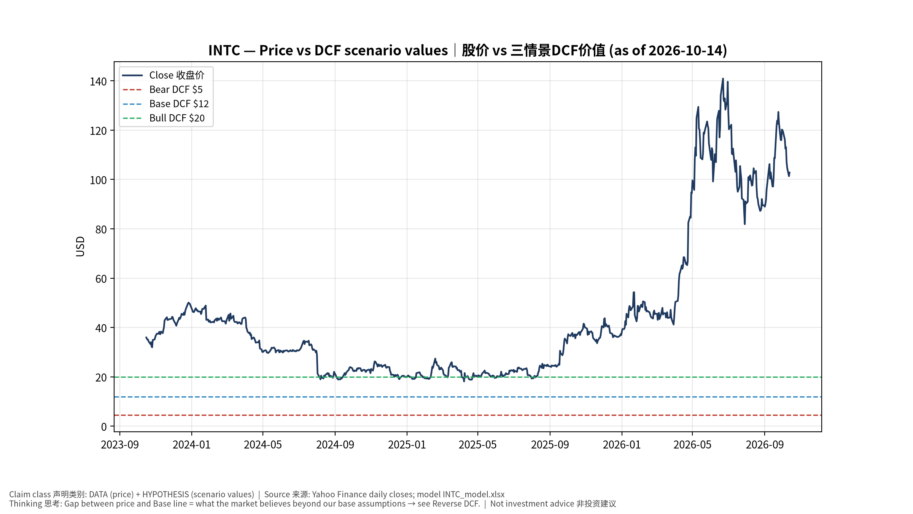
1_price_vs_value
股价vs三情景价值 Price vs scenario values
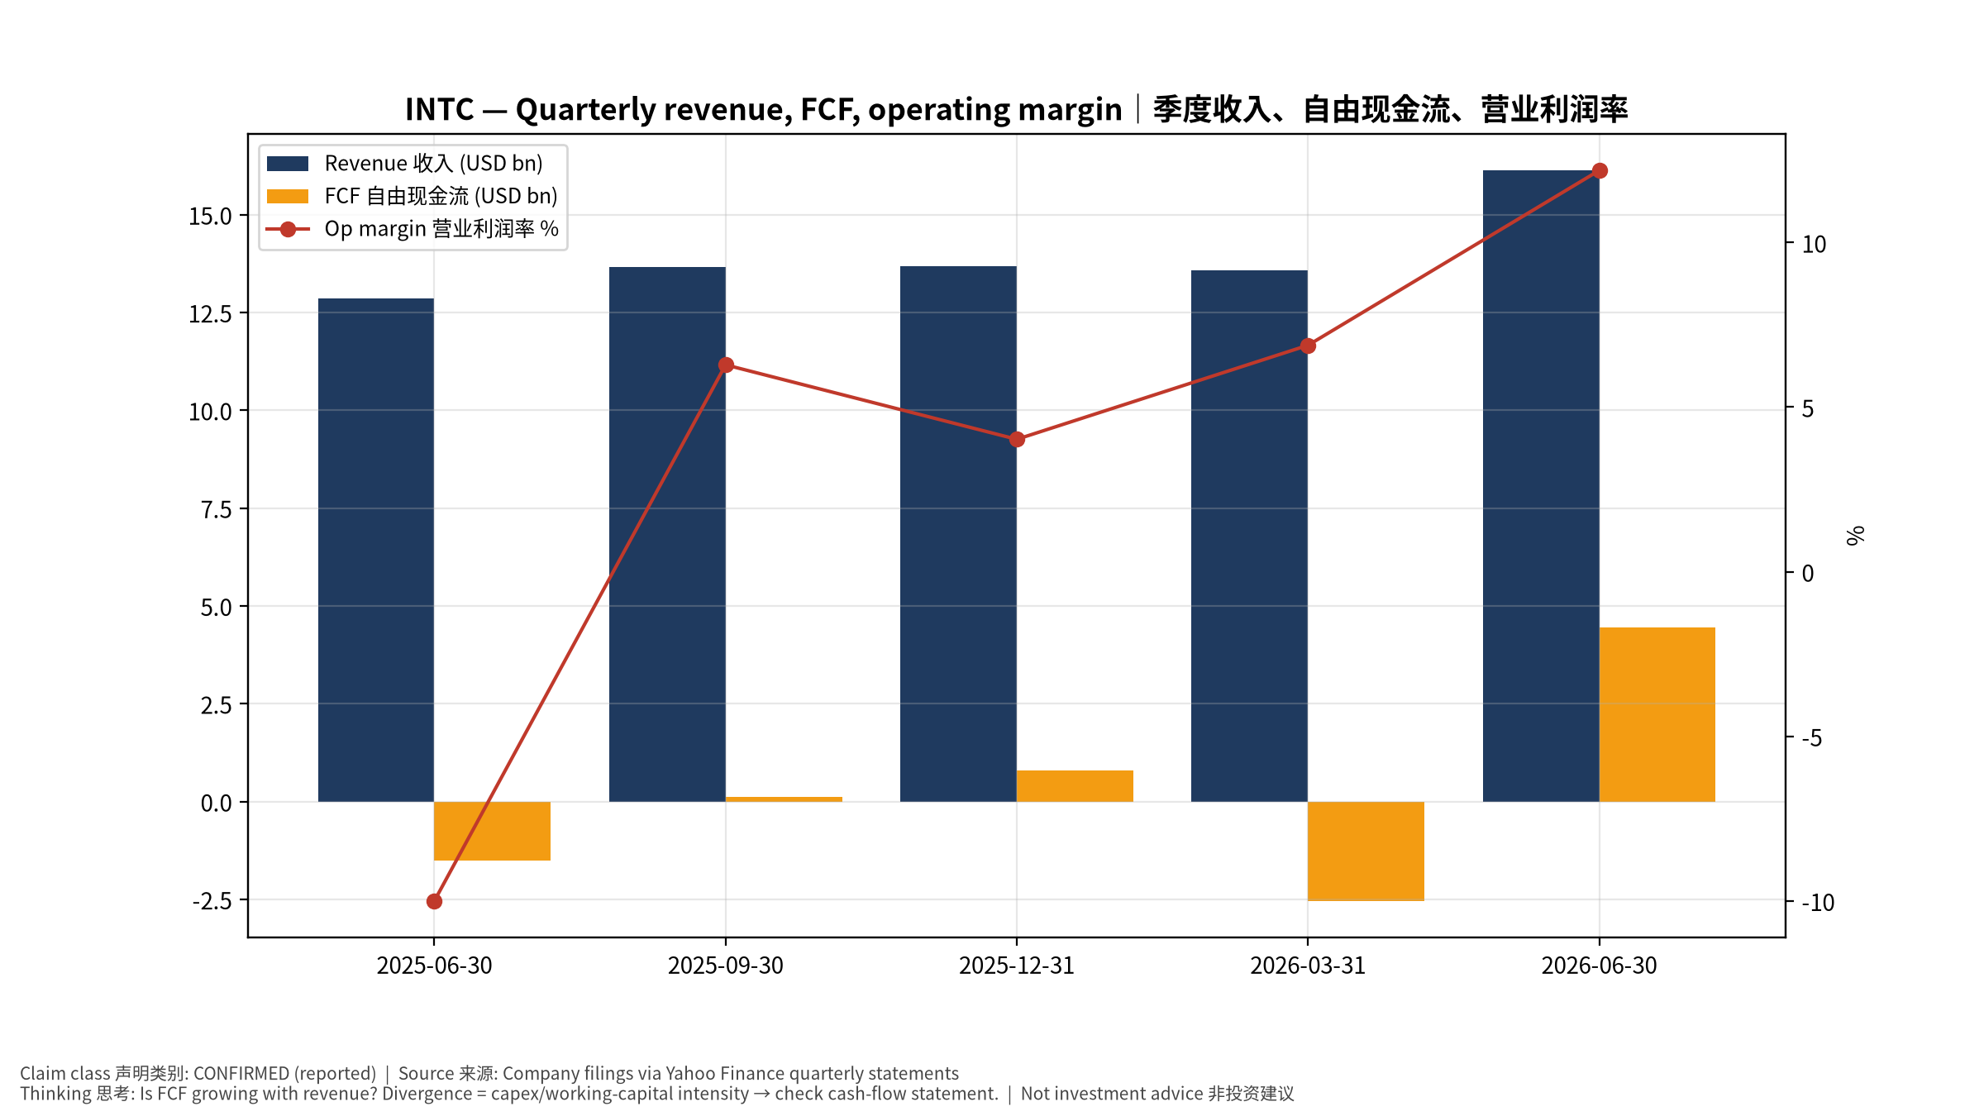
2_financials
季度财务 Quarterly financials
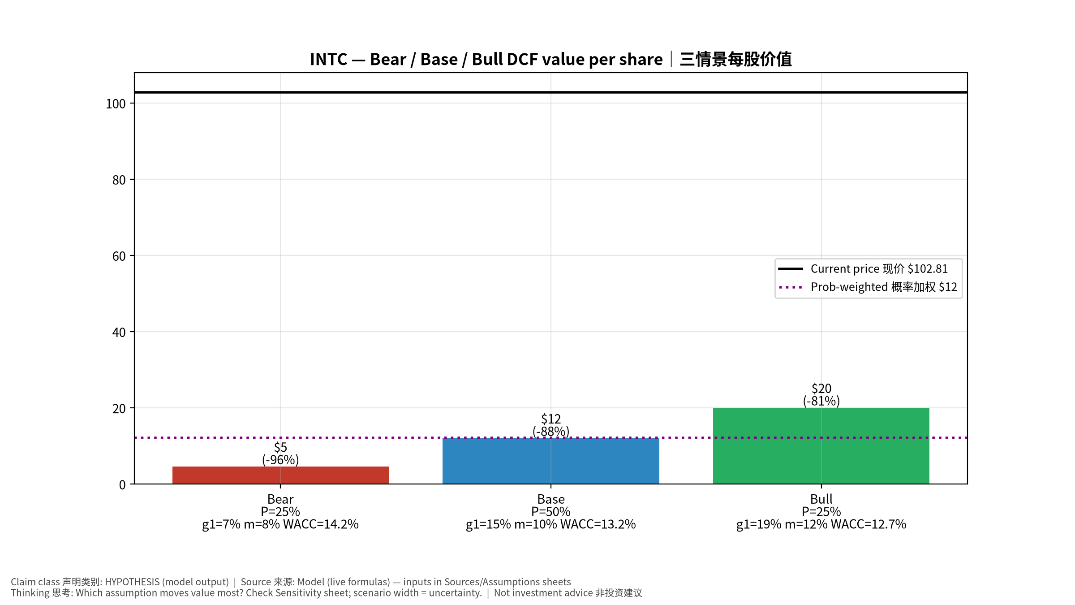
3_scenarios
三情景 Scenarios
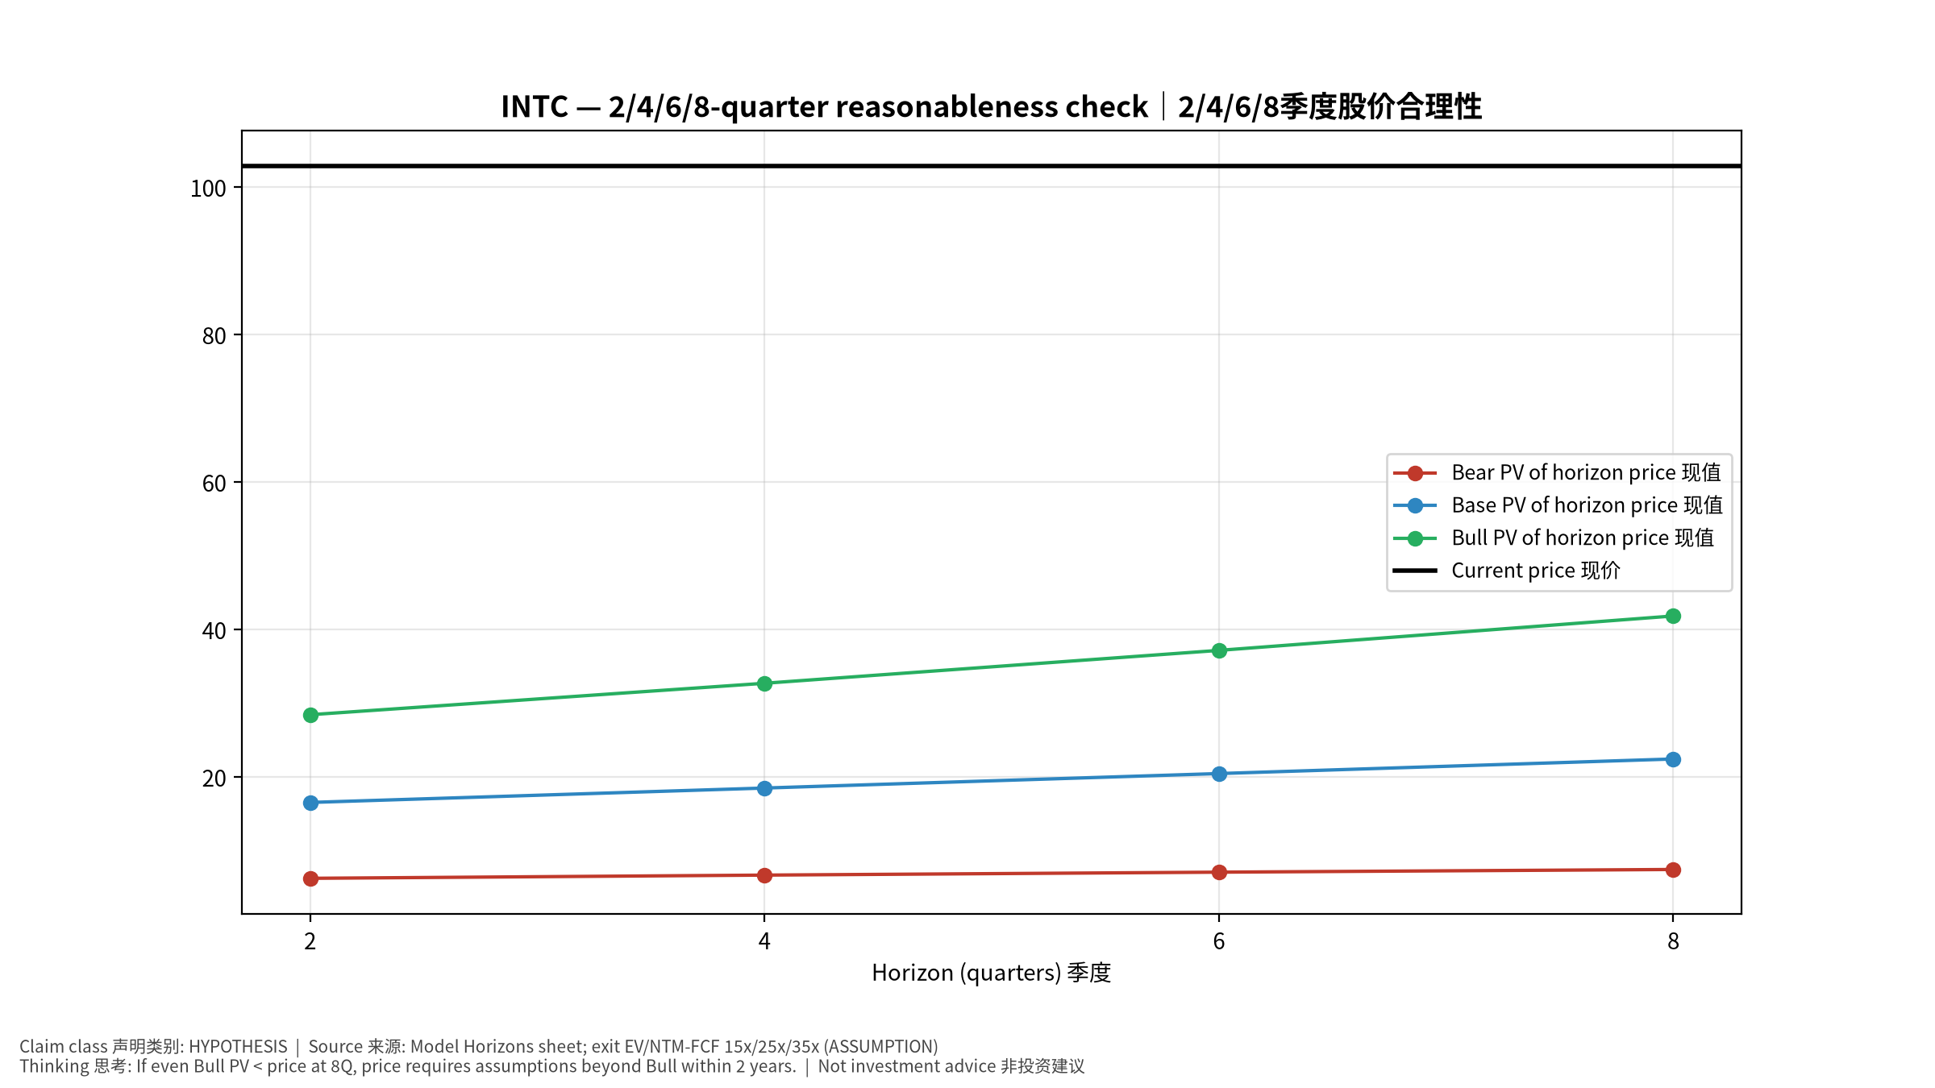
4_horizons
2/4/6/8季度检验 Horizon check
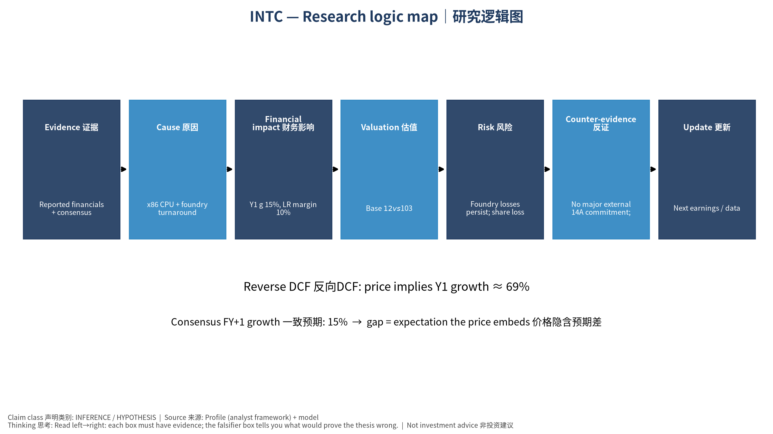
5_logic_map
研究逻辑图 Logic map

INTC Intel Corporation — Equity Deep Dive (Professional English) v20261014-0758
Data as of 2026-10-14 07:58 SGT | Price $102.81 | Mkt cap 543.5 bn USD | Reporting currency USD | Not investment advice.

1. Investment thesis (HYPOTHESIS)
Intel is a turnaround backed by US-government, NVDA and SoftBank stakes; value hinges on landing external foundry customers and stabilizing CPU share—a high-uncertainty option-like name.
- Bull drivers: 14A external anchor customer; server CPU demand from agentic AI; margin recovery｜14A外部大客户；Agent AI拉动服务器CPU；毛利修复
- Bear drivers: Foundry losses persist; share loss to AMD/ARM; dilution｜代工持续亏损；份额流失；股权稀释
- Falsifiers: No major external 14A commitment; foundry operating loss not narrowing; GM <40%｜无14A外部承诺；代工亏损不收窄；毛利率<40%

2. Products, customers, revenue model
- Theme: x86 CPU + foundry turnaround x86+代工转型 | Segments: Client computing 客户端; Data center & AI 数据中心; Intel Foundry 代工; Altera/Mobileye/other 其他
- Business description (DATA): Intel Corporation designs, develops, manufactures, markets, sells, and services computing and related end products and services in the United States, Ireland, Israel, and internationally. It operates through three segments: CCG, DCAI, and Intel Foundry. The company offers client computing group products, including client and commercial CPUs, discrete client GPUs, edge computing, and connectivity products; data center and AI products, such as server CPUs, discrete GPUs, and networking products; and semiconductors comprising wafer fabrication, substrates, and other related products and services. It also provides driving assistance and self-driving solutions; and develops and manufactures multi-beam mask writing tools. The company sells its products through sales organizations, distributors, resellers, retailers, and OEM partners. It serves original equipment manufacturers, original design
- Customers: PC OEMs, cloud/enterprise servers, US government (CHIPS), foundry prospects (NVDA investment, others)｜PC厂、服务器、美国政府、潜在代工客户

3. Industry, competition, regulation, supply chain (ANALYST FRAMEWORK)
- Suppliers: ASML (High-NA EUV), equipment, TSMC (outsourced tiles)｜ASML、设备商、台积电(外包)
- Competitors: AMD, ARM-based CPUs, TSMC/Samsung in foundry｜AMD、ARM CPU、台积电/三星
- Bottlenecks/regulation: 18A/14A yield & external customers, capex funding, execution｜18A/14A良率与外部客户、资本开支资金、执行力
- KPIs: GM%, foundry op loss, 18A yield commentary, DCAI revenue, capex｜毛利率、代工亏损、18A良率、DCAI收入、Capex
- Component spot/contract prices: paid feeds not connected — UNAVAILABLE, tracked qualitatively.

4. Historical financials & cash flow (CONFIRMED, quarterly, USD)
Quarter | Revenue | Gross profit | Op income | Net income | FCF | Op margin
2026-06-30 | 16.1 bn USD | 6.5 bn USD | 2.0 bn USD | -11.0 bn USD | 4.5 bn USD | 12.2%
2026-03-31 | 13.6 bn USD | 5.3 bn USD | 0.9 bn USD | -3.7 bn USD | -2.5 bn USD | 6.9%
2025-12-31 | 13.7 bn USD | 4.9 bn USD | 0.6 bn USD | -0.6 bn USD | 0.8 bn USD | 4.0%
2025-09-30 | 13.7 bn USD | 5.2 bn USD | 0.9 bn USD | 4.1 bn USD | 0.1 bn USD | 6.3%
2025-06-30 | 12.9 bn USD | 3.5 bn USD | -1.3 bn USD | -2.9 bn USD | -1.5 bn USD | -10.0%
Cash 29.7 bn USD; debt 50.5 bn USD; TTM FCF 2.8 bn USD (FCF margin 5.0%).

5. Latest earnings: actual vs consensus vs guidance
Quarter | EPS actual | EPS consensus | Surprise
2025-09-30 | 0.23 | 0.00705 | 31.6241
2025-12-31 | 0.15 | 0.08264 | 0.8151
2026-03-31 | 0.29 | 0.01313 | 21.0868
2026-06-30 | 0.42 | 0.21584 | 0.94589996
- Management guidance: not in automated feed — UNAVAILABLE (to be entered from IR release).
- Next earnings (Yahoo; TENTATIVE until company-confirmed): 2026-10-30; current-quarter EPS consensus 0.39202 (36 analysts); revenue consensus 16.4 bn USD.

6. 2/4/6/8-quarter drivers & price reasonableness
Horizon | Scenario | PV of horizon price | vs current
2Q | Bear | $6.22 | -93.9%
2Q | Base | $16.51 | -83.9%
2Q | Bull | $28.41 | -72.4%
4Q | Bear | $6.66 | -93.5%
4Q | Base | $18.47 | -82.0%
4Q | Bull | $32.68 | -68.2%
6Q | Bear | $7.06 | -93.1%
6Q | Base | $20.43 | -80.1%
6Q | Bull | $37.14 | -63.9%
8Q | Bear | $7.42 | -92.8%
8Q | Base | $22.41 | -78.2%
8Q | Bull | $41.80 | -59.3%

Current-price implied EV/NTM-FCF on Base path: | Horizon
2Q | 124.1x
4Q | 107.4x
6Q | 93.4x
8Q | 81.7x

7. Bear / Base / Bull (HYPOTHESIS)
Scenario | Y1 growth | LR FCF margin | WACC | Terminal g | Prob. | Value/share | vs price
Bear | 7.4% | 8.0% | 14.2% | 2.5% | 25.0% | $4.55 | -95.6%
Base | 14.9% | 10.0% | 13.2% | 3.0% | 50.0% | $11.99 | -88.3%
Bull | 19.4% | 11.5% | 12.7% | 3.5% | 25.0% | $19.99 | -80.6%
Probability-weighted value $12.13 (-88.2% vs price).

8. Valuation: DCF / Reverse DCF / ROIC-WACC / comps / sensitivity
- Base DCF EV 84.2 bn USD; terminal share 46.0%.
- Reverse DCF: at Base margin/WACC the price implies Y1 revenue growth ≈ 69.5% vs consensus FY+1 14.9%.
- WACC (CAPM) = rf 5.2% + β 1.60 × ERP 5.0% = 13.2%.
- SOTP segments: Client computing 客户端; Data center & AI 数据中心; Intel Foundry 代工; Altera/Mobileye/other 其他 — framework only; segment revenue inputs pending from filings.
- Comps (DATA): see table in Chinese section / Excel Comps.
- Sensitivity: Excel Sensitivity (WACC × terminal g).

9. Risks, counterarguments, falsifiers
Foundry losses persist; share loss to AMD/ARM; dilution｜代工持续亏损；份额流失；股权稀释 | Falsifiers: No major external 14A commitment; foundry operating loss not narrowing; GM <40%｜无14A外部承诺；代工亏损不收窄；毛利率<40%

10–12. Source Ledger / Assumption Register / Model Provenance
See tables above (shared, bilingual). - Model file: INTC_model_v20261014-0758.xlsx (live formulas; sheets Inputs→Scenarios→DCF→ReverseDCF→Sensitivity→Horizons→SOTP→Comps→ROIC_WACC→History→Sources→Assumptions) - Engine: production/pipeline/model.py (Python mirror; values in this report = Python mirror, verified against LibreOffice recalculation of the xlsx) - Data snapshot: data/snapshots/20261014-0758 (immutable) | Fetched 2026-10-14 07:58 SGT | Generated 2026-10-14 07:59 SGT - Version: v20261014-0758. Prior versions are never overwritten (see company history page).

