宏观与跨资产专题 Macro & Cross-Asset Special v20261014-0758
数据快照 20261014-0758 (SGT)。来源: FRED、Yahoo Finance。非投资建议。

1. 结论摘要 (INFERENCE)
- 通胀: CPI 同比 +3.4% (2026-08-01)，核心CPI +2.4%，核心PCE +3.0% (2026-08-01)——仍高于2%目标。
- 政策利率上限 4.0% (2026-10-13)；10Y 5.24%；10Y实际利率 2.91%；2s10s 0.42%。
- 美元净流动性代理 ≈ 5,867 bn USD (WALCL−RRP−TGA)。
- 套息压力 Carry Stress: CALM (USD/JPY 1个月 +2.6%，VIX 15.3)。
- 高收益利差 HY OAS 3.11%；芝加哥金融条件指数 NFCI -0.494（负=宽松）。

2. 传导链 Transmission chain
通胀/就业 → FOMC 反应函数 → 2Y → 10Y(含期限溢价/财政) → 实际利率 → WACC → 成长股估值倍数；BOJ → JGB → USD/JPY 速度 → 套息平仓 → 全球流动性。

3. 市场心理与资金 (证据要求)
- 本版可用证据: 跨资产价格(见热力图)、VIX、信用利差。CFTC持仓/基金经理调查/期权偏度 UNAVAILABLE（未接入），因此不对”机构定位”作断言。
- 反身性观察: 若AI龙头上涨同时HYG下跌 → 脆弱的风险偏好。

4. AI 生产率 → 通胀 → Fed (专题框架)
AI Capex ↑ → 生产率 ↑ → 单位劳动成本 ULC ↓ → 核心通胀 ↓ → Fed 更鸽 (鸽派路径)；或 AI Capex ↑ → 电力/建设/芯片需求过热 → 通胀 ↑ → Fed 更鹰 (过热路径)。证据: 11/5 生产率与成本(BLS, CONFIRMED)、ECI 10/30。

5. 跨资产表 (DATA)
资产 | 代码 | 最新 | 日期 | 1D | 1W | 1M | 1Y
S&P 500 | ^GSPC | 7,805.450 | 2026-10-13 | -0.0% | -0.2% | +2.4% | +19.1%
Nasdaq-100 | ^NDX | 30,569.481 | 2026-10-13 | -0.3% | -2.1% | +5.0% | +26.2%
PHLX Semiconductor｜费城半导体 | ^SOX | 12,208.795 | 2026-10-13 | -0.2% | -7.6% | +9.7% | +90.5%
VIX 波动率 | ^VIX | 15.270 | 2026-10-13 | +0.4% | +1.7% | -10.7% | -26.6%
13W T-Bill | ^IRX | 4.057 | 2026-10-13 | +0.2% | +0.5% | +3.1% | +5.3%
5Y UST | ^FVX | 5.007 | 2026-10-13 | -0.2% | -0.4% | +4.5% | +37.3%
10Y UST 收益率 | ^TNX | 5.217 | 2026-10-13 | -0.4% | -1.0% | +5.2% | +28.8%
30Y UST | ^TYX | 5.563 | 2026-10-13 | -0.6% | -1.4% | +4.4% | +20.0%
DXY 美元指数 | DX-Y.NYB | 102.190 | 2026-10-13 | -0.4% | +0.4% | +2.7% | +3.2%
USD/JPY 美元/日元 | JPY=X | 158.322 | 2026-10-14 | -0.1% | +0.0% | +2.6% | +4.2%
EUR/USD | EURUSD=X | 1.120 | 2026-10-14 | +0.4% | -0.4% | -3.0% | -3.5%
WTI 原油 | CL=F | 94.860 | 2026-10-13 | +1.2% | +6.1% | -6.4% | +61.1%
Gold 黄金 | GC=F | 4,179.700 | 2026-10-13 | -0.3% | -0.2% | -4.0% | +4.5%
Copper 铜 | HG=F | 6.721 | 2026-10-13 | +0.3% | +1.9% | +6.2% | +38.6%
Bitcoin | BTC-USD | 83,101.992 | 2026-10-13 | +1.6% | +1.7% | -3.6% | +9.9%
Nikkei 225 日经 | ^N225 | 69,030.922 | 2026-10-09 | -0.0% | +1.1% | +4.0% | +50.9%
TAIEX 台湾加权 | ^TWII | 49,301.961 | 2026-10-12 | -0.0% | +1.7% | +4.7% | +87.8%
KOSPI 韩国综合 | ^KS11 | 6,384.240 | 2026-10-12 | -3.6% | -8.4% | -8.7% | +83.1%
HY Credit ETF 高收益债 | HYG | 77.090 | 2026-10-13 | -0.3% | -0.2% | -1.4% | +2.3%
20Y+ UST ETF | TLT | 78.370 | 2026-10-13 | +0.4% | +1.4% | -2.8% | -9.5%
Semis ETF | SMH | 588.120 | 2026-10-13 | -0.5% | -7.0% | +8.6% | +81.3%

6. FRED 宏观表 (DATA)
指标 | 代码 | 最新 | 日期
CPI | CPIAUCSL | 334.131 | 2026-08-01
Core CPI | CPILFESL | 337.765 | 2026-08-01
Core PCE | PCEPILFE | 130.455 | 2026-08-01
PPI Final Demand | PPIFIS | 157.411 | 2026-08-01
Unemployment Rate | UNRATE | 4.200 | 2026-09-01
Nonfarm Payrolls | PAYEMS | 159,044.000 | 2026-09-01
AHE | CES0500000003 | 37.810 | 2026-09-01
Initial Claims | ICSA | 197,000.000 | 2026-10-03
Real GDP | GDPC1 | 24,408.011 | 2026-04-01
Fed Funds Upper | DFEDTARU | 4.000 | 2026-10-13
2Y UST | DGS2 | 4.800 | 2026-10-09
10Y UST | DGS10 | 5.240 | 2026-10-09
10Y-2Y | T10Y2Y | 0.420 | 2026-10-13
10Y Breakeven | T10YIE | 2.330 | 2026-10-13
10Y Real Yield | DFII10 | 2.910 | 2026-10-09
HY OAS | BAMLH0A0HYM2 | 3.110 | 2026-10-12
Fed Balance Sheet | WALCL | 6,747,560.000 | 2026-10-07
ON RRP | RRPONTSYD | 0.275 | 2026-10-13
TGA | WTREGEN | 880,253.000 | 2026-10-07
Chicago NFCI | NFCI | -0.494 | 2026-10-02
Japan 10Y (monthly) | IRLTLT01JPM156N | 2.940 | 2026-08-01

7. 风险与证伪
- 若核心PCE连续3个月月率≤0.2% → “高通胀粘性”假设被证伪。
- 若USD/JPY在1个月内下跌>5% → 套息压力升级、科技股倍数受压。 ## 8. Source Ledger FRED series IDs as listed (latest observation dates in table); Yahoo Finance daily closes snapshot 20261014-0758. ## 9. Assumption Register Carry rule thresholds (ASSUMPTION); net-liquidity proxy definition (METHOD).

图片报告 Image Report
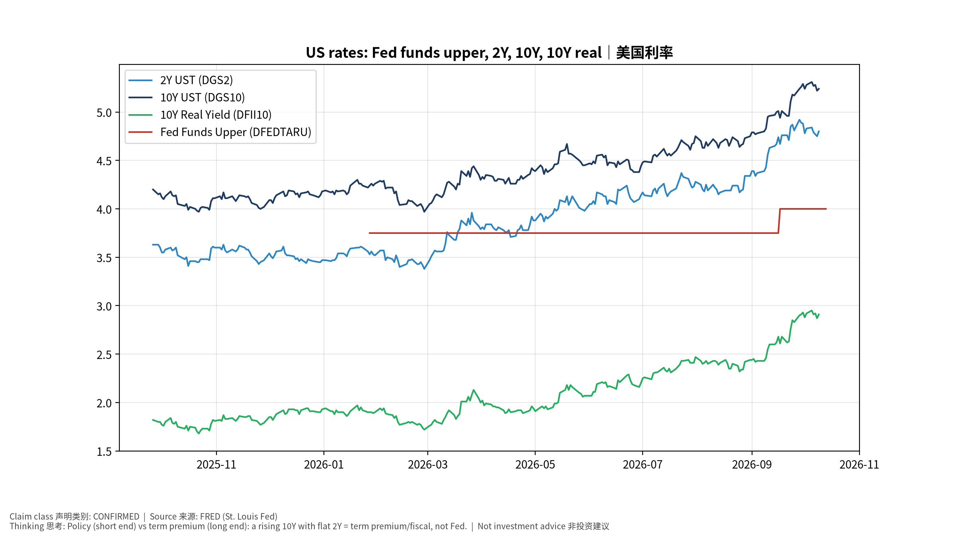
macro_1_rates
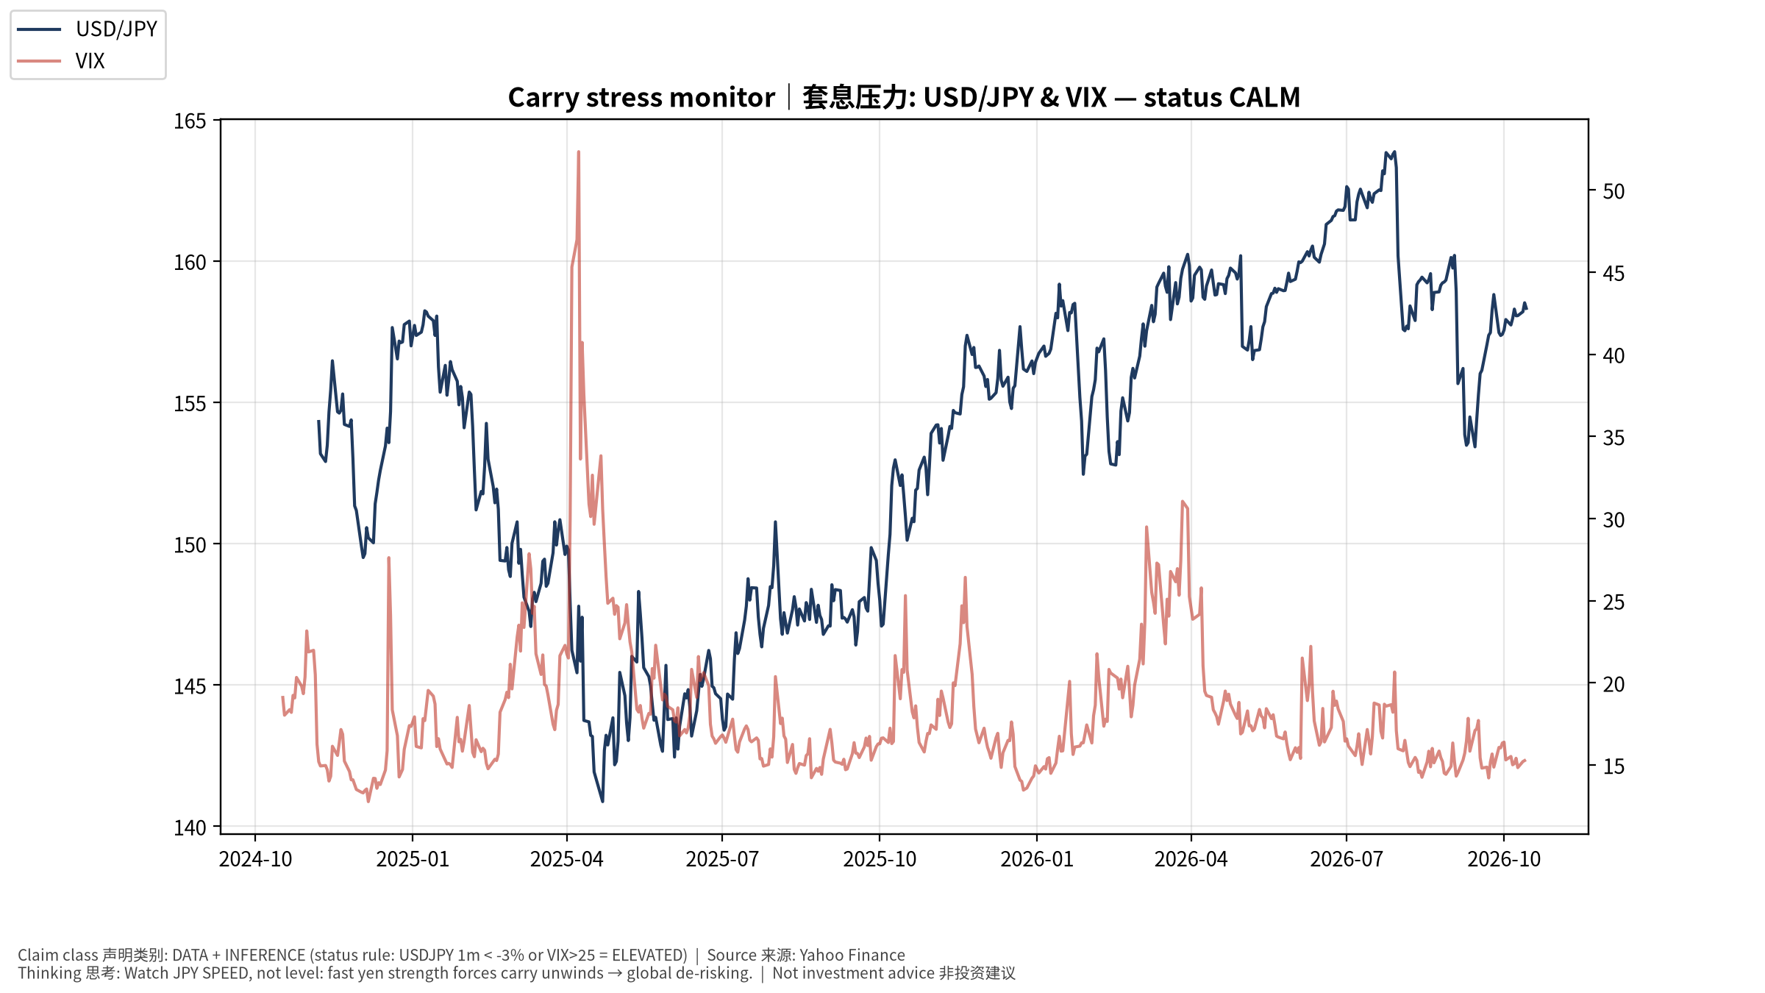
macro_2_carry
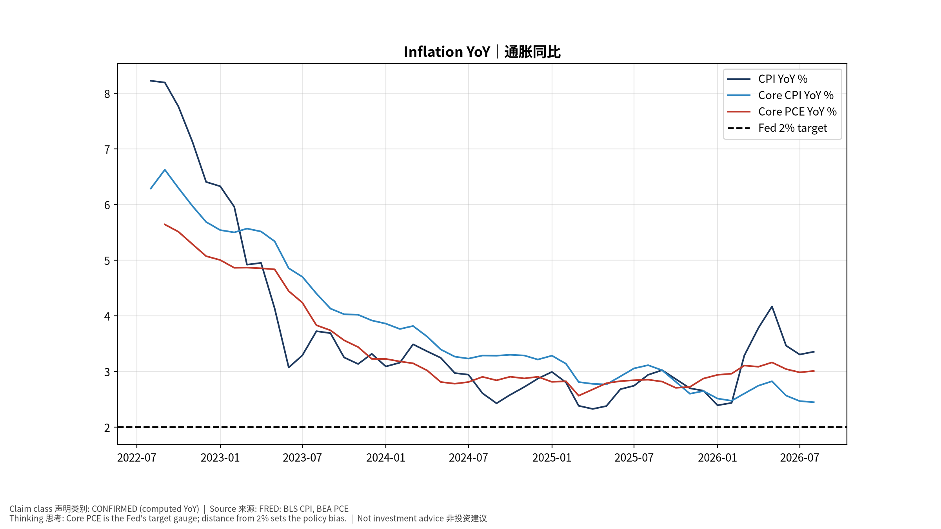
macro_3_inflation
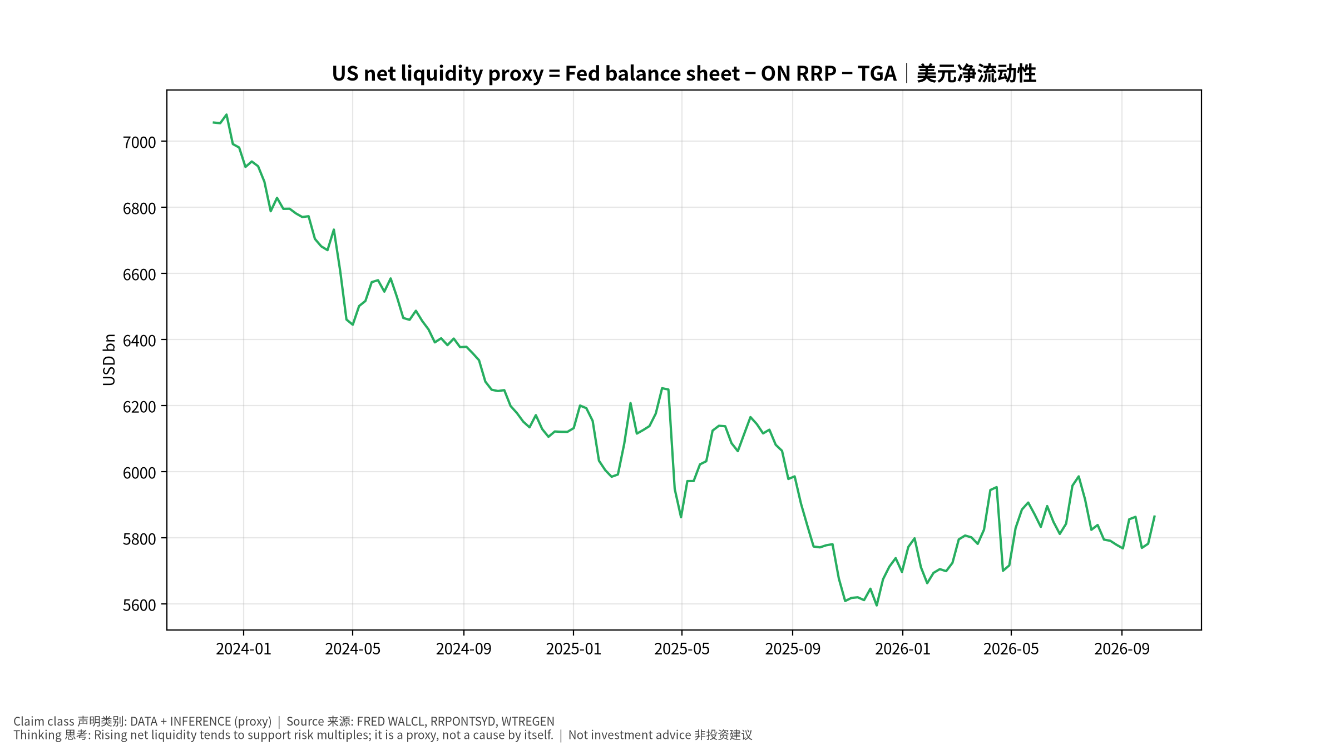
macro_4_liquidity
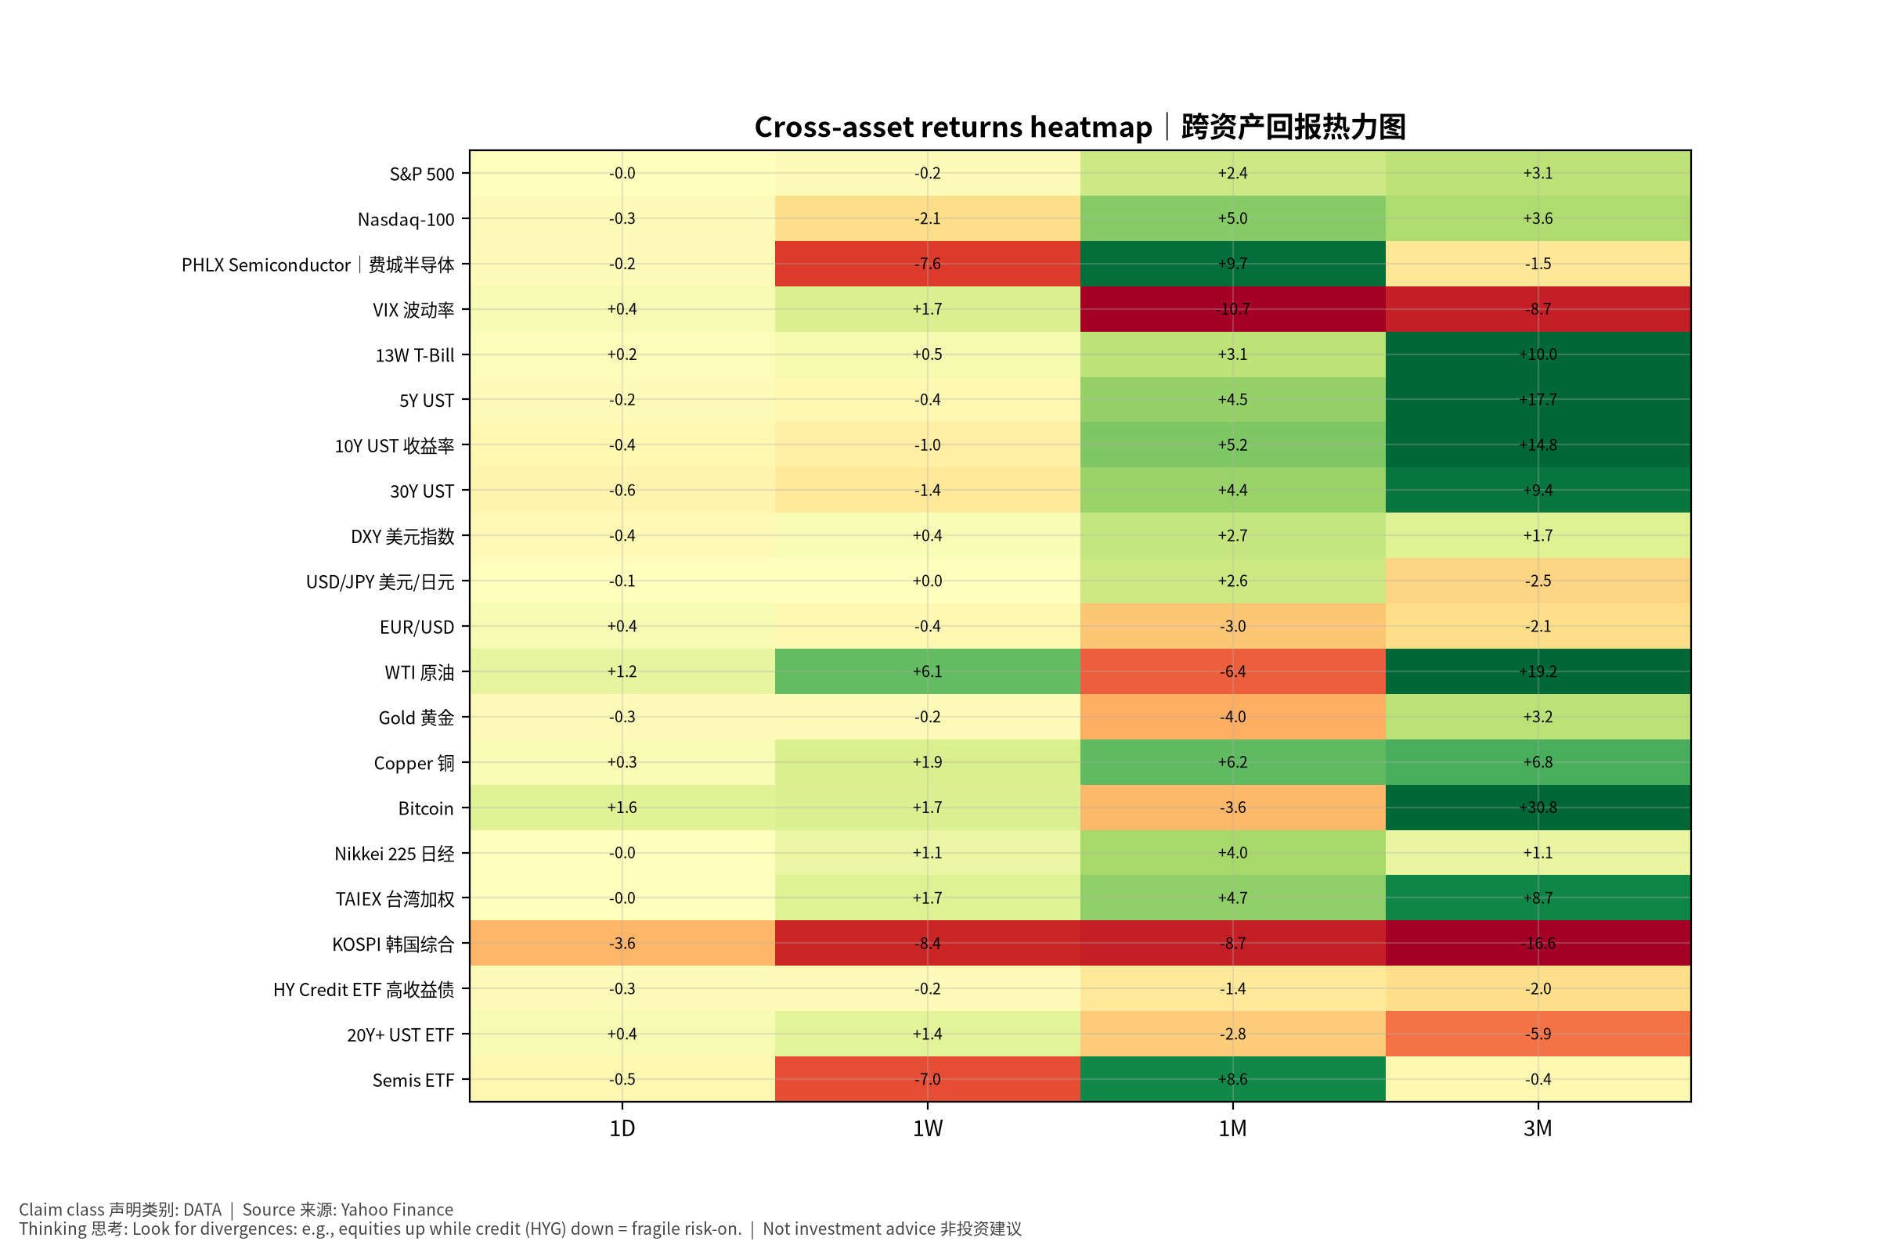
macro_5_crossasset

Macro & Cross-Asset Special (English) v20261014-0758
- Inflation: CPI YoY +3.4%, core CPI +2.4%, core PCE +3.0% — above 2%.
- Fed funds upper 4.0%; 10Y 5.24%; 10Y real 2.91%; 2s10s 0.42%.
- Net liquidity proxy ≈ 5,867 bn USD. Carry stress: CALM (USD/JPY 1M +2.6%, VIX 15.3).
- Positioning claims are withheld: CFTC/fund-manager survey/option skew feeds are UNAVAILABLE in v1.
- AI productivity → inflation → Fed: two competing paths (dovish productivity vs overheating); key evidence Nov 5 Productivity & Costs, Oct 30 ECI.
- Falsifiers: core PCE ≤0.2% m/m for 3 months; USD/JPY −5% in a month. Tables: see Chinese section (bilingual labels).

