RKLB 初学者教学版 (中文) v20261013-1812

① 一句话
Rocket Lab Corporation 是一家 Small/medium launch + space systems 中小型发射+航天系统 公司。现在股价 $65.71。我们的Base模型认为每股价值约 $8（-87.2%）。

② 发生了什么
最近一季财报EPS实际 vs 预期: [‘2026-06-30’, ‘-0.08’, ‘-0.07667’, ‘-0.0434’]（实际、预期、超预期%）。下次财报约 2026-11-10。

③ 术语 Glossary
- DCF (Discounted Cash Flow｜现金流折现): 把未来每年能拿到的现金，按”时间成本”折回今天加总。
- FCF (Free Cash Flow｜自由现金流) = 经营现金流 − 资本开支。
- WACC (Weighted Average Cost of Capital｜加权平均资本成本): 投资人要求的年回报率，用作折现率。
- Reverse DCF (反向DCF): 反过来问”现价要求公司增长多快”。
- Consensus (一致预期): 分析师预测的平均值。
- Falsifier (证伪指标): 一旦出现就说明论点错了的信号。

④ 生活比喻
买这家公司股票≈买一棵果树。DCF就是估算果树未来每年结多少果(FCF)，再考虑”明年的一斤果不如今天的一斤果值钱”(WACC折现)。

⑤ 因果箭头
Small/medium launch + space systems 中小型发射+航天系统 需求 → 收入增长 (g) → 自由现金流 (FCF = 收入 × FCF率) → 折现 (÷(1+WACC)^t) → 每股价值 → 与股价比较 → 预期差

⑥ 数字例题（符号定义）
设 R₀ = 过去12个月收入 = 0.8 bn USD；g₁ = 第一年增速 = 41.3%；m = 长期FCF率 = 15.0%；W = WACC = 13.2%。 第一年收入 R₁ = R₀ × (1+g₁) = 1.1 bn USD。 若第5年FCF率达到 m，则第1年FCF ≈ R₁ × m₁（m₁ 由当前 -48.3% 向 15.0% 线性过渡）= -0.4 bn USD； 折现到今天: FCF₁ ÷ (1+W)¹ = -0.3 bn USD。十年加总 + 终值 = EV 3.2 bn USD。

⑦ 事实 / 预测 / 市场预期
- 事实: 过去财务数据(第4节)、现价。
- 预测(我们的假设): 长期FCF率 15.0%、三情景。
- 市场预期: 一致预期增速 41.3%；价格隐含增速 115.2%。

⑧ 三情景
Bear $4 / Base $8 / Bull $15；概率加权 $9。

⑨ 反方观点与失效条件
反方: Neutron delays; SpaceX price competition; dilution｜Neutron延期；SpaceX压价；稀释 失效条件: Neutron slip beyond guided window; backlog growth stalls｜Neutron超出指引窗口；积压停滞

自我检验题
- 如果WACC上升1个百分点，价值会升还是降？为什么？（提示：分母变大）
- 反向DCF隐含增速高于一致预期意味着什么？

RKLB Beginner Teaching Edition (English) v20261013-1812

① In one line
Rocket Lab Corporation is a Small/medium launch + space systems 中小型发射+航天系统 company. Price $65.71; our Base model value ≈ $8 (-87.2%). ## ② What happened Last quarter EPS actual vs consensus: [‘2026-06-30’, ‘-0.08’, ‘-0.07667’, ‘-0.0434’]. Next earnings ≈ 2026-11-10 (TENTATIVE). ## ③ Glossary DCF (Discounted Cash Flow｜现金流折现); FCF (Free Cash Flow｜自由现金流) = operating cash flow − capex; WACC (Weighted Average Cost of Capital｜加权平均资本成本) = the yearly return investors demand; Reverse DCF (反向DCF) = what growth the price requires; Consensus (一致预期); Falsifier (证伪指标). ## ④ Analogy Owning the stock ≈ owning a fruit tree: DCF estimates future fruit (FCF) and discounts it because fruit next year is worth less than fruit today. ## ⑤ Causal arrows Demand → revenue growth (g) → FCF (= revenue × FCF margin) → discounting ÷(1+WACC)^t → value/share → compare with price → expectation gap ## ⑥ Worked example (symbols) R₀ = TTM revenue = 0.8 bn USD; g₁ = 41.3%; m = long-run FCF margin = 15.0%; W = 13.2%. R₁ = R₀×(1+g₁) = 1.1 bn USD; FCF₁ = -0.4 bn USD; PV = FCF₁/(1+W) = -0.3 bn USD; 10 years + terminal → EV 3.2 bn USD. ## ⑦ Fact vs forecast vs market expectation Facts: reported financials, price. Forecast: our margin/scenario assumptions. Market: consensus growth 41.3%; price-implied growth 115.2%. ## ⑧ Three scenarios Bear $4 / Base $8 / Bull $15; weighted $9. ## ⑨ Counterview & failure conditions Neutron delays; SpaceX price competition; dilution｜Neutron延期；SpaceX压价；稀释 — Falsifiers: Neutron slip beyond guided window; backlog growth stalls｜Neutron超出指引窗口；积压停滞 ## Self-check 1. WACC +1pp → value up or down? 2. What does price-implied growth > consensus mean?
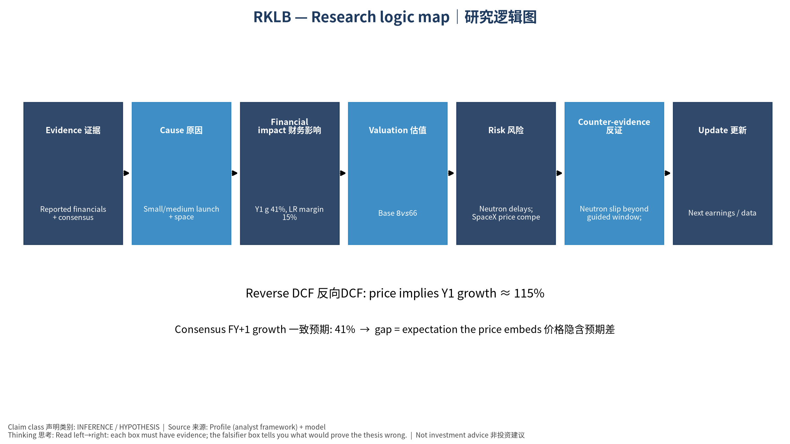
logic

