CCL 初学者教学版 (中文) v20261014-0758

① 一句话
Carnival Corporation Ltd. 是一家 Cruise / consumer travel 邮轮/旅游消费 公司。现在股价 $26.73。我们的Base模型认为每股价值约 $3（-87.0%）。

② 发生了什么
最近一季财报EPS实际 vs 预期: [‘2026-08-31’, ‘1.43’, ‘1.3508’, ‘0.0586’]（实际、预期、超预期%）。下次财报约 2026-12-18。

③ 术语 Glossary
- DCF (Discounted Cash Flow｜现金流折现): 把未来每年能拿到的现金，按”时间成本”折回今天加总。
- FCF (Free Cash Flow｜自由现金流) = 经营现金流 − 资本开支。
- WACC (Weighted Average Cost of Capital｜加权平均资本成本): 投资人要求的年回报率，用作折现率。
- Reverse DCF (反向DCF): 反过来问”现价要求公司增长多快”。
- Consensus (一致预期): 分析师预测的平均值。
- Falsifier (证伪指标): 一旦出现就说明论点错了的信号。

④ 生活比喻
买这家公司股票≈买一棵果树。DCF就是估算果树未来每年结多少果(FCF)，再考虑”明年的一斤果不如今天的一斤果值钱”(WACC折现)。

⑤ 因果箭头
Cruise / consumer travel 邮轮/旅游消费 需求 → 收入增长 (g) → 自由现金流 (FCF = 收入 × FCF率) → 折现 (÷(1+WACC)^t) → 每股价值 → 与股价比较 → 预期差

⑥ 数字例题（符号定义）
设 R₀ = 过去12个月收入 = 27.6 bn USD；g₁ = 第一年增速 = 3.1%；m = 长期FCF率 = 10.0%；W = WACC = 13.2%。 第一年收入 R₁ = R₀ × (1+g₁) = 28.5 bn USD。 若第5年FCF率达到 m，则第1年FCF ≈ R₁ × m₁（m₁ 由当前 11.6% 向 10.0% 线性过渡）= 3.2 bn USD； 折现到今天: FCF₁ ÷ (1+W)¹ = 2.8 bn USD。十年加总 + 终值 = EV 28.6 bn USD。

⑦ 事实 / 预测 / 市场预期
- 事实: 过去财务数据(第4节)、现价。
- 预测(我们的假设): 长期FCF率 10.0%、三情景。
- 市场预期: 一致预期增速 3.1%；价格隐含增速 23.1%。

⑧ 三情景
Bear $-3 / Base $3 / Bull $9；概率加权 $3。

⑨ 反方观点与失效条件
反方: Recession; oil spike; geopolitical disruptions｜衰退；油价飙升；地缘干扰 失效条件: Net yield guide cut; booking curve weakens｜净收益率指引下修；预订曲线走弱

自我检验题
- 如果WACC上升1个百分点，价值会升还是降？为什么？（提示：分母变大）
- 反向DCF隐含增速高于一致预期意味着什么？

CCL Beginner Teaching Edition (English) v20261014-0758

① In one line
Carnival Corporation Ltd. is a Cruise / consumer travel 邮轮/旅游消费 company. Price $26.73; our Base model value ≈ $3 (-87.0%). ## ② What happened Last quarter EPS actual vs consensus: [‘2026-08-31’, ‘1.43’, ‘1.3508’, ‘0.0586’]. Next earnings ≈ 2026-12-18 (TENTATIVE). ## ③ Glossary DCF (Discounted Cash Flow｜现金流折现); FCF (Free Cash Flow｜自由现金流) = operating cash flow − capex; WACC (Weighted Average Cost of Capital｜加权平均资本成本) = the yearly return investors demand; Reverse DCF (反向DCF) = what growth the price requires; Consensus (一致预期); Falsifier (证伪指标). ## ④ Analogy Owning the stock ≈ owning a fruit tree: DCF estimates future fruit (FCF) and discounts it because fruit next year is worth less than fruit today. ## ⑤ Causal arrows Demand → revenue growth (g) → FCF (= revenue × FCF margin) → discounting ÷(1+WACC)^t → value/share → compare with price → expectation gap ## ⑥ Worked example (symbols) R₀ = TTM revenue = 27.6 bn USD; g₁ = 3.1%; m = long-run FCF margin = 10.0%; W = 13.2%. R₁ = R₀×(1+g₁) = 28.5 bn USD; FCF₁ = 3.2 bn USD; PV = FCF₁/(1+W) = 2.8 bn USD; 10 years + terminal → EV 28.6 bn USD. ## ⑦ Fact vs forecast vs market expectation Facts: reported financials, price. Forecast: our margin/scenario assumptions. Market: consensus growth 3.1%; price-implied growth 23.1%. ## ⑧ Three scenarios Bear $-3 / Base $3 / Bull $9; weighted $3. ## ⑨ Counterview & failure conditions Recession; oil spike; geopolitical disruptions｜衰退；油价飙升；地缘干扰 — Falsifiers: Net yield guide cut; booking curve weakens｜净收益率指引下修；预订曲线走弱 ## Self-check 1. WACC +1pp → value up or down? 2. What does price-implied growth > consensus mean?
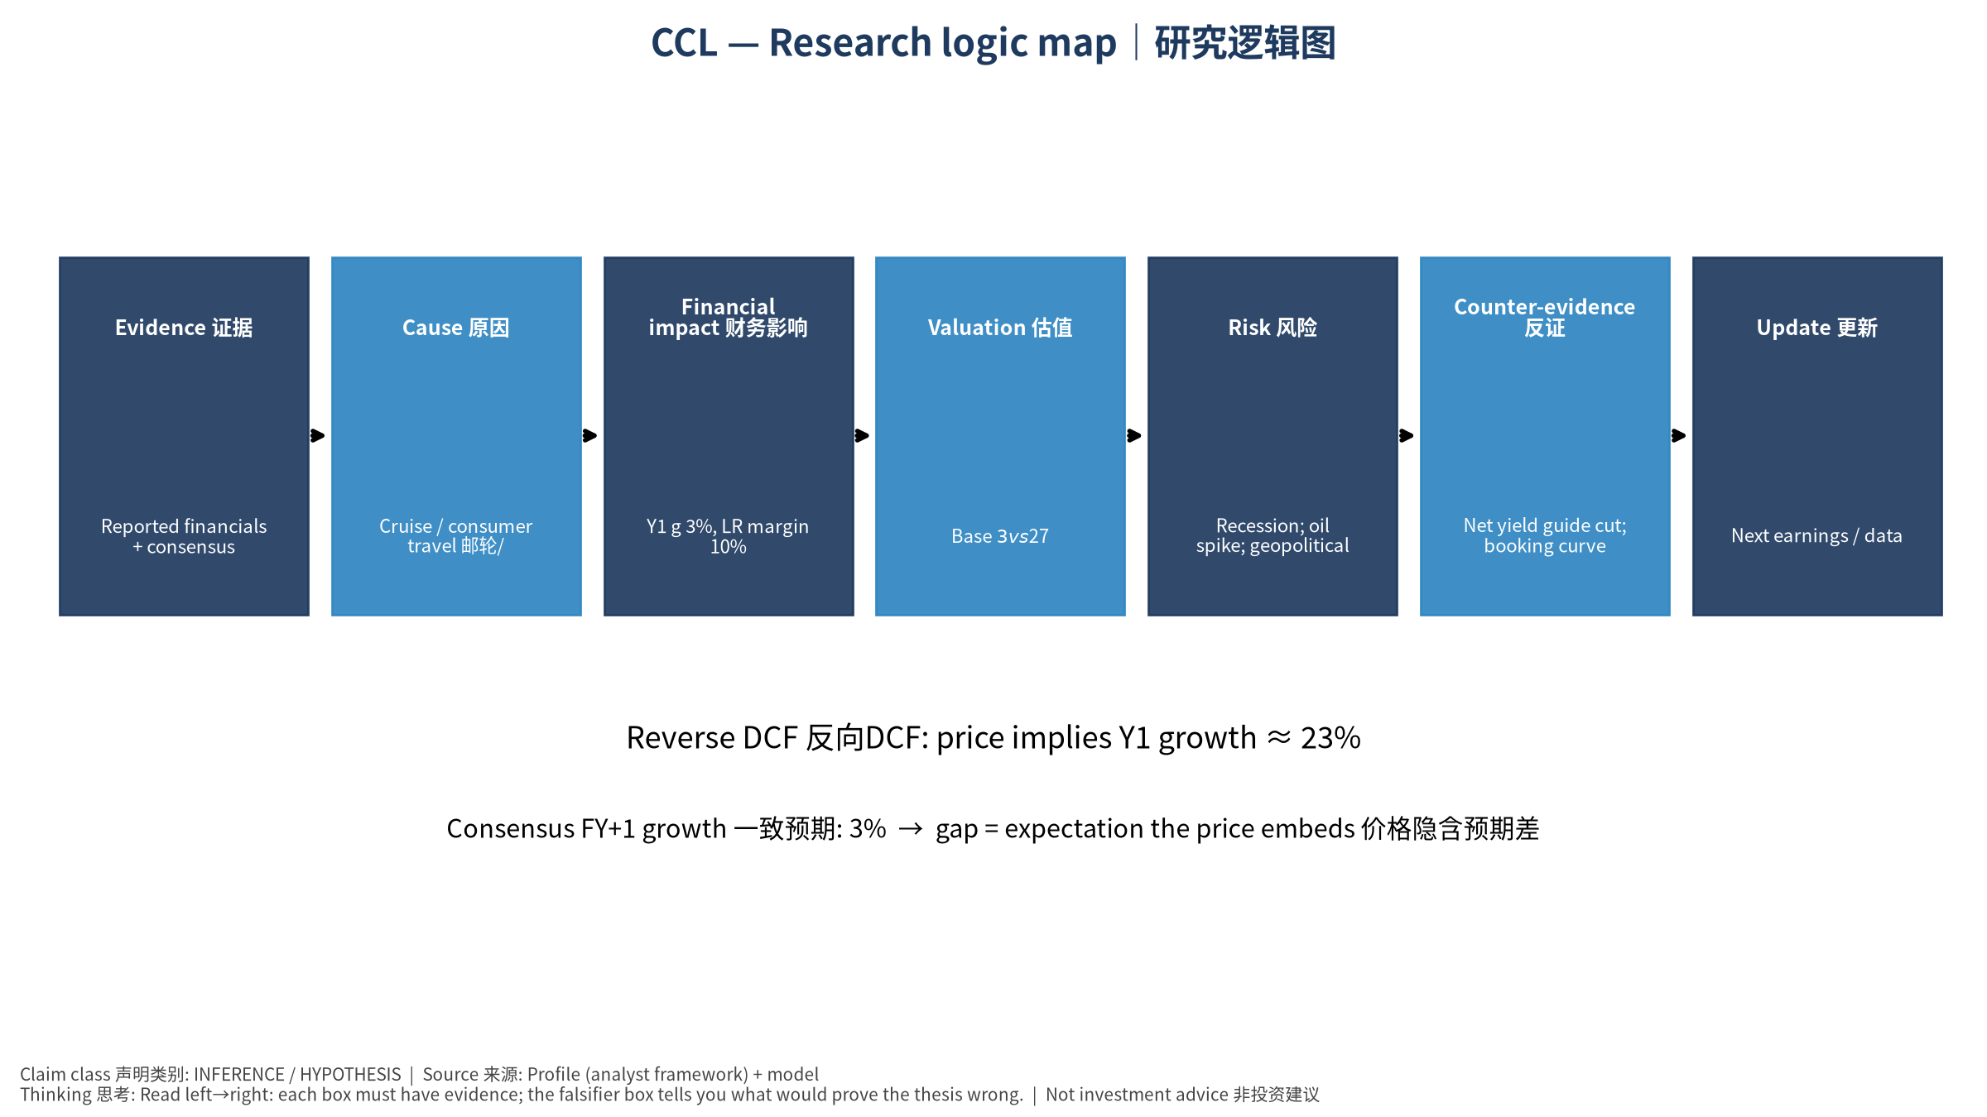
logic

