Beginner Teaching: How to Read Tomorrow Night’s US CPI｜初学者教学版 (English)
Release: Wed 10/14, 20:30 Singapore time. Snapshot 2026-10-13 18:03 SGT (v20261013-1803). Not investment advice.

1. Plain words: what is happening?
Every month the US Bureau of Labor Statistics reports how much a basket of goods and services got more expensive. That’s CPI. Tomorrow’s report covers September. Markets care most about core CPI, which strips out food and energy, because it shows whether inflation is sticking around.

2. Glossary｜术语表
English | 中文 | One-line meaning
CPI (Consumer Price Index) | 消费者价格指数 | a thermometer for consumer prices
Core CPI | 核心CPI | excludes food and energy to remove the “weather noise”
MoM (month-over-month) | 环比 | vs last month
YoY (year-over-year) | 同比 | vs the same month last year
Base effect | 基数效应 | last year’s level makes this year’s y/y look higher or lower
Shelter / OER | 住房 / 业主等价租金 | about a third of CPI; moves slowly
Supercore | 超级核心 | core services excluding shelter; most wage-linked
3m annualised | 三个月年化 | the last three months’ pace scaled to a year
Breakeven inflation | 盈亏平衡通胀率 | the bond market’s bet on future inflation
Term premium | 期限溢价 | extra pay for lending for longer
WACC | 加权平均资本成本 | the discount rate applied to future cash flows
FOMC | 联邦公开市场委员会 | the Fed meeting that sets US rates

3. Everyday analogies
- Core vs headline: taking your temperature right after a run (an energy spike) reads high; core is like waiting ten minutes and measuring again.
- The 2-year Treasury yield: the whole class voting on whether the teacher will add homework (a hike); the vote changes the second the data lands.
- Rates and growth stocks: a seesaw. When rates rise, stocks whose profits are far in the future sink, because future money gets discounted more.

4. Cause and effect
Hot core → Fed hike seen as likelier → 2Y yield up → 10Y up → discount rate up → growth valuations down → Nasdaq and semis down. Cool core → hike odds down → yields down → valuation pressure eases → oversold semis may bounce (memory names have a separate supply problem).

5. Worked numbers (from FRED data and our calculations)
- Example 1 (y/y): August’s core index is 337.765. At +0.22% m/m, September is 337.765 × 1.0022 = 338.51; last September was 330.418, so y/y = 338.51 ÷ 330.418 − 1 ≈ 2.45%. That’s exactly on the 2.4%/2.5% rounding line.
- Example 2 (3-month annualised): July, August and September core at 0.215%, 0.29% and 0.22% give (1.00215 × 1.0029 × 1.0022)^4 − 1 ≈ 2.9%, above the 2.4% y/y, which says recent momentum is faster.
- Example 3 (a stock): over the past year, each +10bp in the 10Y came with an average same-day move of about −2.6% in ARM. If the 10Y rises 8bp tomorrow night, the rate-driven part is about −2.0%. But R² is only 0.04, meaning rates explain about 4% of ARM’s daily moves; the rest is company and industry news.

6. Keep facts, forecasts and market expectations apart
- Facts: August core m/m 0.29%; September payrolls +29k; unemployment 4.2%; Fed target range 3.75–4.00%.
- Market expectations: core m/m 0.2%; October hike odds about 20%, December about 73% (Kalshi).
- Our forecast: core 0.22%; scenario probabilities 25/50/25.

7. Three scenarios
- Cool (≤0.15%, 25%): yields fall; growth stocks and semis may bounce.
- In line (0.16–0.24%, 50%): attention moves to Thursday’s PPI, retail sales and TSMC’s results.
- Hot (≥0.25%, 25%): yields and the dollar rise; Nasdaq and semis come under pressure; an October hike is back on the table.

8. Counterarguments and falsifiers
- Counterpoint: a 10Y above 5.2% is mostly about fiscal supply and term premium, so neither a good nor a bad CPI may move it much.
- Falsifier: if core is hot but the 10Y falls, the market is worried about growth, and the simple “hot → rates up → stocks down” logic fails for the day.
- Self-test: core 0.18%, headline 0.75%, and the 10Y breakeven up 6bp. What do you conclude? (Hint: section 6 of the main book on energy second-round effects.)
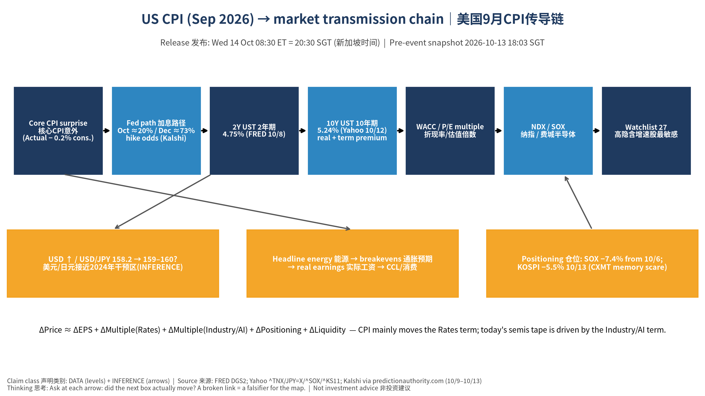
传导链 Transmission chain
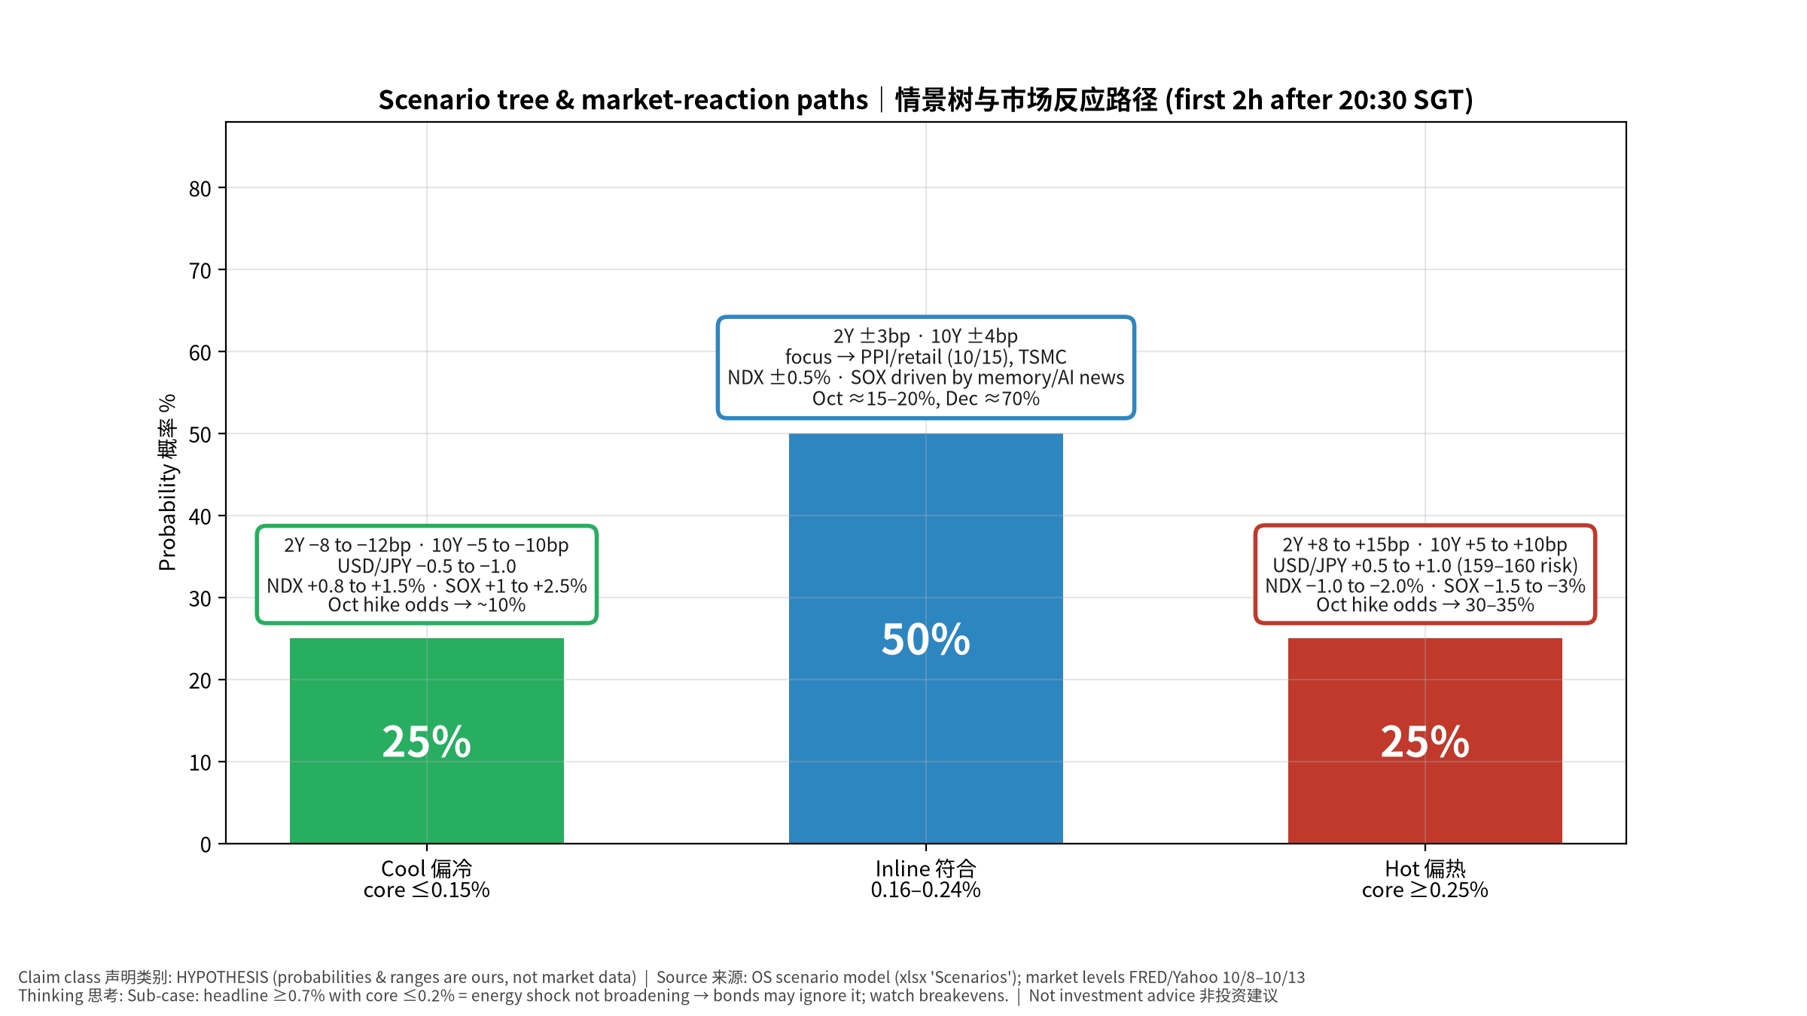
情景树 Scenario tree

