AVGO Broadcom Inc. — 个股深度研究 (专业中文版) v20261014-0758
数据截至 2026-10-14 07:58 SGT｜价格 $357.31｜市值 1,705.7 bn USD｜财报货币 USD｜非投资建议。事实=CONFIRMED/DATA；推断=INFERENCE；假设=ASSUMPTION/HYPOTHESIS。

1. 投资论点 Investment Thesis (HYPOTHESIS)
博通是’XPU/TPU替代GPU’趋势的核心受益者，加上Tomahawk/Jericho以太网与VMware现金流；高客户集中度意味着单一客户项目变动影响巨大。
- 多头驱动: Multiple XPU customers in volume; Ethernet scale-up/out wins; software stable｜多XPU客户放量；以太网胜出；软件稳定
- 空头驱动: Customer in-sourcing (e.g., MediaTek on TPU), lumpy AI revenue, debt from VMware｜客户转单、AI收入波动、VMware债务
- 证伪条件 Falsifiers: AI semi revenue guide decelerates; key XPU customer shifts vendor; VMware revenue declines｜AI半导体指引放缓；主要XPU客户转供应商；VMware收入下降

2. 产品、客户与收入模式
- 主题 Theme: Custom AI ASIC + networking + infrastructure software 定制AI芯片+网络+软件
- 业务分部 Segments: AI semiconductors (XPU+networking) AI半导体；Non-AI semis 非AI半导体；Infrastructure software (VMware) 基础软件
- 公司描述 (DATA, Yahoo/公司申报): Broadcom Inc. designs, develops, and supplies various semiconductor devices and infrastructure software solutions internationally. The company operates in two segments: Semiconductor Solutions and Infrastructure Software. The company offers networking connectivity, such as custom silicon solutions, ethernet switching & routing, ethernet NIC controllers, physical layer devices, and fiber optic components; wireless device connectivity, including RF semiconductor devices, connectivity solutions, custom touch controllers, and inductive charging ASICS; servers and storage system solutions, such as PCIE switches, SAS & raid products, fibre channel products, and HDD & SSD solutions; broadband solutions, includes set-top box, and broadband access; and industrial. The company also offers a private cloud software portfolio, including the VMware Cloud Foundation, Edge, vSphere foundation, telco clo
- 主要客户: Google (TPU), Meta, ByteDance, OpenAI, Anthropic, Apple; enterprises (VMware)｜谷歌TPU、Meta、字节、OpenAI、Anthropic、苹果；企业(VMware)

3. 行业、竞争、监管与供应链 (ANALYST FRAMEWORK)
- 供应商/上游: TSMC (N3/N2, CoWoS), HBM vendors, substrate makers｜台积电、HBM、载板
- 竞争者 (含业外): NVDA, Marvell, Alchip/GUC/MediaTek (ASIC), Arista/Cisco (switching)｜NVDA、Marvell、世芯/创意/联发科、Arista/思科
- 瓶颈/监管: CoWoS allocation, customer concentration, VMware renewal cycle｜CoWoS配额、客户集中度、VMware续约
- 关键KPI: AI revenue, XPU customers count, software revenue, FCF, net debt｜AI收入、XPU客户数、软件收入、FCF、净负债
- 零部件现货/合约价: 本版未接入付费价格源(TrendForce/DRAMeXchange等)——标注 UNAVAILABLE，在KPI监控中以定性方式跟踪。

4. 历史财务与现金流 (CONFIRMED, 季度, USD)
季度 | 收入 | 毛利 | 营业利润 | 净利润 | FCF | 营业利润率
2026-07-31 | 29.6 bn USD | 20.5 bn USD | 16.1 bn USD | 13.1 bn USD | 13.7 bn USD | 54.3%
2026-04-30 | 22.2 bn USD | 15.4 bn USD | 10.9 bn USD | 9.3 bn USD | 10.3 bn USD | 48.9%
2026-01-31 | 19.3 bn USD | 13.2 bn USD | 8.7 bn USD | 7.3 bn USD | 8.0 bn USD | 44.9%
2025-10-31 | 18.0 bn USD | 12.2 bn USD | 7.7 bn USD | 8.5 bn USD | 7.5 bn USD | 42.5%
2025-07-31 | 16.0 bn USD | 10.7 bn USD | 6.1 bn USD | 4.1 bn USD | 7.0 bn USD | 38.1%
2025-04-30 | N/A | N/A | N/A | N/A | N/A | N/A
2025-01-31 | N/A | N/A | N/A | N/A | N/A | N/A
资产负债: 现金 24.0 bn USD；总负债 59.4 bn USD；净现金 -35.4 bn USD。TTM FCF 39.4 bn USD（FCF率 44.2%）。

5. 最新财报: 实际 vs 一致预期 vs 指引
季度 | EPS实际 | EPS一致预期 | 超预期%
2025-10-31 | 1.95 | 1.86817 | 0.0438
2026-01-31 | 2.05 | 2.02326 | 0.013200001
2026-04-30 | 2.44 | 2.39835 | 0.0174
2026-07-31 | 3.32 | 3.238 | 0.0253
- 管理层指引 Guidance: 自动数据源不含指引——UNAVAILABLE（待从公司IR新闻稿录入）。
- 下次财报日 (Yahoo, TENTATIVE 直至公司确认): 2026-12-10；本季EPS一致预期 3.82768（40位分析师）；收入一致预期 34.9 bn USD。

6. 未来2/4/6/8季度驱动与价格合理性
期限 | 情景 | 期限价格现值 | 相对现价
2Q | Bear | $159.49 | -55.4%
2Q | Base | $404.04 | 13.1%
2Q | Bull | $705.07 | 97.3%
4Q | Bear | $169.39 | -52.6%
4Q | Base | $490.49 | 37.3%
4Q | Bull | $918.78 | 157.1%
6Q | Bear | $179.73 | -49.7%
6Q | Base | $594.93 | 66.5%
6Q | Bull | $1,196.06 | 234.7%
8Q | Bear | $190.52 | -46.7%
8Q | Base | $721.12 | 101.8%
8Q | Bull | $1,555.80 | 335.4%

现价隐含的 EV/NTM-FCF (Base 路径): | 期限
2Q | 20.9x
4Q | 16.3x
6Q | 12.7x
8Q | 9.9x
解读: 如果8季度后Base情景所需倍数仍远高于25x，说明价格依赖更远期的增长。

7. 三情景 Bear / Base / Bull (HYPOTHESIS)
情景 | Y1增速 | 长期FCF率 | WACC | 永续g | 概率 | 每股价值 | 相对现价
Bear | 32.1% | 36.0% | 13.6% | 2.5% | 25.0% | $178.65 | -50.0%
Base | 64.1% | 45.0% | 12.6% | 3.0% | 50.0% | $772.22 | 116.1%
Bull | 83.4% | 51.7% | 12.1% | 3.5% | 25.0% | $1,821.30 | 409.7%
概率加权价值 $886.10（相对现价 148.0%）。

8. 估值: DCF / Reverse DCF / ROIC-WACC / 同业 / 敏感度
- DCF Base: EV 3,721.8 bn USD；终值占比 57.0%。
- Reverse DCF 反向DCF: 在Base利润率与WACC下，现价隐含Y1收入增速 ≈ 41.2%；一致预期FY+1增速 64.1%。
- WACC (CAPM) = rf 5.2% + β 1.48 × ERP 5.0% = 12.6%。
- SOTP segments 分部: AI semiconductors (XPU+networking) AI半导体; Non-AI semis 非AI半导体; Infrastructure software (VMware) 基础软件. Status: framework only — segment revenues are INPUT REQUIRED from the latest 10-K/10-Q segment note (not auto-fed, left blank to avoid fabrication)｜分部收入需按最新财报手动录入，未自动填充以避免编造。
- 同业比较 Comps (DATA): | Ticker | 市值 | EV/Sales | Fwd P/E | 收入增速 | 毛利率 | FCF收益率 | |—|—|—|—|—|—|—| | AVGO | 1,705.7 bn USD | 19.5x | 18.4x | 85.5% | 75.5% | 2.3% | | MRVL | 241.5 bn USD | 25.1x | 36.9x | 36.5% | 52.2% | 1.0% | | NVDA | 5,518.1 bn USD | 18.1x | 14.4x | 105.9% | 74.7% | 0.8% | | ANET | 257.9 bn USD | 23.2x | 39.2x | 37.7% | 63.0% | 1.5% | | QCOM | 188.9 bn USD | 4.4x | 17.3x | -4.0% | 54.2% | 5.4% |
- 敏感度: 见Excel Sensitivity 表 (WACC × 永续增长率)。

9. 风险、反方论证与证伪
- 反方观点 Counter-thesis: Customer in-sourcing (e.g., MediaTek on TPU), lumpy AI revenue, debt from VMware｜客户转单、AI收入波动、VMware债务
- 证伪指标: AI semi revenue guide decelerates; key XPU customer shifts vendor; VMware revenue declines｜AI半导体指引放缓；主要XPU客户转供应商；VMware收入下降
- 模型风险: 长期利润率与WACC为假设；终值占比高时估值对假设极敏感。

10. Source Ledger 来源账本
Item | Value | Source/time
Price 股价 | 357.3 | Yahoo Finance quote, fetched 2026-10-14T07:58 SGT
Market cap 市值 | 1.706e+12 | Yahoo info.marketCap 2026-10-14T07:58
Cash 现金 | 2.398e+10 | Yahoo info.totalCash (latest filing) 2026-10-14T07:58
Debt 负债 | 5.942e+10 | Yahoo info.totalDebt (latest filing) 2026-10-14T07:58
Revenue TTM 收入 | 8.91e+10 | Yahoo info.totalRevenue (TTM, USD) 2026-10-14T07:58
FCF TTM 自由现金流 | 3.94e+10 | Sum of last 4 quarterly FCF (q_cash); quarters [‘2026-07-31’, ‘2026-04-30’, ‘2026-01-31’, ‘2025-10-31’] (USD)
Beta | 1.476 | Yahoo info.beta (5Y monthly)
Risk-free 10Y 无风险利率 | 0.0524 | FRED DGS10 2026-10-09
FX USD per USD | 1 | n/a (USD)
Consensus rev growth FY0 | 0.6588 | Yahoo revenue_estimate 0y
Consensus rev growth FY+1 | 0.6413 | Yahoo revenue_estimate +1y

11. Assumption Register 假设登记表
Assumption | Value | Rationale
ERP 股权风险溢价 | 0.05 | ASSUMPTION: 5.0% house mature-market ERP
Beta clamp | [0.8,1.6] → 1.48 | ASSUMPTION: limit extreme betas
Tax rate (ROIC) | 0.18 | ASSUMPTION: blended cash tax 18%
Year-1 growth (Base) | 0.6413 | Consensus FY+1 revenue growth (Yahoo revenue_estimate ‘+1y’); capped at 100%
Growth fade | linear Y1→terminal by Y10 | ASSUMPTION
Starting FCF margin | 0.4422 | DATA: FCF TTM / Revenue TTM, floored -50%
Long-run FCF margin (Base) | 0.45 | ASSUMPTION (analyst framework, reached by Y5; see profile)
Bear/Bull Y1 growth multiplier | 0.5x / 1.3x | ASSUMPTION
Bear/Bull margin multiplier | 0.8x / 1.15x | ASSUMPTION
WACC adj Bear/Bull | +1.0pp / -0.5pp | ASSUMPTION
Terminal g Bear/Base/Bull | 2.5% / 3.0% / 3.5% | ASSUMPTION
Scenario probabilities | 25% / 50% / 25% | ASSUMPTION
Horizon exit EV/NTM-FCF Bear/Base/Bull | 15x / 25x / 35x | ASSUMPTION
Per-share conversion | value × fx ÷ market cap × price | METHOD: avoids ADR/share-class mismatch

12. Model Provenance 模型溯源
- Model file: AVGO_model_v20261014-0758.xlsx (live formulas; sheets Inputs→Scenarios→DCF→ReverseDCF→Sensitivity→Horizons→SOTP→Comps→ROIC_WACC→History→Sources→Assumptions)
- Engine: production/pipeline/model.py (Python mirror; values in this report = Python mirror, verified against LibreOffice recalculation of the xlsx)
- Data snapshot: data/snapshots/20261014-0758 (immutable) | Fetched 2026-10-14 07:58 SGT | Generated 2026-10-14 07:59 SGT
- Version: v20261014-0758. Prior versions are never overwritten (see company history page).

13. 版本与事件时间轴
- v20261014-0758: 首版生产系统报告 (27家同步)。下一事件: 财报 2026-12-10 (TENTATIVE)。

图片报告 Image Report
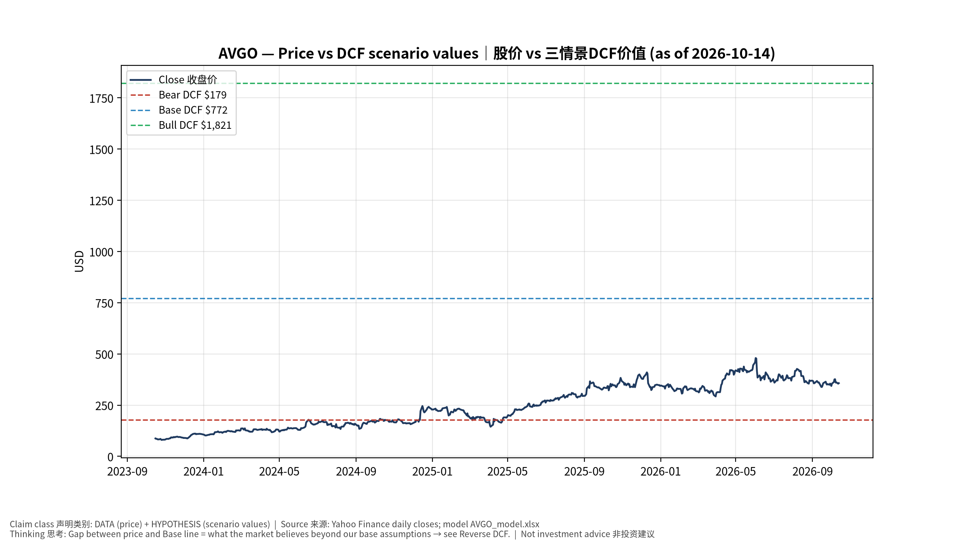
1_price_vs_value
股价vs三情景价值 Price vs scenario values
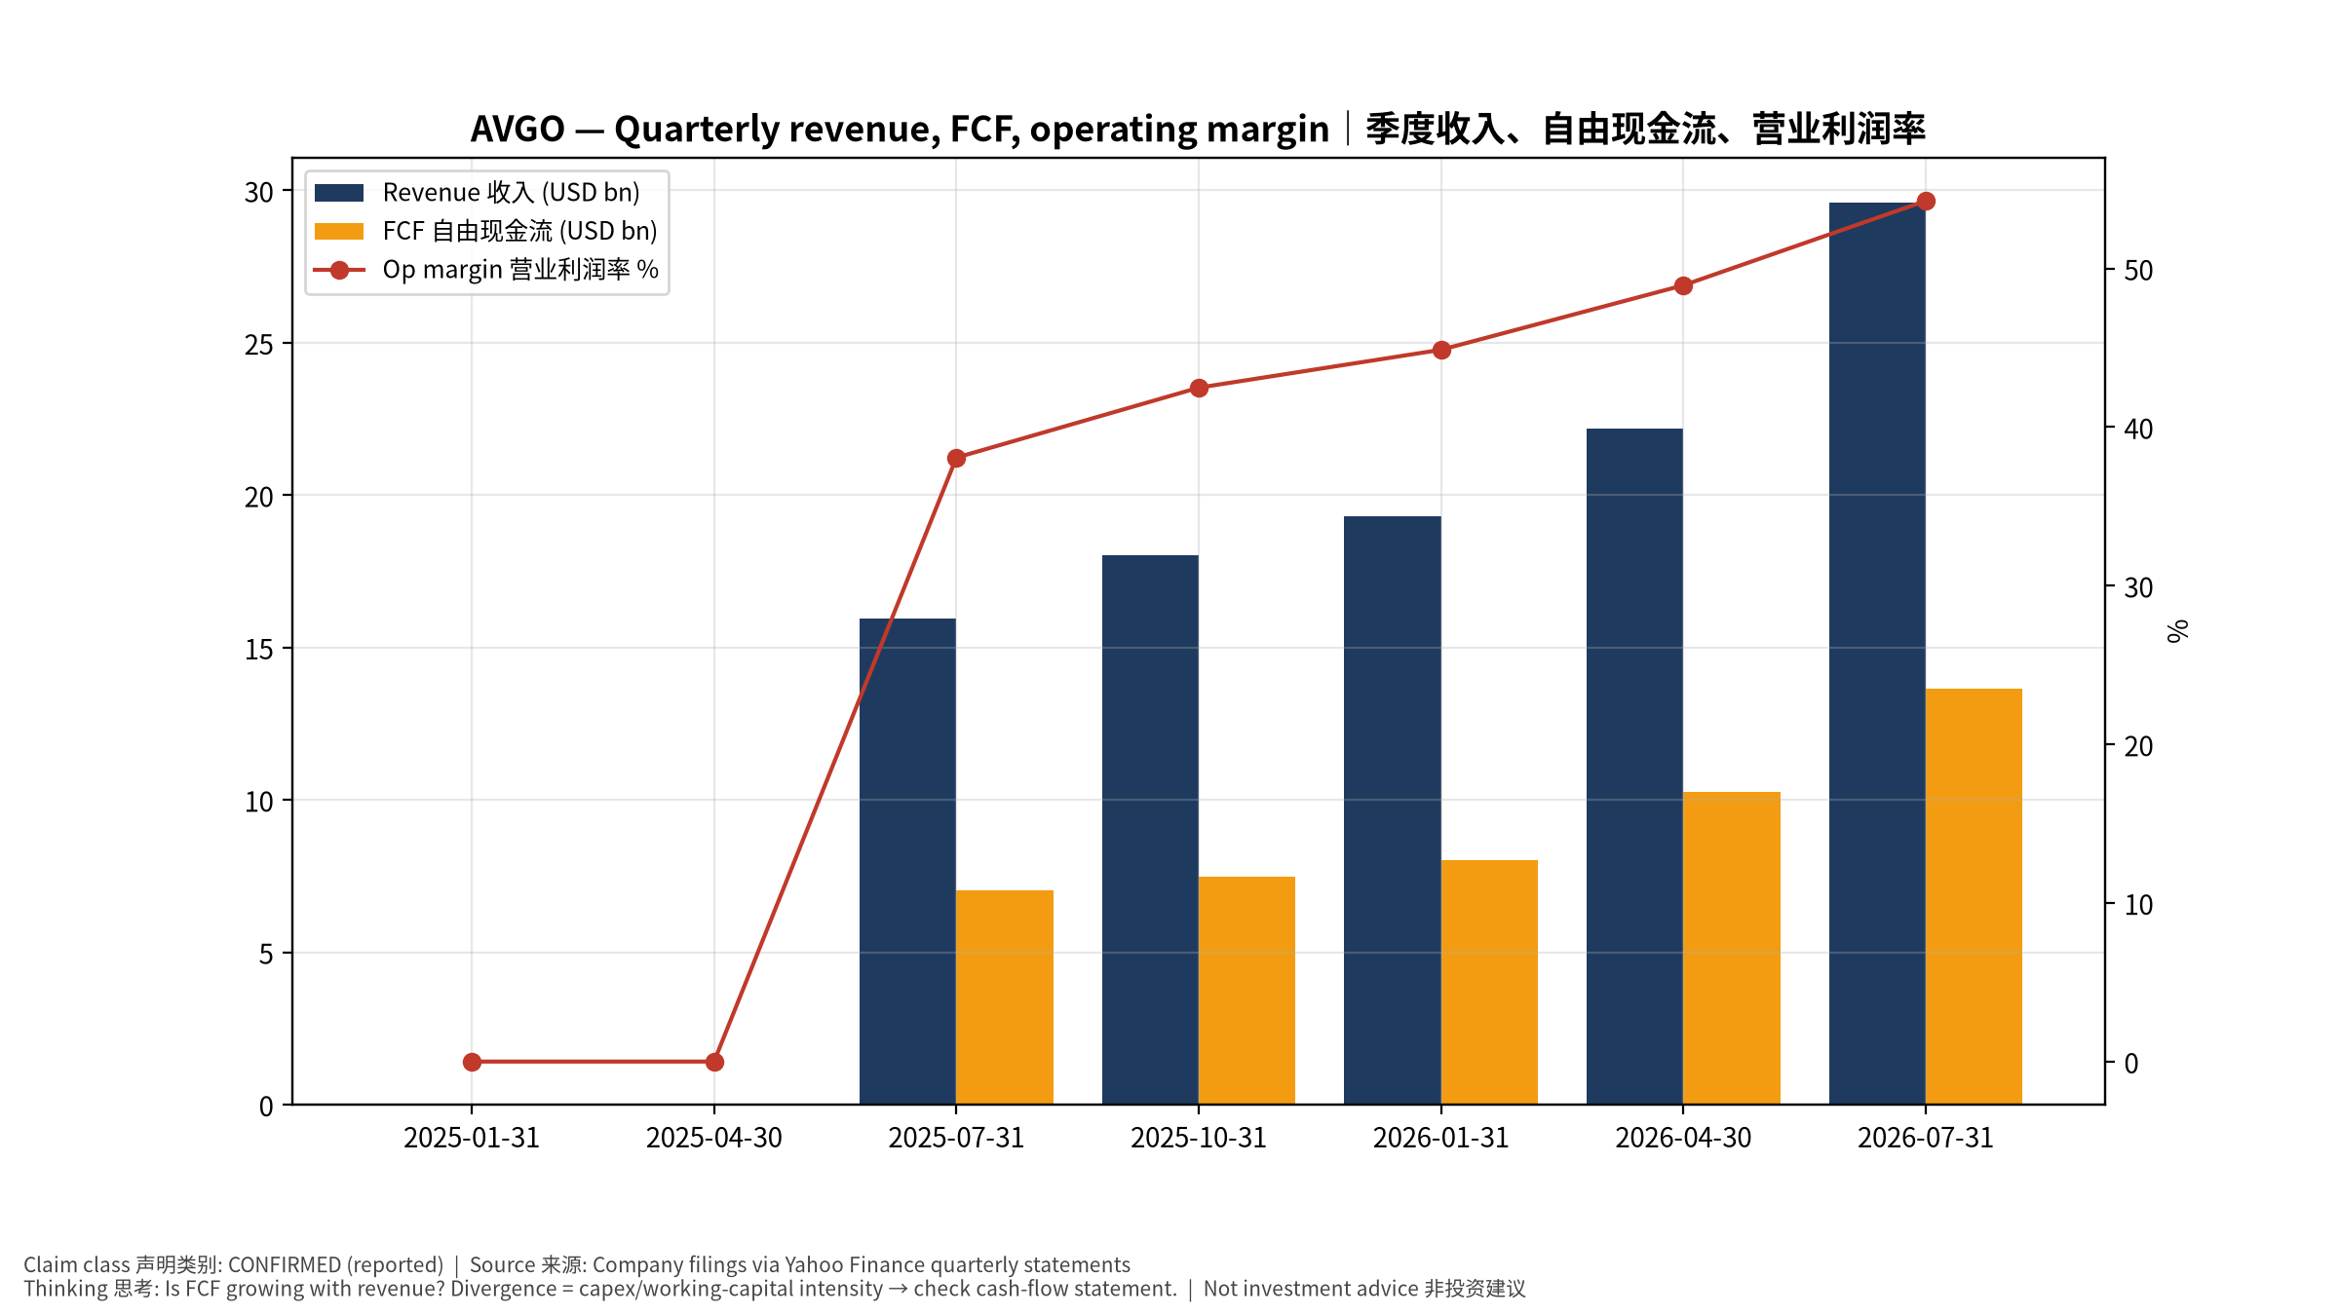
2_financials
季度财务 Quarterly financials
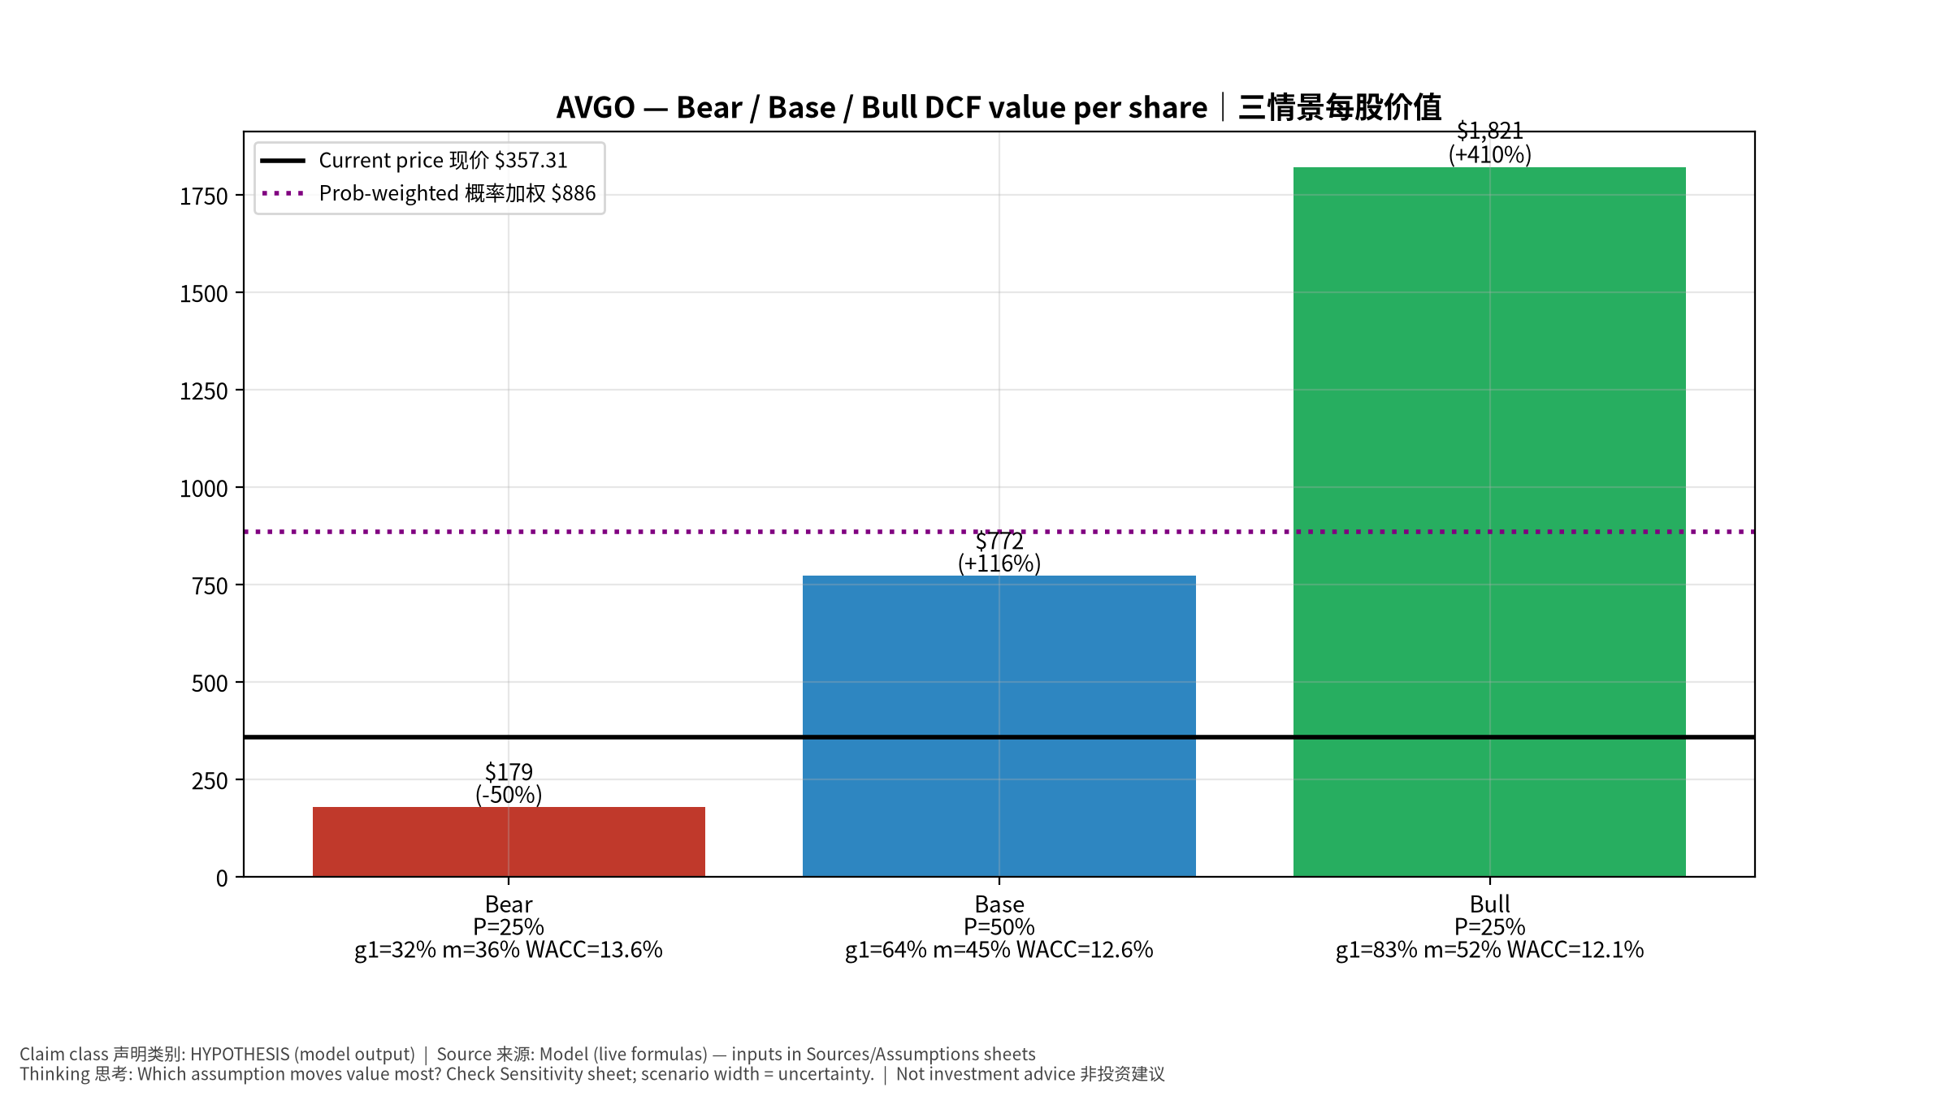
3_scenarios
三情景 Scenarios
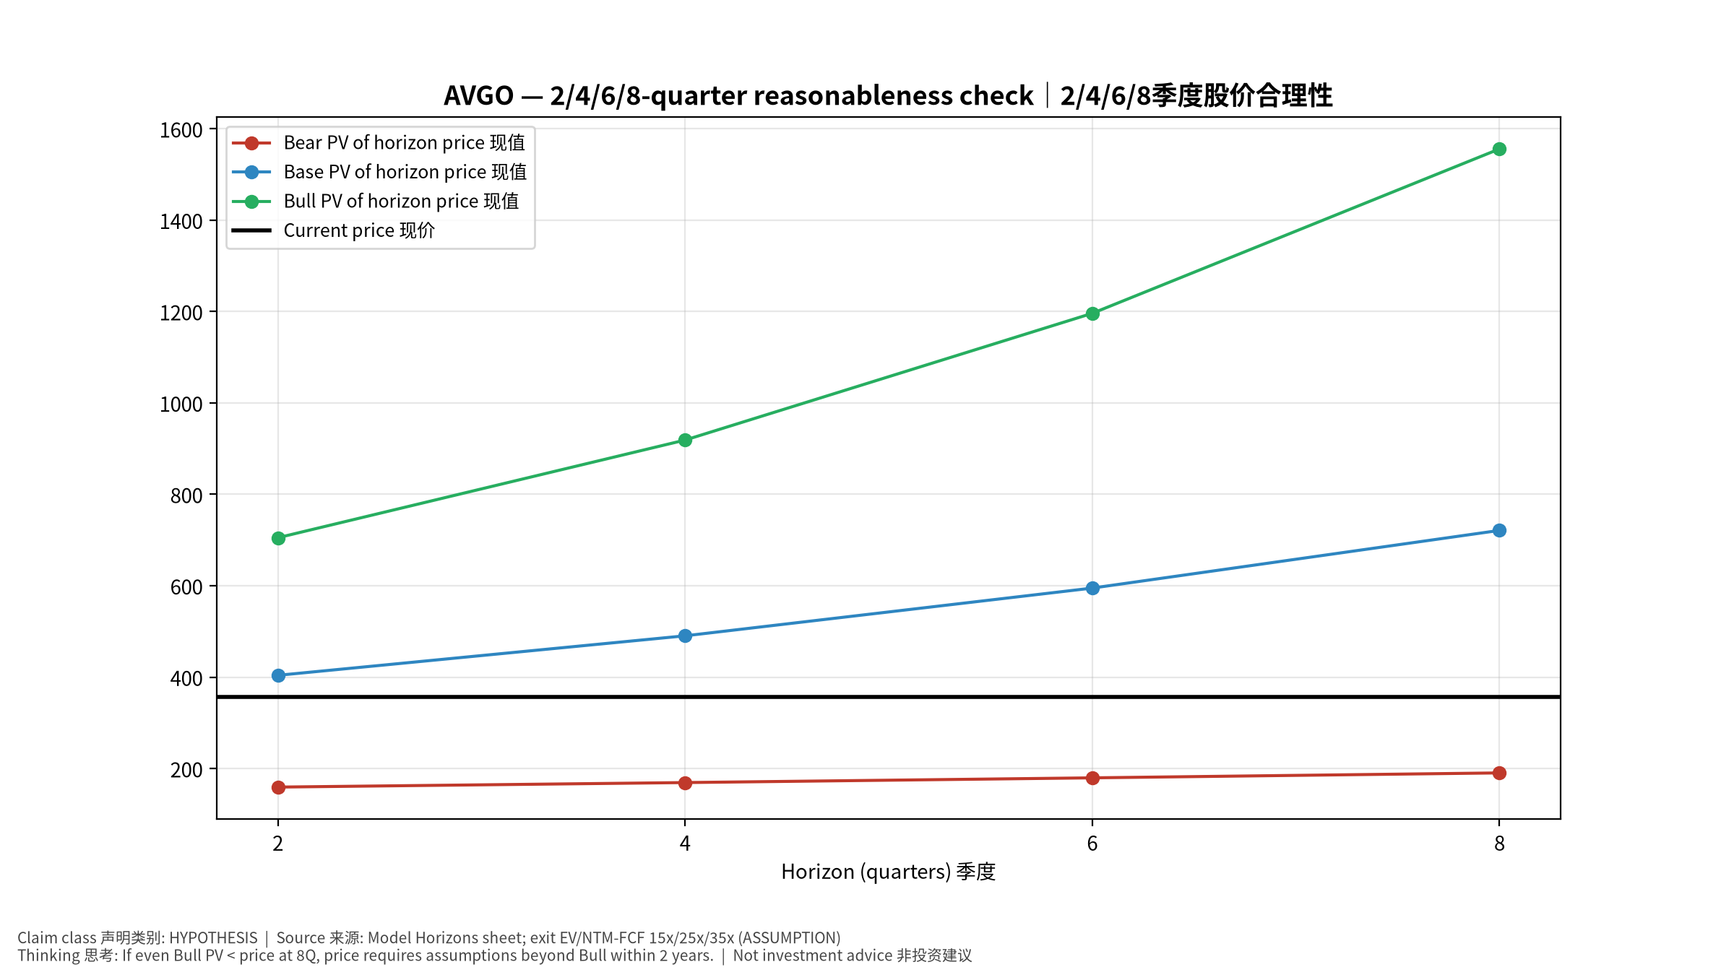
4_horizons
2/4/6/8季度检验 Horizon check
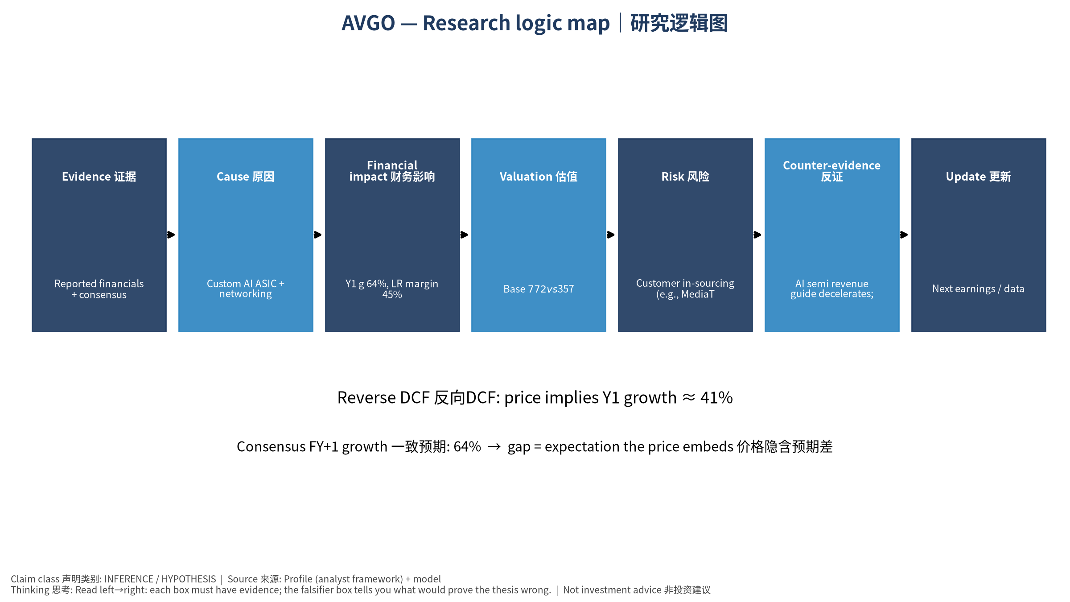
5_logic_map
研究逻辑图 Logic map

AVGO Broadcom Inc. — Equity Deep Dive (Professional English) v20261014-0758
Data as of 2026-10-14 07:58 SGT | Price $357.31 | Mkt cap 1,705.7 bn USD | Reporting currency USD | Not investment advice.

1. Investment thesis (HYPOTHESIS)
Broadcom is the core beneficiary of the XPU/TPU-vs-GPU substitution trend, plus Tomahawk/Jericho Ethernet and VMware cash flow; high customer concentration means single-program shifts matter a lot.
- Bull drivers: Multiple XPU customers in volume; Ethernet scale-up/out wins; software stable｜多XPU客户放量；以太网胜出；软件稳定
- Bear drivers: Customer in-sourcing (e.g., MediaTek on TPU), lumpy AI revenue, debt from VMware｜客户转单、AI收入波动、VMware债务
- Falsifiers: AI semi revenue guide decelerates; key XPU customer shifts vendor; VMware revenue declines｜AI半导体指引放缓；主要XPU客户转供应商；VMware收入下降

2. Products, customers, revenue model
- Theme: Custom AI ASIC + networking + infrastructure software 定制AI芯片+网络+软件 | Segments: AI semiconductors (XPU+networking) AI半导体; Non-AI semis 非AI半导体; Infrastructure software (VMware) 基础软件
- Business description (DATA): Broadcom Inc. designs, develops, and supplies various semiconductor devices and infrastructure software solutions internationally. The company operates in two segments: Semiconductor Solutions and Infrastructure Software. The company offers networking connectivity, such as custom silicon solutions, ethernet switching & routing, ethernet NIC controllers, physical layer devices, and fiber optic components; wireless device connectivity, including RF semiconductor devices, connectivity solutions, custom touch controllers, and inductive charging ASICS; servers and storage system solutions, such as PCIE switches, SAS & raid products, fibre channel products, and HDD & SSD solutions; broadband solutions, includes set-top box, and broadband access; and industrial. The company also offers a private cloud software portfolio, including the VMware Cloud Foundation, Edge, vSphere foundation, telco clo
- Customers: Google (TPU), Meta, ByteDance, OpenAI, Anthropic, Apple; enterprises (VMware)｜谷歌TPU、Meta、字节、OpenAI、Anthropic、苹果；企业(VMware)

3. Industry, competition, regulation, supply chain (ANALYST FRAMEWORK)
- Suppliers: TSMC (N3/N2, CoWoS), HBM vendors, substrate makers｜台积电、HBM、载板
- Competitors: NVDA, Marvell, Alchip/GUC/MediaTek (ASIC), Arista/Cisco (switching)｜NVDA、Marvell、世芯/创意/联发科、Arista/思科
- Bottlenecks/regulation: CoWoS allocation, customer concentration, VMware renewal cycle｜CoWoS配额、客户集中度、VMware续约
- KPIs: AI revenue, XPU customers count, software revenue, FCF, net debt｜AI收入、XPU客户数、软件收入、FCF、净负债
- Component spot/contract prices: paid feeds not connected — UNAVAILABLE, tracked qualitatively.

4. Historical financials & cash flow (CONFIRMED, quarterly, USD)
Quarter | Revenue | Gross profit | Op income | Net income | FCF | Op margin
2026-07-31 | 29.6 bn USD | 20.5 bn USD | 16.1 bn USD | 13.1 bn USD | 13.7 bn USD | 54.3%
2026-04-30 | 22.2 bn USD | 15.4 bn USD | 10.9 bn USD | 9.3 bn USD | 10.3 bn USD | 48.9%
2026-01-31 | 19.3 bn USD | 13.2 bn USD | 8.7 bn USD | 7.3 bn USD | 8.0 bn USD | 44.9%
2025-10-31 | 18.0 bn USD | 12.2 bn USD | 7.7 bn USD | 8.5 bn USD | 7.5 bn USD | 42.5%
2025-07-31 | 16.0 bn USD | 10.7 bn USD | 6.1 bn USD | 4.1 bn USD | 7.0 bn USD | 38.1%
2025-04-30 | N/A | N/A | N/A | N/A | N/A | N/A
2025-01-31 | N/A | N/A | N/A | N/A | N/A | N/A
Cash 24.0 bn USD; debt 59.4 bn USD; TTM FCF 39.4 bn USD (FCF margin 44.2%).

5. Latest earnings: actual vs consensus vs guidance
Quarter | EPS actual | EPS consensus | Surprise
2025-10-31 | 1.95 | 1.86817 | 0.0438
2026-01-31 | 2.05 | 2.02326 | 0.013200001
2026-04-30 | 2.44 | 2.39835 | 0.0174
2026-07-31 | 3.32 | 3.238 | 0.0253
- Management guidance: not in automated feed — UNAVAILABLE (to be entered from IR release).
- Next earnings (Yahoo; TENTATIVE until company-confirmed): 2026-12-10; current-quarter EPS consensus 3.82768 (40 analysts); revenue consensus 34.9 bn USD.

6. 2/4/6/8-quarter drivers & price reasonableness
Horizon | Scenario | PV of horizon price | vs current
2Q | Bear | $159.49 | -55.4%
2Q | Base | $404.04 | 13.1%
2Q | Bull | $705.07 | 97.3%
4Q | Bear | $169.39 | -52.6%
4Q | Base | $490.49 | 37.3%
4Q | Bull | $918.78 | 157.1%
6Q | Bear | $179.73 | -49.7%
6Q | Base | $594.93 | 66.5%
6Q | Bull | $1,196.06 | 234.7%
8Q | Bear | $190.52 | -46.7%
8Q | Base | $721.12 | 101.8%
8Q | Bull | $1,555.80 | 335.4%

Current-price implied EV/NTM-FCF on Base path: | Horizon
2Q | 20.9x
4Q | 16.3x
6Q | 12.7x
8Q | 9.9x

7. Bear / Base / Bull (HYPOTHESIS)
Scenario | Y1 growth | LR FCF margin | WACC | Terminal g | Prob. | Value/share | vs price
Bear | 32.1% | 36.0% | 13.6% | 2.5% | 25.0% | $178.65 | -50.0%
Base | 64.1% | 45.0% | 12.6% | 3.0% | 50.0% | $772.22 | 116.1%
Bull | 83.4% | 51.7% | 12.1% | 3.5% | 25.0% | $1,821.30 | 409.7%
Probability-weighted value $886.10 (148.0% vs price).

8. Valuation: DCF / Reverse DCF / ROIC-WACC / comps / sensitivity
- Base DCF EV 3,721.8 bn USD; terminal share 57.0%.
- Reverse DCF: at Base margin/WACC the price implies Y1 revenue growth ≈ 41.2% vs consensus FY+1 64.1%.
- WACC (CAPM) = rf 5.2% + β 1.48 × ERP 5.0% = 12.6%.
- SOTP segments: AI semiconductors (XPU+networking) AI半导体; Non-AI semis 非AI半导体; Infrastructure software (VMware) 基础软件 — framework only; segment revenue inputs pending from filings.
- Comps (DATA): see table in Chinese section / Excel Comps.
- Sensitivity: Excel Sensitivity (WACC × terminal g).

9. Risks, counterarguments, falsifiers
Customer in-sourcing (e.g., MediaTek on TPU), lumpy AI revenue, debt from VMware｜客户转单、AI收入波动、VMware债务 | Falsifiers: AI semi revenue guide decelerates; key XPU customer shifts vendor; VMware revenue declines｜AI半导体指引放缓；主要XPU客户转供应商；VMware收入下降

10–12. Source Ledger / Assumption Register / Model Provenance
See tables above (shared, bilingual). - Model file: AVGO_model_v20261014-0758.xlsx (live formulas; sheets Inputs→Scenarios→DCF→ReverseDCF→Sensitivity→Horizons→SOTP→Comps→ROIC_WACC→History→Sources→Assumptions) - Engine: production/pipeline/model.py (Python mirror; values in this report = Python mirror, verified against LibreOffice recalculation of the xlsx) - Data snapshot: data/snapshots/20261014-0758 (immutable) | Fetched 2026-10-14 07:58 SGT | Generated 2026-10-14 07:59 SGT - Version: v20261014-0758. Prior versions are never overwritten (see company history page).

