TSM 初学者教学版 (中文) v20261014-0758

① 一句话
Taiwan Semiconductor Manufacturing Company Limited 是一家 Foundry / Advanced packaging 晶圆代工/先进封装 公司。现在股价 $445.12。我们的Base模型认为每股价值约 $350（-21.5%）。

② 发生了什么
最近一季财报EPS实际 vs 预期: [‘2026-06-30’, ‘4.31’, ‘3.88658’, ‘0.1089’]（实际、预期、超预期%）。下次财报约 2026-10-15。

③ 术语 Glossary
- DCF (Discounted Cash Flow｜现金流折现): 把未来每年能拿到的现金，按”时间成本”折回今天加总。
- FCF (Free Cash Flow｜自由现金流) = 经营现金流 − 资本开支。
- WACC (Weighted Average Cost of Capital｜加权平均资本成本): 投资人要求的年回报率，用作折现率。
- Reverse DCF (反向DCF): 反过来问”现价要求公司增长多快”。
- Consensus (一致预期): 分析师预测的平均值。
- Falsifier (证伪指标): 一旦出现就说明论点错了的信号。

④ 生活比喻
买这家公司股票≈买一棵果树。DCF就是估算果树未来每年结多少果(FCF)，再考虑”明年的一斤果不如今天的一斤果值钱”(WACC折现)。

⑤ 因果箭头
Foundry / Advanced packaging 晶圆代工/先进封装 需求 → 收入增长 (g) → 自由现金流 (FCF = 收入 × FCF率) → 折现 (÷(1+WACC)^t) → 每股价值 → 与股价比较 → 预期差

⑥ 数字例题（符号定义）
设 R₀ = 过去12个月收入 = 4,440.5 bn TWD；g₁ = 第一年增速 = 35.9%；m = 长期FCF率 = 30.0%；W = WACC = 11.4%。 第一年收入 R₁ = R₀ × (1+g₁) = 6,034.6 bn TWD。 若第5年FCF率达到 m，则第1年FCF ≈ R₁ × m₁（m₁ 由当前 25.3% 向 30.0% 线性过渡）= 1,584.8 bn TWD； 折现到今天: FCF₁ ÷ (1+W)¹ = 1,422.2 bn TWD。十年加总 + 终值 = EV 55,763.5 bn TWD。

⑦ 事实 / 预测 / 市场预期
- 事实: 过去财务数据(第4节)、现价。
- 预测(我们的假设): 长期FCF率 30.0%、三情景。
- 市场预期: 一致预期增速 35.9%；价格隐含增速 43.0%。

⑧ 三情景
Bear $134 / Base $350 / Bull $654；概率加权 $372。

⑨ 反方观点与失效条件
反方: Geopolitical shock, US tariffs on chips, Intel/Samsung regain share｜地缘冲击、美国芯片关税、英特尔/三星夺回份额 失效条件: GM falls below long-term target band; monthly revenue y/y decelerates sharply; capex cut｜毛利率跌破长期目标区间；月营收同比骤降；Capex下修

自我检验题
- 如果WACC上升1个百分点，价值会升还是降？为什么？（提示：分母变大）
- 反向DCF隐含增速高于一致预期意味着什么？

TSM Beginner Teaching Edition (English) v20261014-0758

① In one line
Taiwan Semiconductor Manufacturing Company Limited is a Foundry / Advanced packaging 晶圆代工/先进封装 company. Price $445.12; our Base model value ≈ $350 (-21.5%). ## ② What happened Last quarter EPS actual vs consensus: [‘2026-06-30’, ‘4.31’, ‘3.88658’, ‘0.1089’]. Next earnings ≈ 2026-10-15 (TENTATIVE). ## ③ Glossary DCF (Discounted Cash Flow｜现金流折现); FCF (Free Cash Flow｜自由现金流) = operating cash flow − capex; WACC (Weighted Average Cost of Capital｜加权平均资本成本) = the yearly return investors demand; Reverse DCF (反向DCF) = what growth the price requires; Consensus (一致预期); Falsifier (证伪指标). ## ④ Analogy Owning the stock ≈ owning a fruit tree: DCF estimates future fruit (FCF) and discounts it because fruit next year is worth less than fruit today. ## ⑤ Causal arrows Demand → revenue growth (g) → FCF (= revenue × FCF margin) → discounting ÷(1+WACC)^t → value/share → compare with price → expectation gap ## ⑥ Worked example (symbols) R₀ = TTM revenue = 4,440.5 bn TWD; g₁ = 35.9%; m = long-run FCF margin = 30.0%; W = 11.4%. R₁ = R₀×(1+g₁) = 6,034.6 bn TWD; FCF₁ = 1,584.8 bn TWD; PV = FCF₁/(1+W) = 1,422.2 bn TWD; 10 years + terminal → EV 55,763.5 bn TWD. ## ⑦ Fact vs forecast vs market expectation Facts: reported financials, price. Forecast: our margin/scenario assumptions. Market: consensus growth 35.9%; price-implied growth 43.0%. ## ⑧ Three scenarios Bear $134 / Base $350 / Bull $654; weighted $372. ## ⑨ Counterview & failure conditions Geopolitical shock, US tariffs on chips, Intel/Samsung regain share｜地缘冲击、美国芯片关税、英特尔/三星夺回份额 — Falsifiers: GM falls below long-term target band; monthly revenue y/y decelerates sharply; capex cut｜毛利率跌破长期目标区间；月营收同比骤降；Capex下修 ## Self-check 1. WACC +1pp → value up or down? 2. What does price-implied growth > consensus mean?
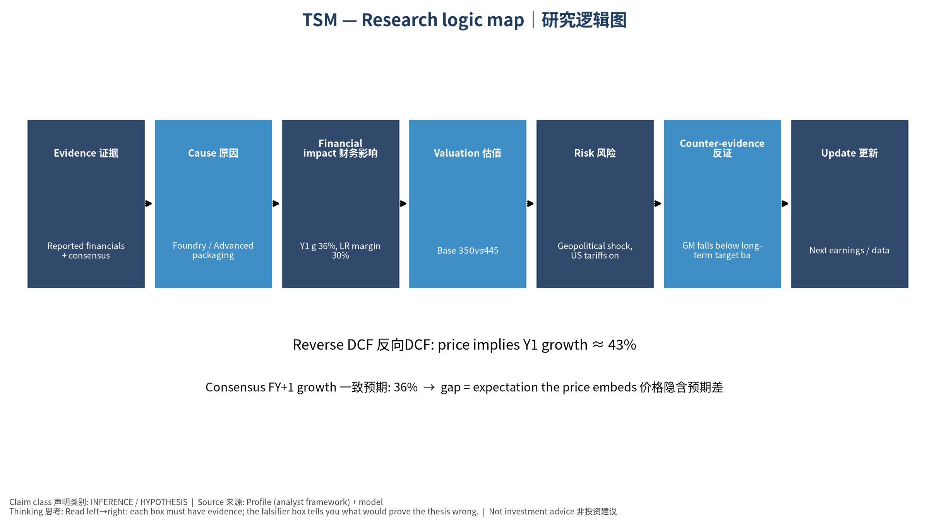
logic

