LITE Lumentum Holdings Inc. — 个股深度研究 (专业中文版) v20261015-0757
数据截至 2026-10-15 07:57 SGT｜价格 $896.33｜市值 81.2 bn USD｜财报货币 USD｜非投资建议。事实=CONFIRMED/DATA；推断=INFERENCE；假设=ASSUMPTION/HYPOTHESIS。

1. 投资论点 Investment Thesis (HYPOTHESIS)
Lumentum是AI光互连上游’激光器瓶颈’受益者(EML、CPO用CW光源、OCS光交换)；股价已反映极高增长，对产能扩张与价格非常敏感。
- 多头驱动: EML shortage persists; CPO ramps 2027; OCS adopted beyond Google｜EML短缺持续；CPO 2027放量；OCS扩散
- 空头驱动: Chinese module makers in-source lasers; price normalization｜中国模块厂自研激光器；价格正常化
- 证伪条件 Falsifiers: Lead times shorten; GM peaks; hyperscaler OCS orders slip｜交期缩短；毛利见顶；OCS订单延后

2. 产品、客户与收入模式
- 主题 Theme: Optical modules/lasers/CPO 光模块/激光器/CPO
- 业务分部 Segments: Components (EML, CW lasers) 器件；Systems (transceivers, OCS) 系统
- 公司描述 (DATA, Yahoo/公司申报): Lumentum Holdings Inc. manufactures and sells optical and photonic products in the Americas, the Asia-Pacific, Europe, the Middle East, and Africa. It offers component products, including semiconductor laser chips, laser sub-assemblies, line subsystems, and wavelength management systems. The company also offers system products, such as optical modules, optical circuit switches, and industrial lasers, including short-pulse solid-state lasers and kilowatt-class fiber lasers. Its products and solutions are used in cloud, artificial intelligence and machine learning (AI/ML), telecommunications, consumer, and industrial end-market applications. The company was incorporated in 2015 and is headquartered in San Jose, California.
- 主要客户: Hyperscalers (Google OCS), NVDA (CPO lasers), module makers｜云厂(谷歌OCS)、NVDA(CPO光源)、模块厂

3. 行业、竞争、监管与供应链 (ANALYST FRAMEWORK)
- 供应商/上游: InP substrates, epi (in-house + LandMark), TOSA parts｜磷化铟衬底、外延(自产+联亚)
- 竞争者 (含业外): Coherent, Innolight, Eoptolink, Broadcom (EML), Sumitomo, Mitsubishi｜Coherent、中际旭创、新易盛、博通、日系
- 瓶颈/监管: EML/InP laser capacity, CPO adoption timing｜EML/InP激光器产能、CPO导入时点
- 关键KPI: Revenue growth, GM%, EML capacity, CPO design wins｜收入增速、毛利率、EML产能、CPO订单
- 零部件现货/合约价: 本版未接入付费价格源(TrendForce/DRAMeXchange等)——标注 UNAVAILABLE，在KPI监控中以定性方式跟踪。

4. 历史财务与现金流 (CONFIRMED, 季度, USD)
季度 | 收入 | 毛利 | 营业利润 | 净利润 | FCF | 营业利润率
2026-06-30 | 1.0 bn USD | 0.5 bn USD | 0.3 bn USD | -7.2 bn USD | 0.2 bn USD | 28.0%
2026-03-31 | 0.8 bn USD | 0.4 bn USD | 0.2 bn USD | 0.1 bn USD | 79.1 mn USD | 21.7%
2025-12-31 | 0.7 bn USD | 0.2 bn USD | 63.9 mn USD | 78.2 mn USD | 43.1 mn USD | 9.6%
2025-09-30 | 0.5 bn USD | 0.2 bn USD | 15.0 mn USD | 4.2 mn USD | -18.3 mn USD | 2.8%
2025-06-30 | 0.5 bn USD | 0.2 bn USD | -3.2 mn USD | 0.2 bn USD | 10.1 mn USD | -0.7%
2025-03-31 | N/A | N/A | N/A | N/A | N/A | N/A
资产负债: 现金 2.7 bn USD；总负债 1.7 bn USD；净现金 1.1 bn USD。TTM FCF 0.3 bn USD（FCF率 10.0%）。

5. 最新财报: 实际 vs 一致预期 vs 指引
季度 | EPS实际 | EPS一致预期 | 超预期%
2025-09-30 | 1.1 | 1.02764 | 0.0704
2025-12-31 | 1.67 | 1.40853 | 0.1856
2026-03-31 | 2.37 | 2.26526 | 0.0462
2026-06-30 | 3.23 | 2.96892 | 0.0879
- 管理层指引 Guidance: 自动数据源不含指引——UNAVAILABLE（待从公司IR新闻稿录入）。
- 下次财报日 (Yahoo, TENTATIVE 直至公司确认): 2026-11-06；本季EPS一致预期 4.20967（22位分析师）；收入一致预期 1.3 bn USD。

6. 未来2/4/6/8季度驱动与价格合理性
期限 | 情景 | 期限价格现值 | 相对现价
2Q | Bear | $99.37 | -88.9%
2Q | Base | $233.86 | -73.9%
2Q | Bull | $404.47 | -54.9%
4Q | Bear | $111.43 | -87.6%
4Q | Base | $300.42 | -66.5%
4Q | Bull | $558.98 | -37.6%
6Q | Bear | $124.78 | -86.1%
6Q | Base | $383.96 | -57.2%
6Q | Bull | $765.86 | -14.6%
8Q | Bear | $139.51 | -84.4%
8Q | Base | $488.37 | -45.5%
8Q | Bull | $1,041.43 | 16.2%

现价隐含的 EV/NTM-FCF (Base 路径): | 期限
2Q | 93.4x
4Q | 67.6x
6Q | 49.3x
8Q | 36.2x
解读: 如果8季度后Base情景所需倍数仍远高于25x，说明价格依赖更远期的增长。

7. 三情景 Bear / Base / Bull (HYPOTHESIS)
情景 | Y1增速 | 长期FCF率 | WACC | 永续g | 概率 | 每股价值 | 相对现价
Bear | 28.5% | 20.0% | 13.9% | 2.5% | 25.0% | $158.11 | -82.4%
Base | 57.0% | 25.0% | 12.9% | 3.0% | 50.0% | $585.30 | -34.7%
Bull | 74.0% | 28.7% | 12.4% | 3.5% | 25.0% | $1,298.45 | 44.9%
概率加权价值 $656.79（相对现价 -26.7%）。

8. 估值: DCF / Reverse DCF / ROIC-WACC / 同业 / 敏感度
- DCF Base: EV 52.0 bn USD；终值占比 56.6%。
- Reverse DCF 反向DCF: 在Base利润率与WACC下，现价隐含Y1收入增速 ≈ 70.4%；一致预期FY+1增速 57.0%。
- WACC (CAPM) = rf 5.2% + β 1.54 × ERP 5.0% = 12.9%。
- SOTP segments 分部: Components (EML, CW lasers) 器件; Systems (transceivers, OCS) 系统. Status: framework only — segment revenues are INPUT REQUIRED from the latest 10-K/10-Q segment note (not auto-fed, left blank to avoid fabrication)｜分部收入需按最新财报手动录入，未自动填充以避免编造。
- 同业比较 Comps (DATA): | Ticker | 市值 | EV/Sales | Fwd P/E | 收入增速 | 毛利率 | FCF收益率 | |—|—|—|—|—|—|—| | LITE | 81.2 bn USD | 26.3x | 24.9x | 109.3% | 44.2% | 0.4% | | COHR | 51.9 bn USD | 7.5x | 18.7x | 33.7% | 37.5% | -1.3% | | CIEN | 51.0 bn USD | 8.6x | 30.4x | 37.0% | 44.1% | 1.2% | | AAOI | 7.3 bn USD | 11.9x | 18.7x | 86.4% | 28.9% | -12.1% | | GLW | 121.4 bn USD | 7.6x | 32.2x | 16.6% | 36.4% | 0.6% |
- 敏感度: 见Excel Sensitivity 表 (WACC × 永续增长率)。

9. 风险、反方论证与证伪
- 反方观点 Counter-thesis: Chinese module makers in-source lasers; price normalization｜中国模块厂自研激光器；价格正常化
- 证伪指标: Lead times shorten; GM peaks; hyperscaler OCS orders slip｜交期缩短；毛利见顶；OCS订单延后
- 模型风险: 长期利润率与WACC为假设；终值占比高时估值对假设极敏感。

10. Source Ledger 来源账本
Item | Value | Source/time
Price 股价 | 896.3 | Yahoo Finance quote, fetched 2026-10-15T07:57 SGT
Market cap 市值 | 8.119e+10 | Yahoo info.marketCap 2026-10-15T07:57
Cash 现金 | 2.738e+09 | Yahoo info.totalCash (latest filing) 2026-10-15T07:57
Debt 负债 | 1.671e+09 | Yahoo info.totalDebt (latest filing) 2026-10-15T07:57
Revenue TTM 收入 | 3.014e+09 | Yahoo info.totalRevenue (TTM, USD) 2026-10-15T07:57
FCF TTM 自由现金流 | 3.001e+08 | Sum of last 4 quarterly FCF (q_cash); quarters [‘2026-06-30’, ‘2026-03-31’, ‘2025-12-31’, ‘2025-09-30’] (USD)
Beta | 1.536 | Yahoo info.beta (5Y monthly)
Risk-free 10Y 无风险利率 | 0.0521 | FRED DGS10 2026-10-13
FX USD per USD | 1 | n/a (USD)
Consensus rev growth FY0 | 1.103 | Yahoo revenue_estimate 0y
Consensus rev growth FY+1 | 0.5696 | Yahoo revenue_estimate +1y

11. Assumption Register 假设登记表
Assumption | Value | Rationale
ERP 股权风险溢价 | 0.05 | ASSUMPTION: 5.0% house mature-market ERP
Beta clamp | [0.8,1.6] → 1.54 | ASSUMPTION: limit extreme betas
Tax rate (ROIC) | 0.18 | ASSUMPTION: blended cash tax 18%
Year-1 growth (Base) | 0.5696 | Consensus FY+1 revenue growth (Yahoo revenue_estimate ‘+1y’); capped at 100%
Growth fade | linear Y1→terminal by Y10 | ASSUMPTION
Starting FCF margin | 0.09957 | DATA: FCF TTM / Revenue TTM, floored -50%
Long-run FCF margin (Base) | 0.25 | ASSUMPTION (analyst framework, reached by Y5; see profile)
Bear/Bull Y1 growth multiplier | 0.5x / 1.3x | ASSUMPTION
Bear/Bull margin multiplier | 0.8x / 1.15x | ASSUMPTION
WACC adj Bear/Bull | +1.0pp / -0.5pp | ASSUMPTION
Terminal g Bear/Base/Bull | 2.5% / 3.0% / 3.5% | ASSUMPTION
Scenario probabilities | 25% / 50% / 25% | ASSUMPTION
Horizon exit EV/NTM-FCF Bear/Base/Bull | 15x / 25x / 35x | ASSUMPTION
Per-share conversion | value × fx ÷ market cap × price | METHOD: avoids ADR/share-class mismatch

12. Model Provenance 模型溯源
- Model file: LITE_model_v20261015-0757.xlsx (live formulas; sheets Inputs→Scenarios→DCF→ReverseDCF→Sensitivity→Horizons→SOTP→Comps→ROIC_WACC→History→Sources→Assumptions)
- Engine: production/pipeline/model.py (Python mirror; values in this report = Python mirror, verified against LibreOffice recalculation of the xlsx)
- Data snapshot: data/snapshots/20261015-0757 (immutable) | Fetched 2026-10-15 07:57 SGT | Generated 2026-10-15 07:58 SGT
- Version: v20261015-0757. Prior versions are never overwritten (see company history page).

13. 版本与事件时间轴
- v20261015-0757: 首版生产系统报告 (27家同步)。下一事件: 财报 2026-11-06 (TENTATIVE)。

图片报告 Image Report
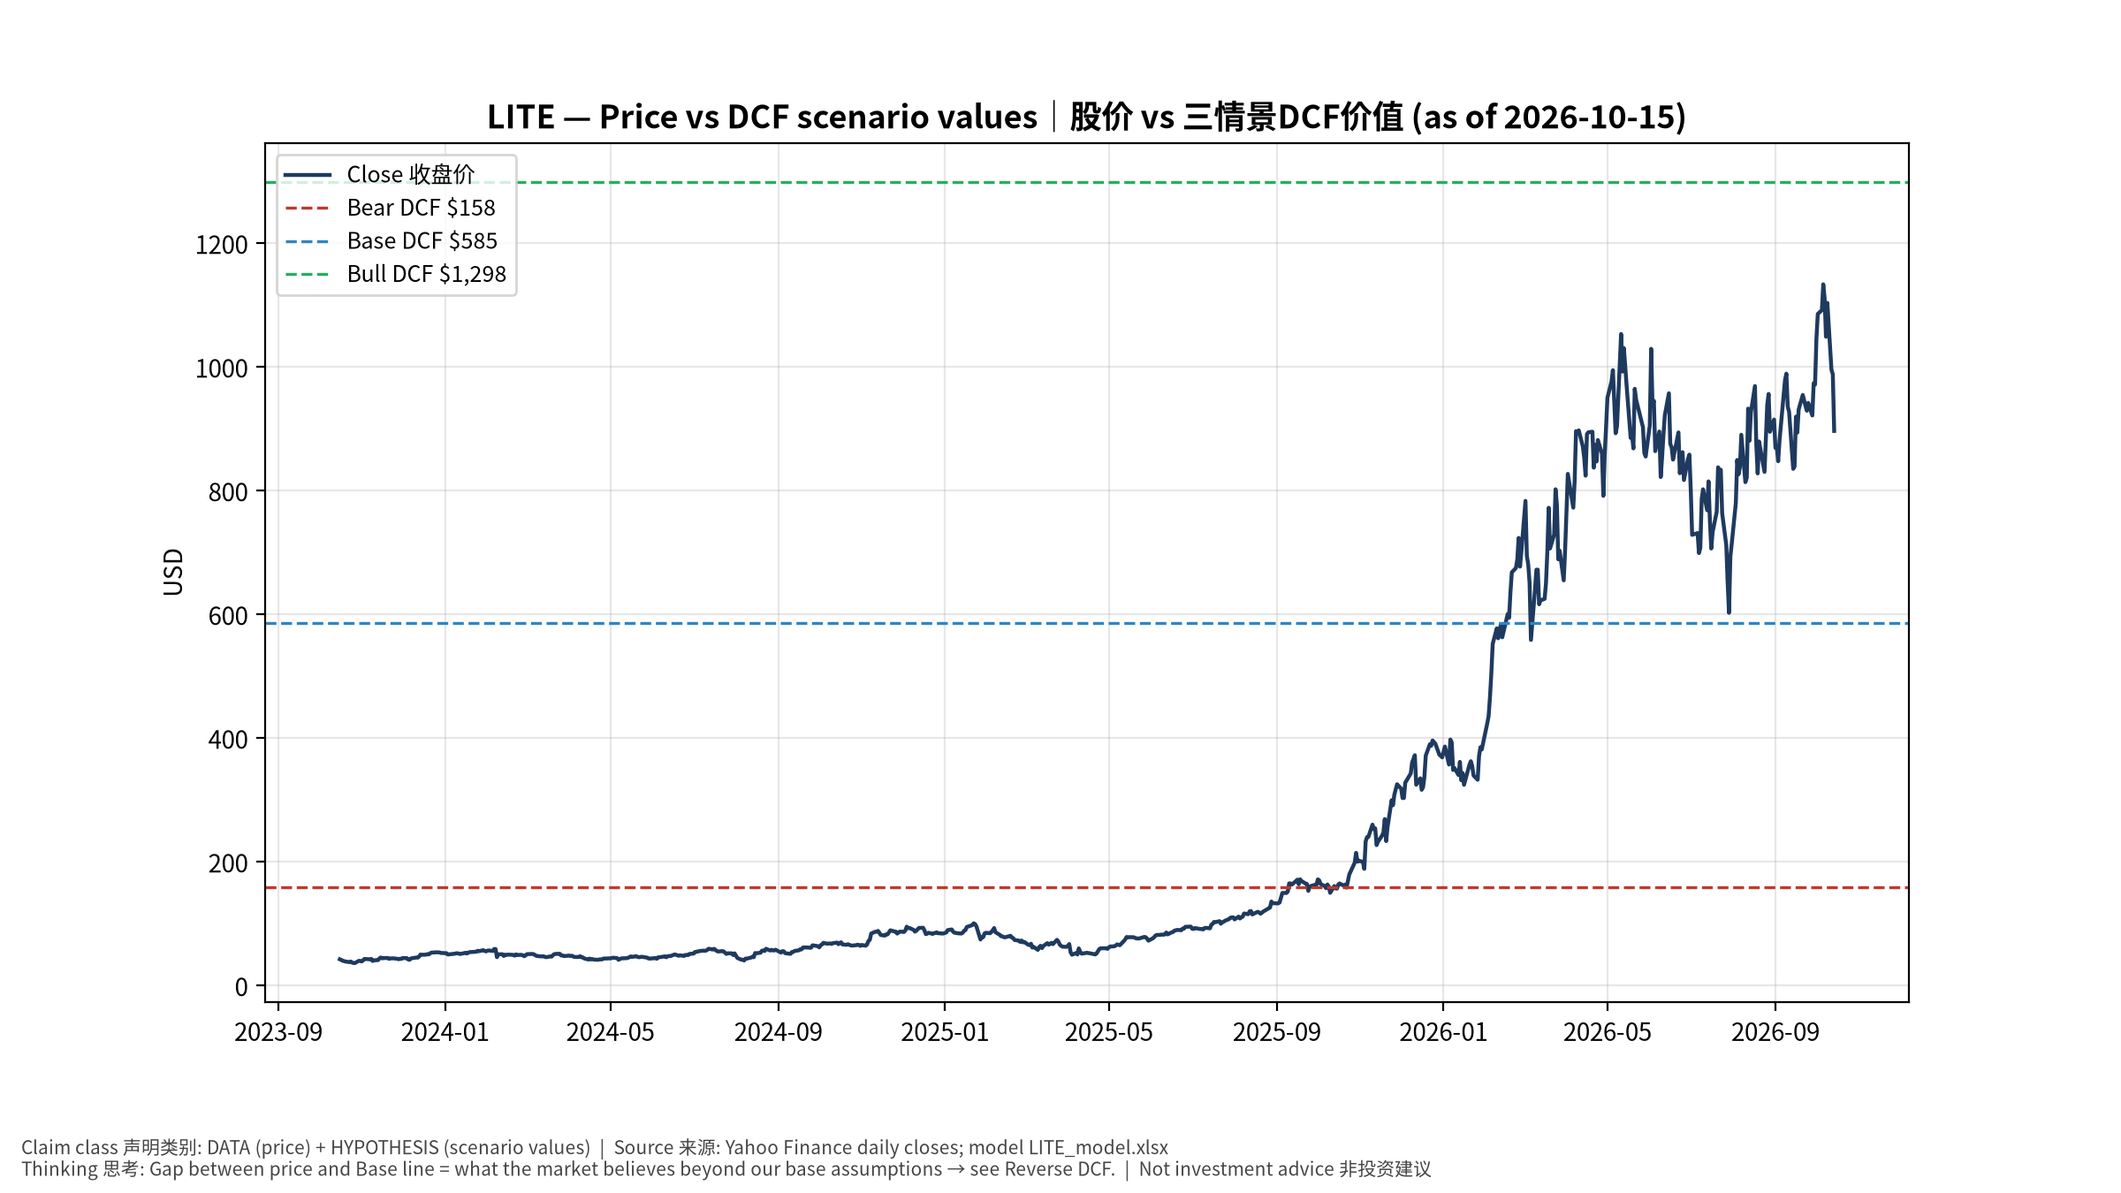
1_price_vs_value
股价vs三情景价值 Price vs scenario values
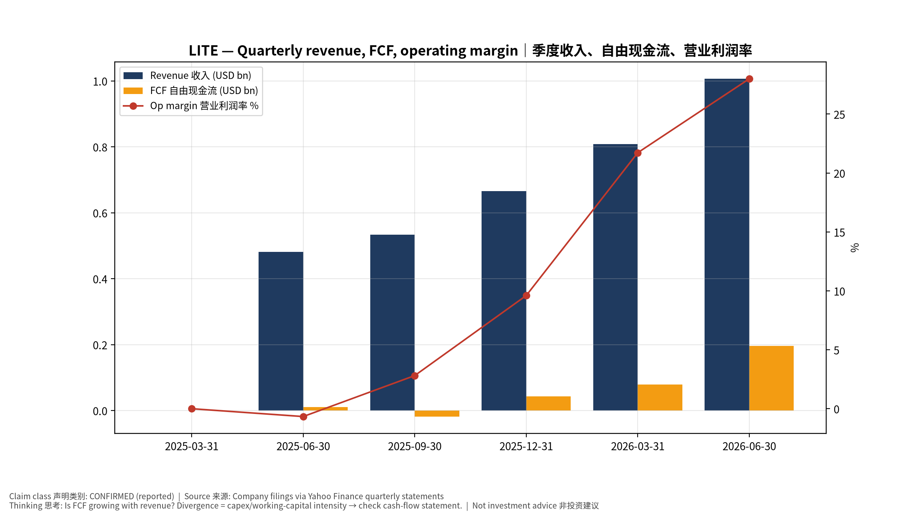
2_financials
季度财务 Quarterly financials
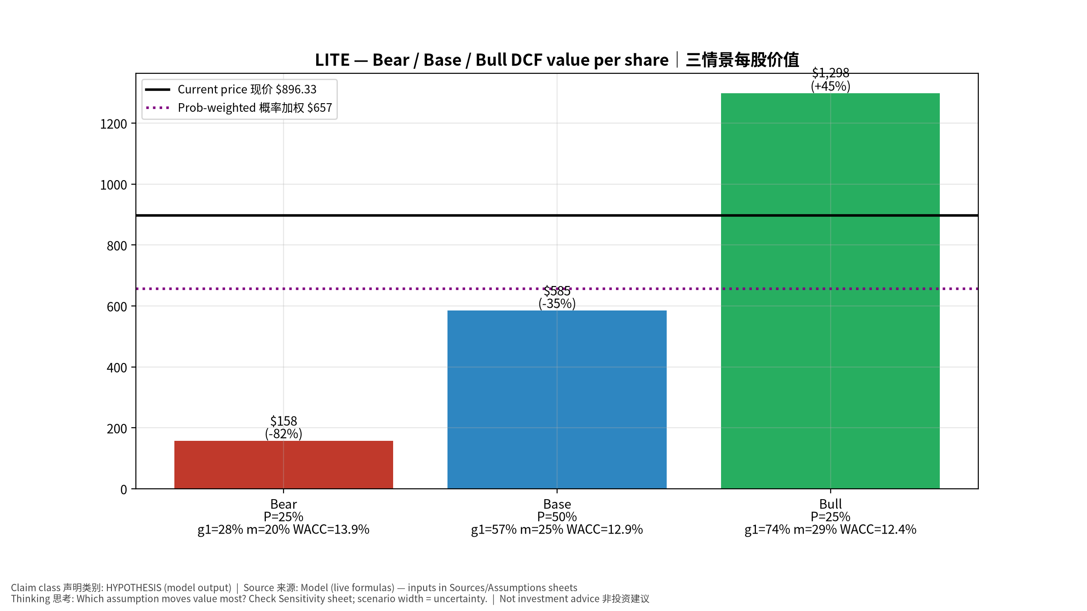
3_scenarios
三情景 Scenarios
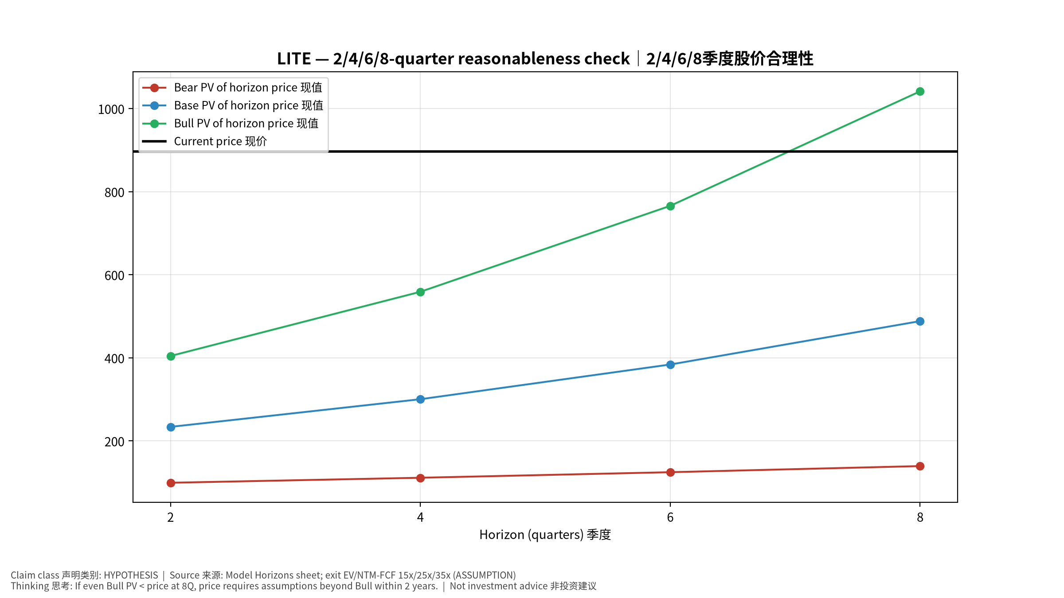
4_horizons
2/4/6/8季度检验 Horizon check
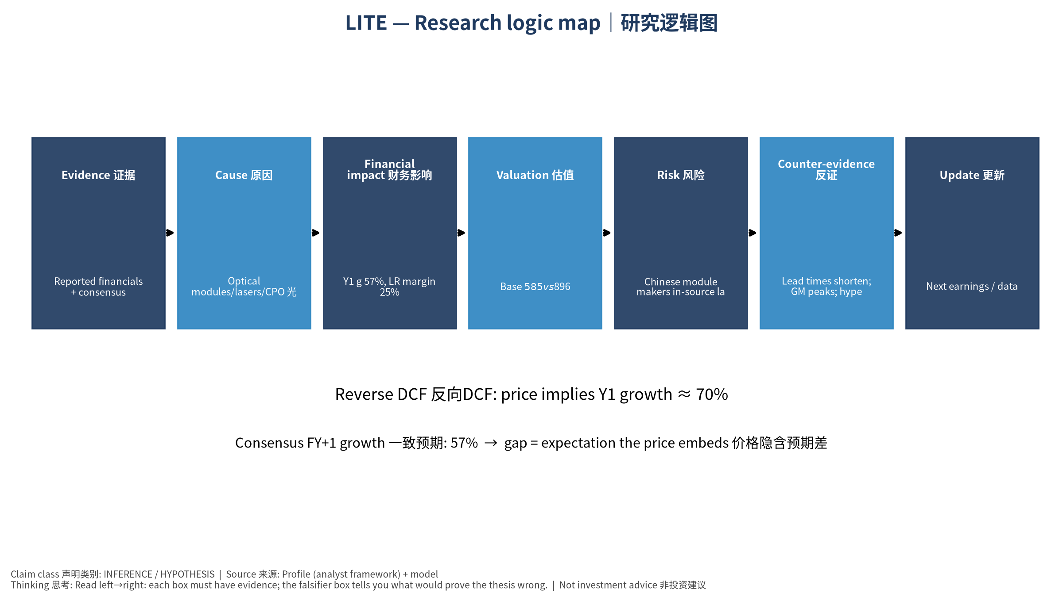
5_logic_map
研究逻辑图 Logic map

LITE Lumentum Holdings Inc. — Equity Deep Dive (Professional English) v20261015-0757
Data as of 2026-10-15 07:57 SGT | Price $896.33 | Mkt cap 81.2 bn USD | Reporting currency USD | Not investment advice.

1. Investment thesis (HYPOTHESIS)
Lumentum benefits from the upstream ‘laser bottleneck’ in AI optics (EMLs, CW sources for CPO, OCS switching); the stock already prices very high growth and is sensitive to capacity additions and pricing.
- Bull drivers: EML shortage persists; CPO ramps 2027; OCS adopted beyond Google｜EML短缺持续；CPO 2027放量；OCS扩散
- Bear drivers: Chinese module makers in-source lasers; price normalization｜中国模块厂自研激光器；价格正常化
- Falsifiers: Lead times shorten; GM peaks; hyperscaler OCS orders slip｜交期缩短；毛利见顶；OCS订单延后

2. Products, customers, revenue model
- Theme: Optical modules/lasers/CPO 光模块/激光器/CPO | Segments: Components (EML, CW lasers) 器件; Systems (transceivers, OCS) 系统
- Business description (DATA): Lumentum Holdings Inc. manufactures and sells optical and photonic products in the Americas, the Asia-Pacific, Europe, the Middle East, and Africa. It offers component products, including semiconductor laser chips, laser sub-assemblies, line subsystems, and wavelength management systems. The company also offers system products, such as optical modules, optical circuit switches, and industrial lasers, including short-pulse solid-state lasers and kilowatt-class fiber lasers. Its products and solutions are used in cloud, artificial intelligence and machine learning (AI/ML), telecommunications, consumer, and industrial end-market applications. The company was incorporated in 2015 and is headquartered in San Jose, California.
- Customers: Hyperscalers (Google OCS), NVDA (CPO lasers), module makers｜云厂(谷歌OCS)、NVDA(CPO光源)、模块厂

3. Industry, competition, regulation, supply chain (ANALYST FRAMEWORK)
- Suppliers: InP substrates, epi (in-house + LandMark), TOSA parts｜磷化铟衬底、外延(自产+联亚)
- Competitors: Coherent, Innolight, Eoptolink, Broadcom (EML), Sumitomo, Mitsubishi｜Coherent、中际旭创、新易盛、博通、日系
- Bottlenecks/regulation: EML/InP laser capacity, CPO adoption timing｜EML/InP激光器产能、CPO导入时点
- KPIs: Revenue growth, GM%, EML capacity, CPO design wins｜收入增速、毛利率、EML产能、CPO订单
- Component spot/contract prices: paid feeds not connected — UNAVAILABLE, tracked qualitatively.

4. Historical financials & cash flow (CONFIRMED, quarterly, USD)
Quarter | Revenue | Gross profit | Op income | Net income | FCF | Op margin
2026-06-30 | 1.0 bn USD | 0.5 bn USD | 0.3 bn USD | -7.2 bn USD | 0.2 bn USD | 28.0%
2026-03-31 | 0.8 bn USD | 0.4 bn USD | 0.2 bn USD | 0.1 bn USD | 79.1 mn USD | 21.7%
2025-12-31 | 0.7 bn USD | 0.2 bn USD | 63.9 mn USD | 78.2 mn USD | 43.1 mn USD | 9.6%
2025-09-30 | 0.5 bn USD | 0.2 bn USD | 15.0 mn USD | 4.2 mn USD | -18.3 mn USD | 2.8%
2025-06-30 | 0.5 bn USD | 0.2 bn USD | -3.2 mn USD | 0.2 bn USD | 10.1 mn USD | -0.7%
2025-03-31 | N/A | N/A | N/A | N/A | N/A | N/A
Cash 2.7 bn USD; debt 1.7 bn USD; TTM FCF 0.3 bn USD (FCF margin 10.0%).

5. Latest earnings: actual vs consensus vs guidance
Quarter | EPS actual | EPS consensus | Surprise
2025-09-30 | 1.1 | 1.02764 | 0.0704
2025-12-31 | 1.67 | 1.40853 | 0.1856
2026-03-31 | 2.37 | 2.26526 | 0.0462
2026-06-30 | 3.23 | 2.96892 | 0.0879
- Management guidance: not in automated feed — UNAVAILABLE (to be entered from IR release).
- Next earnings (Yahoo; TENTATIVE until company-confirmed): 2026-11-06; current-quarter EPS consensus 4.20967 (22 analysts); revenue consensus 1.3 bn USD.

6. 2/4/6/8-quarter drivers & price reasonableness
Horizon | Scenario | PV of horizon price | vs current
2Q | Bear | $99.37 | -88.9%
2Q | Base | $233.86 | -73.9%
2Q | Bull | $404.47 | -54.9%
4Q | Bear | $111.43 | -87.6%
4Q | Base | $300.42 | -66.5%
4Q | Bull | $558.98 | -37.6%
6Q | Bear | $124.78 | -86.1%
6Q | Base | $383.96 | -57.2%
6Q | Bull | $765.86 | -14.6%
8Q | Bear | $139.51 | -84.4%
8Q | Base | $488.37 | -45.5%
8Q | Bull | $1,041.43 | 16.2%

Current-price implied EV/NTM-FCF on Base path: | Horizon
2Q | 93.4x
4Q | 67.6x
6Q | 49.3x
8Q | 36.2x

7. Bear / Base / Bull (HYPOTHESIS)
Scenario | Y1 growth | LR FCF margin | WACC | Terminal g | Prob. | Value/share | vs price
Bear | 28.5% | 20.0% | 13.9% | 2.5% | 25.0% | $158.11 | -82.4%
Base | 57.0% | 25.0% | 12.9% | 3.0% | 50.0% | $585.30 | -34.7%
Bull | 74.0% | 28.7% | 12.4% | 3.5% | 25.0% | $1,298.45 | 44.9%
Probability-weighted value $656.79 (-26.7% vs price).

8. Valuation: DCF / Reverse DCF / ROIC-WACC / comps / sensitivity
- Base DCF EV 52.0 bn USD; terminal share 56.6%.
- Reverse DCF: at Base margin/WACC the price implies Y1 revenue growth ≈ 70.4% vs consensus FY+1 57.0%.
- WACC (CAPM) = rf 5.2% + β 1.54 × ERP 5.0% = 12.9%.
- SOTP segments: Components (EML, CW lasers) 器件; Systems (transceivers, OCS) 系统 — framework only; segment revenue inputs pending from filings.
- Comps (DATA): see table in Chinese section / Excel Comps.
- Sensitivity: Excel Sensitivity (WACC × terminal g).

9. Risks, counterarguments, falsifiers
Chinese module makers in-source lasers; price normalization｜中国模块厂自研激光器；价格正常化 | Falsifiers: Lead times shorten; GM peaks; hyperscaler OCS orders slip｜交期缩短；毛利见顶；OCS订单延后

10–12. Source Ledger / Assumption Register / Model Provenance
See tables above (shared, bilingual). - Model file: LITE_model_v20261015-0757.xlsx (live formulas; sheets Inputs→Scenarios→DCF→ReverseDCF→Sensitivity→Horizons→SOTP→Comps→ROIC_WACC→History→Sources→Assumptions) - Engine: production/pipeline/model.py (Python mirror; values in this report = Python mirror, verified against LibreOffice recalculation of the xlsx) - Data snapshot: data/snapshots/20261015-0757 (immutable) | Fetched 2026-10-15 07:57 SGT | Generated 2026-10-15 07:58 SGT - Version: v20261015-0757. Prior versions are never overwritten (see company history page).

